South Delta Tidal Data Atlas
Graphs and Notes for Calendar Year 2013
Introduction
This document includes the major graphs of 15-minute and daily average data from the south Delta channels for 2013. The goal of this flow and salinity analysis task is to describe and better understand (identify and quantify relationships) the effects of SJR flows, export pumping, tidal elevations and temporary barrier installation (weirs with flap-gate culverts) on salinity (EC) between Vernalis and the south Delta EC compliance stations (SJR at Brandt Bridge, Old River at Union and Old River at Tracy Boulevard). Because most of the water for exports comes into the south Delta through Old and Middle Rivers, the data atlas files include data from Old and Middle River downstream to the stations near Bacon Island used for computing the OMR (combined flow). Data from Rock Slough is also included because CCWD intake to the CCC is an important location for salinity regulation in the Delta (measured at PP#1).
The full task includes the review and summary of data from 2009-2013. This year (2013) included relatively low SJR flows (1,000-2,500 cfs with April-May pulse flow of 4,000 cfs) and low exports (2,000-6,000 cfs) in the January-June period with very low SJR flows (500-750 cfs) and high exports (6,000-10,000 cfs) in the summer months (July-September) and low SJR flow (1,000 cfs with late October pulse flow of 2,500 cfs) with low exports (2,000 cfs to 4,000 cfs) in the fall months (October-December).
For this calendar year (2013), daily data graphs are shown and briefly described to provide an introduction and summary of the flows, elevations, and EC conditions in the SJR and south Delta channels. Next, the basic 15-minute data graphs of tidal elevation, tidal flow, and tidal variation in EC are shown in four quarter-year graphs for each variable (at several locations) for calendar year 2013. The potential effects of Paradise Cut and Sugar Cut salinity (EC) on the Old River at Tracy Boulevard EC are evaluated and described. Several calculated flows into Tom Paine Slough (siphons with flap gates), at the temporary barriers, and tidal flows in Paradise Cut and in Sugar Cut are used to support the data analysis.

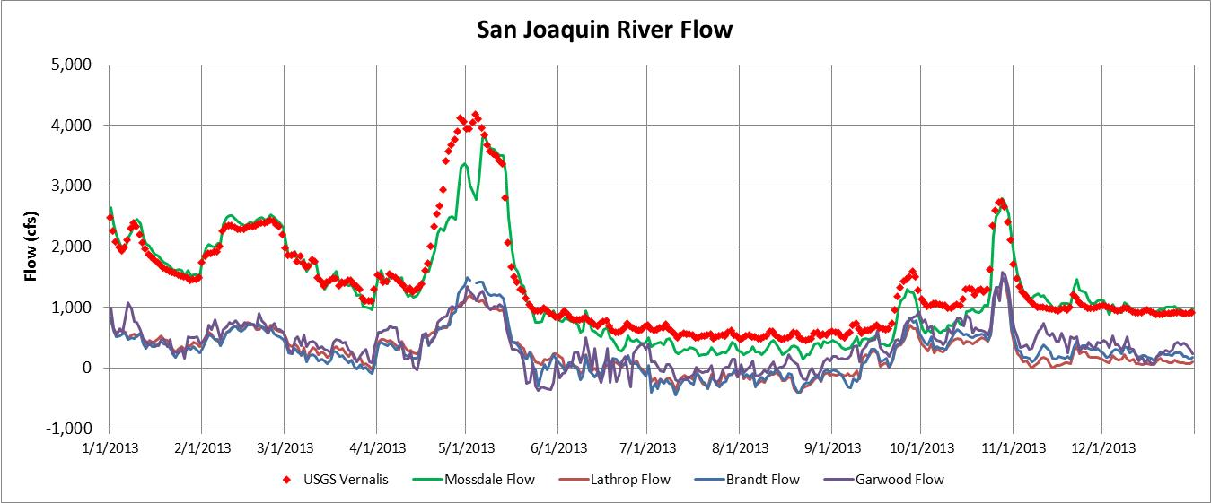
San Joaquin River flows in 2013 were very low, less than 2,500 cfs in January-March and increased during the pulse flow in April-May to about 4,000 cfs. The SJR flow was less than 1,000 cfs from June through mid-September, when a small pulse flow of 1,500 cfs at the end of September was followed by a larger pulse flow of about 2,500 cfs for fish attraction was released from the tributary reservoirs (Stanislaus, Tuolumne, and Merced Rivers) in late October. The SJR flows downstream of Old River were much lower than the flow at Vernalis or Mossdale, because most of the SJR was diverted into Old River. The SJR flow downstream of Old River was often negative (i.e., upstream) in late-May through early September.

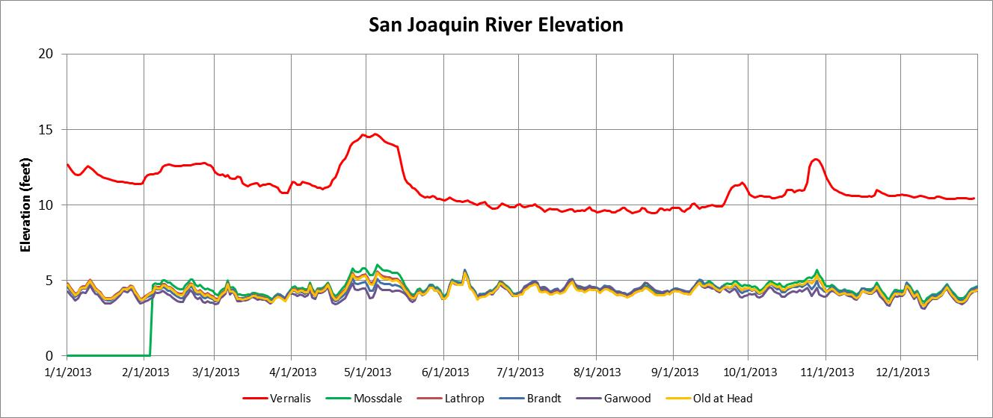
Only during the pulse flows in April-May and in late October of 2013 were river elevations at Mossdale increased slightly. Elevations at Mossdale, Lathrop, Brandt and Garwood indicate a slight elevation gradient (slope) when flows are greater than 2,500 cfs at Vernalis (elevation of greater than 12.5 feet). Average daily tidal ranges in the SJR were about 4 to 5 feet throughout the year (not shown in graph).

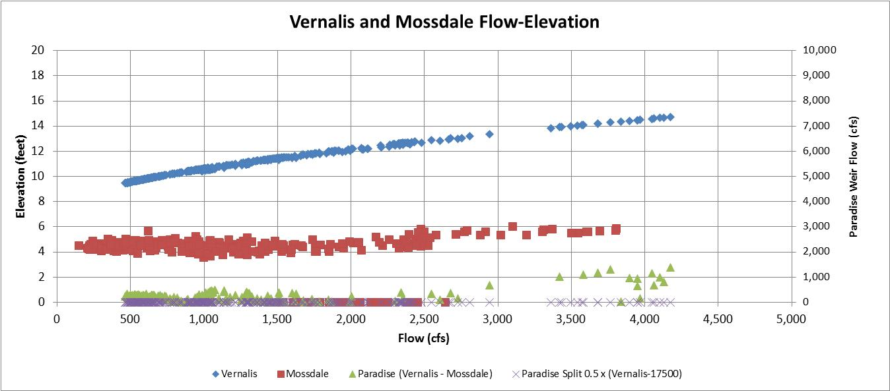
The flow-elevation relationships (rating curves) at Vernalis and Mossdale are compared. The rating curve at Mossdale indicates that the river elevations are increased (above the tidal average of 5 feet) when flows are greater than about 2,000. The rating curve at Vernalis was stable (no changes) throughout 2013. Differences between Vernalis and Mossdale flows (green triangles- right scale compared to Vernalis flow on X-axis) were measured during the April-May pulse flow. Mossdale data appears to be low because Vernalis and Mossdale flows are expected to be about this same at this low flow (because estimated Paradise Weir flow, shown with “X”s is zero).
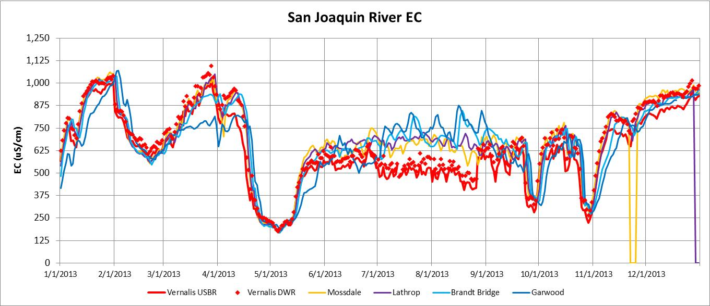
The SJR EC in 2013 was about 250 uS/cm during the pulse flow in April-May and during the pulse flow for fish attraction in late October (reservoir releases). The Vernalis EC objectives (monthly average) are 700 uS/cm for April-August and 1,000 uS/cm for September-March. The highest SJR EC in 2013 was about 1,000 uS/cm in late January, late March, and late December when the SJR flow at Vernalis was about 1,000 cfs. The Vernalis EC was about 500 uS/cm in July and August when the SJR flow was 500-750 cfs; these values appear low compared to the EC at several downstream locations. Because the SJR flows were low, the downstream changes in EC were moderately high (i.e., 125 to 250 uS/cm).

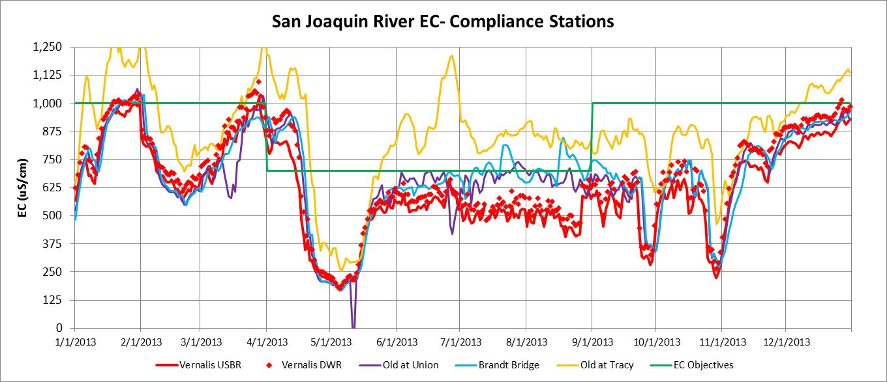
The San Joaquin River at Vernalis EC Objectives are 700 uS/cm from April through August and 1,000 uS/cm from September through March (30-day running average). The south Delta EC objectives are the same as the Vernalis EC objectives at the three compliance locations: SJR at Brandt Bridge, Old River at Union, and Old River at Tracy Boulevard. The EC at Vernalis and at the SJR at Brandt Bridge and Old River at Union stations are generally similar; however, there was a large increase in the eC from Vernalis to Brandt Bridge and Union in June-August of 2013. Old River at Tracy Boulevard EC was often 125-250 uS/cm higher than the Old at Union EC, located just 5 miles upstream. There appears to be a major source of higher EC water in the vicinity of Old River at Tracy Boulevard. The higher EC is measured both during periods with the temporary barriers installed (May-October of 2013) and during periods without barriers (January-April and November-December of 2013).
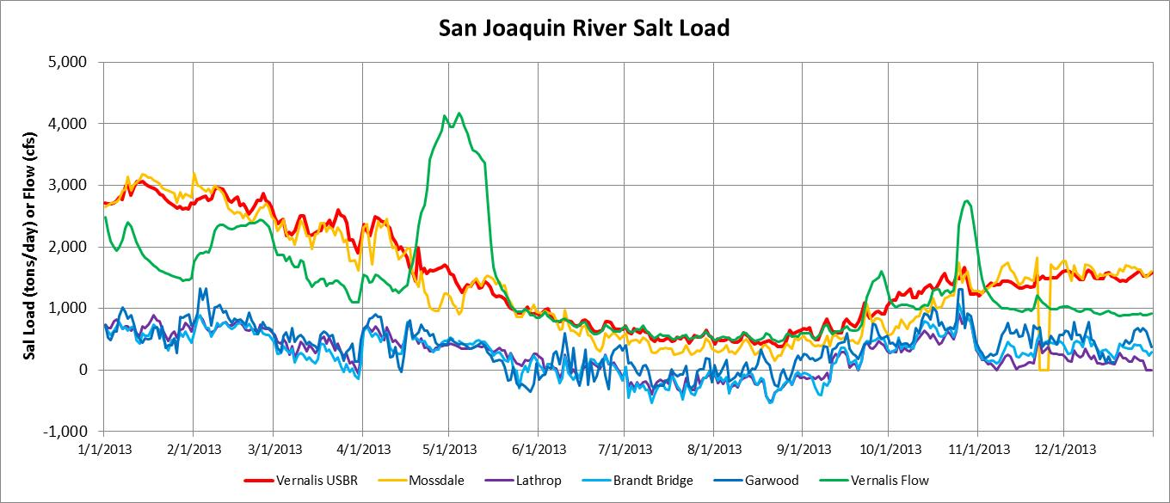
The SJR salt load is estimated as: Salt Load (tons/day) = flow (cfs) x EC (uS/cm) x 0.00175. The SJR salt load at Vernalis was relatively high (2,000 to 3,000 tons/day) during the winter months of January-March, but declined to a minimum of just 500 tons/day in July-September, and increased to about 1,500 tons/day in October-December. The SJR flow is also shown (green line) to indicate periods when the salt load was increased by higher flow and when the salt load remained constant during pulse flows (i.e., dilution of salt load). Although the SJR flow was reduced and the EC increased somewhat, the salt load was similar at Vernalis and Mossdale. The SJR salt load at Lathrop, Brandt Bridge and Garwood was reduced by more than half because more than half of the river was diverted into Old River. The SJR salt load downstream of Old River was negative (flow moving upstream) in July-September because of low SJR flows with high export pumping.
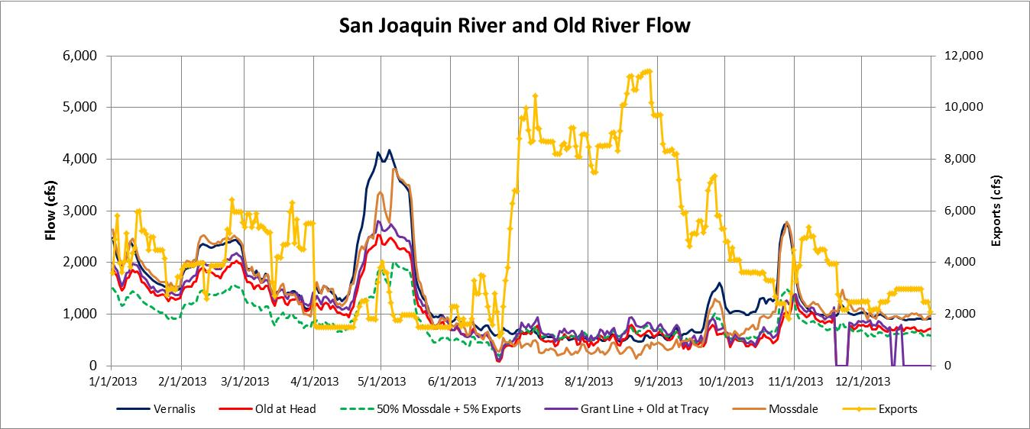
The SJR at Mossdale flow diverted to Old River in 2013 was measured at the head of Old River (red line) and estimated (dashed green line) with the basic relationship for Old River Diversion = 50% Mossdale + 5% of the CVP and SWP exports (shown in gold-right scale). The Grant Line Canal flow plus Old River at Tracy Boulevard flow estimate of the Old River at head flow (purple line) was very similar to the measured Old River at head flow (good confirmation). The Old River flow was a large fraction of the SJR flow in 2013; the measured flow was higher than the estimated flow in January-May and was higher than the Mossdale flow in July-September (due to reverse SJR flow).
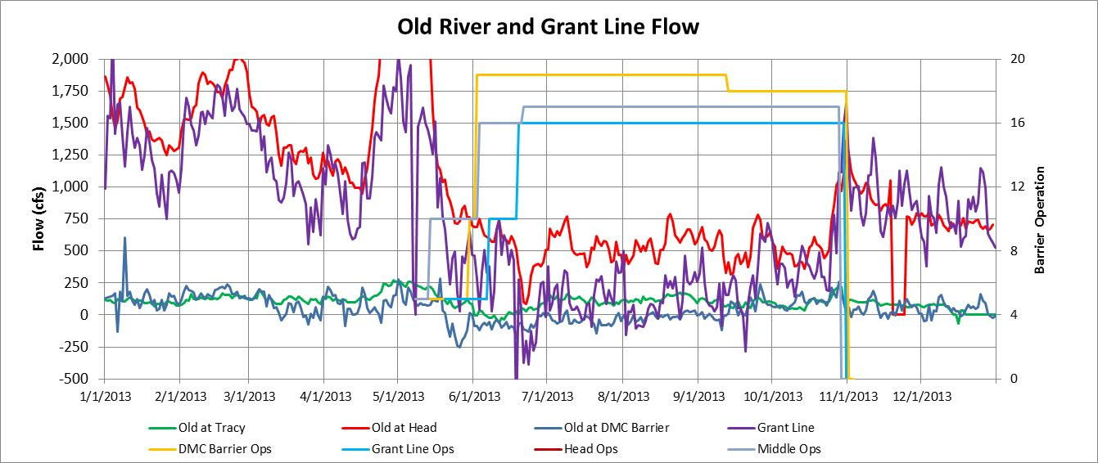
A barrier operation value of 5 (right scale) indicates barrier installation was initiated, a value of 10 indicates the weir was closed but the culverts were open, and higher values indicate the number of flap gates that were operational (10 + flap gates). The head of Old River flow (red line) and Grant Line Canal flow (purple line) indicate that most of the Head of Old River flow passed through Grant Line when the temporary barriers were not installed, in January-May and in November and December. During these periods, the measured net Old River flow at Tracy Boulevard (green line) was similar to the Old River flow at the DMC barrier (blue line).

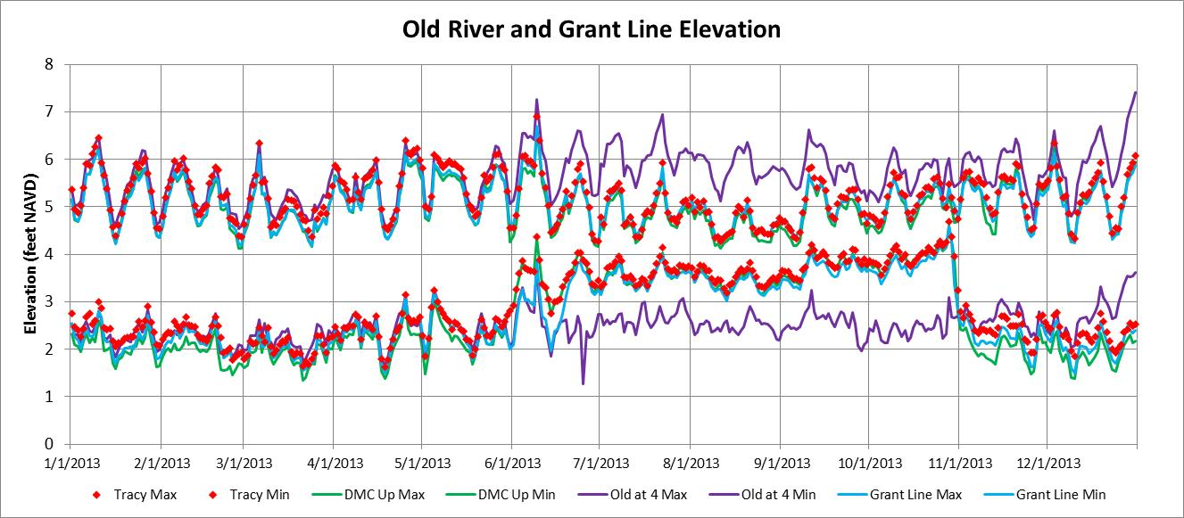
The Old River at Highway 4 minimum and maximum elevations (purple lines) indicate that the tidal elevations generally range from 2 feet to 6 feet. The minimum elevations in Old River at Tracy Boulevard and in Grant Line Canal at Tracy Boulevard were increased slightly to between 3 feet and 4 feet in June when the DMC and Grant Line Canal barriers were installed. At this same time, maximum elevations were reduced by 0.5-1.0 feet. As a result, the tidal elevation range in Old River and in Grant Line Canal was reduced to less than 2 feet (with reduced tidal flows) from June through October.

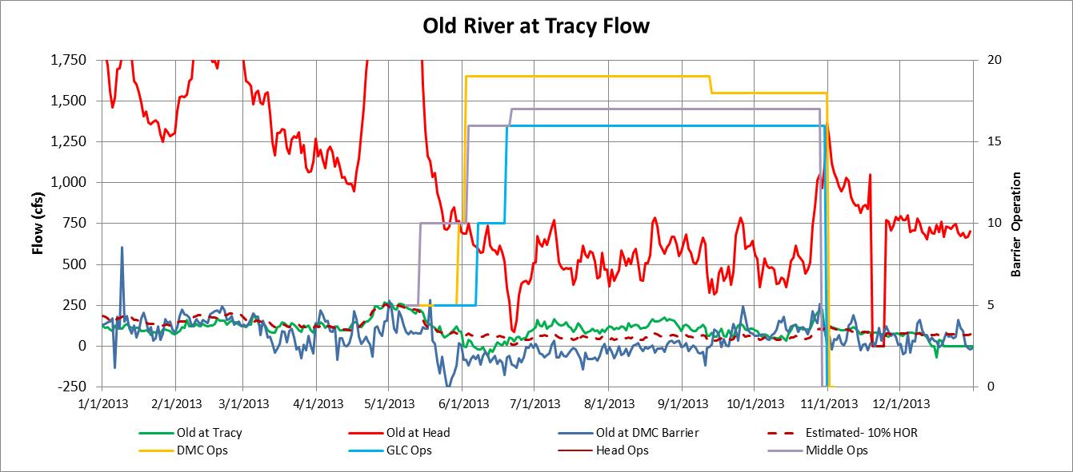
The flow measurements indicate that the Old River at Tracy Boulevard flow can be estimated (dashed brown line) as 10% of the head of Old River flow when temporary barriers are not installed. The flow at the DMC barrier was similar in the winter, but was 100-150 cfs less (often reversed) when the barriers were installed. This difference was likely caused by irrigation diversions. When the Old River at DMC barrier was installed, but without the Grant Line Canal barrier (early June), the Old River at Tracy Boulevard flow was reduced to about 0 cfs. When the Grant Line Canal barrier was installed, with flap gates closed in late-June through October, the Old River at Tracy Boulevard flow increased to about 20% of the head of Old River flow. The flow at the DMC barrier (blue line) was negative (upstream) with the barrier installed until mid-September when the DMC barrier was notched (for adult fish passage). The Old River at Tracy Boulevard flow can be estimated as a fraction of the head of Old River flow; but the flow fraction will change with various Old River at DMC and Grant Line Canal barrier configurations.
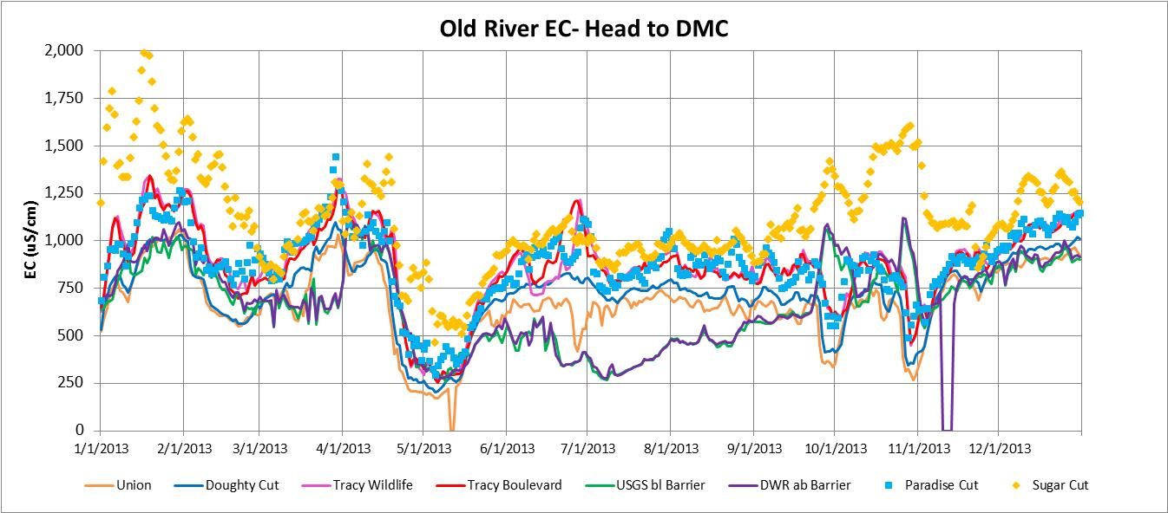
The Old River EC was measured at Union (gold line) and at Doughty Cut (blue line). The City of Tracy treated wastewater discharge (diffuser) is located between the two stations, and the EC increase would be greater with lower Old River flows. The most dramatic EC increases were measured in Old River between Doughty Cut and Tracy Boulevard (a distance of about 2 miles). The EC in Old River at Tracy Boulevard (red line) was highest (1,250 uS/cm) in January, March and June (low SJR flows). The high EC at Tracy Boulevard was confirmed with the Tracy Wildlife EC measurements (pink line). The EC at Tracy Boulevard was generally 100-250 uS/cm higher than the EC at Doughty Cut. The higher EC measured in Sugar Cut (500 to 1,500 uS/cm- gold diamonds) and in Paradise Cut (750 to 1,250 uS/cm- light blue squares) throughout the year indicate possible sources of higher salinity. The daily average EC in Paradise Cut was very similar to the Old River at Tracy Boulevard EC in 2013.
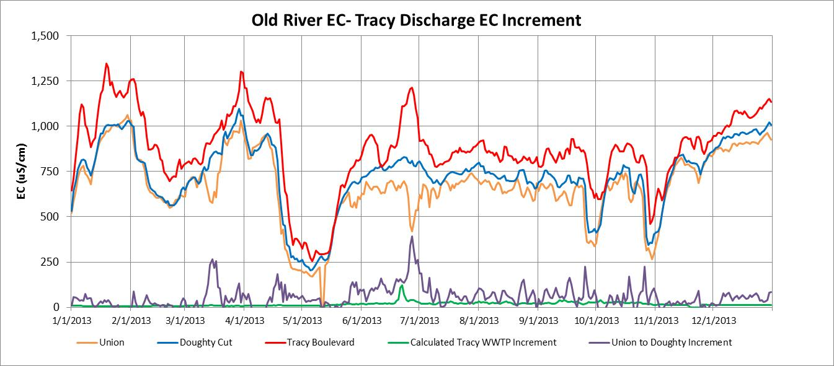
The measured daily EC increment between any two locations along Old River can be approximated with a source discharge (cfs) and a source EC. The EC increment between Union and Doughty Cut that can be attributed to the Tracy WWTP discharge can be calculated as: EC increment (uS/cm) = (Tracy WWTP EC – River EC) x Tracy Discharge / (River Flow + Tracy Discharge). The measured daily Old River EC increments between Union and Doughty (purple line) can be compared with the daily calculated Tracy WWTP EC increments assuming a discharge EC of 1,500 uS/cm and a discharge flow of 15 cfs. The calculated EC increments were greatest during the lowest Old River flow of 500 cfs in the summer months.
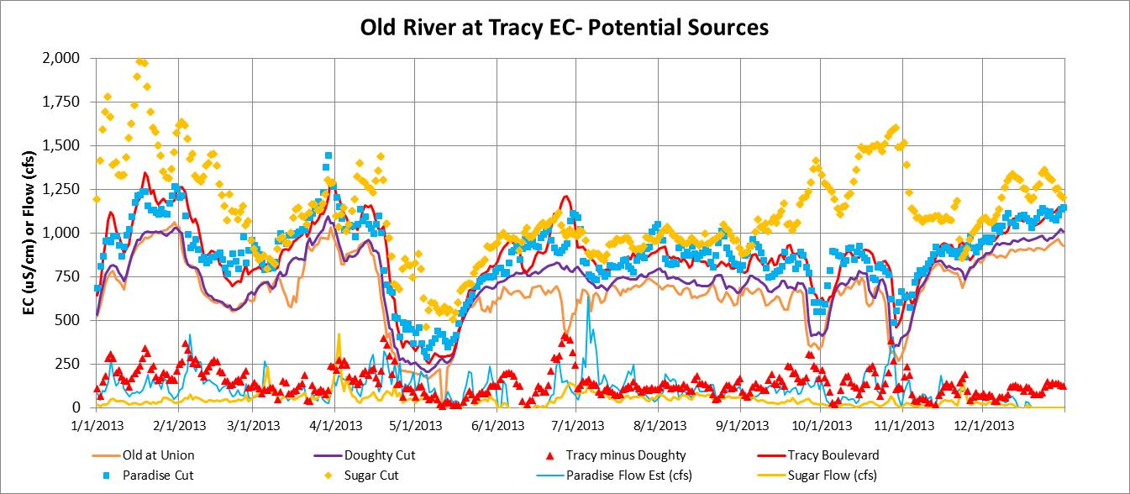
The measured daily EC increment between Doughty Cut and Tracy Boulevard can be approximated with a salt source discharge (cfs) and a salt source EC. The EC increment can be calculated as: EC increment (uS/cm) = (Salt Source EC – River EC) x Salt Source Discharge / (River Flow + Source Discharge). The daily Old River at Tracy Boulevard EC increments (red triangles) were matched with the daily average Paradise Cut EC (blue squares) to estimate the “salt source discharge” (blue line), assuming that Paradise Cut was the only salt source. A larger salt source discharge is needed when the Tracy Boulevard EC increment is large, when the flow in Old River at Tracy Boulevard is higher, or when the Paradise Cut EC was closer to the Old River at Doughty Cut EC. For most of the year, the estimated Paradise Cut salt discharge would have been about 125 cfs (a very high discharge). Because the Sugar Cut EC was often higher than the Paradise Cut EC, the calculated Sugar Cut discharge would have been about 25 cfs to 75 cfs, if Sugar Cut was the only salt source. More analysis of these salt sources will be described later.
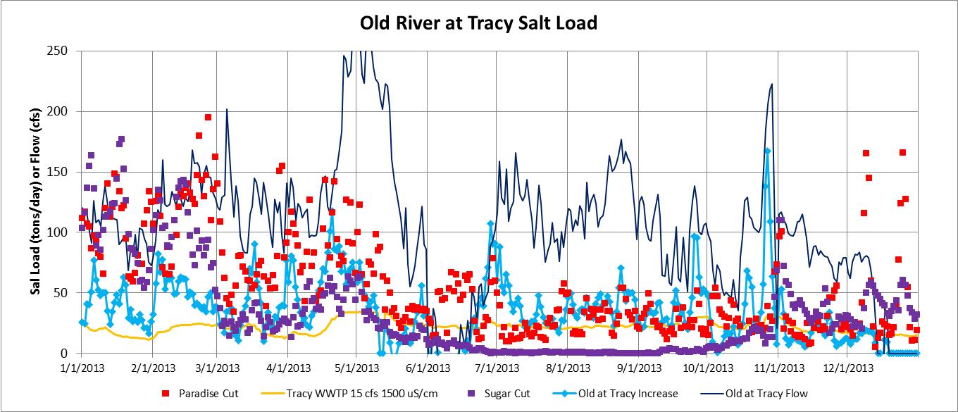
The incremental salt load in Old River at Tracy Boulevard (bright blue line with diamonds) was calculated as the incremental EC (Tracy EC minus the Doughty Cut EC) times the Old River at Tracy flow (dark blue line) times 0.00175 (conversion factor). The incremental salt load was generally about 50 tons/day, although it fluctuated from 25 tons/day to 100 tons/day during 2013. This incremental salt load is equivalent to a flow of 10 cfs with an EC of 2,850 uS/cm more than the Old River EC ( 250 to 750 uS/cm). For comparison, the measured excess salt loads from Paradise Cut during ebb-tide outflow periods each day (red squares) were higher than the incremental salt loads at Tracy for January-April (50-150 tons/day), and were similar to the incremental salt loads at Tracy for May- December (25-50 tons/day). The measured excess salt loads from Sugar Cut were similar to the Paradise Cut loads in January-April and in November-December (25-150 tons/day), but were very low during the irrigation season (May-October) because the Tom Paine Slough diversions greatly reduced the salt loading to Old River.
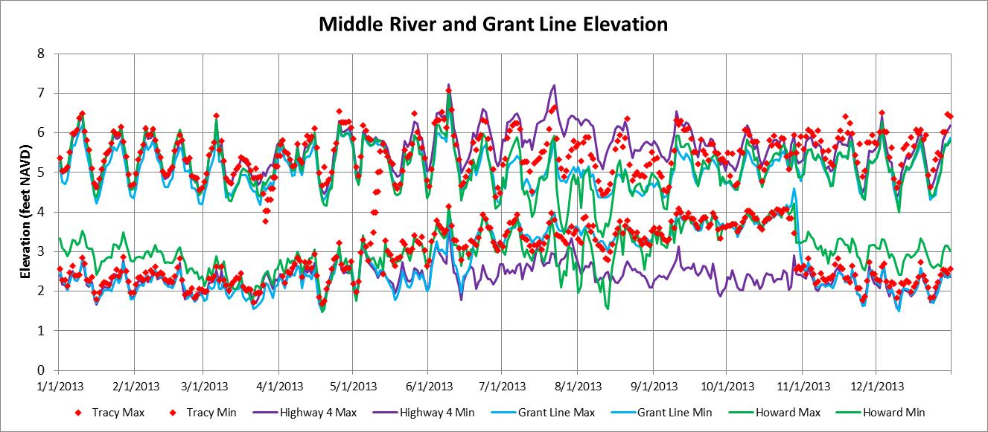
The Middle River at Highway 4 minimum and maximum elevations (purple lines) indicate that the tidal elevations generally range from 2 feet to 6 feet. The Middle River Barrier was installed in mid-May with a weir crest of 3.5 feet that was raised to 4.5 feet on June 21, at about the same time as the Grant Line Canal barrier was installed with a weir crest of 3.5 feet. The minimum elevations in Middle River at Tracy Boulevard (red diamonds) were increased by about 1 foot, from about 2.5 feet to 3.5 feet from June through August, and were slightly higher (4 feet) in September and October with lower irrigation diversions. The maximum elevations (high tides) were reduced in the summer months when the weir crest was raised, Grant Line Canal barrier was installed, and irrigation diversions were greater. The minimum and maximum elevations at Howard Road (green lines) were reduced in July and August, indicating the effects of high irrigation diversions.
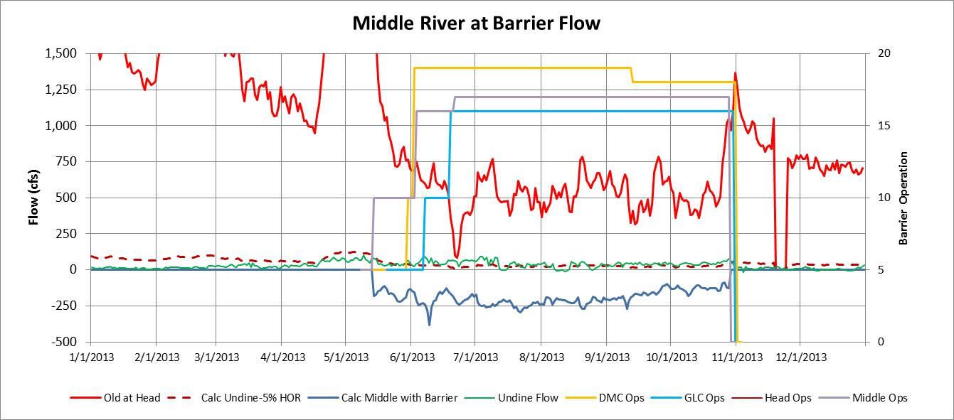
The Middle River flows were measured at Undine Road (green line) near the upstream end (head) from June-December. Based on previous DSM2 modeling [SDIP 2007] with the temporary barriers installed, about 5% of the Old River flow was diverted into Middle River. The calculated flows (brown dashed line) were similar to the measured net flows at Undine Road (25-50 cfs) during the period with barriers. The measured flows at Undine Road were lower (about 0 cfs) when the barriers were removed in November and December. During barrier operation, the flood-tide (upstream) flows over the weir or through the culverts were calculated (blue line) from the elevations upstream and downstream of the barrier. The calculated flows show a seasonal pattern that may reflect the upstream irrigation diversions, with a maximum flow of about 250 cfs. The next graph showing Middle River EC patterns generally confirms this upstream flow during barrier operation, but cannot verify the flow magnitude [Tidal flow measurements were initiated at the Middle River barrier in February 2014].
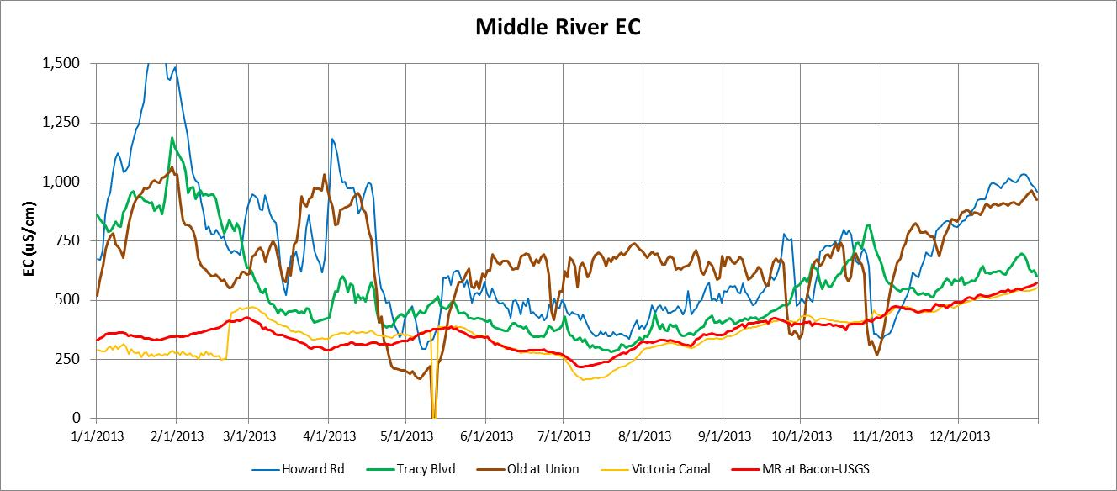
The Middle River EC downstream of the barrier at Victoria Canal or at the USGS station at Bacon Island was 250 to 500 uS/cm in 2013. The EC in Old River at Union was 500 to 1,000 uS/cm from January until mid-April when the SJR pulse flow reduced the EC to 250 uS/cm. The Middle River EC at Tracy Boulevard was much higher than the downstream EC in January and February, but was similar to the downstream EC (100-200 uS/cm higher) for the remainder of the year, suggesting an upstream flow or tidal mixing with the downstream portion of Middle River. The EC at Howard Road (midway between Tracy Boulevard and the head of Middle River) was highest in January, and was similar to the Old at Union EC through May (downstream flow) but was similar to Tracy Boulevard EC when the Middle River barrier was installed (upstream flow). The Old River water diverted into Middle River (see previous graph) does not appear to have had large effects on the EC at Howard Road, while the Middle River barrier was installed. The Middle River barrier reduced the Middle River EC at Tracy Boulevard and at Howard Road (with low EC water from Middle River downstream of Victoria Canal).
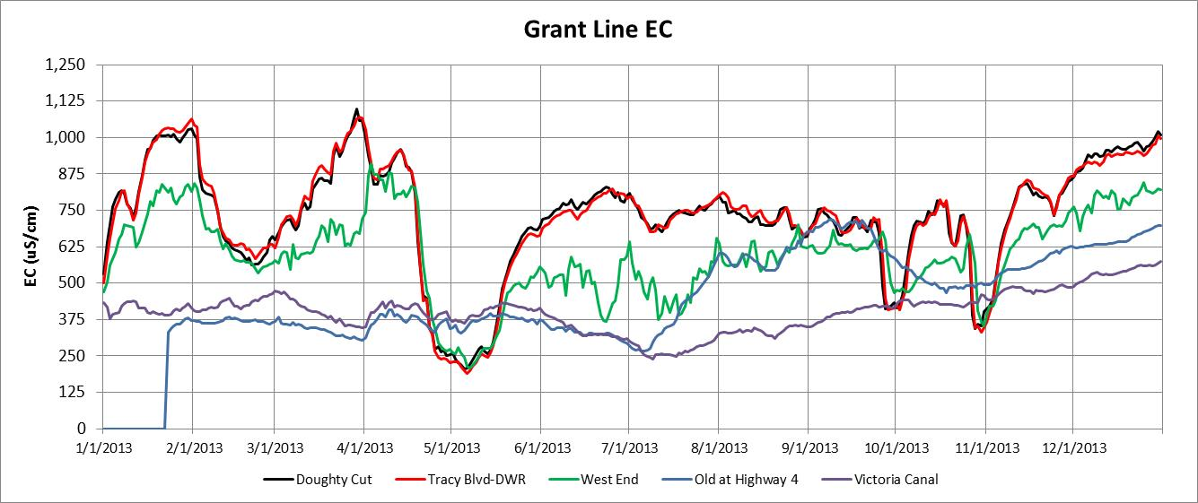
The Grant Line Canal EC at Doughty Cut and at Tracy Boulevard followed the SJR EC pattern that was controlled by SJR flow. The Grant Line Canal EC at the western end was usually less than the EC at Doughty Cut and at Tracy Boulevard because of the high tidal flows at the downstream end of Grant Line Canal. The water from Victoria Canal and from Old River at Highway 4 was tidally mixed into West Canal and Grant Line Canal during flood tides. The salinity in Victoria Canal, in Old River at Highway 4, and in Grant Line at Tracy boulevard are all mixed to give the EC in Clifton Court Forebay (CCF) and at the DMC intake. The different source water for the eastern and western end of Grant Line Canal produce large longitudinal EC gradients in Grant Line Canal; similar longitudinal gradients were measured in Middle River upstream of the barrier and in Old River upstream of the barrier.
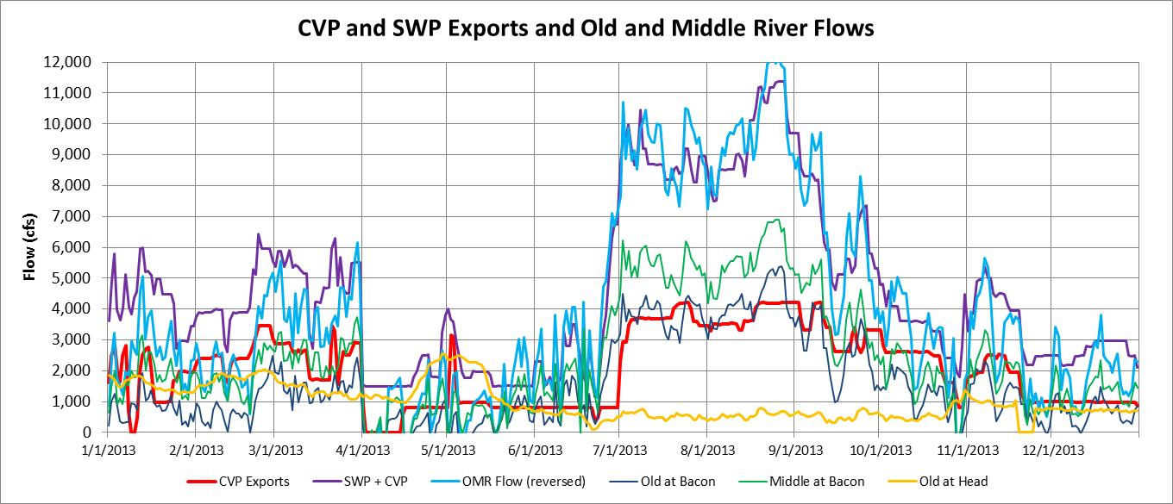
The 2008 USFWS and 2009 NMFS Biological Opinions include measures to provide entrainment protections for delta and longfin smelt and for Chinook salmon and steelhead by limiting the reverse flows in Old River and Middle River (OMR flow, measured on either side of Bacon Island). CVP and SWP exports cause the net daily flow in Old and Middle Rivers to reverse (flow south) whenever the exports are more than the head of Old River flow diversion from the SJR. The agricultural diversions in the south Delta channels (south of the Old at Bacon and Middle at Bacon flow stations) and CCWD diversions at the Old River and Victoria Canal intakes will also cause a higher reversed OMR flow. The OMR flows generally follow the combined exports and agricultural diversions (maximum of about 1,500 cfs) minus the head of Old River flow (gold line). There was a strong spring-neap tidal effect on OMR flow; a daily OMR flow index, calculated from daily estimates of the head of Old River flow, agricultural diversions and exports is now being used to track reverse OMR flows .
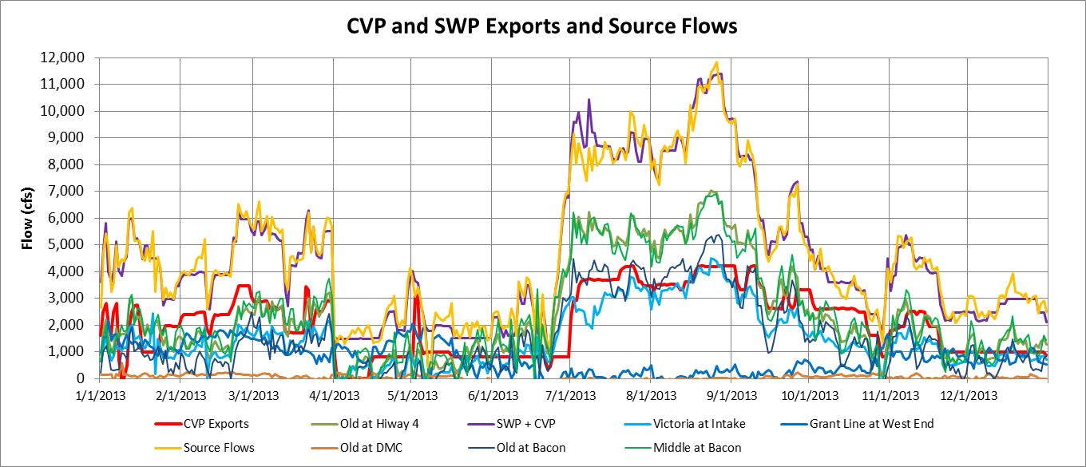
The tidal flows and EC monitoring in the south Delta is comprehensive and accurate. During 2013, the sum of the net tidal flows (daily average) in the south Delta channels provided a very accurate match with the CVP and SWP export flows. The Old River at Highway 4 flows were the largest source of water for CVP and SWP exports; when pumping was near the maximum (permitted) of about 11,000 cfs (late August) the Old River at Highway 4 flow was about 7,000 cfs and the Victoria Canal flow (from Middle River) was about 4,000 cfs. The Old River at Bacon flow was 1000-1500 cfs lower than the Middle River at Bacon flow; during periods of high pumping about 1,000-1,500 cfs from Middle River was diverted to Old River through Railroad Cut (between Bacon Island and Woodward Island) and Woodward Canal (between Woodward Island and Victoria Island). The Grant Line Canal flows and the Old River at DMC flows were less than 250 cfs during the summer months when irrigation diversions in the south Delta are greatest. During periods when all four flow stations were operating, the match with CVP and SWP exports (gold line) was very accurate (within 5%).
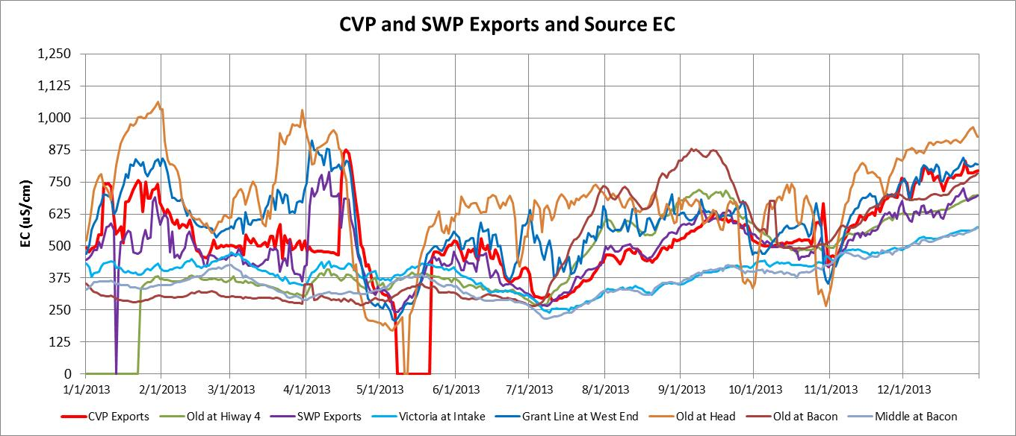
The EC of the CVP (red line) and SWP (purple line) exports and the EC of each water source for the exports were slightly different during most of the year. The EC in Old River at the head (light brown line) and in Grant Line Canal at west end (dark blue line) were often higher than the CVP and SWP export EC values, but the flows from these water sources were relatively small. The EC in Old River at Bacon (dark brown line) and at Old River at Highway 4 (green line) were similar to the EC in Middle River at Bacon (gray line) and in Victoria Canal (light blue line) from January-June, but the Old River EC was higher than the Middle River EC in the months of July-December because of increased seawater intrusion from the SJR into Frank’s Tract and Old River during periods of low Delta outflow. If the Middle River water could be separated from the SJR and Old River water, and supply all of the CVP and SWP exports, the EC of the exports could be reduced substantially (125-250 uS/cm) for most of the year.
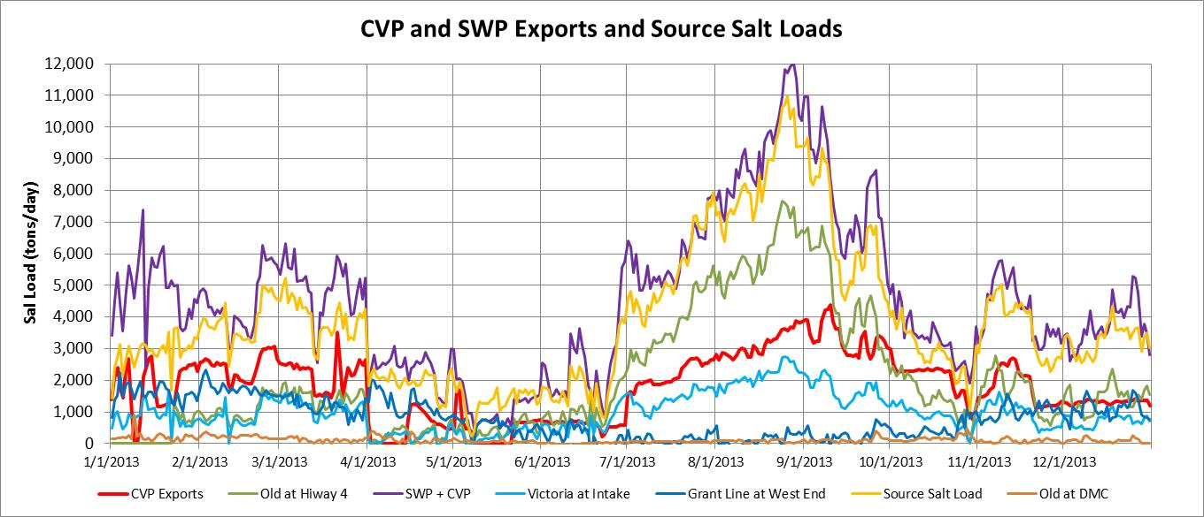
The salt load exported at the CVP (Jones) and SWP (Banks) pumping plants increases with pumping flow and with salinity (EC). The net tidal flows and the daily average EC values were used to calculate the CVP and combined CVP and SWP salt loads (tons/day) as well as the salt loads from Old River at Highway 4, Victoria Canal at the CCWD intake, Grant Line Canal at the west end and Old River at the DMC barrier. The match between the source salt loads and the exported salt loads was generally within 10%. The Old River at Highway 4 was the dominant salt load (60%) during the summer period of maximum exports (with maximum seawater intrusion). A similar match of the salt load sources was calculated using Old River at Bacon (instead of Old at Highway 4) and the Middle River at Bacon (instead of Victoria Canal).
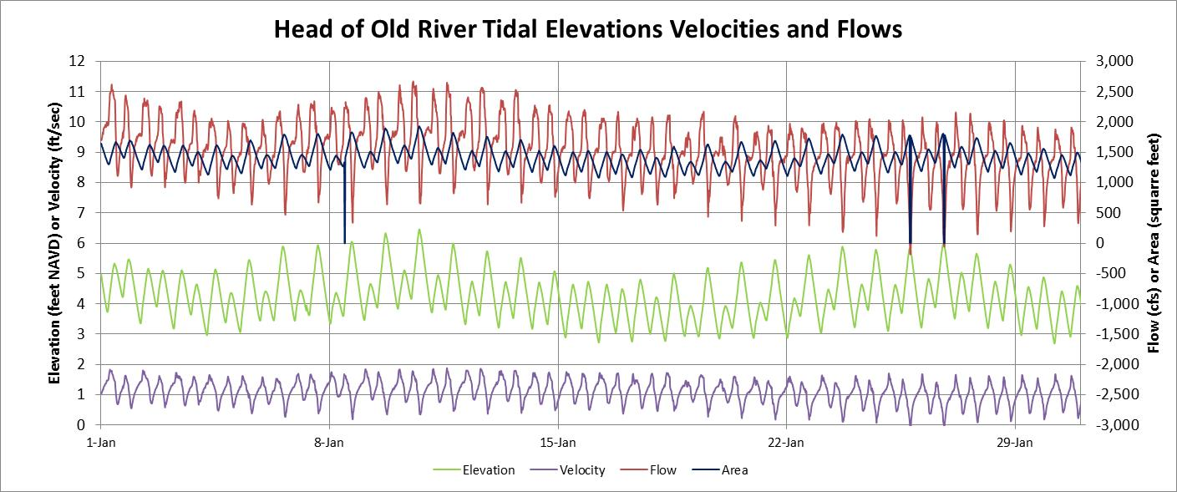
Tidal flow measurements using acoustic-doppler techniques (ADCP) is an amazing technology developed since the 1980s and requires a water elevation measurement to calculate the stream channel cross-section, and a velocity measurement to calculate the channel flow. This graph shows the two measurements and two calculated parameters that are obtained from the head of Old River flow measurement station for January 2013. The water surface elevation (green line, left scale) is usually measured with a pressure device; the channel cross-section must be measured at the station and the depth- area relationship (i.e., area = a + b x depth ^ c) must be “entered” into the data processor. The tidal velocity (purple line, left scale) is measured with an acoustic signal that is transmitted across the entire channel section or a portion of the channel section. Tidal velocities are normally less than 3 ft/sec (2 mph) so tidal flow measurements require very sensitive acoustic processing. Because the head of Old River station is influenced by the SJR flow and by tidal elevations, the velocities and flows generally remain positive (downstream) but have considerable tidal fluctuations. The channel cross-section varied from about 1,000 ft² to 2,000 ft² with tidal elevation.
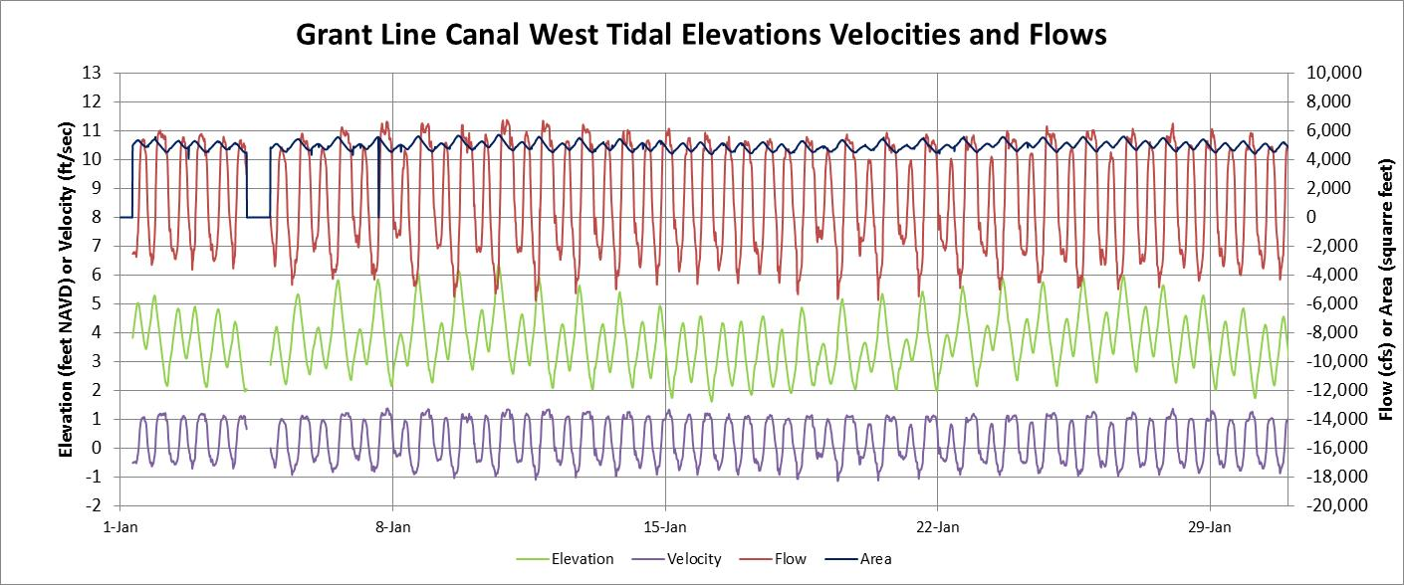
This graph shows the two measurements (elevation, velocity) and two calculated parameters (area, flow) that were obtained from the Grant Line Canal (west end, near mouth) tidal flow measurement station for January 2013. The water surface elevation (green line, left scale) ranged from less than 2 feet to more than 6 feet; the corresponding channel cross-section (black line, right scale) varied from about 4,500 ft² to 5,500 ft² with tidal elevation. The tidal velocity (purple line, left scale) fluctuated from about -1.0 ft/sec to about 1.25 ft/sec. The low velocities measured in this relatively large channel require very sensitive equipment. The corresponding tidal flows ranged from -4,000 cfs at the beginning of each flood-tide period, to about 6,000 cfs during the strongest ebb-tides.
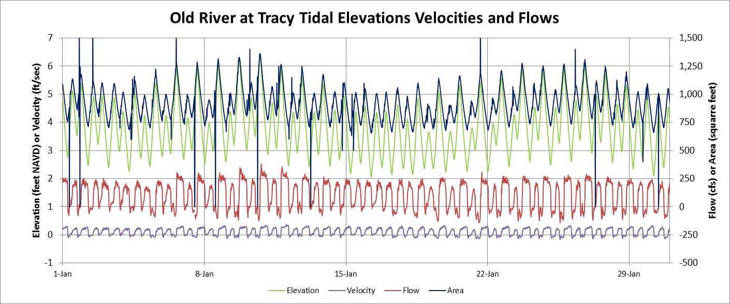
This graph shows the two measurements (elevation, velocity) and two calculated parameters (area, flow) that were obtained from the Old River at Tracy Boulevard tidal flow measurement station for January 2013. The water surface elevation (green line, left scale) ranged from about 2 feet to about 6 feet; the corresponding channel cross-section (black line, right scale) varied from about 750 ft² to 1,250 ft² with tidal elevation. The tidal velocity (purple line, left scale) was very small and fluctuated from about -0.05 ft/sec to about 0.25 ft/sec. The very low velocities measured in this channel require extremely sensitive equipment. The corresponding tidal flows ranged from -50 cfs during flood-tide periods, to about 250 cfs during the ebb-tide periods.

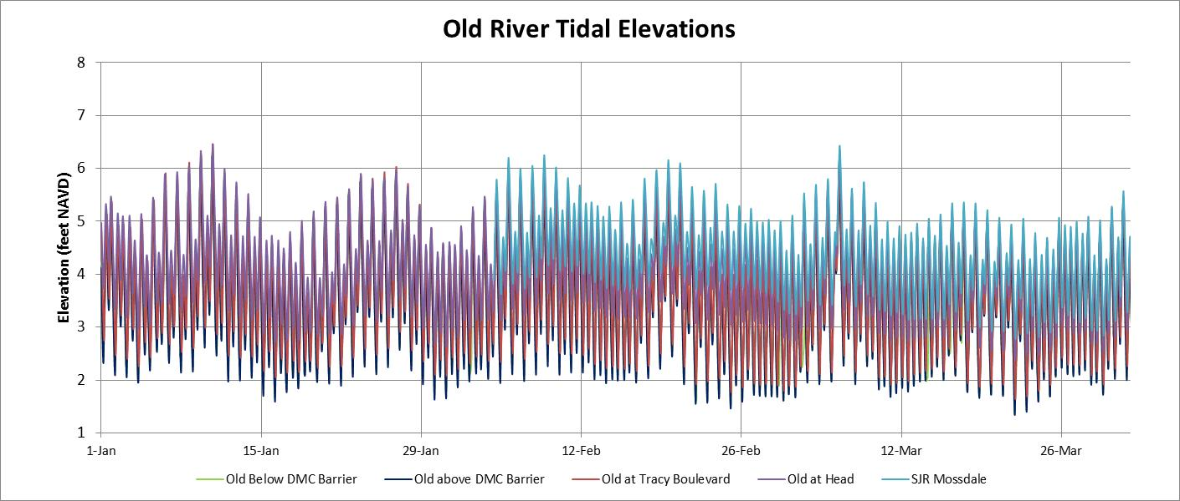
Because of low SJR flows, the tidal elevations in Old River were very uniform in the January-March period, before the temporary barriers were installed. The spring-neap tidal cycle can be detected with a tidal range of 2 feet to 5 feet during neap tides and a tidal range of 2 feet to 6 feet during spring tides. The graphs have a 14-day vertical grid, so there is a spring-neap cycle within each grid. The maximum elevations at the Old River stations and at Mossdale were very similar. The minimum elevations at Mossdale were about 1-2 feet higher than the minimum elevations at the Old River stations.

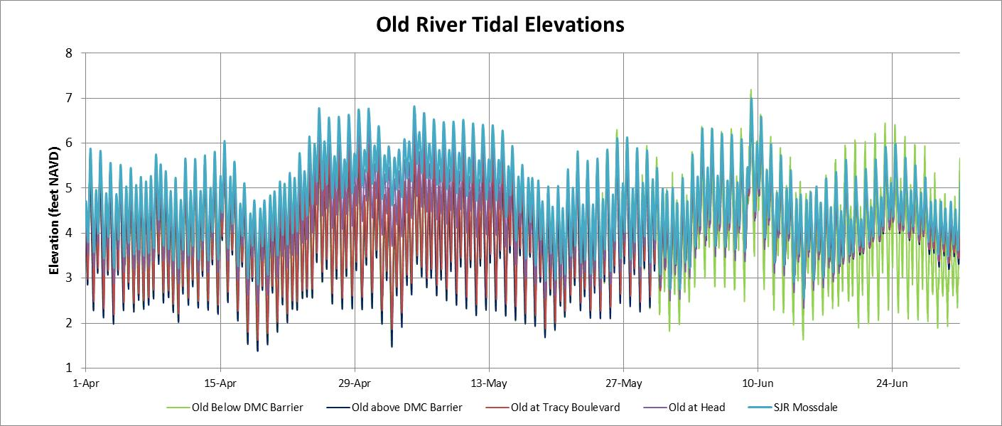
The slightly higher SJR flows in late April and early May (2,000 cfs to 4,000 cfs) increased the Mossdale and head of Old River elevations by about 1 foot. The minimum daily tidal elevations in Old River were increased by about 1 foot in early June when the DMC barrier was installed, and were increased slightly more at the end of June when the Grant Line Canal barrier was installed (with six flap gates operating). These effects can be seen by comparing the elevations upstream of the DMC barrier to those downstream of the barrier (light green line).

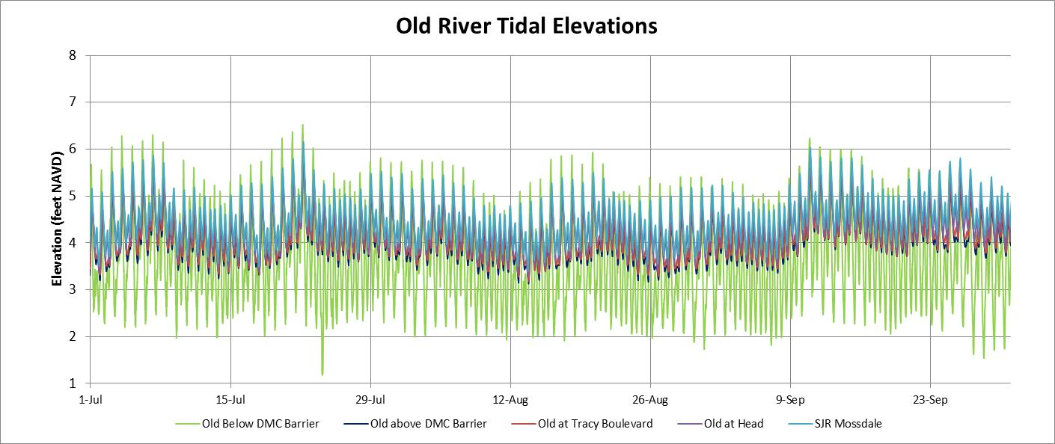
The full effects of the temporary barriers with flap gates operating were observed from July through October of 2013. The tidal elevation range was substantially reduced upstream of the barriers, with a tidal range of less than 2 feet. There was a net downstream flow of about 500 cfs at the head of Old River and about 100 cfs in Old River, but the tidal flushing of salt from Paradise Cut and Sugar Cut was reduced, and most of this salt load remained in Old River, when the tidal range was restricted by the temporary barriers. The temporary barrier benefits from higher minimum elevations should be considered in relation to the water quality effects from the reduced tidal flushing in the south Delta channels.

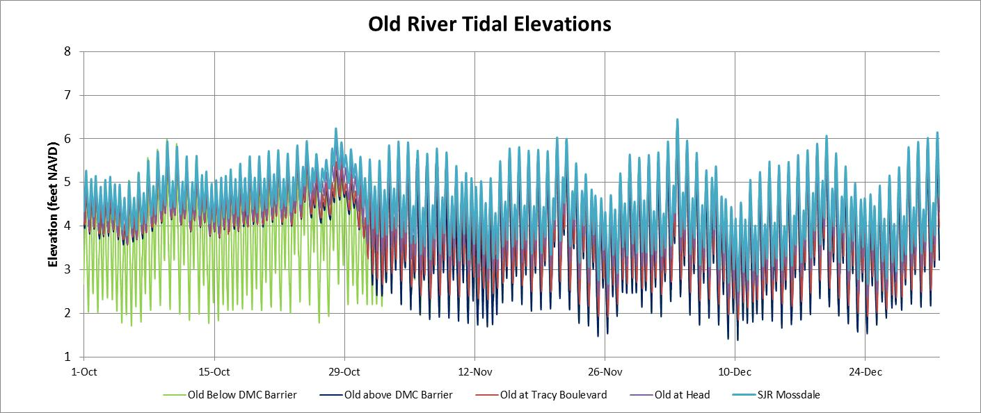
The Old River at DMC, Middle River, and Grant Line Canal temporary barriers were removed at the end of October. The minimum elevations were increased in October, perhaps because of lower diversions. The minimum elevations were reduced from about 4 feet to about 2 feet when the barriers were removed at the end of October. Tidal elevations were again uniform throughout the south Delta channels, with a tidal range of 2 feet to 5 feet during neap tides, and 2 feet to 6 feet during spring tides. The minimum elevations at the head of Old River and at Mossdale were about 1 foot higher than the minimum elevations at the other Old River stations without barriers.

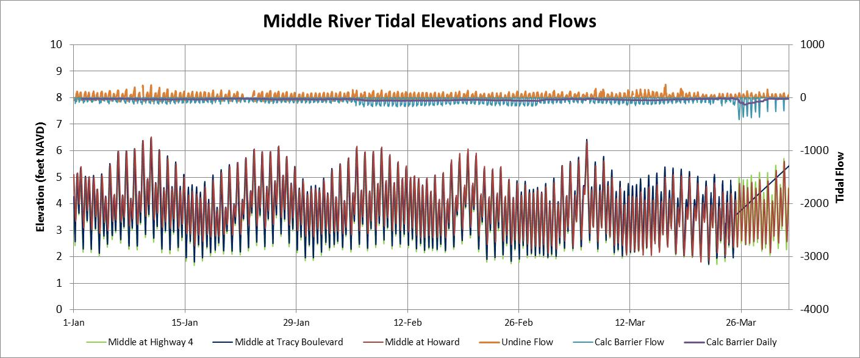
Middle River tidal elevations were similar to tidal elevations in all other south Delta channels from January through mid-May, when the Middle River barrier was constructed, although the six flap-gates were left open until June 3. The measured flows at Undine Road (near the head) were positive but small (<50 cfs) during ebb tides. The flood-tide flows at the barrier were calculated assuming the flap gates were operated, assuming a culvert equation of: flow (cfs) = 300 x elevation difference (ft) ^0.5. The calculation also included flood tide flows over the weir crest elevation. These calculated flows are not accurate for the January-March period without the barrier.

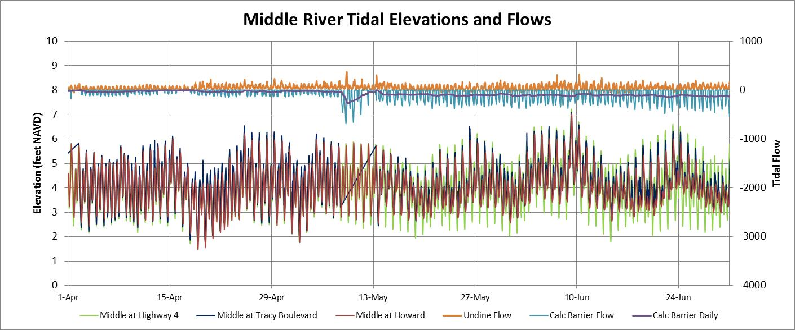The Middle River barrier was installed on May 14, and the flap gates on the six culverts were closed on June 3. The minimum tidal elevations upstream of the barrier (at Tracy Boulevard and Howard Road) were increased to about 1 foot higher than the minimum elevations at Highway 4. The calculated upstream tidal flows (bright blue line) through the culverts or over the weir crest (raised from 3.5 to 4.5 feet on June 21) were about 250-500 cfs, and the daily average upstream flow was about 100 cfs. Measured flows at Undine Road, near the head, were less than 50 cfs, suggested that agricultural diversions along Middle River were a maximum of about 150 cfs. With the barrier installed, water was entering Middle River from upstream and downstream to supply agricultural diversions.
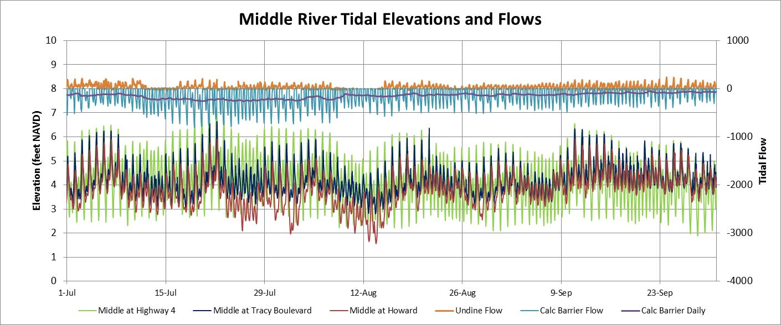
During the July-September period when the three barriers in Middle River, Grant Line Canal, and Old River at DMC were installed, minimum tidal elevations in Middle River upstream of the barrier were about 1 to 2 feet higher than the minimum elevations at Highway 4. The tidal elevations at Howard Road were lower than the elevations at Tracy Boulevard in July and August, suggesting periods when the agricultural diversions were greater than the flows into this section of Middle River. Because there are several agricultural drainage pumps discharging to this section of Middle River, the EC at Howard Road was greater than the EC entering at the barrier (see daily Middle River EC graph).
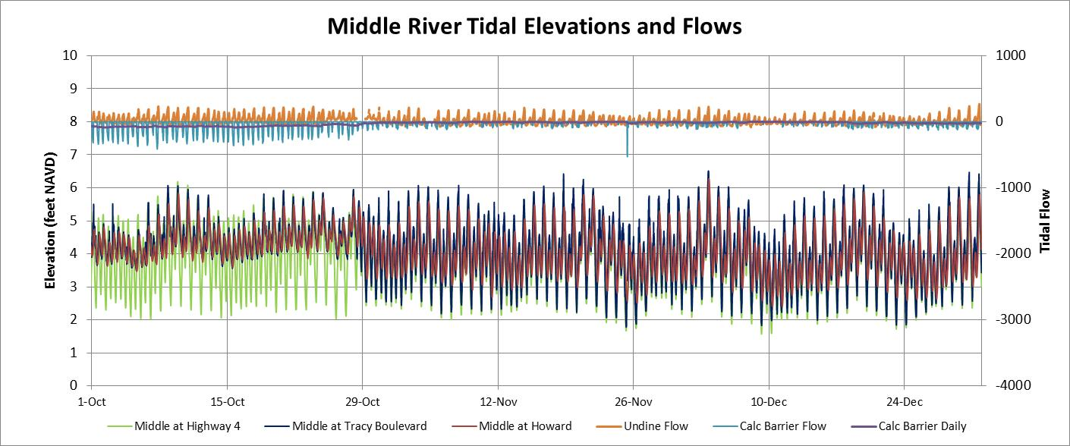
The Middle River, Old River at DMC and Grant Line Canal barriers were removed near the end of October, and the full range of tidal elevations were measured at all Middle River stations in November and December. The measured tidal flows at Undine Road were less than during the period with the barriers. The estimated Middle River flood-tide barrier flows (bright blue line) were not accurate after the barriers were removed. The benefits from the Middle River barrier (increasing minimum elevations) should be evaluated along with the water quality effects of the barrier (increased EC). Perhaps some localized dredging would allow all diversion pumps (or siphons) to be operated without the need for the Middle River barrier. [A tidal flow station was installed by DWR upstream of the Middle River barrier in February 2014].
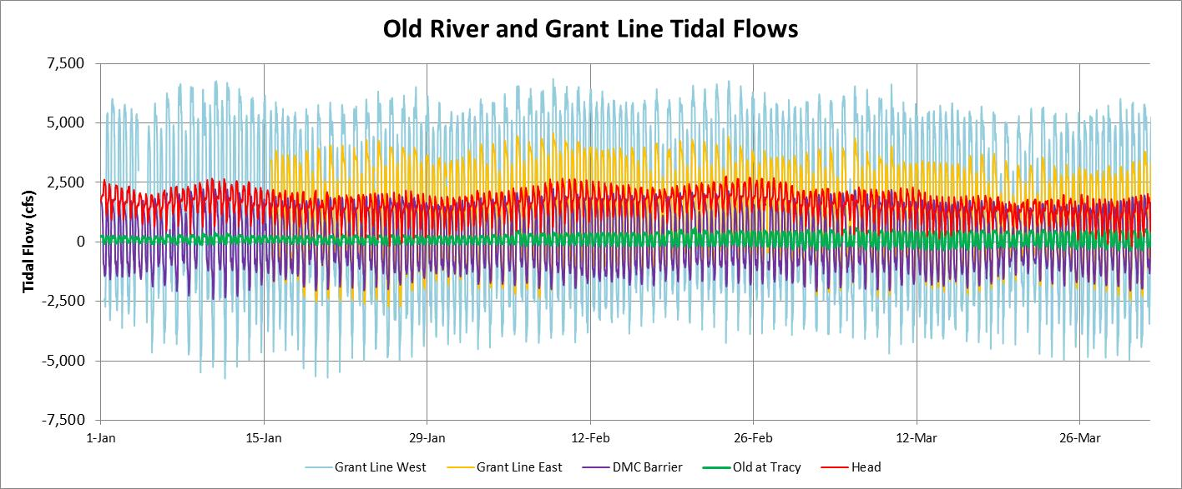
Tidal flows measured at the western end of Grant Line Canal and in Old River at the DMC barrier location indicate the maximum tidal flows in these south Delta channels during the January-March period with no temporary barriers. Tidal flows at the western end of Grant Line Canal (light blue line) varied from -4,000 cfs to 6,000 cfs (tidal range of about 10,000 cfs) with an average flow that followed the head of Old River flow (red line) because most of head of Old River flow is diverted to Grant Line Canal. The tidal flows at the eastern end of Grant Line Canal (gold line) varied from -2,000 cfs to 4,000 cfs (tidal range of about 6,000 cfs); much of the tidal flow at the western end fills (or drains) the Grant Line Canal channel. Tidal flows in Old River at the DMC barrier (purple line) varied from about -1,500 cfs to 1,500 cfs (tidal range of about 3,000 cfs). Tidal flows in Old River at Tracy Boulevard were much smaller and varied from about -250 cfs to about 250 cfs (tidal range of 500 cfs). Tidal flows in Middle River near the barrier began in February 2014; tidal flows without the barrier varied from -1,000 cfs to 1,000 cfs (tidal range of 2,000 cfs).
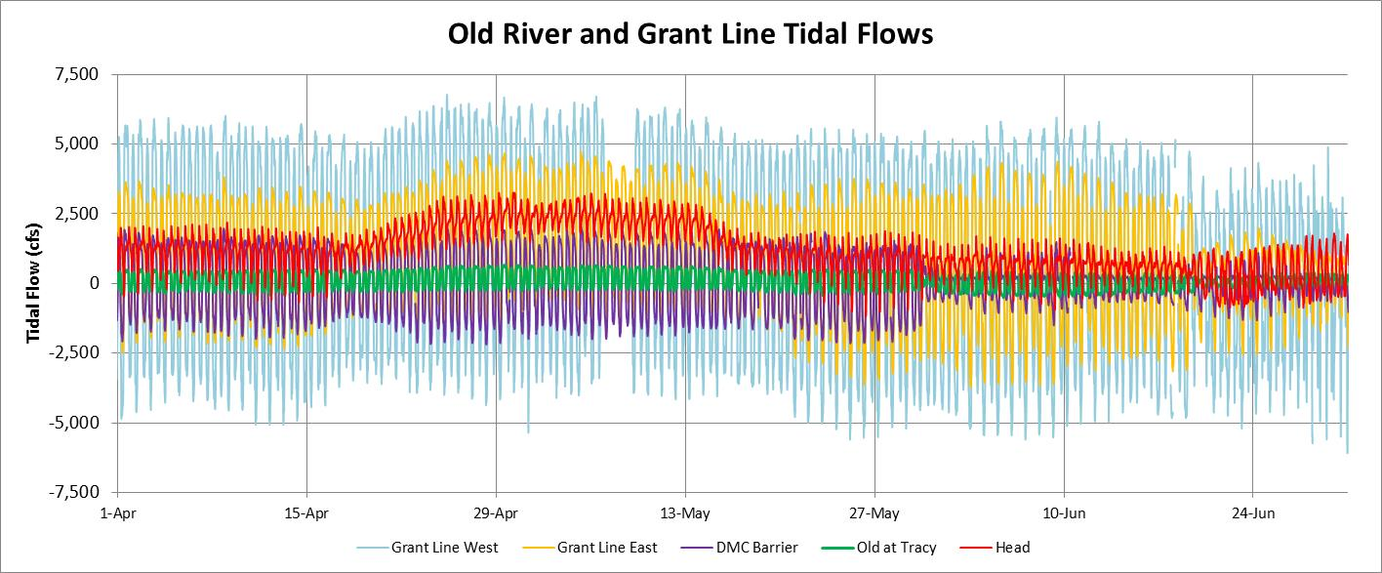
The effects of the SJR pulse flow of about 4,000 cfs in April-May were observed in the Old River and Grant Line Canal tidal flows. The Old River at DMC barrier was installed in early June, reducing both upstream and downstream tidal flow in Old River. The Tracy Boulevard tidal flows were shifted to negative (upstream) when the Old River at DMC barrier was first installed. The flood tide flow at the eastern end of Grant Line Canal (upstream of the Grant Line Canal barrier) was increased in early June when the Old River at DMC barrier was installed without the Grant Line Canal barrier. When the Grant Line Canal barrier was installed in mid-June, the magnitude of the tidal range in flow was reduced, although the daily average flows increased slightly. The Grant Line Canal barrier reduced the peak ebb tide flow and created a more sustained downstream flow in Grant Line Canal. Flood tide flows upstream of the barrier were reduced considerably, with some flow through the culverts and over the barrier (weir crest at about 3.5 feet).
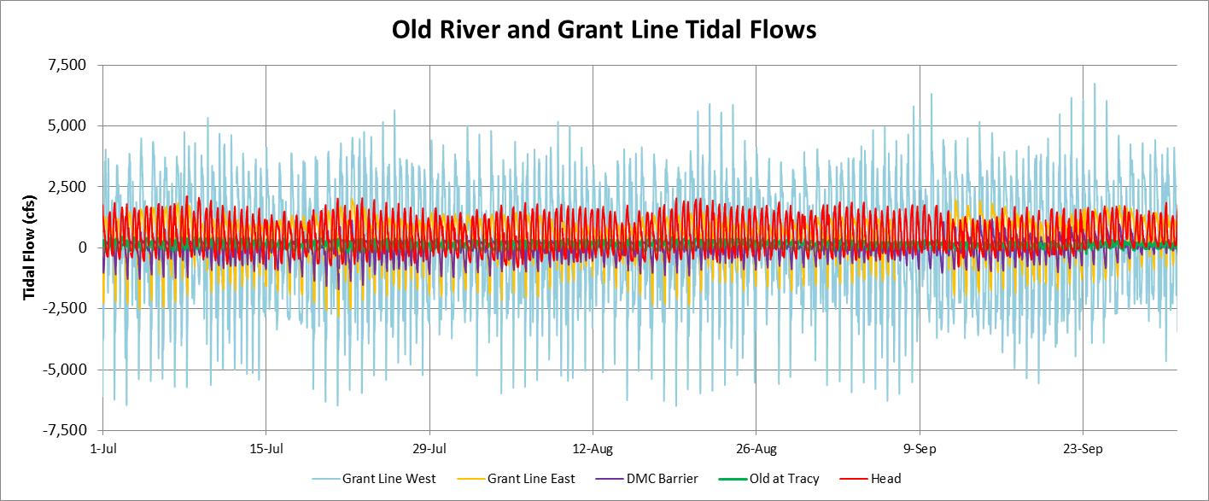
The temporary barriers were installed with culverts operating during the July-September period and the tidal flows in Grant Line Canal and in Old River were substantially reduced. The tidal flows in Old River at the DMC barrier were limited to upstream flows through the flap gates or over the barrier at higher tide elevations (weir crest at about 4.5 feet), and the tidal flows at Tracy Boulevard were small (tidal range of < 250 cfs). The temporary barriers raised the minimum elevations upstream of the barriers by about 1 to 2 feet, but substantially reduced tidal flow variations, to about half of the tidal flows without barriers.
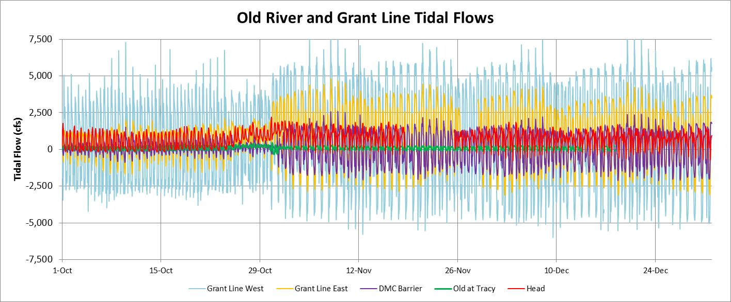
The temporary barriers in Middle River, Old River at DMC and Grant Line Canal at Tracy Boulevard were removed in late October, and the tidal flow variations were increased. The Old River tidal flows at the DMC barrier (removed) ranged from -1,500 cfs to 1,500 cfs. The tidal flows in Grant Line Canal at the western end ranged from -4,000 cfs to 6,000 cfs in November and December, when the head of Old River (net) flow was about 1,000 cfs and combined export pumping was low (about 3,000 cfs). The tidal flows in Grant Line Canal at the eastern end ranged from -2,500 cfs to 3,500 cfs in November and December. The tidal flows in Old River at Tracy Boulevard remained very low even with the barriers removed. Apparently, most of the tidal flows in Old River fill or drain the Old River channel between the DMC barrier and Tracy Boulevard. Tidal flows in Grant Line Canal flow upstream through Doughty Cut to Old River upstream of Tracy Boulevard; therefore, tidal flows at Tracy Boulevard are relatively low.
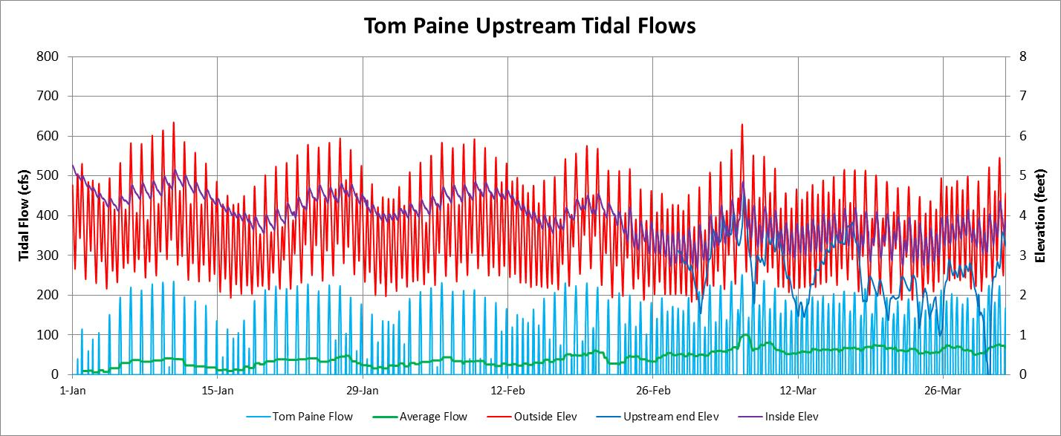
Tidal elevations in Tom Paine Slough are controlled by two box culverts and four siphons with flap gates. The upstream elevations (purple line) remained high until the end of February, suggesting the flap gates were operating (open during flood-tide). Changes in the upstream elevations at end of February may indicate that diversions started early in 2013. The upstream end elevations (dark blue line) were reduced substantially during March, indicating that pumping from the upstream end of Tom Paine Slough had increased. The upstream flow (with flap gates) has been measured at various times and was calculated (light blue line) as: Flow (cfs) = 300 x Elevation Difference (feet) ^ 0.5. This flow would be upstream only (if the flap gates are operating). Diversions would lower the upstream elevation according to the Tom Paine Slough surface area (about 65 acres at 3.5 feet elevation) and diversion rate (maximum of 100 cfs assumed).
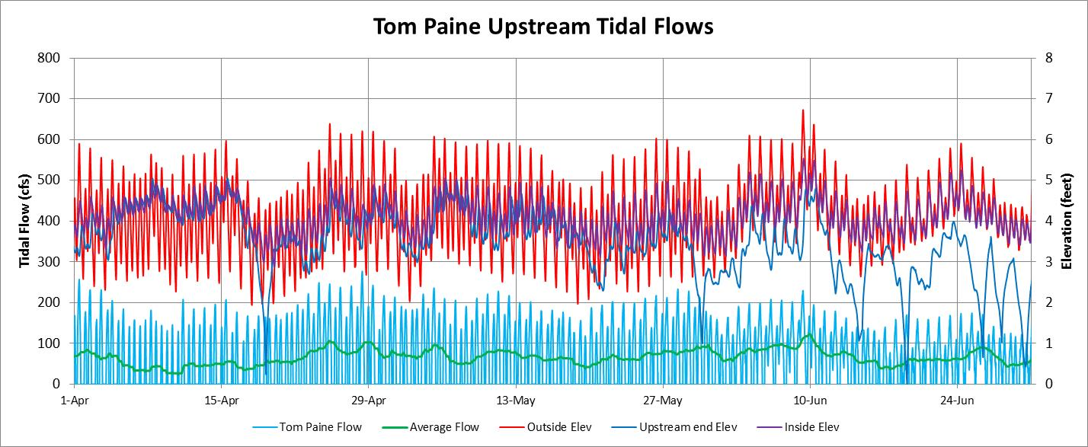
The tidal elevation range in Tom Paine Slough (downstream of the culverts) was reduced when the Old River at DMC barrier was installed on June 1 and the Grant Line Canal barrier was installed on June 15. The upstream elevations were reduced to the minimum downstream elevations, but not lower, by the end of June. The siphon diversions would have been greater if the upstream elevations were reduced to less than the downstream elevations (was one of the flap gates no operating). The daily average diversions (green line) were 50-100 cfs during this period. The elevations at the upstream end of Tom Paine Slough were substantially reduced in June, indicating that the pumping was greater than the upstream siphon flow.

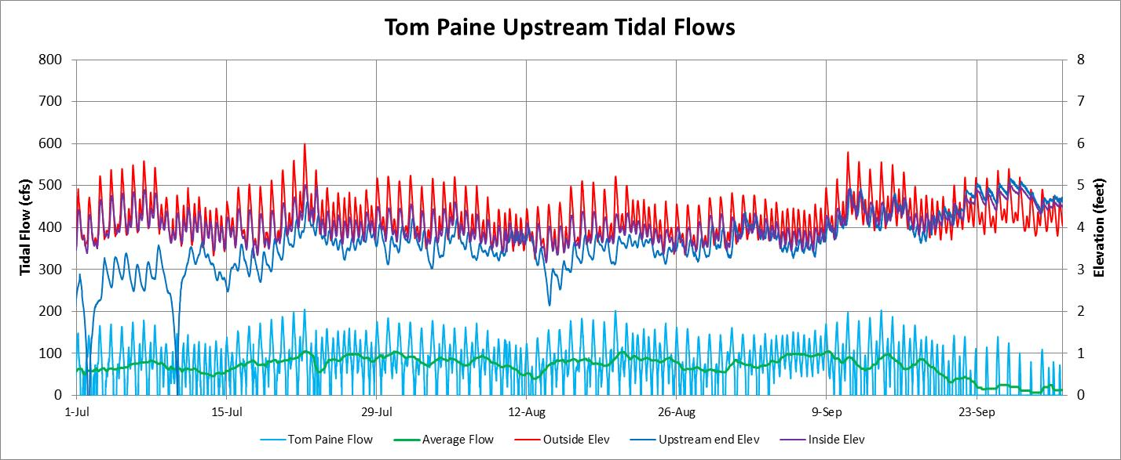
The tidal elevation range in Old River and in Tom Paine Slough (downstream of the siphons) and in Sugar Cut were reduced by the temporary barriers in the summer months. The daily average diversions into Tom Paine Slough were about 75-100 cfs, and the elevations at the upstream end of Tom Paine Slough were reduced in July, suggesting that pumping was greater than the siphon flow. Diversions were discontinued at the end of September, when the upstream elevations were increased to near the maximum tidal elevations downstream of the siphons.
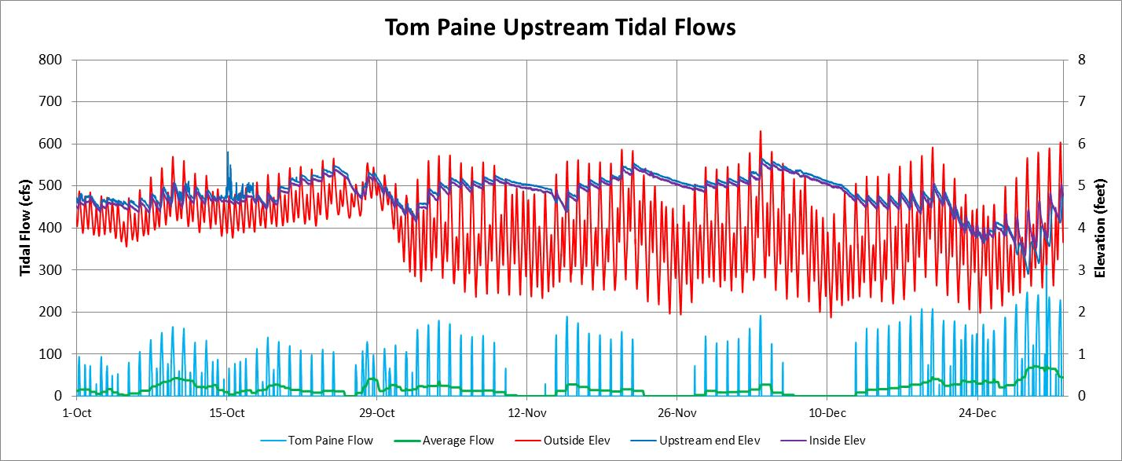
Diversion from Tom Paine Slough had ceased in the October-December period. The Tom Paine Slough upstream water elevations remained high after the temporary barriers were removed at the end of October. The flap gates were apparently operating in November, and the reduction in the upstream elevations were small; the reductions in upstream elevations were increased in December, either from irrigation diversions or one of the flap gates being opened. Additional information about the operation of the Tom Paine Slough siphons and flap gates, and irrigation diversions would be helpful for fully understanding these tidal elevations and calculated flows at the Tom Paine Siphons.

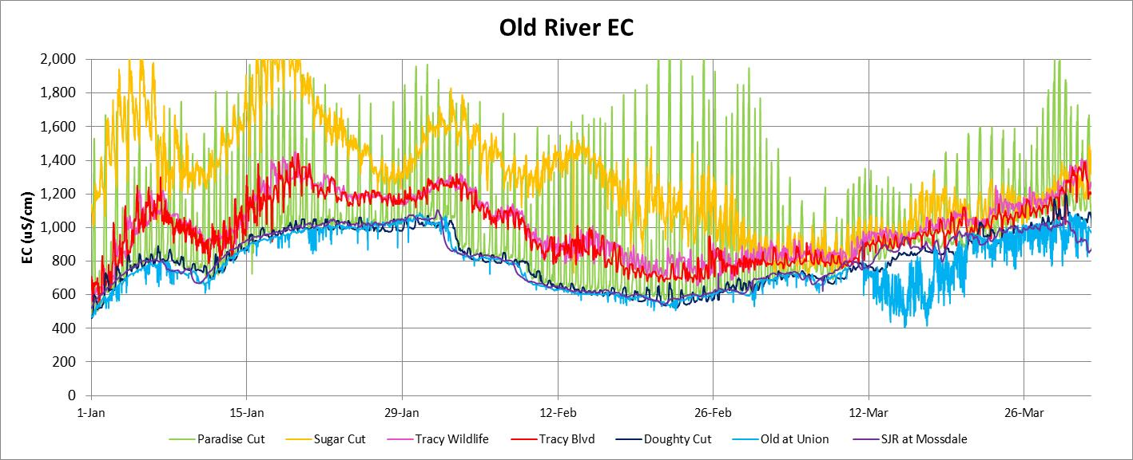
The salinity (EC) in Old River is generally controlled by the SJR EC. The SJR at Mossdale EC (purple line) and the Old at Union EC (bright blue line) and the Doughty Cut EC (dark blue line) were similar in the months of January-March, ranging from 600 uS/cm to 1,000 uS/cm (the Vernalis and south Delta EC objective for September-March). The Old at Union EC had some unexplained fluctuations in March. The EC in Old River at Tracy Boulevard (red line) was much higher than the EC at Mossdale, Union, and Doughty Cut, and had a tidal variation of 100 uS/cm. The EC at Tracy Boulevard was confirmed by an independent station at Tracy Wildlife Island (pink line), just downstream of the Tracy Boulevard station. The Old at Tracy Boulevard EC was 100-250 uS/cm greater than the upstream Old River EC at Doughty Cut or Union. The Paradise Cut EC (green line) had a very large tidal variation of 500-1,000 uS/cm above the Old River EC, with maximum EC of 2,000 uS/cm (highest EC during neap tide). The Sugar Cut EC was much higher than the Old River EC in January and February, with a tidal variation of 100-250 uS/cm. The Sugar Cut EC measurement station is upstream of the Tom Paine Slough siphon and is apparently not tidally flushed with Old River water, like the EC station in Paradise Cut.
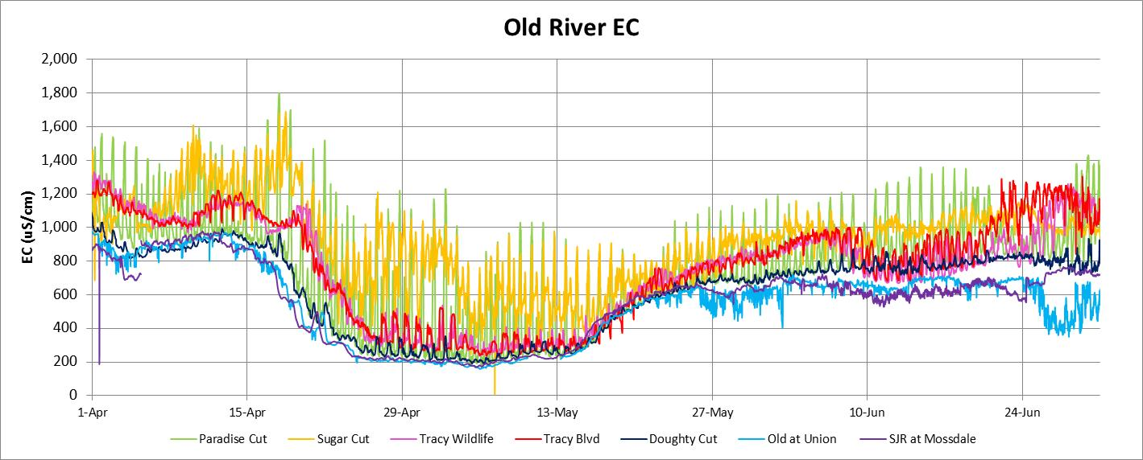
Because of increased SJR flows in late-April and early-May, the SJR EC was reduced to about 200 uS/cm. The Old River at Tracy Boulevard EC (and EC at Tracy Wildlife) showed a distinct daily maximum during the increased flow period. The EC from Sugar Cut and Paradise Cut at the enf of each ebb-tide was much higher than the Old River EC. The tidal variations at the Sugar Cut and Paradise Cut EC stations were increased as the low EC water from Old River was tidally exchanged with the water in Paradise Cut and Sugar Cut. The temporary barriers were installed in June and the EC at Tracy Boulevard and the EC at Tracy Wildlife increased to about 1,200 uS/cm by the end of June. Installing the Old River at DMC barrier without the Grant Line Canal barrier (early June) greatly reduced the Old River at Tracy flow and thereby increased the Tracy Boulevard EC (less dilution flow). The Paradise Cut EC tidal variation was reduced in these months, and the Sugar Cut EC tidal variation remained similar to the EC variation in January-March.
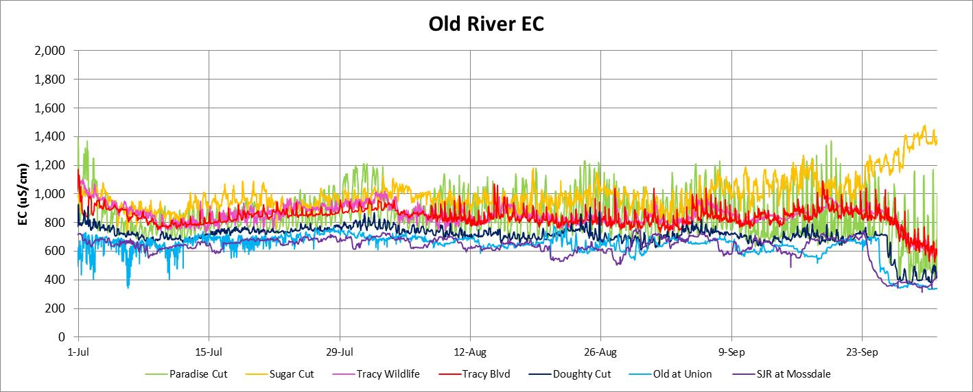
The SJR at Mossdale and Old River at Union EC were quite uniform at 600-800 uS/cm during the summer months. Because of relatively low flows in Old River, there was a time lag between EC changes at Mossdale and EC changes at Union and Doughty Cut (e.g., end of September). The tidal variations in Paradise Cut EC were 200-500 uS/cm during these summer months, suggesting that the (unidentified) salt source was relatively constant. The Old River at Tracy Boulevard (and Tracy Wildlife) were 150-250 uS/cm higher than the Doughty Cut EC, and the tidal variations in the Old River at Tracy Boulevard EC were 50-100 uS/cm, suggesting that the salt source from Paradise Cut was tidally flushed and transported downstream (during ebb tide). The Paradise Cut EC station is close to the mouth (near Old River) and measures Old River EC during flood tides. The Sugar Cut EC measurement station is upstream of Tom Paine Slough. The EC in Sugar Cut was higher than the EC in Old River and remained higher throughout the tidal cycle, because much of the flood tide flow from Old River is diverted at the Tom Paine Slough siphons.
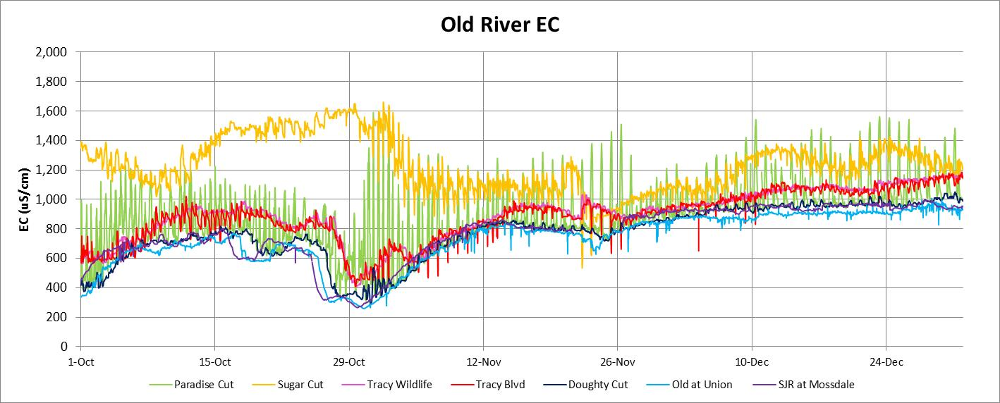
The SJR at Mossdale and Old River at Union and Doughty Cut EC were reduced to 300 uS/cm by the pulse flow at the end of October (for adult Chinook salmon attraction). The Old River at Tracy Boulevard (and Tracy Wildlife) remained about 100-200 uS/cm higher than the EC in Old River at Union or Doughty Cut. The Middle River, Old River at DMC and the Grant Line Canal temporary barriers were removed at the end of October, so the combined effects of reduced minimum elevations, increased tidal flows, and increased net flows on the Old River at Tracy Boulevard EC are difficult to separate. The tidal variations of Paradise Cut EC and of Sugar Cut EC remained similar to the variations seen in previous months, although the periods of increased Sugar Cut EC at the end of October and some periods of reduced tidal variations of Paradise Cut EC remain unexplained. Additional EC stations located upstream in Paradise Cut and near the mouth of Sugar Cut may provide additional information about the salt sources and tidal flushing of these tidal sloughs.
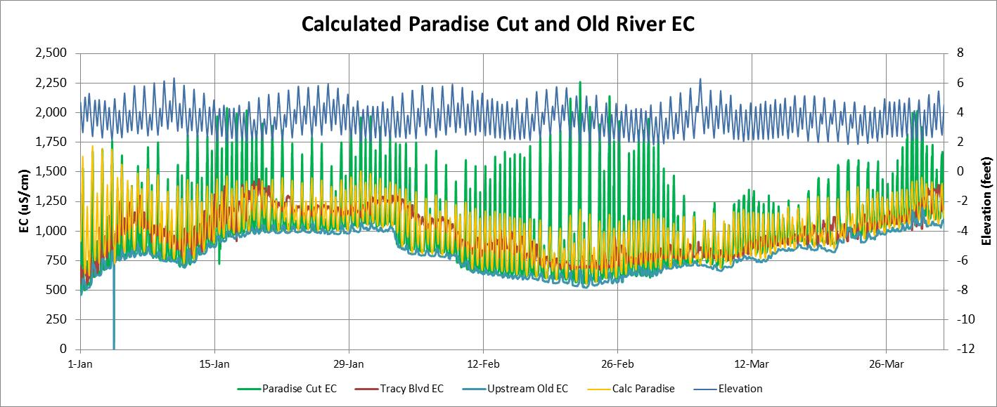
An estimate of the Paradise Cut EC was calculated from the measured tidal elevations (blue line) and assumed geometry segments of Paradise Cut. Ten segments with a total volume of 780 af at 2 feet and 1,440 af at 6 feet were used for Paradise Cut calculations. Water flows out of the segments towards Old River during ebb tides, and Old River water fills Paradise Cut segments during flood tides. An unidentified salt source was assumed to enter at the upstream segment with an EC of 5,000 uS/cm and a constant flow of 10 cfs (87.5 tons/day). The calculated fluctuations of Paradise Cut EC through this period without temporary barriers was about 500-750 uS/cm, which was lower than the measured EC variations. The variations in tidal elevations and tidal flows during each spring-neap tidal cycle apparently had a greater effect than the calculated EC for Paradise Cut.

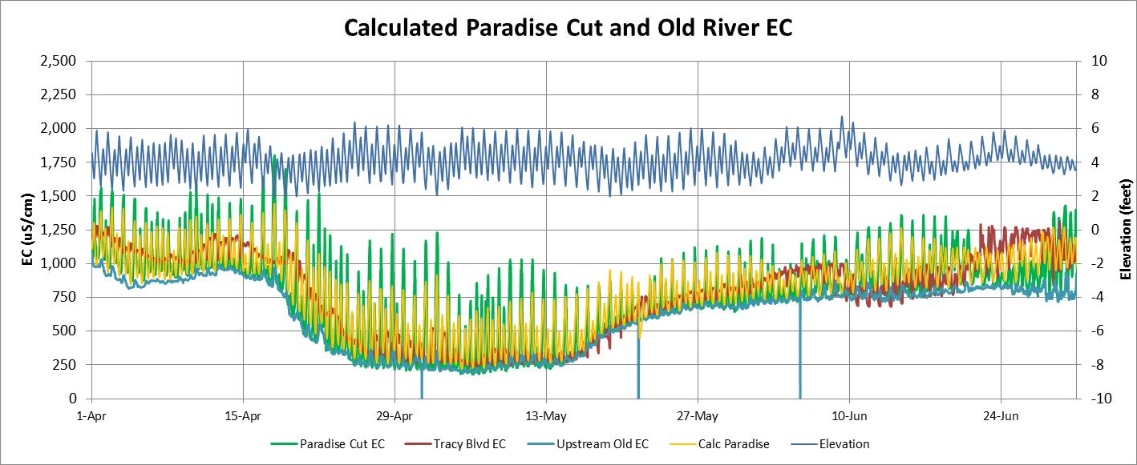
Paradise Cut was filled (flushed) with Old River water during flood tide periods and the minimum Paradise Cut EC was therefore similar to the Old River EC (blue line). The maximum Paradise Cut EC was controlled by the tidal flushing during ebb-tides and the assumed salt source; the maximum EC was greatest during neap tide periods when the tidal fluctuations were reduced (blue line at top, right scale). The calculated EC fluctuations were similar, but more uniform than the measured EC; the assumed salt source appears to be similar to the measured salt source throughout this period. When the barriers were installed in June, the tidal fluctuations were reduced, but the EC variation at the Paradise Cut EC station (near the mouth) remained similar to the variations without the barriers.
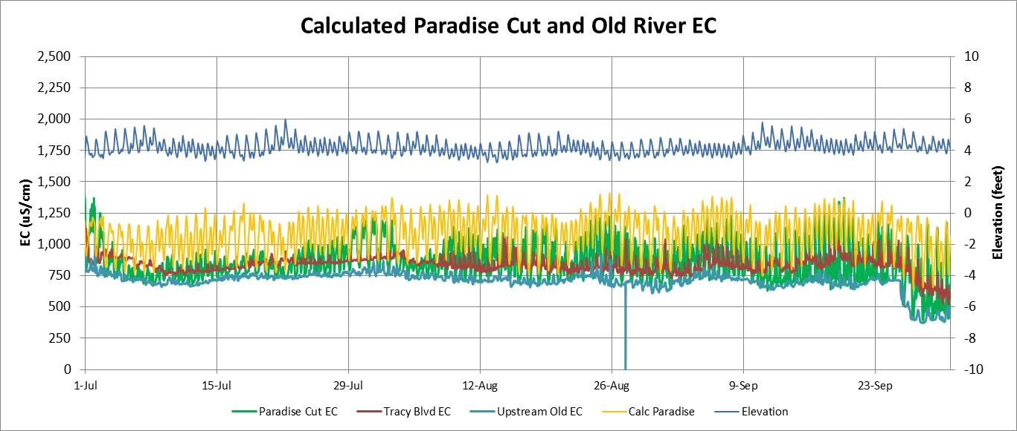
The tidal elevation variations were very small during the summer period when the Old River, Grant Line Canal, and Middle River barriers were installed. The tidal variations in the measured EC and the calculated EC were both about 250-500 uS/cm, with Paradise Cut EC ranging from a minimum EC of 750 uS/cm to a maximum EC of about 1,250 uS/cm. The minimum calculated EC remained higher than the Old River EC during this period, because the downstream segment was not completely filled with Old River water by the greatly reduced flood tide flows. The excess salt loads from Paradise Cut were calculated with the measured EC and the calculated ebb-tide flows as: Excess salt load (tons) = (Paradise Cut EC minus Old River EC) x ebb-tide flow volume (af) x 0.0009. The daily excess salt loads remained relatively constant though the year.

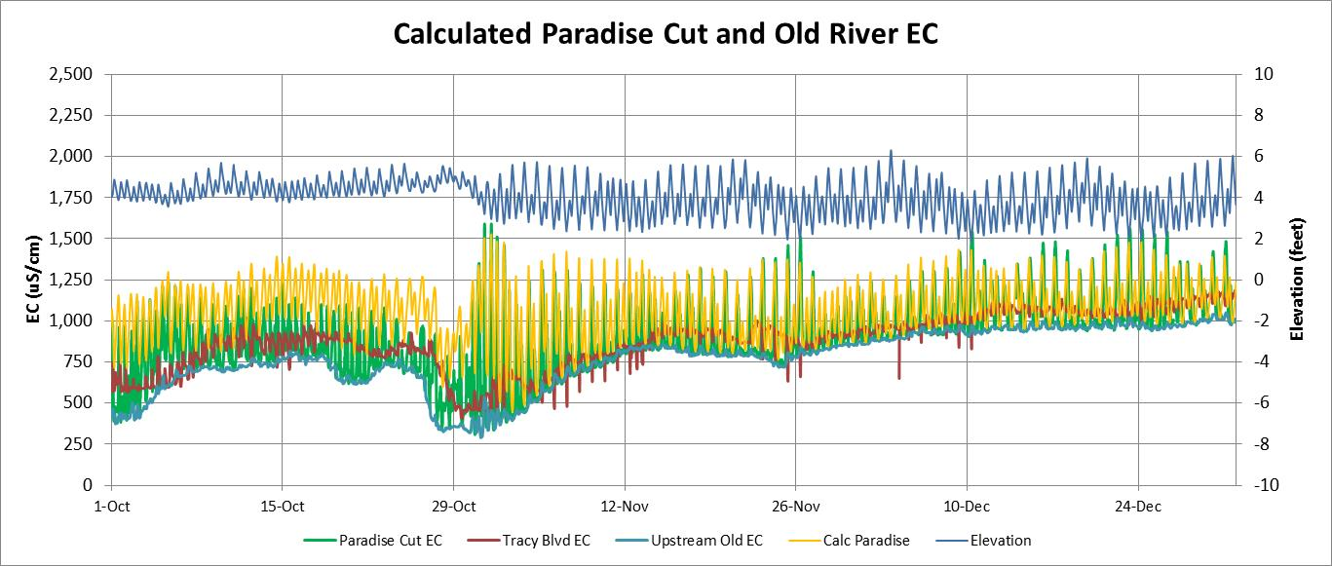
The measured Paradise Cut EC was controlled by several factors that are only partially captured in the calculated Paradise Cut EC. The minimum EC is controlled by the Old River EC during flood tides, and the maximum EC is measured at the end of each ebb tide and is increased during neap-tide periods with reduced tidal elevations. The assumed constant salt source at the upper end of Paradise Cut appears to be generally confirmed by the approximate match with the measured Paradise Cut EC throughout the year. The relatively simple tidal slough flushing calculations provide a reasonably good match with the Paradise Cut EC measurements for the entire year, with full tidal movement (elevations and flows) and with the reduced fluctuations in tidal elevations and flows when the temporary barriers were installed. Notice, for example, the match with the measured increases in Paradise Cut EC tidal fluctuations at the end of October when tidal elevations drop with removal of the temporary barriers, at the same time that Old River EC was reduced by the SJR pulse flow.
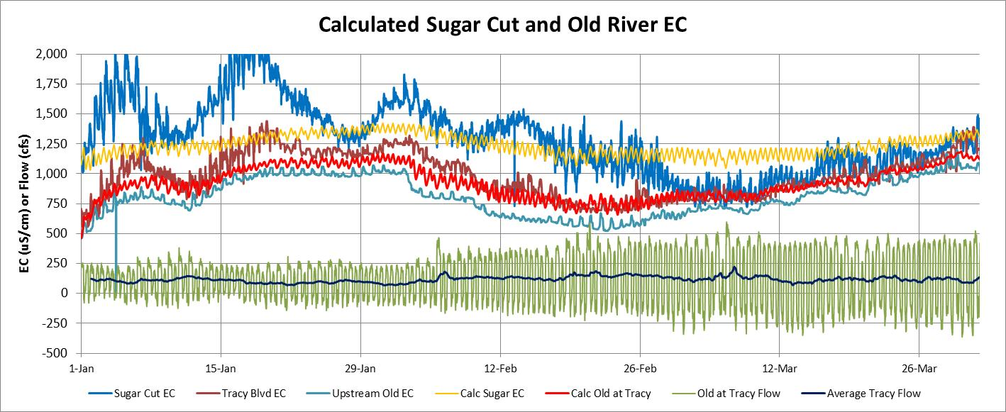
The measured Sugar Cut EC (dark blue) tidal fluctuations were smaller than the Paradise Cut EC fluctuations (previous graphs), and the minimum Sugar Cut EC was usually higher than the upstream Old River EC (light blue line). This was likely caused by the EC measurement station being further upstream (less flood tide flushing from Old River) and because during the summer months, the tidal gates on the Tom Paine Slough siphons divert the water from Old River downstream of the EC monitoring station. The calculated Sugar Cut EC had a smaller EC fluctuation and remained 250-500 uS/cm higher than the Old River EC. The assumed Sugar Cut salt source had an EC of 2,000 uS/cm and a flow of 10 cfs. This graph also shows the measured Old River at Tracy Boulevard tidal flows (green line) that reflects the tidal elevation fluctuations. The calculated effects of the ebb-tide discharge from Paradise Cut and from Sugar Cut on the downstream Old River at Tracy Boulevard EC (red line) were generally similar to the measured EC at Tracy Boulevard, for the assumed salt loads in both Paradise Cut and Sugar Cut. The ebb-tide flows at Tracy Boulevard control the dilution of the salt loads entering Old River and the measured EC increments at Tracy Boulevard.
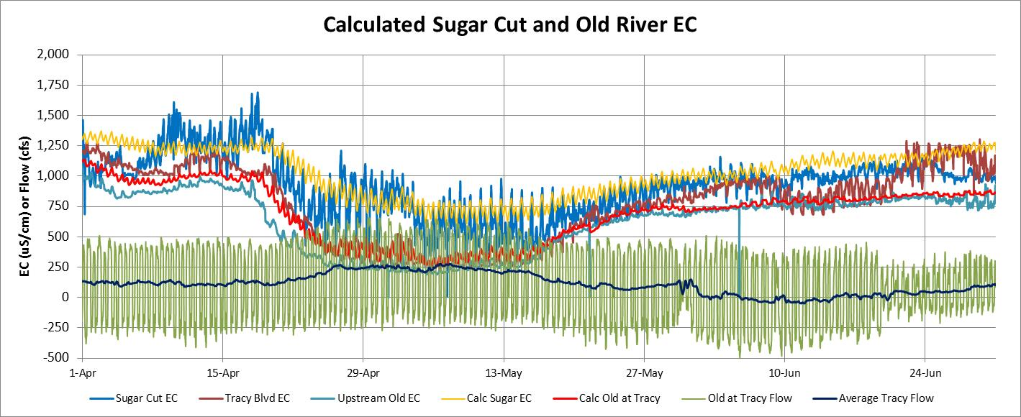
The Old River EC upstream of Paradise Cut (light blue line) was reduced by the SJR pulse flow in April and May, reducing the Old River at Tracy Boulevard EC and also reducing the Paradise Cut EC and Sugar Cut EC. The Old River at Tracy Boulevard EC remained 100-250 uS/cm higher than the Old River at Doughty Cut EC. Tidal flows in Old River at Tracy Boulevard remained high (-250 cfs to 500 cfs) after the DMC barrier was installed, but were reduced when Grant Line Canal barrier was installed in mid-June. The average flows at Tracy Boulevard (black line) control the measured EC increment at Tracy Boulevard. The SJR flow is the most important factor for the Old River at Tracy EC, because the SJR flow controls the SJR EC, and therefore the Old River flow and EC. The Tracy Boulevard EC increment above the Doughty Cut EC is controlled by the net flow at Tracy Boulevard (about 10% of the head of Old River flow) and the excess salt loads from Paradise Cut and Sugar Cut.
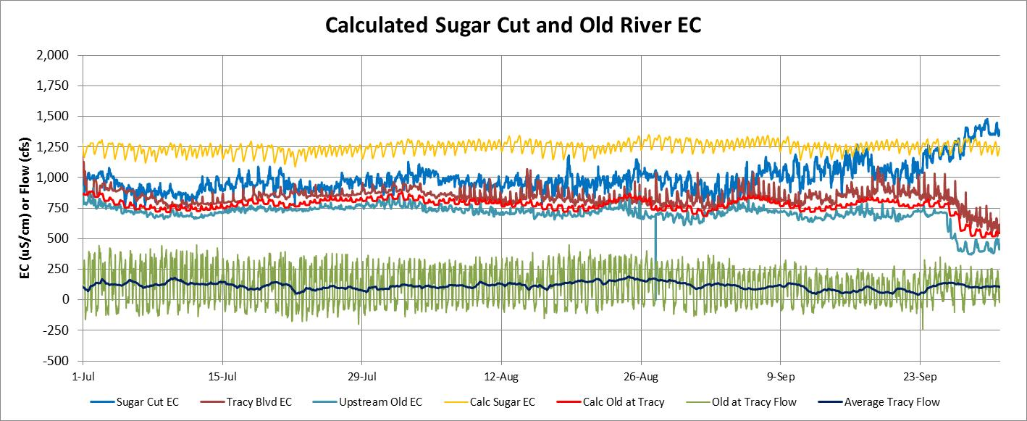
The Old River above Paradise Cut EC (light blue line) was very stable at about 750 uS/cm in the July-September period, until the end of September, when a small pulse flow on the SJR reduced the EC to about 500 uS/cm. The measured Sugar Cut EC was about 1,000 uS/cm during this period and the Tracy Boulevard EC was about 100 uS/cm higher than the Old River above Paradise Cut EC. The calculated Sugar Cut EC was about 1,250 uS/cm, which was higher than the measured Sugar Cut EC of 1,000 uS/cm. The tidal flows at Tracy Boulevard during this period were generally positive, and the net flows were 50-150 cfs. The measured Sugar Cut EC increased at the end of September, perhaps caused by reduced irrigation diversions from Tom Paine Slough (see Tom Paine Upstream Tidal Flow Graphs) which reduced the tidal flushing at the Sugar Cut EC station.
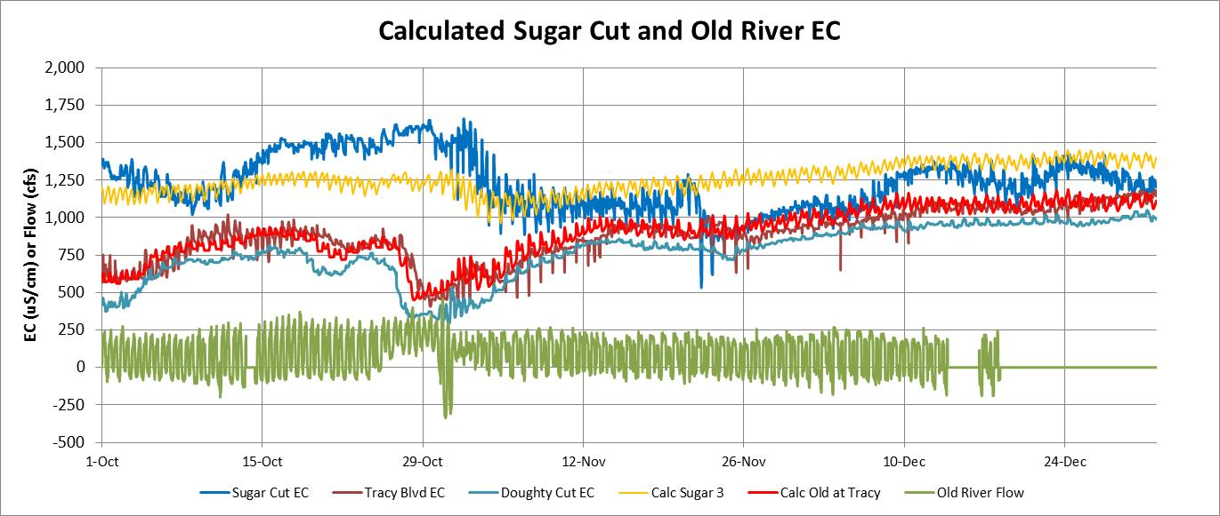
The measured EC in Sugar Cut appears to be sensitive to small changes in the minimum Old River elevations, which controls the ebb-tide flushing in Sugar Cut. The Sugar Cut EC was generally about 250-500 uS/cm greater than the Old River EC. The Sugar Cut EC was lower during the irrigation season when the irrigation diversions at the Tom Paine Slough siphon increase the tidal flushing at the Sugar Cut EC station. The calculation of the tidal flushing of excess salt from Paradise Cut and Sugar Cut to Old River and the downstream movement of higher salinity water to Tracy Boulevard, located about 2 miles downstream of Sugar Cut, appears to match the measured increases in Old River EC between the Union EC compliance station and the Tracy Boulevard EC compliance station. The EC increments were greatest during periods of low Old River flow, and the salt loads from Paradise Cut and Sugar Cut appear to have been relatively constant through the year.
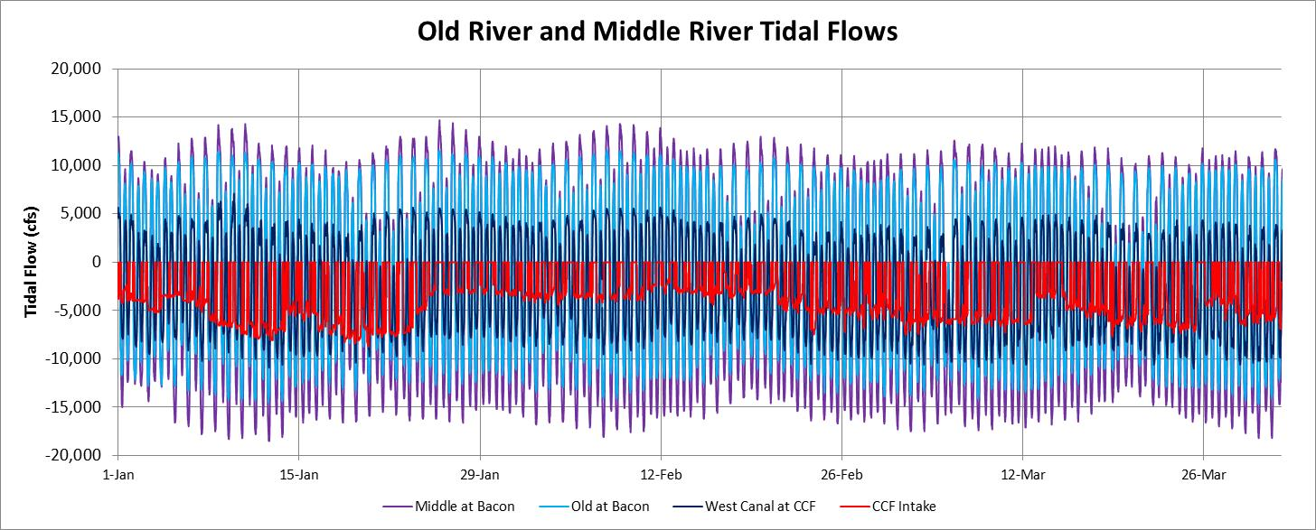
Tidal flows in Middle River at Bacon Island (purple line) and in Old River at Bacon Island (blue line) were similar, although the tidal flows in Middle River were about 20% higher. The Old River at Bacon tidal flows ranged from -12,500 cfs to 10,000 cfs, and the tidal flows in Middle River at Bacon Island ranged from -15,000 cfs to 12,500 cfs. The tidal flows in West Canal downstream of the Clifton Court Forebay (CCF) gates were about 25% of the combined Old and Middle River tidal flows, because the surface are upstream of the CCF intake is about 25% of the surface area upstream from the Old and Middle River flow stations at Bacon Island. The flood-tide flows (negative) were greater than the ebb-tide flows (positive) because of the CCF diversions (red line) for SWP pumping and the DMC diversions (not shown) for CVP pumping. The CCF gates are closed during the flood-tide preceding the higher-high tide each day, to preserve (maintain) the higher-high tide elevations in the south Delta channels.
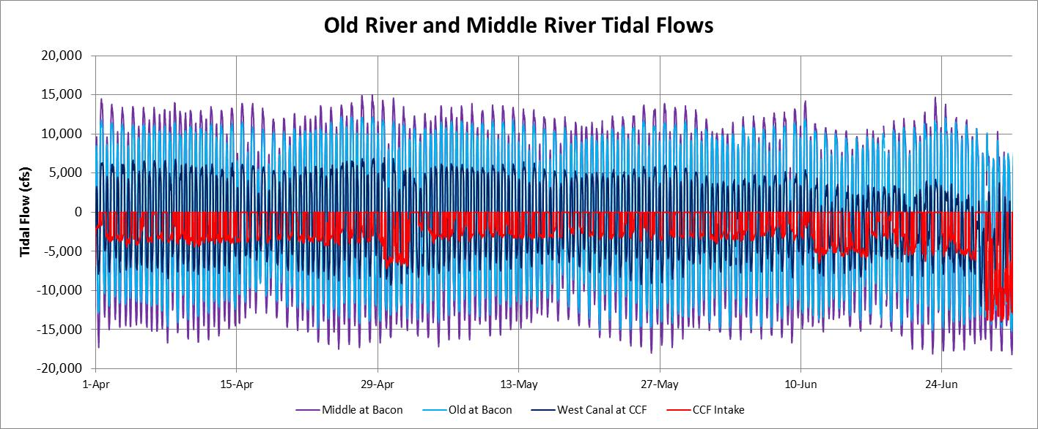
The CCF diversions (red line) were reduced considerably in April-June, so in Old River and Middle River the flood-tide and ebb-tide flows were nearly identical. The ebb-tide and flood-tide flows in West Canal (just downstream of the CCF intake) were also similar until the CCF diversions were increased at the end of June, when the West Canal ebb-tide flows were eliminated, and the flood-tide flows were greatly increased, to supply the CCF diversions (during ebb-tide) as well as the nearly constant DMC diversions.

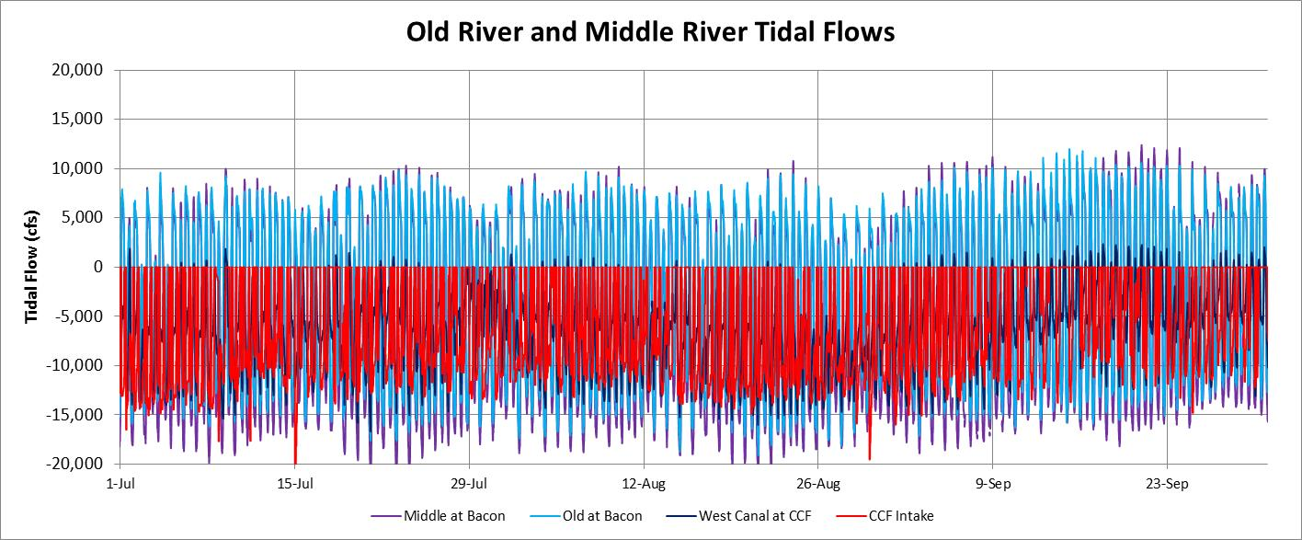
The CCF diversions and DMC diversions were increased to almost maximum pumping in the July-September period. Nevertheless, there were strong ebb-tide (downstream) flows of 5,000 cfs to 10,000 cfs in Old River at Bacon and in Middle River at Bacon. However, tidal flows in West Canal were completely reversed (negative) during most of this period. Some of the flood tide flow in West Canal enters CCF (during ebb tide after the higher high tide each day) and some continues upstream to Grant Line Canal and to the DMC intake and to Old River upstream of the DMC intake.
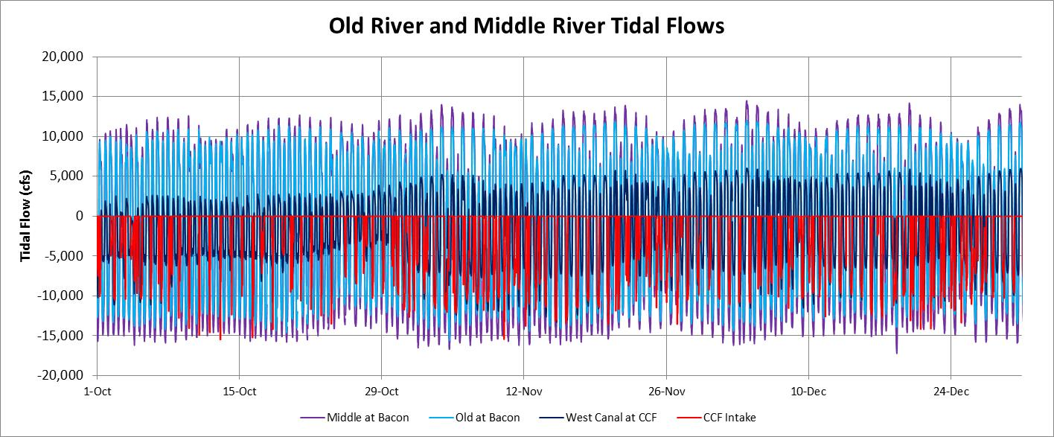
The flow into the CCF is controlled by five tidal gates (each 20 feet wide and 15 feet tall), with a maximum flow of about 15,000 cfs at a head (elevation) difference of 1 foot. The inflow is limited, when the head difference is greater than 1 foot, by partially closing the five gates to prevent scouring from high velocities (above 10 ft/sec), or to close the gates during the higher- high flood tide period (to preserve the high tide elevations), or when the CCF elevation is higher than the West Canal (Old River) elevation. The West Canal tidal flows were increased (tidal flow range of -7,500 cfs to 5,000 cfs) when the temporary barriers were removed at the end of October, because the upstream tidal flows in Grant Line Canal and Old River were increased when the barriers were removed.
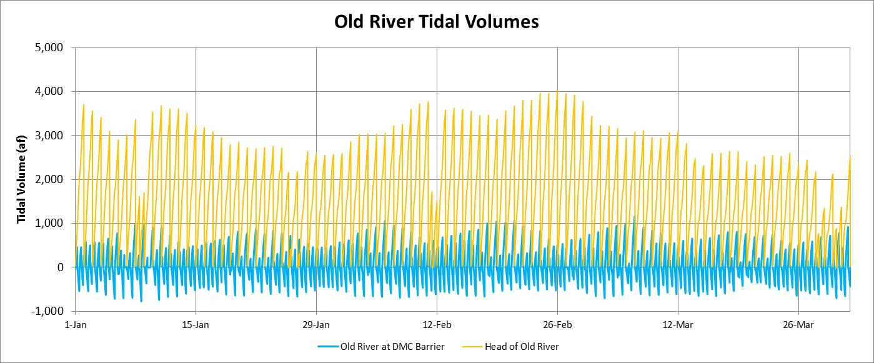
The tidal flows at each station can be summarized with the positive (downstream) and negative (upstream) flow volumes passing the station. The 15-minute tidal flows (cfs) were converted to volumes (acre-feet) and summed for each tidal period (positive or negative flows). For reference, a flow of 1,000 cfs for 15-minutes would be about 20 acre-feet (af). This figure shows the tidal volumes measured at the head of Old River (gold line)and in Old River at the DMC barrier ((bright blue line) for January-March 2013 (no barriers). The head of Old River tidal volumes were about 2,000-4,000 af, and the tidal volume was reset at the beginning of each day. The Old River at DMC tidal volumes had the more typical pattern of two positive and two negative tidal volumes passing the station each day. The positive (downstream) tidal volumes ranged from 250 af to 1,000 af, while the negative (upstream) tidal volumes were more uniform and averaged 500 af (twice each day). This corresponds to about 250 acres between the DMC barrier and Tracy Boulevard, filling with about 2 feet of water during each flood-tide.
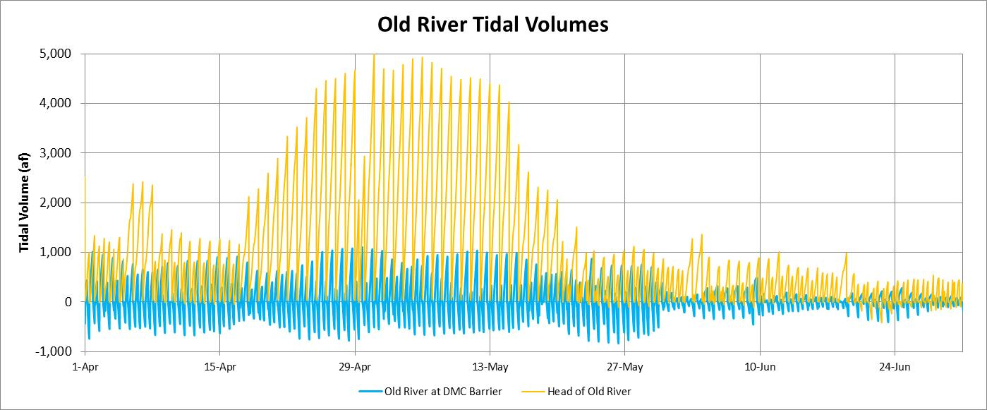
The SJR pulse flow in April-May increased the tidal flow volumes in the head of Old River to about 5,000 af per day (2500 cfs) with no reverse flows (flood-tide). The ebb-tide flow volumes in Old River at the DMC barrier during the pulse flow period were about 1,000 af, and the two flood-tide volumes were about 500 af, so the net flow was very low. The tidal flow volumes at the DMC barrier were reduced substantially (less than half) when the barrier was installed at the beginning of June.

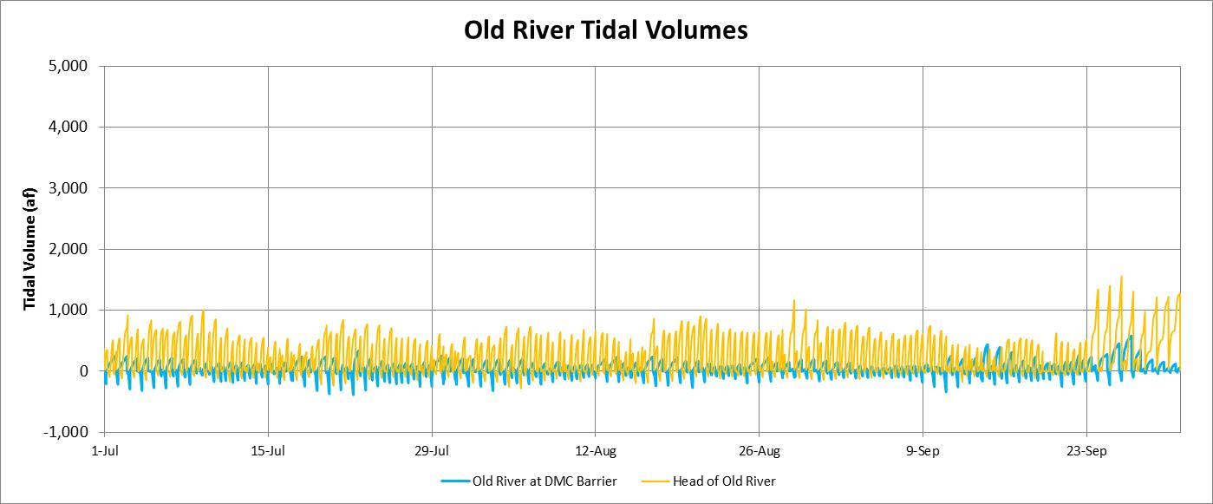
The tidal flow volumes at the head of Old River remained small (500 af each) during the July-September period, and the tidal flow volumes at the DMC barrier were also very small during this period with barriers. The flood-tide flow volume at the DMC barrier was generally once each day during the highest tide each day, while the ebb tide flow was more sustained when the elevations were greater than the weir crest of about 4.5 feet NAVD (or from seepage through the rock barrier).

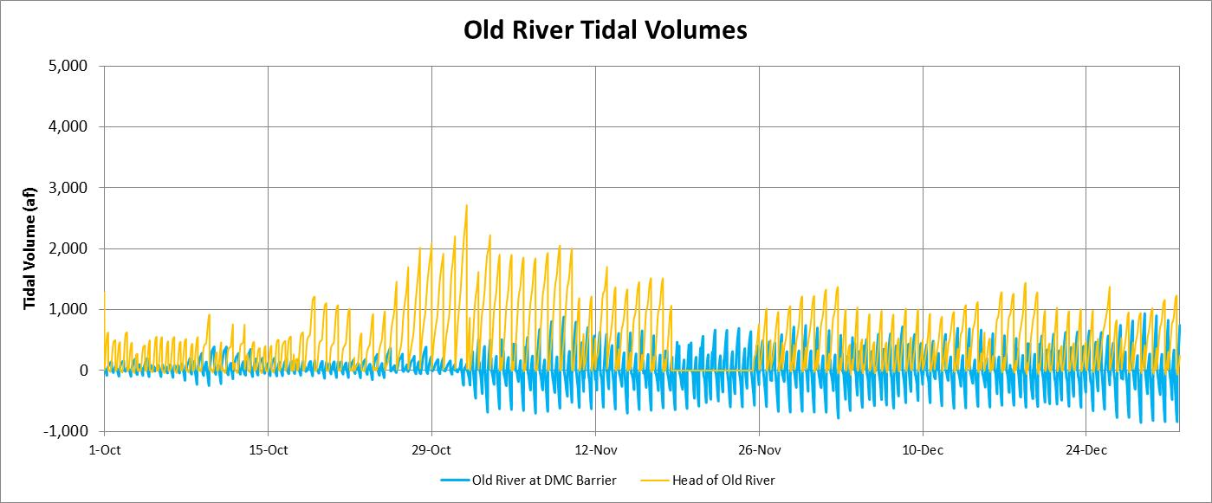
The flow volumes at the head of Old River increased during the fish flow pulse at the end of October, and the tidal flow volumes at the DMC barrier increased substantially when the barrier was removed at the end of October. The full tide volumes fluctuated from 250 af to 750 af with an average of 500 af. The net flow was low (estimated as 10% of the head of Old River flow).
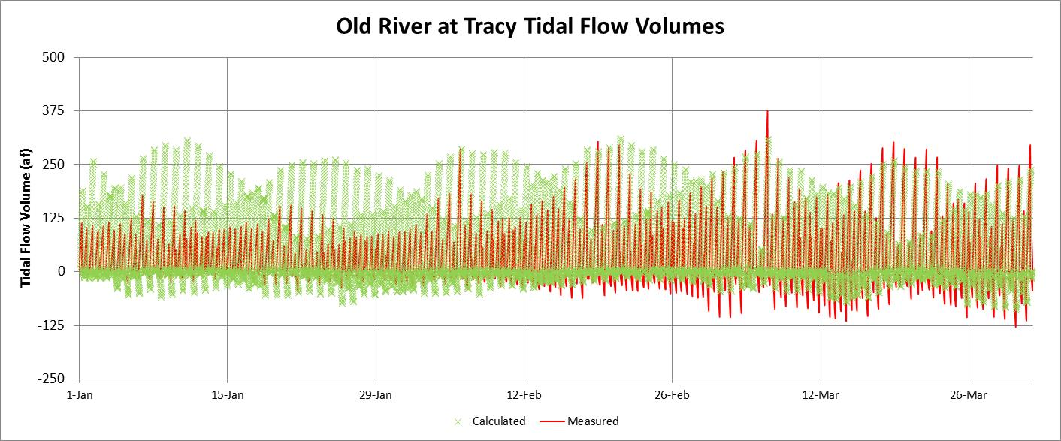
This figure shows the measured tidal volumes in Old River at Tracy Boulevard (red line) compared to the calculated tidal volumes (green crosses) for the January-March period 2013 without temporary barriers (full tidal flows). The 15-minute tidal volumes were calculated as the measured change in elevation at Tracy Boulevard times an assumed upstream surface area of 50 acres, with a net downstream flow assumed to be 10% of the head of Old River flow. Tidal Volume (af) = -elevation change (ft) x area (acres) + net flow (cfs) * 900/43560. An increased elevation (flood-tide) corresponds to a negative tidal volume, while a reduced elevation (ebb-tide) corresponds to a positive tidal volume. The calculated tidal volumes generally match the measured tidal volumes (particularly in February and March) and indicate that very little upstream tidal volume passes Tracy Boulevard. This suggests that most of the flood-tide flow to Paradise Cut, Sugar Cut and Old River upstream of Tracy Boulevard is likely supplied by flood-tide flows in Grant Line Canal.
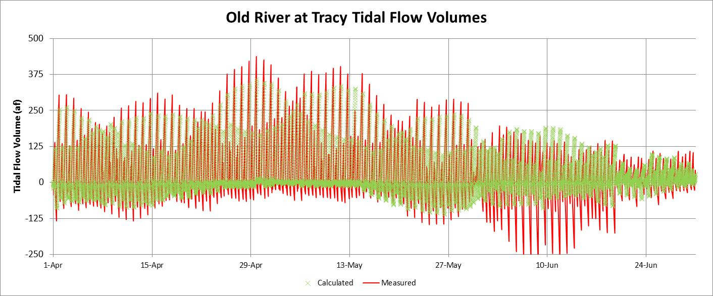
The tidal flow volumes at Tracy Boulevard are very important for understanding the movement of high salinity water from Sugar Cut and Paradise Cut. The scale indicates that the tidal flow volumes are always small. The ebb-tide volumes were about 250 af before the barriers were installed in early June, and were only slightly higher during the SJR pulse flow in late-April and early-May. The flood tide volumes were almost always less than 100 af, and often less than 50 af.
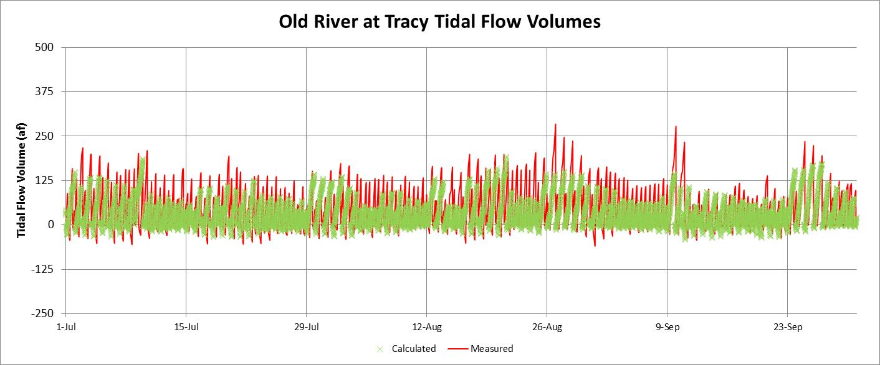
The calculated tidal flow volumes assume that the tidal flow is equal to the change in elevation with an assumed upstream area of 50 acres and with an assumed net flow of 10% of the head of Old River flow; this appears to provide accurate estimates of the measured tidal flow volumes in Old River at Tracy Boulevard while the barriers were installed.

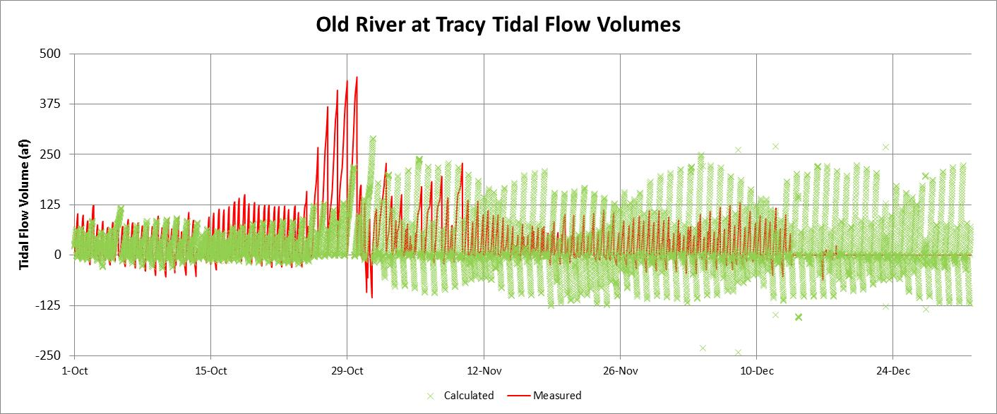
Tidal flow measurements in Old River at Tracy Boulevard are difficult because the velocity is very low. Nevertheless, the ebb-tide flow volumes were increased when the temporary barriers were removed at the end of October, and water elevations upstream of the barriers were reduced as the barriers were breached. The calculated tidal flow volumes assume that the tidal flow is equal to the change in elevation with an upstream area of 50 acres; while this appears to provide accurate estimates of the tidal flows at the Tracy Boulevard while the barriers were installed, the measured tidal volumes were less than the calculated volume in November and December.

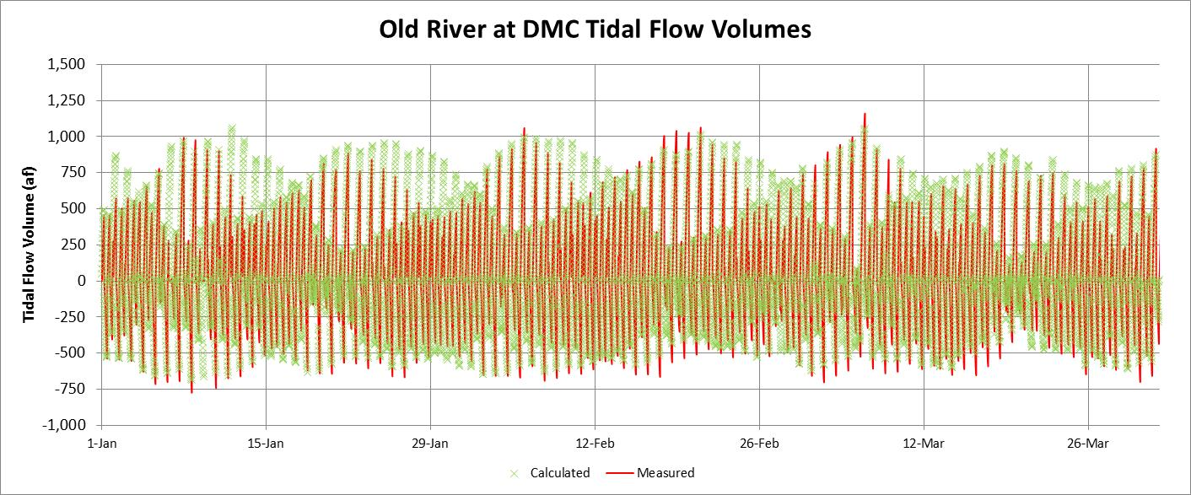
This figure shows the measured tidal volumes in Old River at the DMC barrier (red line) compared to the calculated tidal volumes (green crosses) for the January-March 2013 period without temporary barriers (full tidal flows). The 15-minute tidal volumes were calculated as the measured change in elevation at the DMC barrier times an assumed upstream surface area of 250 acres, with a net downstream flow assumed to be 10% of the head of Old River flow. Tidal Volume (af) = -elevation change (ft) x area (acres) + net flow (cfs) * 900/43560. The calculated tidal volumes matched the measured tidal volumes and indicate that the two flood- tide volumes each day were similar (average of about 500 af) and the two ebb-tide volumes were more variable (250 af to 1,000 af) but also averaged about 500 af. Because the surface area of Old River between the DMC barrier and Tracy Boulevard is about 250 acres, the flood-tide flows in Old River at the DMC barrier do not provide enough water to fill Old River upstream of Tracy Boulevard (or Sugar Cut and Paradise Cut); these channels are likely filled with tidal flows from Grant Line Canal.

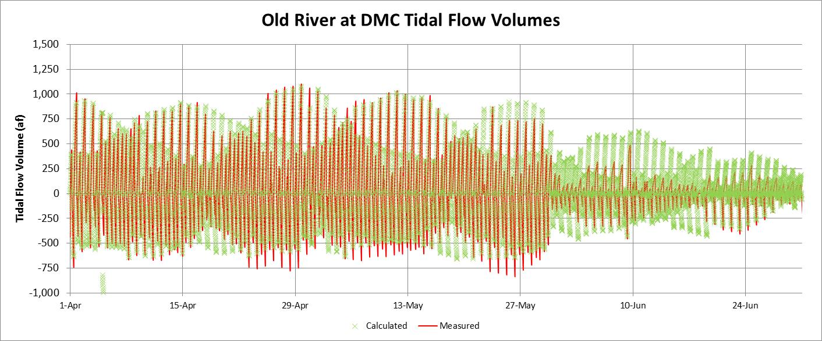
The tidal volumes were reduced substantially when the DMC barrier was installed at the end of May. The net flow, assumed to be 10% of the head of Old River flow, appears to be too high after the barrier was installed; the measured tidal flow volumes were balanced while the calculated ebb-tide volumes were greater than the calculated flood-tide volumes.
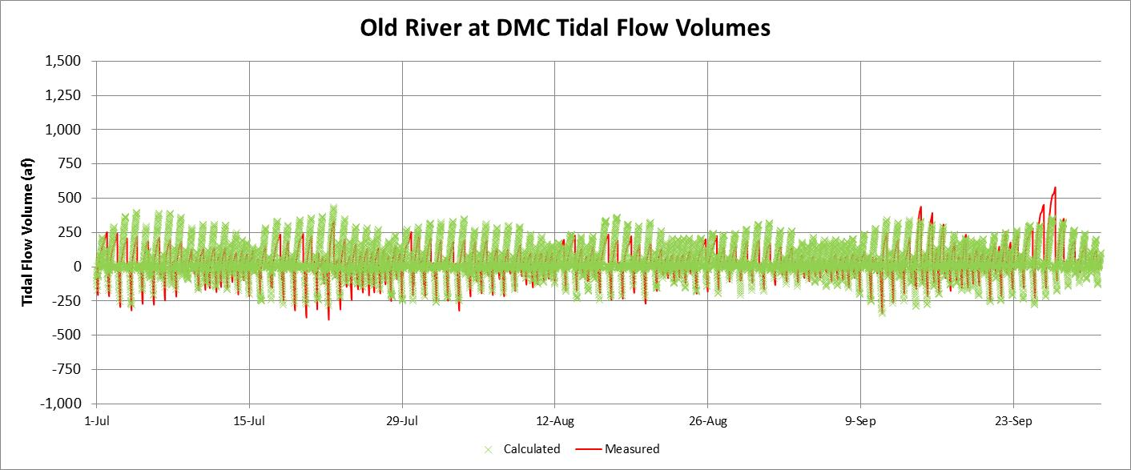
The tidal volumes in Old River at the DMC barrier were very uniform for the July-September 2013 period when the temporary barriers were installed. The measured ebb-tide tide volumes (red line) were less than the calculated ebb-tide volumes (green crosses), suggesting that the net flow was less than the assumed 10% of the head of Old River flow. The measured and calculated flood-tide volumes moving through the culverts or over the barrier crest were less than 250 af, and the measured ebb-tide volumes flowing over the crest were also less than 250 af; therefore the net flow in Old River at the DMC barrier was small. The Old River at DMC temporary barrier generally reduced the tidal flow volumes to less than half of the full tidal flow volumes of about 500 af.

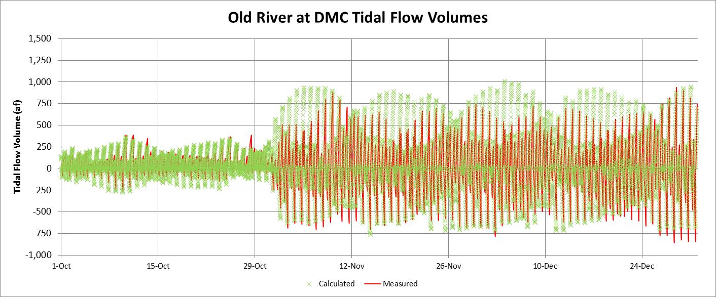
The tidal volumes were increased substantially when the DMC barrier was removed at the end of October. The net flow, assumed to be 10% of the head of Old River flow, appears to be too high after the barrier was removed; the calculated ebb-tide volumes were higher than the measured ebb-tide volumes in November and December. A tidal gate that could be opened during each flood-tide and closed during ebb-tides would create an upstream flow. Because the average tidal volume is about 500 af during each flood-tide (1,000 af each day), a net upstream flow of about 500 cfs would be produced with a tidal gate (tidal pump). Because the salinity (EC) or this downstream Old River water is often lower than the SJR EC (head of Old River water), this upstream circulation would provide some flushing of salts discharged into Old River between the tidal gate and Tracy Boulevard, and would transport all of the salinity from Paradise Cut and Sugar Cut upstream to Doughty Cut (at the end of each ebb tide period). This would substantially reduce the EC increment in Old River at Tracy Boulevard. This was the original design concept for the South Delta Improvement Project (SDIP), which proposed operable tidal gates in Old River, Middle River, and Grant Line Canal.
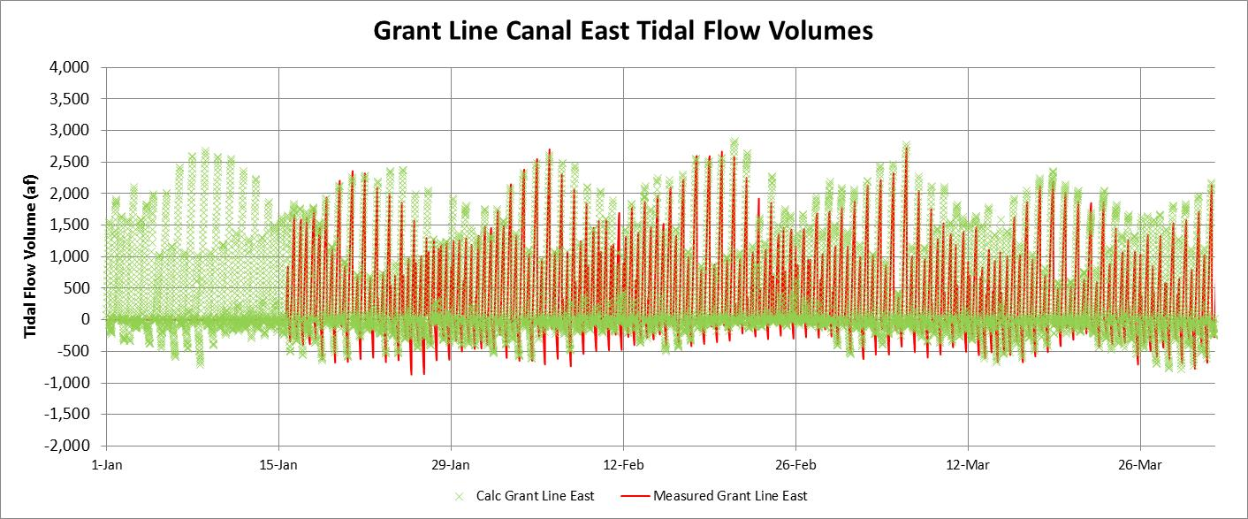
This figure shows the measured tidal volumes in Grant Line Canal at the east end (red line) compared to the calculated tidal volumes (green crosses) for the January-March 2013 period. The assumed upstream surface area was 500 acres, and the net flow was assumed to be 85% of the head of Old River flow. The surface area of Grant Line Canal between the mouth and Tracy Boulevard is about 275 acres. The calculated tidal volumes generally matched the measured tidal volumes. The flood- tide volumes varied from about -125 af to -625 af, with an average of about -250 af. The ebb-tide volumes varied from about 750 af to 2,500 af, with an average of about 1,500 af. The average net flow for January-March 2013 was about 1,500 cfs (3,000 af per day); therefore the full tidal flow volumes without any net flow would have been about 750-1,000 af, corresponding to the assumed upstream areas of 500 acres at the east end and 750 acres at the west end.
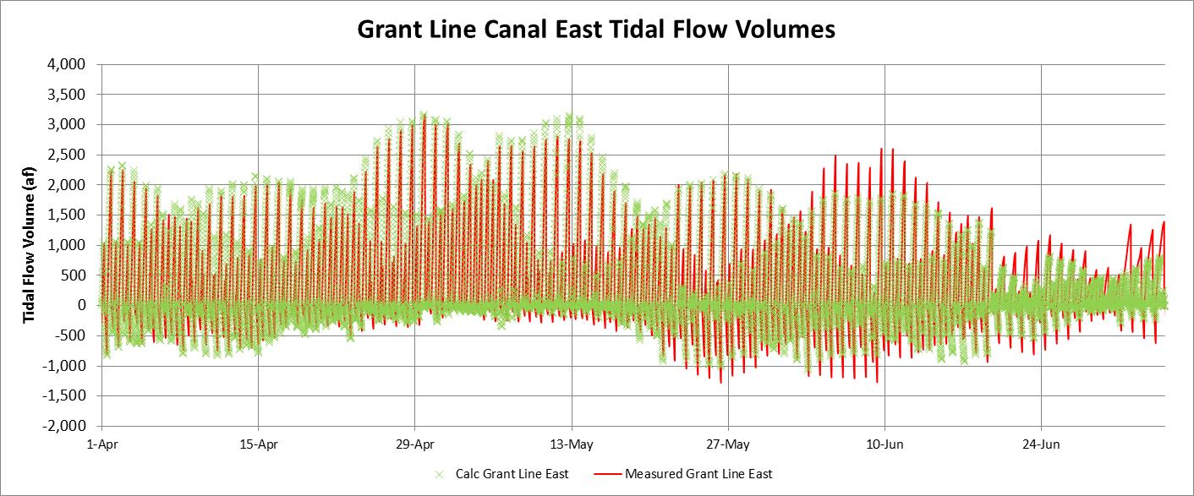
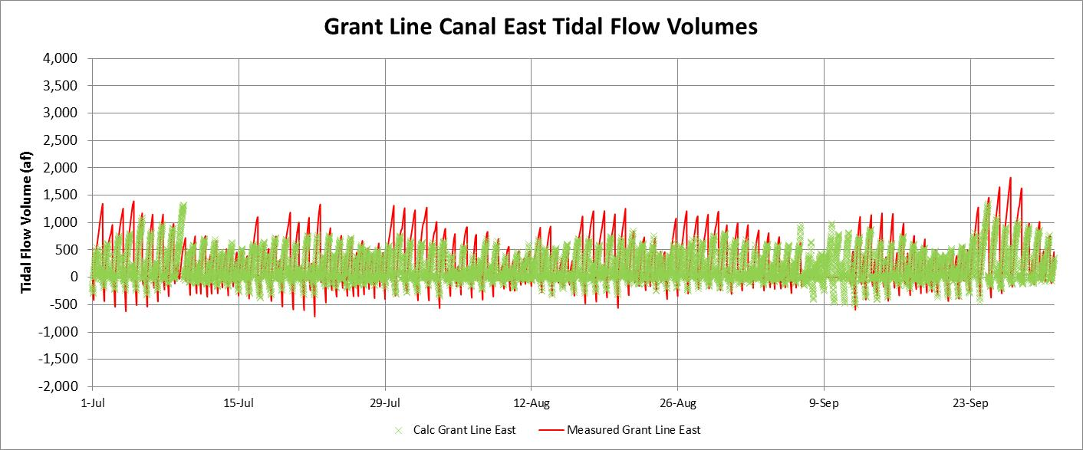
The tidal volumes in Grant Line Canal upstream of the Grant Line Canal barrier (east end) were reduced considerably in the July-September 2013 period when the temporary barriers were installed. The measured flood-tide tide volumes (red line) were smaller than the flood-tide volumes for the January-March period, although the net flow was about 500 cfs, rather than 1,500 cfs. The measured and calculated flood-tide volumes moving through the culverts or over the barrier crest averaged about 250 af, while the measured and calculated ebb-tide volumes flowing over the barrier weir crest (3.5 feet) averaged about 750 af. The Grant Line Canal barrier increased the minimum tidal elevations but reduced the tidal elevation range and thereby reduced the tidal flows upstream of the barrier. The assumed upstream area of 500 acres still provided a good match with the measured tidal volumes, indicating that the tidal flows for Old River upstream of Doughty Cut, as well as for Paradise Cut and Sugar Cut likely originated from Grant Line Canal, and not from Old River.
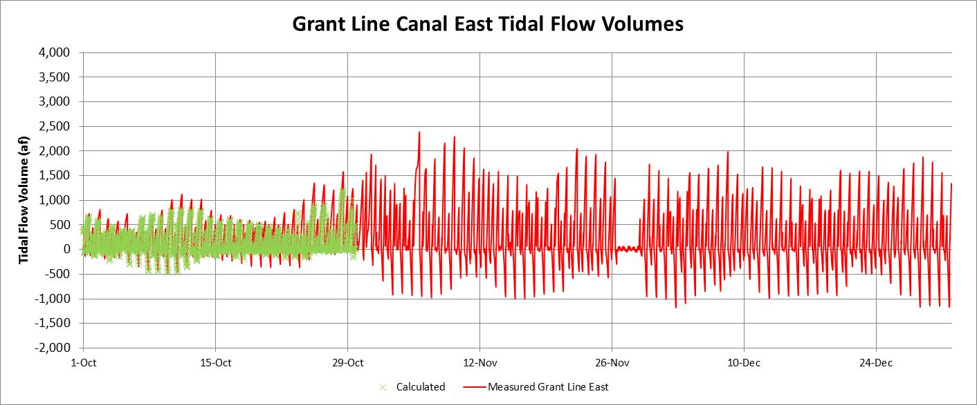
The tidal flow volumes in Grant Line Canal upstream of the Grant Line Canal barrier (east end) increased considerably when the barriers were removed at the end of October. The tidal elevation data was missing, so the estimated tidal volumes were not calculated in November and December.
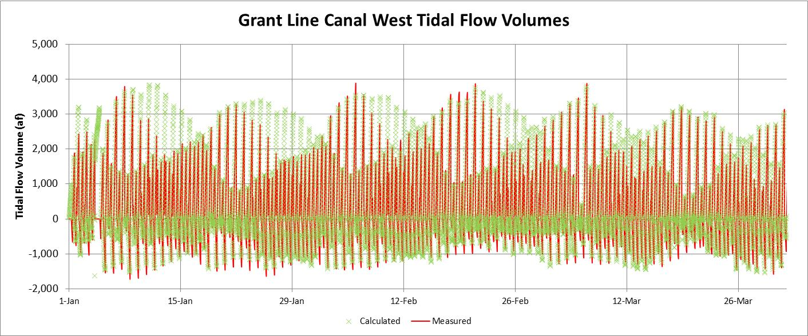
The calculated tidal volumes in Grant Line Canal at the west end (purple boxes) generally matched the measured tidal volumes (green crosses) for the January-March 2013 period without temporary barriers (full tidal flows). The assumed upstream surface area was 750 acres and the net flow was assumed to be 85% of the head of Old River flow. The surface area of Grant Line Canal and Doughty Cut is about 375 acres, the surface area of Old River upstream of Doughty Cut is about 200 acres, the surface area of Paradise Cut is about 175 acres and the surface area of Sugar Cut is about 50 acres (total of 800 acres). The calculated tidal volumes generally matched the measured tidal volumes; the flood- tide volumes (two each day) varied from about -500 af to -1,500 af, with an average of about -750 af. The ebb-tide volumes (two each day) varied from about 1,000 af to 4,000 af, with an average of about 2,000 af. The average net flow for January-March 2013 was about 1,500 cfs (3,000 af per day). About 25% of this net flow volume (750 af) was added to each ebb-tide and each (negative) flood-tide volume. The full tidal flow volumes without any net downstream flow would therefore have been about 1,250-1,500 af (ebb-tide and flood-tide).
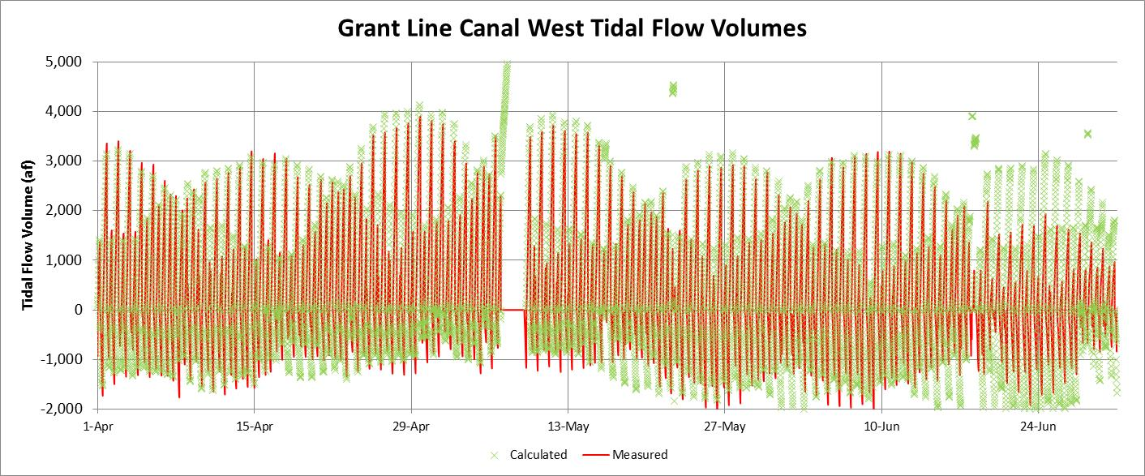

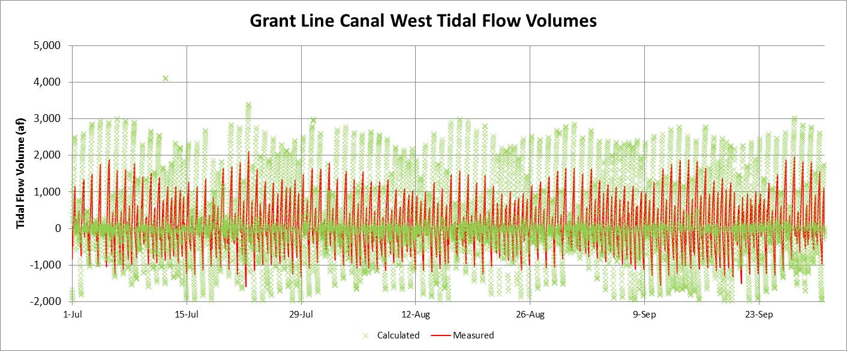

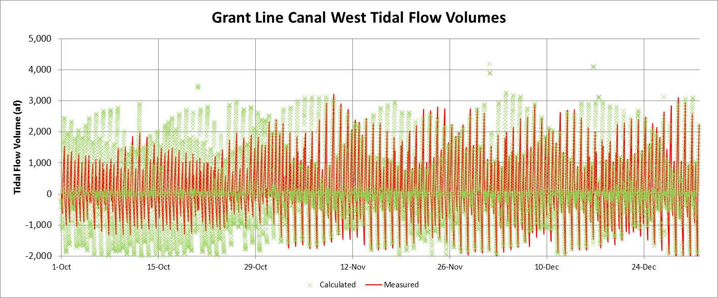

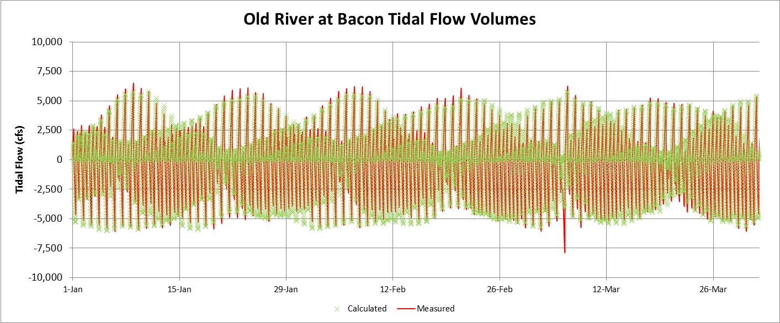
The tidal volumes in Old River at Bacon Island for January-March 2013 show that the estimated tidal volumes, calculated as the tidal elevation changes times the assumed upstream surface area (1,750 acres) minus about half of the upstream net flow for the CVP and SWP export pumps, provides a very good match with the measured tidal volumes. All of the variations from the spring-neap tidal cycle are represented, because the tidal elevations reflect these variations. For the January-March 2013 period, the export pumping was about 5,000 cfs and the head of Old River flow was about 1,500 cfs, so the net flow in Old River and Middle River was about 2,500 cfs. The net flow in Old River was assumed to be -1,250 cfs. Because the tidal variations are relatively large throughout each 30-day spring-neap tidal cycle, the daily average Old River flows fluctuate considerably. A daily OMR flow index, based on the daily export pumping and the daily head of Old River flow would provide a more stable indicator of reverse flows.

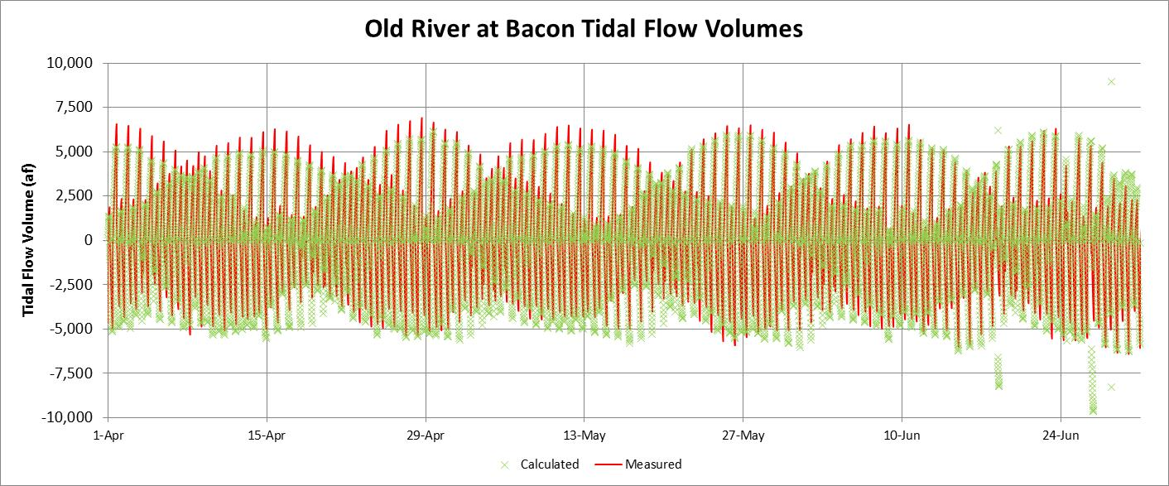

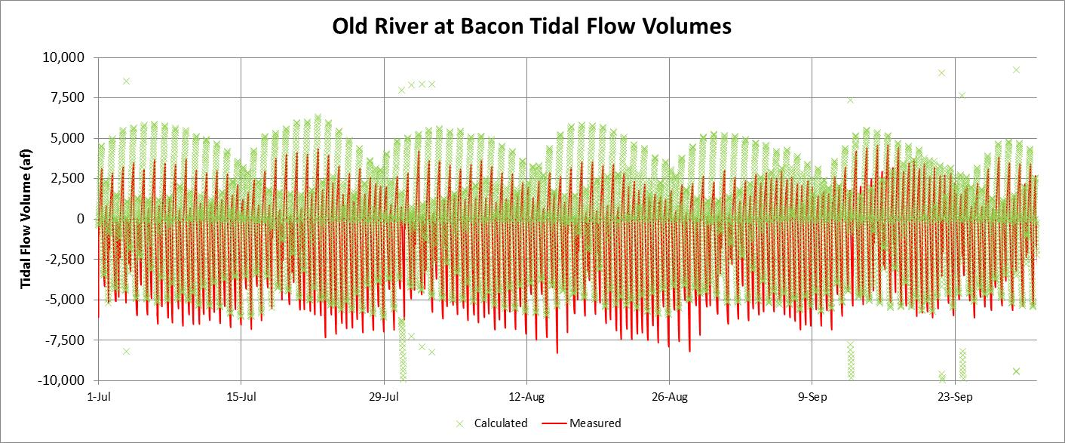

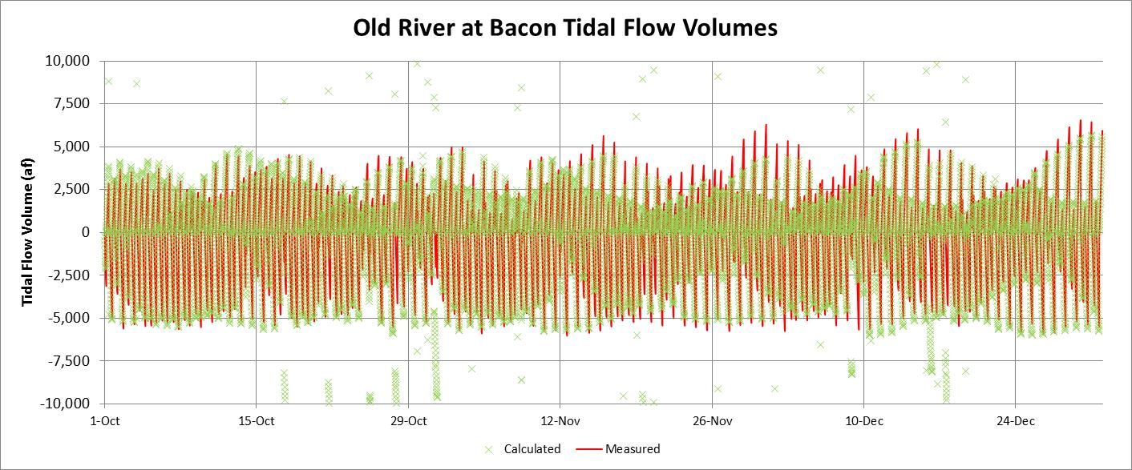

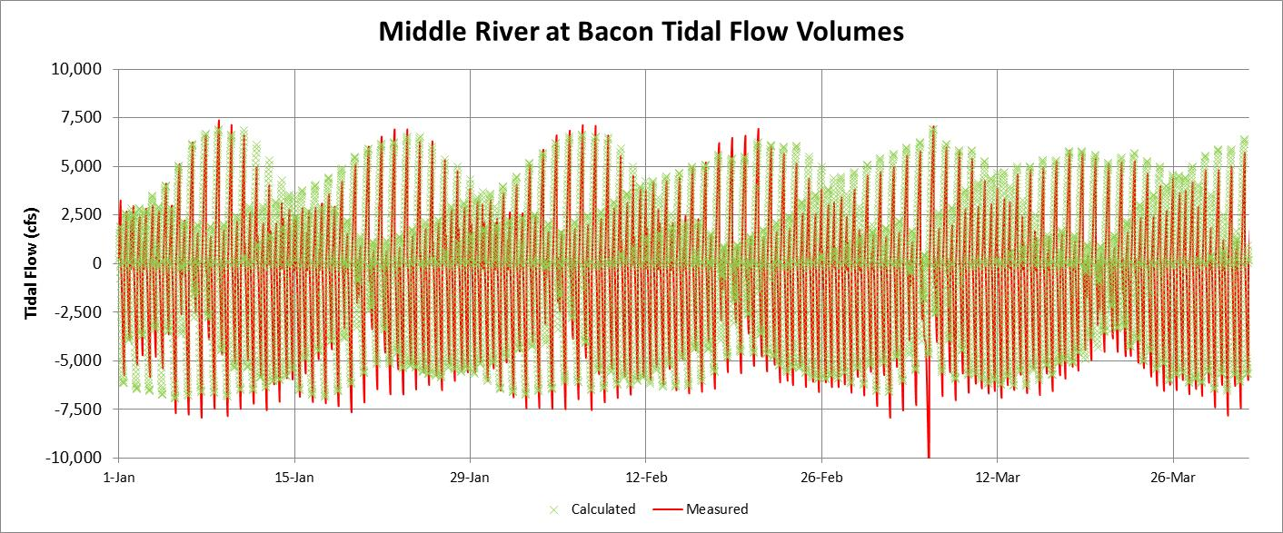
The tidal volumes in Middle River at Bacon Island for January-March 2013 show that the estimated tidal volumes, calculated as the tidal elevation changes times the assumed upstream surface area (2,000 acres) minus about half of the upstream net flow for the CVP and SWP export pumps, provides a very good match with the measured tidal volumes. The total surface area of all channels south of the Old and Middle River stations is about 3,750 acres [DSM2 geometry]. All of the variations from the spring-neap tidal cycle are represented, because the tidal elevations reflect these variations. For the January-March 2013 period, the export pumping was about 5,000 cfs and the head of Old River flow was about 1,500 cfs, so the net flow in Middle River was assumed to be about 1,250 cfs. Because the tidal variations are relatively large throughout each 30-day spring-neap tidal cycle, the daily average Middle River flows fluctuate considerably. A daily OMR flow index, based on the daily export pumping and the daily head of Old River flow would provide a more stable indicator of reverse flows.
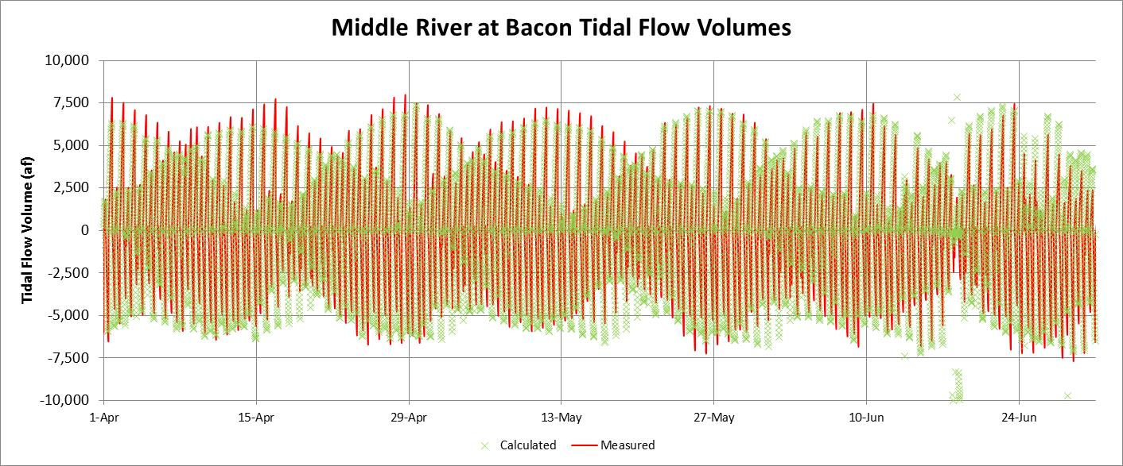

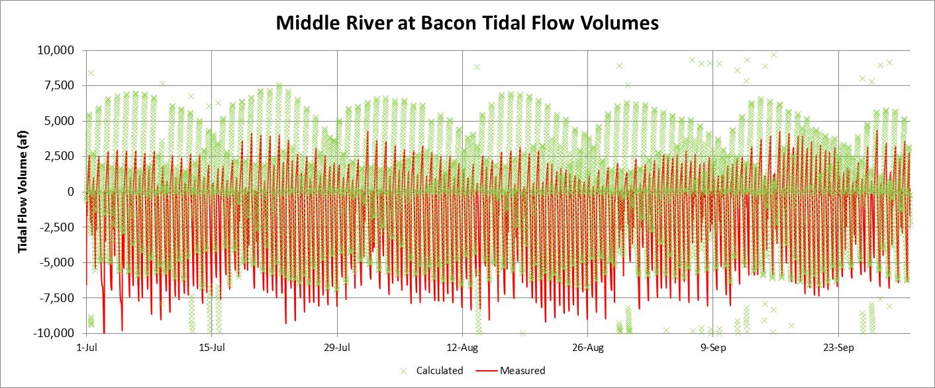

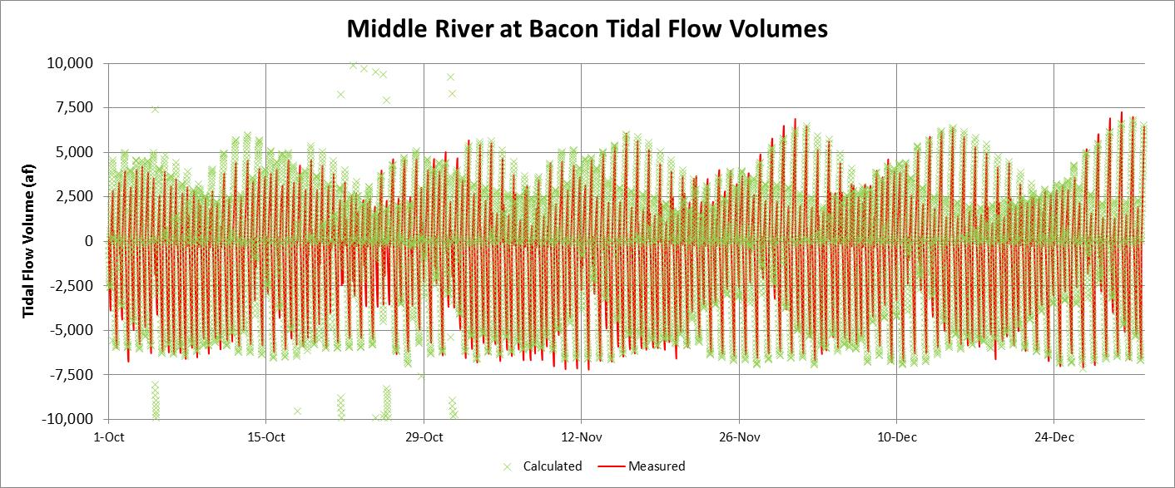
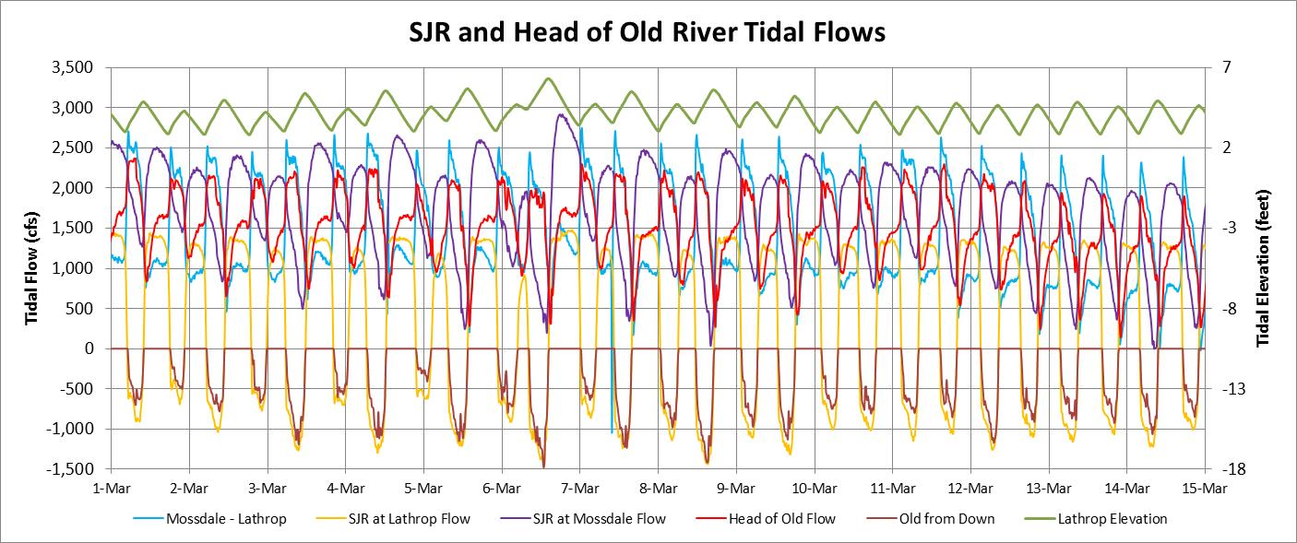
This figure illustrates how the tidal flows in the head of Old River are controlled by the tidal elevations and tidal flows in the SJR at Mossdale (upstream) and at Lathrop (downstream). The tidal flows in the SJR are proportional to the tidal elevation changes (green line, right scale) and the tidal variation is reduced at upstream locations; the tidal flow variation at Lathrop (gold line) was greater than the tidal flow variation at Mossdale (purple line). The daily average Mossdale flow decreased from about 2,000 cfs at the beginning of March 2013 to about 1,500 cfs by mid-month. The tidal flows at Mossdale, located 5 kilometers upstream of Old River, were highest during ebb tide (decreasing elevations, downstream flow), and were lowest during flood-tide. The maximum tidal flow was about 2,500 cfs at the beginning of the month and about 2,000 cfs by mid-month. The tidal flows at Lathrop, located 0.5 kilometers downstream of Old River, were about 1,500 cfs during ebb tides and about -1,000 cfs (reverse flow) during flood tides. The tidal flows in Old River (red line) were about half of the Mossdale flow during ebb tides. During flood tides, as the Mossdale flow decreased, the Old River flow increased to include the upstream flow from Lathrop (brown line). All of the flood-tide reverse flow at Lathrop (-1,000 cfs) was “squeezed” into Old River during this period of relatively low SJR flow.
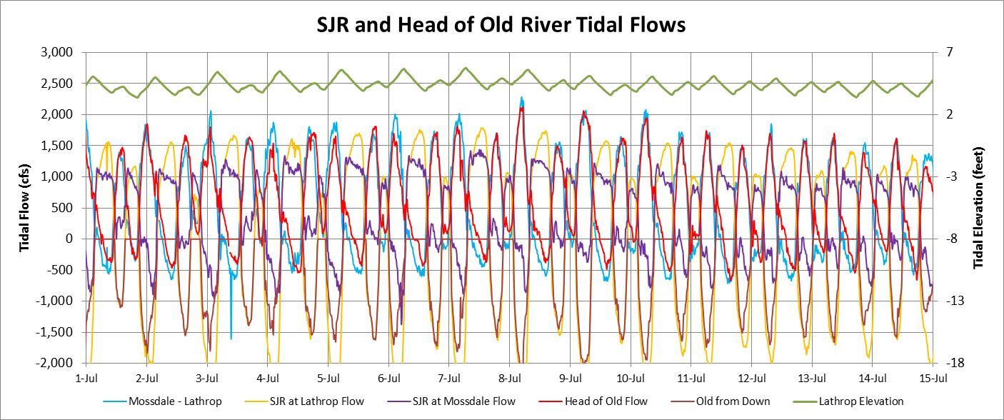
During the first half of July 2013 the SJR flow at Mossdale was less than 500 cfs, and the maximum tidal flows at Mossdale (purple line) were about 1,000 to 1,500 cfs. The SJR flow diverted into Old River (red line) was low during ebb-tides; most of the SJR flow continued downstream in the SJR past Lathrop. The Old River flow was negative (upstream flow to the SJR) near the end of each ebb-tide. This was influenced by the temporary barriers, which caused tidal elevations in Old River (upstream of the barriers) to remain higher than the SJR elevations. The minimum flood-tide (reversed) flows at Lathrop were about -2,000 cfs and the maximum flows into Old River were almost as high (1,500 cfs). The majority of the reverse flow at Lathrop enters Old River (brown line), but the Mossdale flow was also reversed at the end of each flood tide. The measured Old River flows (red line) were nearly equal to the Mossdale flow minus the Lathrop flow (light blue line) in July 2013. The Lathrop flows were replaced with a new tidal flow station at Dos Reis (about 3 kilometers downstream) beginning in June 2013. Most of the water entering Old River in July 2013, with the temporary barriers, was diverted during flood tides.
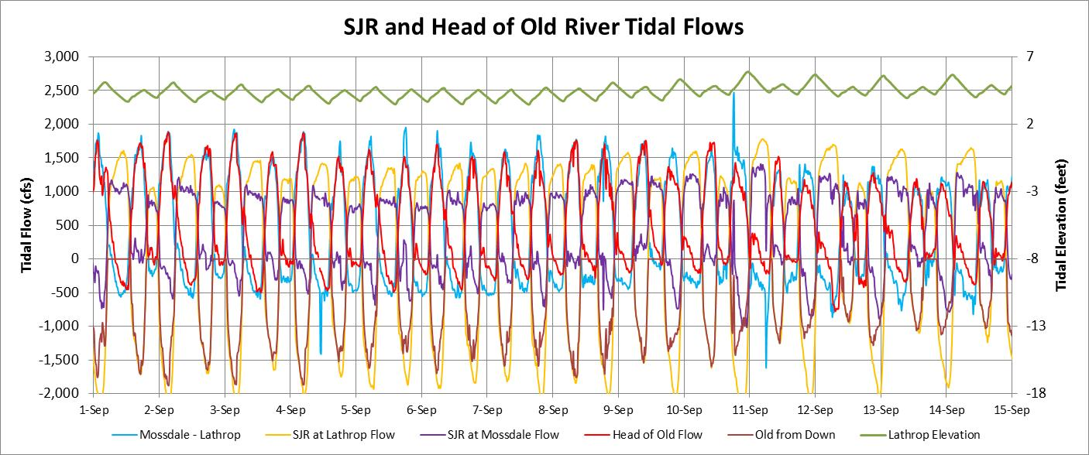
During the first half of September 2013, the SJR flow at Mossdale was about 500 cfs, and the maximum tidal flows at Mossdale were about 1,000 cfs. The tidal flows at Lathrop (Dos Reis) ranged from about 1,500 cfs to about -1,500 cfs. The Old River flows (red line) were low during ebb-tides (barriers were installed) and were slightly reversed (about -500 cfs) near the end of each ebb-tide. Most of the upstream SJR flow at Lathrop (Dos Reis) entered Old River (brown line) during flood-tides, and the Mossdale flows (purple line) were also reversed (about -500 cfs) for a short time near the end of each flood-tide period.

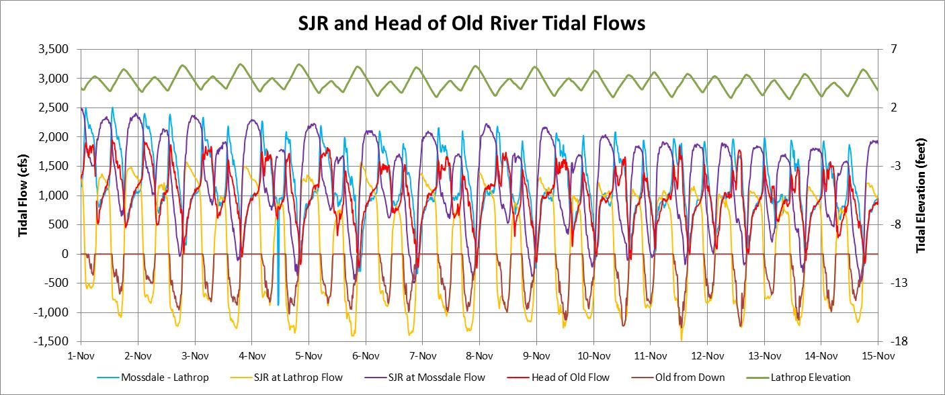
During the first half of November 2013, the SJR flow at Mossdale was about 1,000 cfs and the maximum tidal flow at Mossdale was about 2,000 cfs. Tidal flows at Lathrop (Dos Reis) ranged from about 1,500 cfs to -1,000 cfs (similar to the flows in March). The Old River flow was about half of the Mossdale flow during ebb-tide, but the Old River flow increased during each ebb-tide (likely caused by the Old River elevations decreasing slightly faster than the SJR elevations). During flood-tides, most of the reverse SJR flow at Lathrop entered Old River (brown line). Reverse flows at Mossdale and in Old River sometimes were measured at the end of the flood tide (highest elevations). Although the tidal flow variations in Old River are complicated, and dependent on the tidal elevations and tidal flows in the SJR, the daily average SJR flow diversion into Old River was generally well-estimated as 50% of the Mossdale flow plus 5% of the CVP and SWP exports.

