What is the Constituent Tracker?

In collaboration with USGS (concept and algorithm development) and DWR, the development of this project aims to advance the Bay-Delta Live (BDL) data management platform to provide data and decision support tools for viewing and analyzing continuous water quality conditions at finer spatial scales within the Delta. This data assimilation application may be incorporated into existing monitoring programs to evaluate current conditions, assess turbidity and nutrient conditions, supplement or replace DWR early warning turbidity transect operations, as well as help to evaluate changes due to wetland restoration, flow alteration and other management actions.

The Constituent Tracker (CT) takes measured observations of water quality constituents or proxies (specific conductivity and turbidity) and measured velocities and uses both to prepare graphical products showing excursions of these constituents from their slack-water distributions (viewing data at a constant point in tide). This work is performed in order to assess the feasibility of this approach being used as a predictive tool to reduce the need for in situ measurements of turbidity.

Relevance and Benefits
Endangered species protections for Delta smelt, a functionally extinct endemic-to-the-Sacramento/San Joaquin Delta fish, can significantly constrain water supplies south of the Delta in the winter, when, tragically, there is greatest amount of water available for export.

There are a number of different regulatory triggers aimed at protecting delta smelt that can curtail pumping: the main triggers being salvage at the pumps and elevated turbidities in the central and south Delta. For example, reductions in pumping are required when the 14-day average turbidity exceeds 12 NTU at stations PRI, HOL, and VCU (see Figure 1). In addition, biweekly spatial mapping of the turbidity distribution in the loop from Old River to Woodward Canal to Middle River, to the San Joaquin to Old River (Figure 2) by DWR is used by the Delta Smelt Working Group - a multi-agency regulatory entity that provides guidance to the water project operators on compliance with State and Federal Delta Smelt biological opinions. To obtain the example “heat” maps shown in figure 2, DWR drags a water quality Sonde behind a boat while collecting GPS position data.

Unfortunately, the data collected via boat can be misleading. These data can be aliased by the tidal currents because the tidal currents can move the turbidity field back and forth in these channels on the order of 5 miles twice a day, every day (more on this below). In addition, transecting data like those shown in figure 2 are expensive and puts people unnecessarily in harm’s way (e.g. people in boats in rough winter weather).

The Problem of Tidal Aliasing

The spatial distribution of water quality constituents over the transect shown figure 2 can move up to about ~4.5 miles, a distance known as the tidal excursion. The tidal excursion is the distance a parcel of water travels with the tidal currents in ½ tidal cycle. An Eulerian estimate of the tidal excursion is, (see Appendix B for origin of this relationship). To estimate the tidal excursion in Old River we note the peak flood currents at station HOL (A station on Old River immediately south of Franks Tract (see figure 1) are roughly 43 cm/s (1.75 ft/s), which gives an Eulerian tidal excursion estimate of 7.5 km (4.7 mi) based on eq. A.5. The length of Old River between Franks Tract and Clifton Court Forebay (CCFB) is 25 km (16mi), so the tidal excursion, and by extension the location of the turbidity field, can move, or be off by as much as 1/3 the length of Old River between Franks Tract and CCFB, respectively. To get a sense of the scale of the movements of water quality constituents within Old River, consider that if the high turbidity region near station HOL were mapped at the end of ebb, it would move to the position shown on figure 2B (January 6), the distance shown by the red line placed west of Old River.

This well-known phenomenon is known as tidal aliasing: the collection of spurious data when the sampling time is a significant fraction of the fundamental period of the phenomena being measured – in our case the M2 partial tide, which has a period of 12.42 hours. Basically the boat-measured spatial distribution is highly aliased because the turbidity field moves a significant distance with the tidal currents during the period the boat is collecting data.

In summary, if the transect shown figure 2 begins at the end of ebb and finishes at the end of flood (e.g. roughly 6 hours) the turbidity measurements during the early part of the transect will more closely represent the position of the turbidity field as far north as it will be for a given tidal day, while the portion of the transect taken near the end of flood will more closely represent of the position of the turbidity field when it is as far south as it will be during the tidal day – as much as ~4.5 miles closer, during spring tides.

This project is aimed at using the advection-based model to estimate the position of the turbidity field in the Old and Middle River corridor to: (1) obviate the need for on-the-water boat transects, and (2) provide non-aliased estimates of the location of the turbidity field at slack water after the max flood and ebb each day. Finally, by stringing together images of the turbidity field at slack after max flood (Figure 3), the Delta Smelt Working Group and, by extension, the water project operators will be able to determine if maximum excursion of turbidity into the Delta on a given day is moving farther into the south Delta, which could warrant a pumping curtailment, or if it is moving away from the pumps and no action is needed.

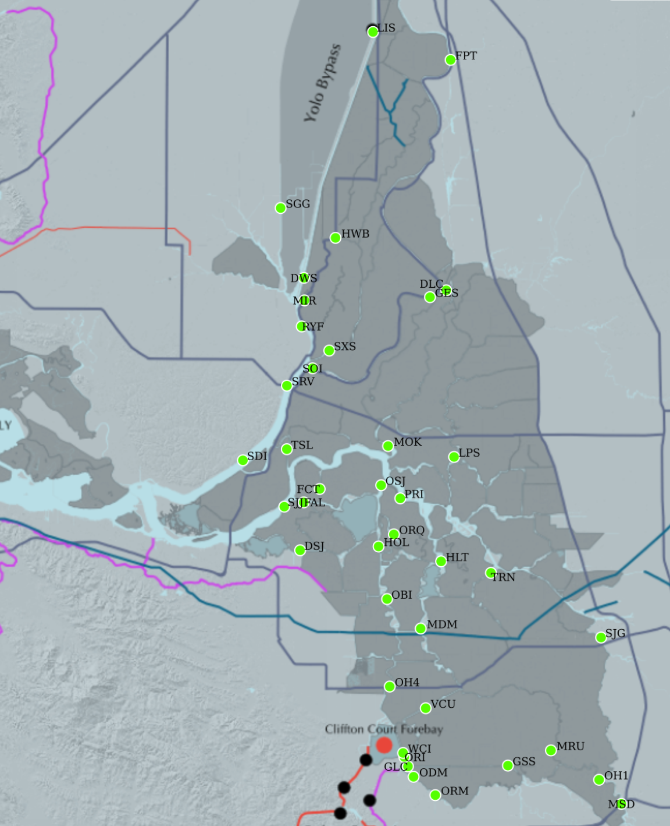
Figure 1 – Study area and the location of USGS fixed site flow and water quality sampling locations. The constituent tracker would also utilize DWR-run flow and water quality gages in the Delta to increase the precision of the spatial maps produced using this approach.

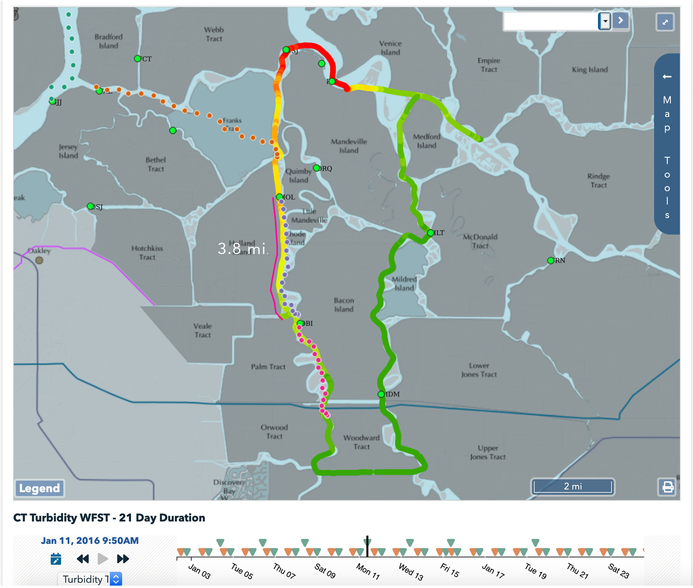
Figure 2 – Turbidity transects collected by DWR by dragging a YSI sonde by boat (Courtesy of the 1/11/16 Delta Smelt Working Group notes). These transect take approximately 6 hours to complete depending on the tidal currents and weather (which is often inclement), roughly ½ of the principal tidal period of 12.42 hours (M2 partial tide).

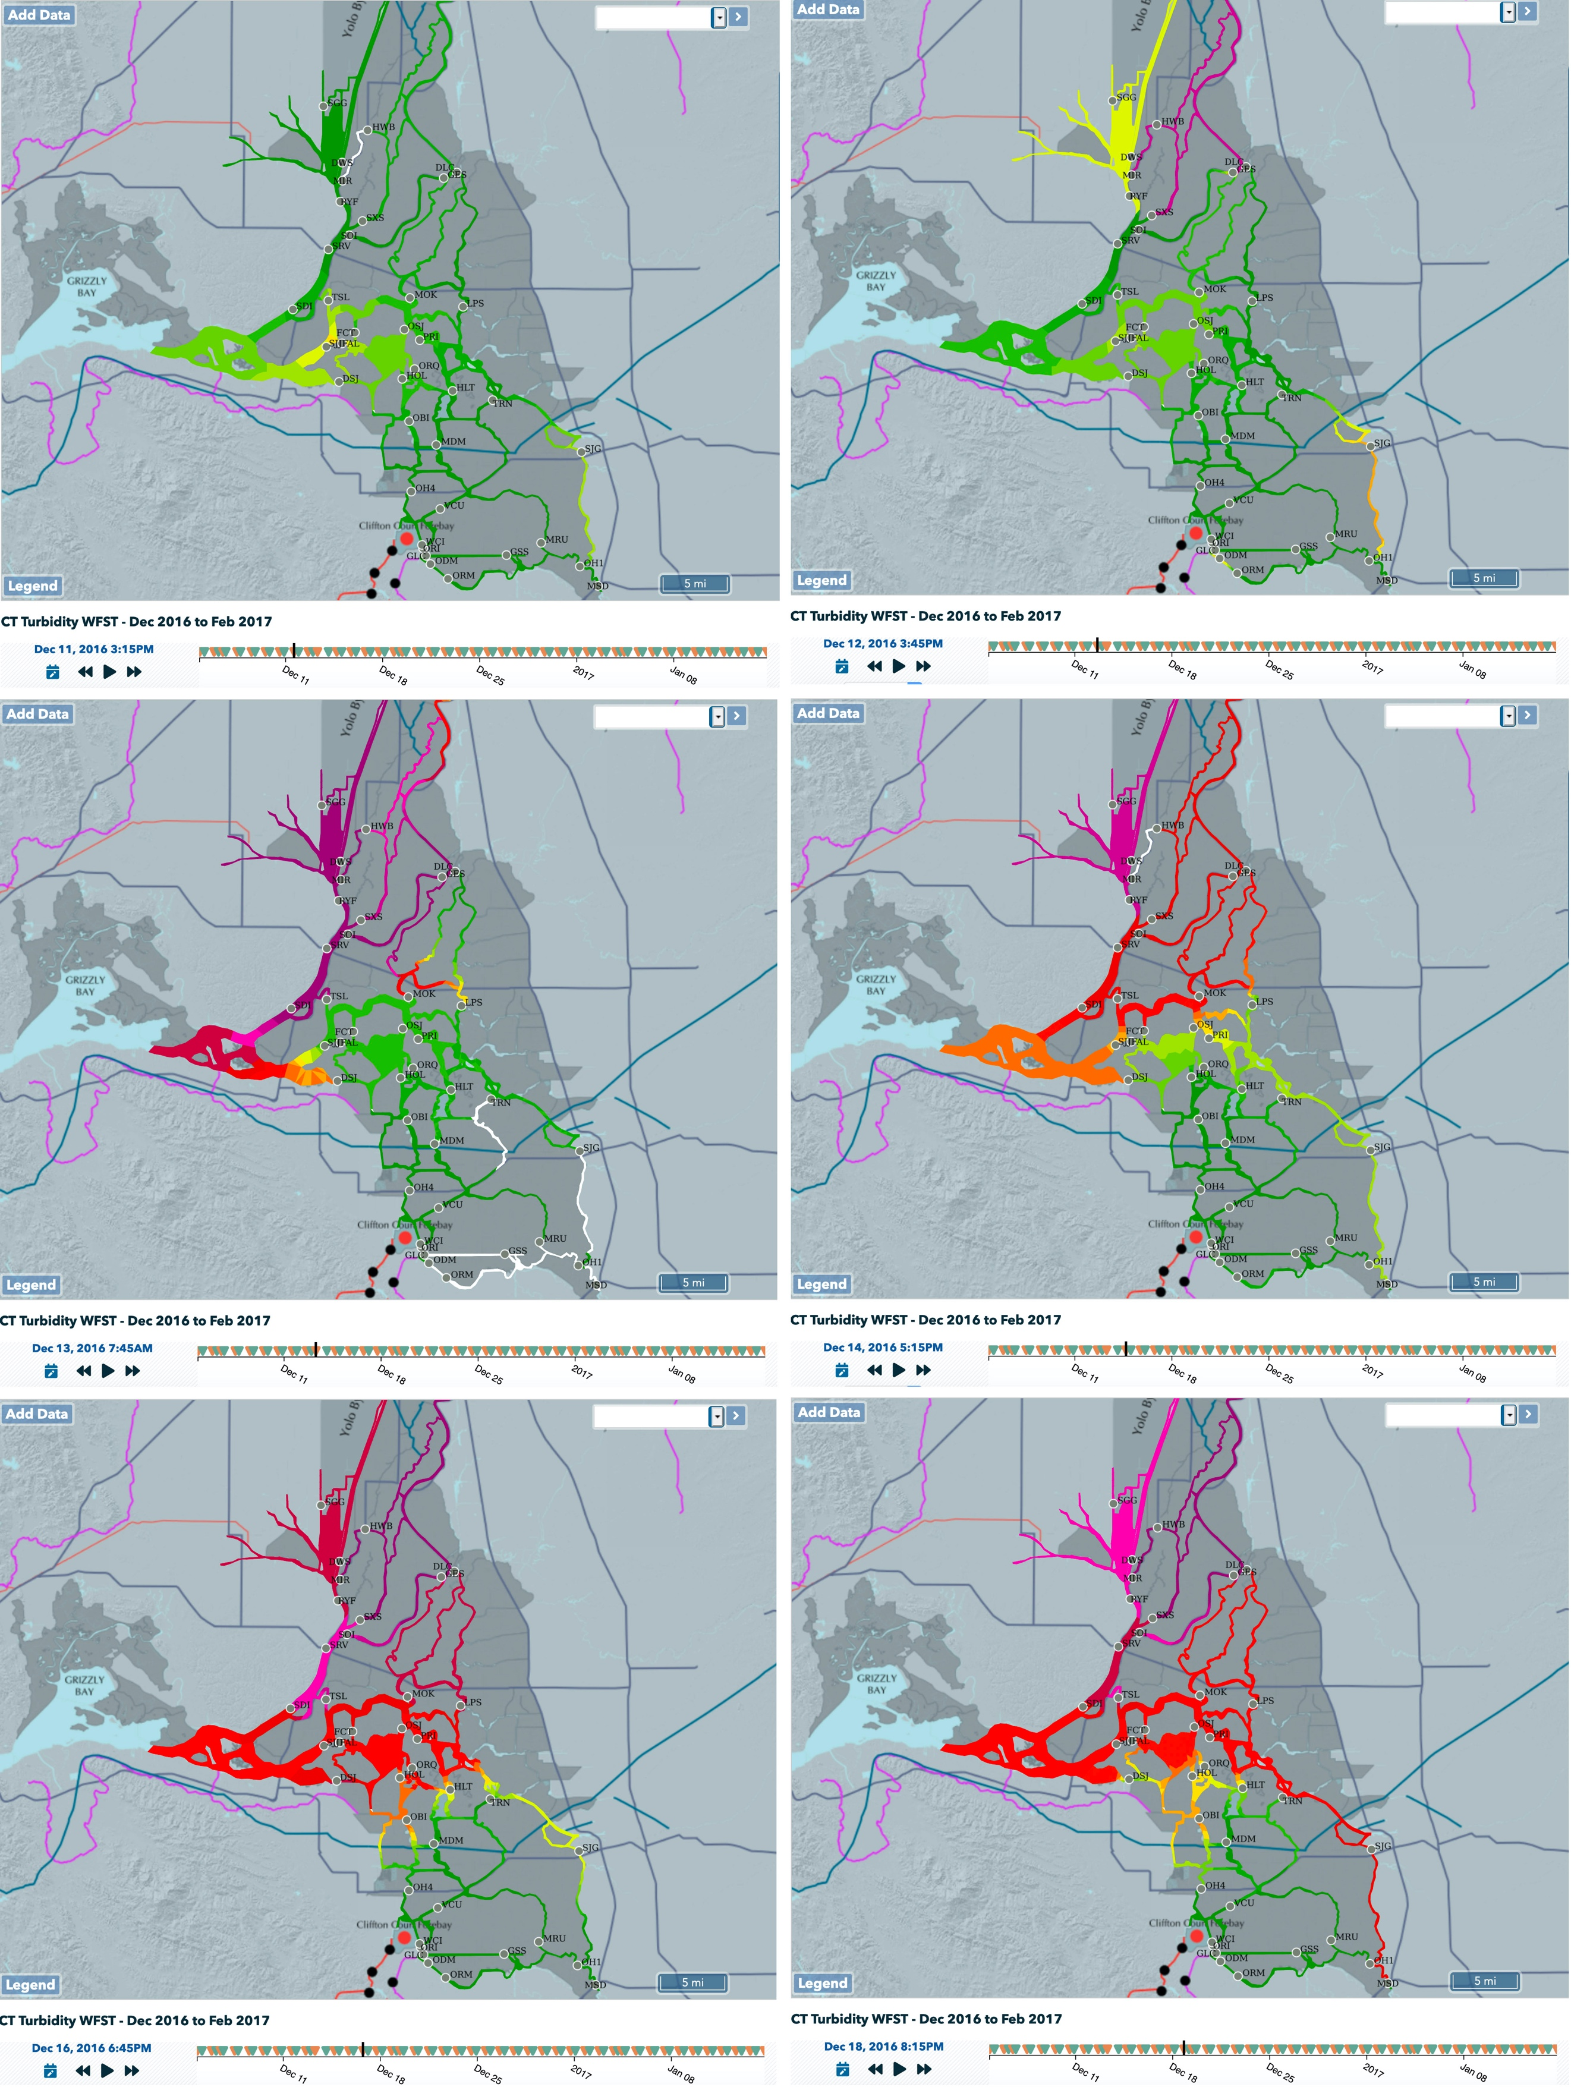
Figure 3: First Flush December 2016: Constituent Tracker – Turbidity at slack after Max Flood

Approach
The aim of this project is to capture constituent spatial distributions at slack after the maximum flood and maximum ebb each day (e.g. the farthest constituent fields move into and out of the Delta during each tidal day, respectively). For example, from a management perspective we want to know how far salinity and turbidity intrudes into the Delta. Or, said another way, we want to know where salinity and turbidity fields are at slack after flood tide.

Phase 1: This application linearly interpolates the spatial distributions to a common point in tide (not time) where the common points in tide (phase) are at slack after max flood and at slack after max ebb. Spatial maps that are linearly interpolated to a common point in tide will give us a Delta scale estimate of the extreme positions of the constituent fields that occur within a tidal day: either fully into the Delta (slack after max flood) or out of the Delta (slack after max ebb).

Identifying the peak ebb/flood set in a given tidal day is non-trivial because the peak currents during flood and ebb tides can be similar, if not identical (Figure 4). The period of similar peak currents occurs during periods when the diurnal inequality is minimal, which typically occurs during the transition between spring and neap tides, or on places/times when river flows create uni-directional flows. Thus, picking out the maximum flood ebb/sets can be challenging.

Given this ambiguity, this application uses the maximum tidal excursion associated with each tide instead of the max current speed to pick the max ebb/flood set. The tidal excursion - the time integral of velocity from slack to slack (Equation A.1) – doesn’t rely solely on the current extremes but includes the duration of a given tide in the calculation which gives us better discrimination between tide cycles. This project is focused on comparing the extreme positions of constituent fields over a tidal cycle, so using the tidal excursion for this phase is the main objective. Furthermore, the tidal excursion needs to be computed for phase 2. Notably, changes in the spring/neap cycle are much more apparent in the tidal excursion (in this case the tidal excursions during spring tides are roughly 40% longer than during neaps), and, importantly for this project, differences in the tidal excursion between tides are greater (Figure 4).
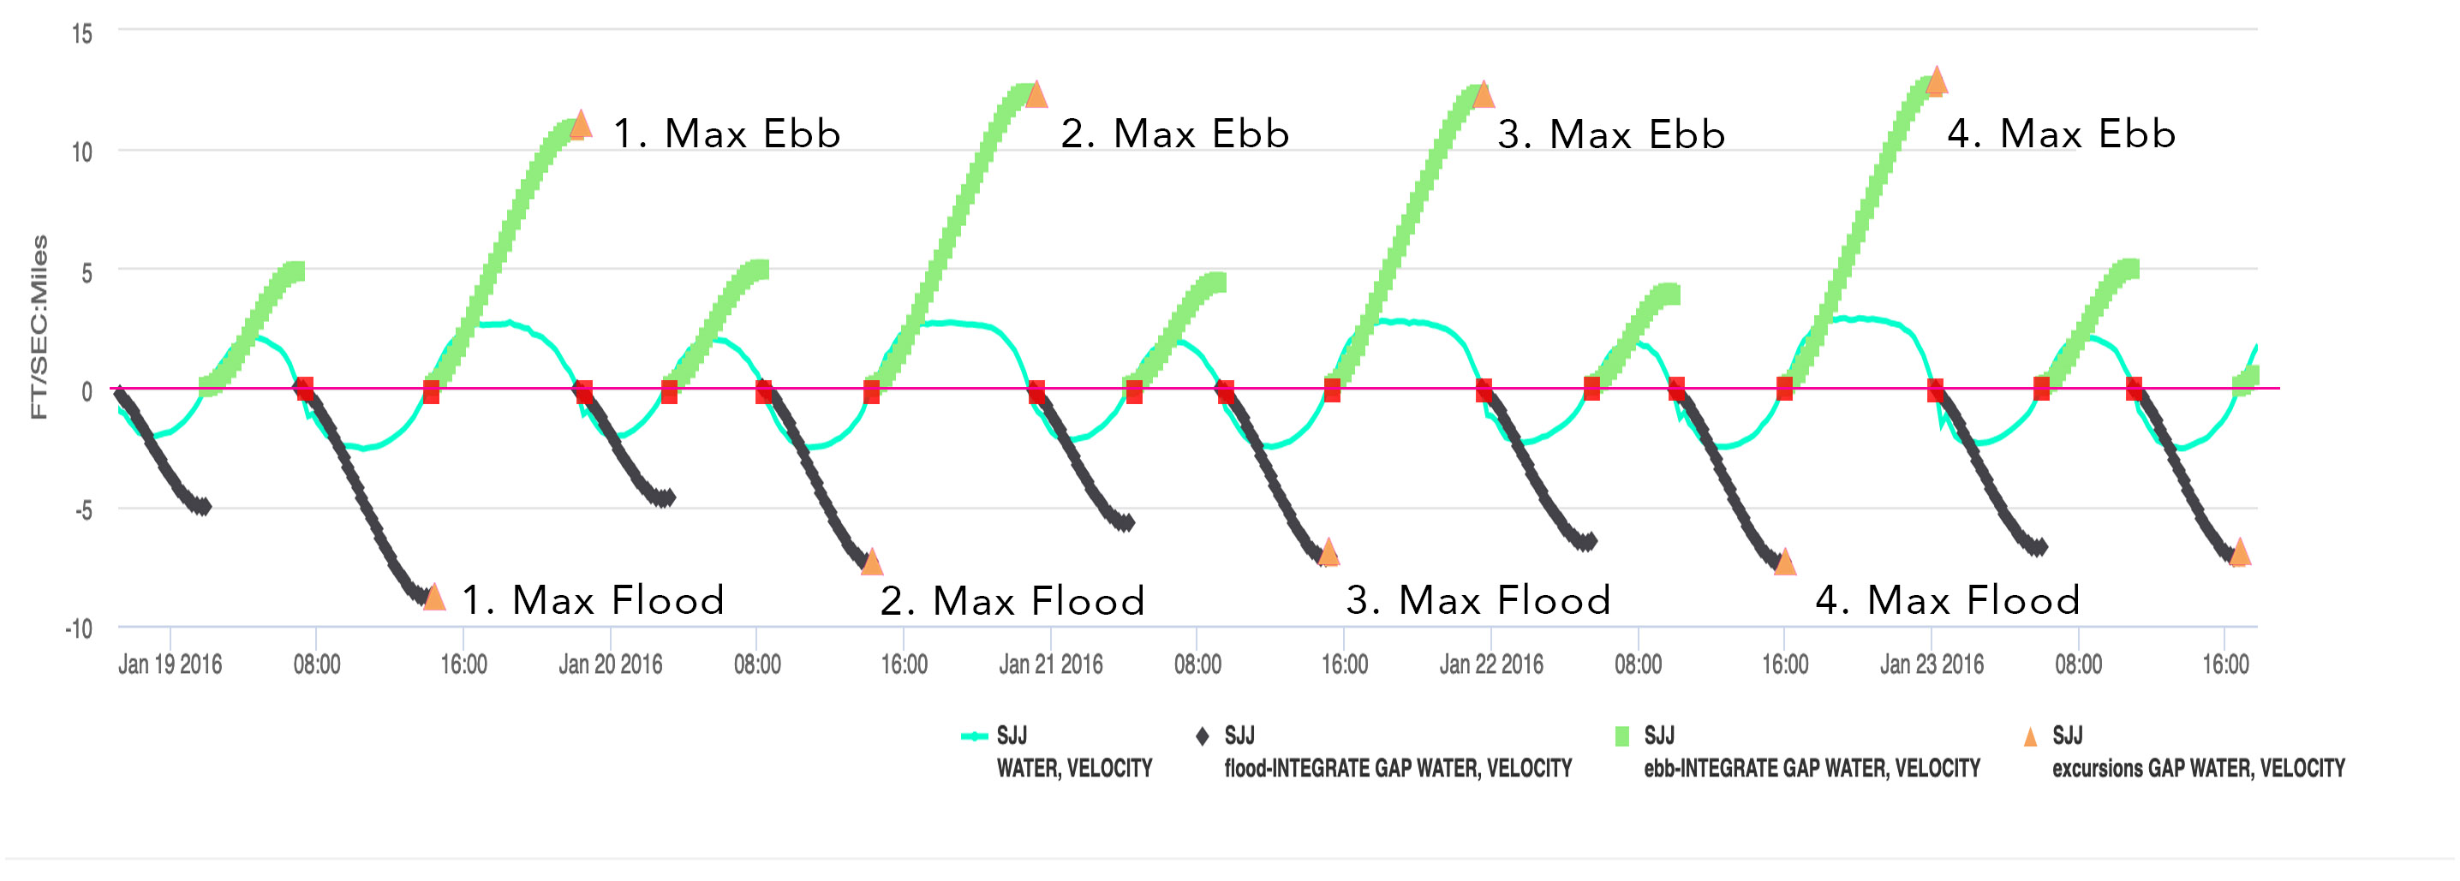
Figure 4 – Time series plot of velocity (blue-green line, scale not shown) and the tidal excursion: green = ebb & black = flood, time integral of velocity from slack to slack, maximum excursion (orange triangles) and slack water periods (red squares on the red zero line) at Jersey Point.

Figure 5 shows how the peak electrical conductivity (EC) is affiliated with slack after flood tide, which corresponds to the maximum salinity intrusion that occurs within a tidal day. Whereas the lowest EC’s are associated with slack after ebb tides. Finally, figure 6 shows how EC varies over the spring/neap cycle, where the maximum salinity intrusion on each day declines as the daily maximum flood tide declines in the transition between spring to neap tides. Finally, the fact that EC and the tidal currents are in quadrature (e.g. 90 degrees out of phase) is a strong indication that transport of EC at this station is advection dominated, as it is throughout the Delta, consistent with the principal assumption on which this project is based.

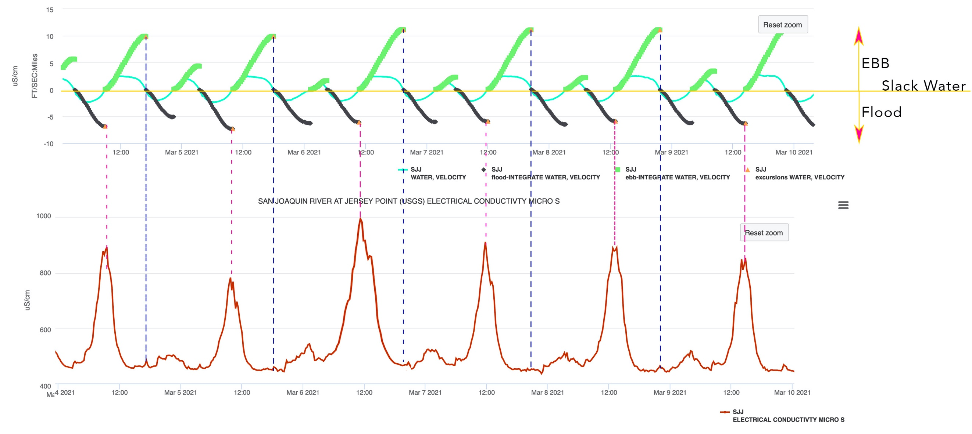

Figure 5 – Time series of electrical conductivity (bottom panel) and tidal excursion (green line; ebb, black line; flood, top panel) and water velocity (blueline, top panel) collected at the San Joaquin River at Jersey Point (March 4-5, 2021). Vertical dashed blue line indicates slack after max ebb and the vertical dashed purple line represents slack after flood tide.

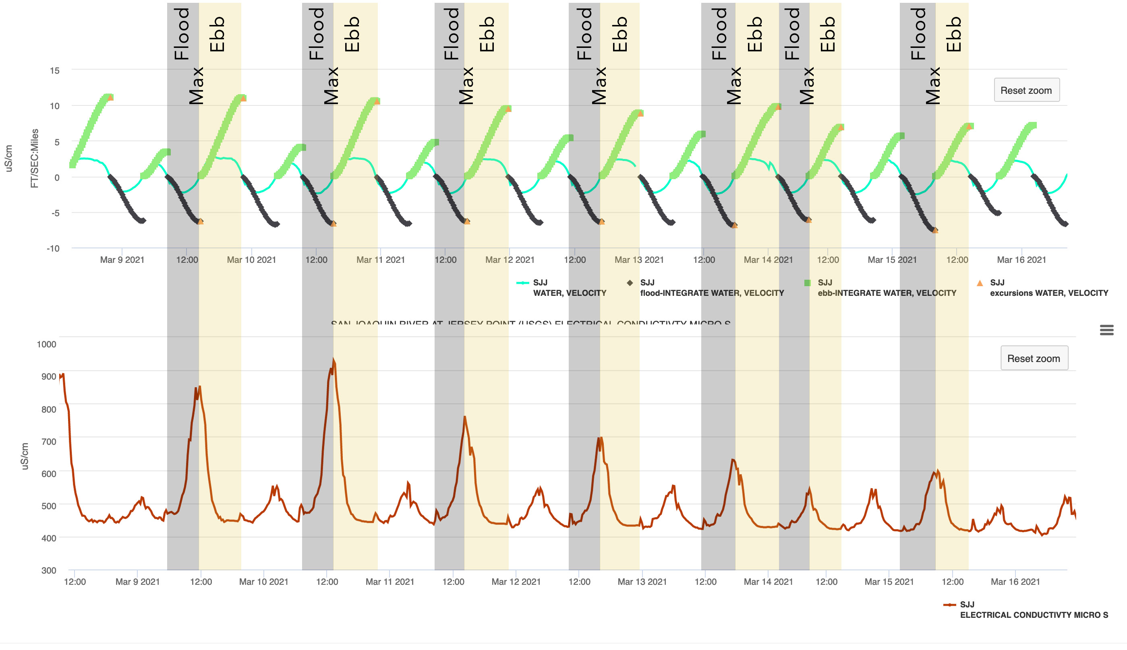
Figure 6 - Time series of electrical conductivity (top panel) and tidal excursion (cyan line, bottom panel) and water velocity (green line, bottom panel) collected at the San Joaquin River at Jersey Point (November 23 – December 3, 2015.

Algorithms

The CT tackles the reality of real time data by first running a series of signal processing algorithms to prepare the data. The procedure is as follows:
- Analyzing the Data:
  - Fill data gaps (4 hours maximum fill)
  - Smooth and Normalized Velocity data
  - Identifying slack water from velocity:
    - Zero Crossing
    - Peaks and Valleys
    - High to High (Hi2Hi)
    - Low to Low (Lo2Lo)
- Heuristic Algorithms: Making Decisions with the Data:
  - Signal to Noise Algorithm to identify a good signal: Yes or No.
    - If yes – Identify the start and end of tidal epic using Velocity:
      - Zero Crossing
      - Hi2Hi
      - Lo2Lo
    - If no – the application moves down stream along a predefined river reach to the next station and runs the same data check.
  - Run the Flood and Ebb Integrates
  - Find & record the excursion times and distances

Tideline Development

The creation of a “Tideline” was developed to visually aggregate tidal epics at slack water for the max flood and ebb for each station during the tidal cycle. The user interface displays a constant point in tide (figure XXX)

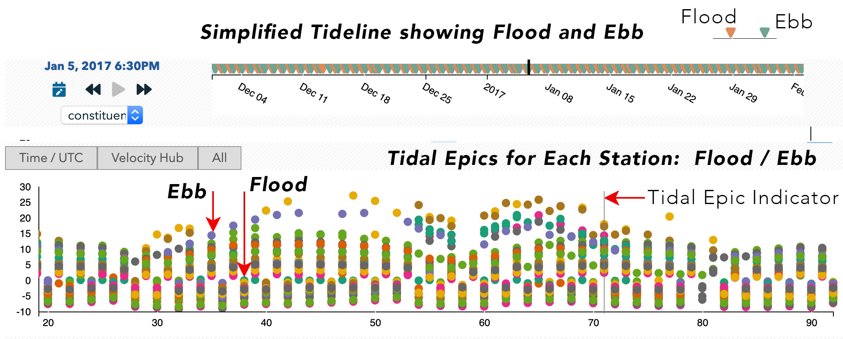
Figure XXX: Tideline Graphical Interface. Each dot represents a real time station at slack water for max flood and max ebb.

Dynamic Weights

Data Assimilation results are displayed using a custom GIS grid. Constituent values for each polygon are generated using a weighted algorithm provided by RMA. Previous versions used a fixed station list. Due to the nature of the real time data network, station data may be interrupted or absent for the period of time the CT is loaded.
Using a Dynamic Weighting Algorithm, we are now able to compensate for missing data. The application has been tested for Turbidity and Electrical Conductivity back to 2010. Data is provided by the California Data Exchange Center (CDEC). CDEC is the data service of choice because of the wide combination of data available from USGS, DWR, USBR and other organizations.

Unfortunately, linearly interpolating to a constant point in tide approach (e.g. phase 1) cannot predict the spatial constituent gradients between stations because the spatial distributions are linearly interpolated between stations, which leads us to phase 2.

Phase 2: Particle Tracking: The CT implemented an algorithm to estimate the spatial variability in constituents between stations. Fortunately, we use the work identifying the max ebb/flood set in phase 1 by simply affiliating the incremental distance water has traveled from the measurement location for each time a water quality measurement is recorded (Figure 7).

The Constituent Tracker has geo-referenced each water quality station on a grid. By doing so, the CT can then plot the location and distance of the excursion points across this grid. The particles contain copious amounts metadata including the stations’ constituent value. At the mapping of these excursions, the particles’ value is transferred to the underlying grid cell.

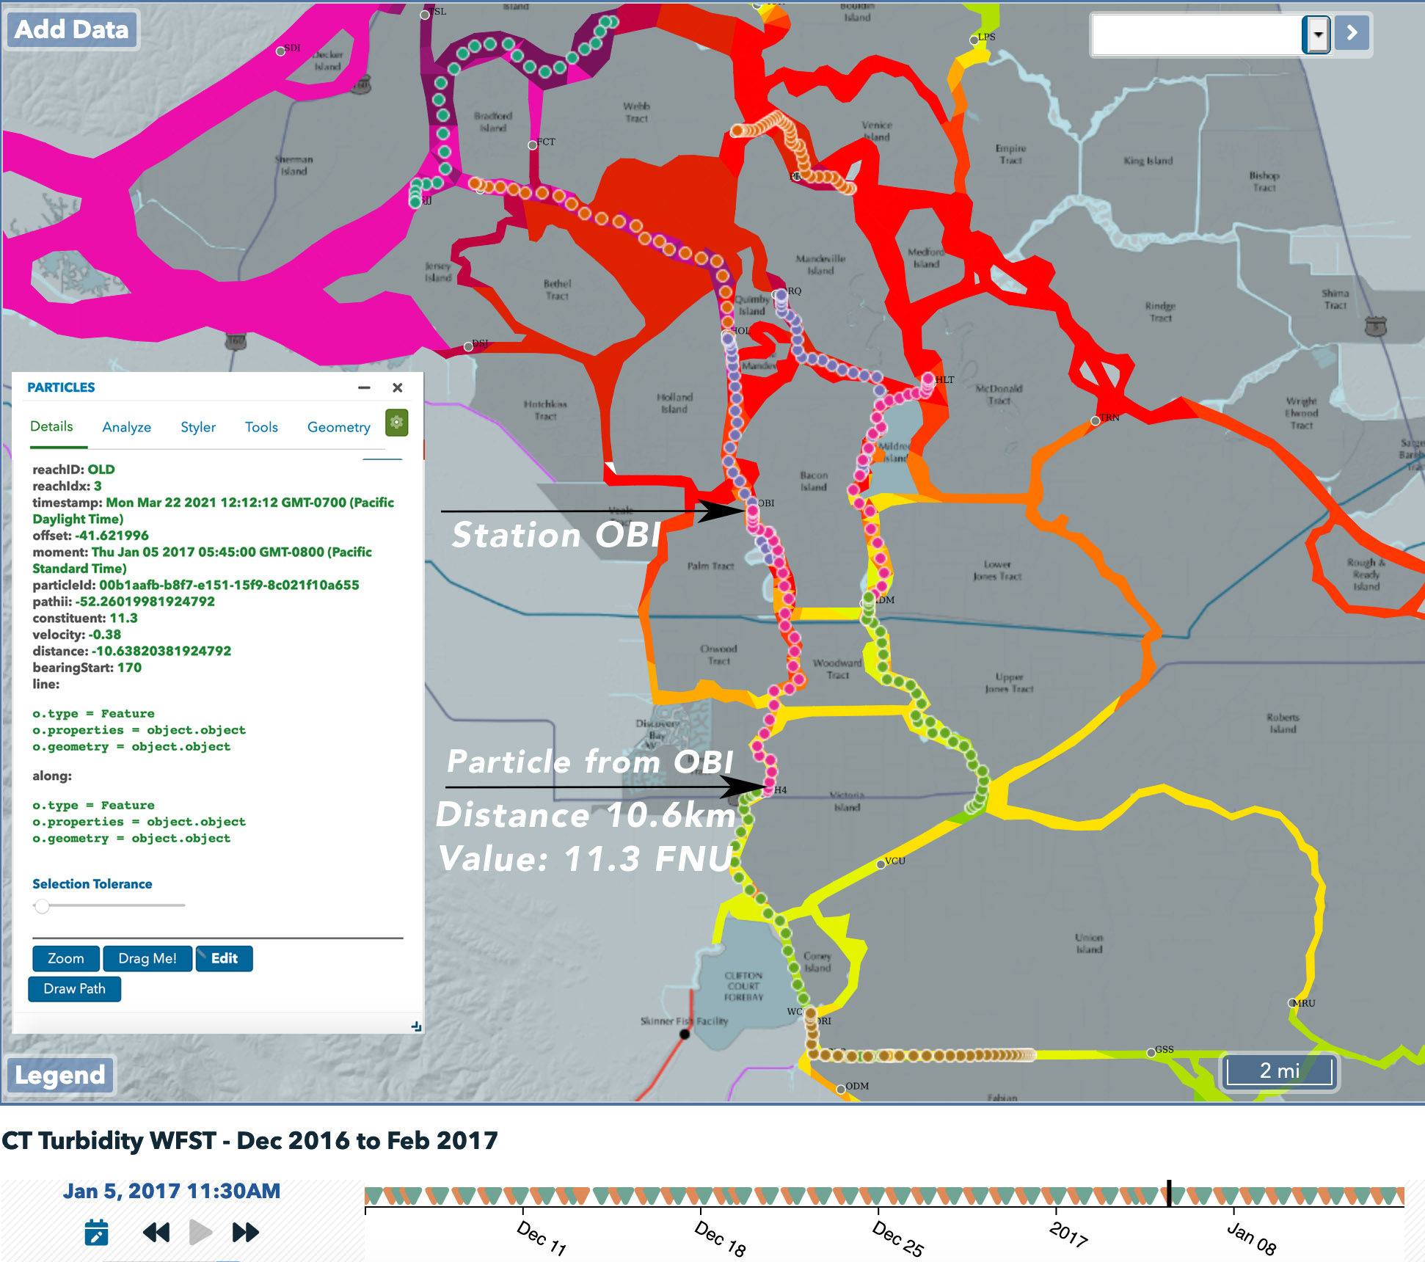
Figure 7: Particle Tracking from Station OBI on Max Flood. Distance traveled = 10km (6.59 mi)

Velocity Hub

The Velocity Hub (vHub) (Figure 8) is the graphical user interface to access the particle tracking for each stations’ excursions. Clicking on the vHub button on the Tideline will open up the interface. Clicking on a station will draw the excursions on the map for the tidal epic selected on the tideline. The user can advance the tides using the forward and back buttons on the player controls. The user can also select the Flood/Ebb/All toggle button to advance the data per tidal epic.

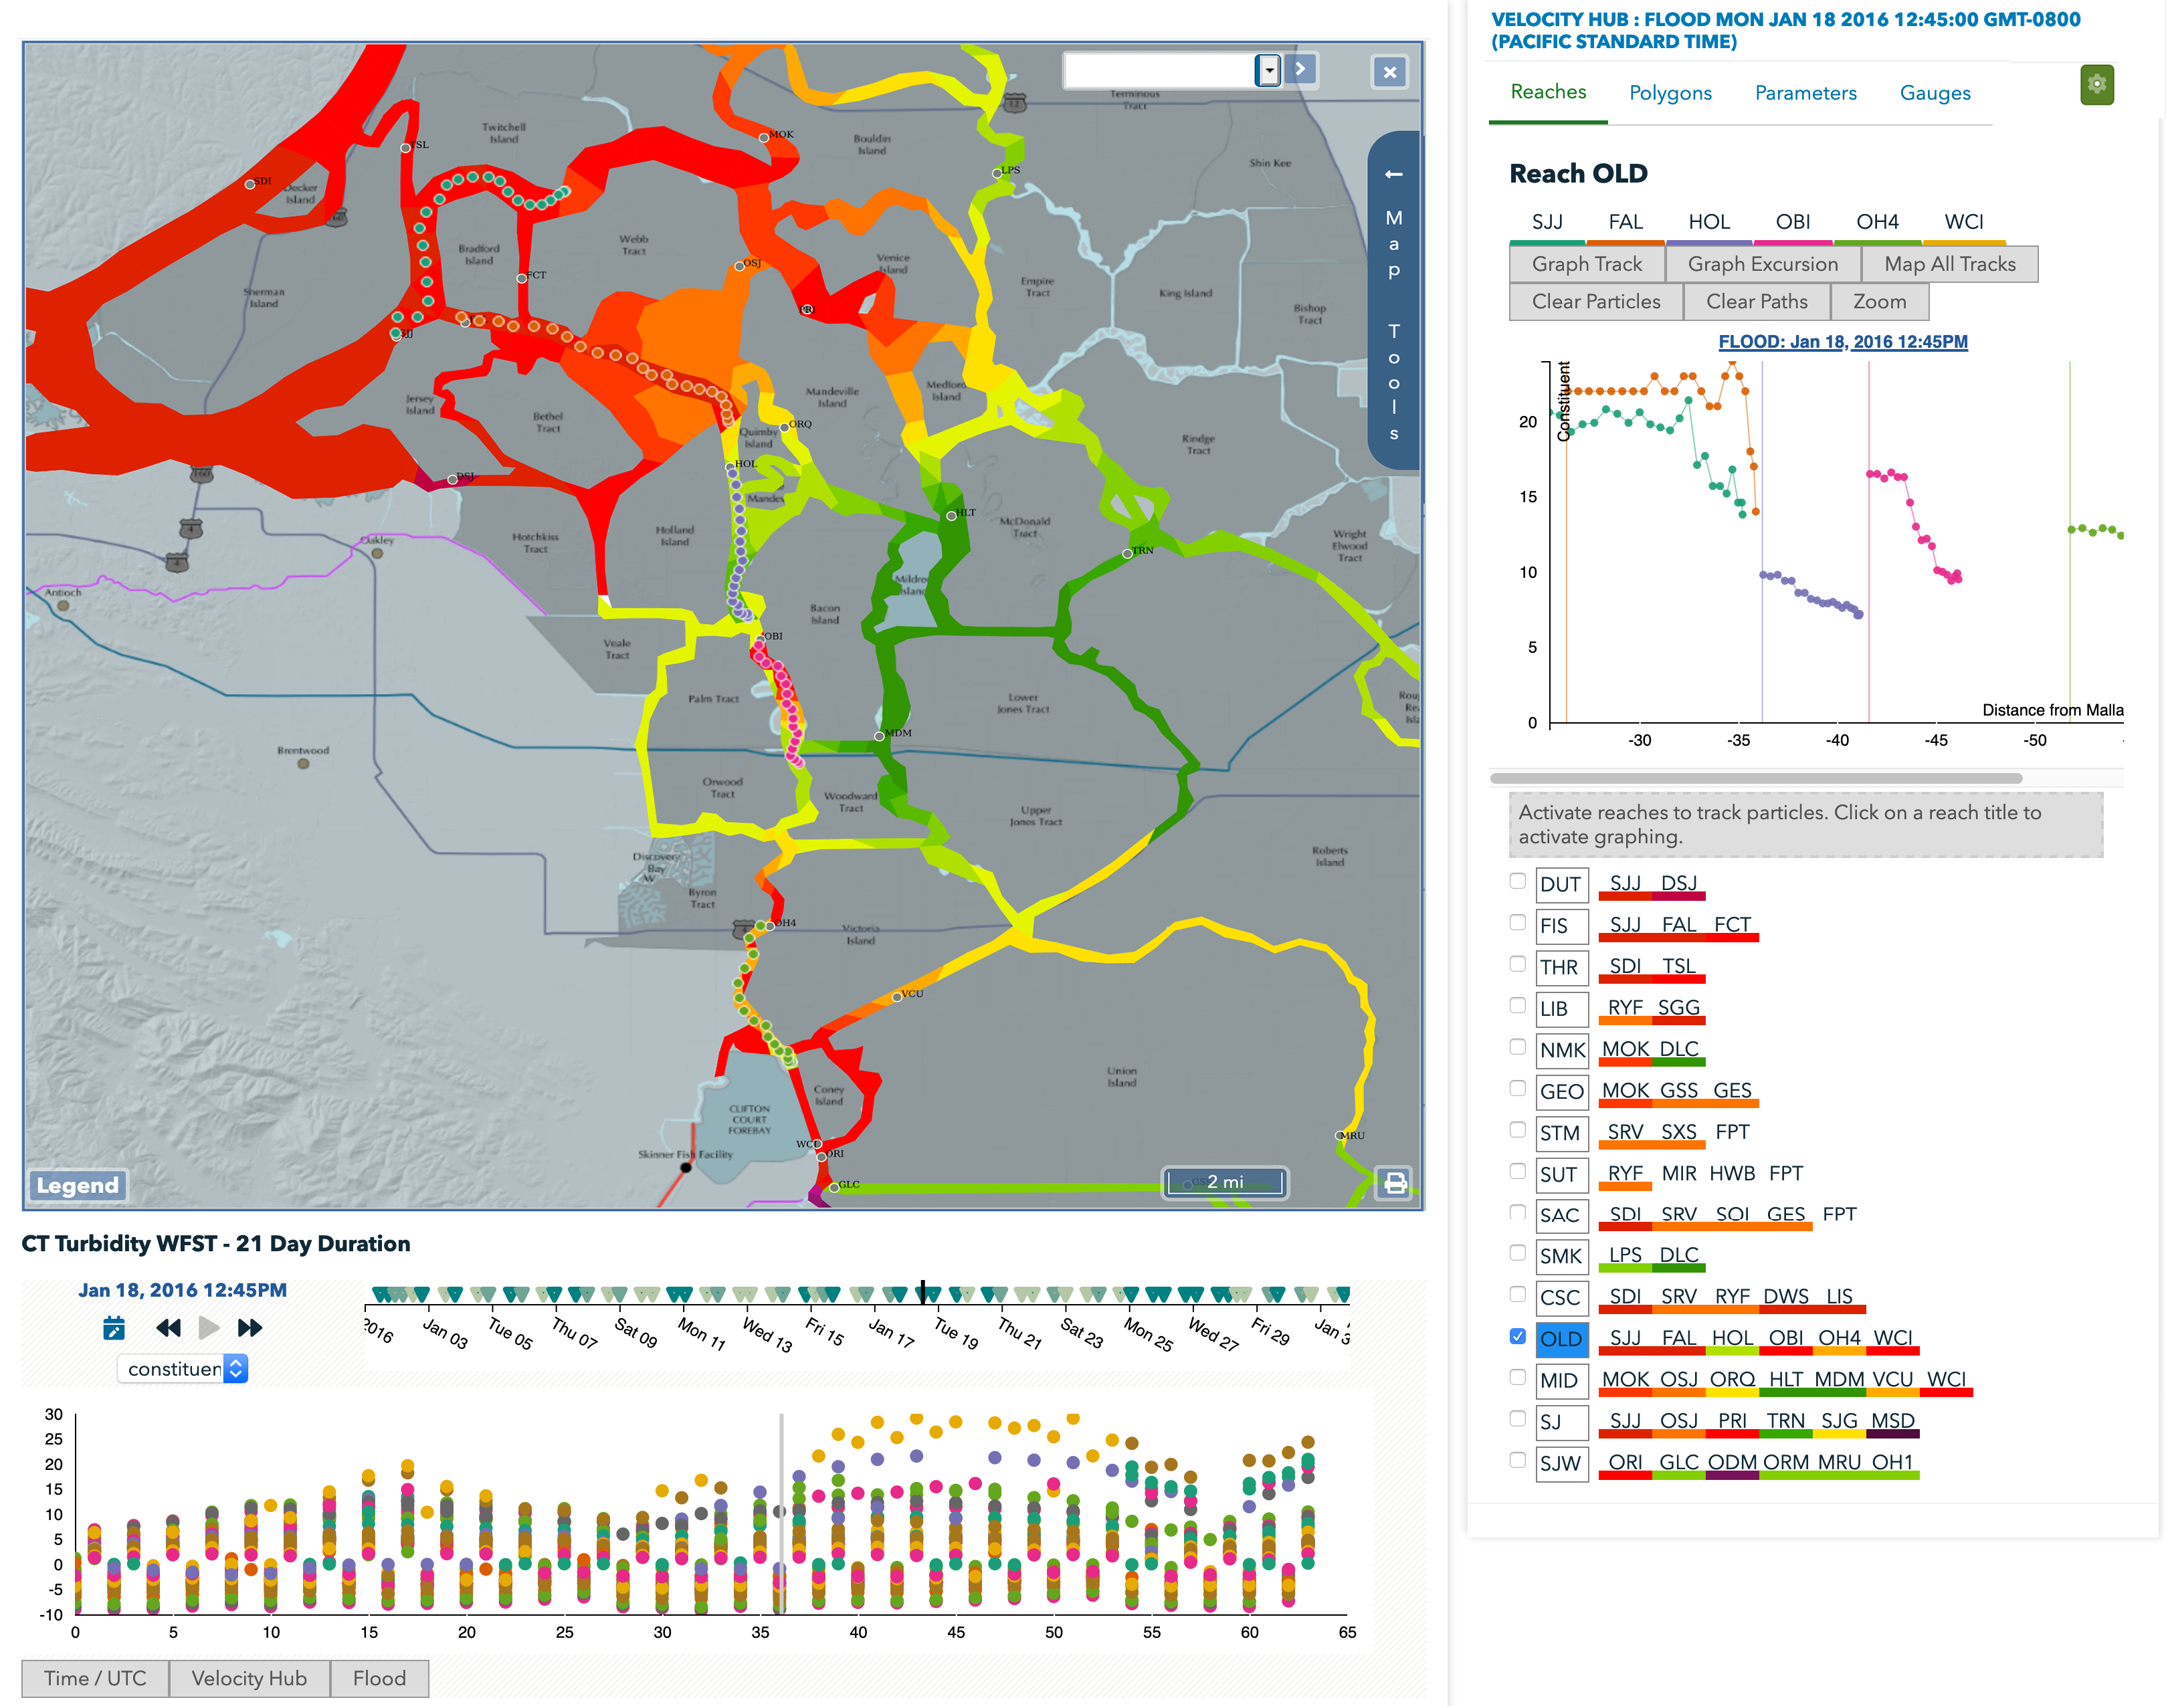
Figure 8: Image of the map, velocity hub and the tideline. The upper right graph displays the excursion data and distances from Mallard for the selected Old River Reach. The particles are displayed on the maps. .

Appendix B – Eulerian Tidal Excursion Estimate
The tidal excursion, the maximum distance traveled by a parcel of water on a single tide, can be estimated based on a local Eulerian velocity measurements,, simply as:

(A.1)

where is the time of slack water and is the next slack water.
If we let and , and the tidal currents can be reasonably approximated by a single partial tide, , then equation 1 becomes

(A.2)

(A.3)

L_{ex}= U*P/pi (A.4)

Now, if we assume the tidal currents in the Delta are well represented by the M2 tide, P=12.42 hrs, 6.21 hrs, or ,, and the peak currents are in cm/s, the tidal excursion is

(A.5)

L_{ex}(mi) = 2.6969*U(ft/s) (A.6)

