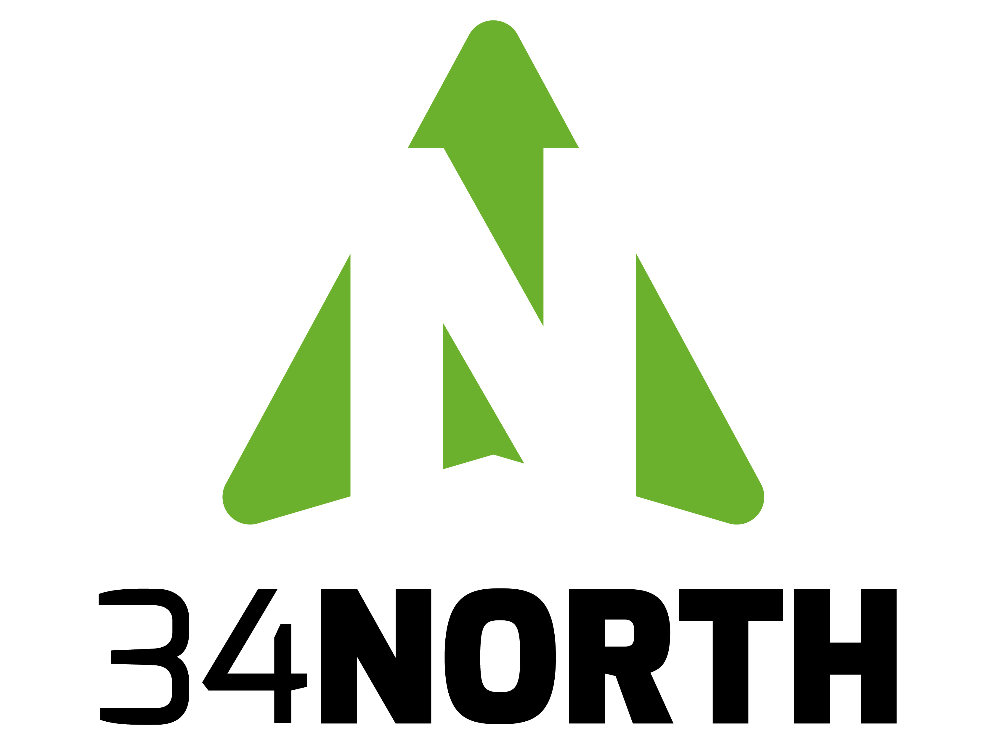

**THE DATA**

EMP Data in its current format and implementation:

1. **Supports and serves data for multiple end points and client applications including the projects below. Discontinuation of the program would affect each project:**
   1. **California Estuary Workgroup Workspace:** A data and information workspace to support a multi stakeholder collaboration tasked with identifying key questions to assess the ecological health of the San Francisco Bay-Delta Estuary, the data and methods available and needed to address the questions, and the methods to access, display, and work with the data and information through a new California Estuaries Portal, linked from the [Are Our Aquatic Ecosystems Healthy?](http://www.mywaterquality.ca.gov/eco_health/) (workspace found here caestuaries.OPENNRM.org)
   2. **The California Water Quality Monitoring: Council Portals (Estuaries):** The development of the California Estuary portal originated from the CA State Senate action from November 2007, a [Memorandum of Understanding (MOU)](http://www.mywaterquality.ca.gov/monitoring_council/docs/sb1070mou.pdf) was signed by the Secretaries of the California Environmental Protection Agency (Cal/EPA) and the California Natural Resources Agency to establish the California Water Quality Monitoring Council (Monitoring Council). The MOU was mandated by [CA Senate Bill 1070](http://www.mywaterquality.ca.gov/monitoring_council/docs/sb1070chptrd.pdf) (Kehoe, 2006) and requires the boards, departments and offices within the California Environmental Protection Agency (Cal/EPA) and the California Natural Resources Agency to integrate and coordinate their water quality and related ecosystem monitoring, assessment, and reporting. The EMP data is organized and processed from the Estuary Workgroup Workspace and syndicated to the California Resource Control Board site discussed above. The content relies heavily on the EMP data. (<http://www.mywaterquality.ca.gov/eco_health/estuaries/>)
   3. **Delta Operations and Live Conditions Dashboards:** The March 2014 release of [www.baydeltalive.com](http://www.baydeltalive.com) contains many new features to support Delta stakeholders with easy to access Operations and Live Conditions Data and Information. Using the concept of a “common operating picture” or “dashboards” BDL users will have secure access, to view, manage, visualize and download data for the following areas below. Data aggregation mechanisms for well established but disparate datasets and data sources are being developed using tools from the [www.baydeltalive.com](http://www.baydeltalive.com) website. This data is aggregated and displayed in real-time or as it becomes available and posted by the data providers. The COP will be developed for displaying and accessing datasets, data visualizations, interactive maps and GIS, modeling results, Live Conditions and data operation metrics and assessments. An interactive editor will be added to record meeting notes, discussions, and conclusions. Users will have the ability to archive their conclusions and the datasets that were used in the decision making process for that time frame.

Datasets Include:

* All CDEC Real-Time Stations with a focus on Turbidity (real time interpolations), Salinity (for tracking the salt field) and Flows
* Daily Operations Data: Delta Hydrology, Reservoir Storage and Releases.
* CDEC running averages of real-time data.
* IEP: Environmental Monitoring Program Data
* Weather Data
* Salvage Data Summaries for Smelt, Steelhead, Spring and Fall Salmon Runs
* Daily Operations Summary
* Tides
* Display modeling data from DWR Turbidity Model.
* Acoustic telemetry Results from Select Stations
* X2
  1. **1641 Interactive (Product in development. 50% Complete:**

The interactive report summarizes the results (via the web) the water quality monitoring and special studies conducted by the Environmental Monitoring Program (EMP) within the Sacramento-San Joaquin Delta and Suisun and San Pablo bays (the estuary) during calendar year 2010. This monitoring is mandated by Water Right Decision 1641 (D-1641) and this report is being submitted to fulfill the reporting requirements of that decision. The project intent is to extend the effort to include all report years, detailed trend analysis and translation of data from the EMP team. The project includes maps, analytics, data visualizations, metadata, reference documentation and supporting website to explain the report to the public. Report is currently displaying trend analysis from 1975 to 2012 from some data parameters.

**e.** **Real-time web-based software application for Acoustic Telemetry Data for Water Operations in the Delta**

The DWR EMP Data will be used as an important dataset for analyzing results from several major fish tracking studies. The project application is to support Army Corp, USGS, MWD, DWR and participating agencies with the management of the receiver network ops and visualization of raw and processed data from the receivers in order to support the goal of rigorous statistical management-decision telemetry data. The resulting web component will customize existing OPENNRM software components and reside on baydeltalive.com for management and public consumption of information. 34 North will also develop a receiver management dashboard for regular monitoring and maintenance of receiver instrumentation.

The web based application features will provide decision support for the following:

1. Graphical representation of fish behavior in reaches.
2. Fish Tracks
3. Operations dashboard for viewing and understanding study results.
4. Support management decisions with relevant and rigor statistical data.
5. Begin phase 1 implementation of basic survival model for statistical analysis.
6. Ability to view and analyze antecedent and real time study conditions.
7. Present an operation dashboard to better understand entrainment probabilities.
8. Present an operation dashboard for instrumentation/receiver management.
9. Compare fish behavior and fish survival results with existing environmental data including: IEP EMP Data, CDEC, NOAA, X2 and Tides. Generate reports.
10. **Data Comparison:** EMP data hosted with OPENNRM is used, compared and analyzed with all EMP parameters, CDEC data, CEDEN data, (Data to be added in 2014: Trawl data, NOAA Web Services, NWIS USGS, Live Fish Tracking Data) and more that 120 GIS layers.
11. **EMP Data used with projects, maps and reports:** Datasets, graphs, interactive maps etc can be associated with projects, documents, interactive maps, RSS feeds and knowledge base.
12. **EMP Data Catalogue:** The development of an environmental data catalog is currently a task financed by an Estuary Portal collaborator. DWR will benefit from this additional project financing and data will be presented in catalog view.
13. **Open Data:** Upon completion of the second phase, data will be available using open data standards: dbf, excel, csv, graph format and Web Services.

**OPENNRM CLIENT APPLICATION- BENEFITS**

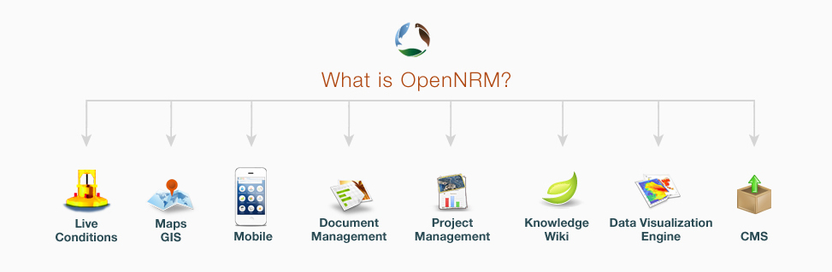

1. OPENNRM is more than a mapping technology. Our agile development strategy has taught us that while data intensive interactive map viewers are vital tools for resource managers BUT users ultimately need more. As a result we have developed a platform that is map centric, yet includes critical workspace modules for comprehensive workflow. The modules include: Asset management (4.0), Content management, project management, wiki, data visualization tools, graphing engine, social components (groups, profiles, following, sharing and more), dashboard template engines and real time data tools.
2. OPENNRM architecture allows for easy modification of software modules in an every changing workflow environment. The future of resource management is being defined on a daily basis and OPENNRM embraces this reality with AGILE development practices.
3. OPENNRM is an easily accessed system that allows free and easy sharing of data sources, geographical and other, statistics, reports, data and documents capable of being shared and utilized on the plane of a map with other access points. Access can be assured confidently from the core framework.
4. Data Management, Accessibility and Syndication: Aggregate and organize data and information: The emergence and evolution of a number of techniques have created new levels of expectation for data sharing websites and applications. The prevalence of RSS as a means of syndication, as well as the increasing use of open standards such as OWL, RDF and REST are allowing software developers to leverage these advances to create sophisticated data sharing consumers and producers. The OPENNRM flexible framework is consistent with these advances in technology.
5. OPENNRM provides a content management system to allow users to manipulate content stored in an object-oriented database.
6. The content storage allows for redundant mechanisms to import and export data with the single goal of data sharing: OWL, RSS, JSON, CSV, netCDF. Maximizing interoperability with other RSS/XML based distribution channels.
7. The OPENNRM content directory publishes every object and data type in the database as RSS feeds and JSON arrays. The directory may be queried through the OPENNRM framework or optionally through a REST interface so that content may be consumed independently of the User Interface.
8. The OPENNRM framework embeds an RDD feed reader and may consume any content that provide RSS, GeoRSS or JSON feeds.

The OPENNRM framework is geographically enable via GeoRSS and JSON to enable filtering of content channels based on selected regions, areas of responsibility, hot spots, presets etc. using the mapping interface. Searching geographically for geo-coded information is enable for all object type extending the map to include document libraries, project database, data, visualizations, wiki knowledge bases, publications or whatever file type related to a specific location. This feature supports simple and robust construction of common operating pictures, adaptive management scenarios, regional management cyberinfrastructure, workspaces and project collaboration tools.

1. Software development is no longer hierarchical. Instead, software is best implemented like a web or collections of hubs that create a larger whole. OPENNRM modular design embraces this concept and makes it possible for us to develop custom dashboards, interfaces and products quickly and easily. It also makes it possible for you to deploy instances for various end-users that can easily communicate with other OPENNRM instances.
2. Experience. 34 North has years of experience working with the following companies to create collaborative workspaces to solve large environmental issues: USGS, NOAA, USFWS, NASA, NSF, USBR, DataOne, Earth cube, OpenGEO/Boundless, Oak Ridge National Laboratory, California Department of Water Resources, NGO’s, Agriculture, private agencies etc. We deeply understand the challenges that come with bringing groups like this together.
3. **Configurable Dashboards:** Create Common Operating Pictures, Dashboards, Regional Views, Project Views, User Views or any combination of data necessary. The OPENNRM concept of dashboards is supported by an extensive templating system for building data pictures using ALL object types (documents, images, videos, visualizations, graphs, interactive maps, knowledge base). The templates can include interactive maps and visualizations (or series of maps and visualizations, photos, videos, document libraries, project pages, resource lists, knowledge base references (e.g. species, operational procedures, definitions, water quality objectives etc), team members, real time station data. Data stories are constructed using various tools including the document library, project collaborator, map services etc. and then these stories are combined to create data stories at different scales.

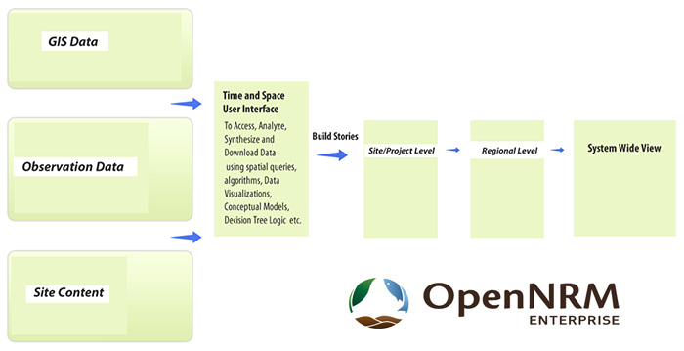

1. **Open Source.** Although current implementations of OPENRM are licensed to clients under the GPL V3 open source license we are preparing for GITHUB release of OPENNRM modules in the next 6 months.

ESRI POINTS

1. Geodatabase and shapefile are proprietary formats. Need Arc Map to open them.
2. Scaling is expensive with ArcServer.
3. You will need more than a map.

Interesting Case Study NOAA. Most of NOAA use the same open source stack as OPENNRM. Specifically their Emergency Response Program.

<http://boundlessgeo.com/case-study/noaa/>