Metropolitan Water District of Southern California
TASK ORDER
Task Order No. |  | Agreement No.
Consultant | 34 North
Authorized Classifications/Individuals | See Attachment A for approved fee schedule
Authorized Sub-Consultant(s)/ODC | None
BDL Constituent Tracker Data Collection Enhancements, Drought Emergency Monitory, X2 Tracking, Incorporate Pilot Level Testing of Salinity Profiling Equipment aimed at making Dynamically-Based Predictions of X2
BACKGROUND
BDL is a web based scientific data hub tool designed through a collaborative effort serving scientists, regulators, policy makers and agency managers interested in Delta specific projects. The BDL data portal and its’ supporting components provide Delta Scientists and agency managers with in-depth analysis of Delta conditions and management information. By synthesizing hundreds of remote and localized data sets and web services, users can develop a common operating picture to support water management issues. Data products include operations dashboards, analytics, live conditions data and a GIS mapping infrastructure and document management capabilities.

OBJECTIVE
Use the BDL infrastructure along with the Constituent Tracker program to educate how the delta really works by supporting USGS (funded by the State Water Resources Control Board) in communicating real time water quality data results. Specifically target to the emergency drought monitoring, turbidity conditions, and salt fluxes.

In kind funding provided by USGS, USBR, DWR, and the SWRCB. USBR, DWR, and SWRCB are currently funding the USGS and the Center for Watershed Sciences to add additional real-time water quality monitoring stations to the existing monitoring network.

SUBTASK 1 INTEGRATE ADDITIONAL REAL TIME MONITORING STATIONS INTO THE CONSTITUENT TRACKER DATA ASSIMILATION MODEL
Consultant will update the CDEC lookup table and add new stations to the Explore Data Section of BDL giving higher station resolution and extent to the Constituent Tracker to aid USGS in monitoring for drought, turbidity and food web conditions.
Additional Drought Monitoring Stations (figure 1):
- X2 STUDY STATIONS: CM16, CM19, CM24a, CM31, CM5, CM10, CM13
- DROUGHT STUDIES: CM18-SJ, CM25-SJ, CM22, RIO
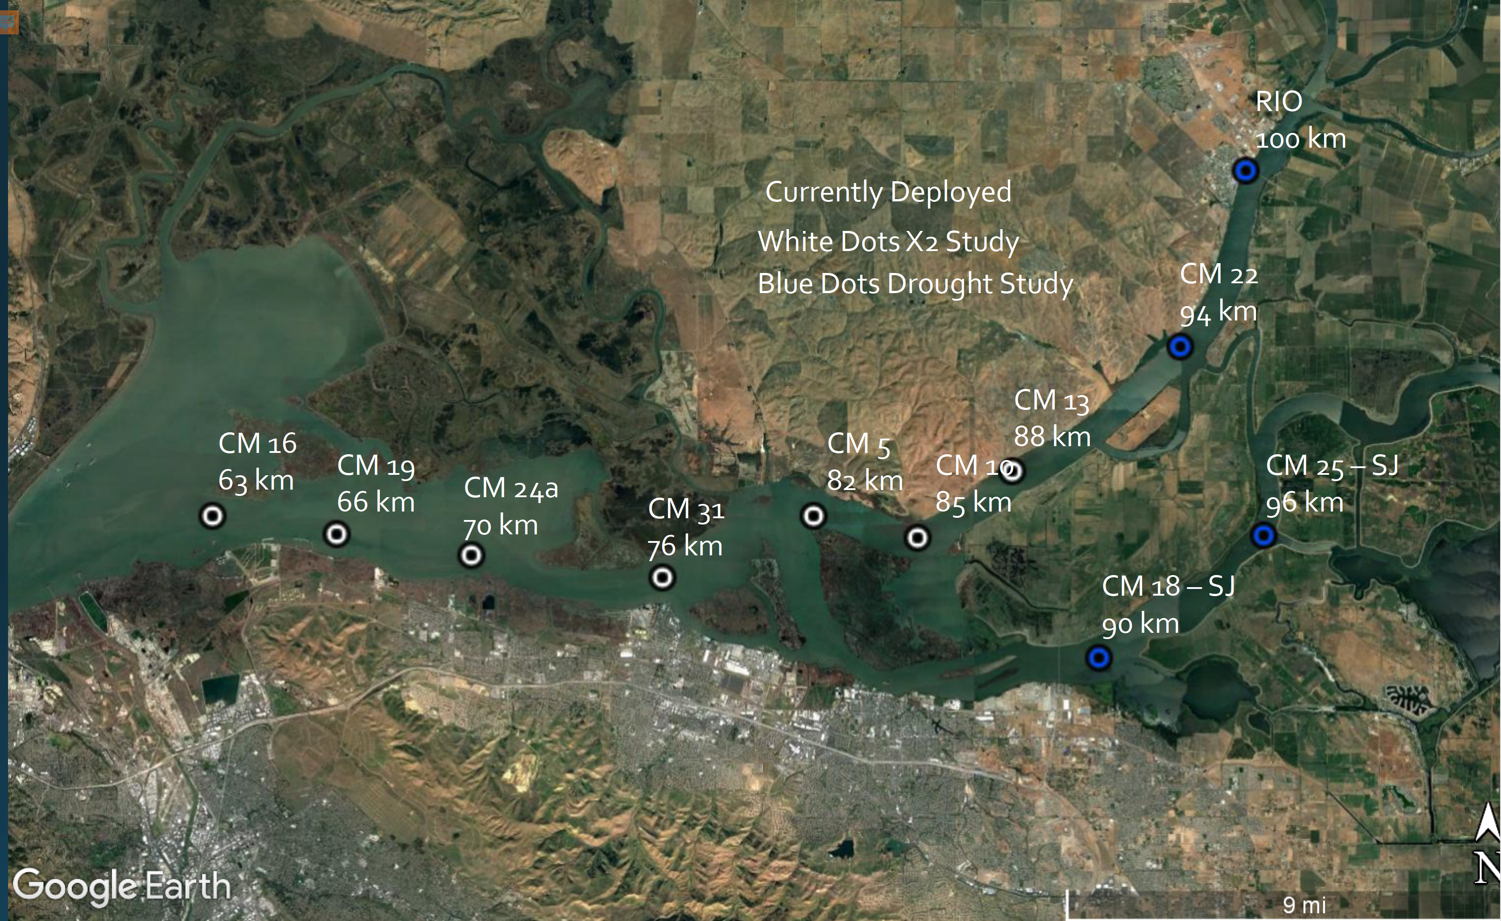
Figure 1: Additional Drought Monitoring stations current being added by USGS with funding provided by DWR, USBR, and SWRCB.

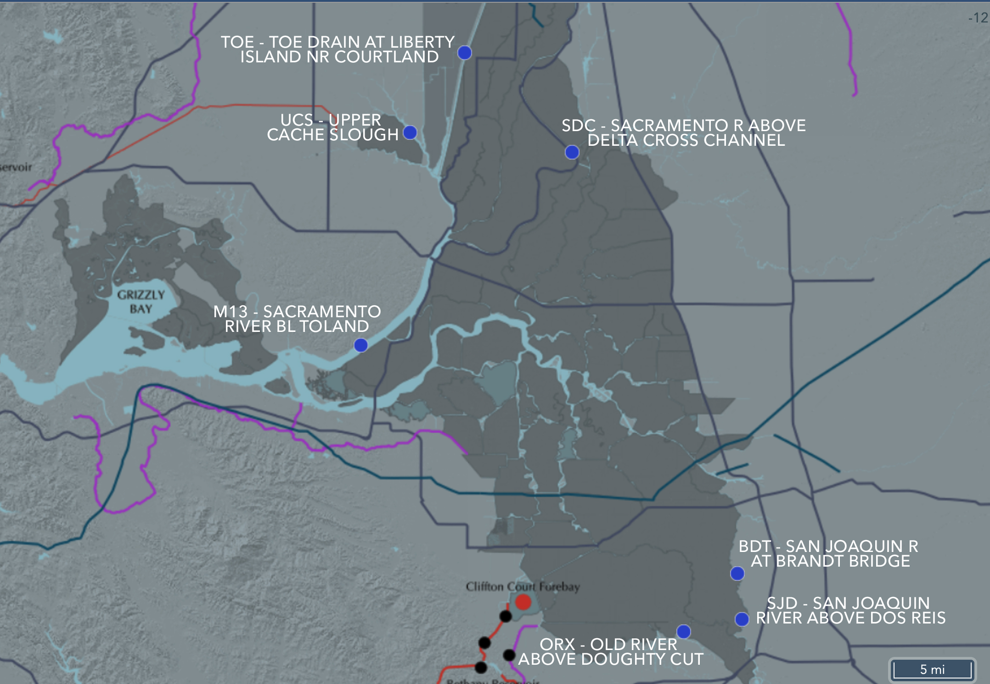
Additional Stations across the Delta paired with Velocity / Electrical Conductivity & Turbidity stations: M13, SSI, UCS, TOE, SAL, ORX, OLD, SJD, BDT, SDC (figure 2). These stations will ad needed constituent data resolution.

Figure 2: Additional stations that are pair with Electrical Conductivity / Turbidity and Velocity

DELIVERABLE(S)
Updated station list enabling consultant to add this new data to the model configuration for the Turbidity and Electrical Conductivity Constituent Tracker.

SUBTASK 2 DELTA MODEL GRID ADDITIONS FOR THE CONSTITUENT TRACKER
The added stations for drought and X2 monitoring are located west of the confluence and thus out of the existing gridded network. Consultant will add existing grid cells down the Sacramento River and San Joaquin River into Grizzley Bay to cover the west most station C16. The Delauney Triangulation method is the only option for delivering adequate performance over a web-based environment. Consultant will convert the existing grid to the Delauney Triangles reducing the indices count by approximately 25%.

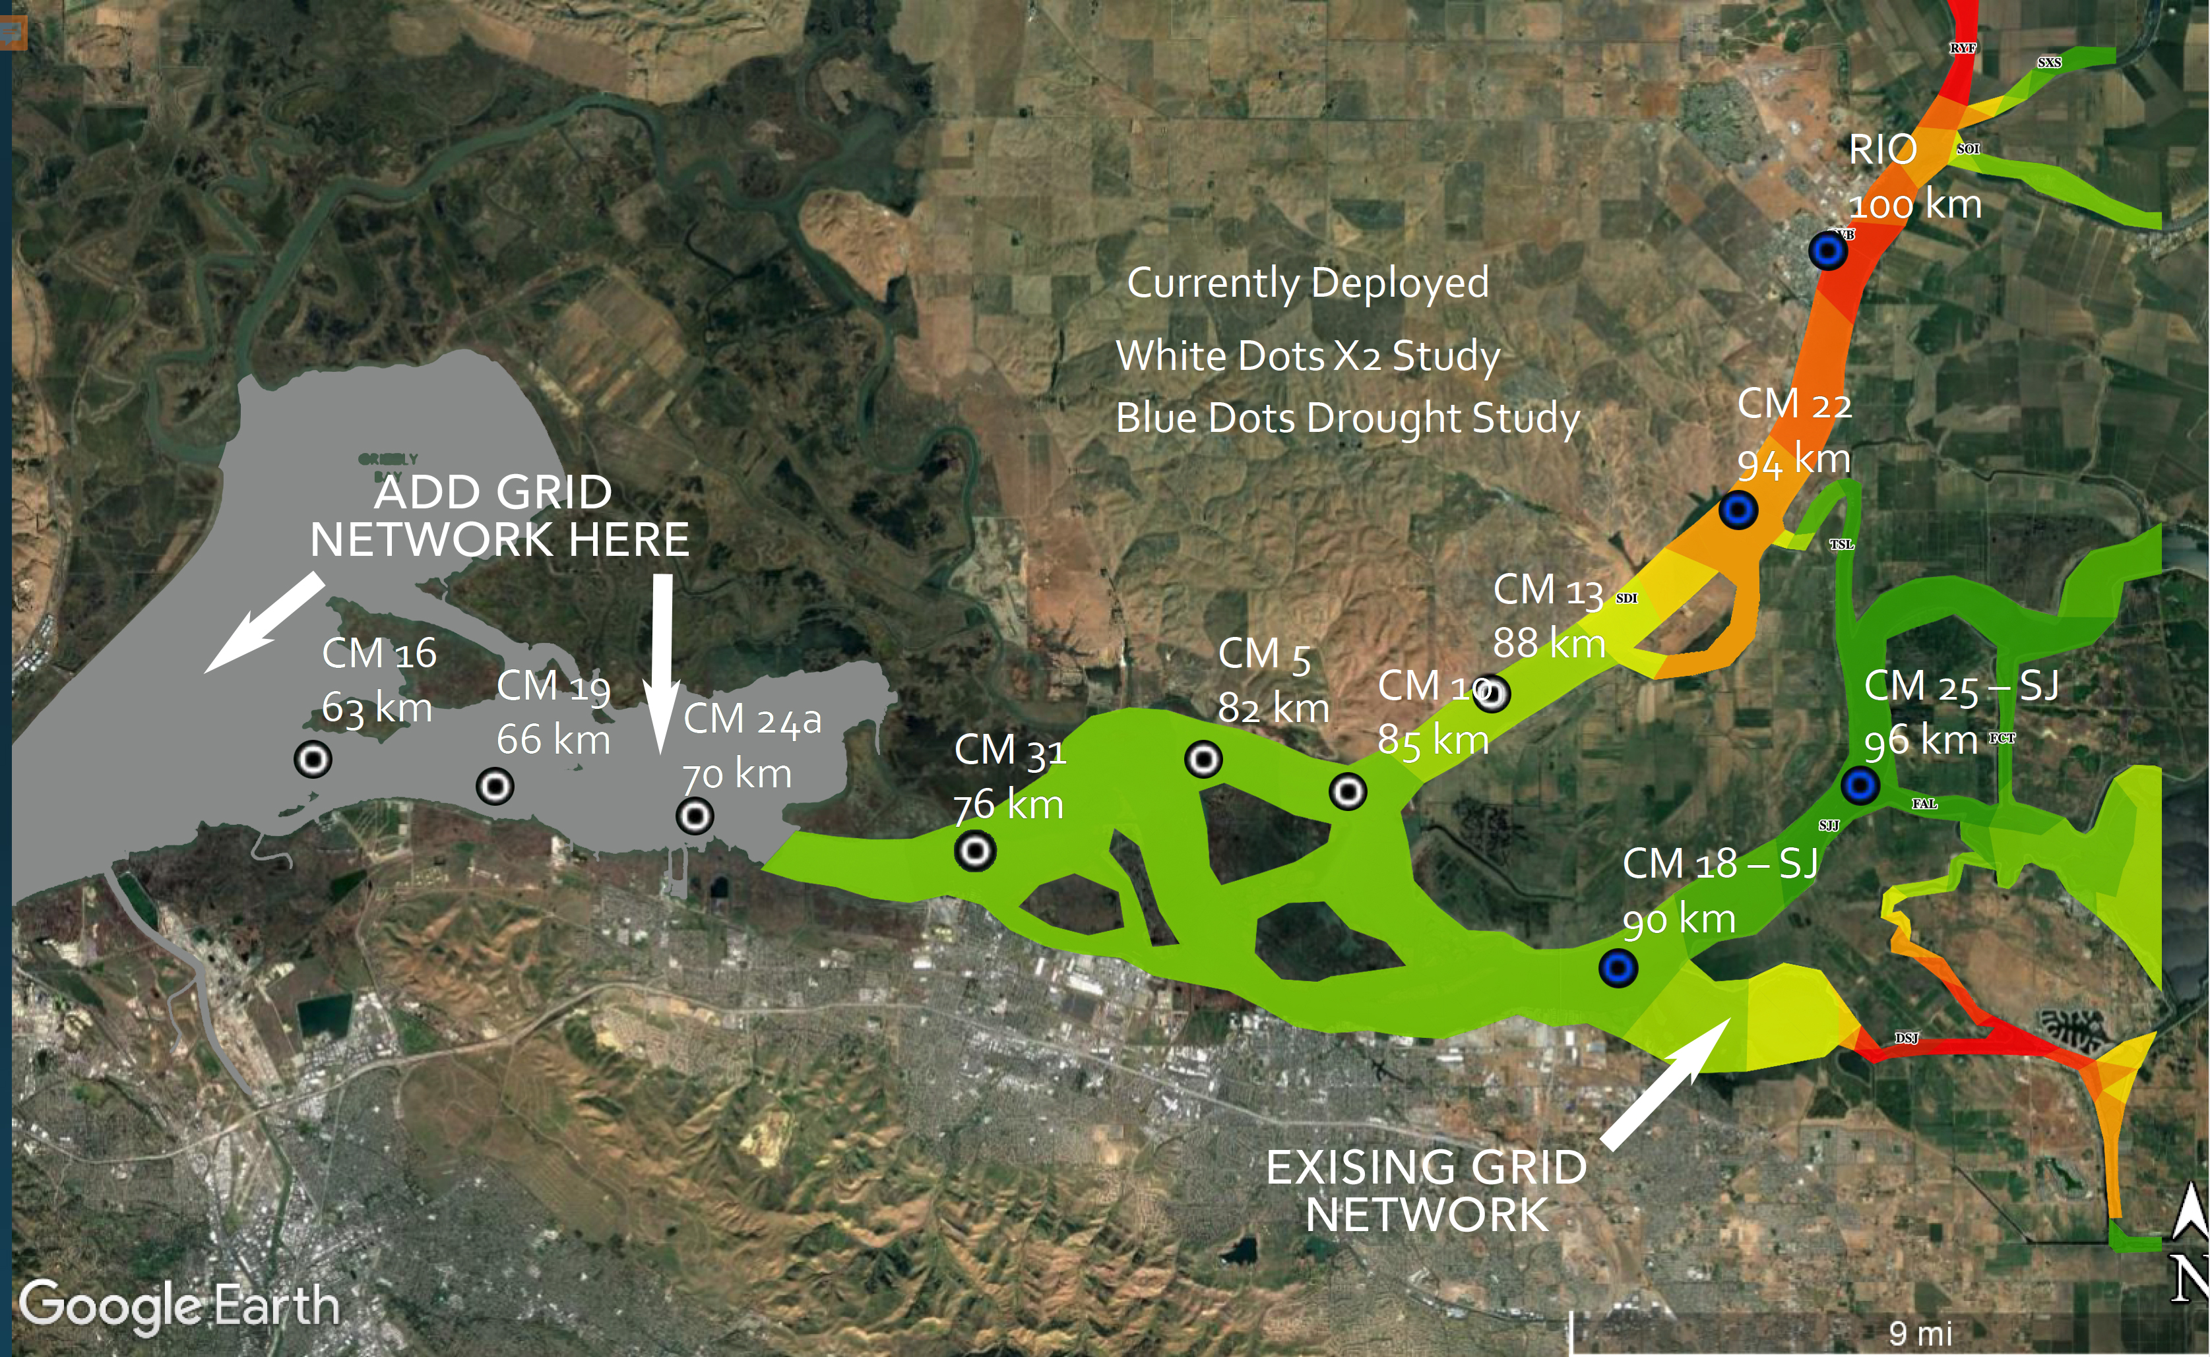
Figure 3: Map of existing grid extents and new stations added for the Emergency Drought. Image Courtesy of USGS.

DELIVERABLE(S)
Update model GIS grid to increase performance and extents to cover new stations.

SUBTASK 3 RUN WEIGHTS PROGRAM WITH THE ADDED STATIONS
Adding new stations and grid extents requires an updated weights file to properly calculate values across the grid cells. Consultant will run the RMA Weights program for both False River Barrier configurations, upload weights file and built new model versions for both Electrical Conductivity and Turbidity data assimilations on BDL.

DELIVERABLE(S)
Update weighted grid reflecting new station list and grid extents. This will accurately linear interpolate real-time station data across the gridded network. Consultant will build new models with the updated grid, station list and weights file for both EC and Turbidity.

SUBTASK 4 SPLIT SAN JOAQUIN RIVER AT THE MOKELUMNE JUNCITON TO REFLECT REAL WORLD CONDITIONS WHEN THE TWO RIVERS MIX.

Based on hydrodynamic, water quality and acoustic telemetry fish tracking observations and study, USGS would like Consultant to split our grid to reflect a hydrodynamic scenario in the San Joaquin River at the junction of the Mokelumne River and downstream to Threemile Sl. As seen in figure 4, when the Mokelumne River empties into the SJR there is a considerable stratification of turbidity values across the SJR. Our current grid does not reflect this separation of water quality values as the two rivers join. The grid mixes the values immediately as the Mokelumne R. empties into the SJR as shown in figure 5. This figure shows the advection algorithms’ particle tracking. The particles transfer their values onto the grid. A separation of the grid will also direct the particles for each river into separate sections.
Consultant will create an appropriate separation in the GIS grid to reflect the real-world stratification scenarios.

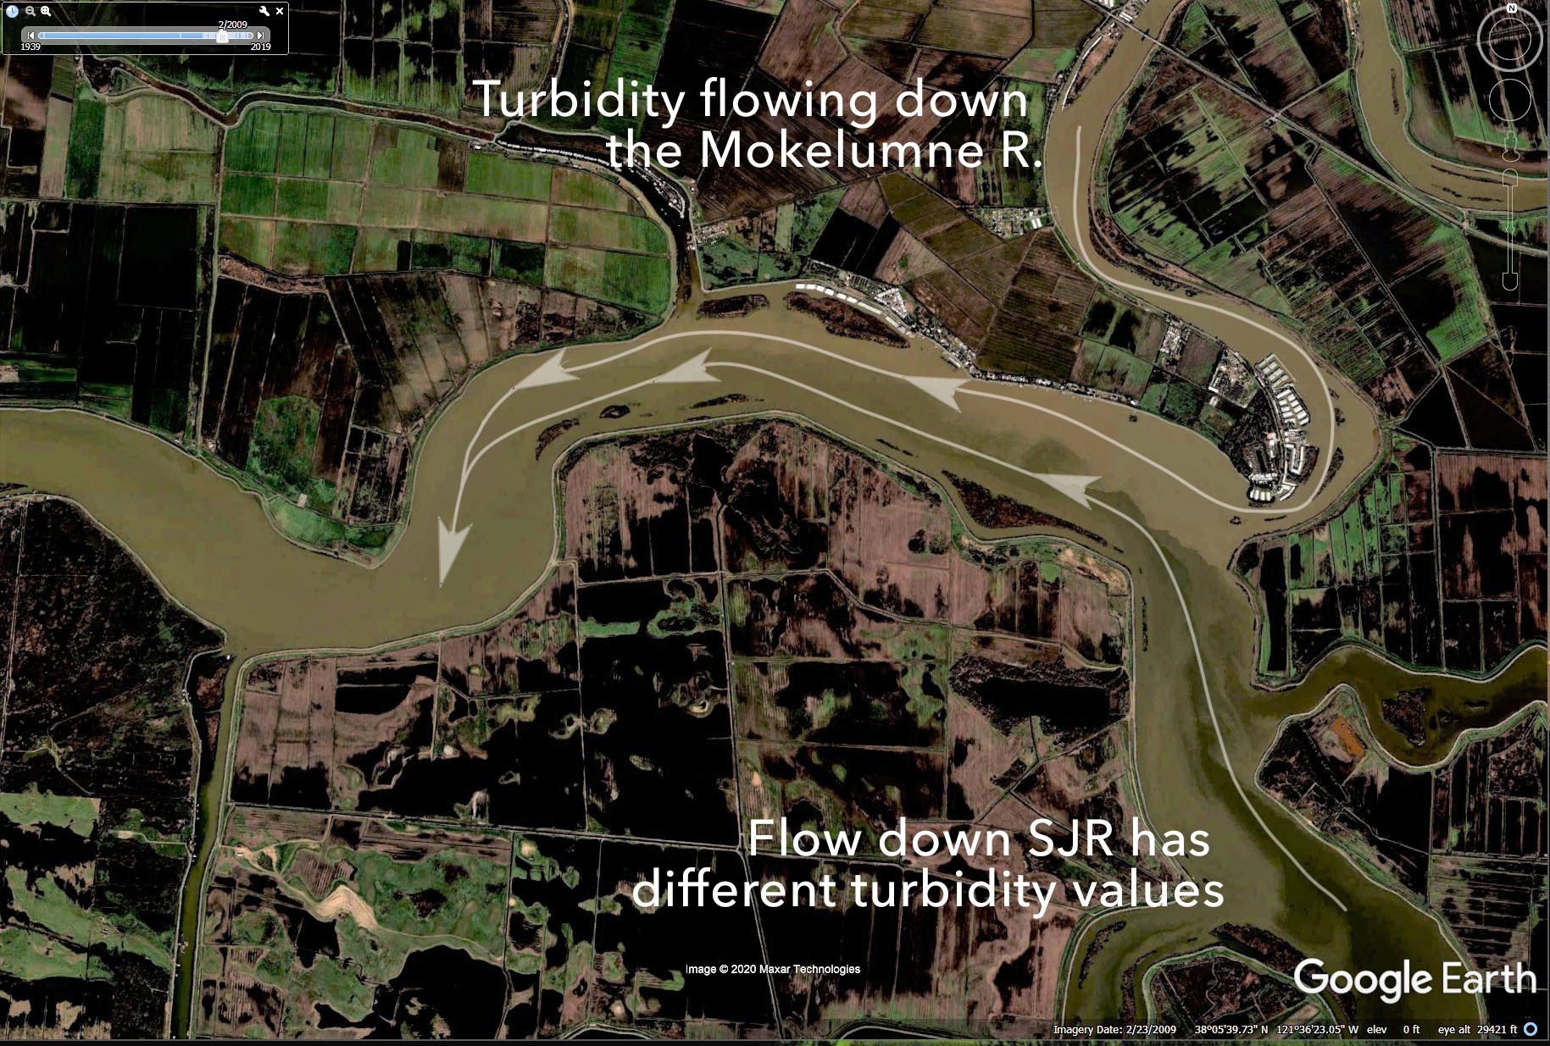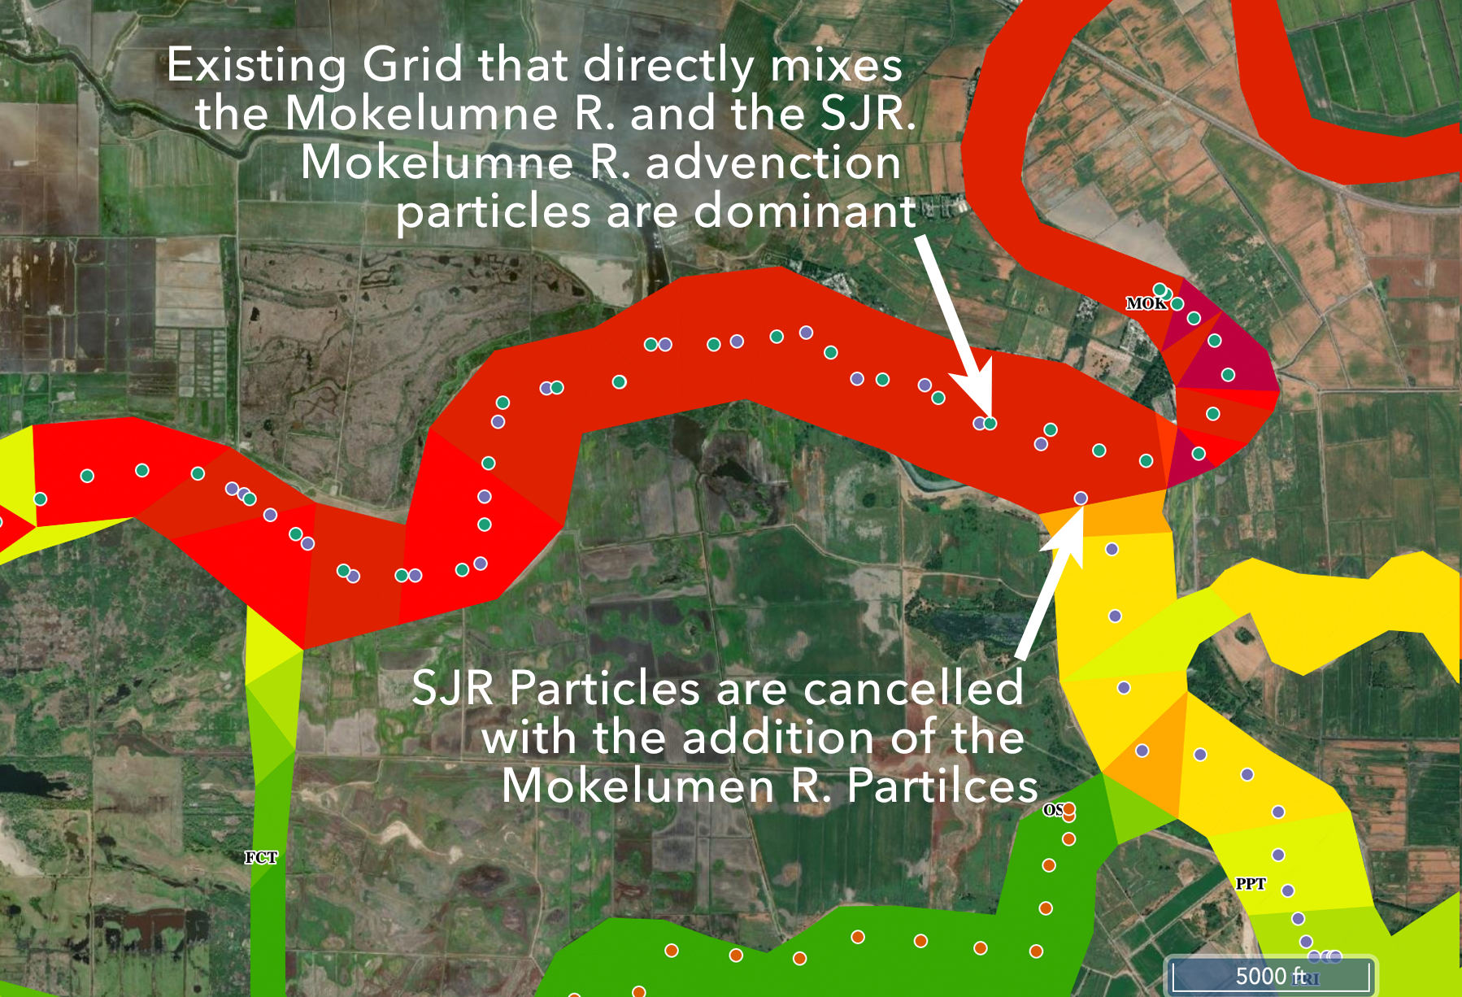
Figure 4: Satellite image of different turbidities. Figure 5: Existing grid and advection particle tracking does not account for Mok R & SJR stratification OR tidal excursions stratifications of WQ contributions from Threemile Slough. Images Courtesy of USGS.

USGS is requesting help explaining how the Sacramento Delta works regarding the changing hydrodynamics and water quality conditions to scientists, engineers, managers and stakeholders. Modifying the grid from the Mokelumne R. down to Threemile Slough will also aid the education of tidal action and the influence of Threemile slough as it joins the San Joaquin River (figures 5, 6 & 7).

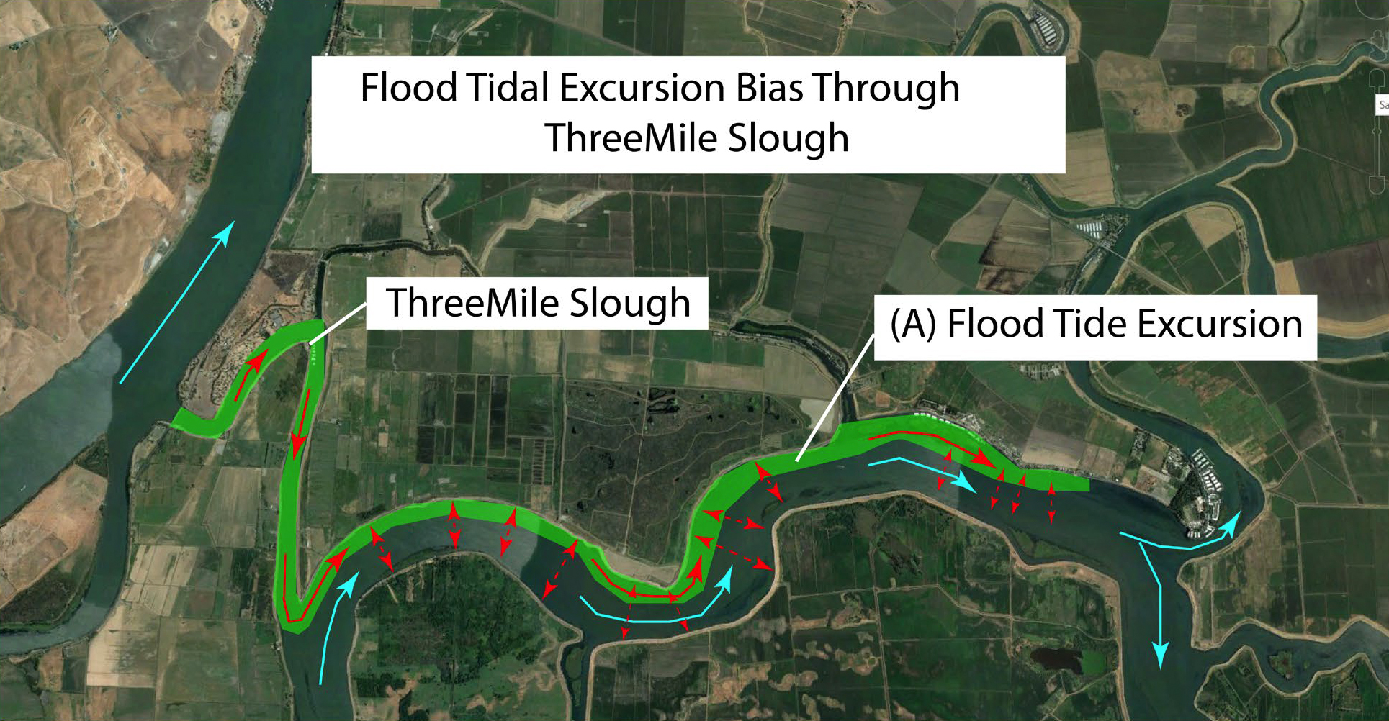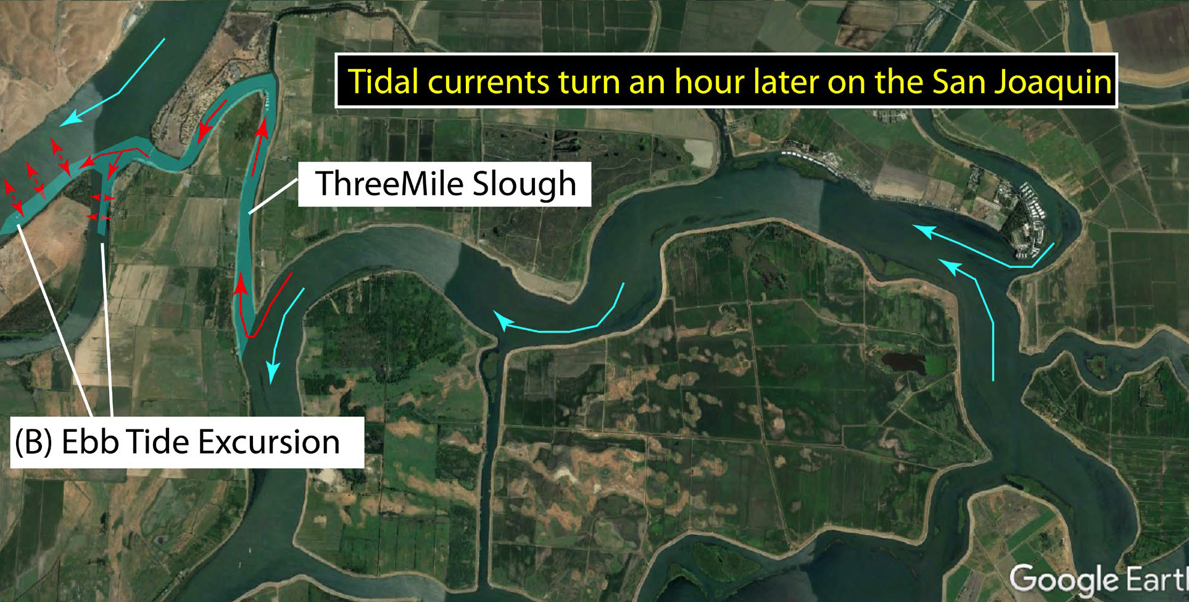
Figure 6: Flood tidal excursion bias through Threemile Sl. Figure 7: Tidal currents turn and hour later on the SJR compared to Threemile Sl. Images Courtesy of USGS.
DELIVERABLE(S)
The modified grid and particle tracking locations will reflect real world conditions at key river junctions and bodies of water for both the Turbidity and Salinity CT models. These modifications will enable users to better understand the complexity of Delta hydrodynamics.

SUBTASK 5 ASSIST USGS (FUNDED BY SWRCB) TO ACCURATELY VISUALIZE X2 POSITION MEASUREMENTS
Jon: What are the data options to view cross section data? Should we just shoot for map based visualizations or attempt a cross section visualization?

This subtask will support a USGS study (funded by SWRCB) to accurately measure the position of X2 and conduct pilot level testing of salinity profiling equipment aimed at making dynamically-based predictions of X2 by providing map based and graphic cross sections of this data. This project will directly support data management and reporting to managers for the continued drought emergency.
Option 1: Consultant will design a user interface to visualize bottom and side looking ADCP data (figure 8-9) on the BDL platform. Consultant will apply modifications to its’ existing code base to dynamically access and visualize river cross section data.
Option 2: Using the Constituent Tracker and Advection algorithm infrastructure, Consultant will plot ADCP data using the Velocity Particle Tracker to estimate X2 position along the Sacramento River cooridor. Particle metadata will include a timestamp, Electrical Conductivity value, velocity at the time of recording, and distance the particle has traveled. Using this this technique along with consultation from USGS, Consultant can map and track X2, the Low Salinity Zone (LSZ) and the Estuarine Turbidity Max (ETM) using our map-based interface and the USGS advection algorithm.

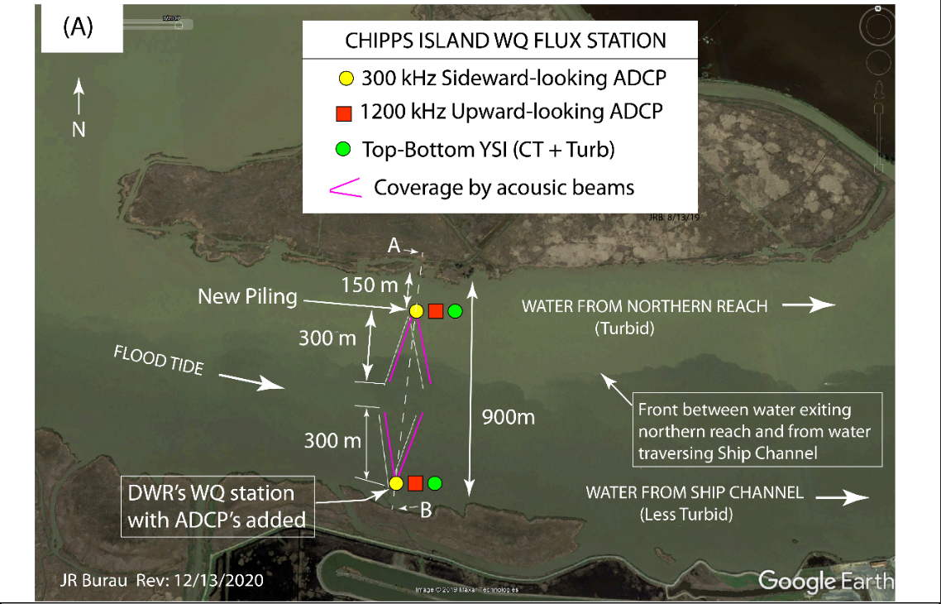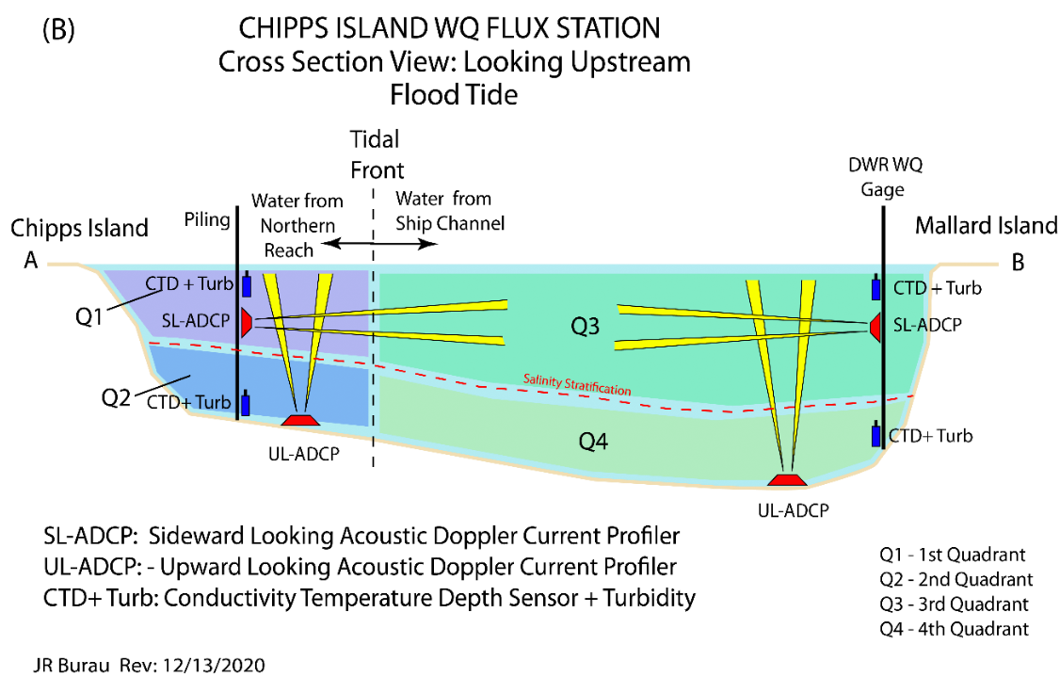
Figure 8: Plan view of ADCP locations. Image Courtesy of USGS. Figure 9: Cross Section of Side looking and Upward looking ADCP’s. Image Courtesy of USGS.
The aim of the joint project between SWRCB and USGS is to make dynamically-based predictions of X2. The goal of this subtask is to create web-based visualization techniques to help USGS and the SWRCB visualize the data allowing for real time analysis.
Linkage to Fall Flow Action: Utilizing the added data network, this subtask could also track the Estuarine Turbidity Maximum (ETM) (figure 10).
X2 or 2 psu is the convergence (Null zone) of the biological maximum and the turbidity maximum also known as the Estuarine Turbidity Maximum (ETM). The ETM in a tidal strait is not a constant, steady value. The center of mass moves coherently in response to tidal energy, stratification, and gravitational circulation (Ganju and Schoelhamer, 2008).

USGS has expressed they want to utilize the BDL infrastructure to report this data back to SWRCB as well as add these data visualization results to their monthly reports to the drought monitoring task force.

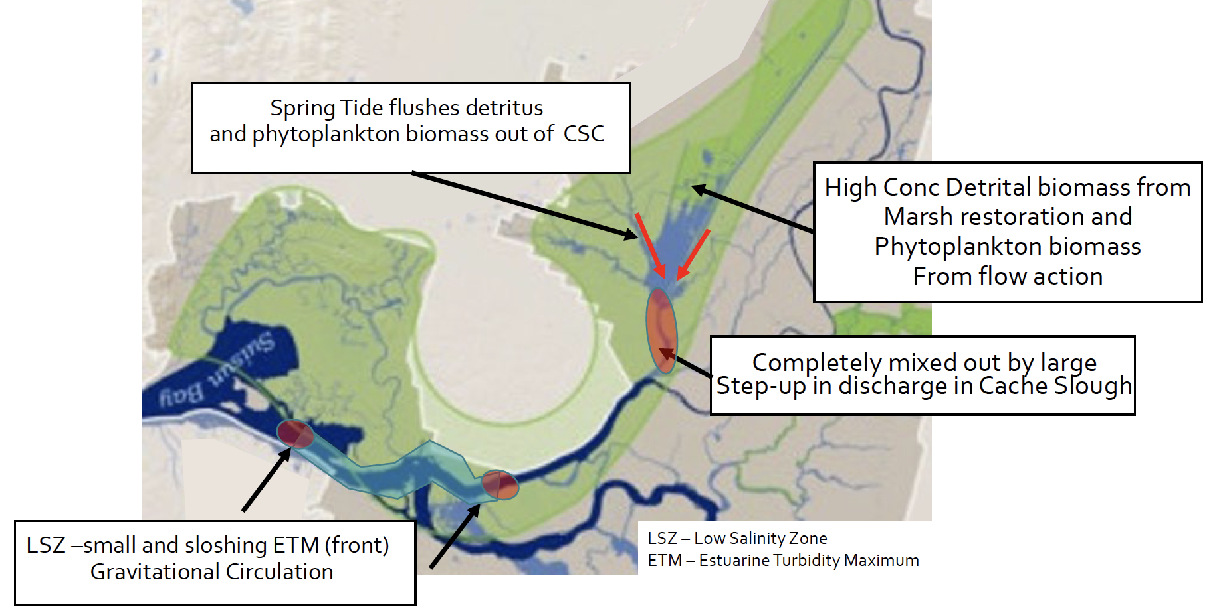
Figure 10: Export of negatively buoyant materials from cache slough complex is severely diluted as it transits Cache slough. It is re-accumulated in the ETM. Image Courtesy of USGS.

DELIVERABLE(S)
Data visualizations using side looking and upper looking ADCP data to show cross sectional data for top and bottom electrical conductivity and velocity profiles.

SUBTASK 7 Analyze Flow Data to Interpret Anomalies to Serve as a First Alert to Guide Response to Levee Failure
Working with USGS, Consultant will customize existing code and embed an algorithm provided by USGS to analyze anomalies in flow, discharge data across the Delta. This task could potentially be used to alert managers to possible levee failures. Consultant will ingest data provided by CDEC on a 15 minute schedule, run the USGS algorithm and create an email notification system to send an alert back to USGS managers to analyze the data.
Limitations: Due the frequency in which data loggers are updating CDEC (15 minutes to 1 hour intervals), this system should not be used as true emergency management system. However, it should serve as a test case of data infrastructure and the use of using data and BDL to analyze data streams that can trigger an email notification. If, in the future, BDL is giving access to more timely data, this system could serve as first alert system.

DELIVERABLE(S)
Consultant will implement an algorithm provided by USGS to analyze anomalies in flow, discharge data and create an email notification system to alert select users when a flow anomaly is triggered at specific station location.

SUBTASK 8 ADVANCED EXPLORE DATA AND GRAPHING CAPABILITIES
USGS has indicated that their staff is using BDL and it’s dashboards and data assimilations to access their station network. NWIS and CDEC are very efficient at providing data, however the web interface does not easily allow for data investigation and discovery. BDL has a unique opportunity to provide a custom experience for USGS and be the preferred web interface to access the USGS real time data network for the staff at the Center for Watershed Science. This network is funded by USBR with an annual budget of $XXXXXX for data networks. With emergency drought funding for new stations in the amount of $XXXXX.
They have requested 34 North upgrade our Explore Data workflow and user experience when accessing, graphing and downloading data for further analysis.
The graphic below (provided by USGS) is a draft example of how they would like to upgrade our workflow.
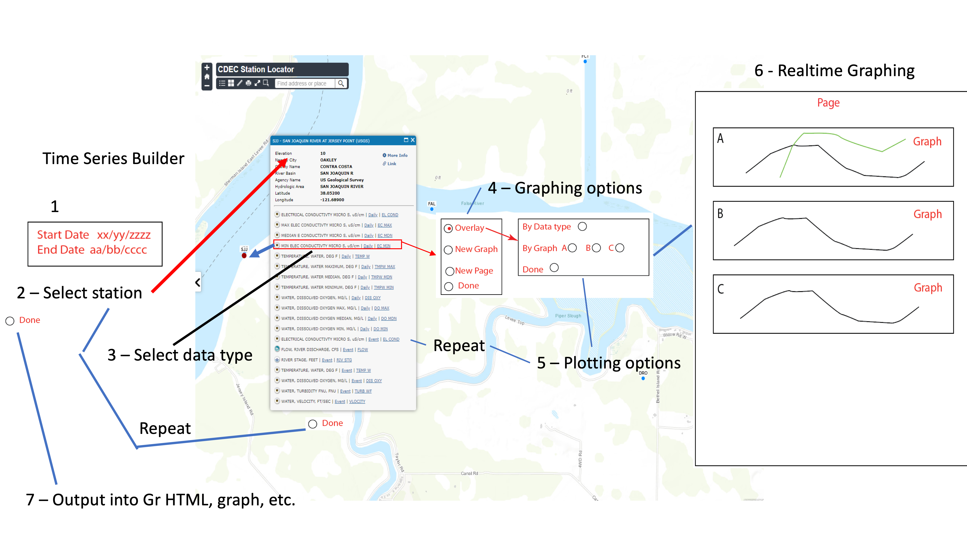
Users would like the flexibility to use the map interface to click on stations and load different sensor types directly from the station roll over. Consultant will upgrade the graphing interface to better serve the user’s needs. Such as targeting which graph container to load and overlay different sensor types.

DELIVERABLE(S)
Consultant will upgrade its’ existing Explore Data tools and enhance the user experience per requirements provided by USGS. Upgrade station roll overs to access all sensors and load data directly from the roll over and send data into the graphing engine. Upgrade Graph User interface to better target graphing containers. There are currently multiple locations where the user can download data in a CSV format. Consultant will upgrade the UI to better serve the user experience for download locations.

