Dept. of Water Resources/ESA/ICF

*Bay Delta Office Data Management Solutions*

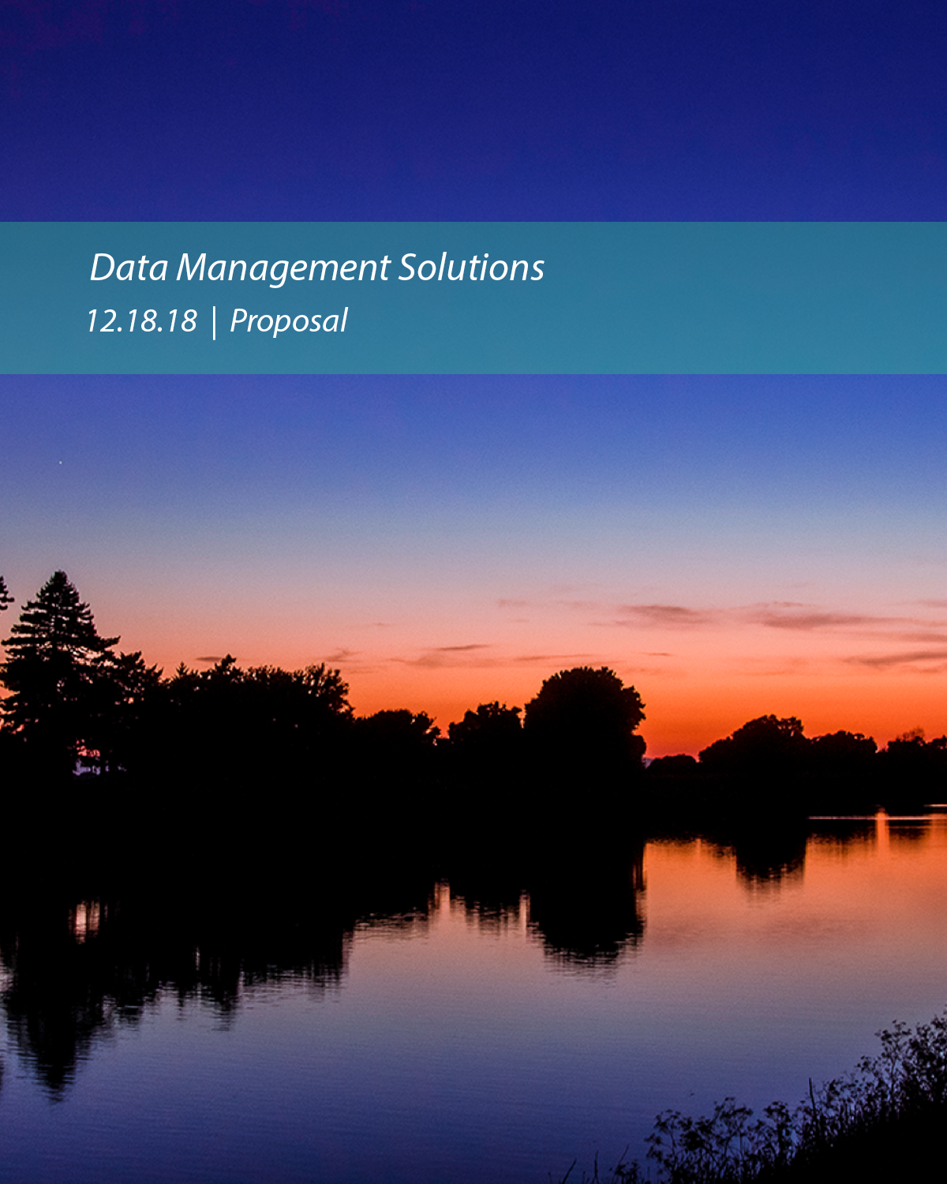

**34 North**

**40169 Truckee Airport Rd, Suite 202**

**Truckee, CA 96161**

**Phone: 530-587-3434**

**Cell: 310-600-5350**

**Chris Fitzer**

**Fisheries Program Manager**

**ESA | Environmental Science Associates**

2600 Capitol Ave Ste 200

Sacramento, CA 95816

Phone: a16.564.4500

**Subject: DWR BDO Data Management Solutions Proposal**

CHANGE BASED ON NEW CONTENT

Table of Contents

Technical Proposal

Cover Letter

Attachment 1: Cover Sheet 1.1

Attachment 2: Required Attachment Checklist 2.1

Attachment 3: Proposal/Proposer Certification 3.1

Attachment 4: Proposer Minimum Qualifications 4.1

4.1: Proof of Proposer’s Qualified Experience 4.1.1

4.2: Proof of Project Lead’s Qualified Experience 4.2.1

4.3: Utilizing SB and DVBE Program Goals 4.3.1