**Does Water Temperature in the San Joaquin River and its Tributaries Support Chinook Salmon (Oncorhynchus tshawytscha) Migration?**

1. Monitoring temperature in the San Joaquin River and its tributaries will help us better understand if conditions support migration and other life stages of the Chinook Salmon. Two San Joaquin River runs (spring and fall) of the Chinook salmon are currently struggling for survival. There are varying reasons for their decline and temperature is one factor.

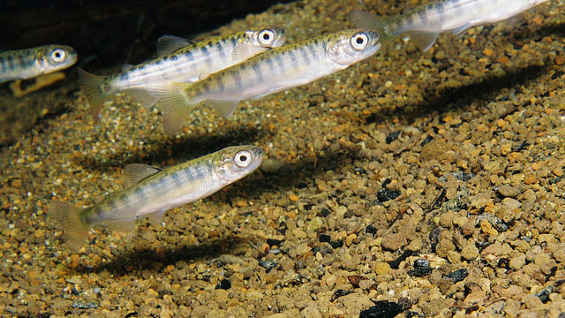 http://baydeltalive.com/docs/7748

### Saved Map

### San Joaquin River Basin

<http://baydeltalive.com/maps/7747>

1. **About the Chinook salmon life-cycle**

Chinook salmon are anadromous, which means they spawn in freshwater, but migrate to the ocean where they remain for their adult lives. After years of living in the open ocean, they return to their natal freshwater streams to reproduce. Females dig nests in gravel- bedded streams called redds where they deposit their **eggs**. After the male fertilizes the eggs, the female covers the redd with gravel. The embryos hatch into larval fish called **alevin** that remain in the gravel redd nourished by the yolk sac of the egg from which they were born. The alevin absorbs the yolk sac and grow, emerging from the gravel as **fry**. (See life stage illustration below) The fry begin their migration downstream toward the ocean. As they to grow, they develop scales and dark vertical bars on their sides called parr markings. At this stage they are called **parr**. Smoltification is a physiological change that enables the fish to adapt from living in freshwater to living in saltwater. At the completion of this process they are called **smolt**. Smolt typically remain in brackish water estuaries as **juveniles** before they move into the open ocean**.**  A**dults** migrate throughout the North-east Pacific until returning to the freshwater streams to reproduce.

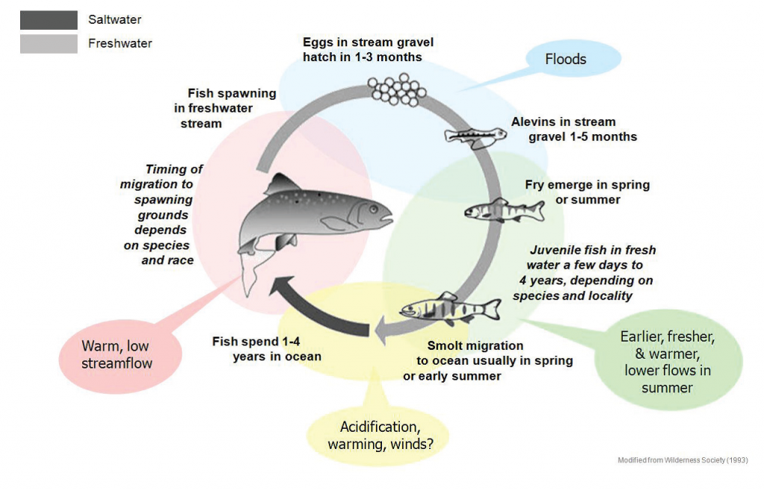

http://baydeltalive.com/docs/7750

The life cycle of a Salmon takes it from rivers to the ocean and back again. At every steps, they face challenges of a changing world, shown in the shaded bubbles. Source: Washington State Recreation and Conservation Office

**Saved Map**

[CHINOOK PACIFIC COAST RANGE](javascript:dispatchPage('',%20'Maps','Map%20Page',%20'Map%20Page',%20%207752);)

<http://baydeltalive.com/maps/7752>

1. **Chinook Salmon and the San Joaquin River?**

There are two distinct runs of Chinook salmon in the San Joaquin River. Runs are designated based on the timing that adults enter into freshwater from the ocean toward their natal spawning streams. Many factors, however, influence the precise timing of the runs such as water temperature, flow characteristics and maturation of the fish.

Fall-run Chinook salmon migrate upstream between September and December. They are sexually mature when they enter freshwater streams and spawn between October and December.

Spring-run Chinook salmon typically migrate upstream between February and May. They remain in cold freshwater habitats while they sexually mature and spawn between August and October.

|  |  |  |  |  |  |  |  |  |  |  |  |  |
| --- | --- | --- | --- | --- | --- | --- | --- | --- | --- | --- | --- | --- |
| **Fall-run** | | | | | | | | | | | | |
| **Life Stage** | **Jan** | **Fed** | **Mar** | **Apr** | **May** | **Jun** | **Jul** | **Aug** | **Sep** | **Oct** | **Nov** | **Dec** |
| Adult Migration |  |  |  |  |  |  |  |  |  |  |  |  |
| Spawning |  |  |  |  |  |  |  |  |  |  |  |  |
| Incubation and Emergence |  |  |  |  |  |  |  |  |  |  |  |  |
| Rearing |  |  |  |  |  |  |  |  |  |  |  |  |
| Ocean Migration |  |  |  |  |  |  |  |  |  |  |  |  |
| **Spring-Run** | | | | | | | | | | | | |
| Adult Migration |  |  |  |  |  |  |  |  |  |  |  |  |
| Holding |  |  |  |  |  |  |  |  |  |  |  |  |
| Spawning |  |  |  |  |  |  |  |  |  |  |  |  |
| Incubation and Emergence |  |  |  |  |  |  |  |  |  |  |  |  |
| Rearing |  |  |  |  |  |  |  |  |  |  |  |  |
| Ocean Migration |  |  |  |  |  |  |  |  |  |  |  |  |

http://baydeltalive.com/docs/7753

### Saved Map, “

### Monitoring Water Temperature in the San Joaquin River Basin

### <http://baydeltalive.com/maps/7745>

1. **Why is water temperature important?**
2. Water temperature is the single most important factor that affects the distribution and survival of Chinook salmon. Chinook are cold water species and respond to small water temperature variations during different life stages. Unlike most mammals whose body temperature stays nearly constant, Chinook are poikilotherms, which mean their body temperature varies with the temperature of their environment; i.e. water temperature.

### 

### http://baydeltalive.com/docs/7756

### B Water temperature affects every life-cycle stage of the Chinook salmon. The timing for spawning and egg hatching are temperature-dependent. Growth, development and metabolic rate are directly influenced by water temperature. The following water temperatures are a compilation of guidelines set by the U.S. Environmental Protection Agency Region 10 and additional information used as criteria for these limits. All temperatures are constant unless otherwise indicated.

### 

### http://baydeltalive.com/docs/7754

1. **Migration**: Adults enter freshwater streams when temperatures are within an optimal range.

EPA Guidelines: Applies during maximum summer time temperatures.

*18°C -*generally in the lower part of river basin*

*20°C *-generally in the lower parts of the river basin where water reaches this temperature naturally, but cold-water refugia are available for fish to escape to.*

\**based on the 7 day average of the daily maximum values*

Considerations

for Guidelines: Lethal Limit *(one week exposure)*: 21°-22° C (69.8 F – 71.6 F)

Migration Blockage and Delay: 21° C (average) 69.8F

Adult Swimming Performance Reduced: > 20°C

Adult Swimming Performance Optimal: 15°-19° C

Reduction in Fitness due to cumulative stresses: > 17-18°C (prolonged exposures)

### 

### http://baydeltalive.com/docs/7755