Organize, Visualize, Collaborate
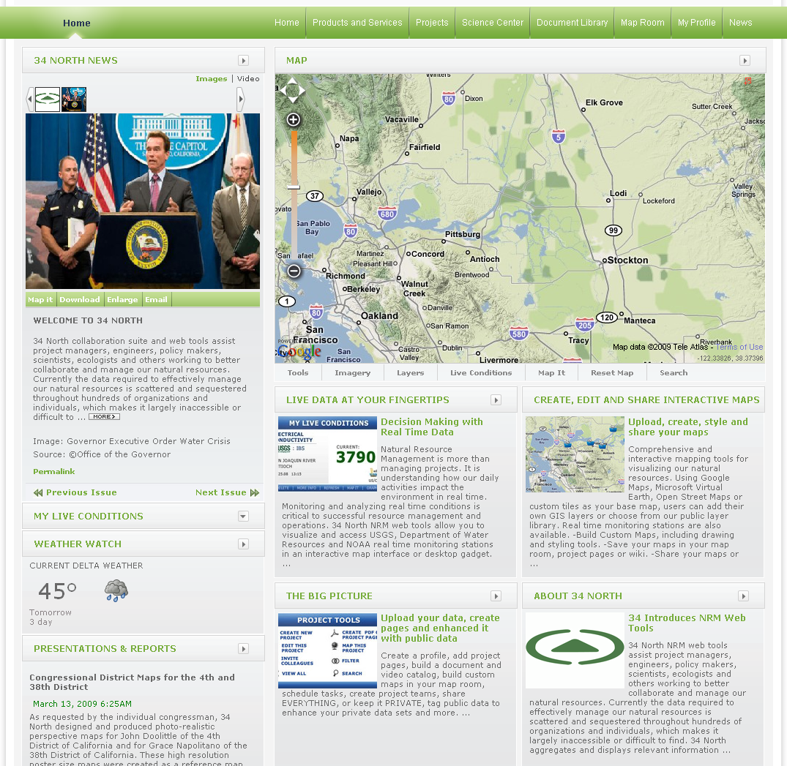
The Challenge
  - Hundreds of stakeholders and interests
  - Information is fragmented, isolated, outdated
  - Data visualization difficult, complicated and in many cases non-existent.
  - Need for a central hub to organize California Delta Resources

34 North Web Tools Solution
  - Allow user to aggregate and organize community knowledge and resources
  - Interdisciplinary cooperation
  - Permissions based data sharing. Make it PUBLIC or keep it PRIVATE
  - Visualize the Delta

Project Management Tools
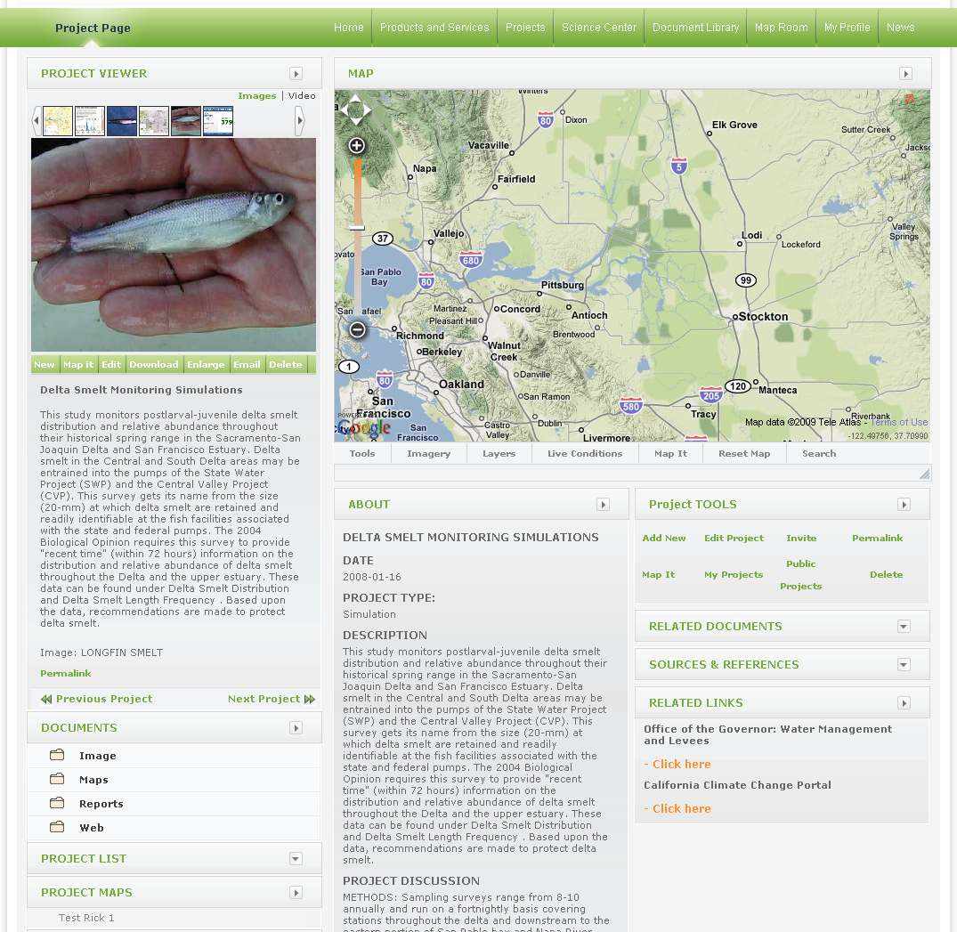
- Simplify collaboration and communication tasks.
- Create and Manage project pages, project teams & maps.
- Post and share documents, meeting agendas, minutes and related materials.
Publish project data for private or public access

Asset and Content Management System
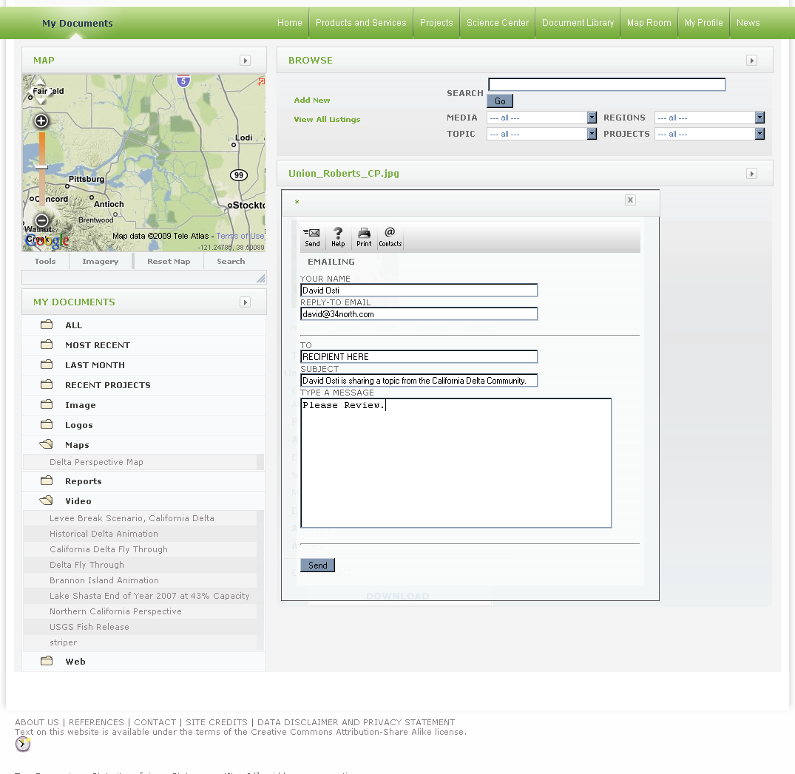
- Single/Multiple file upload capability & assign metadata.
- Supports all popular data formats (image, video and text): .doc, .xls, .jpg, .psd, .kml, .shp, .wmv, .pdf
- Geo-Locate assets.
- Create document libraries.
- Easily assign assets to projects, wiki pages, GIS Shapefiles (parcels etc).
- Share assets with colleagues, project teams, the public or keep private.

Visualize Your Environment - GIS Map Service
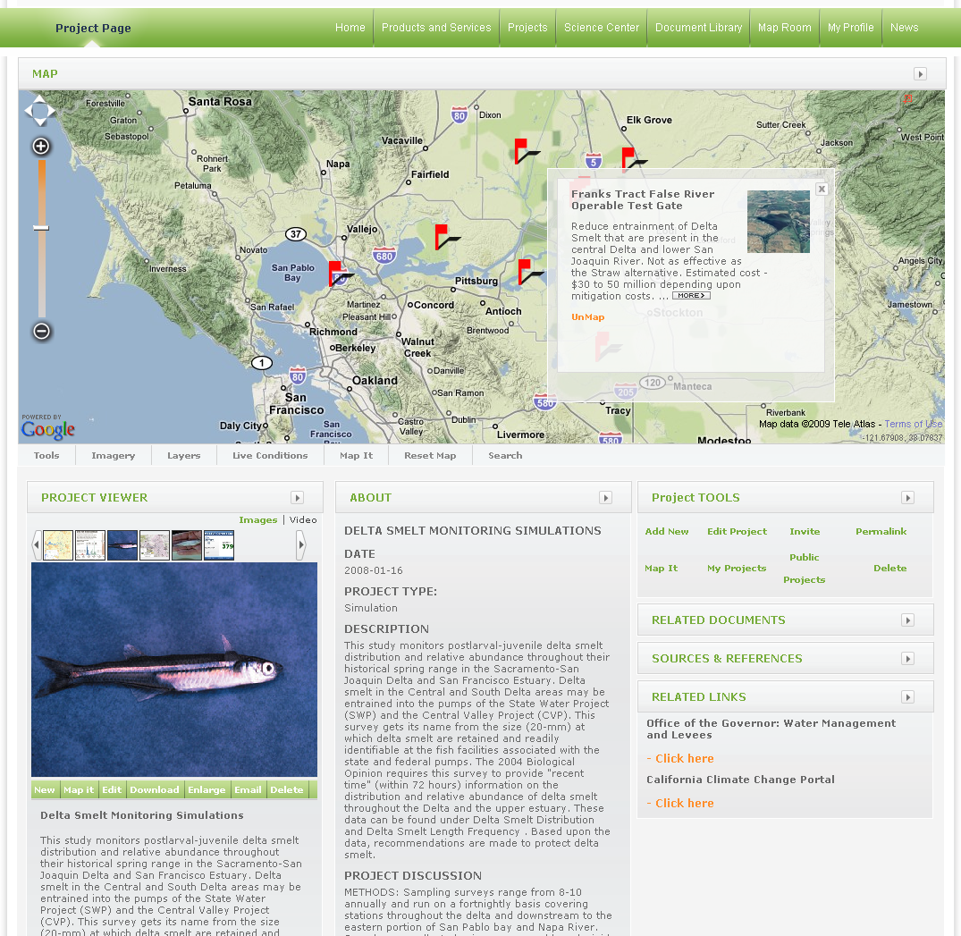
- Comprehensive Tool for visualizing and managing your Data.
- Access geo referenced assets in map view.
- Right click to easily assign new assets to a point, line, polygon or its feature data (upgraded version).
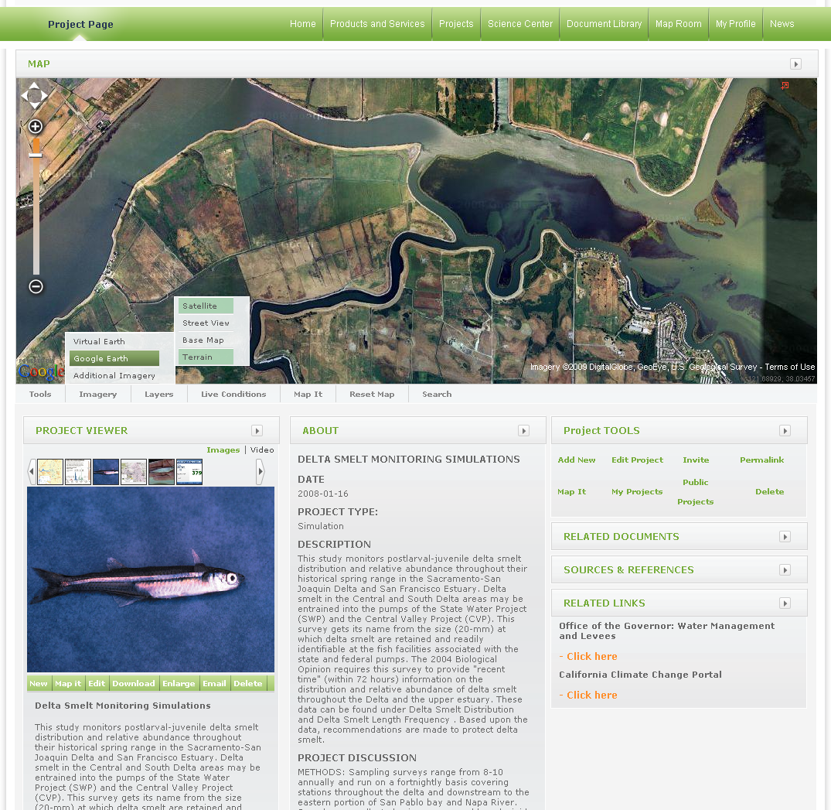
- Access and contribute an unlimited amount of information layers.
- Map Service comes preloaded with more than 120 Delta related data layers from CaSil and other sources.
- Save and share map layouts with your team.
- Customize maps using: Google Earth, Virual Earth, Open Street Maps or custom tiles.
- Export data to 3D environments such as Google Earth, Virtual Earth, & NASA World Wind.
- Visualize Your Environment - Realtime Monitoring
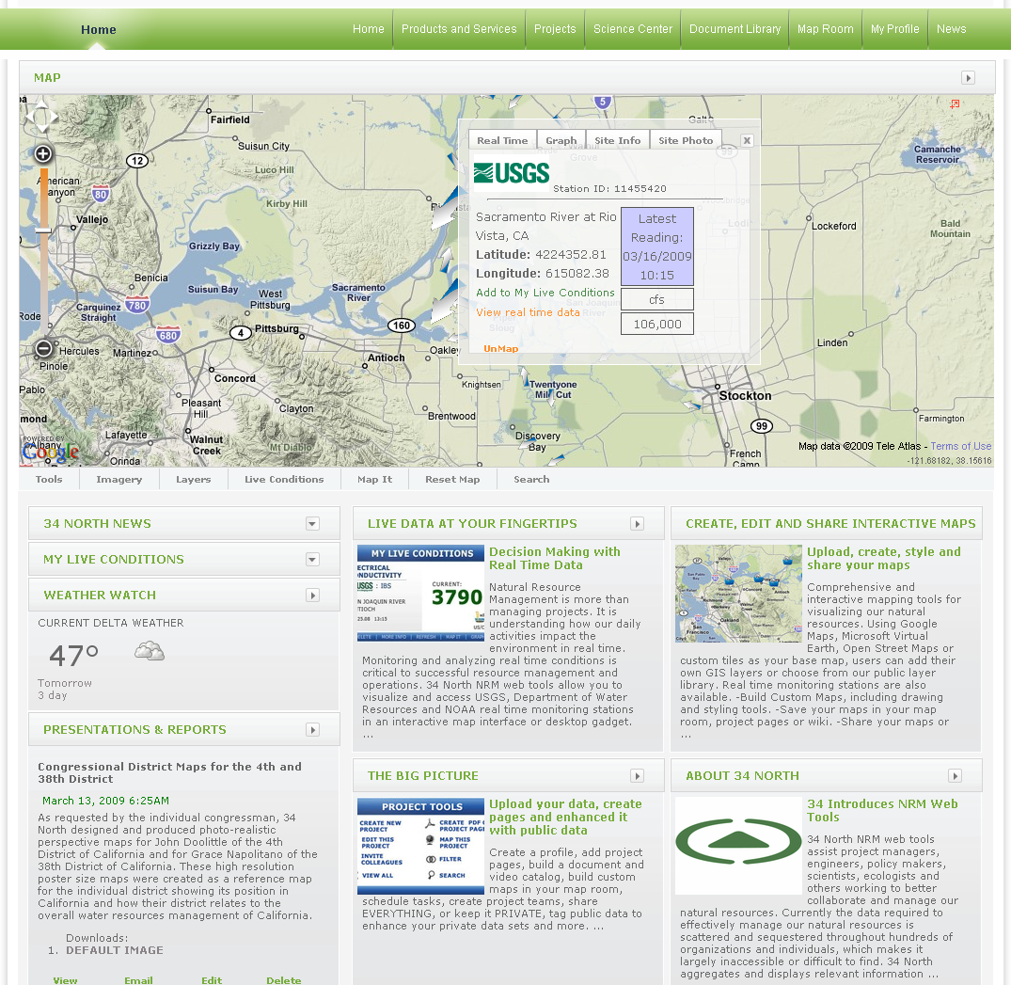
- Access and visualize the California Delta’s USGS, CDEC, DWR and NOAA real time monitoring stations.
- View hydraulic and water quality data including: Turbidity, River Discharge, Salinity, Chlorophyll, tides, weather, water Ph, river height, wind speeds and more…

Meeting your needs
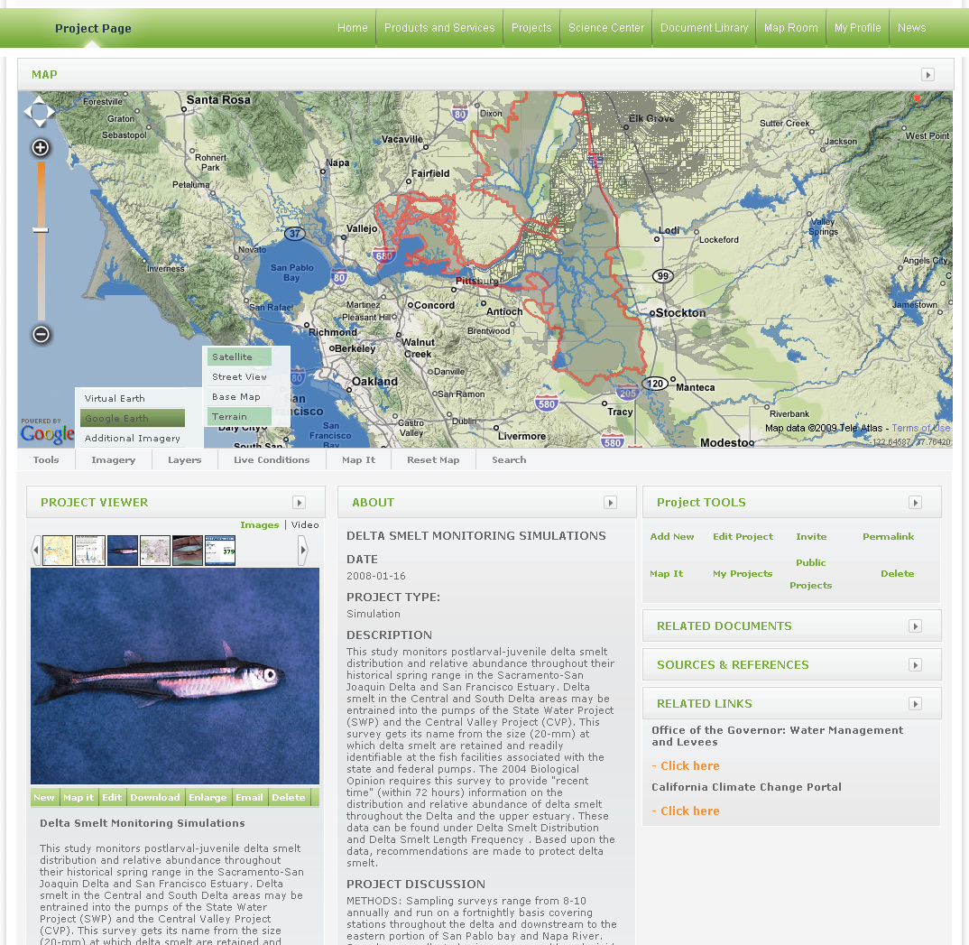
- Aggregates and organizes significant amounts of data
- Allows participants to add and share data
- Create visualization tools for major initiatives including: BDCP, SNCCP, FHCP and Delta Visions.
- Organize and visualize your data to better understand and communicate: existing delta science, water quality, diversions, trawl data, discharges, riparian rights, appropriative rights
- Searchable data and features

- 34 North tools are built using an open source framework to maximize interoperability between existing IT infrastructure and tomorrows application releases.
    - 34 North tools and applications can work with almost all Relational Databases. Our current database architecture uses RDBMS PostgreSQL and PosGIS spatial type.
    - 34 North provides support for DB2, ESRI Enterprise ArcSDE, Oracle 11g, Microsoft Server 2008 (including new spatial types).
    - 34 North can implement multi-user geo databases
    - Ability to support distributed database systems through a combination of data connectors and web enabled databases via query tools serving RSS and GeoRSS feeds.
- 34 North interoperability strategy goes beyond the database to include mobile devices and applications, syndication tools, environmental monitoring stations.

Proposal Overview
- Deltawaterrights.com/Baydeltawaterrights.com is supported by the Baydeltalive.com project.
- Deployed to support small workgroup, additional users or public access will require more server support and increased customer/maintenance support.
- Custom homepage to reflect needs of the group.
- Proposal outlines Deltawaterrights.com LITE version allowing users access to:
    - 1. Content Management
    - 2. Live Mapviewer: Add custom layers, Save and share map views, add point data etc.
    - 3. Spatial wiki
    - 4. Project Organization Features
- Note: Upgraded versions can include: simulations and data visualization features, enhance project management activities (assigning and tracking task, deliverables), Historical Monitoring data, Map Assistant (used for manipulated layer data including colors, labels, transparencies), advanced search techniques
- **See version handout for details
- 34 North Extended Services
- Database integration with existing water rights data sets
- Custom imagery tiles
- Custom GIS layers
- Visualization
- Data mining, data aggregation and programming needs

Store & Share Your Documents
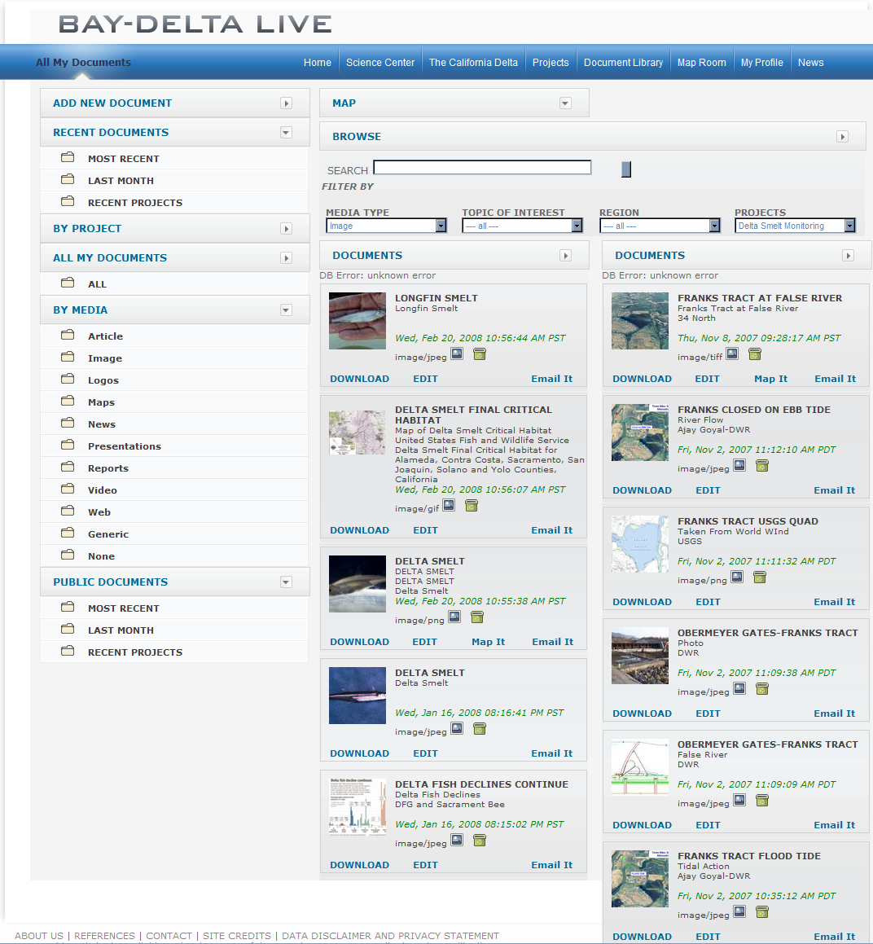
  - Upload and share any file type to the document library
  - Organize, search and assign documents to project pages, wiki and more
  - Geo-reference all assets in your library for viewing geo-spatially

Organize Your Projects
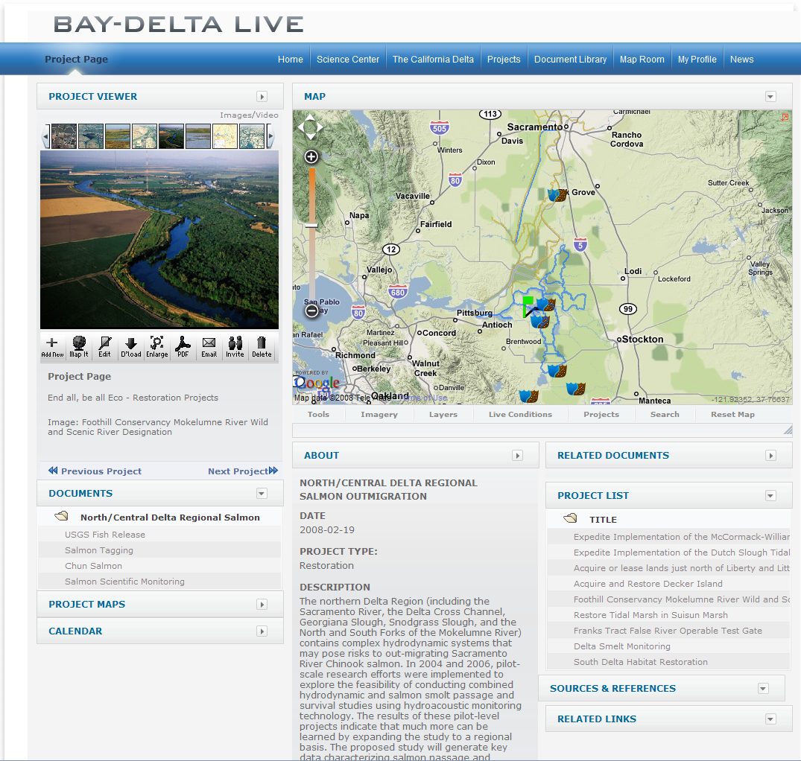
Create and manage project pages and teams
Build project pages accessible to all stakeholders or just your organization.
Pages Include: Project Document Libraries, related documents, media and links, project profiles, simple scheduling, project map room and map layers, and Live Condition widgets

Visualize the Science
View tabular data spatially. Spreadsheet = Animation
- Create collaborative and project specific operation centers: real time data, historical data, research, project information, teams info and scheduling in one central location.
- Meet the Scientist: Profile of top Delta scientists and their projects manage by the scientists themselves

Create a Water Rights wiki inside the California wiki
Species, Bodies of Water, Infrastructure and Land Feature wiki pages for everything Delta.
- Written and Managed by Delta stakeholders

