Turbidity Status 1-22-2010

J.R. Burau
The first flush is here and is moving through the system. Even though turbidities have substantially increased at Freeport (Figure 1), the first flush has not reached Chipps Island (Figure 2), where the front edge of the plume of high turbidity is oscillation with the tides somewhere between Decker Island (our proposed sampling location) and Chipps. The first flush has reached Rio Vista (Figure 3), yet there is a considerable turbidity gradient in within a tidal excursion of this sampling location, as can be seen in the tidal fluctuations in the turbidity measurements at this site. Compare measurements, for example, to Freeport (Figure 1), where the turbidity does not vary with the tides.

On the San Joaquin side, at Jersey Point, peaks in turbidities correspond to slack after ebb tides. This pattern suggest that the turbidities are higher in the interior delta both (1) prior to the first flush (e.g. before Jan 18) suggestive of wind-wave re-suspension in Franks Tract), and (2) during the first flush (e.g. after Jan 18), suggesting either a Mokelumne River (Sac water entering though Georgiana Slough and/or the Mokelumne River itself) or San Joaquin source. The Mokelumne, therefore, looks to substantially contribute to elevated turbidities in the central delta during the first flush transitory period, based on these preliminary data. Thus, the recommendation to augment the existing monitoring network to collect turbidity data in the Mokelumne appears to be a good one.

Cheers,
Jon

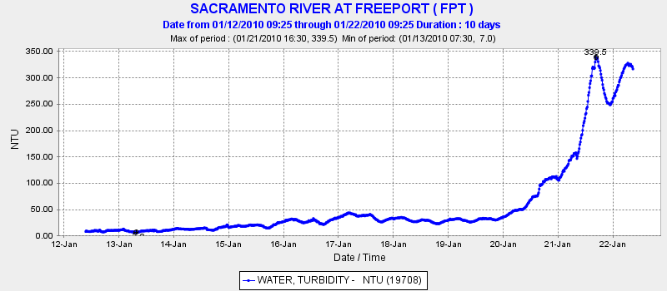
Figure 1 – Turbidity (in NTU) measured in the Sacramento River at Freeport.

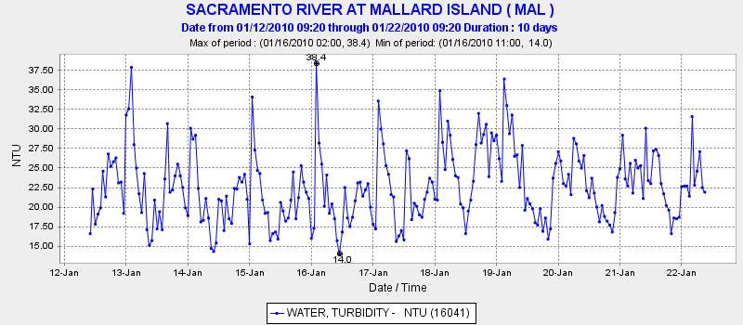Figure 2 – Turbidity (in NTU) measured at Mallard Island (on the boundary between the Delta and Suisun Bay.

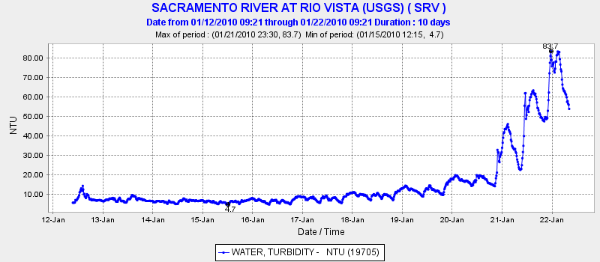Figure 3 - Turbidity (in NTU) measured in the Sacramento River at Rio Vista.

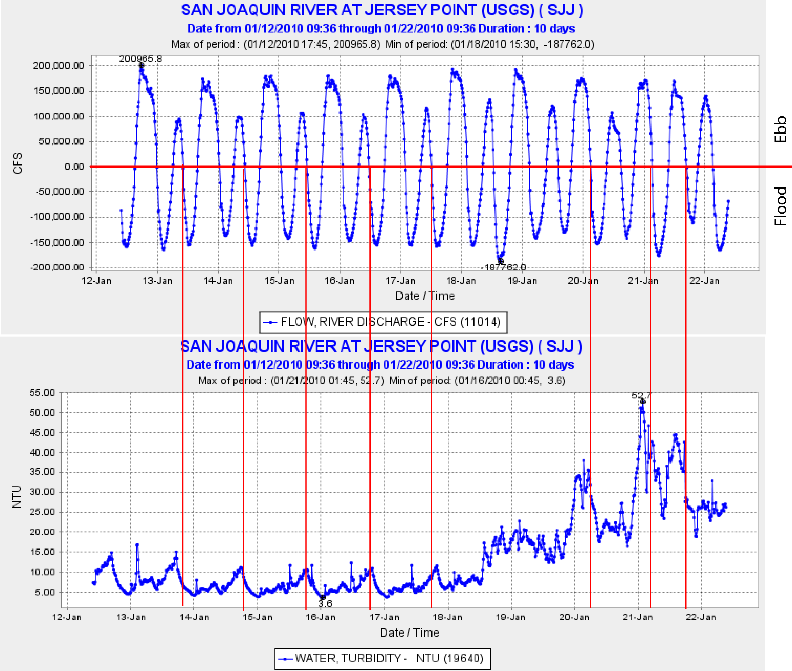Figure 4 – Flow (in CFS, upper panel) and turbidity (in NTU, lower panel) measured in the San Joaquin River at Jersey Point. Vertical lines indicate slack after ebb – this tidal current phase roughly corresponds with peaks in turbidity at Jersey Point.

