Wind-Wave generated turbidity in central delta 1-22-2010

J.R. Burau
Wind-wave re-suspension that occurs in conjunction with large winter storms appears to be very important in driving turbidities in the vicinity of Franks Tract. For example, elevated turbidities in False River during the period shown in figure 1 appear to (1) strongly correlate with wind speed (panel 1A, measured at Travis Air Force Base), (2) where peaks in turbidity occur at the end of ebb (panels 1B and 1C, suggesting their origin is Franks Tract) and (3) the occurrence of the turbidity peaks at False River predate the arrival of fluvial (Sac River) inputs from Threemile Slough (panel 1D) and the Mokelumne River @ San Joaquin (panel 1E). This process creates an isolated pocket of turbidity in the Central Delta that is not associated with the first flush but rather with a meteorological event. At the time this data were collected (Jan 22, 2010) large “clear” water areas exist between the low salinity zone (Suisun Bay) and Franks Tract and between Franks Tract and the pumps (figure not shown).

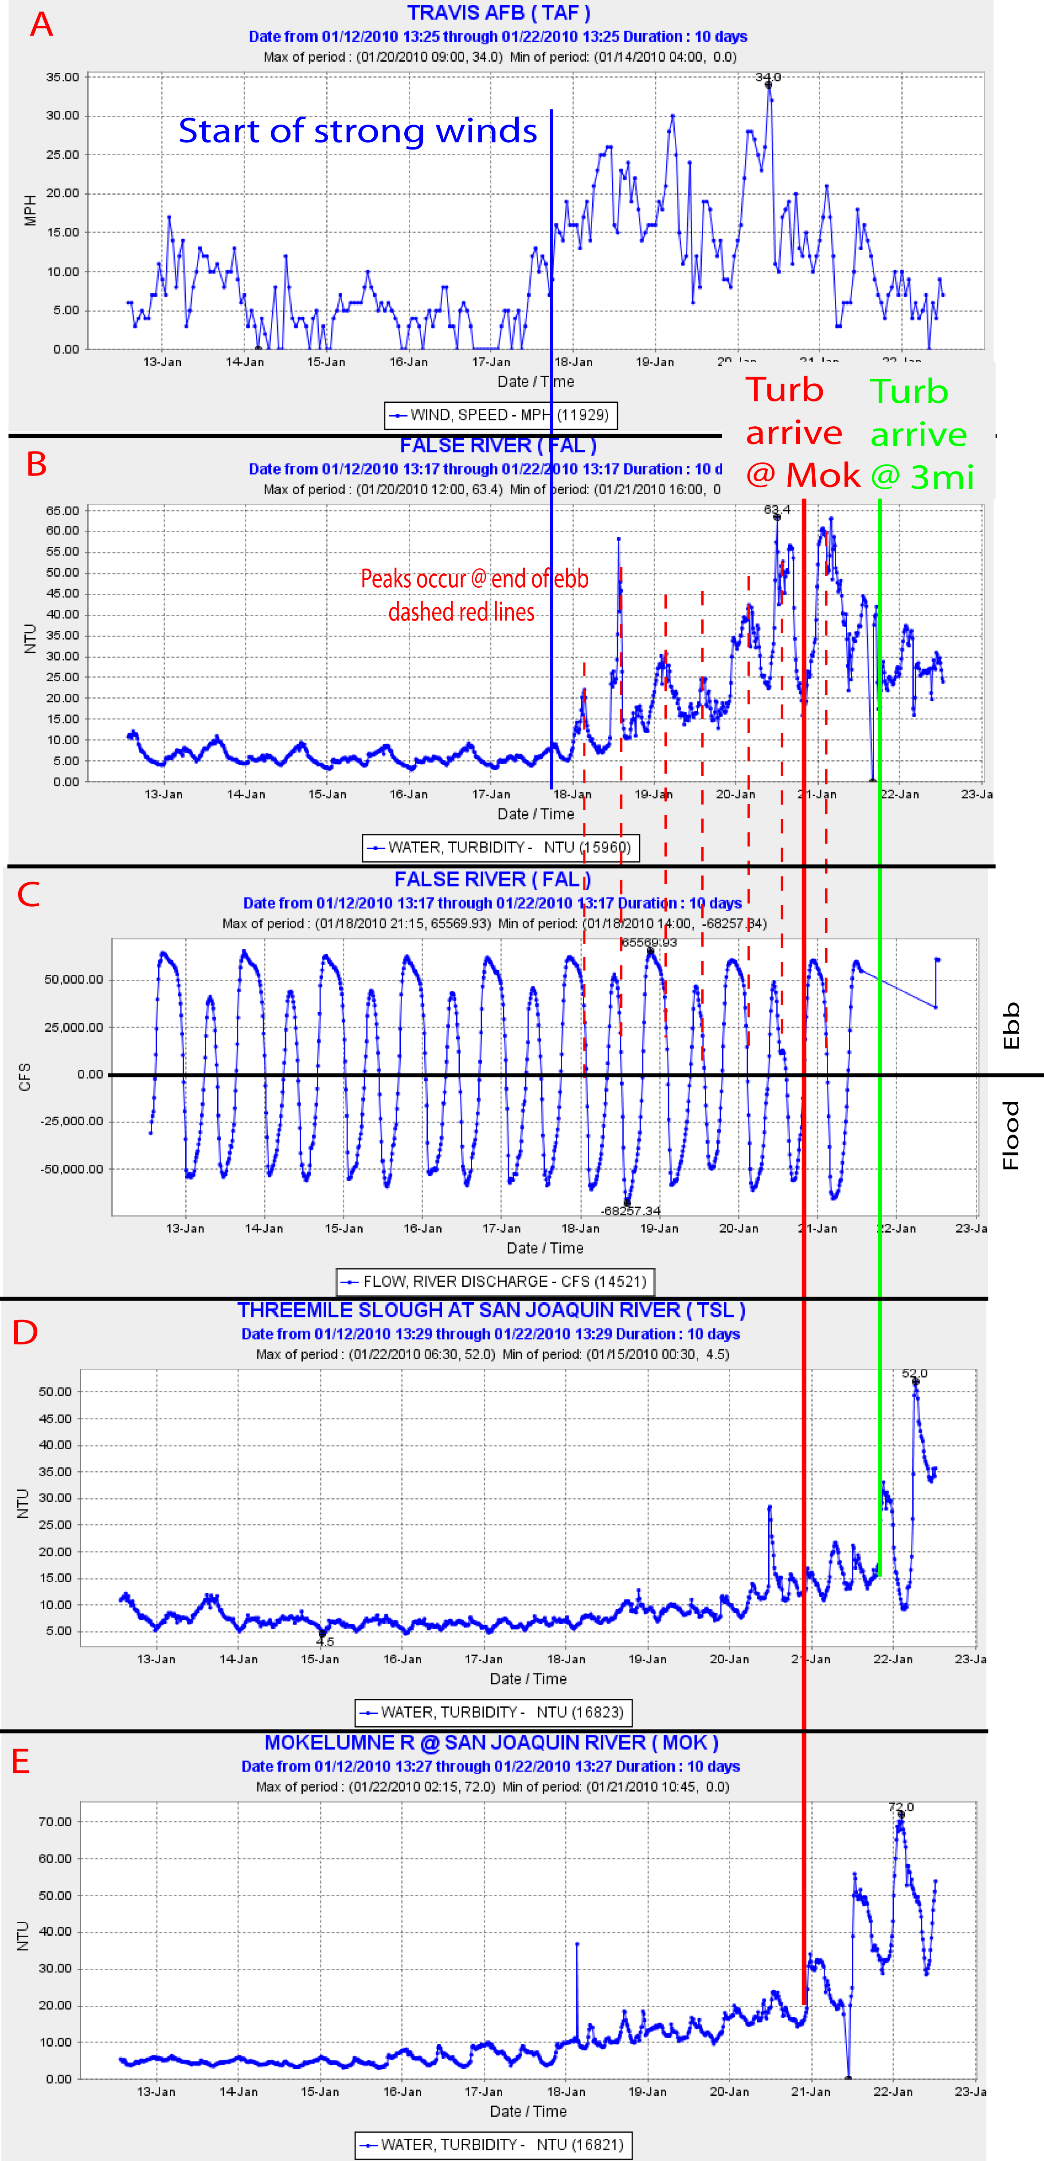
Figure 1 –

