**Water Quality Conditions Interactive Portal**

**Tab 1 Hydrology**

[**What is Hydrology?**](http://water.usgs.gov/edu/hydrology.html)

Hydrology is the study of water—its quantity, quality, location, and movement. Hydrology also includes documenting the changes that take place in the quantity and quality of water as it passes through the water cycle. Hydrology includes the study of freshwater, saltwater, surface water, groundwater, precipitation, and water quality.

The water cycle, or hydrologic cycle, in the San Francisco Estuary starts with the evaporation of water from the Pacific Ocean. The evaporation forms clouds that rise in elevation as they reach the land. As the clouds rise, they cool and are able to hold less water so they drop rain over the valley, and rain and snow over the mountains of the Sierra Nevada. The rain soaks into the ground or runs off into streams. Snow accumulates at higher elevations until it melts and becomes runoff, which infiltrates into the ground or flows into streams and rivers. Water from the Sierra snowpack eventually reaches storage reservoirs, where outflow can be regulated and where water operators manage water releases from the reservoirs for environmental and human uses. By the time water in rivers reaches the Delta, there is loss via evaporation, evapotranspiration, and consumptive use. In the lower reaches of the estuary, freshwater from the rivers interfaces with saltwater from the ocean and mixes with the ebb and flow of the daily tide cycles.

**Why is Hydrology Important?**

* Hydrology is important in the San Francisco Bay Delta Estuary because water conditions change due to tidal actions, climatic variations, and water management for consumptive uses, such as agriculture and drinking water.
* Monitoring hydrologic variables (like rainfall, runoff, storage, releases, diversions and discharges from water users) helps us better understand how water changes in space and time.
* Understanding hydrologic variables is important for managing California’s water resources, including their use for agriculture, drinking water, and biological resources (fish and aquatic species)
* The hydrologic cycle is important to consider for the management of water resources to mitigate the effects of long-term drought, monitor flow, water quality and other environmental variables as well as to prepare for floods.

Carousel Photo 1

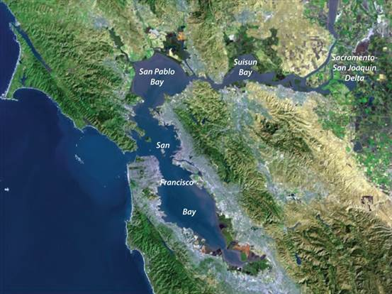

Caption: The San Francisco Bay Delta Estuary is influenced by many important hydrologic variables. Data on these variables are collected by local, state, and federal agencies to better understand how to manage our water resources. (Photo courtesy of Bay-Delta Live).

Carousel Photo 2:

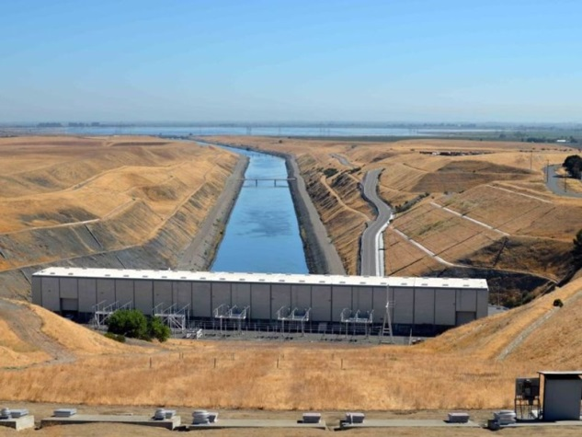

Caption: The State and Federal water projects move water from the south Delta using pumping plants like this one. (Photo: DWR, H.O. Banks pumping plant, courtesy of the DWR)

Carousel Photo 3:

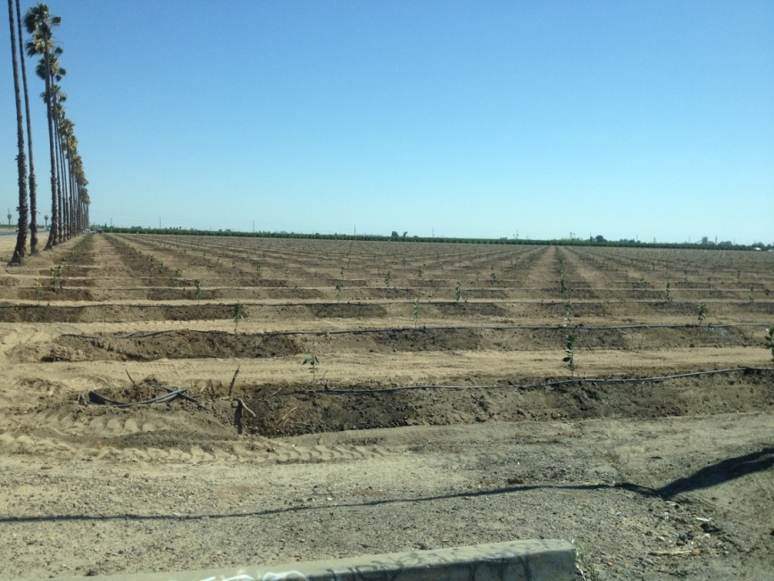

Caption: Agricultural water users rely on water from the Delta on lands like this newly planted orchard. This field is drip irrigated to help conserve water that is exported from the Delta. (Photo courtesy of Bill Templin, DWR)

Carousel Photo 4

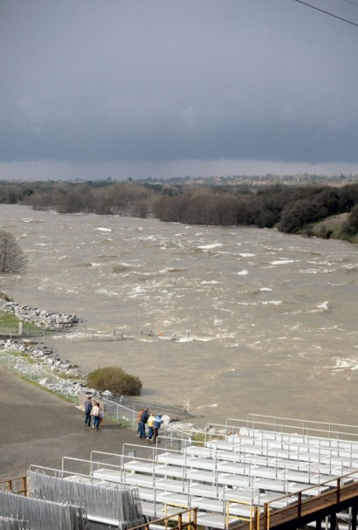

Caption: Hydrologic data on stream flows during floods are critical for helping to monitor stress on Delta levees and to make better reservoir water management decisions (Photo courtesy of Dennis Plessas)

Carousel Photo 5:

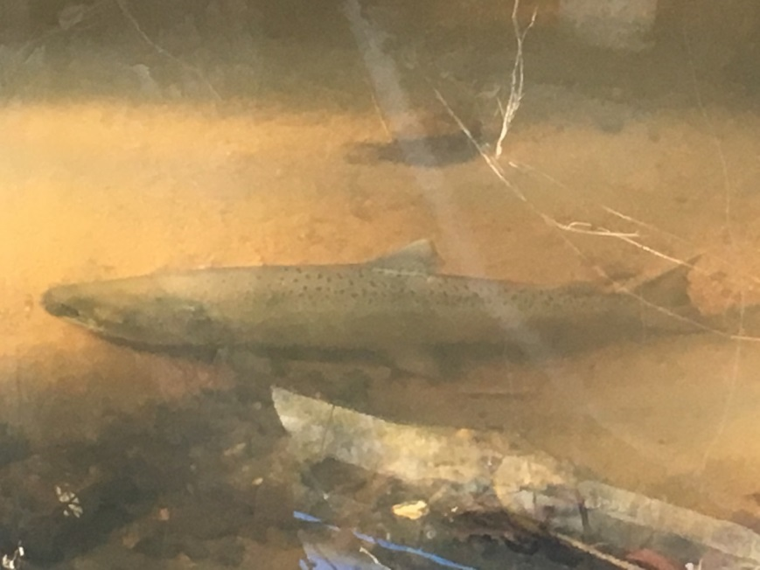

Caption: Hydrologic data on flows help monitor native fish migrations (like this Chinook salmon). Anadromous fish move upstream during peaks in stream flow following rainfall / runoff events or reservoir releases. (Photo courtesy of Bill Templin, DWR)

Carousel Photo 6:

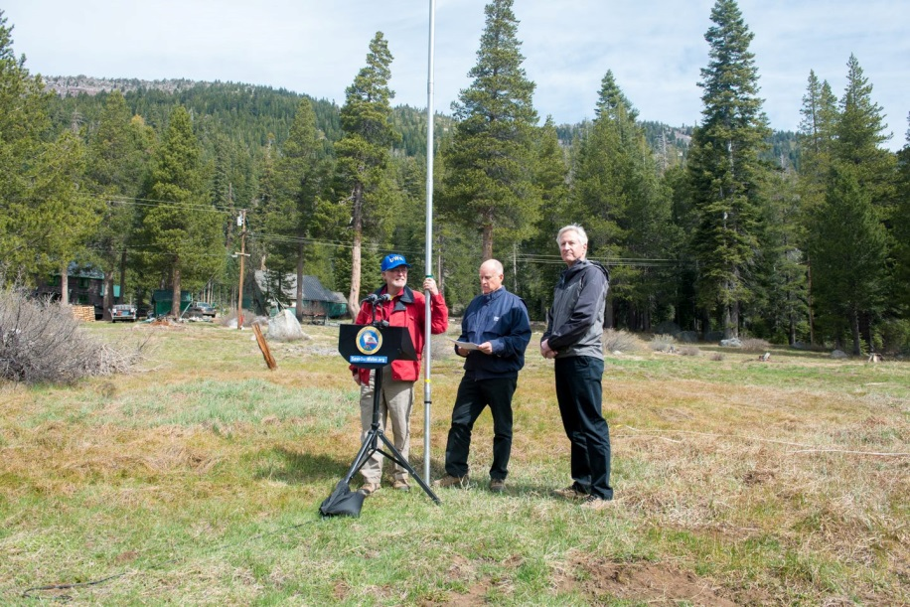

Caption: DWR staff collects data on snowpack levels in the Sierra Nevada (like shown in this May 1, 2015 photo with Governor Jerry Brown and Department of Water Resources Director Mark Cowin). Networks of real-time stations are also maintained that store data on snowpack and rainfall (Photo courtesy of Bay-Delta Live).

**Tab 2 - How is Hydrology monitored?**

Hydrologic data are collected in the field, and the data are synthesized into information about real-time hydrologic conditions, which is used to make more informed water management decisions. These data are collected using a variety of climatic and hydrologic instruments at gaging stations and other sites throughout California. Monthly discrete hydrologic data are collected at some of these sites, while real-time data are increasingly collected at fixed gaging stations. The California Department of Water Resources (DWR) and many other local, state, and federal agencies collect and monitor hydrologic data throughout California.

*Read more*

Many types of hydrologic data, such as rainfall, river stage, flow, and reservoir storage, are monitored and collected by agencies throughout California. These data are accessible to the public online, through resources like the California Data Exchange Center ([CDEC](http://cdec.water.ca.gov/cdecstation/)) and [Bay-Delta Live](http://www.baydeltalive.com/).

On CDEC, you can locate hydrologic stations throughout California, and query the database for real-time, daily, monthly, current, and historical data. A sample CDEC map with the locations of active stations in the Delta region can be seen in Figure 1.

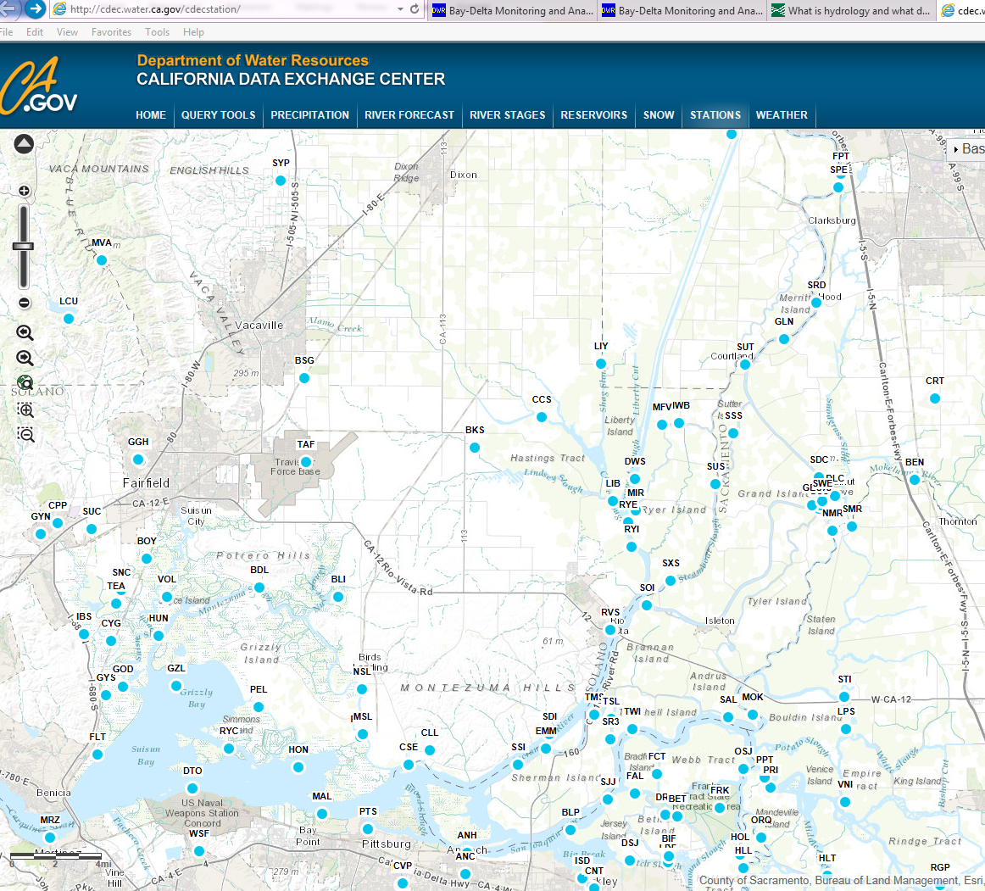

**Figure 1: CDEC map showing hydrologic data stations in the Delta region.**

Hydrologic data are collected in varying intervals, which range from monthly to every 15 minutes. These preliminary data are stored on data loggers housed in gaging stations and at most stations, the data are transmitted by satellite to websites, like CDEC, in real-time.

One example of discrete hydrologic data is an individual stream flow measurement. These measurements must be made at various river stages (water levels) over time, and entered into rating tables that can be plotted to produce a rating curve. These curves and rating tables provide the stage-discharge relations that allow real-time or discrete measurements of stage to be converted to flow estimates that are specific to the stage at each station. In order to keep the stage/discharge correlation accurate, flow measurements and observations of changes in channel conditions must be made frequently enough to capture changes that may influence that relationship. These changes can include scour, fill, or changes in the gage pool control feature, which is typically a channel break like a water fall, weir, or channel constriction. The rating tables must be updated regularly so that the stage readings continue to accurately represent the actual discharges at each specific gage as time passes and conditions change.

Examples of real-time hydrologic data include rainfall, stage, and flow estimates. These data are extremely important for water management and health/safety purposes (e.g., flood events)

Hydrologic data can be visualized online using the [Bay-Delta Live](http://www.baydeltalive.com/) portal options “Explore Data” and “Data Visualizations.” The Explore Data option allows users to select stations by the data source, sensor type, and data category by region, as shown in Figure 2.

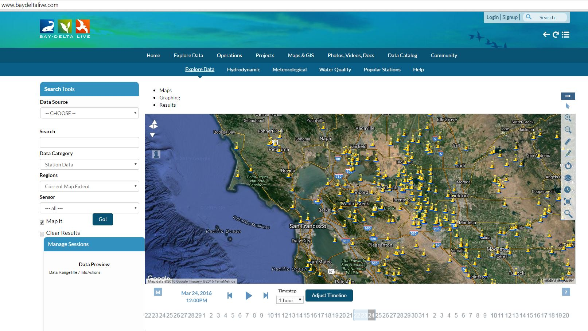

Figure 2: Map from Bay Delta Live, showing locations of data collection stations in the San Francisco Bay Estuary region.

The types of hydrologic data that we are including on this portal include precipitation (rain and snow), runoff, and Net Delta Outflow (NDO). These data types directly relate to the water quality, benthic, phytoplankton and zooplankton that we monitor in the Interagency Ecological Program (IEP) Environmental Monitoring Program ([EMP](http://www.water.ca.gov/iep/activities/emp.cfm)). Links are provided for each of these types of hydrologic data so you can learn more about how each data type is monitored.

Drop Down Box for Links to Hydrologic Data

1. Precipitation (represented by Water Year Classification) and Unimpaired Runoff: <http://cdec.water.ca.gov/cgi-progs/iodir/wsihist>

2. Net Delta Outflow: <http://www.water.ca.gov/dayflow/output/inputdata.cfm>