Appendix e
Operations Plan
Table of Contents
APPENDIX E Operations Plan E-1
E.1 Introduction E-1
E.2 Operators and Decision-makers E-5
E.3 Factors to be Considered for Operations E-5
E.3.1 Hydrodynamics and Water Quality Factors E-5
E.4 Potential Measures for Controlling Entrainment E-6
E.5 Gate Operation Protocols E-6
E.5.1 Operational Triggers and Off-Ramps E-12
E.5.2 Adult Delta Smelt (December through March) E-16
E.5.3 Larvae/Juvenile Delta Smelt (March through June) E-21
E.5.4 July through November E-23
E.6 Forecasted Operations – Adult and Larvae/Juvenile Behavior Models E-23
E.6.1 Forecasting Process E-23
E.6.2 Adult Smelt Model E-24
E.6.3 Juvenile and Larvae Model E-24
E.7 Operations Coordination and Timely Interface with Smelt Working Group E-24
E.8 Consistency between OCAP RPAs and Planned 2-Gates Operations E-25
E.9 Monitoring for Operational Triggers E-31
E.10 Coordination with Decision-Making Process E-31
E.10.1 Teams and Technical Groups E-31
E.10.2 Real Time Decision-Making Process for RPA Components 1 and 2 E-32
Tables
Table E-1 Summary of RPA Requirements¹ and Proposed Operations E-3
Table E-2 Planned Operational Periods for 2-Gates Fish Protection Demonstration Project E-6
Table E-3 Triggers for adult operational period (December-March). E-19
TableE-4 Triggers for larval and juvenile operational period (March and June) E-23
Table E-5 Comparison between Adult Delta Smelt Protections in FWS OCAP RPA Component 1 and 2-Gates Operations E-26
Table E-6 Comparison between Adult Delta Smelt Protection in FWS OCAP RPA Component 1 Action 2 and 2-Gates Operations 1 E-28
Table E-7 Comparison between Larval and Juvenile Delta Smelt Protection in FWS OCAP RPA Component 2 and 2-Gates Operations 2 E-29
Table E-8 Operations Plan for NMFS OCAP RPA IV. Actions 2.1 and 2.3 E-30
Table E-9 Delta Smelt Risk Assessment Matrix (DSRAM) – Triggers for FWS BO RPA* and for 2-Gates Project E-35
Table E-10 Delta Smelt Risk Assessment Matrix (DSRAM) – Tools for Change for FWS BO RPA* and for 2-Gates Project E-36

Figures
Figure E-1 Annual schedule of 2-Gates Project Operations and relevant RPA requirements, and IEP monitoring for December 2009 – June 2011 E-9
Figure E-2 Annual schedule of 2-Gates Project Operations and relevant RPA requirements, and IEP monitoring for December 2011 – June 2015. E-11
Figure E-3 Decision tree and triggers for Adult 2-Gates Operation Period E-14
Figure E-4 Decision tree and triggers for Larval and Juvenile 2-Gates Operation Period E-15
Figure E-5 Typical sequence of 2-Gates operations, experimental periods, and OMR flow restrictions. E-18
Figure E-6 Framework for Decision Making, Operations and Monitoring E-34

Operations Plan

Introduction
This operations plan characterizes anticipated operations of the 2-Gates Project, describes how these operations complement and coordinate with regulatory requirements imposed by recent Biological Opinions (BOs), and summarizes operational triggers and the decision-making process.
Initial Project operations are based on an understanding of the patterns and relationships of Delta hydrodynamics, water quality parameters (particularly turbidity), delta smelt life cycle and behavioral responses to flow and water quality cues at different life stages, and entrainment by the export facilities. The initial concept for operating the Project was developed and refined using extensive hydrodynamic and delta smelt behavioral modeling by Resource Management Associates (RMA) (Appendix A).
The Project goes beyond simply reducing negative flows in Old and Middle Rivers (OMR flows), as specified in the BOs. Entrainment reduction may be accomplished by controlling the distribution and continuity of turbidity and salinity conditions that have been identified as a component of pre-spawning, adult delta smelt habitat (FWS 2008). It is anticipated that the Project will enhance the isolation of delta smelt from water management operations at the Central Valley Protect (CVP) and State Water Project (SWP) pumps by limiting the upstream movement of higher concentrations of turbidity in Old and Middle Rivers from December into March. In addition, tidal operation of the 2-Gates Project may also increase dispersive mixing of water in the central or southern Delta seaward toward the western Delta. This has the potential to (1) reduce entrainment risk by dispersing larval/juvenile smelt spawned in the central and southern Delta away from the export pumps, (2) transport juvenile smelt westward toward rearing habitat near Suisun Bay, and (3) enhance export of nutrients and phytoplankton to the west Delta. Water supply benefits can be realized if it is demonstrated that entrainment at the CVP and SWP facilities is reduced or averted by modifying the general distribution of delta smelt north and west of the region of control of the gates.
The Project is designed to be operated in conjunction and coordination with OMR flow restrictions in the FWS OCAP BO (FWS 2008) and the NMFS OCAP BO (NMFS 2009). Table E-1 illustrates the timing of Project operations and the most relevant RPA actions. This Plan describes how the Project operations fit into the context of the RPA actions.
The control of water movement from the central Delta into the south Old and Middle Rivers is critical to the control of entrainment of delta smelt (and other pelagic species) by the CVP and SWP export facilities. Since conditions can change rapidly, the Project includes a real-time data gathering and decision framework that evaluates the best course of action for particular hydrodynamic and water quality conditions, delta smelt distributions, and anadromous fish migrations. This Plan describes operational triggers, with further details on the monitoring to detect these triggers provided in the Science Investigation Program & Monitoring Plan (Appendix C).
Initial Project operations will be adapted iteratively, based on monitoring and evaluation. This Plan concludes with a description of how the Project will provide additional information and another management tool to the resource agencies’ decision-making process for delta smelt protection.
Table E-1 Summary of RPA Requirements¹ and Proposed Operations
Month | 2-Gates  1. Pre-spawning Adult Delta Smelt entrainment protection | 2-Gates  2. Larval and juvenile delta smelt entrainment protection (dispersive mixing) | FWS  RPA Component 1  Adult delta smelt migration and entrainment |  | FWS  RPA Component 2 Entrainment protection of larval and juvenile delta smelt | NMFS Action IV. 2.1  Maintain SJR Inflow/Export ratio | NMFS Action IV. 2.3  Reduced exports to limit negative OMR flows depending on presence of salmonids
Month |  |  | Action 1 - High entrainment risk. | Action 2- extended protection |  | NMFS Action IV. 2.1  Maintain SJR Inflow/Export ratio
Dec | December – March  Operate gates to maintain low turbidity zone in Old and Middle Rivers, until water temperature ≥12ºC or spawning detected. |  | December 1-19  Limit exports to reduce negative OMR flows  (-2,000 cfs) for 14 days. | December 20– March  Limit exports to  reduce negative OMR flows  - When turbidity & salvage low: -3,500 to -5,000 cfs,  - When conditions may increase salvage: -1,250 to -2,000 cfs.  End when water temperature ≥12ºC or spawning detected.
Jan |  |  |  |  |  |  | Jan 1 – June 15  OMR flow (-5,000 to -2,500 cfs) until after June 1 water temperature at Mossdale ≥ 22ºC for 7 days.
Feb

Mar
Mar |  | Early-mid March - March 31  Once temperature ≥12ºC or spawning detected, operate gates for dispersive mixing. |  |  | Early-mid March - June 30  Once temperature ≥12ºC or spawning detected, limit exports to reduce negative OMR flows (-1,250 to -5,000) until June 30 temp ≥25°C.
April |  |  |  |  |  | April 1 – May 31  Maintain Vernalis Inflow/Export ratio depending on water supply parameters (interim 2009-2011) or depending on water year (long term 2012+)
May
June |  | June 1-30  Operate gates for dispersive mixing until temperature ≥ 25ºC
1. Source: USFWS 2008, NMFS 2009. All OMR flow requirements are 14-day running average, with simultaneous 5-day average no more than 25 percent more negative than the requirement.
E

Operators and Decision-makers
The U.S. Bureau of Reclamation (Reclamation), or its designee, will maintain and operate the Project facilities (e.g., gates, small boat portage ramps) in a manner that is consistent with operations of the OMR flow restrictions under the OCAP RPAs. Information from the hydrodynamic and behavioral models will be provided to Reclamation and used to optimize the timing and duration of gate operations.
Decisions will be made via an adaptive process, discussed in more detail at the end of this Operations Plan. Under the FWS OCAP BO, the Smelt Working Group (SWG) meets to consider fish distribution and relative abundance in light of Delta conditions and makes recommendations to USFWS. The Service then brings the proposed action (which may be modified from what the SWG has recommended) to Water Operations Management Team (WOMT). Under the NMFS OCAP BO, the Delta Operations for Salmon and Sturgeon Technical Working Group (DOSS) provides recommendations to NMFS, which then brings proposed action to WOMT. The WOMT can either adopt the FWS’s determination or can suggest an alternative action. The FWS then makes the ultimate decision. The Project operations will fit into this adaptive process. A 2-Gates Study Team will be formed to assess forecast modeling and real-time data on Delta conditions and make recommendations on gate operations to the SWG, DOSS and agencies. In this manner, the Project will provide a new management tool (gate operations) and additional data for the regulatory agencies’ decisions.

Factors to be Considered for Operations

Hydrodynamics and Water Quality Factors
Historically, entrainment of delta smelt at the export facilities has occurred primarily during December through June. The scientific understanding of smelt movement, behavior, and entrainment continues to evolve, but it is recognized that the presence of water quality factors in the south Delta and net flow reversals in Old and Middle Rivers can be a significant cause for delta smelt entrainment. The distribution of pre-spawning adult delta smelt is believed to be strongly related to specific ranges of salinity and turbidity. The recently released OCAP BO (USFWS 2008) strongly supports the linkages between turbidity and delta smelt occurrence and salvage. These water quality factors (electrical conductivity greater than 400 µmhos/cm and turbidity greater than 12 NTU) occur in different parts of the Delta depending on hydrologic conditions and operation of the SWP and CVP facilities. These water quality factors normally occur in the regions of Suisun Marsh and Cache Slough. However, under certain hydrologic and operating conditions, the water quality factors can be substantially moved into the central and south Delta due to reversal of flows on the Old and Middle Rivers.
Adult pre-spawning delta smelt are believed to “seek-out” this turbidity plume by “surfing” the tides and in so doing transport themselves to more inland areas in advance of spawning. The mechanism of pre-spawning delta smelt migration to inland areas has not been verified. Under the current configuration of the south Delta, high exports during these times cause net flow reversals of Old and Middle Rivers, drawing these water quality conditions into the south Delta, which can lead to significant entrainment of pre-spawning adult delta smelt. In addition, delta smelt spawning in the central and south Delta is believed to cause subsequent larval and juvenile smelt entrainment due to the progeny’s proximity to the export facilities.

Potential Measures for Controlling Entrainment
Management strategies to reduce the risk of delta smelt entrainment should seek to control adverse hydrodynamic conditions associated with either the movement of the water quality factors into the central and south Delta or the direct transport of the early life stages from this region to the export facilities. A dual hydrodynamic approach for protecting against delta smelt entrainment is believed to be the most appropriate strategy. The proposed strategy focuses on the operation of a gate system on Old River and Connection Slough to balance negative flows in the Old and Middle River channels and limit development of water quality characteristics that will influence movement of delta smelt habitat into the south Delta. The 2-Gates operation will provide the necessary control on Old and Middle Rivers when used in concert with other actions to manage OMR negative flows. These two actions need to work in concert to provide comprehensive management of entrainment effects at potentially reduced water costs.

Gate Operation Protocols
The protocols for operating the gates are based on our conceptual understanding of factors affecting smelt entrainment, as described earlier, and refined through hydrodynamic and behavioral modeling. Currently, there are two operational periods, based on delta smelt life-stage-specific objectives and season under the FWS OCAP BO: (1) pre-spawning adult protection and (2) larval and juvenile protection (Table E-2). Gate operations will begin as early as December each year when smelt distributions are located north and west of the Project facilities as determined by flow, turbidity and salinity, and biological data collected by Project monitoring.
The anticipated operations planned for the initial year are discussed below. Operations in subsequent years or within the initial operational year could be adjusted, based on monitoring data, to improve project effectiveness and to refine hypotheses. A multi-year schedule of the Proposed Action’s gate operating periods and experimental periods, along with relevant RPA periods and IEP monitoring programs, is presented for December 2009-July 2011 (Figure E-1) and December 2011-July 2015 (Figure E-2).
Table E-2 Planned Operational Periods for 2-Gates Fish Protection Demonstration Project
Operational Period | Season | Operational schedule | Triggers, Off-ramps, and Notes
Pre-spawning Adult protection | Approximately December 1 to 15 – early March | Gates closed 0.5-2.5 hours daily. | - Gates will be operated to balance flows and maintain a low turbidity zone in Old and Middle Rivers.  - Trigger for Operations - turbidity ≥ 12 NTU at San Joaquin River at Jersey Point.  - Off-ramp- Water temperatures ≥ 12 degrees C or “spent” female smelt detected in Spring Kodiak trawl (SKT) or salvage.
Larval and Juvenile Protection | Early March-March 31 | Old River gate closed on flood tide (twice daily, about 10 hours total daily) and open on ebb and slack tides (~14 hours daily). Connection Slough gate closed about 20 hours daily and open during slack tide (~4 hours daily). | - Gates will be operated to maximize dispersive mixing.  - Trigger for operations - water temperatures ≥ 12 degrees C or “spent” female smelt detected in SKT or salvage..
Larval and Juvenile Protection | April 1- May 31 | Gates open at all times. | - Gates will not be operated during this period (Ref NMFS RPA IV 2.1)
Larval and Juvenile Protection | June 1-June 30 | Old River gate closed on flood tide (twice daily, about 10 hours total daily) and open on ebb and slack tides (~14 hours daily). Connection Slough gate closed about 20 hours daily and open during slack tide (~4 hours daily). | - Trigger for operations – commence gate operations June 1  - Off-ramp - June 30 or when Delta water temperatures ≥ 25 degrees C. Gates open continuously until trigger monitoring commences in December.
No project operations | July – Nov | Gates open at all times. | - Gates will be open continuously to allow fish movement and navigation.  - Monitoring for triggers for adult operations resume in December.

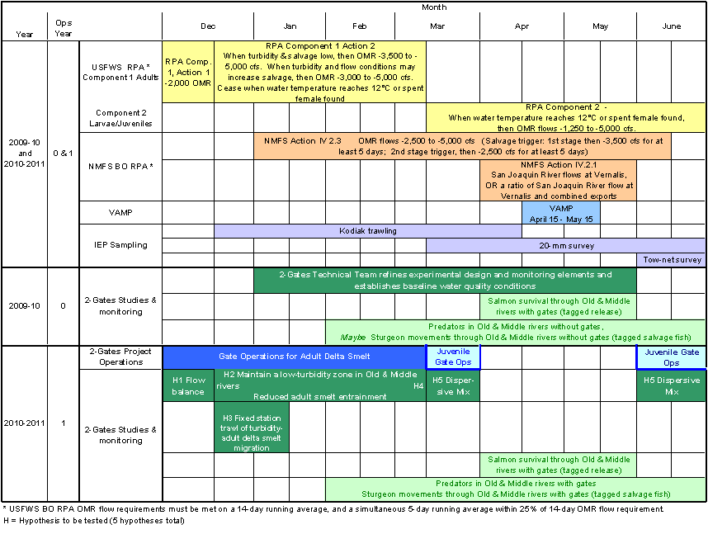
Figure E-1 Annual schedule of 2-Gates Project Operations and relevant RPA requirements, and IEP monitoring for December 2009 – June 2011
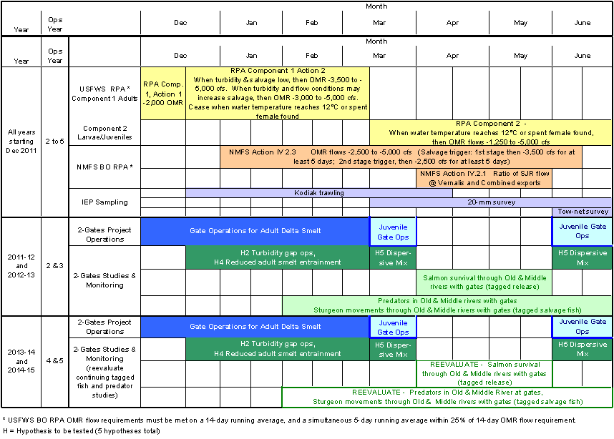
Figure E-2 Annual schedule of 2-Gates Project Operations and relevant RPA requirements, and IEP monitoring for December 2011 – June 2015.

Operational Triggers and Off-Ramps
The start and conclusion of each operational period are triggered by specific water quality conditions (turbidity, temperature), date, and/or natural history (evidence of spawning). Decision trees depicting triggers for gate operations and OMR flow requirements are presented for the adult operational period (Figure E-3) and the larval and juvenile operational period (Figure E-4).
Turbidity ( ≥12 NTU) is the trigger for initiating adult protective measures for both the Proposed Action and USFWS SWP/CVP Operations RPA Component 1 (USFWS 2008b). The USFWS RPA Component 1 is triggered when the three-day-average turbidity from three stations (Prisoner’s Point, Holland Cut, and Victoria Canal) is ≥12 NTU. The Proposed Action uses turbidity data from a different location, namely when turbidity reaches 12 NTU at the San Joaquin River at Jersey Point. Modeling indicates that this would occur 3 to 21 days earlier than the three-station trigger to initiate USFWS RPA Component 1. Using Jersey Point data provides more advance warning of conditions that are expected to trigger pre-spawning adult smelt migration, and thus allows more time to formulate decisions regarding gate operations.

Water temperature and initiation of delta smelt spawning are used as the triggers for measures to protect larval and juvenile delta smelt. The USFWS RPA Component 1 is suspended and RPA Component 2 is triggered when (1) mean daily water temperatures at Mossdale, Antioch, and Rio Vista are ≥ 12° C, or (2) delta smelt have begun spawning (spent female delta smelt are detected in SKT or salvage). The RPA Component 2 is suspended June 30 or when daily average water temperatures reach 25° C for three consecutive days at Clifton Court Forebay. The Proposed Action utilizes these same triggers. (The RPA Component 2 can also be suspended any time the three-day average flow on Sacramento River at Rio Vista is ≥90,000 cfs and the three-day average flow on the San Joaquin River at Vernalis is ≥10,000 cfs.)

Data on physical triggers (turbidity, temperature, average daily flow) will be provided from fixed monitoring stations in the Delta, as described in the Science Investigation Program and Monitoring Plan (Appendix C). If an information gap occurs during real-time monitoring of a particular trigger, such as turbidity at Jersey Point, data from surrounding stations and sources will be used to provide information for decision-making. These include turbidity at other stations, especially upstream of Old and Middle Rivers, flow information for the Sacramento River and other incoming tributaries (indicating conditions that would result in a first flush event or a pulse of rising turbidity and flow), and storm forecasts.
Although salvage is a trigger for USFWS RPA requirements, it will not be used as a trigger to commence adult gate operations because it is not an early warning indicator. Salvage data does provide valuable feedback for guiding gate operations and exports, testing hypotheses, and adaptive management. Salvage will be used as a warning sign for evaluating and adjusting operations as necessary.

Figure E-3 Decision tree and triggers for Adult 2-Gates Operation Period

Figure E-4 Decision tree and triggers for Larval and Juvenile 2-Gates Operation Period

Adult Delta Smelt (December through March)

Objective
To provide equal or improved protection of pre-spawning adult delta smelt from entrainment with early operation of the Project facilities and early implementation of RPA Component 1 Action 1 and, once demonstrated to be an effective tool for the protection of delta smelt, to allow SWP and CVP water exports to increase while operating within the required OMR flow range established by the OCAP BOs (FWS 2008) and all other water management requirements.

Action
To protect pre-spawning adult delta smelt as they migrate inland, the gates will be operated from the onset of the higher turbidity conditions from December into March. After December 1, gates would be operated in Old River and Connection Slough to balance flows in Old River and Middle River either before or in conjunction with RPA Component 1 Action 1 in order to maintain a low turbidity zone (<12-15 NTU) in Old River and Middle River between the central Delta and the south Delta export facilities (Hypothesis 2). The gates will be closed 0.5-2.5 hours daily in advance of a forecast high turbidity event.
Gate operations would occur while OMR flow requirements are in place during this period. When turbidity or salvage reach trigger levels during December 1-19, USFWS RPA Component 1 Action 1 would be implemented, which requires average daily OMR flow no more negative than -2,000 cfs for a total duration of 14 days, with a 5-day running average no more negative than -2,500 cfs (within 25 percent). RPA Component 1 Action 2 would be implemented after Action 1 (after December 19) or when determined by the SWG. When turbidity and salvage are low during this period, average daily OMR flow would be no more negative than -3,500 cfs to -5,000 cfs (14-day running average), with a 5-day running average within 25 percent. When conditions occur that may result in increased salvage (i.e. turbidity or salvage triggers met), average daily OMR flow would be no more negative than -1,250 cfs to -2,000 cfs (14-day running average), with a 5-day running average within 25 percent. Forecast model simulations will be rerun in response to real-time turbidity data as needed to detect upcoming high turbidity events.
The decision process for adult gate operations according to trigger conditions is illustrated in Figure E-3.

Timing
The adult operations will occur December into March. A typical sequence for gate operations and experimental periods is illustrated in Figure E-5. This illustrates how the Scientific Investigation Program may be conducted within the context of the OCAP RPAs, including the testing of the various hypotheses during the monitored “before” condition with gates open and the “after” condition with gates in operation. The “after” condition may also include the potential to increase exports within the illustrated discretionary OMR flow ranges of the FWS and NMFS RPA’s should the added delta smelt protection afforded by the gates be demonstrated. Forecast modeling will commence December 1, with gate operations commencing with the first flush in December. However, the SWG can recommend an earlier start
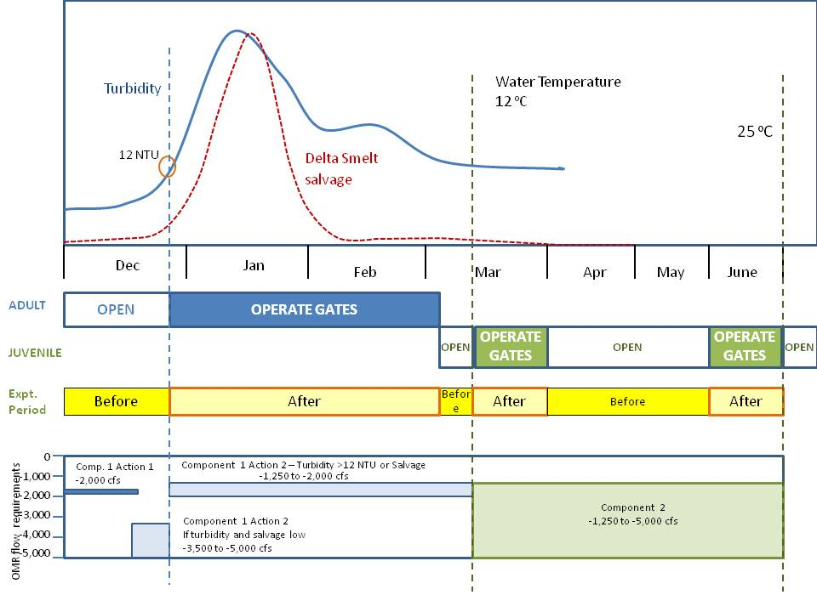
Figure E-5 Typical sequence of 2-Gates operations, experimental periods, and OMR flow restrictions.
or interruption based on other conditions such as Delta inflow that may affect vulnerability to entrainment. The 2-Gate adult operations will occur concurrently with the FWS OCAP RPA Component 1.

Triggers
The triggers for gate operations are described in Table E-3:
- Turbidity. Commence gate operations when turbidity ≥ 12 NTU at the San Joaquin River at Jersey Point station. Monitor turbidity at stations along Old and Middle Rivers to determine how far the more turbid water extends toward the south Delta. Suspend gate operations when a low turbidity zone (<12 NTU) no longer exists on Old and Middle rivers before the export facilities (i.e. turbidity ≥ 12 NTU at Holland Cut, Victoria Canal, any other station south of the Old River gate, and Clifton Court Forebay). If turbidity dissipates and drops below 12 NTU along Old and Middle Rivers, resume turbidity monitoring to detect a possible secondary flush that would recommence gate operations.
- Salvage. Cease gate operations if three days of delta smelt salvage occur after December 20 at either facility or cumulative daily salvage count is above a risk threshold, based upon the “daily salvage index” approach reflected in a daily salvage index value ≥0.5 (daily delta smelt salvage > one-half prior year FMWT index value).
Table E-3 Triggers for adult operational period (December-March).
Trigger | Description | Threshold | Action
Turbidity | Turbidity (NTU) at various stations (1) | < 12 NTU @ JP | Monitor for trigger, no gate operations
Turbidity | Turbidity (NTU) at various stations (1) | > 12 NTU @ JP AND  <12 NTU in Old and Middle R | Commence gate operations
Turbidity | Turbidity (NTU) at various stations (1) | > 12 NTU throughout Old and Middle River and central Delta | Cease gate operations, wait for turbidity to drop and equilibrate, recommence trigger monitoring.
Salvage | Delta smelt Salvage index -Calculated ratio of adult salvage to fall Midwater Trawl index (2) | Delta smelt salvage < salvage trigger | Continue with gate operations plan
Salvage |  | Delta smelt salvage > salvage trigger AND  Turbidity > 12 NTU @ JP and <12 NTU @ OMR | Cease gate operations, consult with SWG, evaluate actions
Salvage | Salmonid catch index (3) | >10 fish/day Nov-Feb  >15 fish/day Mar-April | Consult with DOSS, evaluate actions
Salvage | Condition of female delta smelt | Spent female found in salvage | Cease adult gate operations, and  Shift to juvenile gate operations
Temperature | Water temperature at 3 stations (4) | Temperature >12ºC
Spring Kodiak Trawl | Condition of female delta smelt | Spent female detected in SKT
SWG – Smelt Working Group, DOSS – Delta Operations for Salmon and Sturgeon Technical Group
1. Turbidity measured at JP (San Joaquin River at Jersey Point) and several stations in Old and Middle Rivers
2. Delta smelt salvage trigger from FWS OCAP BO, Attachment A (FWS 2008).
3. Salvage index for juvenile salmon from NMFS OCAP BO,RPA Action IV.3, p. 652-3 (NMFS 2009)
4. Water temperature three station daily mean at Mossdale, Antioch, and Rio Vista.

scenarios and alerts:
- If turbidity levels drop below 12 NTU along Old and Middle River stations for three days following a high turbidity event, this would indicate that turbidity has settled out and water is clearer. Cease gate operations and leave gates open, but continue to monitor turbidity at Jersey Point for a potential additional pulse of turbidity and any additional migrating adult delta smelt.
- If turbidity levels increase above 15 NTU throughout Old and Middle Rivers, as measured at several stationary monitoring sites, this would indicate that the high turbidity plume as extended down to the South Delta and there is no low-turbidity zone that delta smelt would avoid. Cease gate operations but continue to monitor turbidity at Jersey Point and along Old and Middle River to see if turbidity levels drop below 12 NTU. If this occurs, resume monitoring for turbidity (≥ 12 NTU at Jersey Point) to trigger gate operations for adults.
- If salvage or Spring Kodiak trawl (SKT) surveys document adult delta smelt in the south Delta or at the export facilities, this would indicate that the low turbidity zone was not maintained or was ineffective at reducing delta smelt movement toward the export facilities. Gate operations would cease and the gates would remain open until another triggering event occurred.
- Water supply - If there is a clear-water low turbidity zone (<12 NTU) on Old and Middle Rivers (<12 NTU at OLD and MID stations) and salvage rates are at an acceptably low level for the last 3 days (as defined by the SWG), then the SWG can consider allowing exports to increase (but still remaining within RPA Component 1 limits on negative OMR flows). The SWG will make a recommendation to the FWS, which will make the final determination regarding timing and level of OMR flow.

off-ramps:
Temperature. Water temperature reaches 12ºC based on a three station daily mean at Mossdale, Antioch, and Rio Vista. Most successful delta smelt spawning occurs in the temperature range of 12-18ºC (FWS 2008). The water temperature threshold (≥ 12ºC) signals a transition from adult to larvae/juvenile delta smelt management actions.
Biological. Onset of spawning indicated by presence of spent females in SKT or salvage facilities.
Adult gate operations will be continued until these triggers are met or until hydrodynamic forecast modeling indicates that Project operations will not benefit adult delta smelt distribution relative to potential entrainment by the SWP and CVP pumping facilities.

Rationale
Hydrodynamic modeling results indicate that the gates should be closed about an hour per day, to balance flows between Old and Middle Rivers in order to manage the turbidity plume and presumably adult delta smelt distributions. Behavioral modeling has shown that the 2-Gates Project, in conjunction with OMR flow restrictions (RPA Component 1 Actions 1 and 2) may be effective in preventing the formation of turbid conditions that are linked to pre-spawning movement of delta smelt generally within the central Delta, thereby reducing the entrainment of delta smelt at the CVP and SWP pumps. These early actions may also control the initial distribution of larval and juvenile delta smelt in locations that reduce the probability of entrainment at the CVP and SWP export pumps. Hydrodynamic forecast modeling will inform the decision regarding initiation and conclusion of this operation period.
There are real-world limitations to successfully managing turbidity distribution in the Delta, including the occurrence of infrequent and unplanned events occur at unpredictable times. For example, turbidity associated with very large San Joaquin outflow that does not coincide with a similar event on the Sacramento watershed may overwhelm the ability to maintain a low turbidity region in the Old and Middle River corridor. Also, when Delta outflows are high, adult delta smelt are located far west of the central Delta and entrainment vulnerability is low.

Larvae/Juvenile Delta Smelt (March through June)

Objective
To provide equal or improved protection of larval and juvenile delta smelt from entrainment by increasing dispersive mixing to enhance downstream transport, and, once demonstrated to be an effective tool for the protection of delta smelt, to allow SWP and CVP water exports to increase while operating within the required OMR flow range established by the OCAP BOs (FWS 2008) and all other water management requirements.

Action
The gates will be operated tidally to increase dispersive mixing from the central and south Delta toward the western Delta. The Old River gate will be closed on flood tide (twice daily, about 10 hours total daily) and open on ebb and slack tides (~14 hours daily). Connection Slough gate will be closed about 20 hours and open during slack tide (~ 4 hours daily). Net daily OMR flow, according to the USFWS RPA Component 2, will be no more negative than -1,250 to -5,000 cfs based on a 14-day running average with a simultaneous 5-day running average within 25 percent of the applicable requirement for OMR. A real-time hydrodynamic and delta smelt distribution forecasting system for juvenile and larval delta smelt will used to forecast optimum Project operations for dispersive mixing as a means of protecting juvenile and larval delta smelt. Monitoring of salinity (EC) and flow at different stations will be used to calculate and measure fluxes that are indicative of hydrodynamic mixing processes.
The decision process for adult gate operations according to trigger conditions is illustrated in Figure E-4.

Timing
The larval and juvenile operations begin in March immediately after pre-spawning adult operations likely in March. A typical sequence for gate operations and experimental periods is illustrated in Figure E-5. This gate operation schedule will be suspended for April and May, and the gates will be open continuously April 1 through May 31 to coincide with the San Joaquin salmon and steelhead outmigration period as defined in the NMFS OCAP BO (RPA Action IV.2.1) (NMFS 2009). Gate operations will resume for the month of June. Based upon daily salvage data, the SWG may recommend an earlier start to RPA Component 2, which may lead to an earlier start of 2-Gates larval and juvenile operations. The Service will make the final determination.

triggers for gate operations
The triggers for larval and juvenile gate operations are described in Table E-4:
- Temperature. Daily mean water temperatures ≥ 12ºC at three stations (Mossdale, Antioch and Rio Vista).
- Biological. Onset of spawning indicated by presence of spent females in SKT or in salvage at either facility.

scenarios and alerts:
- If the distribution of larval or juvenile delta smelt (20mm survey) or juvenile salmon (SKT) were more in the eastern Delta or Middle River than central Delta, then the SWG and DOSS would be informed. Under the juvenile operations scenario, flows from this region of the Delta would trend toward the south and the export pumps. The technical groups would review data on fish distribution, relative discharage of the San Joaquin River, and particle tracking, and then make a recommendation on whether gate operations for dispersive mixing should continue, or should be suspended and the gates left open.
- If juvenile salmonids from the Mokelumne River (acoustic tagging) were found in the south Delta (acoustic tagging, SKT) or in salvage, then consult with DOSS, cease gate operations and evaluate.
- If salvage reaches OCAP RPA trigger levels for delta smelt or salmonids, then consult SWG and DOSS and evaluate whether to continue, adjust, or suspend gate operations and leave the gates open.

off-ramps:
Temperature. Water temperature reaches a daily average of 25ºC for three consecutive days at Clifton Court Forebay. This is close to the thermal maxima for delta smelt (Swanson et al. 2000).
Temporal. June 30. Gates will be open continuously July 1 through November 30 to allow fish movement and navigation.

Rationale
To provide added protection to larvae/juvenile delta smelt, the gates will be operated to enhance dispersive mixing for downstream transport. Gate operations for larvae/juvenile smelt will take place during March and June. During this period, the OMR flow requirements are -1,250 cfs to -5,000 cfs (RPA 2 from the USFWS 2008 OCAP BO). From April 1 through May 31, the gates will not be operated, and will remain in a fully open position, to coincide with the San Joaquin salmon and steelhead outmigration period as defined in the NMFS OCAP BO (NMFS 2009, RPA IV.2.1). In some years, conditions may occur when very large San Joaquin inflow may overwhelm tidal flows in the Old and Middle river channels. This will mask the effects of the Project.
TableE-4 Triggers for larval and juvenile operational period (March and June)
Trigger | Definition | Threshold | Action
Temperature | Water temperature at 3 stations (3) | Temperature >12ºC | Start gate operations for dispersive mixing
Temperature | Water temperature at 3 stations (3) | Temperature >25ºC | End operations for the year,  Leave gates open
Dates | Period for juvenile operations | April 1-May 31 | Suspend juvenile gate operations,  Open gates for salmonid outmigration
Dates | Period for juvenile operations | June 30 | End operations for the year,  Leave gates open
Salvage | Delta smelt Salvage index -Calculated ratio of adult salvage to fall Midwater Trawl index (1) | March: Adult concern level  June: 0 (zero) | Consult with SWG, review ops, evaluate actions
Salvage | Salmonid catch index (2) | >15 fish/day Mar-April | Consult with DOSS, review gate ops, evaluate
20 mm survey | Distribution of delta smelt | Delta smelt # in East Delta elevated | Consult with SWG, evaluate whether hydrodynamics will carry out or to south
Acoustic tagging | Distribution of juvenile salmonids | Mokelumne salmon in south delta | Consult with DOSS, review gate ops, evaluate actions
SWG – Smelt Working Group, DOSS – Delta Operations for Salmon and Sturgeon Technical Group
1. Delta smelt salvage trigger from FWS OCAP BO, Attachment A (FWS 2008).
2. Salvage index for juvenile salmon from NMFS OCAP BO,RPA Action IV.3, p. 652-3 (NMFS 2009)
3. Water temperature three station daily mean at Mossdale, Antioch, and Rio Vista.

July through November
The gates will not be operated from July through November and will remain in a fully open position.

Forecasted Operations – Adult and Larvae/Juvenile Behavior Models

Forecasting Process
Computer simulation modeling output of Delta hydrodynamics, water quality and the distribution of delta smelt will be the provided for consideration in the determination of Project facilities operations. Effective real-time forecasting requires establishment of initial conditions using historic simulations; gathering and validation of data for real-time boundary conditions; timely agency interaction to determine inflow, quality, and operations forecasts; acquiring and interpreting smelt survey and salvage data; generating output forecasting products; field testing; and documentation.
Forecasts will be performed when requested and/or approximately every two weeks. Forecasts will utilize the most recent field observations of delta smelt density; and forecasted estimates of inflow, inflow water quality, and operations from system operators and data collection groups. For each forecast period, several simulations may be performed using alternative estimates of future conditions. An initial set of forecast simulations will be performed using best estimates of future operations provided by USBR and DWR system operators. Upon review of simulated delta smelt distribution and entrainment estimates by the Smelt Working Group (SWG) a second set of forecast simulations may be performed with revised future operations with the objective of identifying operations that protect delta smelt from entrainment.

Adult Smelt Model
A real-time hydrodynamic and adult delta smelt behavioral forecasting system will be refined based on the existing RMA Bay-Delta Model used in the development of the Project. The forecasting system will use the delta smelt behavioral model and will address scientific postulations that the adult smelt may be “surfing” the tides as a means of staying within their desirable habitat range. Additionally, patterns of salinity and turbidity habitat may correlate with smelt abundance, such that the smelt behavior model will impart habitat seeking behavior on the particles. Further descriptions of the existing modeling systems are described in Appendix A.

Juvenile and Larvae Model
A real-time hydrodynamic and delta smelt distribution forecasting system for juvenile and larval delta smelt will be developed based on the existing RMA Bay-Delta Model used in the development of the Project. Passive RMA particle tracking and water quality computer modules will be used to forecast optimum Project operations for dispersive mixing as a means of protecting juvenile and larval delta smelt. The model will address unique aspects of the larval stage, including observed behaviors associated with turbidity and light.

Operations Coordination and Timely Interface with Smelt Working Group
Project operations are intended to be informed by forecasts based on simulation modeling and in-field monitoring. Applicable in-field monitored data will be incorporated into the forecast modeling system and forecast updates produced. It is anticipated that it will require one day to gather new observed data, perform data validation, perform historic simulation with latest available data, gather best estimate future operations from delta operators, and prepare and run initial outputs. These computer outputs will then be post-processed and results (forecast products) will be available for review by Reclamation and the SWG.
It is anticipated that these forecasts and ‘proposed short-term operations’ will be reviewed by the SWG, the Water Operations Management Team (WOMT) and other applicable review and approval organizations as a part of their normal activities. Following this review, approved operations will be described and implemented by Reclamation or its designee.
It is anticipated that the following detailed monitoring data and forecast predictions will be provided:
- Turbidity concentrations (triggering operations at > 12 NTU) at the region of control of the 2-Gates Project, defined here as San Joaquin River at Jersey Point. As noted above, forecasting of these conditions will be accomplished through a real-time network of stations from which measurements of turbidity and salinity concentrations and other constituents can take place. Other turbidity measurements will be supported by the Project at locations specified in the Science Investigation Program & Monitoring Plan (Appendix C) and as required by the FWS OCAP BO.
- Average Daily Flow. Supplemental monitored information (as described in Appendix C) and modeled forecasts will be provided by the Project in addition to the information need to evaluate restriction of OMR negative flow rates under the FWS OCAP BO will be demonstrated.
- Daily Mean Water Temperatures. Supplemental monitored information (as described in Appendix C) and modeled forecasts will be provided by the Project in addition to the information needed to implement the conditions listed in the FWS OCAP BO (at Mossdale, Antioch, and Rio Vista ≥ 12ºC).

Consistency between OCAP RPAs and Planned 2-Gates Operations
The 2-Gates Project is designed to be operated in a manner that is consistent with operations of the OMR flow restrictions under the OCAP RPAs. The RPAs most relevant to the Project include:

fws ocap bo
- RPA 1 Component 1 Action 1: Adult Migration and Entrainment (First Flush) (Table E-5)
- RPA 1 Component 1 Action 2: Adult Migration And Entrainment (Table E-6)
- RPA 2 Component 2: Entrainment Protection Of Larval Smelt (Table E-7)

nmfs ocap bo
- RPA IV Action 2.1 San Joaquin River Inflow to Export Ratio (Table E-8)
- RPA IV Action 2.3 Reduced exports to limit negative flows in OMR depending on presence of salmonids (Table E-8)
The objectives, actions, timing, triggers and off-ramps for the delta smelt RPAs are directly compared to the Project operations in Tables 4-6. The actions and timing of the salmonid RPAs are presented in Table E-7, including notes on how the Project operations relate to these RPAs. In all cases, the Project operates within the OMR flow requirements.
Table E-5 Comparison between Adult Delta Smelt Protections in FWS OCAP RPA Component 1 and 2-Gates Operations
 | OCAP BO RPA (FWS 2008)  Component 1, Action 1: Adult Migration And Entrainment (First Flush) | 2-GATES DEMONSTRATION PROJECT  Operation 1: Pre-spawning Adult Delta Smelt (Hypotheses 1, 2, 3 & 4)
Objective | A fixed duration action to protect pre-spawning adult delta smelt from entrainment during the first flush, and to provide advantageous hydrodynamic conditions early in the migration period. | To provide equal or improved protection of pre-spawning adult delta smelt from entrainment with early operation of the Project facilities and early implementation of RPA Action 1, and to allow SWP and CVP water exports to increase while operating within the required OMR flows established by the OCAP BOs and all other water management requirements.
Action | Limit exports so that the average daily OMR flow* is no more negative than -2,000 cfs for a total duration of 14 days, with a 5-day running average no more negative than -2,500 cfs (within 25 percent). | Operate gates in Old River and Connection Slough to balance flows in Old River and Middle River (Hypothesis 1) in conjunction with RPA Action 1 in order to maintain a low turbidity zone (<12-15 NTU) in Old River and Middle River between the central Delta and the south Delta export facilities (Hypothesis 2). Gates closed 0.5-2.5 hours daily in advance of a forecast high turbidity event.  Average daily OMR flow* is no more negative than -2,000 cfs for a total duration of 14 days, with a 5-day running average no more negative than -2,500 cfs (within 25 percent).  Perform 2-Gates “before” and “after” conditions testing during RPA Action 1 (Parts A and B). “After” conditions will be performed as necessary to maintain the low turbidity zone described above.
Timing | Action 1: December 1 to December 20 – Based upon an examination of turbidity data from Prisoner’s Point, Holland Cut, and Victoria Canal and salvage data from CVP/SWP (see below), and other parameters important to the protection of delta smelt including, but not limited to, preceding conditions of X2, FMWT, and river flows; the SWG may recommend a start date to the Service. The Service will make the final determination.  Action 2: After December 20 – The action will begin if the 3 day average turbidity at Prisoner’s Point, Holland Cut, and Victoria Canal exceeds 12 NTU. However the SWG can recommend a delayed start or interruption based on other conditions such as Delta inflow that may affect vulnerability to entrainment. | November 15 – Complete forecast model (new computer simulation model of Delta hydrodynamics, water quality and delta smelt distribution) output and review available data including but not limited to preceding conditions of delta smelt distribution (FMWT) and river flows. The SWG will review modeling and observed data and make recommendations as appropriate for additional simulations, a start date for gate operations and/or conducting an early December Kodiak trawl.  December 1- Update forecast. Make decision whether to do early December Kodiak trawl. Forecast modeling will be performed starting December 1 and repeated when requested and/or approximately every two weeks. Forecasts will use most recent field observations of delta smelt density (FMWT, early Kodiak trawl if available); and forecasted estimates of inflow, inflow water quality, and operations. For each forecast period, several simulations may be performed using alternative estimates of future conditions. Upon review of simulated delta smelt distribution and entrainment estimates by the SWG, a request may be made by the SWG or WOMT for a second set of forecast simulations.  After December 15 – Gate operations and RPA Action 1 will begin when turbidity at Jersey Point exceeds 12 NTU. This is an earlier triggering of OMR flow control and other Project facilities. Gates closed 0.5-2.5 hours daily in advance of a forecast high turbidity event. Forecast model simulations will be rerun in response to real-time turbidity data as needed to detect upcoming high turbidity events.  However, the SWG can recommend an earlier start or interruption based on other conditions such as Delta inflow that may affect vulnerability to entrainment.
Triggers  (Part B only) | Turbidity: 3-day average of 12 NTU or greater @ all three stations (Prisoner’s Point, Holland Cut, Victoria Canal) OR  Salvage: Three days of delta smelt salvage after December 20 at either facility or cumulative daily salvage count that is above a risk threshold based upon the “daily salvage index” approach reflected in a daily salvage index value ≥0.5 (daily delta smelt salvage > one-half prior year FMWT index value). | Turbidity: 12 NTU or greater @ Jersey Point.  Following first flush event: If turbidity levels drops below 12 NTU at Old and Middle River monitoring stations** for 3 days following a high turbidity event, then cease gate operations (gates remain open) and reinitiate monitoring for turbidity triggering event for adult operations. If turbidity once again reaches or exceeds 12NTU at Jersey Point, then reinitiate adult gate operations (RPA Action 1 will still be in place) until turbidity drops below 12 NTU OR off-ramps triggers are reached (see below).
 | The window for triggering Action 1 concludes when either offramp condition described below is met. These offramp conditions may occur without Action 1 ever being triggered. If this occurs, then Action 3 is triggered***, unless the Service concludes on the basis of the totality of available information that Action 2 should be implemented instead.0 | Water supply trigger: If there is a clear-water low turbidity zone on Old and Middle Rivers (<12 NTU at OLD and MID stations**) AND salvage rates are at an acceptably low level for the last 3 days (as defined by the SWG),  THEN  The SWG will consider allowing exports to increase while still remaining within RPA 1 limits on negative OMR flows (from the operation of the export pumps). The SWG will make a recommendation to the FWS, which will make the final determination regarding timing and level of OMR flow.
Suspension of Action | Flow: OMR flow requirements do not apply whenever a three day flow average is greater than or equal to 90,000 cfs in Sacramento River at Rio Vista and 10,000 cfs in San Joaquin River at Vernalis. Once such flows have abated, OMR flow requirements of the Action are again in place. | Salvage or SKT fish surveys: Gate operations will be suspended if salvage or SKT surveys indicate that adult delta smelt have already entered the south Delta.
Off-ramps*** | Temperature: Water temperature reaches 12ºC based on a three station daily mean at Mossdale, Antioch, and Rio Vista  OR  Biological: Onset of spawning (presence of spent females in SKT or at Banks or Jones). | Turbidity – Turbidity throughout Old and Middle Rivers** exceeds 12-15 NTU (i.e. no low-turbidity zone exists), then open the gates and cease 2-Gates Adult Operations until (1) low turbidity conditions return or (2) triggers are reached for Gate Operations 2: Larval and Juvenile Protection (Dispersive Mixing).  Temperature: Water temperature reaches 12ºC based on a three station daily mean at Mossdale, Antioch, and Rio Vista OR  Biological: Onset of spawning (presence of spent females in SKT or at Banks or Jones).
* OMR Flows for this and all relevant actions will be measured at the Old River at Bacon Island and Middle River at Middle River stations, as has been established already by the Interim Order.
** Monitoring of the turbidity plume will include Old River (OR at Franks Tract, Holland Cut, OR at the 2-Gates structure, and OR at Bacon Island) and Middle River stations (OR at Quimby Island, Connection Slough gates, Middle River at Bacon Island, and Victoria Canal).
*** The offramp criteria for Actions 1 and 2 to protect adults from entrainment are identical to the initiation triggers for Action 3 to protect larval/juveniles from entrainment

Table E-6 Comparison between Adult Delta Smelt Protection in FWS OCAP RPA Component 1 Action 2 and 2-Gates Operations 1
 | FWS OCAP BO RPA Component 1  Action 2: Adult Migration And Entrainment | 2-GATES DEMOSTRATION PROJECT  Operations 1: Pre-Spawning Adult Smelt (Hypotheses 1, 2, 3 & 4)
Objective | An action implemented using an adaptive process to tailor protection to changing environmental conditions after Action 1. As in Action 1, the intent is to protect pre-spawning adults from entrainment and, to the extent possible, from adverse hydrodynamic conditions. | To provide equal or improved protection of pre-spawning adult delta smelt from entrainment and to allow SWP and CVP water exports to increase while operating within the required OMR flows established by the OCAP BOs and all other water management requirements.
Action | The range of net daily OMR flows will be no more negative than -1,250 to - 5,000 cfs*. Depending on extant conditions (and the general guidelines below) specific OMR flows within this range are recommended by the SWG from the onset of Action 2 through its termination (see Adaptive Process in Introduction). The SWG would provide weekly recommendations based upon review of the sampling data, from real-time salvage data at the CVP and SWP, and utilizing most up-to-date technological expertise and knowledge relating population status and predicted distribution to monitored physical variables of flow and turbidity. The Service will make the final determination. | Operate gates in Old River and Connection Slough to balance flows in Old River and Middle River in order to maintain a low turbidity zone (<12-15 NTU) in Old River and Middle River between the central Delta and the south Delta export facilities.  Gates closed 0.5-2.5 hours daily in advance of a forecast high turbidity event.  The range of net daily OMR flows will be no more negative than -1,250 to - 5,000 cfs.
Timing | Beginning immediately after Action 1. Before this date (in time for operators to implement the flow requirement) the SWG will recommend specific requirement OMR flows based on salvage and on physical and biological data on an ongoing basis. If Action 1 is not implemented, the SWG may recommend a start date for the implementation of Action 2 to protect adult delta smelt. | Gate operations will begin when turbidity at Jersey Point exceeds 12 NTU and be maintained until the monitored turbidity is below the amount and there is a low turbidity zone (<12-15 NTU) in Old River and Middle River between the central Delta and the south Delta export facilities**.  Forecast model simulations will be rerun every two weeks or as needed to detect changes in turbidity, delta smelt distribution and salvage events.
Suspension of Action | Flow: OMR flow requirements do not apply whenever a three day flow average is greater than or equal to 90,000 cfs in Sacramento River at Rio Vista and 10,000 cfs in San Joaquin River at Vernalis. Once such flows have abated, the OMR flow requirements of the Action are again in place. | Salvage or SKT fish surveys: Gate operations will be suspended if salvage or SKT surveys indicate that adult delta smelt have already entered the south Delta.
Off-ramps*** | Temperature: Water temperature reaches 12ºC based on a three station daily average (Rio Vista, Antioch, Mossdale) OR  Biological: Onset of spawning (presence of spent females in SKT or at either facility) | Temperature: Water temperature reaches 12ºC based on a three station daily average (Rio Vista, Antioch, Mossdale) OR  Biological: Onset of spawning (presence of spent females in SKT or at either facility)
* OMR Flows for this and all relevant actions will be measured at the Old River at Bacon Island and Middle River at Middle River stations, as has been established already by the Interim Order.
** Monitoring of the turbidity plume will include Old River (OR at Franks Tract, Holland Cut, OR at the 2-Gates structure, and OR at Bacon Island) and Middle River stations (OR at Quimby Island, Connection Slough gates, Middle River at Bacon Island, and Victoria Canal).
*** The offramp criteria for Actions 1 and 2 to protect adults from entrainment are identical to the initiation triggers for Action 3 to protect larval/juveniles from entrainment

Table E-7 Comparison between Larval and Juvenile Delta Smelt Protection in FWS OCAP RPA Component 2 and 2-Gates Operations 2
 | FWS OCAP BO RPA  Component 2:  Entrainment Protection Of Larval Smelt | 2-GATES DEMOSTRATION PROJECT  Operations 2: Larval And Juvenile Smelt (Dispersive Mixing) (Hypothesis 5)
Objective: | Minimize the number of larval delta smelt entrained at the facilities by managing the hydrodynamics in the Central Delta flow levels pumping rates spanning a time sufficient for protection of larval delta smelt, e.g., by using a VAMP-like action. Because protective OMR flow requirements vary over time (especially between years), the action is adaptive and flexible within appropriate constraints. | To provide equal or improved protection of larval and juvenile delta smelt from entrainment, with higher than minimum allowed water exports under OCAP BO RPAs and other requirements, by increasing dispersive mixing to enhance downstream transport.
Action: | Net daily OMR flow will be no more negative than -1,250 to -5,000 cfs based on a 14-day running average with a simultaneous 5-day running average within 25 percent of the applicable requirement for OMR*.  Depending on extant conditions (and general guidelines below) specific OMR flows within this range are recommended by the SWG from the onset of Action 3 through its termination.**  The SWG would provide these recommendations based upon weekly review of sampling data, from real-time salvage data at the CVP/SWP, and expertise and knowledge relating population status and predicted distribution to monitored physical variables of flow and turbidity. The Service will make the final determination. | Old River gate closed on flood tide (twice daily, about 10 hours total daily) and open on ebb and slack tides (~14 hours daily). Connection Slough gate closed except during slack tide (~4 hours daily).  Gates will be operated to maximize dispersive mixing in the central Delta toward the west Delta. Before and after field testing of hypothesis 5 will be performed.  Net daily OMR flow will be no more negative than -1,250 to -5,000 cfs based on a 14-day running average with a simultaneous 5-day running average within 25 percent of the applicable requirement for OMR*.  Forecast modeling - A real-time hydrodynamic and delta smelt distribution forecasting system for larval and juvenile delta smelt will used to forecast optimum Project operations for dispersive mixing.
Timing: | Initiate the action after reaching the triggers below, which are indicative of spawning activity and the probable presence of larval delta smelt in the South and Central Delta. Based upon daily salvage data, the SWG may recommend an earlier start to Action 3. The Service will make the final determination. | 2-Gates Operations 2 beginning immediately after 2-Gates Operations 1 (likely in March) and continuing until March 31. Gate operations cease April 1 – May 31 (gates remain open), and recommence June 1 through June 30.  Based upon daily salvage data, the SWG may recommend an earlier start to Action 3. The Service will make the final determination.
Triggers: | Temperature: When temperature reaches 12oC based on a three station average at Mossdale, Antioch, and Rio Vista. OR  Biological: Onset of spawning (spent females in SKT or at either facility). | Temperature: When the 3-station daily mean water temperatures at Mossdale, Antioch and Rio Vista ≥ 12ºC. OR  Biological: Onset of spawning (presence of spent females in SKT or at either facility).
Suspension of Action: |  | Gate will be open continuously April 1 - May 31 to coincide with the San Joaquin salmon and steelhead outmigration period (NMFS 2009, RPA IV.2.1). Gates will be open continuously July 1 - November 30 to allow fish movement and navigation.
Offramps: | Temporal: June 30; OR  Temperature: Water temperature reaches a daily average of 25 ºC for three consecutive days at Clifton Court Forebay. | Temporal: June 30; OR  Temperature: Water temperature reaches a daily average of 25ºC for three consecutive days at Clifton Court Forebay.
* Both the 14-day and the 5-day running averages will be computed using the “tidally filtered” daily average OMR flows reported by USGS.
** Maximum negative OMR flows will range between -2000 and -3500. During certain years of higher or lower predicted entrainment risk, requirements as low as -1,250 or -5,000 will be recommended to the Service by the SWG.

Table E-8 Operations Plan for NMFS OCAP RPA IV. Actions 2.1 and 2.3
 | NMFS OCAP BO RPA IV.  Action 2.1: San Joaquin River Inflow to Export Ratio. | NMFS OCAP BO RPA IV.  Action 2.3: Reduced exports to limit negative flows in OMR depending on presence of salmonids.
Objective: | To reduce the vulnerability of emigrating CV steelhead within the lower San Joaquin River to entrainment into the channels of the South Delta and at the pumps due to the diversion of water by the export facilities in the South Delta, by increasing the inflow to export ratio. To enhance the likelihood of salmonids successfully exiting the Delta at Chipps Island by creating more suitable Table B-hydraulic conditions in the main stem of the San Joaquin River for emigrating fish, including greater net downstream flows. | Reduce the vulnerability of emigrating juvenile winter-run, yearling spring-run, and CV steelhead within the lower Sacramento and San Joaquin rivers to entrainment into the channels of the South Delta and at the pumps due to the diversion of water by the export facilities in the South Delta. Enhance the likelihood of salmonids successfully exiting the Delta at Chipps Island by creating more suitable Table B-hydraulic conditions in the mainstem of the San Joaquin River for emigrating fish, including greater net downstream flows.
Action: | Make releases as necessary from New Melones and/or reduce exports to maintain San Joaquin River flows at Vernalis at target levels (details in NMFS 2009, p.641-645) | From January 1 through June 15, reduce exports, as necessary, to limit negative flows to -2,500 to -5,000 cfs in Old and Middle Rivers, depending on the presence of salmonids. The reverse flow will be managed within this range to reduce flows toward the pumps during periods of increased salmonid presence.
Timing: | April 1 – May 31 (VAMP period) | January 1 – June 15
Triggers: | April 1 – May 31 | January 1 – June 15  Daily salvage of salmonids
Relevance to 2-Gates Project | 2-Gates Project will not be operated during VAMP period, gates will remain open | OMR flow restrictions will be coordinated with FWS RPAs.  2-Gates Project will operate within the OMR flow requirements of both BOs

Monitoring for Operational Triggers
The 2-Gates Project will obtain real-time information for operational triggers from programs monitoring hydrodynamics (flow), water quality (turbidity, temperature), and fish (salvage at fish facilities, surveys in Delta, acoustic tagging for salmonids). In most cases the data is available from existing monitoring programs. The Project will augment existing monitoring where necessary. For example, additional sensors will be added for water quality, especially in Old and Middle Rivers and at the gate facilities, to provide greater spatial resolution and/or more frequent monitoring triggers. The individual monitoring programs are described in further detail in the Science Investigation Program & Monitoring Plan (Attachment C).

Coordination with Decision-Making Process

Teams and Technical Groups
As described in the OCAP BOs, Reclamation and DWR work closely with the Service, NMFS, and DFG to coordinate the operation of the CVP and SWP with fishery needs. This coordination is facilitated through several forums in a cooperative management process that allows for modifying operations based on real-time data that includes current fish surveys, flow and temperature information, and salvage or loss at the project facilities, (hereinafter “triggering event”). Key teams and technical groups participating in the decision-making process:
- The Water Operations Management Team (WOMT) is comprised of representatives from Reclamation, DWR, the Service, NMFS, and DFG. This management-level team was established to facilitate timely decision-support and decision-making at the appropriate level. Although the goal of WOMT is to achieve consensus on decisions, the participating agencies retain their authorized roles and responsibilities.
- The Smelt Working Group (SWG) evaluates biological and technical issues regarding delta smelt and develops recommendations for consideration by the Service. The SWG consists of representatives from the Service (chair), DFG, DWR, EPA, and Reclamation. The SWG compiles and interprets the latest near real-time information regarding state- and federally-listed smelt. The SWG may meet at any time at the request of the Service, but generally meets weekly during the months of December through June, when smelt salvage at the salvage facilities has occurred historically. The SWG will submit their recommendations in writing to the Service and DFG. The SWG will employ a delta smelt risk assessment matrix (DSRAM) to assist in evaluating the need for operational modifications of SWP and CVP to protect delta smelt. This document will be a product and tool of the SWG and will be modified by the SWG with the approval of the Service, in consultation with Reclamation, DWR and DFG, as new knowledge becomes available. The currently approved DSRAM is shown in Tables E-9 and E-10 (Attachment A of the FWS OCAP BO). Additional triggers and management tools anticipated from 2-Gates Project are indicated at the bottom of these tables.
- The Delta Operations for Salmon and Sturgeon (DOSS) Technical Working Group provides recommendations to WOMT and NMFS on measures to reduce adverse effects of Delta operations of the CVP and SWP to salmonids and green sturgeon. The DOSS group is comprised of staff from Reclamation, DWR, CDFG, USFWS, and NMFS. The DOSS group and WOMT will use information from monitoring to make decisions regarding Delta Cross Channel gate closures and export pumping. The team will coordinate with the SWG to maximize benefits to all listed species; and coordinate with the other technical teams to ensure consistent implementation of the NMFS OCAP BO RPA. Monitoring data related to triggers in the decision tree will be reported on DAT calls and evaluated by DOSS. Reclamation/DWR shall take actions within 24 hours of a triggered condition occurring. If the decision tree requires an evaluation of data or provides options, then DOSS shall convene within one day of the trigger being met. DOSS shall provide advice to NMFS, and the action shall be vetted through WOMT standard operating procedures.
The Project will coordinate with this decision-making process through another team established for this purpose:
- The 2-Gates Technical Team makes recommendations to the SWG and DOSS on Project operations to protect delta smelt. Reclamation will convene a 2-Gates Technical Team for the purpose of refining the study design for the experiments. The experiments will be developed to ensure that results are statistically robust and uncertainties due to experimental design have been minimized to the fullest extent possible. Additional expertise may be included in the workgroup, at the discretion of the agencies. The 2-Gates Team reviews and evaluates monitoring data and forecast modeling in order to guide operations of the gates in Old River and Connection Slough.

Real Time Decision-Making Process for RPA Components 1 and 2
The Project will coordinate with the decision-making process described in the 2008 FWS OCAP BO and presented in Figure E-6:
- Within one day after the SWG recommends an action should be initiated, changed, suspended or terminated, the SWG shall provide to the Service a written recommendation and a biological justification. The SWG shall use the process described in Attachments A and B to provide a framework for their recommendations. The Service shall determine whether the proposed action should be implemented, modified, or terminated; and the OMR flow needed to achieve the protection. The Service shall present this information to the WOMT.
- The WOMT shall either concur with the recommendation or provide a written alternative to the recommendation to the Service within one calendar day. The Service shall then make a final determination on the proposed action to be implemented, which shall be documented and posted on the Sacramento Fish and Wildlife Service’s webpage.
- Once the Service makes a final determination to initiate a new action, it shall be implemented within two calendar days by Reclamation and DWR, and shall remain in effect until the need for the action ends or the OMR flow is changed, as determined by the Service, consistent with the RPA and described within Attachment B. Data demonstrating the implementation of the action shall be provided by Reclamation to the Service on a weekly basis.
- If the Service determines that an OMR flow change is required while an action is ongoing, Reclamation and DWR shall adjust operations to manage to the new OMR flow within two days of receipt of the Service’s determination. This new OMR flow shall be used until it is adjusted or the action is changed or terminated based on new information, as described in the RPA and Attachment B (FWS 2008).
The FWS identified a suite of triggers (Table E-9) and responses or “tools for change” (Table E-10) in their BO (Attachment A) to guide decision-making. The Project will expand the options for response available to the SWG, WOMT, DOSS and the agencies. We provide a new functional trigger for a key process (turbidity, which is hypothesized to cue adult spawning migration) and another tool for management (operable gates to allow manipulations of hydrodynamics and turbidity distribution).

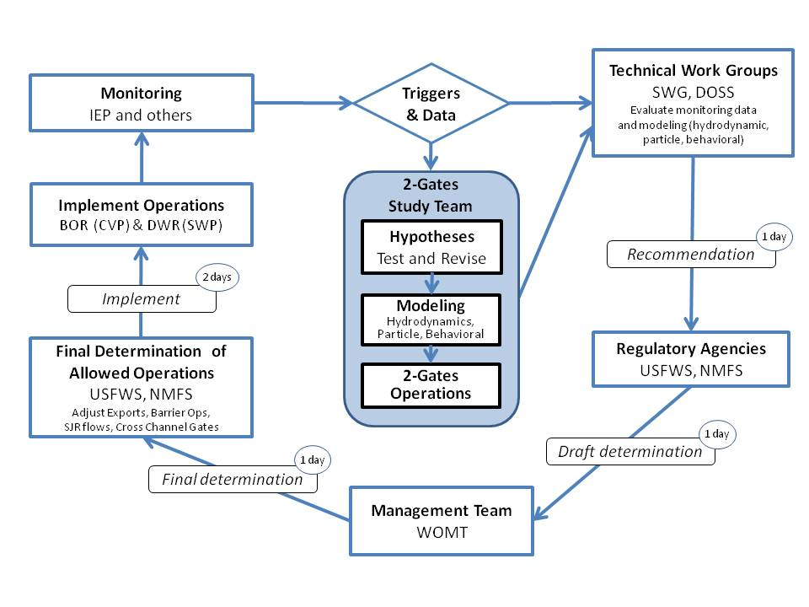

Figure E-6 Framework for Decision Making, Operations and Monitoring
Table E-9 Delta Smelt Risk Assessment Matrix (DSRAM) – Triggers for FWS BO RPA* and for 2-Gates Project
Triggers | December | January | February | March | April | May | June | July
Life Stage | Adults | Adults | Adults | Adults and Larvae | Adults and Larvae | Larvae and Juveniles | Larvae and Juveniles | Juveniles
Previous Year’s Fall  Midwater Trawl (FMWT) Recovery Index | Index below 74 | Index below 74 | Index below 74 | Index below 74 | Index below 74 | Index below 74 | Index below 74 | Index below 74
Risk of Entrainment |  |  |  | X2 upstream of Chipps Island and temps are ≥12° | X2 upstream of Chipps Island and temps are between 12° and 18°C | X2 upstream of Chipps Island and mean delta-wide temps <18°C and south delta temps below 28°C | X2 upstream of Chipps Island and temps are below 28°C | X2 upstream of Chipps Island and temps are below 28°C
Duration of Spawning period (number of days temperatures are between 12 and 18°C) |  |  |  |  | 39 days or less by April 15 | 50 days or less by May 1
Spawning Stage as determined by spring Kodiak trawl and/or salvage |  |  | Presence of Adults at spawning stage ≥ 4 | Adult spawning stage ≥ 4 | Adult spawning stage ≥ 4
smelt distribution (Spring Kodiak Trawl SKT) | SKT | SKT | SKT | See footnote #5 or negative 20mm centroid or low juvenile abundance | Negative 20mm centroid or low juvenile abundance | Negative 20mm centroid or low juvenile abundance | Negative 20mm/summer townet centroid or low juvenile abundance | Negative 20mm/summer townet centroid or low juvenile abundance
Salvage Trigger (Dec-Mar = ratio of adult salvage (FMWT) | Adult concern level calculation | Adult concern level calculation | Adult concern level calculation | Adult concern level calculation |  | If salvage is above zero | If salvage is above zero
Triggers for 2-Gates Project
Turbidity | >12 NTU @ Jersey Point | >12 NTU @ Jersey Point | >12 NTU @ Jersey Point
Larval and Juvenile (Temperature) |  |  |  | Temps ≥12°C |  |  | Temps 12°C - 25°C
* From Appendix A of FWS OCAP BO (FWS 2008a)

Table E-10 Delta Smelt Risk Assessment Matrix (DSRAM) – Tools for Change for FWS BO RPA* and for 2-Gates Project
Tools for Change* | December | January | February | March | April | May | June | July
Export reduction at one or both facilities | X | X | X | X | X | X | X | X
Change in barrier operations |  |  |  |  |  | X | X | X
Change in San Joaquin River flows |  |  |  | X | X | X | X | X
Change in position of cross channel gates |  |  |  |  |  | X | X
NEW for 2-Gates Project  Change in gate operations on Old and/or Connection Slough/Middle Rivers | X | X | X | X |  |  | X
*Tools for change are actions that the Smelt Working Group can recommend to the DATA and WOMT to help protect delta smelt.
Adapted from FWS 2008 OCAP BO, Attachment A

At this time the Project will not operate during the April 1to May 31 period to avoid potential adverse effects on emigrating salmon and steelhead. The Project will not change any conditions within the RPAs or operations specified in either the NMFS or FWS BOs.
RPA Component 1 Action 2 OMR flow requirements do not apply whenever a three day flow average is greater than or equal to 90,000 cfs in Sacramento River at Rio Vista and 10,000 cfs in San Joaquin River at Vernalis. Once such flows have abated, OMR flow requirements of the Action are again in place (USFWS 2008b).
OMR flows for this and all relevant actions would be measured at the Old River at Bacon Island and Middle River at Middle River stations, as has been established already by the Interim Order. OMR flow requirements are generally measured as 14-day running average, with a simultaneous 5-day running average within 25 percent of the 14-day flow requirement.
RPA Action 2 OMR flow requirements do not apply whenever a three day flow average is greater than or equal to 90,000 cfs in Sacramento River at Rio Vista and 10,000 cfs in San Joaquin River at Vernalis. Once such flows have abated, OMR flow requirements of the Action are again in place (FWS 2008b).
OMR flows for this and all relevant actions will be measured at the Old River at Bacon Island and Middle River at Middle River stations, as has been established already by the Interim Order.
Monitoring sites for turbidity distribution along Old and Middle Rivers include existing stations (OR at Franks Tract, Holland Cut, OR at Bacon Island, MR at Columbia Cut, MR at Bacon Island, and Victoria Canal), and new stations that will be established (OR at Old River gate, OR at Woodward Island, OR at Victoria Island, MR at Connection Slough gate, MR at Woodward Island, MR at Victoria Island).

