Appendix I
Summer and Spring Rare Plant Surveys
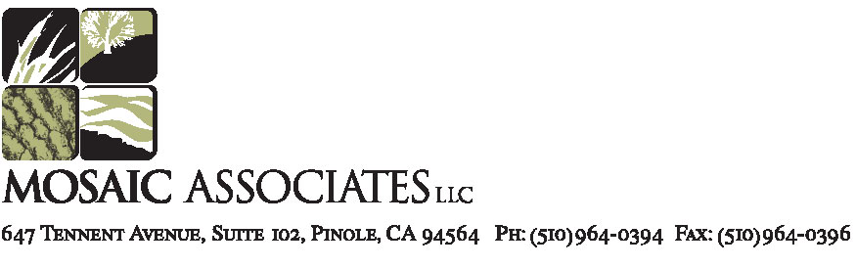

October 7, 2009

Ara Azhderian
San Luis and Delta Mendota Water Authority
PO Box 2157
Los Banos, CA 93635

RE: Summer, Fall and Spring Rare Plant Surveys, Two Gates Project Locations, Bacon Island and Holland Tract, San Joaquin and Contra Costa Counties

Dear Ara:

This report contains the findings of the summer, spring, and/or fall rare plant surveys that were conducted for the 2-Gates Project Locations on Bacon Island, Mandeville Island, and Holland Tract, San Joaquin and Contra Costa Counties (“the study area”, Figure 1). Mosaic Associates conducted a summer rare plant survey on September 23 and 29, 2008, a spring rare plant survey on June 24, 2009, and a fall survey on October 6, 2009 (on Mandeville Island) during daylight hours. The completion of these surveys is intended to partially satisfy the Environmental Commitments set forth in the Environmental Assessment for the 2-Gates Project. With the completion of the fall botanical survey on Mandeville, the only remaining survey for rare plants within the study area for the 2-Gates Project is a spring survey on Mandeville Island.

METHODS

Amy Richey of Mosaic Associates and Tom Mahony of Coast Range Biological carried out botanical surveys timed to coincide with the blooming periods for target species on September 23 and 29, 2008 and on June 24. Mr. Mahony conducted the survey on Mandeville Island on October 6, 2009. The surveys were conducted according to California Department of Fish and Game (CDFG 2000) and United States Fish and Wildlife Service (USFWS 2000) protocols. During the surveys, a meandering transect method was employed, in which all plant species detected were identified and recorded. Plants were identified to species using the Jepson Manual (Hickman 1993) where necessary.

Through a review of the California Natural Diversity Data Base (CNDDB 2008), the CDFG list of State and Federally listed rare plants (CDFG 2008b), and the California Native Plant Society’s Inventory of Rare and Endangered Plants (CNPS 2008), 18 special-status plant species were considered for their potential to occur on the study area. A complete list of these species, their habitat affinities, and blooming periods, is included as Table 2. Ten of these species were ruled out due to absence of suitable habitat.

Plants that rate a “Moderate” or higher likelihood of presence, based on an analysis of the habitats present within the study area, and upon documented occurrences of the species within the study area and within the four-quad search area surrounding the project sites, merit the conduct of rare plant surveys. The following eight special-status plant species with a moderate or higher potential to occur with in the study area were identified:

- bristly sedge (Carex comosa): Has same habitat requirements as Carex vulpinoidea, which has been documented on the project site. Flowering Period: May-Sep.
- brown fox sedge (Carex vulpinoidea): has been documented on project site (in 2002). Flowering Period: May-Jun. This plant was observed on the levee margin of Bacon Island at Old River during the June 2009 rare plant survey.
- woolly rose-mallow (Hibiscus lasiocarpus): This plant was observed on the levee margin of Bacon Island at Old River during the September 2008 rare plant survey. It has been documented within the islands of Old River nearby the study area, and on the levee margins just south of study area. Flowering Period: June-Sept.
- Mason's lilaeopsis (Lilaeopsis masonii): 68 records within the four-quad search; and 4 within the study area. Flowering Period: Apr-Nov.
- Delta mudwort (Limosella subulata): Mudflat habitats available for this species are absent in the levee areas. Absence of such mudflat habitat greatly reduces the likelihood of this species’ presence, and it was not observed during the summer or spring rare plant surveys. Additionally, the nativity of this species is under scrutiny; the Jepson manual lists it as a non-native. Flowering Period: May-Sep.
- eel-grass pondweed (Potamogeton zosteriformis): may occur in aquatic habitats on site, though none was observed during the summer or spring rare plant surveys. Flowering Period: Jun-Jul.
- marsh skullcap (Scutellaria galericulata): Occurs in marshes and swamps, suitable habitat is present on levee margins, though none was observed during the summer or spring rare plant surveys. Flowering Period: Jun-Sep.
- side-flowering skullcap (Scutellaria lateriflora): Occurs in marshes and swamps, suitable habitat is present on levee margins, though none was observed during the summer rare plant survey. Flowering Period: Jul-Sep.
- Suisun Marsh aster (Symphyotrichum lentum): This species occurs on the levee margins of Old River, with one individual on the Bacon Island side, and several dispersed on the Holland Tract side. It has been documented near the project site in Old River islands. Flowering Period: May-Nov.

SITE LOCATION AND DESCRIPTION

The study areas are located on Holland Tract, Bacon Island, and Mandeville Island in Contra Costa and San Joaquin Counties. Portions of the study areas are used for levee maintenance or agriculture, while other areas are fallow. Surrounding land use is primarily agricultural. The Old River flows between Holland Tract and Bacon Island to the west of Bacon Island, while Connection Slough flows between Bacon Island and Mandeville Island to the north of Bacon Island. The project areas have level topography, except on the levee sides.

The study area on Bacon Island at Old River contains two disused two-story wood frame farm residences. There are no structures present within the study areas on Holland Tract or Mandeville Island. The Mandeville Study Area is actively farmed with corn and is grazed with sheep.

Vegetation

Vegetation in the study area is dominated by ruderal herbaceous vegetation and agricultural cropland. Other habitat types present within the study area include ruderal scrub, Coastal and Valley Freshwater Marsh, seasonal wetland, mixed riparian woodland, and planted trees. The ruderal herbaceous type would correspond most closely to Holland’s (1986) Pasture series (11206), or to Sawyer and Keeler-Wolf’s (1995) California annual grassland series. Dominant herbaceous species observed in the ruderal herbaceous areas included ripgut brome (Bromus diandrus), poison hemlock (Conium maculatum), Bermuda grass (Cynodon dactylon), Mediterranean mustard (Hirschfeldia incana), field bindweed (Convolvulus arvensis) and field radish (Raphanus sativus), and stinging nettle (Urtica dioicia).

Our survey focused on the Coastal & Valley Freshwater Marsh vegetation type located on the river side of the levee margins. This series is dominated by cattails and tules up to 4 meters tall, and is most extensive in the upper portion of the Sacramento-San Joaquin River Delta. It is common in the Sacramento and San Joaquin Valleys in river oxbows and other areas on the flood plain (Holland 1986). Narrowleaf cattail (Typha angustifolia) and tule rush (Schoenoplectus acutus) are among the dominant hydrophytic vegetation along the levee margins of Connection Slough and Old River.

Seasonal Wetland. Seasonal wetlands occur throughout the study areas in a variety of geomorphic settings including swales, shallow concave basins, and creek channels; primarily in areas with concave topography and fine textured and/or compacted soils which impede surface water infiltration, or allow groundwater infiltration to occur. The seasonal wetlands on Bacon Island near Connection Slough were located in a shallow basin that is sparsely vegetated. Species that did occur in the basin or near the margin included Bermuda grass, umbrella sedge (Cyperus eragrostis), knotweed (Polygonum arenastrum), and an unidentified plant that may be dogbane (Apocynum cannabinum). On Bacon Island near Old River, the seasonal wetlands were dominated by Bermuda grass and water smartweed (Polygonum amphibium).

Mixed Riparian Woodland. Although not specifically described in Holland (1986), mixed riparian woodland consists of annual and perennial native and non-native riparian herbaceous and woody species. This vegetation type is typically found along stream and river banks, on terraces adjacent to floodplains, and along perennial or intermittent streams, gullies, springs or seeps. On site, the mixed riparian woodland would conform most closely to Holland’s Great Valley Willow Scrub, described as “An open to dense, broadleafed, winter-deciduous shrubby streamside thicket dominated by any of several Salix species. Dense stands usually have little understory or herbaceous component. More open stands have grassy understories, usually dominated by introduced species” (Holland 1986). Mixed riparian woodland on Bacon Island occurs near the Old River and includes mostly shrubby willows (Salix sp.), the majority of which are not tall in stature, but do form a dense stand.

Planted Trees. In a small area around the abandoned farmhouse, on Bacon Island, Old River, several planted trees are present, including cottonwood (Populus fremontii), apple (Malus x domestica), and sweet almond (Prunus dulcis).

RESULTS

We detected three rare plant species on the river sides of the levees on Old River; one individual of wolly rose mallow (Hibiscus lasiocarpus) and one individual of brown fox sedge (Carex vulpinoidea) on Bacon Island, Old River, and several Suisun Marsh aster (Symphyotrichum lentum) individuals on Holland Tract and Bacon Island along Old River. No rare plants were detected within the project area on either the Mandeville or Bacon Island sides of Connection Slough.

A map displaying the locations of the rare plants is provided as Figure 2. A complete inventory of all plant species detected is included as Table 1.

The following four spring-blooming species with a moderate to high potential for occurrence were not detected during our surveys: bristly sedge (Carex comosa), Mason’s lilaeopsis (Lilaeopsis masonii), marsh skullcap (Scutellaria galericulata), and side-flowering skullcap (Scutellaria lateriflora). In relation to delta mudwort, although there are records in the vicinity, mudflat habitats available for this species are absent in the levee areas. Absence of such mudflat habitat greatly reduces the likelihood of this species’ presence, and it was not observed during the summer rare plant survey. Additionally, the nativity of this species is under scrutiny; the Jepson Manual (Hickman 1993) lists it as a non-native.

The eight summer-blooming special-status species with a very low or low potential to occur were not detected during our summer rare plant survey. These included: heartscale (Atriplex cordulata), San Joaquin spearscale (Atriplex joaquiniana), big tarplant (Blepharizonia plumosa), soft bird’s beak (Cordylanthus mollis ssp. mollis), Delta button-celery (Eryngium racemosum), Delta tule pea (Lathyrus jepsonii var. jepsonii), Delta mudwort (Limosella subulata), and Antioch Dunes evening-primrose (Oenothera deltoids ssp. howellii).

Sincerely,

Amy Richey
Mosaic Associates

Enclosures:
Literature Cited
Figure 1. Project Location Map
Figure 2. Habitat Types and Rare Plant Location Map
Table 1. List of Species Detected at the 2-Gates Study Area
Table 2. List of Potentially Occurring Special Status Plants

literature cited

California Department of Fish and Game (CDFG). 2000. Guidelines for Assessing the Effects of Proposed Projects on Rare, Threatened, and Endangered Plants and Natural Communities. State of California, The Resources Agency, Department of Fish and Game, December 9, 1983, Revised May 8, 2000

California Department of Fish and Game (CDFG). 2008. List of Terrestrial Natural Communities recognized by the California Natural Diversity Database. Natural Diversity Database, Wildlife and Habitat Data Analysis Branch. September.

California Department of Fish and Game (CDFG). 2008b. State and Federally Listed Endangered, Threatened, and Rare Plants of California. Habitat Conservation Division, California Natural Diversity Data Base. February.

California Native Plant Society (CNPS). 2008. Online Inventory of Rare and Endangered Plants of California. Sacramento, CA.

California Natural Diversity Data Base (CNDDB). 2008. Rare Find (computer application). California Department of Fish and Game.

Hickman, J.C. 1993. The Jepson Manual: Higher Plants of California. University of California Press, Berkeley, California. 1400 pp.

Holland, R. 1986. Preliminary Descriptions of the Terrestrial Natural Communities of California. California Department of Fish and Game, The Resources Agency. 156 pp.

Sawyer, J.O. and T. Keeler-Wolf. 1995. A Manual of California Vegetation. California Native Plant Society, Sacramento. 471 pp.

United States Fish and Wildlife Service (USFWS). 2000. Guidelines for Conducting and Reporting Botanical Inventories for Federally Listed, Proposed and Candidate Plants. January.
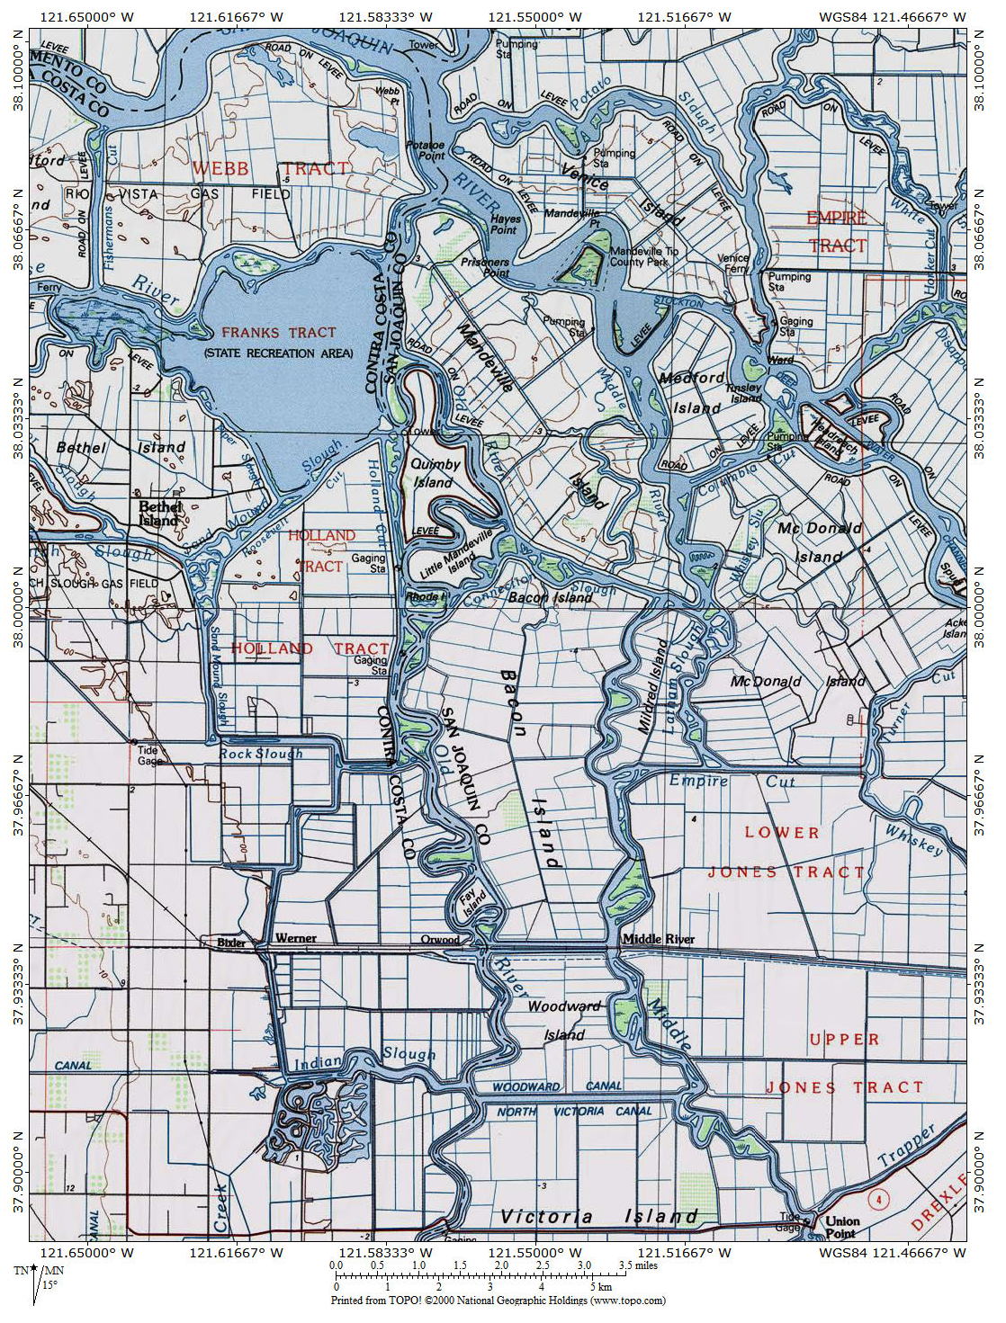
Figure 1. Project Location Map
Approximate locations of 2 Gates
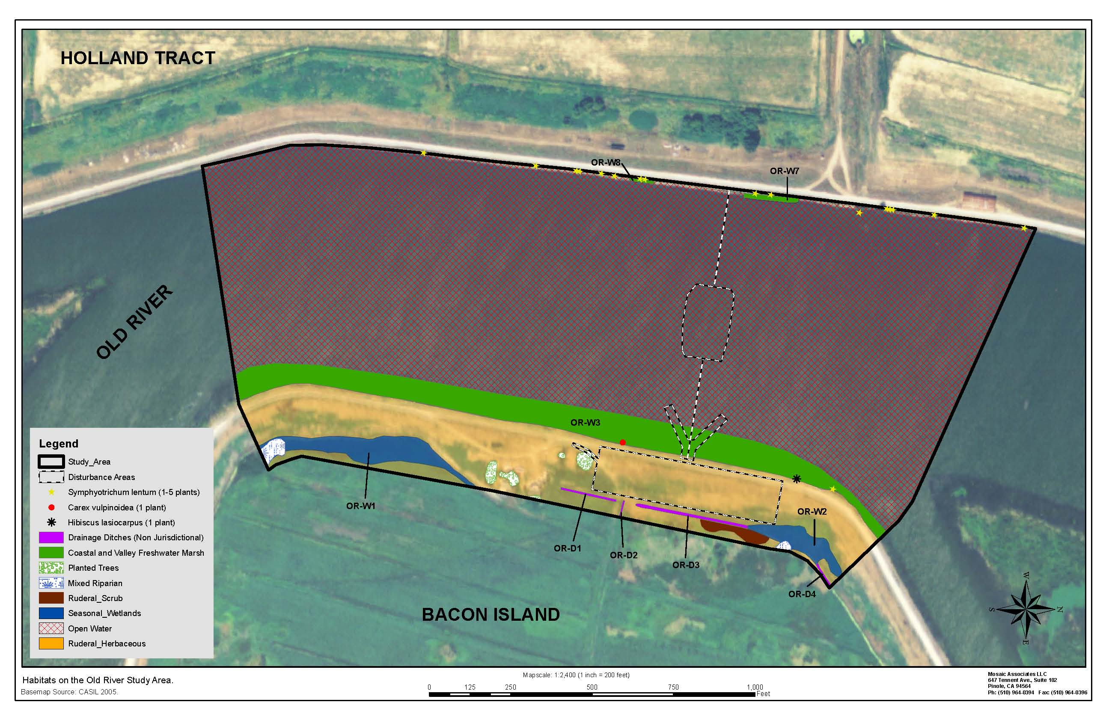
Figure 2. Habitat Types and Rare Plant Location Map. No rare plants were detected at the Connection Slough site.

Table 1: Plant Species Detected at the Two Gates Project Site

Family | Botanical Name | Common Name | Sep-08 | Jun-09 | Oct-09
Apiaceae | Conium maculatum | poison hemlock | x | x | x
Apiaceae | Foeniculum vulgare | fennel |  |  | x
Apocynaceae | Apocynum cannabinum | Indian hemp | x | x
Asteraceae | Artemisia douglasiana | mugwort | x | x
Asteraceae | Baccharis douglasii | marsh baccharis | x
Asteraceae | Baccharis salicifolia | mulefat | x
Asteraceae | Carduus pycnocephalus | Italian thistle | x | x
Asteraceae | Centaurea solstitialis | yellow starthistle | x | x | x
Asteraceae | Cirsium vulgare | bull thistle | x | x | x
Asteraceae | Conyza canadensis | horse weed | x | x | x
Asteraceae | Euthamia occidentalis | western goldenrod | x
Asteraceae | Gnaphalium canescens | white everlasting | x |  | x
Asteraceae | Heliantha annua | cultivated sunflower | x | x
Asteraceae | Heterotheca grandifolia | talegraph weed | x |  | x
Asteraceae | Lactuca serriola | prickly lettuce | x | x | x
Asteraceae | Picris echioides | bristly ox-tongue | x | x
Asteraceae | Salsola kali | tumbleweed | x | x
Asteraceae | Silybum marianum | milk thistle | x | x | x
Asteraceae | Sonchus asper | prickly sow thistle | x | x | x
Asteraceae | Symphyotrichum lentum | Suisun marsh aster | x
Asteraceae | Xanthium strumarium | common cocklebur | x | x
Asteraceae | Anthemis cotula | dog fennel |  | x
Asteraceae | Cotula coronopifolia | brass buttons |  | x
Boraginaceae | Heliotropium curassavicum | seaside heliotrope | x | x | x
Boraginaceae | Amsinckia menziesii cf | common fiddleneck |  | x
Brassicaceae | Brassica nigra | black mustard | x | x | x
Brassicaceae | Hirschfeldia incana | Mediterranean mustard | x | x | x
Brassicaceae | Lepidium latifolium | perennial pepperweed | x | x
Brassicaceae | Raphanus sativus | cultivated radish | x | x | x
Cactaceae | Opuntia ficus-indica | Indian Fig Opuntia | x | x
Caryophyllaceae | Spergularia rubra | Purple Sand Spurry |  | x
Chenopodiaceae | Chenopodium rubrum | red goosefoot | x | x | x
Convolvulaceae | Calystegia sepium ssp. limnophila | hedge bindweed | x | x | x
Convolvulaceae | Convolvulus arvensis | field bindweed | x | x | x
Cyperaceae | Cyperus eragrostis | umbrella sedge | x | x | x
Cyperaceae | Cyperus esculentus | yellow nutsedge | x
Cyperaceae | Schoenoplectus acutus | tule rush | x | x | x
Cyperaceae | Schoenoplectus californicus | California bull rush | x | x
Dryopteridaceae | Athyrium filix-femina | common ladyfern | x | x
Dryopteridaceae | Athyrium felix-femina | common ladyfern | x | x
Equisetaceae | Equisetum arvense | common horsetail | x
Euphorbiaceae | Eremocarpus setigerus | turkey mullein | x | x
Fabaceae | Lotus corniculatus | birdsfoot trefoil | x | x
Fabaceae | Medicago sativa | alfalfa | x |  | x
Fabaceae | Melilotus albus | sweet white clover | x | x
Geraniaceae | Erodium cicutarium | redstem filaree |  | x
Iridaceae | Iris pseudacorus | yellow iris | x | x | x
Juglandaceae | Juglans regia | English walnut | x | x
Juncaceae | Juncus effusus | common rush | x | x | x
Lamiaceae | Mentha arvensis | wild mint | x | x | x
Lamiaceae | Stachys albens | whitestem hedgenettle | x
Malvaceae | Hibiscus lasiocarpus | woolly rose mallow | x | x
Malvaceae | Malva sp. cf |  | x | x | x
Malvaceae | Malvella leprosa | alkali mallow |  |  | x
Moraceae | Ficus L. | fig tree | x | x
Onagraceae | Epilobium ciliatum | fringed willowherb | x | x
Onagraceae | Ludwigia peploides | floating primrose-willow | x | x
Plantaginaceae | Plantago major | common plantain |  | x
Poaceae | Arundo donax | giant reed | x | x
Poaceae | Bromus diandrus | ripgut brome | x | x | x
Poaceae | Cortaderia jubata | pampas grass | x | x
Poaceae | Cynodon dactylon | Bermuda grass | x | x | x
Poaceae | Cynosurus echinatus | hedgehog dogtail |  |  | x
Poaceae | Elymus sp. cf |  | x
Poaceae | Hordeum murinum | mouse barley | x | x | x
Poaceae | Lolium multiflorum | Italian ryegrass | x | x
Poaceae | Paspalum dilatatum | Dallis grass | x | x
Poaceae | Polypogon australis | Chilean rabbitsfoot grass | x | x
Poaceae | Sorghum halpense | Johnson grass | x | x | x
Poaceae | Avena fatua | wild oat |  | x
Poaceae | Distichlis spicata | inland saltgrass |  | x
Poaceae | Hordeum marinum | Mediterranean barley |  | x
Poaceae | Polypogon monspeliensis | rabbitsfoot grass |  | x
Polygonaceae | Polygonum amphibium | water smartweed | x | x | x
Polygonaceae | Polygonum arenastrum | common knotweed | x | x | x
Polygonaceae | Polygonum hydropiperoides | waterpepper | x |  | x
Polygonaceae | Rumex crispus | curly dock | x |  | x
Polygonaceae | Rumex pulcher | fiddle dock | x |  | x
Pontederiaceae | Eichhorinia crassipes | water hyacinth | x | x | x
Potamogetonaceae | Potamogeton sp. | pond weed | x
Rosaceae | Malus x domestica | cultivated apple | x
Rosaceae | Prunus dulcis | sweet almond | x | x
Rosaceae | Rubus discolor | Himalayan blackberry | x | x | x
Rosaceae | Rubus ursinus | California blackberry | x | x
Rubiaceae | Cephalanthus occidentalis var. californicus | California buttonwillow | x | x
Salicaceae | Populus fremontii | Fremont cottonwood | x | x
Salicaceae | Salix exigua | narrow-leaved willow | x | x
Salicaceae | Salix laevigata | red willow | x | x | x
Salicaceae | Salix lasiolepis | arroyo willow | x | x
Solanaceae | Petunia parviflora | wild petunia | x
Solanaceae | Solanum sp. | nightshade | x | x
Typhaceae | Typha latifolia | broad-leaf cattail | x | x
Typhaceae | Typha angustifolia | narrow-leaved cattail |  |  | x
Urticaceae | Urtica dioicia | stinging nettle | x | x | x

Table 2. Potentially Occurring Special-Status Plant Species at the Two Gates Project Area, Bacon Island , Holland Tract, and Mandeville Island, San Joaquin and Contra Costa Counties, California.

Special-Status Plant Species Identified within the Bouldin Island, Woodward Island, Jersey Island, and Brentwood 7.5 minute Quadrangles Containing the Project Sites and Vicinity
Common Name  Scientific Name | Habitat Affinities | Blooming Period |  | Potential To Occur in Study Area | Listing Status¹
 |  |  |  |  | Federal | State | CNPS
heartscale  Atriplex cordulata | Chenopod scrub, Meadows and seeps, Valley and foothill grassland(sandy)/saline or alkaline |  | Apr-Oct | Very low. Some very marginal habitat present, but no alkaline soils observed. | – | – | List 1B
San Joaquin spearscale  Atriplex joaquiniana | Chenopod scrub, Meadows and seeps, Playas, Valley and foothill grassland/alkaline |  | Apr-Oct | Very low. Some very marginal habitat present, but no alkaline soils observed. | – | – | List 1B
big tarplant  Blepharizonia plumosa | Valley and foothill grassland |  | Jul-Oct | Very low. Some very marginal habitat present, but no occurrences reported. Grasslands on site receive regular disking. | – | – | List 1B
round-leaved filaree  California macrophylla | Cismontane woodland, Valley and foothill grassland/clay |  | Mar-May | Low. Grasslands on site receive regular disking. | – | – | List 1B
bristly sedge  Carex comosa | Coastal prairie, Marshes and swamps(lake margins), Valley and foothill grassland |  | May-Sep | Moderate. Suitable habitat present in levee margins. | – | – | List 2
brown fox sedge  Carex vulpinoidea | Marshes and swamps(freshwater), Riparian woodland |  | May-Jun | Moderate to High. Observed on study area (Old River). Has potential to occur on levee margins. | – | – | List 2
soft bird's-beak  Cordylanthus mollis ssp. mollis | Marshes and swamps(coastal salt) |  | Jul-Nov | Very Low. Other halophytes do not occur in the study areas. | FE | SR | List 1B
Delta button-celery  Eryngium racemosum | Riparian scrub(vernally mesic clay depressions) |  | Jun-Sep | Low. Marginal habitat present. | -- | SE | List 1B
woolly rose-mallow  Hibiscus lasiocarpus | Marshes and swamps(freshwater) |  | Jun-Sep | High. Observed on Bacon Island at Old River. Documented as occurring in islands of Old River in 1992. Has potential to occur on levee margins. | – | – | List 2
Delta tule pea  Lathyrus jepsonii var. jepsonii | Marshes and swamps(freshwater and brackish) |  | May-Jul(Sep) | Low. Has potential to occur on levee margins. | – | – | List 1B
Mason's lilaeopsis  Lilaeopsis masonii | Marshes and swamps(brackish or freshwater), Riparian scrub |  | Apr-Nov | Moderate to High. Documented as occurring on study area (Old River); has potential to occur on levee margins. | – | SR | List 1B
Delta mudwort  Limosella subulata | Marshes and swamps |  | May-Aug | Low. Documented as occurring near study area; suitable mudflat habitat not present; has potential to occur on levee margins, though mudflat habitat does not occur. | – | – | List 2
Antioch Dunes evening-primrose Oenothera deltoides ssp. howellii | Inland dunes |  | Mar-Sep | None. Dune habitats not present within the study areas. | FE | SE | List 1B
eel-grass pondweed  Potamogeton zosteriformis | Marshes and swamps(assorted freshwater) |  | Jun-Jul | Moderate. Suitable habitat present within aquatic habitats. | – | – | List 2
marsh skullcap  Scutellaria galericulata | Lower montane coniferous forest, Meadows and seeps(mesic), Marshes and swamps |  | Jun-Sep | Moderate. Suitable habitat present in levee margins. | – | – | List 2
side-flowering skullcap  Scutellaria lateriflora | Meadows and seeps(mesic), Marshes and swamps |  | Jul-Sep | Moderate. Suitable habitat present in levee margins. | – | – | List 2
Suisun Marsh aster Symphyotrichum lentum | Marshes and swamps(brackish and freshwater) |  | May-Nov | Moderate to High. Observed on Old River Study Area; suitable habitat present in levee margins. | – | – | List 1B
caper-fruited tropidocarpum Tropidocarpum capparideum | Valley and foothill grassland(alkaline hills) |  | Mar-Apr | Very low. No alkaline soils observed. | – | – | List 1B
¹ FE = federally listed as endangered; SE = state listed as endangered; SR = state listed as rare; List 1B = rare, threatened, or endangered in California and elsewhere; List 2 = Rare, threatened, or endangered in California, but more common elsewhere.
Source: CNDDB 2008. Data compiled by Mosaic Associates in 2008.

