ATTACHMENT a
Sacramento-San Joaquin Delta Turbidity Modeling

RMA

RESOURCE MANAGEMENT ASSOCIATES, INC.

FAIRFIELD, CALIFORNIA

TECHNICAL MEMORANDUM

Sacramento-San Joaquin Delta Turbidity Modeling

Prepared For:
Metropolitan Water District of Southern California

October 2008

Introduction
Metropolitan Water District of Southern California (MWD) has funded development of a smelt behavior model that imparts a habitat seeking behavior on the particles in the RMA-2 hydrodynamic model. This model uses salinity, represented as electrical conductivity (EC), and turbidity gradients as well as hydrodynamics to drive smelt movement. To achieve reasonable smelt behavior patterns, the model must first produce reasonable hydrodynamic, EC and turbidity results. The model has been extensively calibrated for hydrodynamics and EC during previous studies. This document serves to describe the simulation and reconnaissance level calibration of turbidity using the RMA Bay-Delta models.

Background
To date, all of the models for near-term Delta solutions have simulated Delta smelt as neutrally buoyant particles. While this may be true for the larval stage, swimming behavior becomes important as the fish mature. Swimming behavior of adult fish is not well understood at this time. Analyses of adult Delta Smelt take at the primary export locations by David Fullerton with MWD have suggested that the magnitude of the take is significantly impacted by salinity and turbidity distributions. It is hypothesized that that the adult smelt may be “surfing” the tides as a means of staying within their desirable habitat range.

Objectives
The objective of this effort is to calibrate the turbidity model to the best available in-Delta turbidity data so that reasonably accurate turbidity simulation results can be provided to the RMA Delta smelt behavior model.

Numerical Models
The RMA suite of finite element hydrodynamic and water quality models employed for this study have been used extensively since 1977 in engineering applications to examine flow and transport of constituents in surface water systems (RMA, 1997; 1998a; 1998b; 1999; 2001; 2003). One of the unique characteristics of the suite of models is the ability to represent a physical system using 1, 2, and/or 3 dimensional approximations within a single computational network. This allows construction of efficient computational networks where the level of spatial resolution varies according to the needs of the problem. Originally developed with the support of the U.S. Army Corps of Engineers Waterways Experiments Station, the models have undergone continued development and refinement by RMA. One of the most important additions has been the capability to accurately represent wetting and drying in shallow estuaries (RMA, 2001).

The RMA finite element model of the San Francisco Bay and Sacramento – San Joaquin Delta has been calibrated and refined through many previous studies (for a detailed description of the latest and most rigorous calibration effort, see http://rmanet.com/zip/ FloodedIslandsCalibrationFinalReport-2005-06-30.zip).

Hydrodynamics have been simulated for this study using RMA-2, a two-dimensional depth-averaged finite element model that solves the shallow water equations to provide temporal and spatial descriptions of velocities and water depths throughout the regions of interest. The model uses the Smagorinski formulation for modeling of turbulent momentum transfer (King et al., 1975). RMA-2, capable of simulating the de-watering of tidal flats, is uniquely suited for modeling of inter-tidal hydrodynamics in the marshes and mudflats that characterize boundaries of the Bay-Delta.

RMA-11 has been successfully applied in numerous previous projects to simulate the fate and transport of sediments and other conservative and non-conservative water quality constituents in surface water systems. Velocities and water depths obtained from hydrodynamic model results are used to solve the advection-dispersion equation for each constituent simulated. RMA-11 has been designed for compatibility with model results obtained from one-, two-, or three-dimensional hydrodynamic simulations (US Army Corps of Engineers, 1997).

Model Configuration
The RMA finite element model of the Bay-Delta, shown in Figure 1-1, extends from the Martinez to the confluence of the American and Sacramento Rivers, and to Vernalis on the San Joaquin River. A two-dimensional depth-averaged approximation is used to represent the Suisun Bay region, the Sacramento-San Joaquin confluence area, Sherman Lake, the Sacramento River up to Rio Vista, Big Break, the San Joaquin River up to its confluence with Middle River, False River, Franks Tract and surrounding channels, Old River south of Franks Tract, and the Delta Cross Channel area. The Delta channels and tributary streams are represented using a one-dimensional cross-sectionally averaged approximation.

The size and shape of elements are dictated by changes in bottom elevation and other hydraulic and salinity considerations. Wetting and drying of the tidal mudflats has been represented in sufficient detail to provide a good definition of change in the tidal prism with change in tidal stage.

Bottom elevations and the extent of mudflats were based on bathymetry data collected by National Oceanic and Atmospheric Administration (NOAA), California Department of Water Resources (DWR), U.S. Army Corps of Engineers (USACE) and U.S. Geological Survey (USGS). These data sets have been compiled by DWR and can be downloaded from DWR’s Cross Section Development Program (CSDP) website at http://baydeltaoffice.water.ca.gov/modeling/deltamodeling/models/csdp/index.html. Additional data were collected around Franks Tract by DWR and USGS in 2004. USGS 10 m resolution Delta Bathymetry grids were obtained from the Access USGS website at http://sfbay.wr.usgs.gov/access/Bathy/Delta/.

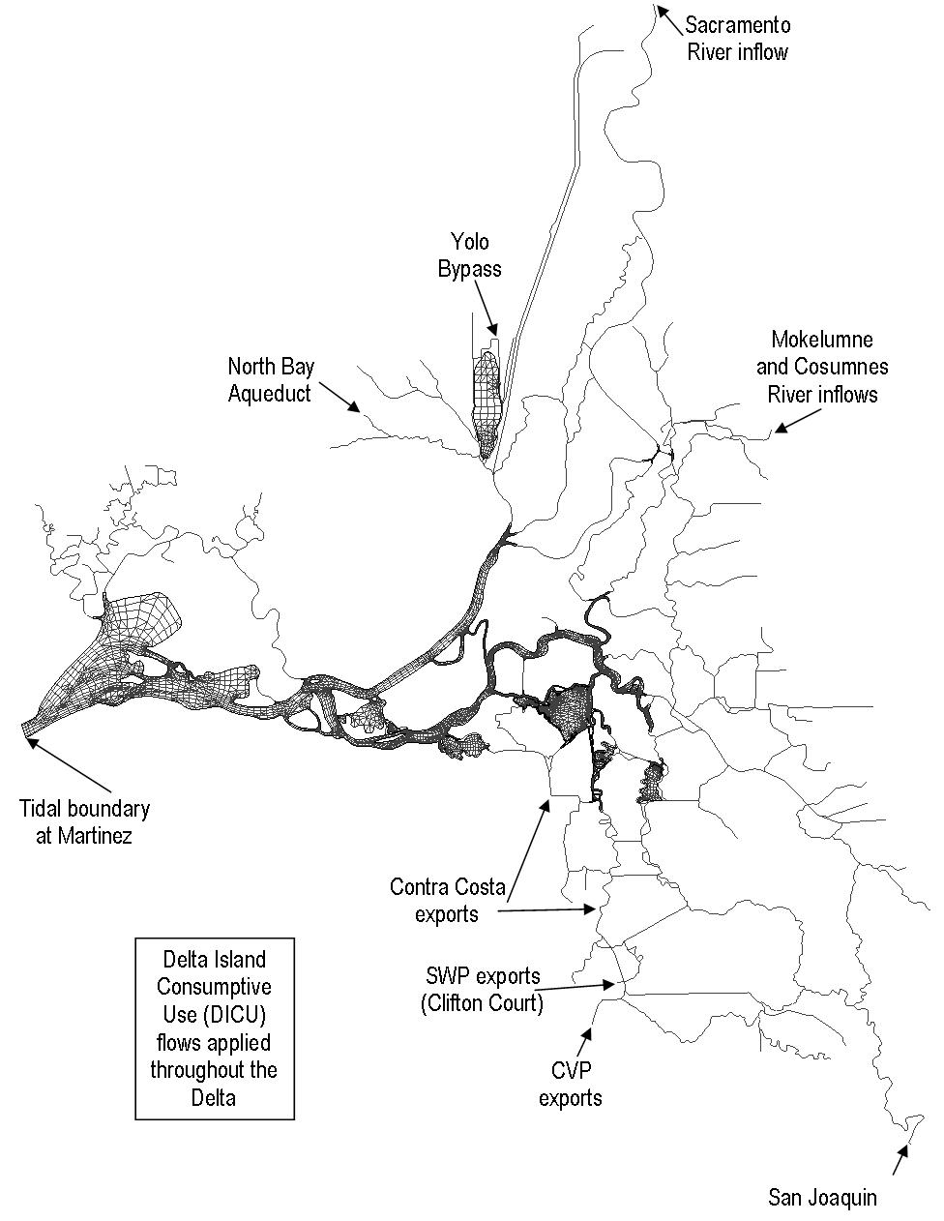
Figure 1-1 Finite element model configuration of the Sacramento – San Joaquin Delta.

Turbidity Simulation
Hydrodynamics and turbidity were simulated using the RMA Bay-Delta Model for the period of December 1, 2007 through March 31, 2008. This period was selected because much more in-Delta turbidity data were available than for earlier years, and because it was a period of interest with regard to Delta smelt behavior. During this time of high flows in Sacramento River and reverse flows in the south Delta, large smelt salvage spikes were seen at the south Delta export facilities. Increased turbidity resulting from the high flows is suspected to have contributed in part to the large smelt salvage numbers.

For earlier turbidity simulations used in the smelt behavior model, turbidity was simulated as a conservative constituent. In-Delta data for the time periods simulated (winters of 1999-2000 through 2003-2004) were not adequate to determine if this was a reasonable approximation. Therefore, the more recent period was selected, with sufficient data to perform a reconnaissance level calibration. The 2007-2008 turbidity was first simulated conservatively, however computed turbidity concentrations were found to be higher than observed at all monitoring stations.

A complete sediment transport simulation was not attempted for this study due to lack of data (e.g. particle size information) and limitations on time and budget. Rather, a reconnaissance level calibration of turbidity was performed using an exponential decay rate to approximate settling and other losses. An exponential decay rate was applied rather than a constant settling rate because it more closely approximates a sediment transport simulation, allowing more rapid decline in turbidity when concentrations are higher and particle sizes are larger.

Boundary Conditions
Boundary conditions for hydrodynamics include tidal elevations at the ocean boundary and tributary inflows to the system. Hydrodynamic boundary conditions for the 2007-2008 period were developed from available observed data provided by USGS, NOAA, Bay Delta and Tributaries Project (BDAT) and California Data Exchange Center (CDEC). Specific data sources are listed in Table 2-1.

Delta exports applied in the model include State Water Project (SWP), Central Valley Project (CVP), Contra Costa exports at Rock Slough and Old River intakes, and North Bay Aqueduct. Daily average export flows from CDEC are used for the CVP and North Bay Aqueduct. Contra Costa’s Old River export flows are from Contra Costa Water District (CCWD). Hourly SWP export flows are computed using gate flow equations (Hills, 1988) based on BDAT time series data of:

- water surface elevations outside Clifton Court Forebay;
- water surface elevations inside Clifton Court Forebay; and
- Gate opening height of the five Clifton Court Forebay Gates.

Turbidity simulations require specification of constant or time-varying concentration boundaries at Martinez and all inflow locations. Turbidity boundary conditions are developed from available observed data provided by CDEC. While building the turbidity data boundary conditions, abnormally large peaks were deleted from the datasets and the resulting gaps were estimated by linear regression. The values of turbidity at Sacramento River were used for Yolo Bypass, Cosumnes River, Mokelumne River and Calaveras because no data were available for these inflows. Time series of edited turbidity data applied to the model boundaries are plotted in Figure 2-2.

Permanent gates and temporary barriers represented in the model include the Delta Cross Channel (DCC), Old River near Tracy (DMC) barrier, Old River at Head barrier, Middle River barrier, Montezuma Slough salinity control gates, Grant Line Canal barrier, and Lawler buffer ditch culvert (see Figure 2-3). Historical gate and barrier operations were applied in the model.

Delta Island Consumptive Use (DICU) values were applied on a monthly average basis and were derived from monthly DSM2 input values (http://baydeltaoffice.water.ca.gov/modeling/deltamodeling/models/dicu/dicu.cfm).

Table 2-1 Inflows, outflows and turbidity data sources used to set model boundary conditions
Model Input Locations |  | BC type | Data Source | Monitoring Location | BC type | Data Source | Monitoring Location
Martinez |  | Tidal elevation | NOAA | Martinez | Turbidity | CDEC | Martinez
Sacramento River |  | Inflow | USGS | Sacramento River at Freeport | Turbidity | CDEC | Sacramento River at Hood
San Joaquin River |  | Inflow | USGS | San Joaquin River at Vernalis | Turbidity | CDEC | San Joaquin River at Mossdale
Yolo Bypass |  | Inflow | CDEC | Yolo Bypass at Lisbon | Turbidity | CDEC | Sacramento River at Hood
Cosumnes River |  | Inflow | CDEC | Cosumnes River at Michigan Bar | Turbidity | CDEC | Sacramento River at Hood
Mokelumne River |  | Inflow | CDEC | Camanche Reservoir Outflow | Turbidity | CDEC | Sacramento River at Hood
Calaveras |  | Inflow | CDEC | Mormon Slough at Bellota | Turbidity | CDEC | No boundary condition applied - set at ambient
SWP |  | Outflow | BDAT | Clifton Court | -- | -- | --
CVP |  | Outflow | CDEC | Tracy Pumping Plant | -- | -- | --
CCWD Rock Slough Intake |  | Outflow | CCWD | near Brentwood | -- | -- | --
CCWD Old River Intake |  | Outflow | CCWD | near Discovery Bay Flow diversion | -- | -- | --
North Bay Aqueduct |  | Outflow | CDEC | Barker Slough Pumping Plant | -- | -- | --

Figure 2-2 Boundary conditions of turbidity at Martinez, Sacramento River, and San Joaquin River.
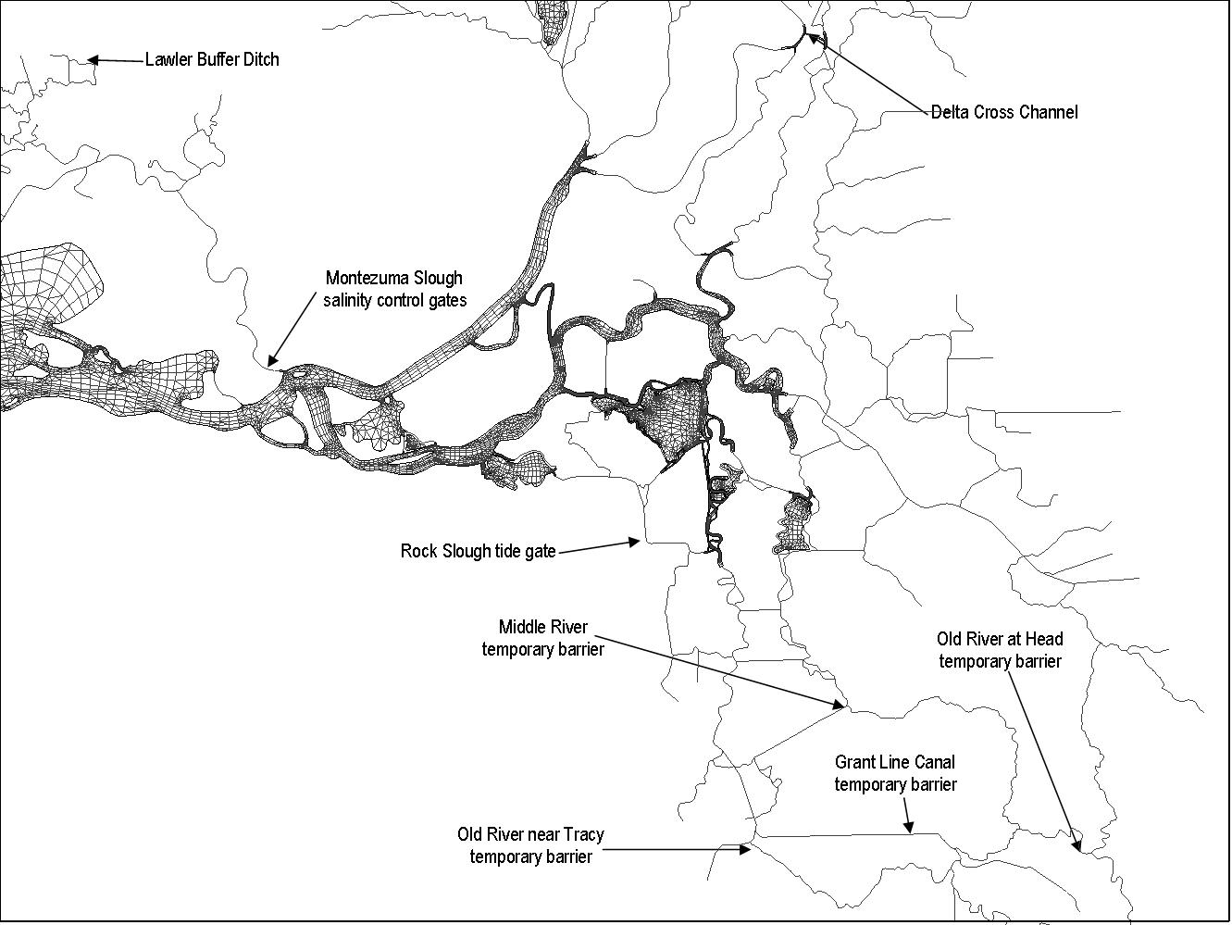
Figure 2-3 Gate and barrier locations.

Initial Conditions
The initial condition of turbidity in the Sacramento – San Joaquin Delta was set as a constant value of 10 NTU throughout the model grid.

Turbidity Calibration Results
Measured turbidity data from CDEC and BDAT were used for the model calibration. There were eleven turbidity monitoring stations with available data for the December 2007 – March 2008 calibration period. Locations are shown in Figure 2-4.

Through iterative calibration simulations, the decay rate found to result in the best overall fit with observed data was -0.05/day. The best fit was determined by visual inspection of the computed and observed turbidity time series.

Turbidity simulated as a conservative constituent and turbidity computed with the calibrated decay rate are plotted with the observed data in Figure 2-5 through Figure 2-15. Comparisons of computed and observed turbidity are shown with wind speed, wind direction, and local precipitation at False River, Holland Cut, and Old River in Figure 2-15 through Figure 2-17.

In general, the application of the decay rate brings computed turbidity concentrations to within reasonable agreement of observed data. At Mallard Island, Rio Vista, Antioch, Clifton Court, Grantline Canal and Rough and Ready Island, the computed results follow the trends of the observed data and are in reasonable agreement with the magnitude of the concentration. At several locations, short term differences between computed and observed turbidity appear to be related to smaller tributary inflows for which observed turbidity/suspended sediment data was not available and to resuspension events associated with strong winds in specific directions.

At Mallard Island, in Figure 2-5, calibrated turbidity reproduces the observed peaks in mid-January and early February, and is approximately 10 NTU higher and slightly out of phase with the peak in March. Calibrated turbidity generally falls 5 to 10 NTU below observed during the non-storm periods when turbidity concentrations are lower.

Figure 2-6 shows computed and observed turbidity at Rio Vista. At this station, data are available beginning in February. Calibrated turbidity is within the range of observed data throughout much of the simulation at this location. Computed turbidity peaks at the end of March are as much as 90 NTU higher than observed.

At Antioch, in Figure 2-7, calibrated turbidity is within the range of observed values during storm peaks, but falls below observed by as much as 15 NTU as concentrations decline following storms.

At Prisoners Point, in Figure 2-8, the computed result follows the trends of observed data, but is higher in magnitude by as much as 35 NTU. This location is likely influenced by boundary conditions applied to the east side rivers for which there were no data.

Rough and Ready island turbidity is plotted in Figure 2-9. At this location, compared to observed data there is a delay of several days in the rise of computed turbidity during the storms at the beginning and end of January. This indicates that there are turbidity inflows not included in the model, such as the Calaveras River and French Camp Slough that are causing the early increases. Where the model does show turbidity peaks, it is as much as 10 NTU higher than observed data during the early January peak and as much as 20 NTU higher than observed data during the early March peak. Observed data for the storm at the end of January appear to be unreliable.

At False River, Holland Cut, Old River at Bacon Island and Victoria Canal near Byron, (Figure 2-10 through Figure 2-13) the computed magnitudes of turbidity are generally in reasonable agreement with observed data, however there are some trends that the model does not reproduce. It is hypothesized that sediment resuspension induced by wind in Franks Tract and sediment laden local rainfall runoff may be at least partly the cause of the observed turbidity spikes that the model does not replicate. Plots of observed precipitation, wind speed and wind direction at the Twitchell Island CIMIS station compared with computed and observed turbidity in False River, Holland Cut and Old River at Bacon Island are shown in Figure 2-16, Figure 2-17 and Figure 2-18, respectively.

In False River (Figure 2-10), the model produces turbidity concentrations within 0 to 10 NTU for much of the simulation. As shown in Figure 2-16, the turbidity peaks missed by the model seem to correspond with winds blowing from about 150 degrees, or from the direction of Franks Tract. Precipitation events also correlate with the times of elevated turbidity. The lag between precipitation events and elevated turbidity could be due to natural runoff time or could result from pump out from Delta islands following storms.

At Holland cut in Figure 2-11, the model produces turbidity concentrations within 0 to 10 NTU for much of the simulation. As shown in Figure 2-17, the turbidity peaks missed by the model correlate well with winds blowing from about 350 degrees, or again, from the direction of Franks Tract. Precipitation does not seem to affect turbidity at this station.

At the Old River at Bacon Island station in Figure 2-12, the model produces turbidity concentrations within 0 to 10 NTU for much of the simulation. As seen in Figure 2-18, the turbidity peaks missed by the model show a delayed response from the wind and again, no correlation with precipitation data. This location reflects what is seen at Holland Cut, but the response is delayed and dampened.

This is similarly true at Victoria Canal (Figure 2-13) but with much more dampening. The computed turbidity peak at this location in late February is nearly 15 NTU higher than observed.

At the entrance to Clifton Court, shown in Figure 2-14, daily average computed turbidity tend to be lower than daily observed data by 5 to as much as 30 NTU. This station is also affected by the wind and/or precipitation generated turbidity.

Computed turbidity in Grantline Canal (Figure 2-15) is within the range of observed values throughout most of the calibration period. Computed turbidity does not rise as early or as gradually in response to storm events as observed data indicate.

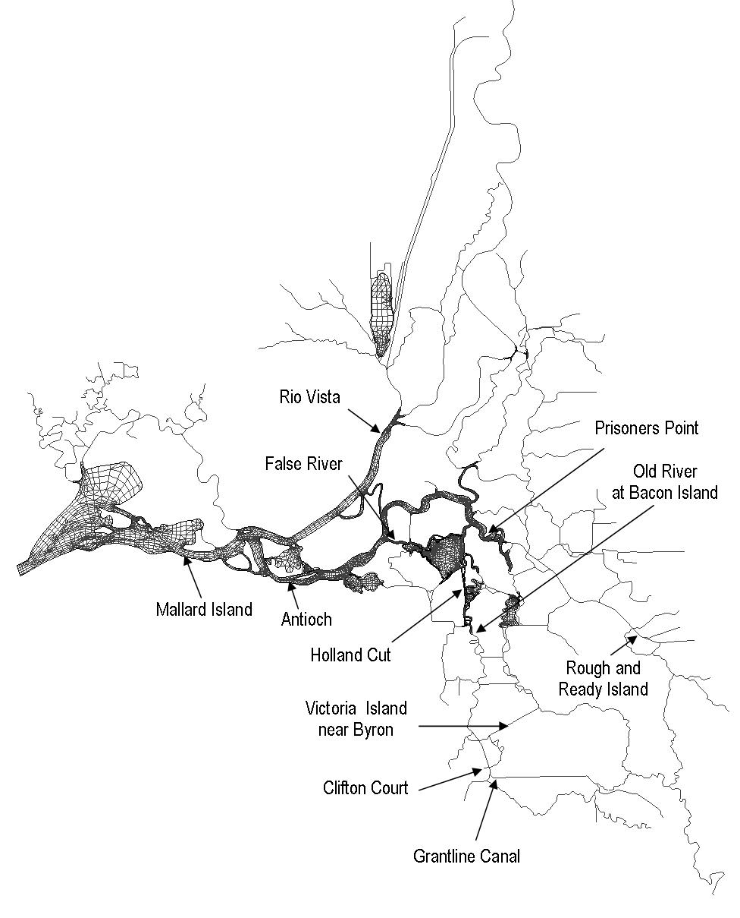
Figure 2-4 Locations of turbidity monitoring stations.

Figure 2-5 Observed and computed (conservatively and with decay) turbidity at Mallard Island.
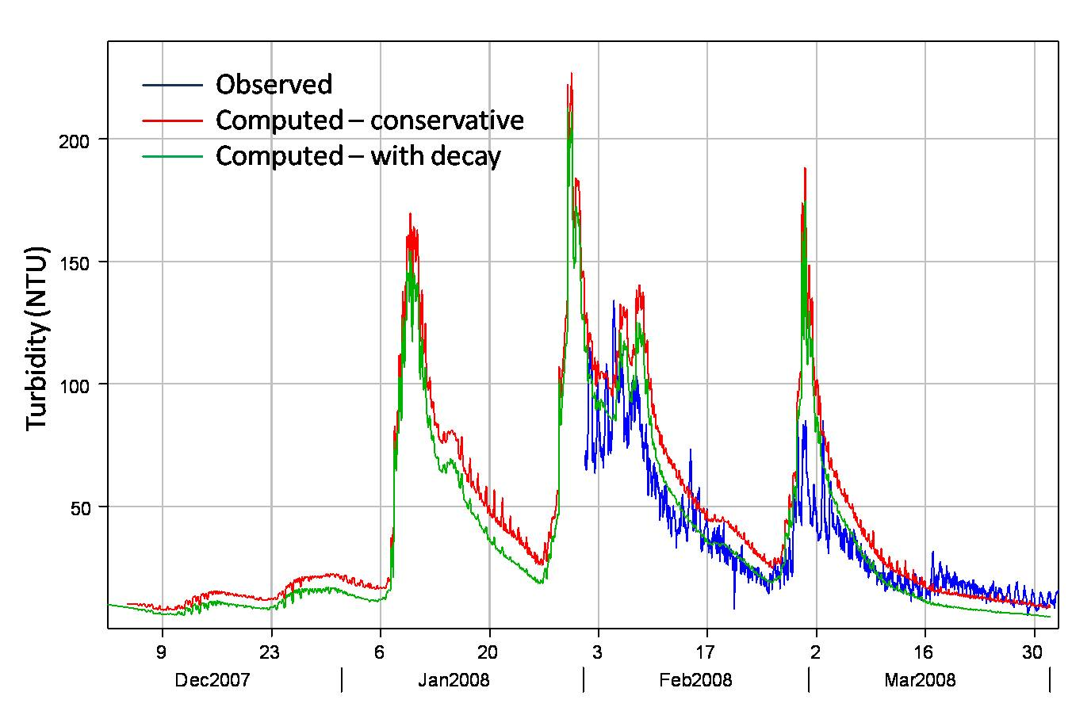
Figure 2-6 Observed and computed (conservatively and with decay) turbidity at Rio Vista.
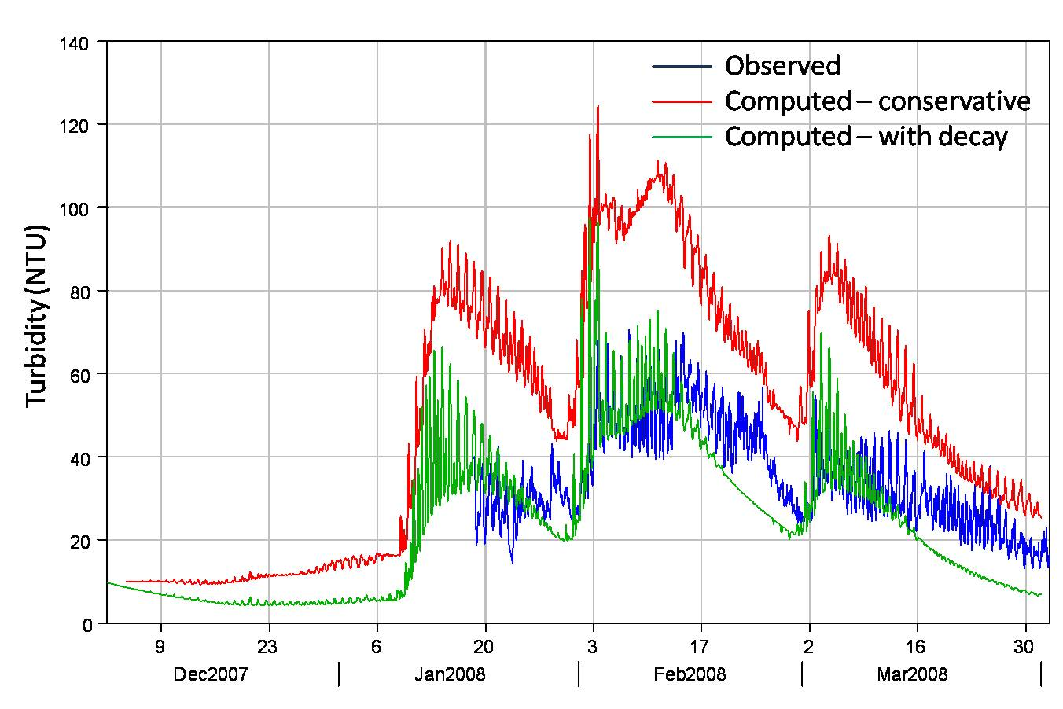
Figure 2-7 Observed and computed (conservatively and with decay) turbidity at Antioch.
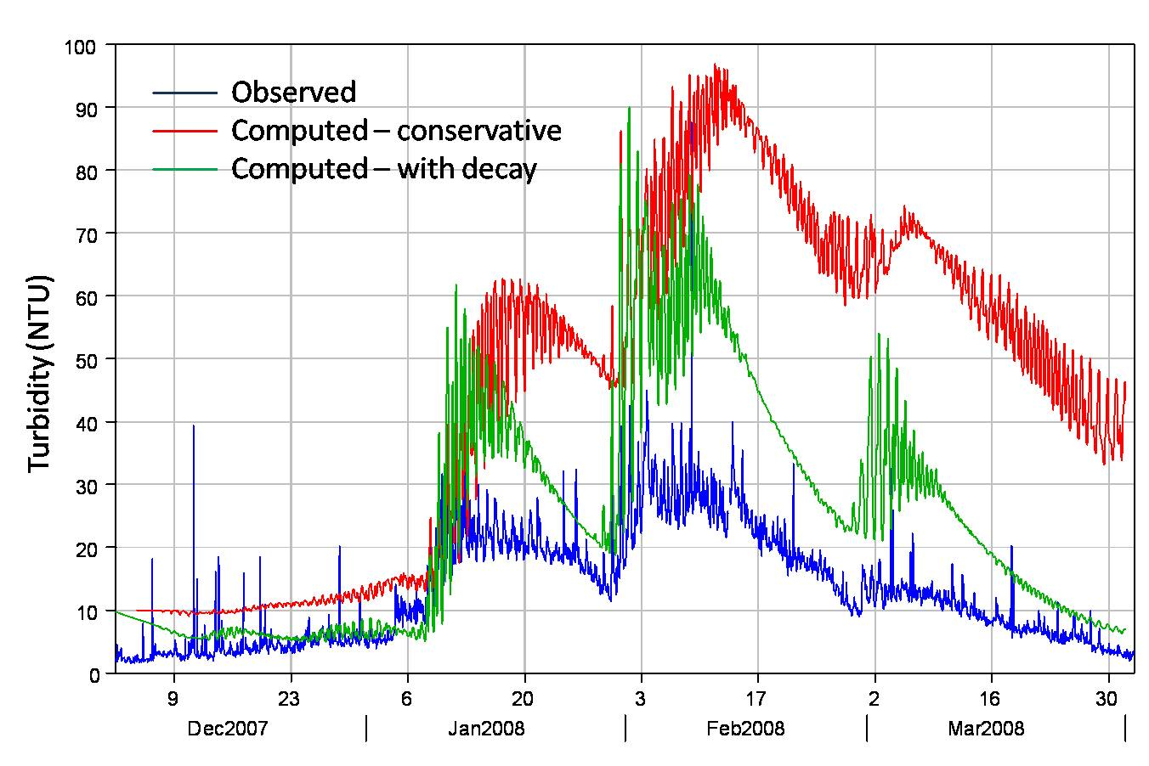
Figure 2-8 Observed and computed (conservatively and with decay) turbidity at Prisoners Point.
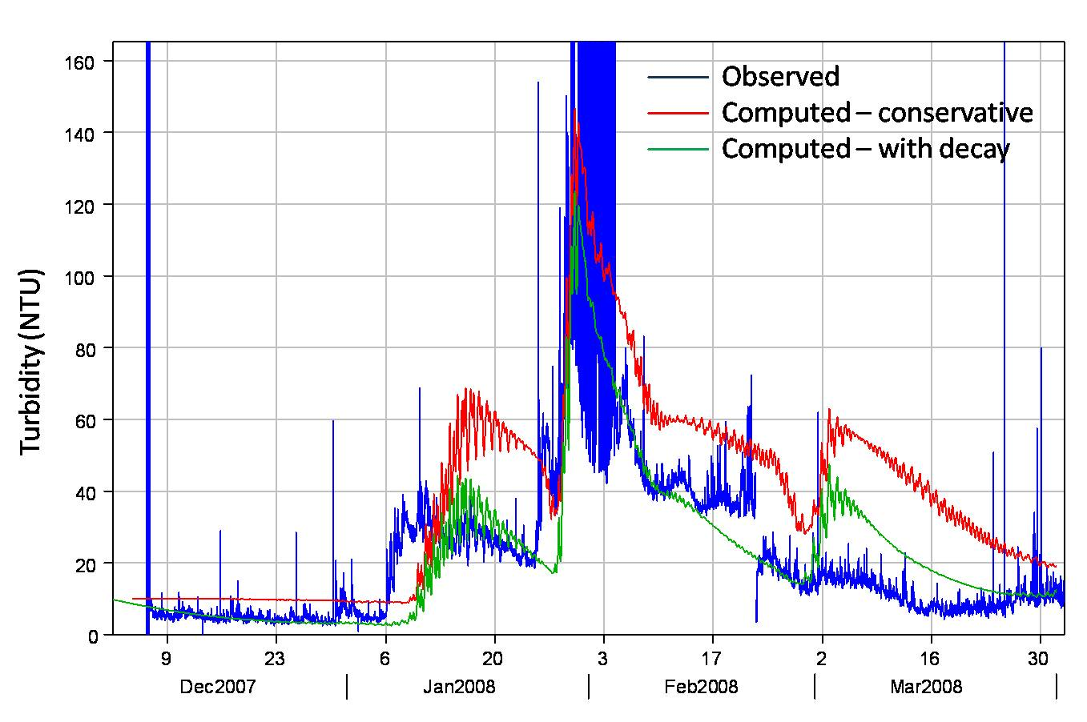
Figure 2-9 Observed and computed (conservatively and with decay) turbidity at Rough and Ready Island.
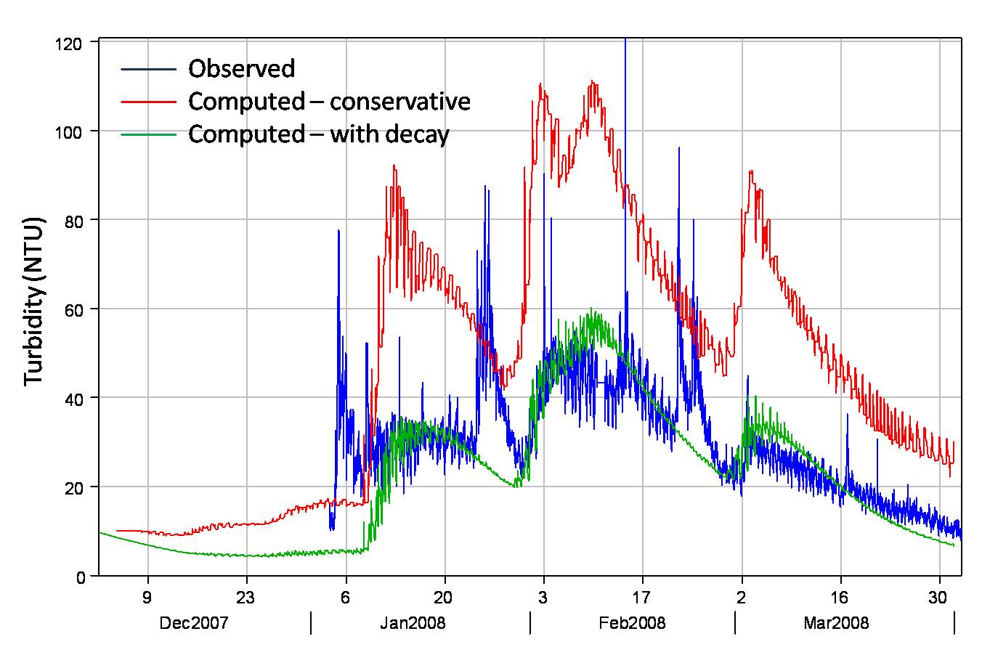
Figure 2-10 Observed and computed (conservatively and with decay) turbidity at False River.
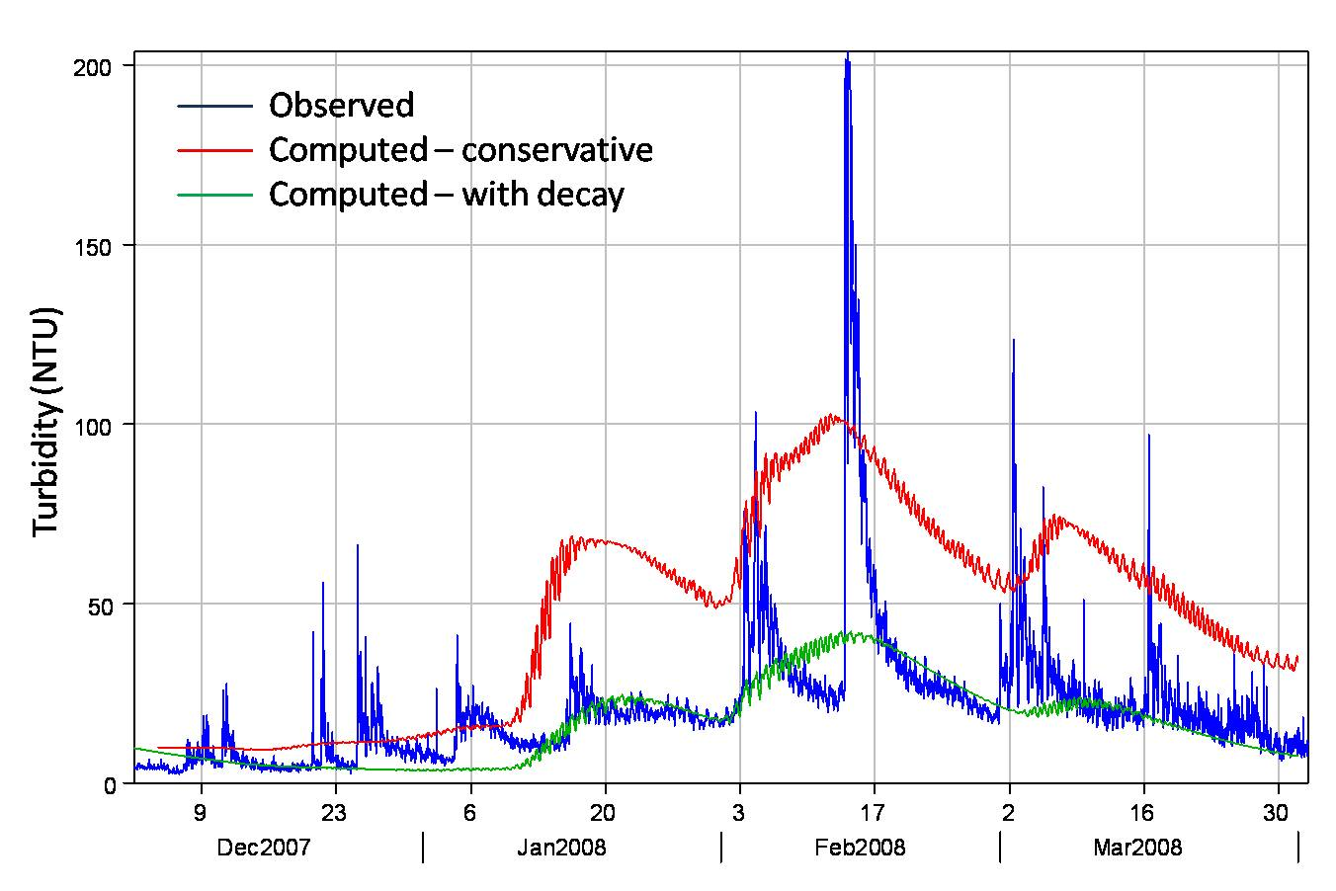
Figure 2-11 Observed and computed (conservatively and with decay) turbidity at Holland Cut.
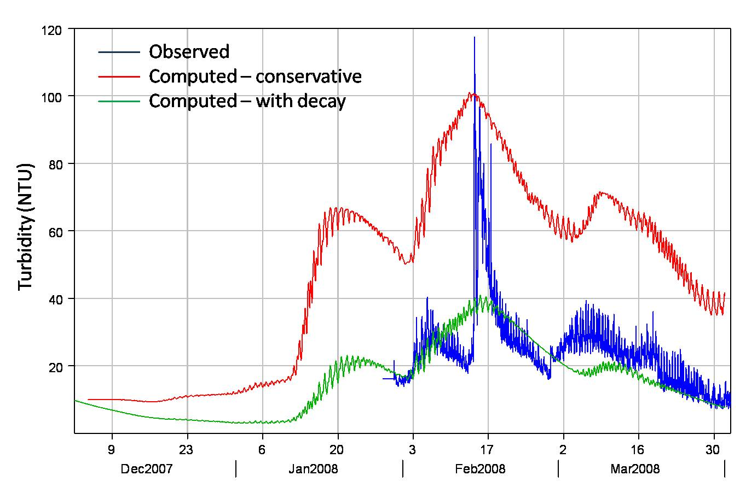
Figure 2-12 Observed and computed (conservatively and with decay) turbidity at Old River at Bacon Island.
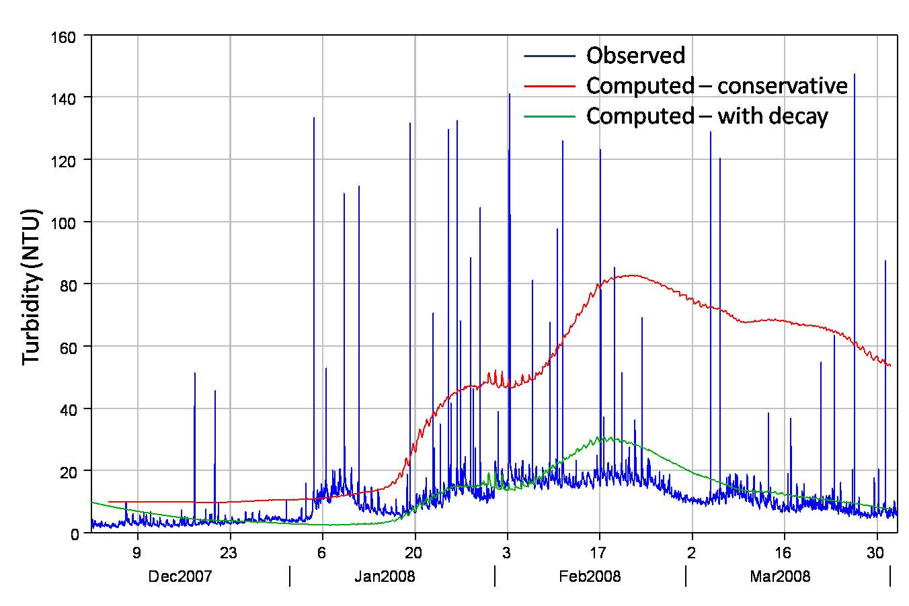
Figure 2-13 Observed and computed (conservatively and with decay) turbidity at Victoria Canal near Byron.
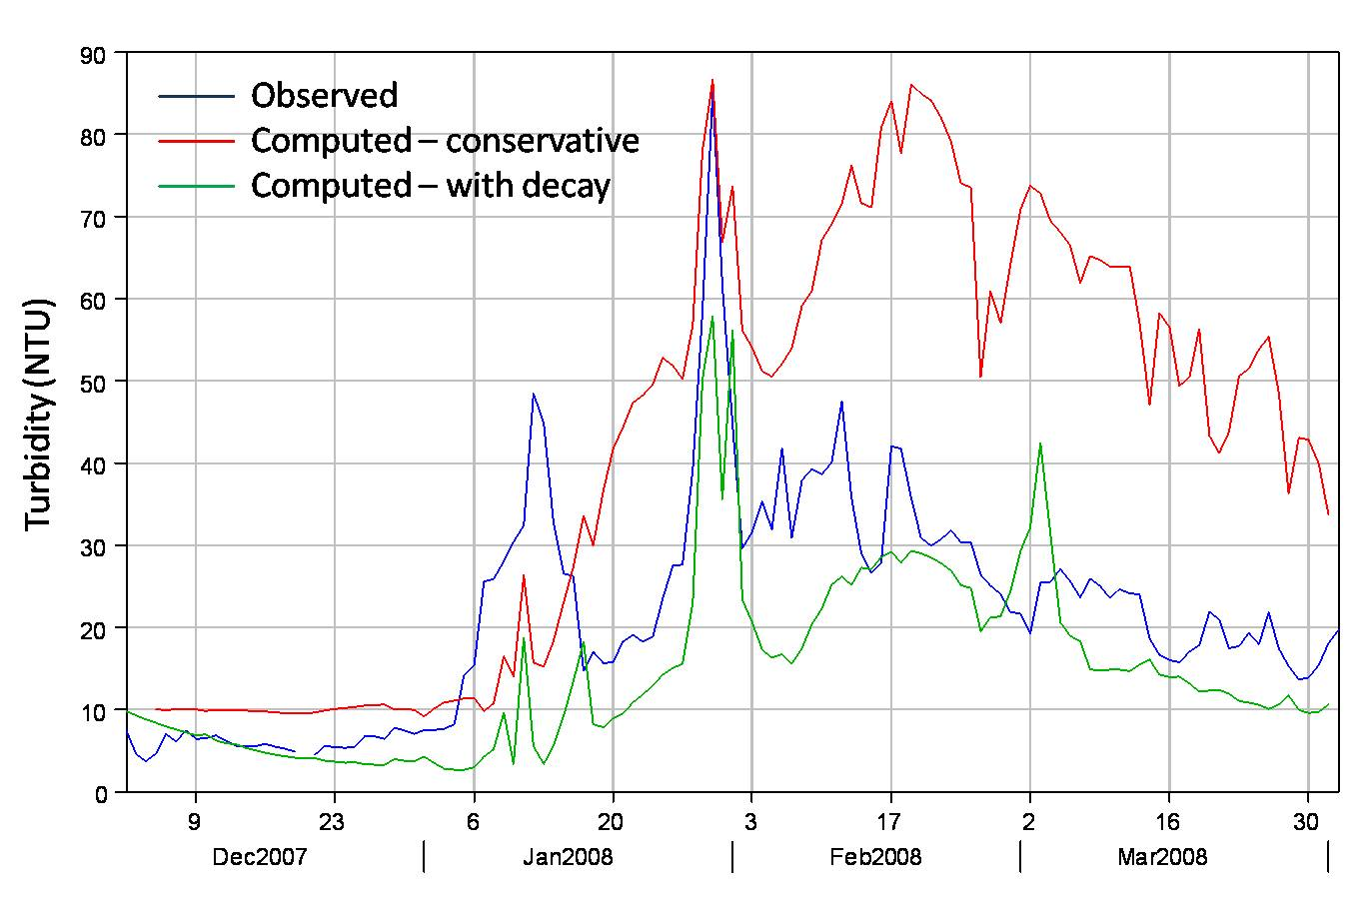
Figure 2-14 Observed (daily average) and computed (conservatively and with decay) turbidity at Clifton Court.
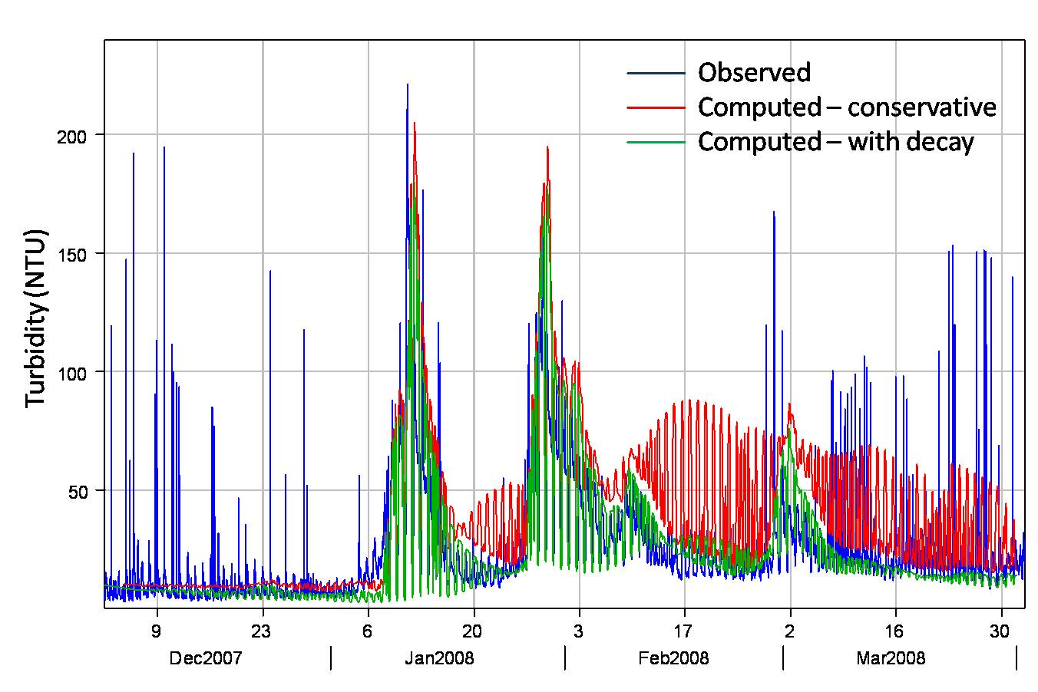
Figure 2-15 Observed and computed (conservatively and with decay) turbidity at Grantline Canal.
Figure 2-16 Computed and observed turbidity in False River and Twitchell Island precipitation, wind speed and wind direction.
Figure 2-17 Computed and observed turbidity in Holland Cut and Twitchell Island precipitation, wind speed and wind direction.
Figure 2-18 Computed and observed turbidity in Old River at Bacon Island and Twitchell Island precipitation, wind speed and wind direction.

Summary and Conclusions
A reconnaissance level calibration of turbidity has been successfully conducted. Results confirm that the addition of a loss term (represented in the model as an exponential decay) produces turbidity concentrations that are in reasonable agreement with observed data and can provide a good starting point for particle tracking simulations utilizing turbidity values and gradients to govern particle behavior.

To achieve more refined level of calibration of the turbidity model, addition of a resuspension term should be considered, which would take into account current speed and wind effects. The simulation results presented in this report for False River, Holland Cut, and Old River, in particular, could guide application of a resuspension algorithm in Franks Tract.

Data limitations impact the model results. The turbidity data used for these simulations were obtained in raw form and edited to remove apparently bad data and fill missing data for application to the model boundaries. Collaboration with the agency staff responsible for turbidity data collection may improve use of the data for model boundary conditions. Further, additional monitoring locations for other important tributaries such as the Calaveras Mokelumne and Consumnes rivers would also improve model results.

References
Hills, “New Flow Equations for Clifton Court Gates”, Technical Memorandum. California Department of Water Resources, State Water Project Division of Operations and Maintenance, Sacramento California, 1988.
King, I. P., W. R. Norton and K. R. Iceman, 1975, A finite element solution for two-dimensional stratified flow problems’, in R. H. Gallagher, J. T. Oden, C. Taylor and O. C. Zienkiewicz, Finite Elements in Fluids, J. Wiley, Chapter 7.
Resource Management Associates, Inc. (RMA), 1997 “Upper Newport Bay Final Model and GUI Development and Implementation Report”, prepared for U.S. Army Corps of Engineers Los Angeles District, October 1997.
Resource Management Associates, Inc. (RMA), 1999 “Upper Newport Bay Feasibility Report: Upper Newport Bay Alternative Analysis”, prepared for U.S. Army Corps of Engineers Los Angeles District, November 1999.
Resource Management Associates, Inc. (RMA), 1998a “Upper Newport Bay Feasibility Report: Upper Newport Bay Salinity Study”, prepared for U.S. Army Corps of Engineers Los Angeles District, October 1998.
Resource Management Associates, Inc. (RMA), 1998b “Upper Newport Bay Feasibility Report: Upper Newport Bay Numerical Model Development Baseline Conditions Analysis”, prepared for U.S. Army Corps of Engineers Los Angeles District, July 1998.
Resource Management Associates, Inc. (RMA), 2001 “Newport Bay Water Quality Model Development” 3-D Stratified Flow Analysis, prepared for California Regional Water Quality Control Board, Santa Ana Region, February 2001.
Resource Management Associates, Inc. (RMA), 2003 “Newport Bay Water Quality Model Update”, prepared for California Regional Water Quality Control Board, Santa Ana Region, November 2003.
Suits, B., 2002, Calibrating DSM2-QUAL Dispersion Factors to Practical Salinity, 23rd Annual Progress Report (Chapter 6), “Methodology for Flow and Salinity Estimates in the Sacramento-San Joaquin Delta and Suisun Marsh”.
US Army Corps of Engineers, 1997, “Upper Newport Bay Feasibility Report: Final Model and GUI Development and Implementation Report”, prepared by Resource Management Associates, Inc., under contract to Coastal Frontiers Corporation.

