ATTACHMENT c
Monitoring and Analysis to Determine if Elevated Turbities from the Sacramento River Trigger Movement of Adult Delta Smelt

Authors: John Burau, USGS and Bill Bennett, Watershed Sciences UCD

Monitoring and Analysis

Physical ProcessEs influencing spawning migrations of delta smelt

Goals

We propose a set of integrated hydrodynamic and fish sampling studies that are designed to evaluate the role of water transparency, i.e. turbidity, in determining the timing of the annual spawning migration by delta smelt from Suisun Bay to freshwater habitats in the Delta. Field-sampling will be tailored to address the following question:
- Does elevated turbidity (i.e., turbidity > 10-12 NTU) in the analysis to determine if elevated turbidities from the Sacramento River following early-winter storm events act to trigger the sudden migration of adult delta smelt from Suisun Bay trigger movement of adult delta smelt into the western Delta from Suisun Bay?

Background and Objectives

Recently, growing evidence suggests low water transparency is a key characteristic of delta smelt habitat (Bennett 2005, Feyrer et al. 2007, Nobriga et al. 2008). Monitoring of turbidity levels in the south Delta may also effectively indicate when these fish are likely to be lost in water export operations during the winter season (Grimaldo et al. in press). However, an equally critical problem for management of delta smelt is that their spawning habitats and the processes triggering migration to them have never been documented. Growing evidence suggests that (a) delta smelt undergo a relatively sudden and discrete shift in their distribution during late December to early January that (b) seems to be associated with the first storms of the winter season; the actual migration may be (c) triggered by the elevated turbidity produced by the higher water flows and land runoff that provide suitable habitat along the migration route. Better knowledge of the processes underlying this "spawning migration" from locations in Suisun Bay to the freshwater Delta is crucial for understanding the reproductive ecology of this endangered species, as well as to provide an early-warning system for guiding water export operations.

We propose to directly measure the hydrodynamic conditions as delta smelt shift their distribution into the Delta through intensive field-sampling immediately following the first winter storm event. By integrating monitoring of hydrodynamics with fish-sampling during this key period we will directly test the question of whether adult smelt remain in areas of elevated turbidity in Suisun Bay and Suisun Marsh (or “stage”) through the late-fall and early winter (Bennett 2005) until turbid flows from the Sacramento River and Delta form a turbidity “bridge” by exceeding a threshold of 10-12 NTU (Grimaldo et al. in press).

The data from this experiment will be used to (1) tighten the linkage between observed delta smelt distributions observed from the fall mid-water trawl and spring Kodiak trawl surveys and turbidity, (2) enhance, calibrate and verify the delta smelt behavior model developed by RMA (refs? John DeGeorge), and, (3) provide an early and real-time warning system that would alert the water project operators to the onset of delta smelt migration into the central Delta where they become increasingly vulnerable to entrainment in the export facilities.

Experimental design

We propose to concurrently monitor hydrodynamic conditions and conduct fish sampling over a complete tidal cycle, or about 12h, at two locations (near Decker Island in the Sacramento River, and near Jersey Point in the San Joaquin River – see Figure 1). We would sample at these fixed locations and let the tidal currents bring the fish (and turbidity) to us, because tidal excursions in the Delta can be quite long – on the order of 8 miles in the western delta (see Figure 1). Such a sampling design would allow us to effectively sample a total of 16 miles of river channel at each location over each tidal cycle.

Choosing fixed locations allows us to also evaluate a potential drawback in the protocols of the current IEP fish monitoring surveys. Typically, the current surveys sample at fixed locations, largely irrespective of the tidal current phase, and require about five days to sample the entire system. Sampling in this way can misrepresent abundance and spatial distribution. For example, a patch of delta smelt residing in the Liberty Island area at the end of a flood tide can be advected to a location seaward of the city of Rio Vista during the next ebb tide (e.g. a distance of roughly 8 miles in 6 hours) assuming delta smelt “go with the flow” (see Figure 2). Thus it is conceivable that a typical IEP survey may repeatedly sample from the same delta smelt aggregation – inflating the actual spatial extent and abundance of the population.

We would sample on alternate days for about one week, or until the fish noticeably shift their distribution up the Sacramento or San Joaquin rivers. Previous work indicates that delta smelt typically arrive at the fish salvage facilities within about three days following a sharp increase in turbidity (Grimaldo et al. in press); this suggests the reaction to elevated turbidity is relatively immediate. There is a several day lag-period between the onset of precipitation in the Sacramento Valley and increased Sacramento River flows and turbidities (refs). Therefore, we propose to have boats and crew on standby, ready to begin trawling immediately after it rains during the first “large” storm of the year. We will, of course, be subject to the inaccuracies of meteorological predictions. Nonetheless, using this approach, we hope to have several days of sampling under low Sacramento River discharges and turbidities before the river responds with increased discharge and turbidity. Thus, we anticipate that few, if any, delta smelt will be detected (i.e. caught) during the pre-turbid period, whereas fish would be detected as they move past our sampling location once a turbidity bridge forms between the low salinity zone and the western Delta.

Sampling protocols

Hydrodynamic monitoring would collect time series of river discharge and velocity (either depth or laterally averaged), as well as electrical conductivity, temperature, salinity, and turbidity of the water at each sampling location. Fish sampling would use either the highly effective Kodiak trawl system, or the traditional mid-water trawl net; the former is highly efficient for sampling delta smelt but requires four boats, whereas the mid-water trawl is less effective but requires only two boats. Ideally, sampling would be done by the IEP under our supervision and onboard assistance. Fish sampling would occur on an hourly schedule and all captured delta smelt would be measured and preserved for analysis of growth (i.e. otoliths) and overall health and condition (i.e. histology) following standard protocols enlisted for the POD studies (Bennett et al. 2008).

ESA compliance: Ideally, all delta smelt captured (i.e. "take") would be covered under existing IEP permitting. This will require negotiations with IEP management.

Analysis

In order to more accurately determine the spatial distribution of delta smelt and to more closely correlate elevated turbidities with delta smelt movements within the western delta we propose to sample at two fixed locations (Figure 1)

We propose to geo-reference the trawl and water quality time series data collected at our fixed-site sampling locations in space by estimating the locations where the sampled water at the fixed site would have been at the previous slack water by: (1) assuming pure advection (e.g. no dispersive mixing and no smelt behavior within a tidal excursion of our sampling locations) and (2) that we can make the relatively minor corrections to the fixed site measured velocities to account for amplitude and phase differences that occur along a tidal excursion trajectory in a Lagrangian frame by using a simple wave equation based on the linearized shallow water equations (see below). For more detailed rigorous discussions of Euler-Lagrangian transformations see refs).

For our simple minded Eulerian-Largangian transformation we turn to the seminal analytical work of Officer, 19xx, in which he develops a wave equation based on the simplified (1D) equations of motion (see also Burau and Cheng, 19xx)

$\frac{∂^{2}η}{∂t^{2}}=C_{0}\frac{∂^{2}η}{∂x^{2}}−β\frac{∂η}{∂t}$ (2)

where,

$η$= sea level variations referenced to the mean tide

t = time

$C_{0}=\sqrt{{\text{gh}}_{0}}$, wave celerity
g = gravity (9.81 m/s²)
$h_{0}$ = depth below mean tide
x = along channel distance
$$β_{n}=\frac{8n^{2}{\text{gU}}_{n}}{3{πh}_{0}^{4/3}}$$
n = Manning’s friction coefficient
$U_{n}$ = velocity amplitude of the nth partial tide with frequency,$ω_{n}$

Solutions to equation 2 take the form

$η=H_{n}e^{−μ_{n}x}\text{cos}(ω_{n}t−κ_{n}x)$ (3)

where,

$κ_{n}=\frac{2π}{λ}=\frac{ω_{n}}{C_{0}}$ (4)

$λ$= Wave length of a particular partial tide

Substituting 3 into 2 one can arrive at

$μ_{n}=\frac{β_{n}}{2C_{0}}$ and

$u=\frac{H_{n}ω_{n}}{h_{0}\sqrt{μ_{n}^{2}+}κ_{n}^{2}}e^{−μ_{n}x}\text{cos}(ω_{n}t−κ_{n}x+α_{n})$ (5)

where the phase angle between the depth averaged current, u, and water level, $η$, is

$$α_{n}={\text{tan}}^{−1}(\frac{μ_{n}}{κ_{n}})={\text{tan}}^{−1}(\frac{β_{n}}{2ω_{n}})$$

These relations assume one dimensional flow, a flat bottom, they neglect the divergence of the wave transport in the continuity equation, baroclinic effects, along-channel diffusion of momentum, advective acceleration and a linearisation of bottom friction. Most of these assumptions are met at our sampling locations, particularly the sampling location in the Sacramento River near Decker Island. For example, the channels in these locations have flat bottoms, relatively benign bathymetry overall within a tidal excursion of our sampling locations, we landward of baroclinic effects.

In our case, we are only interested in using these relations to correct Eulerian measures for wave propagation and dissipation at distances away from our fixed location. Thus, we propose to use the form of equation (5)

$u=U(x_{0},t)e^{−\text{Ax}}\text{cos}(−κx)$ (6)

where we drop $α_{n}$ (because, for our purposes, we don’t care about the phase relation between the currents and water levels), x now represents a distance from our sampling location, $x_{0}$, $U(x_{0},t)$is the appropriately averaged velocity measured at $x_{0}$, the $ω_{n}t$ is dropped because we will have the complete time evolution of the currents from data (e.g. $U(x_{0},t)$, we don’t need to assume a perfect sinusoud) and $−κx$allows for the correction to the phasing of the locally measured currents at distances x from $x_{0}$ along the excursion path. We propose to estimate A, $κ$ based on data or numerical model results for each location shown in Figure 1.

Therefore, the distance a parcel of water has traveled to our trawling locations from the previous slack water is $L_{\text{ex}},$

$L_{\text{ex}}=\int{u(t)}\text{dt}$ xx

where $t_{0}$ is the time of any specified slack water and $t_{1}$is any time t. Thus, samples taken at time t at our fixed sampling location will be georeferenced to slack water by putting it a distance Lex from our fixed sampling location along the tidal excursion trajectory (see the red line in Figure 1).

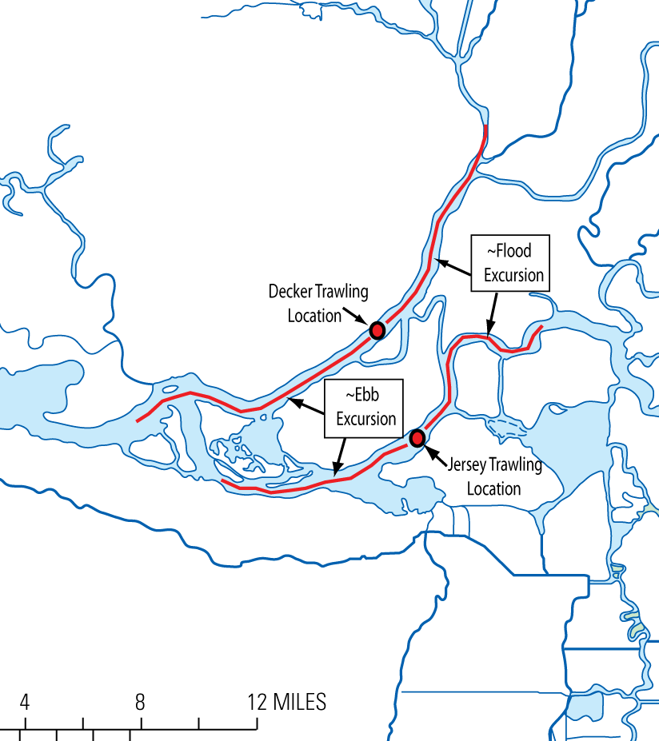

Figure 1. Trawl locations in (a) the Sacramento River adjacent to Decker Island and (b) in the San Joaquin River
near Jersey point.
Tidal excursion (both flood and ebb) estimates are indicated by the red lines. In the western delta the tidal excursions, the distance a parcel of water travels between slack waters, can be over 8.5 miles long. The indicated tidal excursions show that a large portion of the western delta can be sampled simply sampling at a single location and letting the currents bring the turbidities (other water quality parameters) and fish to you. Hourly sampling will provide fairly high spatial resolution with data collected at roughly six locations within each tidal excursion.

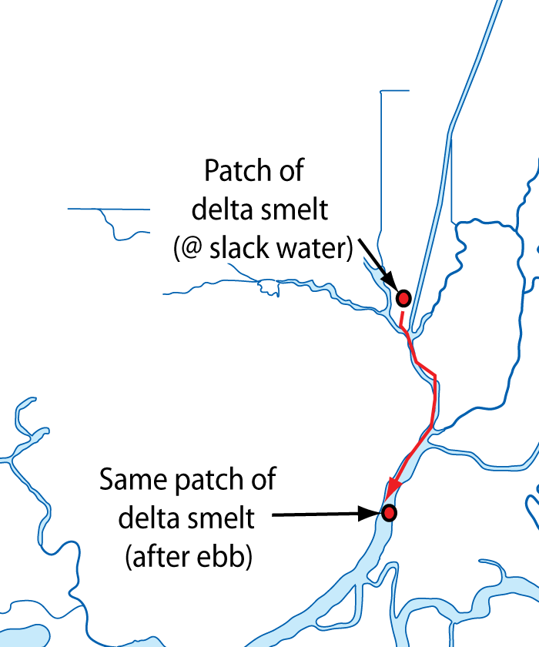

Figure 2. Inference of spatial distributions of delta smelt based on trawling data collected irrespective of the
tidal current phase can be problematic because the tidal excursions in the western Delta are on the order of the
scale of landscape.
For example, a patch of delta smelt located in Liberty Island at slack after flood tide can be advected to a location seaward of Rio Vista in a single six hour ebb tide, as is shown above. Are these fish in Liberty Island or in the western Delta? The answer is both. For pelagic organisms whose home is in a moving water column, “location” is illusory and relative. In this case, the same patch of delta smelt could be placed anywhere within the tidal excursion trajectory shown (e.g. red line) depending on when AND where a trawl is taken. Sampling at a fixed location and tidally correcting the data in space to a common point in the tide (we chose slack water because this is a time of minimum motion) using the locally measured velocity provides a method of unambiguously georeferencing their location. And, as we collect time series at a fixed location using this sampling strategy we’ll be able to say something about their spatial distribution depending on (1) how rapidly they respond to changes in turbidity, (2) how numerous they are. At the very least, we hope to be able to say they are either upestuary or downestuary of the sampling location. Being able to say this is very important at the Jersey Point location since if delta smelt are downestuary of Jersey Point they are not likely to be entrained in the pumps. If, on the other hand, this sampling strategy suggests they are upestuary of Jersey Point then smelt so positioned in the delta are at significantly greater risk of being entrained in the pumps.

