Terrestrial Biological Resources
Not for Public Distribution-
for Internal Review Only
The terrestrial biological resources investigation for the Proposed Action is based on surveys conducted at the proposed sites on Bacon Island and Holland Tract. In the case of Mandeville Island, the resource assessment is provisional, based on a review of aerial photography and binocular-aided visual scans of the riverbank from Bacon Island. From that, preliminary assumptions were made about the types of habitats present and estimates of their size and location. For all proposed sites, the following pertinent documents were used:
- California Natural Diversity Database (CNDDB) list for the area affected by the Proposed Action (DFG 2008).
- California Native Plant Society’s (CNPS) plant list for the Brentwood, Jersey Island, Woodward Island, and Bouldin Island 7.5-minute quadrangles, via electronic inventory (CNPS September 2008).
- USFWS endangered and threatened species list for the Brentwood, Jersey Island, Woodward Island, and Bouldin Island 7.5-minute quadrangles (USFWS 2008).
- DFG Special Status Species List (DFG 2008).
- Action Specific Implementation Plan for the Contra Costa Canal Replacement Project, CCWD, March 2007.
- Preliminary Delineation of Waters of the United States for the Delta Wetlands Project (Jones & Stokes 2001) and correspondence with the Natural Resources Conservation Service (April 2, 2002), Jones & Stokes (April 19, 2002), and the Sacramento District of the Corps (May 20, 2002) concerning jurisdictional areas on Holland Tract, Bacon Island, Bouldin Island and Webb Tract.
Mosaic Associates conducted preliminary wetland delineations at the Old River and Connection Slough sites on Holland Tract and Bacon Island. The field work for the preliminary delineation at Mandeville Island will be conducted prior to construction. Delineations were carried out on August 1 and 8, 2008; and September 9, 23 and 29, 2008. The preliminary delineation, “Delineation and Preliminary Jurisdictional Determination of Wetlands and Other Waters of the U.S. under Section 404 of the Clean Water Act for the Proposed Two-Gates Project Area, Contra Costa and San Joaquin Counties, California” (Mosaic Associates, August 2009), is included in Appendix H.
An inventory of habitats present within the study areas defined for the Proposed Action and an assessment of the presence of habitats suitable for terrestrial special-status species were conducted by Mosaic Associates on August 1 and 8, 2008; and September 9, 23 and 29, 2008. Maps of habitats are depicted in Figures 3.5-1 and 3.5-2.

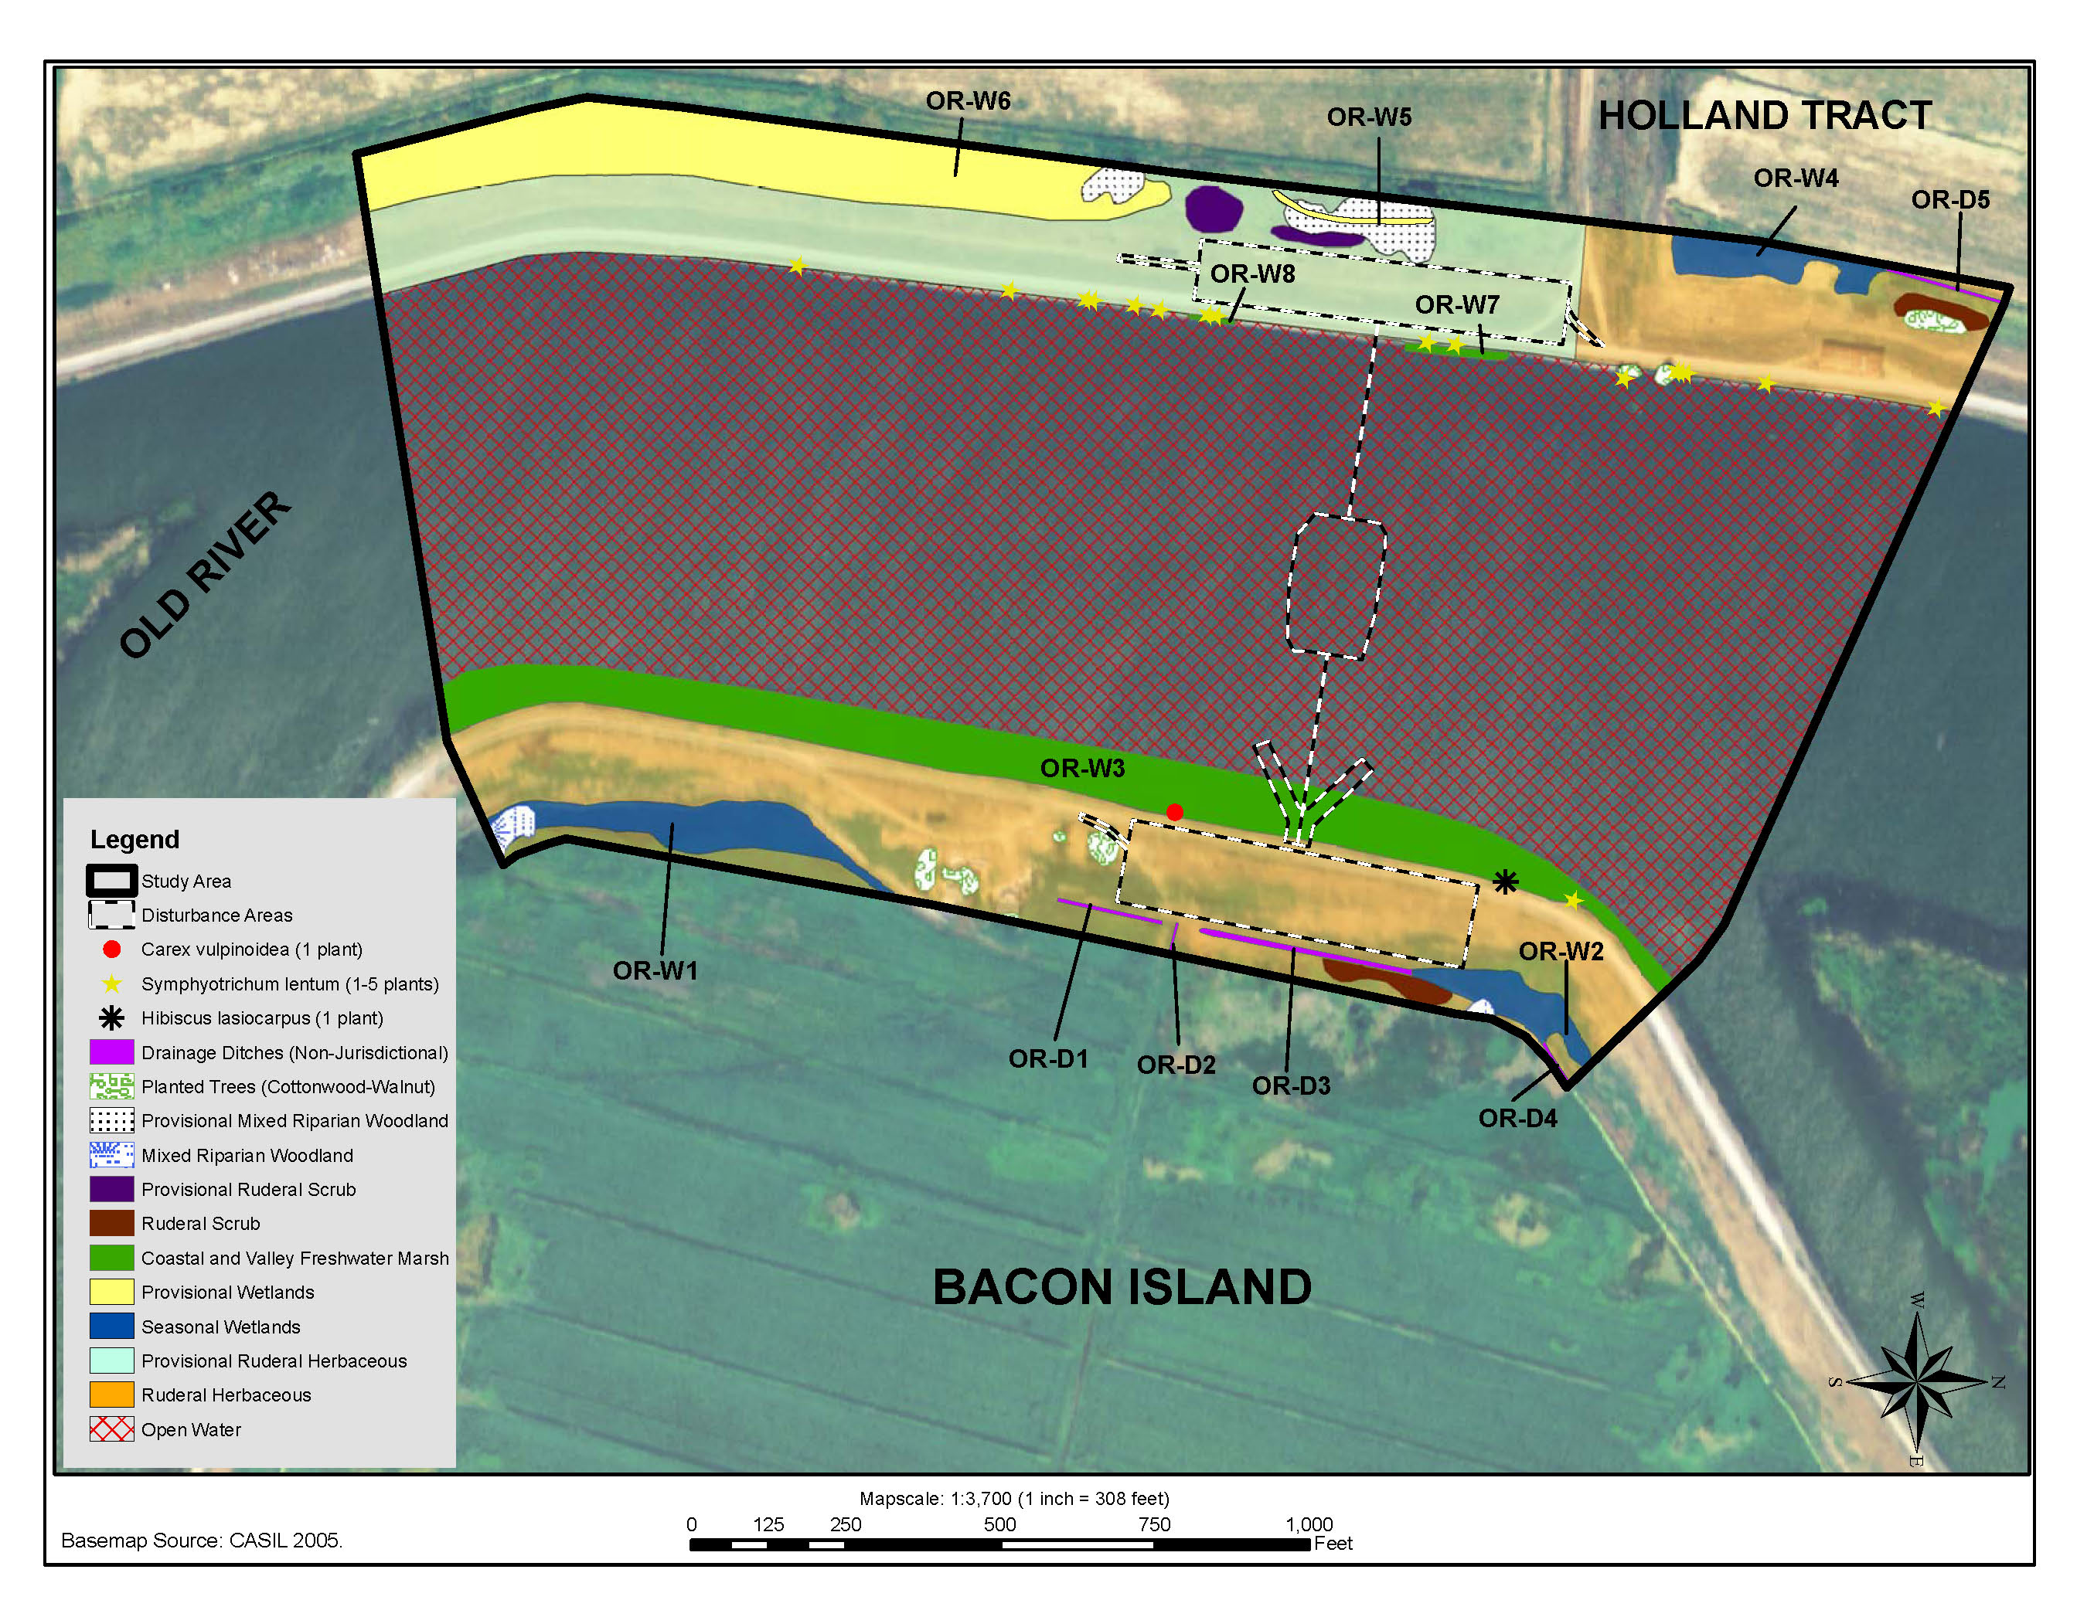
Figure 3.5-1 Habitats on the Old River Study Area
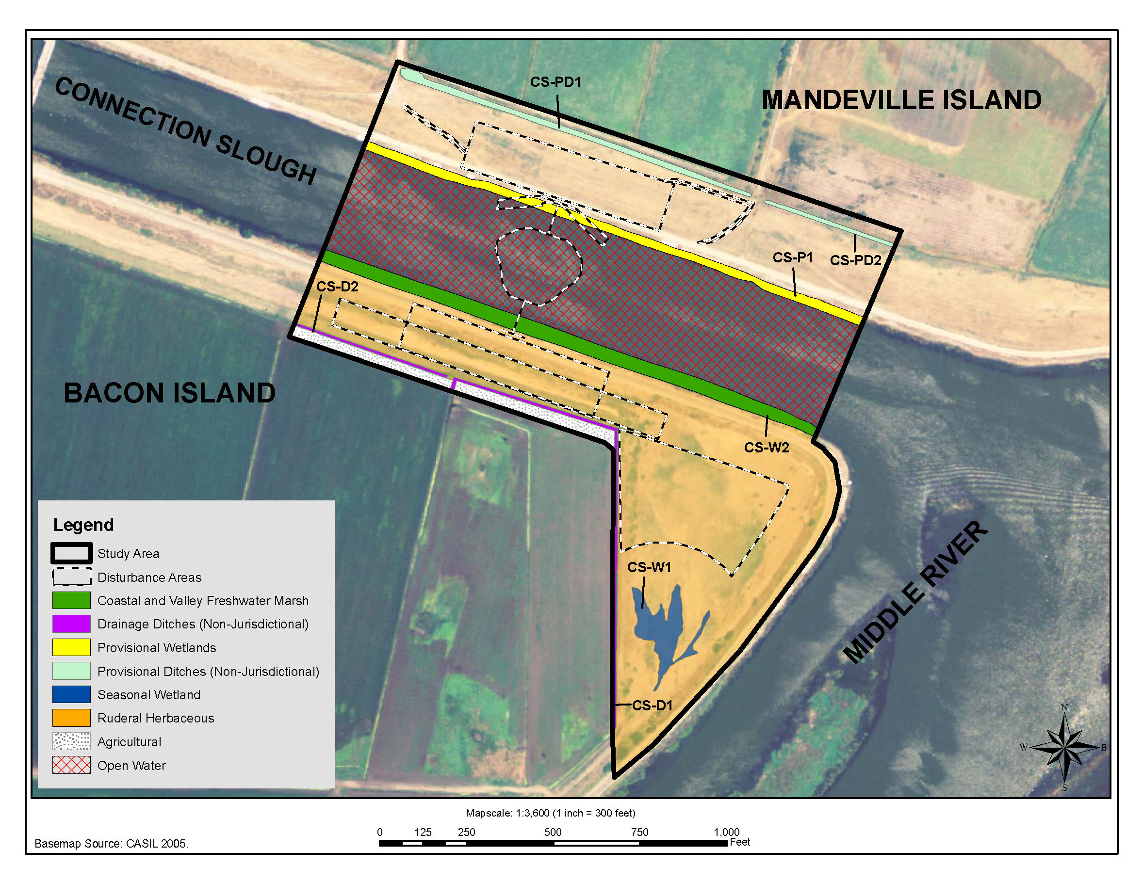
Figure 3.5-2 Habitats on the Connection Slough Study Area
Summer rare plant surveys for late-blooming species at the Old River and Connection Slough sites were conducted on September 23 and 29, 2008. Two summer-blooming rare plants were detected – woolly rose mallow (Hibiscus lasiocarpus, List 2.2) and Suisun Marsh aster (Symphyotrichum lentum, List 1B.2). A spring rare plant survey was conducted at both sites on June 24, 2009. One spring-blooming rare plant was detected – brown fox sedge (Carex vulpinoidea, List 2). Rare plant survey results are reported in the Rare Plant Surveys, Two Gates Project Locations letter report (Mosaic Associates, July 10, 2009), enclosed in Appendix I.
A habitat assessment for the federally and state threatened giant garter snake (GGS) (Thamnophis gigas) was conducted by Swaim Biological, Inc. (2008). The 2-Gates Project Habitat Assessment for the Giant Garter Snake (Thamnophis gigas) (Swaim Biological 2008) is enclosed in Appendix J.
Dry- and wet-season sampling for federally listed large branchiopods, including vernal pool fairy shrimp (Branchinecta lynchi), vernal pool tadpole shrimp (Lepidurus packardi) and Conservancy fairy shrimp (Branchinecta conservatio) consistent with USFWS’ Interim Survey Guidelines to Permittees for Recovery Permits under Section 10(a)(1)(A) of the ESA for the Listed Vernal Pool Branchiopods (1996) were conducted in the 0.5-acre wetland on Bacon Island south of Connection Slough in October 2008 (dry season) and November and December 2008, and January, February and March 2009 (wet season) (Helm Biological 2009a, 2009b, 2009c). No listed large branchiopods were detected during the surveys, and since the wetland never ponded water during any of the wet season site visits, the wetland basin was determined to be unsuitable for federally listed large branchiopods. The wet- and dry-season reports, as well as supplementary information on rainfall during the wet-season surveys (Helm Biological 2009c) are enclosed in Appendix K.

Affected Environment
The study areas on Bacon Island and Mandeville Island are actively farmed, and land surrounding the agricultural fields is regularly disked. Portions of Holland Tract are under cultivation, but in the study area, the fields are fallow. Adjacent fields on Holland Tract were utilized as rangeland for cattle at the time of the field visit. Maintenance dredging occurs in the agricultural ditches on all islands.
Most of the land bordering the study areas is farmland, rangeland, or open space. Several unused structures (old farmhouses) are located on Bacon Island near the Old River site; a large barn is located on Holland Tract. A structure is visible on aerial photographs of Mandeville Island near the access bridge.
Levees have been constructed along both banks of Old River and Connection Slough. The roads on the Old River levees are private. The road on the Bacon Island side of Connection Slough is public, while the road on Mandeville Island is private. Periodic levee maintenance includes the control of vegetation and repairs of the riprap above the waterline.
The portion of the Proposed Action located on Holland Tract is located in Contra Costa County. The remainder (the Bacon Island and Mandeville Island sites) is located in San Joaquin County. The study areas in which the Proposed Action’s effects on terrestrial species and wetland and other waters habitats were evaluated encompass a larger area than the area subject to construction disturbance associated with the construction of the gates. This allowed for a comprehensive analysis of the effects of the Proposed Action on potentially occurring special-status species associated with the construction and operation of the gates.

Special-Status Natural Communities
One special-status natural community is present within the study area – Coastal and Valley Freshwater Marsh. This vegetation community characteristically forms a dense vegetative cover dominated by perennial, emergent monocots 1 to 15 feet high that reproduce by underground rhizomes. This series is most extensive in the upper portion of the Sacramento-San Joaquin River Delta, and is common in the Sacramento and San Joaquin valleys in river oxbows and other areas on the flood plain (Holland 1986). Narrow bands of vegetation, approximately 10 feet wide, along the levee margins fit this description. Nearby islands within the Old River and Connection Slough channels also fit this description, although they are just outside the study area. Narrowleaf cattail (Typha angustifolia), tule rush (Schoenoplectus acutus), and California bulrush (Schoenoplectus californica) are among the dominant hydrophytes of Connection Slough and Old River.

Special-Status Species
Special-status plant, fish, and terrestrial species are generally defined as those species that are legally protected or otherwise considered sensitive by federal, state, or local resource conservation agencies and organizations. This includes species protected under federal and California Endangered Species Acts (ESA and CESA) and species identified as sensitive by the California Department of Fish and Game (DFG), and species identified in the CNPS’s Inventory of Rare and Endangered Vascular Plants of California (CNPS 2008).
Searches were conducted for sensitive biological resources that have been documented in the U.S. Geological Survey (USGS) Woodward Island, Bouldin Island, Jersey Island, and Brentwood 7.5-minute quadrangles, which cover the proposed sites and vicinity. The nine-quadrangle area recommended by CNPS and DFG protocol was not searched because the range of habitats within a nine-quadrangle search of the surrounding area is much more diverse than the habitats encountered within the study area and within the four-quadrangle search. The four-quadrangle search that was conducted encompasses the habitat types, and therefore the suite of species that may reasonably be encountered in the vicinity of the Proposed Action. The California Natural Diversity Database (CNDDB) also was searched, as were the USFWS-generated list of Federal Endangered and Threatened Species that occur in the four USGS quadrangles listed above; and the CNPS’ Inventory of Rare and Endangered Plants of California. Based on these database searches and existing site conditions, animal species having the potential to occur on the proposed sites were identified based on their occurrence in the search area and the presence of habitat suitable for those species. These include Conservancy fairy shrimp (Branchinecta conservatio), vernal pool fairy shrimp (Branchinecta lynchi), vernal pool tadpole shrimp (Lepidurus packardi), giant garter snake (Thamnophis gigas), western pond turtle (Actinemys marmorata), northwestern pond turtle (Actinemys marmorata marmorata), Swainson’s hawk (Buteo swainsoni), tricolored blackbird (Ageliaus tricolor), black rail (Laterallus jamaicensis coturniculus), western burrowing owl (Athene cunicularia), and loggerhead shrike (Lanius ludovicianus).

Terrestrial Environment
Habitats present in the study areas include ruderal herbaceous, agricultural cropland, ruderal scrub, coastal and valley freshwater marsh, seasonal wetland, mixed riparian woodland, and planted trees. Figures 3.5-1 and 3.5-2 depict the habitat types present within the study areas. Habitat types are described below.
Ruderal Herbaceous. This habitat type is the most common one found within the study areas. Ruderal herbaceous communities are those, which colonize highly disturbed areas. Portions of the study areas receive regular discing maintenance. This habitat type would correspond most closely to Holland’s (1986) Pasture series (11206), or to Sawyer and Keeler-Wolf’s California Non-Native Grassland series (1995). Dominant herbaceous species observed in the ruderal herbaceous areas included ripgut brome (Bromus diandrus), poison hemlock (Conium maculatum), Bermuda grass (Cynodon dactylon), Mediterranean mustard (Hirschfeldia incana), field radish (Raphanus sativus), and stinging nettle (Urtica dioicia).
Agricultural. Small areas within the study area were under active cultivation for crops such as sunflower (Helianthus annuus) and corn (Zea mays).
Ruderal Scrub. Ruderal scrub is similar to ruderal herbaceous habitat, in that it is a plant community that colonizes disturbed areas, but instead it is composed of bushy, woody, or taller-statured species. A few patches of dense, monotypic Himalayan blackberry (Rubus discolor) located on Holland Tract and Bacon Island within the Old River study area fit this description.
Coastal and Valley Freshwater Marsh. This series is dominated by cattails up to 4 meters tall, and is most extensive in the upper portion of the Sacramento-San Joaquin River Delta. It is common in the Sacramento and San Joaquin valleys in river oxbows and other areas on the flood plain (Holland 1986). Narrowleaf cattail, tall fescue, and tule rush are among the dominant hydrophytic species along the agricultural ditches and on the levee margins of Connection Slough and Old River.
Seasonal Wetland. Seasonal wetlands occur throughout the study areas in a variety of geomorphic settings including swales, shallow concave basins, and irrigation ditches and canals; primarily in areas with concave topography and fine textured and/or compacted soils which impede surface water infiltration, or allow groundwater infiltration to occur. The seasonal wetland on Bacon Island near Connection Slough was located in a shallow, sparsely vegetated basin south of the proposed gate. Species that occur in the basin or near the margin include Bermuda grass, umbrella sedge (Cyperus eragrostis), knotweed (Polygonum arenastrum), and dogbane (Apocynum cannabinum). On the Holland Tract, and on Bacon Island near Old River, the seasonal wetlands were dominated by Bermuda grass and water smartweed (Polygonum amphibium).
Mixed Riparian Woodland. Although not specifically described in Holland (1986), mixed riparian woodland consists of annual and perennial native and non-native riparian herbaceous and woody species. This vegetation type is typically found along stream and river banks, on terraces adjacent to floodplains, and along perennial or intermittent streams, gullies, springs or seeps. On site, the mixed riparian woodland would conform most closely to Holland’s Great Valley Willow Scrub (63410), described as “An open to dense, broadleafed, winter-deciduous shrubby streamside thicket dominated by any of several Salix species. Dense stands usually have little understory or herbaceous component. More open stands have grassy understories, usually dominated by introduced species” (Holland 1986). Mixed riparian woodland on Bacon Island occurs near Old River and includes mostly shrubby willows (Salix sp.), most of which are not tall in stature, but do form a dense stand. On Mandeville Island, maps indicate that there is a riparian area nearby the proposed site that may provide mixed riparian woodland habitat.
Planted Trees. In a small area around the abandoned farmhouse on Bacon Island at Old River, several planted trees are present, including cottonwood (Populus fremontii), apple (Malus x domestica), and sweet almond (Prunus dulcis).

Terrestrial Animals
The proposed sites are located on the Woodward Island and Bouldin Island USGS 7.5-minute quadrangles. Because of the location of the sites near the edges of the quadrangles, the contiguous Brentwood and Jersey Island quadrangles for our analysis of potentially occurring species also were included. A list of terrestrial animal species for these quadrangles contained 12 federally listed species under the jurisdiction of the USFWS and three additional state-listed species (Table 3.5-1). Four species are listed by both the federal ESA and CESA.
Wildlife observed on the proposed sites during the August and September 2008, and June 2009 site visits to the Old River and Connection Slough sites included Swainson’s hawk, northern harrier (Circus cyaneus), western gull (Larus occidentalis), barn swallow (Hirundo rustica), double-crested cormorant (Phalacrocorax auritus), red-winged blackbird (Agelaius phoeniceus), bull frog (Rana catesbiana), cat fish (Ictalurus spp.), mink (Mustela vison), and ground squirrel (Spermophilus beecheyi). Additionally, sign of raccoon (Procyon lotor) and coyote (Canis latrans) was observed. Virginia rail (Rallus limicola) and sora (Porzana carolina) could also occur at the proposed sites.
Terrestrial mammal species that may utilize the proposed sites and vicinity include black-tailed jackrabbit (Lepus californicus), red fox (Vulpes vulpes), gray fox (Urocyon cinereoargenteus), America badger (Taxidea taxus), long-tailed weasel (Mustela frenata). California ground squirrels are present on Bacon Island. Other rodents such as California meadow voles (Microtus californicus), house mouse (Mus musculus), deer mouse (Peromyscus maniculatus), and Botta's pocket gopher (Thomomys bottae) could also be present at the proposed sites.
Mammals that use aquatic habitat, including the river otter (Lutra canadensis), common muskrat, (Ondatra zibethicus), and American mink could also occur within the proposed sites. Additionally, beaver (Castor canadensis) has been documented as occurring in marshes along the lower San Joaquin River (DWR 2008) and has the potential to occur at the proposed sites.
Reptiles that could use habitat within the proposed sites and vicinity include the gopher snake (Pituophis melanoleucus), terrestrial garter snake (Thamnophis elegans), striped racer (Masticophis lateralis) (DWR 2008), GGS, and western and northwestern pond turtles.
No proposed or designated critical habitat for terrestrial species occurs at the proposed sites. Table 3.5-2 provides a list of terrestrial animal species of special concern and indicates whether they have been found on the sites or in the four 7.5-minute quadrangle map area noted above. Several special-status birds and other birds that receive protection under the Migratory Bird Treat Act (MBTA) and the California Fish and Game Code have the potential to nest or forage on the proposed sites and in the vicinity.
Table 3.5-1 Federally Listed and State-Listed Terrestrial Wildlife Species Known from the Vicinity of the Proposed Action
Common Name | Scientific Name | Listing Status¹ |  | Designated Critical Habitat | Critical Habitat on Proposed Site | Likelihood of Occurrence in Study Area
Common Name | Scientific Name | Federal | State | Designated Critical Habitat | Critical Habitat on Proposed Site | Likelihood of Occurrence in Study Area
Invertebrates
Conservancy fairy shrimp | Branchinecta conservatio | FE |  | Yes | No | Highly unlikely. Not detected during 2008/2009 surveys.
Longhorn fairy shrimp | Branchinecta longiantenna | FE |  | Yes | No | Highly unlikely. Not detected during 2008/2009 surveys.
Vernal pool fairy shrimp | Branchinecta lynchi | FT | -- | Yes | No | Highly unlikely. Not detected during 2008/2009 surveys.
Delta green ground beetle | Elaphrus viridis | FT |  | Yes | No | Highly unlikely. Atypical habitat.
Vernal pool tadpole shrimp | Lepidurus packardi | FE |  | Yes | No | Highly unlikely. Not detected during 2008/2009 surveys. t
Valley elderberry longhorn beetle | Desmocerus californicus dimorphus | FT |  | Yes | No | None. Elderberry host plant is absent.
Amphibians
California tiger salamander | Ambystoma californiense | FT | SSC | Yes | No | None. Site is isolated from occupied habitat.
California red-legged frog | Rana aurora draytonii | FT |  | Yes | No | None. Presumed to be extirpated from region due to colonization by introduced species.
Reptiles
Alameda whipsnake | Masticophis lateralis euryxanthus | FT | ST | Yes | No | None. No suitable habitat.
Giant garter snake | Thamnophis gigas | FT | ST | No | No | Low. Suitable habitat is present.
Birds
Swainson’s hawk | Buteo swainsoni | --- | ST | No | No | Moderate Observed foraging on Bacon Island, 9/8/08, and on Holland Tract 6/24/09. Pair observed in nest tree on east side of Bacon Road, at the SW corner of lower Jones Tract at Middle River.
California black rail | Laterallus jamaicensis coturniculus | -- | ST | No | No | Moderate. Documented in Old River in study area, and Middle River, near study area in 1992 and 1993
California clapper rail | Rallus longirostris obsoletus | FE | SE | No | No | None. Not known from vicinity of Proposed Action.
Bank swallow | Riparia riparia | -- | ST | No | No | None. No suitable nesting habitat.
Mammals
San Joaquin kit fox | Vulpes macrotis mutica | FE | ST | No | No | None. Isolated from occupied habitat in region.
Note: Species list developed from the USFWS List of Endangered and Threatened Species that Could Occur or May be Affected by the Project (USFWS 1/31/08) and the CNDDB occurrences recorded for the Jersey Island, Bouldin Island, Brentwood, and Woodward Island quadrangles, which contain the proposed sites.
¹Listing status definitions: FT = federally listed as threatened; FE = federally listed as endangered; FSC = federal species of concern; ST = state listed as threatened; SE = state listed as endangered; SSC = state species of special concern; SFP = state fully protected species.

Table 3.5-2 State¹ Terrestrial Wildlife Species of Concern and Fully Protected Species Known from the Vicinity of the Proposed Action
Common name | Scientific name | Listing Status² |  | Documented to Occur at Proposed Sites | Likelihood of Occurrence in Study Area
Reptiles
Western pond turtle | Actinemys marmorata | SSC | Yes, in three locations 2002 |  | High. Observed in canals adjacent to proposed sites.
Northwestern pond turtle | Actinemys marmorata marmorata | SSC | No |  | High. Observed in canals adjacent to proposed sites .
Silvery legless lizard | Anniella pulchra pulchra | SSC | No |  | None. No suitable habitat.
Birds
Tricolored blackbird | Agelaius tricolor | SSC | No |  | Moderate. Suitable habitat is present.
Burrowing owl | Athene cunicularia | SSC | No |  | Unlikely. Suitable habitat is present, but no records from vicinity.
Northern harrier | Circus cyaneus | SSC | Yes, observed foraging 6/24/09 |  | Moderate. Suitable habitat is present.
White-tailed Kite | Elanus leucurus | DFG Fully Protected | No |  | Moderate. Suitable habitat is present.
Heron/egret/cormorant rookeries | Egretta sp, Ardea sp,, Phalacrocorax sp. | Great blue heron is a “special animal” | No |  | Moderate. Suitable habitat is present.
Loggerhead shrike | Lanius ludovicianus | SSC | No |  | Moderate. Suitable habitat is present.
Mammals
Western red bat | Lasiurus blossevillii | SSC | No |  | Moderate. Suitable habitat is present.
Note: Species list developed from the CNDDB occurrences recorded for the Brentwood, Woodward Island, Bouldin Island, and Jersey Island quadrangles, which contain the proposed sites, or the presence of suitable habitat.
¹No federal terrestrial wildlife species of special concern are present in the vicinity of the Proposed Action.
²Listing status definitions: SSC = state species of special concern.

invertebrates
Focused surveys for the federally threatened vernal pool fairy shrimp, vernal pool tadpole shrimp and Conservancy fairy shrimp were conducted in the 0.5-acre seasonal wetland on Bacon Island at Connection Slough (Helm Biological 2009a, 2009b). Historically, this was not VPFS or VPTS habitat, but the levees have isolated the area from the prolonged periods of flooding that occurred historically. No listed large branchiopods were detected, and the wetland was determined to be unsuitable for these species.
The proposed sites, access roads, and 100-foot buffer areas were surveyed for the presence of elderberry shrubs (Sambucus spp.), which serve as the host plant for valley elderberry longhorn beetle. No elderberries were detected during these surveys, leading to the conclusion that valley elderberry longhorn beetle is absent from the study area.

amphibians and reptiles
A habitat assessment by Swaim Biological (2008) concluded that the proposed sites are located within the historic and current range of GGS, and that suitable habitat for the GGS exists within the study areas for the Proposed Action (Appendix J).
The GGS has four main habitat requirements as outlined by the draft recovery plan: (1) adequate water during active season to support prey species (i.e., blackfish [Orthodon microlepidotus], Pacific tree frog [Pseudacris regilla], carp [Cyprinus carpio], mosquito fish [Gambusia affinis] and bullfrogs [Rana catesbeiana]); (2) emergent wetland vegetation (i.e., cattails [Typha spp.]) and bulrushes (Scirpus spp.) for foraging habitat and cover from predators; (3) upland habitat with grassy banks and openings in vegetation for basking; (4) higher elevation upland habitats for cover and refuge (i.e., burrows and crevices) from flood waters during winter (USFWS 1999).
Habitat quality for the GGS is generally good at all of the proposed sites. The main waterways, including Old River, are likely not highly preferred habitat, but may provide corridors for movement. These contain the basic features necessary for GGS, including emergent vegetation and cover. The banks of the Old River are lined with rip-rap with interstitial spaces that provide cover from predators and that also may aid in thermoregulation. Much of Old River is also lined by cattails and bulrush. Both plants provide cover and are positively associated with GGS presence. The results of the habitat features associated with each site are summarized in Table 3.5-3 and discussed in greater detail below.
The west bank of the Old River is adjacent to high-quality GGS habitat. A small canal that runs parallel to the levee road may provide foraging habitat though the deep banks and quantity of emergent vegetation creates a fair amount of shade that may inhibit thermoregulation. The larger, diked canal perpendicular to the levee road provides better foraging habitat for GGS. The banks are moderately sloped with abundant emergent vegetation for cover, and with adequate exposure for thermoregulation. The canal itself appears to have slow-flowing water, and a silt substrate, features positively associated with GGS. Small schools of catfish (Ictalurus spp.) are present in the canal. These are generally regarded as predatory game fish, but young catfish may also be a prey source for GGS (USFWS 1999). The levee provides upland habitat and winter refugia above the high water mark. California ground squirrels are absent, but other rodents such as California meadow voles (Microtus californicus) are likely present and provide burrows that may be used as retreats for GGS.
The west bank of the Old River site has suitable habitat and there are seasonal wetlands that provide potential forage and cover habitat during the GGS active season that are just to the west across the dirt road. On the east side of Old River, there are wetlands directly fringing the riverbank that comprise the best GGS habitat on the east side of the Old River within the proposed site.
In the Connection Slough site on Bacon Island, the study area is adjacent to an irrigation ditch with shallow water flowing over silt. Abundant bullfrogs and mosquitofish, both prey species for GGS, were observed in the ditch. The presence of bullfrogs suggests that the channel provides water year-round since bullfrog tadpoles do not metamorphose until their second season, overwintering in their larval form. Other crucial habitat features such as emergent vegetation and upland habitat were present at the site. California ground squirrels, whose burrows provide ideal hibernacula for GGS, also were observed. A seasonal wetland south of the proposed gate may provide additional foraging areas in the spring.
Surveys were not possible on Mandeville Island, but a provisional analysis of aerial photography and a binocular-aided scan of the riverbank were made. It appears from these that within the study area on Mandeville, a drainage ditch similar to those encountered on Bacon Island exists, and that emergent vegetation is present along the Connection Slough that could provide suitable GGS habitat.
Table 3.5-3 Summary of GGS Habitat Features Present at each Site
Site Location | Water Availability | Prey Species | Emergent Vegetation | Basking sites | Upland Refugia and Burrows
Old River Gate Site | Year-round | Fish present | Present | Present | Present
Connection Slough Gate Site, Bacon Island | Year-round | Fish present Bullfrogs present | Present | Present | Present

Western pond turtle (WPT) has been reported on the proposed sites and in their vicinity, and suitable habitat exists onsite for this species. Large woody debris, rip-rap, and shallow water with algal mats or emergent vegetation often harbor WPT. Nesting sites are usually on south or west-facing slopes with bare, clay, or silt soils, or with sparse vegetation of short grasses or forbs, and may be located as much as 0.25 mile from suitable aquatic habitat (Holland 1994). Additionally, there is a record of the northwestern pond turtle northeast of the study area. WPT has recently received some taxonomic study. Formerly this species was called Clemmys marmorata. The species phylogeny had been split into two subspecies, a northern (A. m. marmorata) and a southern (A. m. pallida). The characters used to distinguish the species were, however, ill-defined, and it has been argued that the subspecies distinction should be abandoned, and a new phylogeny should be applied, reuniting the species under A. marmorata while recognizing the existence of four distinct clades (Bury and Germano 2008, Spinks and Shaffer 2005). Records for both WPT and northwestern pond turtle exist for the proposed sites, but these subspecies are now considered one species. Regardless of the name applied to the species or subspecies, records for WPT exist on the proposed sites and within the vicinity.
Other special-status amphibian and reptiles, including California red-legged frog (Rana aurora draytonii), Alameda whipsnake (Masticophis lateralis euryxanthus), California tiger salamander (Ambystoma californiense), and silvery legless lizard (Anniella pulchra pulchra) are not expected to occur at the proposed sites or vicinity due to the absence of suitable habitat (Alameda whipsnake), isolation from occupied habitat in the region and historic site conditions that were unsuitable (California tiger salamander, silvery legless lizard), or their extirpation from this portion of the Delta due to the mass colonization of introduced fishes and bullfrogs (California red-legged frog).

birds
Swainson’s hawk was observed foraging on Bacon Island on September 8, 2008, and June 24, 2009, and there is a documented nest tree 2.5 miles to the southwest on the Lower Jones Tract along Middle River. Large trees suitable for nesting are present on Holland Tract and Bacon Island near the Proposed Action. Large trees may be present on Mandeville Island, either within the proposed site or within 250 feet of the proposed site.
California black rails have been documented in the study area within Old River and in Connection Slough, as well as in Middle River, although no black rail vocal responses were heard anywhere near the proposed sites during recent black rail surveys conducted by DWR (personal communication, M. Bradbury 2009). The records indicate that the birds were observed on the in-channel islands near the study areas. Black rails use marsh and mudflat habitat, retreating to areas with dense cover when tides are high. The levee habitats on site provide only marginal cover in high tide situations.
Suitable habitat for the western burrowing owl is present on Bacon Island near Connection Slough. However, no sign of owl use was observed on September 8, 2008, and the habitat area is small and disconnected from other areas known to host burrowing owl.
The tricolored blackbird and the loggerhead shrike have the potential to occur onsite due to presence of suitable habitat. Habitat suitable for bank swallow (Riparia riparia) nesting is absent from the proposed sites.
Large trees are present on the Holland Tract, Old River site, both within the study area (within the “provisional mixed riparian woodland” polygons in Figure 3.5-1), and within 0.25 miles of the study area on Holland Tract to the northwest and the south. Large trees also appear to be located on Mandeville Island that could serve as potential nesting sites for other raptors and migratory birds, and the study area does provide foraging habitat for Swainson’s hawk, northern harrier, white tailed kite (Elanus leucurus), and other birds of prey. Northern harriers are a ground nesting species, establishing their nests in undisturbed patches of dense, tall vegetation (Shuford 2008). Northern harriers were observed foraging in the vicinity of the proposed sites on June 24, 2009. White tailed kite build nests placed near top of dense oak, willow, or other tree stands; usually 6 to 20 meters (20-100 feet) above ground (Dixon et al. 1957). Suitable nesting habitat is present in the riparian scrub and the planted trees for these and other birds covered under the MBTA.
Large wading bird species, such as the great blue heron, great egret (Ardea alba), and double-crested cormorants usually nest in colonies on the tops of secluded tall trees or snags; usually the tallest available (Zeiner et al. 1988-1990). No heron, egret, or cormorant rookeries have been observed on the proposed sites.

mammals
San Joaquin kit fox (Vulpes macrotis mutica) are not expected to occur at the proposed sites due to the lack of connectivity between known kit fox occurrences and the proposed sites, with the rivers and sloughs creating barriers to movement.
The western red bat (Lasiurus blossevillii) has the potential to roost on the sites. The abandoned farmhouse structures on Bacon Island; a barn located on the Holland Tract; and large mature trees on Bacon Island, Holland Tract, and possibly on Mandeville Island could serve as potential roosting habitat; however, there were no incidental observations of bats or sign of bats during the wetland delineation work (Mosaic Associates 2008). The structures and large trees present within the study area would not be disturbed, so the Proposed Action would not affect this species.

Plants
A 2008 CNDDB and CNPS search identified locations of special-status plant species within a four-quad radius of the proposed sites (Bouldin Island, Woodward Island, Jersey Island, and Brentwood 7.5 minute quadrangles). Eighteen plant species listed either under ESA or CESA or on the CNPS list are shown in Table 3.5-4. Soft bird’s beak (endangered under ESA), Delta button-celery (endangered under CESA), and Antioch Dunes evening primrose (endangered under ESA and CESA) were the only endangered plant species documented to occur within the four-quadrangle search surrounding the proposed sites.
Table 3.5-4 Special-Status Plant Species
Common Name  Scientific Name | Potential to Occur in Study Area | Listing Status¹
Common Name  Scientific Name | Potential to Occur in Study Area | Federal | State | CNPS
Heartscale  Atriplex cordulata | Very low. Some very marginal habitat present, but no alkaline soils observed. | – | – | List 1B
San Joaquin spearscale  Atriplex joaquiniana | Very low. Some very marginal habitat present, but no alkaline soils observed. | – | – | List 1B
Big tarplant  Blepharizonia plumosa | Very low. Some very marginal habitat present, but no occurrences reported. Grasslands on site receive regular disking. | – | – | List 1B
Round-leaved filaree  California macrophylla | Low. Grasslands on site receive regular disking | – | – | List 1B
Bristly sedge  Carex comosa | Moderate. Suitable habitat present in levee margins. | – | – | List 2
Brown fox sedge  Carex vulpinoidea | Present. Documented to occur on study area (Old River) in spring 2009. Has potential to occur on levee margins. | – | – | List 2
Soft bird’s-beak  Cordylanthus mollis ssp. mollis | Very Low. Other halophytes do not occur in the study areas. | FE | SR | List 1B
Delta button-celery  Eryngium racemosum | Low. May occur in Riparian Scrub on Mandeville, if present. Marginal habitat present. | -- | SE | List 1B
Woolly rose-mallow  Hibiscus lasiocarpus | Present. Also detected on islands of Old River in 1992. Suitable habitat present on levee margins. Detected on Bacon Island in summer 2008. | – | – | List 2
Delta tule pea  Lathyrus jepsonii var. jepsonii | Low. Has potential to occur on levee margins. | – | – | List 1B
Mason’s lilaeopsis  Lilaeopsis masonii | Moderate to High. Documented as occurring on study area (Old River) in 2002; has potential to occur on levee margins. | – | SR | List 1B
Delta mudwort  Limosella subulata | Low. Documented as occurring near study area, but mudflat habitat does not occur in study area. | – | – | List 2
Antioch Dunes evening-primrose  Oenothera deltoides ssp. howellii | None. Dune habitats not present within the study areas. | FE | SE | List 1B
Eel-grass pondweed  Potamogeton zosteriformis | Moderate. Suitable habitat present within aquatic habitats. | – | – | List 2
Marsh skullcap  Scutellaria galericulata | Moderate. Suitable habitat present in levee margins. | – | – | List 2
Side-flowering skullcap  Scutellaria lateriflora | Moderate. Suitable habitat present in levee margins. | – | – | List 2
Suisun Marsh aster  Symphyotrichum lentum | Present. Documented in Old River north of study area; suitable habitat present in levee margins. Detected on Bacon and Holland in summer 2008. | – | – | List 1B
Caper-fruited tropidocarpum  Tropidocarpum capparideum | Very low. No alkaline soils observed. | – | – | List 1B
1FE = federally listed as endangered; SE = state listed as endangered; SR = state listed as rare; List 1B = rare, threatened, or endangered in California and elsewhere; List 2 = Rare, threatened, or endangered in California, but more common elsewhere.
Source: DFG 2008. Data compiled by Mosaic Associates in 2008.

Plants that rate a “Moderate” or higher likelihood of presence, based on an analysis of the habitats present within the study area and upon documented occurrences of the species within the study area and within the four-quadrangle search area surrounding the proposed sites, merit the conduct of rare plant surveys. The following eight special-status plant species with a moderate or higher potential to occur with in the study area were identified:
- Brown fox sedge (Carex vulpinoidea): Has been documented on the proposed Bacon Island site on the bank of Old River in June 2009. Flowering Period: May-June.
- Bristly sedge (Carex comosa): Has the same habitat requirements as Carex vulpinoidea, which has been documented on the proposed site. Flowering Period: May to September. Not detected during summer rare plant surveys on Bacon Island and Holland Tract.
- Woolly rose-mallow (Hibiscus lasiocarpus): This plant was observed on the levee margin of Bacon Island at Old River during the September 2008 rare plant survey. It has been documented within the islands of Old River near the study area and on the levee margins just south of study area. Flowering Period: June to September. Detected on Bacon Island.
- Mason’s lilaeopsis (Lilaeopsis masonii): 68 records within the four-quadrangle search; and 4 within the study area. Flowering Period: April to November. Not detected during summer rare plant surveys on Bacon Island and Holland Tract.
- Eel-grass pondweed Potamogeton zosteriformis: May occur in aquatic habitats on site, though none was observed during the summer rare plant survey. Flowering Period: June to July. Not detected during summer rare plant surveys on Bacon Island and Holland Tract.
- Marsh skullcap (Scutellaria galericulata): Occurs in marshes and swamps, suitable habitat is present on levee margins, though none was observed during the summer rare plant survey. Flowering Period: June to September. Not detected during summer rare plant surveys on Bacon Island and Holland Tract.
- Side-flowering skullcap (Scutellaria lateriflora): Occurs in marshes and swamps, suitable habitat is present on levee margins, though none was observed during the summer rare plant survey. Flowering Period: July to September. Not detected during summer rare plant surveys on Bacon Island and Holland Tract.
- Suisun Marsh aster (Symphyotrichum lentum): This species occurs on the levee margins of Old River, with one individual on the Bacon Island side, and several dispersed on the Holland Tract side. It has been documented near the proposed site in Old River islands. Flowering Period: May to November. Detected on Bacon Island and Holland Tract during September 2008.
A rare-plant survey for summer-blooming target species was conducted on September 23, 2008 at the Old River site and on September 29, 2008 on the Bacon Island side of Connection Slough. A rare plant survey for spring-blooming target species was conducted on the same sites on June 24, 2009. Three species – brown fox sedge, woolly rose mallow, and Suisun marsh aster were detected within the study area (Figure 3.5-1).
The following four summer-blooming species with a moderate to high potential for occurrence were not detected during the surveys: bristly sedge, Mason’s lilaeopsis, marsh skullcap, and side-flowering skullcap. In relation to Delta mudwort, although there are records in the vicinity, mudflat habitats suitable for this species are absent in the levee areas. Absence of such mudflat habitat greatly reduces the likelihood of this species’ presence, and it was not observed during the summer rare plant survey. Additionally, the nativity of this species is under scrutiny; the Jepson Manual (Hickman 1993) lists it as a non-native.
The eight summer-blooming special-status species with a very low or low potential to occur were not detected during the summer rare plant survey. These included: heartscale (Atriplex cordulata), San Joaquin spearscale (Atriplex joaquiniana), big tarplant (Blepharizonia plumosa), soft bird’s beak (Cordylanthus mollis ssp. mollis), Delta button-celery (Eryngium racemosum), Delta tule pea (Lathyrus jepsonii var. jepsonii), Delta mudwort and Antioch Dunes evening-primrose (Oenothera deltoids ssp. howellii).
A survey for spring-blooming species at the Old River site and on the Bacon Island side of Connection Slough was conducted on June 24, 2009. One brown fox sedge plant was detected on the Bacon Island bank of Old River. The other spring-blooming species with potential to occur, including round-leaved filaree (California macrophylla) and caper-fruited tropidocarpum (Tropidocarpum capparideum), and eel grass pondweed (Potamogeton zosteriformis) were not detected during the spring rare plant survey.
Rare plant surveys on Mandeville Island have not yet been completed due to access constraints. It is unlikely that any rare plant species would be found on the landward side of the levee because the hillsides are regularly disked, dredging is used periodically to control vegetation and weed growth within the agricultural ditches, and the habitat requirements for the species with potential to occur are present on the river side of the levees.

Wetland Resources and Other Waters
A preliminary wetland delineation of the study areas on Holland Tract and Bacon Island was conducted in August and September 2008 (Mosaic Associates 2009). Table 3.5-5 provides the acreage of potentially jurisdictional wetlands and other waters of the U.S. Impacts to wetlands would be limited to the area of fill from the piles installed to support the boat ramps, shading effects from the boat ramps, and the installation of sheet piles perpendicular to the levees. Portions of the river beds (other waters) would be excavated and backfilled with rock to support the barges, and the barges would be secured to the riverbed. The actual area of fill depends on the size of barge used for the gates.
Table 3.5-5 Acreages of Potentially Jurisdictional Waters of the United States¹
Habitat | Feature | Hydrological Connectivity ² | Adjacency ² | Acreage | Approximate  Area of Fill³
In-channel Freshwater Marsh (FM)
 | CS-W2 | Connection Slough | C | 1.36 | negligible
 | CS-P1 | Connection Slough | C | 0.87 | 0.06
 | OR-W3 | Old River | C | 3.39 | 0.10
 | OR-W7 | Old River | C | 0.06 | 0
 | OR-W8 | Old River | C | 0.01 | 0
 | FM Total |  |  | 5.69 | 0.16
Other Waters (OW)
 | CS-OW1 | Old River, Middle River | C | 10.83 | 1.08-1.32
 | OR-OW1 | Big Break | C | 39.78 | 0.61-1.22
 | OW Total |  |  | 50.61 | 1.63
Seasonal Wetland (SW)
 | CS-W1 |  | A | 0.50 | 0
 | OR-W1 |  | A | 0.81 | 0
 | OR-W2 |  | A | 0.38 | 0
 | OR-W4 |  | A | 0.40 | 0
 | OR-W5 |  | A | 0.06 | 0
 | OR-W6 |  | A | 3.12 | 0
 | SW Total |  |  | 5.27 | 0
Total Jurisdictional |  |  |  | 61.57 | 1.85-2.70
Non-jurisdictional Irrigation/Drainage Ditches (D) ⁴
 | AS-D1 |  |  | 0.22 | 0
 | AS-D2 |  |  | 0.06 | 0
 | CS-D1 |  |  | 0.23 | 0
 | CS-D2 |  |  | 0.07 | 0
 | CS-PD1 |  |  | 0.41 | 0
 | CS-PD2 |  |  | 0.10 | 0
 | OR-D1 |  |  | 0.02 | 0
 | OR-D2 |  |  | 0.01 | 0
 | OR-D3 |  |  | 0.07 | 0
 | OR-D4 |  |  | 0.01 | 0
 | OR-D5 |  |  | 0.03 | 0
 | D Total |  |  | 1.23 | 0
Total Non-Jurisdictional |  |  |  | 1.23 | 0
Notes:
1. Wetland areas on Mandeville Island and a portion of Holland Tract are provisional, based on aerial map interpretation.
CS = Connection Slough, OR = Old River W = wetland number, D = ditch number PW = potential wetland, PD = potential ditch; for mapped locations, see Appendix H.
2. Adjacency / Hydrological Connection to Corps Jurisdictional Waters of the United States
Duration of fill discharge would be limited to the period of the demonstration project.
Areas on Mandeville are estimates.
3. The actual area of fill depends on the size of barge used for the gates.
4. A jurisdictional determination by the Corps has not been conducted. The ditches are assumed to be non-jurisdictional because they are inundated through water siphoned from the rivers.
In-Channel Freshwater Marsh
In-channel freshwater marsh, totaling 5.69 acres, is present on the proposed site along Old River and Connection Slough between the mean watermark (MWM) and ordinary high-water mark (OHWM). A conservative average width of 6 feet of hydrophytic vegetation along all banks of the canal that did not contain riprap was used to calculate the total acreage of these wetland features on the proposed site. The hydrophytic vegetation along the canal is strongly associated with the small bench of substrate located between the MWM and OHWM. Dominant hydrophytic vegetation in the in-channel freshwater marsh includes Tule rush (Shoenoplectus californicus, OBL), bulrush (Shoenoplectus acutus, OBL), and common cattail (Typha latifolia, OBL).
Seasonal Wetland
Seasonal wetland, totaling 5.27 acres, was delineated on Bacon Island and Holland Tract. Indicators of wetland hydrology included inundation, sediment deposits, and drainage patterns in wetlands. Dominant vegetation in the seasonal wetland included Bermuda grass (Cynodon dactylon, FAC), umbrella sedge (Cyperus eragrosits, OBL), knotweed (Polygonum arenastrum, NL), and water smartweed (Polygonum amphibium, OBL).
Agricultural Ditches
Agricultural ditches, totaling 1.23 acres, were delineated on Bacon Island, Holland Tract, and provisionally estimated on Mandeville Island. We are assuming that the hydrology in these areas is artificial. Indicators of wetland hydrology included inundation, sediment deposits, and drainage patterns in wetlands.
A = “adjacent” due to definition in 33 CFR part 328.
C = Contiguous with, or located within, the listed feature.
D = Connected by ditch or other drainage feature.
CV = Connected, directly or indirectly, by culvert or storm drain.
F = Connects by surface flow during flood events.

Regulatory Setting
The following laws and regulations related to terrestrial biological resources are applicable to the Proposed Action.

Federal Endangered Species Act
The ESA of 1973 protects plants and animals that are listed by the federal government as “endangered” or “threatened.” The ESA is enforced by the USFWS and NMFS. NMFS’ jurisdiction is limited to the protection of marine mammals and fishes and anadromous fishes; all other species are within the USFWS’ jurisdiction. Section 9 makes it unlawful for anyone to “take” (harass, harm, pursue, hunt, shoot, wound, kill, trap, capture, or collect or attempt to engage in such conduct) a listed animal, including significantly modifying its habitat. Section 7 of the ESA requires federal agencies to insure that any action authorized, funded or carried out by them is not likely to jeopardize the continued existence of listed species or result in the destruction or adverse modification of habitat critical to such species’ survival.
Each federal agency must consult with the USFWS or NMFS, or both, regarding federal agency actions. The consultation is initiated when the federal agency determines that its action may affect a listed species and submits a written request for initiation to the USFWS or NMFS, along with the agency’s biological assessment of its proposed action. If the USFWS or NMFS concurs with the action agency that the action is not likely to adversely affect a listed species, the action may be carried forward without further review under the ESA. Otherwise, the USFWS or NMFS, or both, must prepare a written BO describing how the agency action will affect the listed species and its critical habitat. Reclamation, as the federal lead agency for the Proposed Action, is responsible for initiating Section 7 ESA consultation.

Clean Water Act, Section 401
California regulates discharges of fill and dredged material under Section 401 of the CWA and the Porter-Cologne Water Quality Control Act. The appropriate Regional Water Quality Control Board, in this case the Central Valley RWQCB, must issue a Water Quality Certification for discharges requiring Corps permits for fill and dredge discharges remains a core responsibility.

Rivers and Harbors Act, Section 10
Section 10 of the Rivers and Harbors Act (33 U.S.C. 401 et seq.) requires authorization from the Corps for the construction of any structure in or over any navigable water of the United States, the excavation/dredging or deposition of material in these water or any obstruction or alteration in a navigable water. Structure or work outside the limits defined for navigable waters of the U.S. require a §10 permit if the structure or work affects the course, location, condition, or capacity of the water body.

Migratory Bird Treaty Act (MBTA)
The Migratory Bird Treaty Act (MBTA) (16 U.S.C. 703-712; Ch. 128; July 13, 1918; 40 Stat. 755) as amended by: Chapter 634; June 20, 1936; 49 Stat. 1556; P.L. 86-732; September 8, 1960; 74 Stat. 866; P.L. 90-578; October 17, 1968; 82 Stat. 1118; P.L. 91-135; December 5, 1969; 83 Stat. 282; P.L. 93-300; June 1, 1974; 88 Stat. 190; P.L. 95-616; November 8, 1978; 92 Stat. 3111; P.L. 99-645; November 10, 1986; 100 Stat. 3590 and P.L. 105-312; October 30, 1998; 112 Stat. 2956) implements various treaties and conventions between the U.S. and Canada, Japan, Mexico and the former Soviet Union for the protection of migratory birds. Under the Act, taking, killing or possessing migratory birds is unlawful. Unless permitted by regulations, the Act provides that it is unlawful to pursue, hunt, take, capture or kill; attempt to take, capture or kill; possess, offer to or sell, barter, purchase, deliver or cause to be shipped, exported, imported, transported, carried or received any migratory bird, part, nest, egg or product, manufactured or not. Actions that are likely to result in take of birds protected under the MBTA require the issuance of take permits from the local FWS jurisdiction. Birds protected under the act include all common songbirds, waterfowl, shorebirds, hawks, owls, eagles, ravens, crows, native doves and pigeons, swifts, martins, swallows and others, including their body parts (feathers, plumes etc), nests, and eggs. A complete list of protected species can be found at 50 CFR 10.13.

Environmental Consequences

No Action Alternative
The No Action alternative would not affect terrestrial species because no development would occur.

Proposed Action
This section focuses on potential impacts at the proposed sites along Old River and Connection Slough. If the larger barge size option is adopted, consequently triggering the use of the Roberts Island #1 disposal site, use of this additional disposal site would not result in added impacts to terrestrial biological resources because it is an existing disposal site and all disposal activities would comply with all permit conditions.

Common Species
Suitable habitat for mammals, including ground squirrels, voles, mice, gophers, weasels, and foxes, as well as for reptiles, including the gopher snake, garter snake, and striped racer, is present within the proposed sites. Construction activities that could disturb these animals include the storage or removal of existing structures and debris, and disposal of dredge spoils. Vehicle movement, grading, and installation of sheet piles and the gate structures could have temporary effects on existing habitat and on animal activity.
These land-based disturbances would be limited to a relatively small area and would be confined to a period starting in October and lasting five weeks into November. Short-term effects on habitat used by reptiles and burrowing mammals would be followed by recolonization of those areas disturbed during construction. Therefore, proposed construction would have a temporary, minor impact on burrowing mammals and reptiles. Proposed activities are also unlikely to affect commonly occurring birds such as red winged blackbird, tree swallow, killdeer, black-necked stilt, great egret and sora because construction would occur outside of the nesting season of most birds (mid-March to late July). Gate operations would not affect nesting and foraging habitat, since operations are not expected to disturb habitat and birds within and in the vicinity of operations would presumably be habituated to daily operations. Gate removal would take place from the water, so no impacts to commonly occurring mammals, reptiles, or birds are anticipated.
Proposed activities could have temporary effects on aquatic mammals, including river otter, common muskrat, and beaver at both the facilities construction and removal stages of the Proposed Action, if those animals were present. However, installation and removal activities would have a minor impact on these animals since they would not involve actions that could pose a direct or indirect threat to these mobile animals. Additionally, proposed activities would not have permanent impacts on their aquatic habitat and would affect only a limited area.

Special-Status Species
Impacts of the Proposed Action on special-status animal and plant species are described below. No impacts on other federally listed, proposed, or candidate terrestrial species or destruction or adverse modification of proposed or designated critical habitat would occur as a result of Proposed Action implementation. Impacts on the species described below would be short-term, occurring only during facilities construction and removal activities, and they would be minor because adequate provisions would be incorporated into the Proposed Action to reduce or avoid adverse impacts (refer to environmental commitments BIO-1 through BIO-9 (described in Section 2).

Giant Garter Snake
Habitat suitable for GGS is present at both gate locations. The proposed sites are within habitat designated for the recovery of the species, and GGS is assumed to be present. Construction of the Proposed Action has the potential to take individual snakes if they are present in the area subject to disturbance. GGS are active during the summer (season defined as May 1 to September 30) and hibernate in upland burrows and refugia during the winter (season defined as October 1 to April 30). During the active period for GGS, a take of snakes could occur during the movement of construction equipment and other vehicles, the removal of debris, rock and vegetation, grading, deposition of dredge spoils and by the installation of the sheet piles and the gate structures. During the dormant period, GGS could be crushed or entombed during grading, the installation of the sheet piles on the levees, dredge spoil disposal and the removal of debris or rock in which snakes could be hibernating, or hibernating snakes could be exposed during earthwork.
Construction may result in a temporary loss of habitat for GGS as upland refugia and burrows suitable for hibernation may be crushed by earthmoving equipment, and debris piles that function as upland refugia are removed from within the laydown areas to accommodate construction activities. This would be a short-term impact to habitat as burrowing mammals would likely recolonize areas disturbed during construction. The most significant land-based disturbance would occur during construction starting in October (during the dormant season) and lasting five weeks into November.
Figure 3.5-3 shows the areas of upland and aquatic GGS habitat that would be impacted during gate construction. Upland habitat included areas above the high tide line subject to disturbance during construction, while aquatic habitat included areas of emergent vegetation within the proposed construction area. At the Old River gate location, approximately 2.60 acres of upland habitat and 0.18 acres of aquatic habitat would be affected during construction, while at the Connection Slough gate, approximately 6.94 acres of upland habitat and 0.08 acres of aquatic habitat would be affected during construction.
Installation of the barge and gates during November would involve access along the roads, but would not impact GGS because there would be no earthmoving work that could disturb, expose or entomb GGS hibernating in upland refugia, and GGS would not be present above ground on roadways.

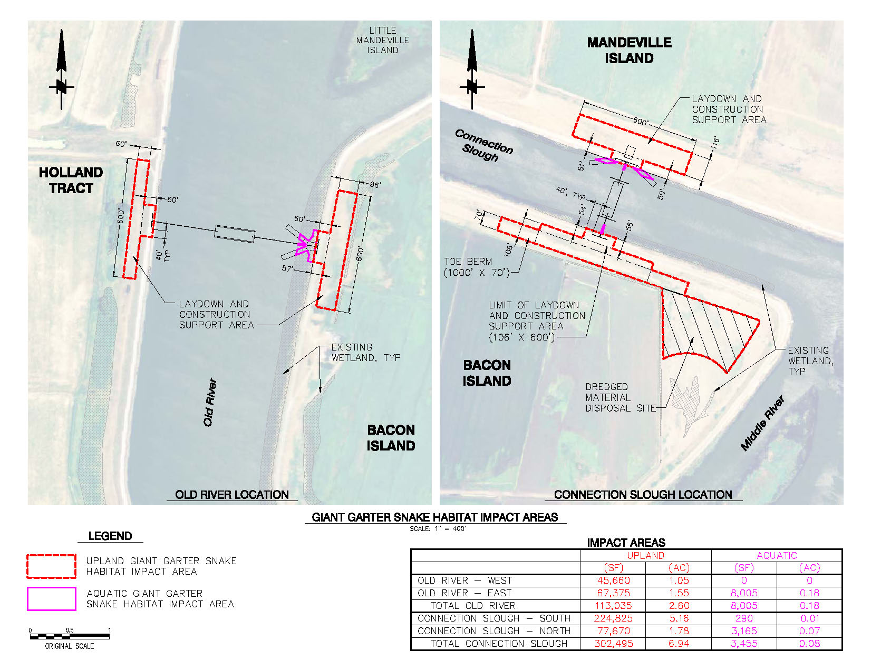

Figure 3.5-3 Giant Garter Snake Habitat Impact Areas
Environmental Commitment BIO-1 would require the conduct of preconstruction surveys, biological monitoring during construction, and the implementation of a number of protection measures, such as minimizing habitat disturbance, worker environmental awareness training, exclusionary fencing. Although initial construction is expected to occur during the dormant period for GGS, measures have been included that would reduce or avoid impacts should construction not occur as currently anticipated. They also would apply to facilities removal activities should they occur during the dormant season. Table 3.5-6 describes GGS conservation measures for the Proposed Action that have been adapted from the Programmatic Consultation for U.S. Army Corps of Engineers 404 Permitted Projects with Relatively Small Effects on the Giant Garter Snake within Butte, Colusa, Glenn, Fresno, Merced, Sacramento, San Joaquin, Solano, Stanislaus, Sutter and Yolo Counties, California (USFWS 1997). Given the implementation of BIO-1, impacts to GGS from construction would be short-term and minor.

Table 3.5-6 Summary of Giant Garter Snake Conservation Measures
Construction Timing Alternative | Duration of Impacts / Time of Year | Type and Area of Impacts (acres) | Conservation Measure:  Compensation
October 1 through  April 30 | Temporary (2 seasons) / impacts to occur during dormant season | Upland habitat: 9.54 ac  Aquatic habitat: 0.26 ac | Restoration and up to 6:1 replacement  Restoration:  Restore salvaged refugia and revegetate habitats disturbed during construction  Replacement:  Upland habitat: 39.2 ac  Aquatic habitat: 19.6 ac
May 1 through September 30 | As above / impacts to occur during active season | As above | Restoration plus 1:1 replacement  Restoration:  Restore salvaged refugia and revegetate habitats disturbed during construction  Replacement:  Upland habitat: 6.5 ac  Aquatic habitat: 3.3 ac

Proposed operations would not affect GGS or impede their movement. The snakes are highly mobile and would be able to move around the sheet piles on the levees.

Western and Northwestern Pond Turtle
Western pond turtle (and the subspecies, northwestern pond turtle) has been documented to occur in the canal west of the Old River site on Holland Tract, on the channel islands north of the Old River study area, and to the south, on Old River. Construction and removal of the proposed facilities may impact western or northwestern pond turtles if present within the study area. Environmental Commitment BIO-2 requires that not more than 48 hours prior to the start of site disturbance, a qualified biologist familiar with WPT behavior would conduct focused visual surveys for western pond turtles and any nesting activity (i.e., nests, egg shell fragments) in the study area, silt fencing around the perimeter of the laydown area, and supervision of vegetation removal within the laydown areas by a qualified biologist. Measures also have been included to address procedures to be followed if juvenile or adult WPT are found aestivating or hibernating on the Project site or if a nest is found in the construction area. A worker environmental training awareness program also would be implemented. Given the implementation of BIO-2, impacts to WPT from construction would be short-term and minor.
Proposed operations would not affect these organisms since operations would not alter their habitat or involve actions that could pose a direct or indirect threat to these mobile animals.

Western Burrowing Owl
There are no CNDDB records of burrowing owls, a federal and state species of concern, in the Bouldin Island or Woodward Island topographic quadrangles surrounding the Old River and Connection Slough sites. However, suitable habitat for burrowing owls is present on Bacon Island at Connection Slough, as an abundance of ground squirrel burrows are present in the laydown and spoil disposal areas. Land-based construction activities, including the installation and removal of sheet piles, pile-supported boat ramps, clearing, grading, the storage or movement of rock or other construction materials, or disposal of dredge spoils could result in a direct take of individuals or result in the failure of an active nest, if burrowing owls are present in the disturbance area.
Environmental Commitment BIO-3 requires surveys for western burrowing owl and avoidance or mitigation for owls, if present; and implementation of a worker environmental training awareness program,, in compliance with the California Burrowing Owl Consortium’s (CBOC) Burrowing Owl Survey Protocol and Mitigation Guidelines (1993) and the DFG Staff Report on Burrowing Owl Mitigation (1995) . Given the implementation of BIO-3, impacts to burrowing owls from construction would be short-term and minor.
Proposed operations would not have any impacts on burrowing owls since the operations would not require land-based earthwork.

Swainson’s Hawk
Swainson’s hawk has been observed foraging on site and could nest in trees on Holland Tract, Bacon Island at Old River and Mandeville Island that are located within 0.25 mile of the proposed sites.
Installation of the proposed facilities is not likely to affect Swainson’s hawk nesting behavior because construction would occur outside of the nesting season (mid-March to late July). Removal of the gates and boat ramps during the in-water work window (July 1 through November 30) would take place toward the end of the nesting season when young birds are active and nest abandonment due to construction disturbance is extremely unlikely, or after the nesting season. However, in the event that nesting is delayed due to cold or wet spring weather, or the first nesting attempt fails and a second nest effort occurs, fledging behavior can be delayed until well into August. Gate removal could affect nesting behavior if it occurs within 0.25 mile of an active nest with young birds that have not fledged.
Environmental Commitment BIO-4 requires preconstruction surveys for Swainson’s hawk prior and implementation of avoidance or mitigation activities, if present. These may include postponing site disturbance until a qualified nest monitor determines that the young birds have fledged and are no longer reliant on the nest site or nest monitoring by a biologist with stop-work authority in the event of disturbances to nesting behavior, and a reduced no-disturbance buffer if site conditions suggest that a reduced buffer area would not disturb nesting behavior (based on amount and type of ongoing disturbance, such as farm activities, boating, traffic, etc.). Given the implementation of BIO-4, impacts to Swainson’s hawk from construction would be short-term and minor.
Proposed operations would not result in impacts to Swainson’s hawk. Nesting and foraging habitat would not be impacted by gate operations, since operations are not expected to disturb habitat, and birds nesting in proximity to the gates would presumably be habituated to ongoing operations since operations would begin prior to the nesting season.

Black Rail
Black rail has been documented to occur in the dense emergent wetland habitat on the islands in Old River and Connection Slough, although no black rail vocal responses were detected during recent surveys by Department of Water Resources (personal communication, M. Bradbury 2009). Nesting and foraging habitat for this species is present in the emergent wetland vegetation on the east bank of Old River, although the potential for it to be present in the construction area is low due to the limited extent of this habitat on the bank of the river.
As proposed, construction activities would not affect the nesting activities of black rail, because construction activities would occur October through December, outside the nesting season. Removal of the gates and boat ramps between July and November could take place during or after the nesting season. Removal activities could adversely affect the nesting behavior of these species, if occupied nests are present, as could construction if it occurred outside the currently scheduled period.
Environmental Commitment BIO-5 requires preconstruction surveys for black rail prior to gate removal activities and avoidance or mitigation activities, if present. Such measures may include a delay in gate removal until young birds are foraging independently and nest monitoring by a qualified biologist with stop-work authority in the event that gate removal operations posed a risk to nest habitat. Given the implementation of BIO-5, impacts to black rail from construction would be short-term and minor.
Proposed operations would not result in impacts to black rail. Nesting and foraging habitat would not be impacted by gate operations, since operations are not expected to disturb habitat, and birds nesting in proximity to the gates would presumably be habituated to ongoing operations since operations would begin prior to the nesting season for all species of concern. Gates would be open during flood events, producing less than a 0.1-foot change in flood stage elevations in a 100-year event, so the disturbance of low-lying nesting habitat is unlikely.

Other Raptors and Migratory Nesting Birds
Suitable nesting habitat for various raptors, as well as other migratory bird species, is present on or near the proposed sites. Numerous species have the potential to nest onsite, either in the marsh areas fringing the levees, or within trees, shrubs and grassland on the landward sides of the levees. These could include the including northern harrier, white-tailed kite, tricolored blackbird, loggerhead shrike, and other birds protected by the MBTA.
Construction activities would not affect the nesting activities because land-based construction activities would occur October through December, outside the nesting season. Removal of the gates and boat ramps between July and November would occur towards the end of or after the nesting season. Removal activities could adversely affect the nesting behavior raptors or other protected species, if occupied nests are present, as could construction if it occurred outside the currently scheduled period.
Environmental Commitment BIO-6 requires preconstruction surveys for nesting birds prior to construction activities and implement avoidance or mitigation activities for nesting birds, if present. These may include a no-disturbance buffer in which no new site disturbance is permitted and observation of the buffer until August 15, or a qualified biologist determines that the young are foraging independently or the nest has failed. Given the implementation of BIO-6, impacts to nesting birds from construction would be short-term and minor.
Proposed operations would not result in impacts to protected bird species. Nesting and foraging habitat would not be impacted by gate operations, since operations are not expected to disturb habitat, and birds nesting in proximity to the gates would presumably be habituated to ongoing operations since operations would begin prior to the nesting season for all species of concern. Gates would be open during flood events, producing less than a 0.1-foot change in flood stage elevations in a 100-year event, so the disturbance of low-lying nesting habitat is unlikely.

Plants
Of the nine rare plants determined to have a potential to occur on the study area, seven are summer blooming plants, and one species, eel-grass pondweed, is distinguishable from other pondweed by its vegetative parts. A summer rare plant survey was conducted at the Old River site on September 23, 2008 and on the Bacon Island side of the Connection Slough site on September 29, 2008. A spring survey of the Old River and the Bacon side of the Connection Slough site was undertaken on June 24, 2009. Three rare plants were observed within the study area: brown fox sedge, woolly rose-mallow, and Suisun Marsh aster.
Individual special-status plants present within the development envelope of the Proposed Action could be negatively impacted by work conducted within this area. Environmental Commitment BIO-7 requires preconstruction surveys for rare plants and, avoidance or mitigation for rare plants, if present. The measure may also include the installation of orange construction fencing around the plants prior to site disturbance and ensuring that rare plants are not disturbed during construction. If areas cannot be surveyed during the appropriate season due to lack of access, a mitigation plan, approved by DFG, would be developed and implemented. Given the implementation of BIO-7, impacts to plants from construction would be short-term and minor.
No impacts would occur during operations because no new ground disturbance would occur.

Riparian and Wetland Habitats
Construction would occur within ruderal herbaceous and wetland habitats only. Project designs specifically avoid mixed riparian woodland and seasonal wetland habitats present on Holland Tract and Bacon Island in the Old River site. Impacts to ruderal herbaceous and freshwater marsh wetland habitats on the Connection Slough Site have been minimized through the location and design of the Proposed Action. There is no mixed riparian habitat located in the Connection Slough construction area. Project plans avoid disturbance of riparian vegetation and minimize impacts to sensitive wetland communities. Sensitive riparian and wetland habitats near the proposed site could be impacted however, through the inadvertent disturbance of adjacent areas outside the construction footprint during construction and removal.
Environmental Commitment BIO-8 requires the installation, and weekly inspection of, orange construction fencing around the perimeter of sensitive wetland and riparian habitats adjacent to the landward footprint of the proposed sites to prevent the movement of construction equipment into these sensitive areas during construction. Given the implementation of BIO-8, impacts to riparian and wetland habitats from construction would be short-term and minor.
No impacts would occur during operations because no new disturbance would occur.

Jurisdictional Waters of the U.S.
Implementation of the Proposed Action would result in the discharge of approximately 1.63 acres of fill into potentially jurisdictional waters of the U.S., including wetlands and other waters subject to Corps jurisdiction under the CWA, and Section 10 of the Rivers and Harbors Act. Construction of the pier-supported boat ramps would require the discharge of fill to Coastal and Valley Freshwater Marsh wetlands as well as unvegetated waters of the U.S. The boat ramps would also result in the temporary conversion of approximately 0.16 acre of freshwater marsh wetland habitat to unvegetated waters of the U.S. due to shading and the loss of vegetated cover during the demonstration period. Construction of the gates would require the excavation of unvegetated waters of the U.S. and the discharge of fill in other waters of the U.S. associated with the rock fill surrounding the barge and the installation of the barge. Seasonal wetlands in the laydown areas and in the spoil disposal area would be avoided. A berm would be constructed around the dredged spoils disposal area to prevent runoff from the disposal site into the seasonal wetland and pertinent federal standards for the discharge of dredged material would be observed. Impacts to wetlands and other waters have been minimized by the use of sheet piles rather than rock dikes to span the channels to the barges.
Environmental Commitment BIO-9 indicates that mitigation for the discharge of fill to wetland habitats would meet the requirements established by the Corps and RWQCB and may include a variety of measures, including the removal of the boat ramps and piers upon completion of the five-year demonstration period and the replanting of native plant materials to restore freshwater marsh vegetative habitat to the site; the purchase of wetland mitigation credit at an approved wetland mitigation bank or through the approval and implementation of a wetland mitigation and monitoring plan; and the installation of orange construction fencing around the perimeter of wetlands and other waters in proximity to construction activities to prevent accidental disturbance during construction. Given the implementation of BIO-9, impacts to riparian and wetland habitats from construction would be temporary and minor.
No impacts would occur during operations because no new disturbance would occur.

Wildlife Movement
The Proposed Action would not interfere with the movement of terrestrial wildlife species or movement corridors once the construction activities are completed. All terrestrial special-status species with potential to occur within the area affected by the Proposed Action are highly mobile and would be able to move around the gates. Periods of operation are expected to have minimal impacts on the movement of terrestrial wildlife.

