Cultural Resources
Not for Public Distribution-
for Internal Review Only

Affected Environment

Cultural Overview

Archaeology and Regional Prehistory
Archaeological investigations in the Delta region began in the early 1890s with the excavations conducted by J. A. Barr and W. H. Holmes; the two amassed considerable collections of artifacts from mounds in the Stockton area, which were eventually donated to the U.S. National Museum (Moratto 1984:177). Found throughout the Delta, mound sites typically contain several strata of cultural deposits covering multiple millennia of occupation. Not surprisingly, early attempts to construct a chronology of the northern San Joaquin Valley were based on the excavations in the Delta region, most notably by Elmer J. Dawson. Dawson recognized cultural change in the strata at his mound site near Lodi and proposed a succession of periods (early, middle, and late) to categorize such change (Moratto 1984:177). Although the importance of his chronology was initially minimized by preeminent archaeologist W. E. Schenck, Dawson’s sequence eventually was supported by studies in the Delta and lower Sacramento Valley during the 1930s.
The tripartite chronology has been reworked several times since Lillard, Heizer, and Fenenga (Moratto 1984) offered their sequence (Early, Transitional, and Late periods) for the Central Valley in the late 1930s. While subsequent chronologies have labeled the three eras differently, each time period does display a common suite of characteristics (Moratto 1984:180–214).
- Early Period/Early Horizon/Windmiller Pattern. Extended burials with westerly orientation are typically accompanied by funerary goods, including shell ornaments and beads. The high frequency of large projectile points indicates that subsistence centered on game. Grinding implements are present but infrequent.
- Transitional Period/Middle Horizon/Berkeley Pattern. Flexed burials with variable orientation are often accompanied by red ochre and sometimes by funerary items. There is a greater reliance on acorns, as suggested by the higher frequency of mortars and pestles compared to the previous period. Projectile points remain large, and bone tools are frequent and well developed.
- Late Period/Late Horizon/Augustine Pattern. Burials are typically flexed with a scarcity of grave artifacts. Subsistence continues to focus on acorns and other plant materials. Projectile points are smaller and marked with serrations. Shell beads and other ornaments are well developed, owing to an intensification of trade.
The above chronology helps consolidate a vast amount of data into a manageable number of time periods, but like any taxonomic division, it implicitly minimizes the importance of differences that exist within each time period and does not account for geographical variability. Such variation confounds attempts to devise an orderly chronology with absolute dates for each time interval. For instance, the earliest component of CA-SJO-68 contains mortars, pestles, and a bone awl (typically associated with the Berkeley Pattern), yet the site has been dated to around 4500 B.P., one of the earliest known sites in the Central Valley (Moratto 1984:207). In addition, radiocarbon dates from 31 central California sites indicate that the time ranges of the Windmiller, Berkeley, and Augustine patterns show considerable overlap, especially after 1750 B.P. (see Moratto 1984:200, Figure 5.11). The analysis suggests that the Windmiller and Berkeley Pattern sites in San Joaquin County (CA-SJO-145 and -91) were coeval with Augustine sites in Sacramento County between 1750 and 750 B.P. Moreover, consideration of geographical similarities and differences in the archaeological record of California indicates that the east-west flow of goods among the Bay, Delta, and Central Sierra regions was more pronounced than the economic ties between northern and southern valley peoples (Moratto 1984:215).
Habitation in the Central Valley predating the Early Period/Windmiller Pattern is evidenced by assemblages found near the Tulare and Buena Vista lakebeds as well as in the surrounding foothills and mountains. It is likely that most archaeological material in the Delta region dating to this early time is deeply buried under alluvium. Moratto (1984:214) observed that as much as 10 meters of sediments may have accumulated during the past 5,000 years.

Ethnography
The likely inhabitants in the vicinity of the Proposed Action were the Northern Valley Yokuts, whose territory extended south from Bear Creek near Stockton to the south side of the San Joaquin River past Mendota, east to the Sierra Foothills, and west to the Coast Range (Wallace 1978a:462). Specifically, the Chulamni tribe occupied the area west of present-day Stockton. Given the fluidity of tribal borders, however, it is possible that the Plains Miwok, located north of the Yokuts, also used the area. Wallace (1978a:462) subsumes the Chulamni into the Northern Valley Yokuts but acknowledges that others have considered the tribe as Plains Miwok.
Pettigrew et al. (1994:3 34–3 35) note that the Northern Valley Yokuts occupied year round villages along the San Joaquin River and other major tributaries to exploit riverine resources. The Delta wetlands stocked an array of waterfowl and aquatic resources as well as herds of browsing mammals that frequented the fringes of the marshes. Wallace (1978a:464) states that fish were one of the most important resources procured, with salmon topping the list of preferred varieties. Like all California peoples, prehistoric inhabitants of the Delta also depended on acorns and other plant foods.
The Northern Valley Yokuts were organized into individual autonomous villages composed of single-family structures (Moratto 1988:174). The structures were small and usually built from woven tule mats. Other structures included sweathouses and ceremonial chambers. Villages were established on high ground near drainages and other valley water sources (Moratto 1988:174).
Most stone artifacts were fashioned of chert from nearby coastal sources, and obsidian was imported from other locations (Wallace 1978a:465). Mortars and pestles were the dominant ground stone tools; bone was used to manufacture awls for making coiled baskets. Tule was important in the manufacture of mats and boats, and other materials were acquired by trading with neighboring Miwok and Coastanoans.
As with other Indian groups in the valley, the lifeways of the Northern Valley Yokuts were dramatically altered as a result of contact with Spanish explorers and missionaries, miners, ranchers, and other European immigrants who entered the valley after 1800. Population estimates for the eighteenth century put the number of Yokuts living in the San Joaquin Valley at around 41,000. However, the introduction of European culture and Old World diseases proved devastating to the native population. Traditional lifestyles were diminished and numerous people died from epidemics (Moratto 1988:174).

History

Early Exploration and Settlement
The first recorded European encounter with the Yokuts occurred in 1772 when Spanish explorer Pedro Fages led a group of soldiers through Tejon Pass into the San Joaquin Valley (Wallace 1978b:459). During the late 1700s, the Spanish established a string of missions along the California coast. Although initially insulated from the direct impact of the missions, the Northern Valley Yokuts no doubt had some contact with the Spanish. Mission San Jose was founded in 1797, effectively establishing a Spanish presence along the Northern Valley Yokuts’ western border. Gabriel Moraga and his band entered the valley in 1806 to locate new lands for missions, find and return runaway Indians, and relocate stolen livestock (Clough and Secrest 1984:25–27). Moraga is credited with naming several valley geographical features, including the San Joaquin and Stanislaus rivers. Although Mexico’s independence from Spain ended expansion of the missions in California by the early 1820s, European encroachment on the areas occupied by the indigenous peoples continued. In the late 1820s, fur trappers began their forays into the California interior. Jedediah S. Smith passed through the area during a fur trapping expedition in 1827, and French Canadian trappers of the Hudson’s Bay Company established a seasonal base at French Camp just south of present-day Stockton (Shideler 1988:1).
Although relatively short lived, California’s Mexican administration (1821–1848) facilitated the economic transition between Spanish mercantilism and Euro-American capitalism. The Colonization Act of 1824 and the Supplemental Regulations of 1828 afforded private individuals—both Mexican nationals and immigrants—the right to obtain title to land (Hackel 1998:132). In 1834, the missions were secularized, effectively freeing up their enormous landholdings to private interest. From this point until California’s accession into the Union, the Mexican authorities made over 800 land grants, often designated as “ranchos,” to individuals with the intent to settle and improve these parcels (Monroy 1998:180).
In 1844, the government granted William Gulnac, a native of New York, the Campo de los Franceses, a nearly 49,000 acre tract that included French Camp (Smith 2004:148–152). One year later, Gulnac, who was unable to permanently settle on the land, sold the property to Captain Charles H. Weber in exchange for his $60 grocery bill owed at Weber’s store in San Jose. Weber, a German immigrant, went on to establish the town of Stockton in 1849. Smith’s (2004:158) map of Mexican land grants indicates that the sites included in the Proposed Action were not part of any rancho; prior to the mid 1800s, the marshlands west of Stockton were unsuitable for ranching or agriculture.
The gold rush triggered a mass immigration to California. Stockton, which could be reached via steamboat from San Francisco, served as the port of entry to the gold fields east of the town. As the gold fervor subsided, former miners looked to other pursuits, and Stockton became an important shipping center for wheat, cattle, dairy products, and other goods.

Farming and Development of the Delta
Early attempts by farmers in the 1850s to reclaim the swamplands west of town confirmed the fertility of the soil, but their makeshift levees were largely ineffectual during times of flood (Lortie 1996:4; Maniery 1993:7). Large-scale, long-term reclamation required a capital investment beyond the means of individual landowners. Taking advantage of a series of federal and state reclamation acts, wealthy investors from San Francisco purchased large tracts of swampland at cheap prices with the intent to reclaim them for agricultural purposes. These landowners included George T. Roberts (Roberts Island), Henry Bacon (Bacon Island), James Haggin (Staten Island), T. H. Williams (Victoria Island), and the Sargent brothers (Bouldin and King islands) (Maniery 1993:7). Horse-drawn scrapers were used to build levees and dredge waterways, and much of the labor was provided by former rail workers. Many of these Chinese laborers were then retained to till the newly reclaimed soil. Construction proceeded on a trial-and-error basis, and the first levees often could not protect the reclaimed “islands” (which lay below sea level) during times of flood. By the late 1870s, engineering methods had improved, and reclamation efforts apparently reached at least a moderate level of success. In 1879, Thompson and West acknowledged past difficulties while foreseeing a promising outlook for the reclamation of the Delta: “The results already achieved from the unportentous beginning have been great. What the future may have in store is not hidden behind a shadow, yet its extent is incalculable” (Gilbert 1968:42).
Beginning in the 1890s, however, cracks began to develop not only in the original land monopoly of San Francisco investors but also in the levees themselves. The initial levees made from peat soil were subject to sinking and fracture, and the high waters of winter and spring caused breaches around many of the islands (Maniery 1993:9). Continual repair and maintenance costs led many original landowners to sell their properties. Some of these transactions involved the transfer of title from one San Francisco investor to another, although by the 1910s and 1920s the property in the Delta was being sold or leased in smaller parcels to a larger number of individual farming operations (Lortie 1996:7, Maniery 1993). The introduction of such heavy machinery as the clamshell dredge spurred the construction of new levees and facilitated the maintenance of existing ones; peat was replaced with more stable sediment dredged from river bottoms (PAR Environmental Services 1996:9). Most notably, the California Delta Farms Company, established by Lee Philips in 1907, reclaimed vast acreage for lease to farmers, including George Shima, who raised predominantly potato crops on Bacon, McDonald, and other Delta islands (Maniery 1993:11).
Before the turn of the century, the only means to transport harvested crops off the Delta islands was via boat. Farming operations included landings to assist the loading of cargo onto ships headed for markets in Stockton, Sacramento, and San Francisco (PAR Environmental Services 1996:10–11). The arrival of the railroad in 1900 and the construction of roads and bridges in the 1910s made the region more accessible, which not only reduced freight costs but increased the value of the Delta land.
Small communities arose at or near the convergence of these transportation routes in the vicinity of the Proposed Action. Located along the waterway known as the Middle River with access to the Atchison, Topeka and Santa Fe Railway, the town of Middle River served as an important shipping point and the site of an asparagus cannery as early as 1915 (Hillman and Covello 1985:217–218). Similarly, the town of Holt lay at the intersection of the southern end of Whiskey Slough, the Santa Fe tracks, and the Delta Borden Highway (the precursor of SR 4). Completed in 1915, the highway was the first paved roadway through the Delta and included a series of swing bridges spanning the numerous waterways of the marshlands. Located a few miles upstream from the town of Middle River, the Middle River Bridge (P 39 000474) was built in 1915 as part of this early transportation network; it remains today as a historically and architecturally significant structure (California Department of Transportation 1990:116).
In addition to its importance as a transportation center for agricultural and dairying interests, Holt became the focus of social activity in the Delta (Hillman and Covello 1985:211–214). The town’s saloons, a blacksmith, general stores, and other commercial businesses attracted farmworkers from the surrounding areas. A 1910 map shows a spur of the Santa Fe tracks leading to a cannery located along Whiskey Slough, and a 1917 photo depicts multistory restaurants and hotels (Hillman and Covello 1985:212, 214). Continual improvement in transportation networks ironically led to Holt’s demise, as local residents found it easier to drive to nearby Stockton. The highway has since been rerouted 0.5 mile south of its original path, and presently little remains of Holt except for a marina on Whiskey Slough and a nearby post office that still bears the town’s name.
While engineering methods and technology have come a long way since the mid and late 1800s, rising river levels still pose a very real threat to the levee system. In 1983, waters broke through around nearby Mildred Island; the area has remained submerged. In spring 2004, a breach occurred at the southwest corner of the Upper Jones Tract. The levee has since been repaired, and currently most of the water has been drained from the area.

George Shima—the “Potato King”
Typical of most Central Valley areas, the infusion of immigrant manpower and vision has been integral to the development and modernization of the agriculture industry in the California Delta region. Holt housed an ethnic collage of farmworkers, including Chinese, Portuguese, Italian, and Mexican immigrants (Hillman and Covello 1985:214). In particular, Japanese were the primary work force in the Delta from the early twentieth century until their internment in detention camps during World War II. For most first generation Japanese immigrants, however, farm labor was not an end in itself but the first step in securing a better life for the worker and his family.
Like Kyutaro Abiko, who established the Yamato Colony in Merced County, George Shima (Kinji Ushijima) came to California from Japan with more aspirations than capital. After laboring in the potato fields, he had saved enough money to lease his own plot in 1893 (Maniery 1993:11). For about a decade, Shima endured economic and natural hardships, often relying upon loans from friends to stave off bankruptcy. In 1902, he teamed with Lee Philips.
Usually, Philips acquired ownership to land, built levees and ditches, and secured an island. He then leased it to Shima, usually under an oral agreement and a hand shake. Shima then provided labor and equipment to burn off vegetation, prepare the land for planting, and farm (Maniery 1993:12).
By 1906, luck and market conditions had finally swung Shima’s way. He produced more than 3 million bags of potatoes on 8,000 acres of leased land, which gave one newspaper reason to dub him the “Potato King” (Maniery 1993:12–13). In 1907, Shima recorded a substantial profit when the price of potatoes soared due to shortages in the market.
Up until 1910, Shima cultivated leased land exclusively. While ownership of an agricultural parcel is perhaps more profitable over the long haul, the lessee of land does enjoy certain benefits: he is not saddled with property costs such as levee maintenance and can devote more of his finances to farming operations since less money is tied up in property investments. In this way, Shima was able to leverage his resources to control thousands of acres of farmland. The lease arrangement with Philips and his California Delta Farms Company worked especially well for Shima, who was able to maintain a constant turnover of land by leasing newly reclaimed areas and terminating the leases on older parcels. Long before the introduction of modern fertilizers, Shima considered that a plot was no longer suitable for potato crops after 3 years of cultivation (Maniery 1993:12). As his empire grew, the Potato King sought to invest his profits in property; he bought an 800 acre farm in 1910 and added another 800 acre lot the following year. In 1913, however, passage of the California Alien Act prohibited the purchase of land by a noncitizen, although Shima and other Japanese could indirectly acquire land through their U.S. born children (Maniery 1993:14). In addition to the lands he leased from the California Delta Farms Company, Shima maintained his own property and leased other plots to individual farmers.
In 1916, Shima leased 5,600 acres on Bacon Island, which had been reclaimed by the California Delta Farms Company the year before (Maniery 1993:15). In general, the management of such vast acreage was structured into camps, each headed by a foreman who oversaw the cultivation of 100 to 500 acres (Maniery 1993:20–22). Located near the waterways, these camps typically contained a foreman’s house, cookhouse, and one or more boarding houses; larger camps included other ancillary structures such as a blacksmith or machine shop. Camps housed from 20 to 50 men in small units to as many as 350 to 400 in larger complexes. Based on the size and number of structures, Camp No. 3 (CA-SJO-213H)—south of the Old River site on Bacon Island—typifies one of the larger complexes, whereas Camp No. 4 (CA-SJO-214H), adjacent to the Old River, appears to be one of the smaller settlements.

Historic and Prehistoric Resources at the Proposed Sites

Methods

Records Searches and Background Research
Records searches for the Proposed Action were completed by the Central California Information Center at California State University, Stanislaus on September 10, 2008 and by the Northwest Information Center at Sonoma State University on October 3 and 13, 2008. Site record files, maps, and other materials were examined to identify previously recorded cultural resources (e.g., prehistoric sites, historic sites, historic buildings/structures, and isolated artifacts) and prior surveys conducted within the proposed sites. Sources consulted also included the Historic Property Data File, the National Register of Historic Places, the California Register of Historical Resources, the listings of California Historical Landmarks, the California Inventory of Historic Resources, and the California Points of Historical Interest. The records searches identified the following information regarding the Old River and Connection Slough sites (Figure 3.6-1). A records search at the Central California Information Center at California State University, Stanislaus for the Roberts Island #1 disposal site (Figure 2-1) on September 2, 2009 did not identify any cultural resources within the boundaries of the disposal site. This dredge materials disposal site was previously surveyed and is currently used for the disposal of dredge materials (Port of Stockton 2003).

Old River
The Old River APE consists of an area approximately 600 feet long and 140 feet wide on either side of Old River and an approximately 900 foot long by 275 foot wide corridor across the channel (Figure 3.6-2). The area across the channel includes the sites for the cargo barges, pilings, and boat ramps that would be located in the channel. The APE was previously surveyed. Greenway and Soule (1977) surveyed the Holland Island portion of the Old River APE and Maniery et al. (1989) surveyed the Bacon Island and Holland Island portion of the Old River site for the Delta Wetlands Project. Maniery et al. (1989) identified site CA-SJO-214H, Shima Camp No. 4, near, but beyond the Old River APE. Maniery et al. (1989) also identified the Old River site as being within the Bacon Island Rural Historic District. Maniery determined that the Bacon Island Rural Historic District was eligible for inclusion in the National Register of Historic Places (NRHP), but the Office of Historic Preservation has not reviewed and concurred with this determination. In addition, the Holland Tract levee, which was built in 1910, is within the Old River APE. The Historic Property Data File identifies this levee as not eligible for inclusion in the NRHP.

Connection Slough
The APE for the Connection Slough Area consists of an area approximately 600 feet long and 140 feet wide on either side of Connection Slough, an approximately 3-acre dredged materials disposal area on the northeast corner of Bacon Island, and an approximately 400 foot long by 400 foot wide corridor across the channel (Figure 3.6-3 and Figure 2-10 [Bacon Island disposal area]). The area across the channel includes the sites for the cargo barges, pilings, and boat ramps that would be located in the channel (Figure 3.6-3). The Mandeville Island portion of the APE has not been previously surveyed, but the APE on Bacon Island was previously surveyed by Maniery et al. (1989) for the Delta Wetlands Project. Subsequent documentation relating to that project included Maniery’s (1993) NRHP evaluation of the Bacon Island Rural Historic District and Jones & Stokes’ (1995) executive summary of the Draft Environmental Impact Report (EIR). These investigations did not identify any cultural resources in the Connection Slough APE, but the section of Bacon Island within the Connection Slough APE is within the boundaries of the Bacon Island Rural Historic District (Maniery 1993: Figure 26). Maniery determined that the Bacon Island Rural Historic District was eligible for inclusion in the NRHP, but the Office of Historic Preservation has not reviewed and concurred with this determination.

Roberts Island Disposal Site #1
The APE for the Roberts Island Disposal Site #1 consists of an approximately 250-acre area adjacent to a levee along the San Joaquin River (Figure 3.6-3). Previous survey of the Roberts Island disposal site #1 APE did not identify any cultural resources (Port of Stockton 2003). The APE also is currently used for the disposal of dredged materials.
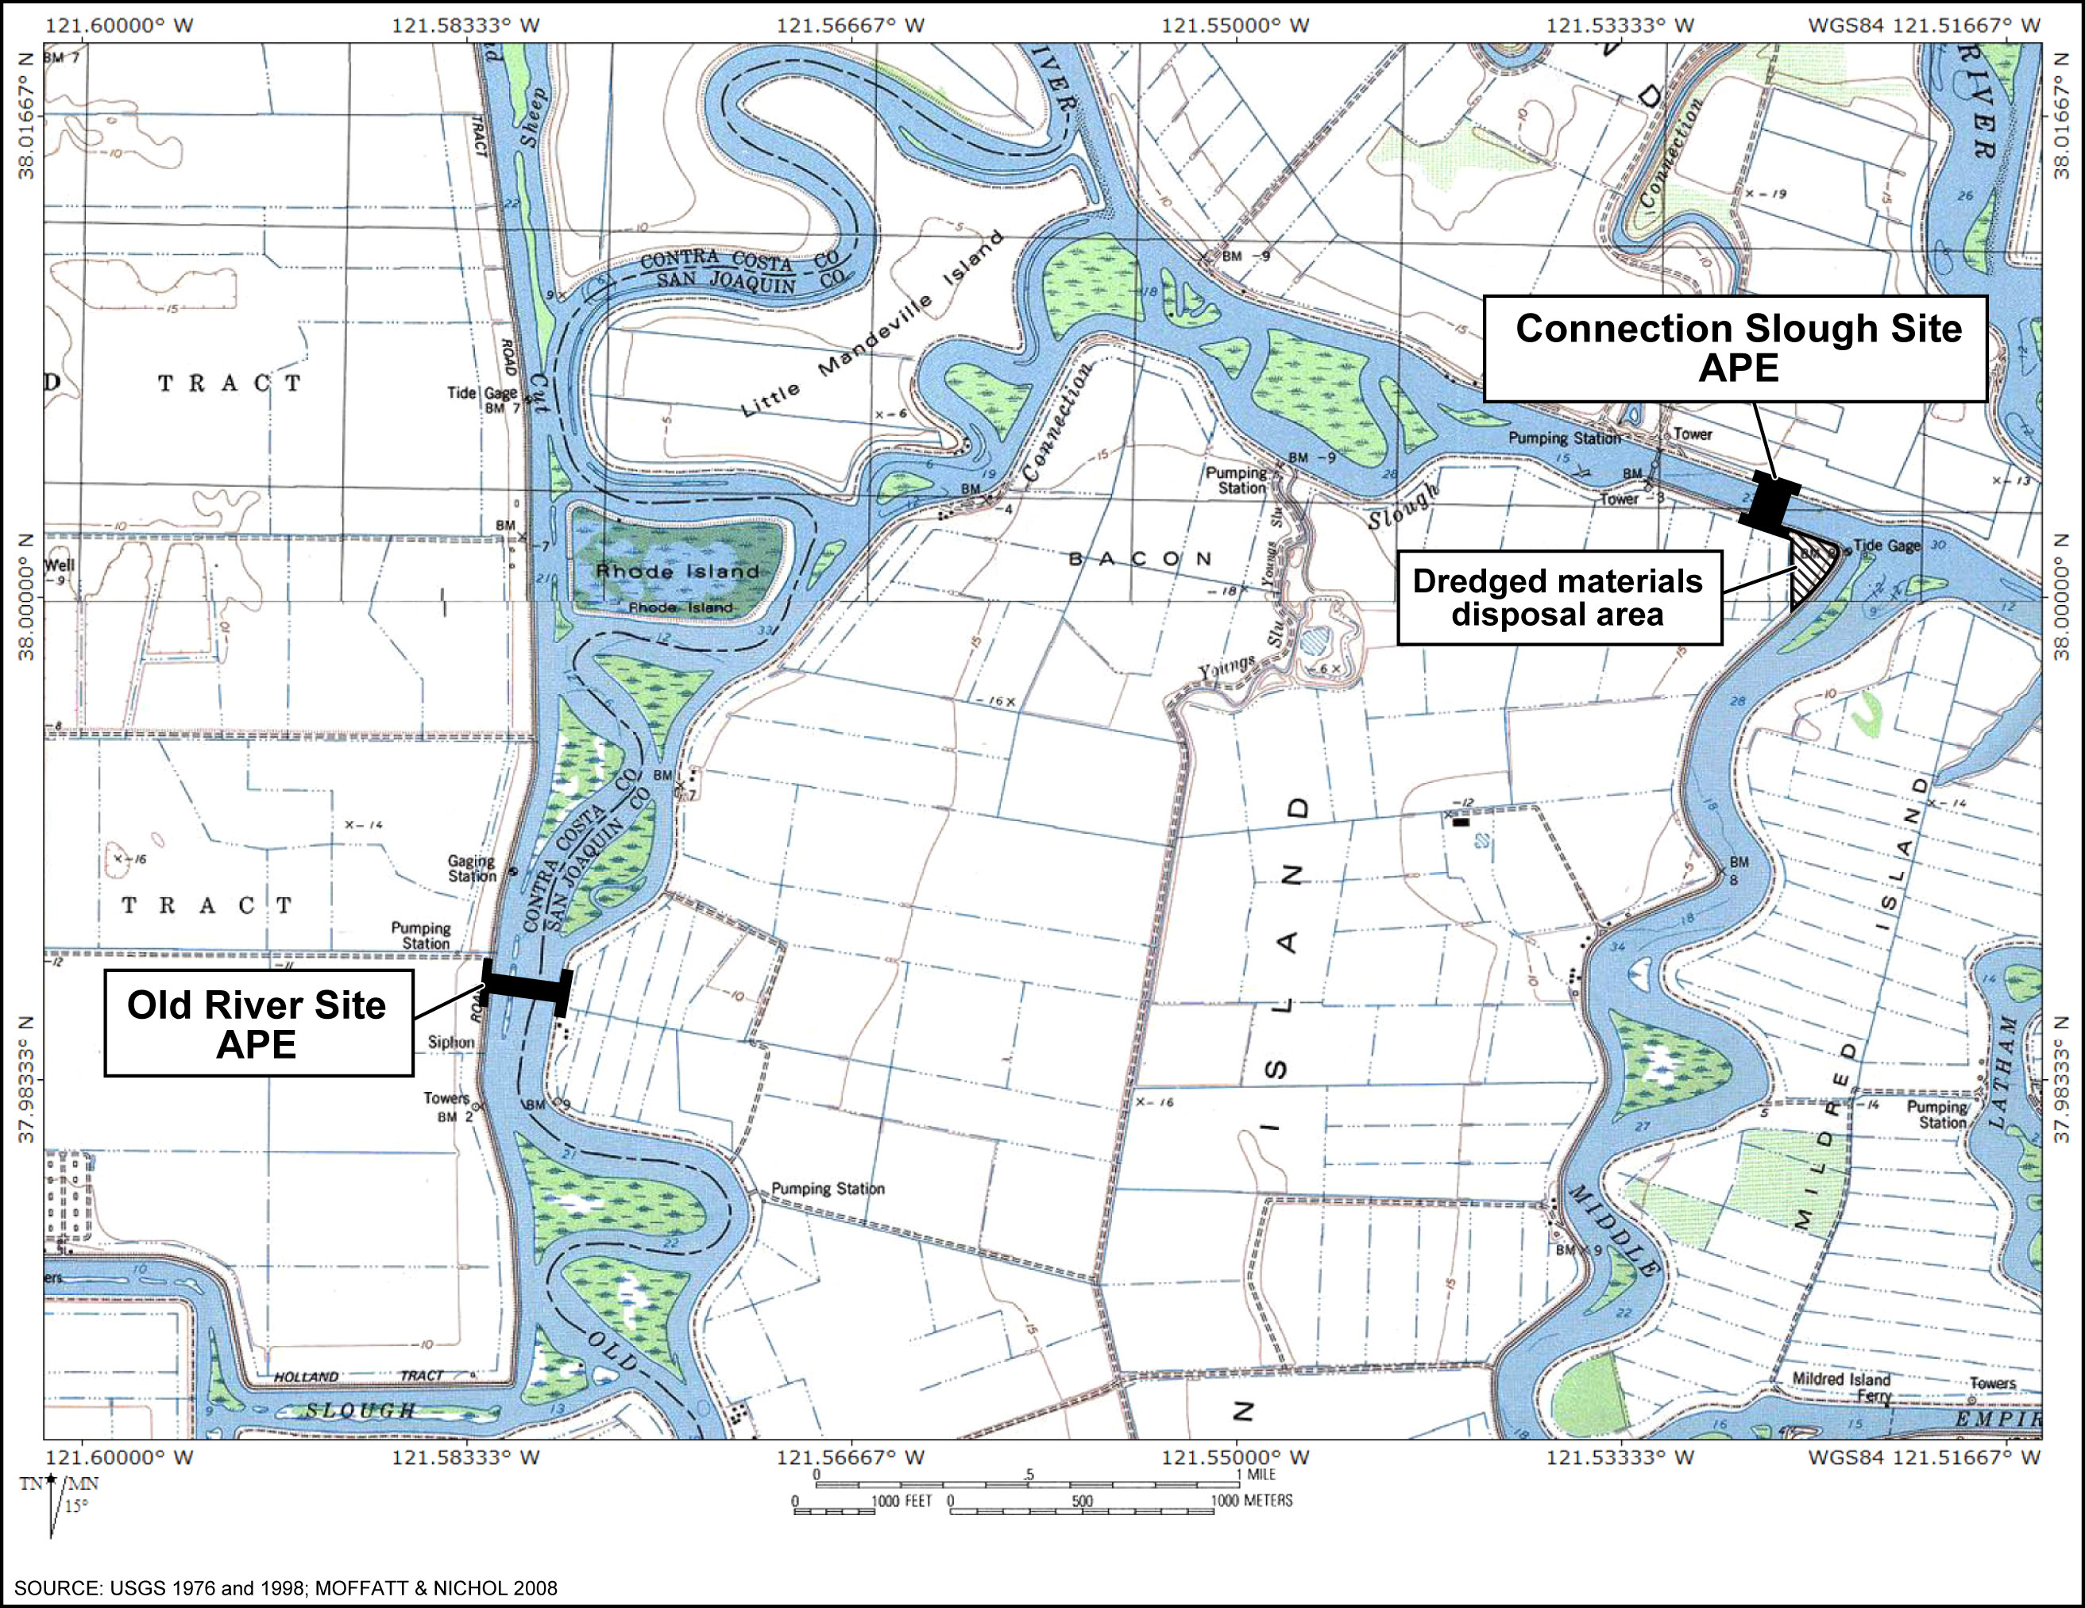
Figure 3.6-1 Location of Areas of Potential Effect
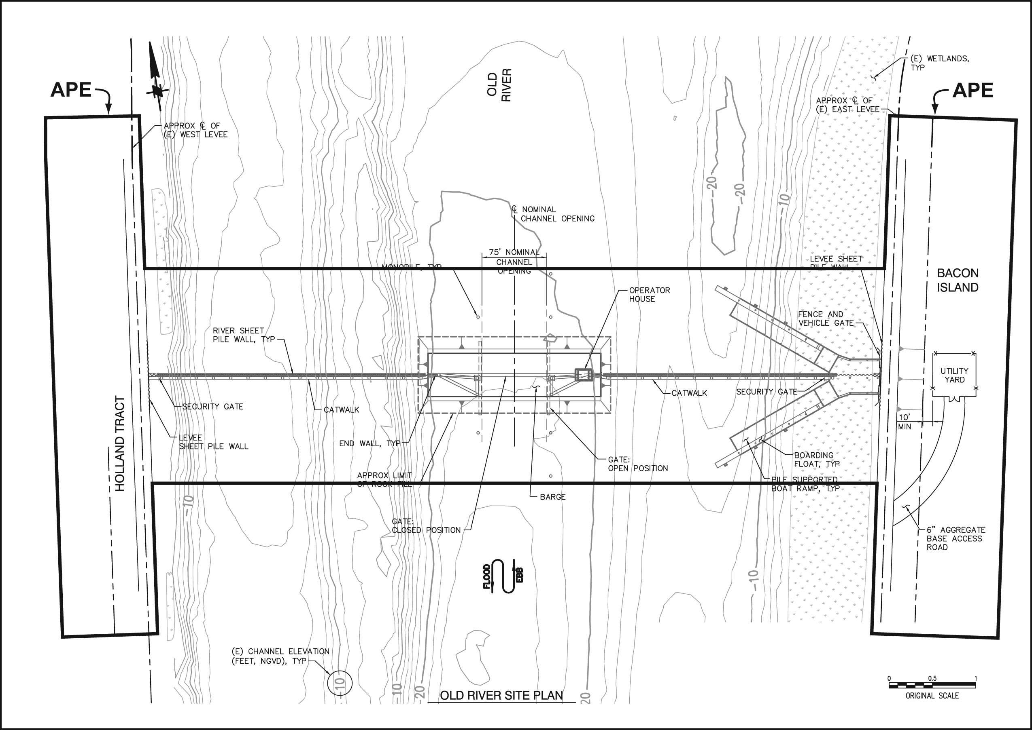
Figure 3.6-2 Old River Site Plan View and APE
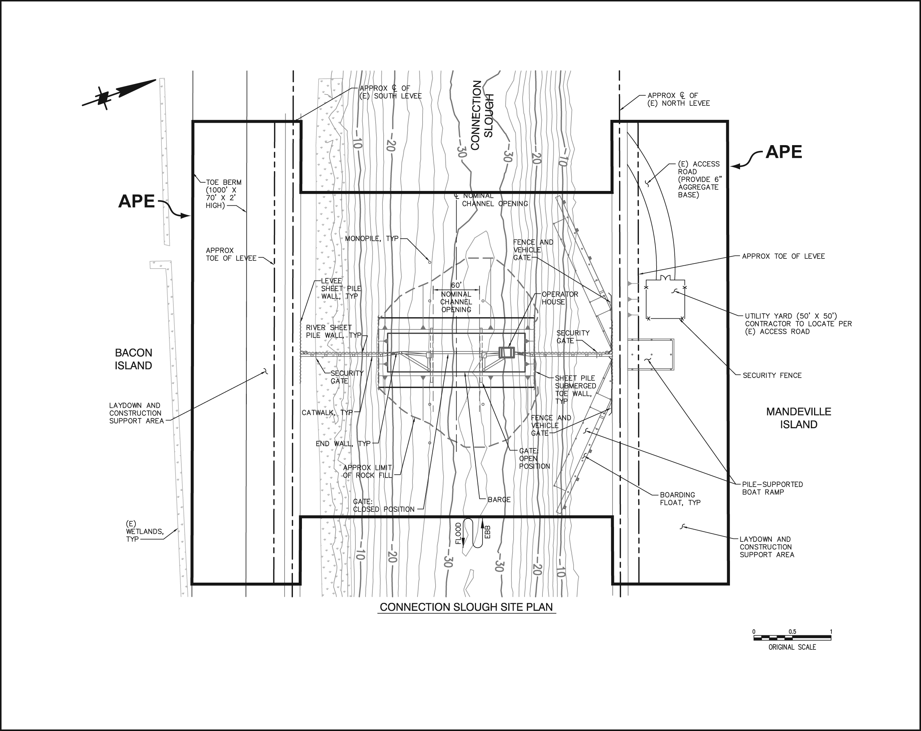
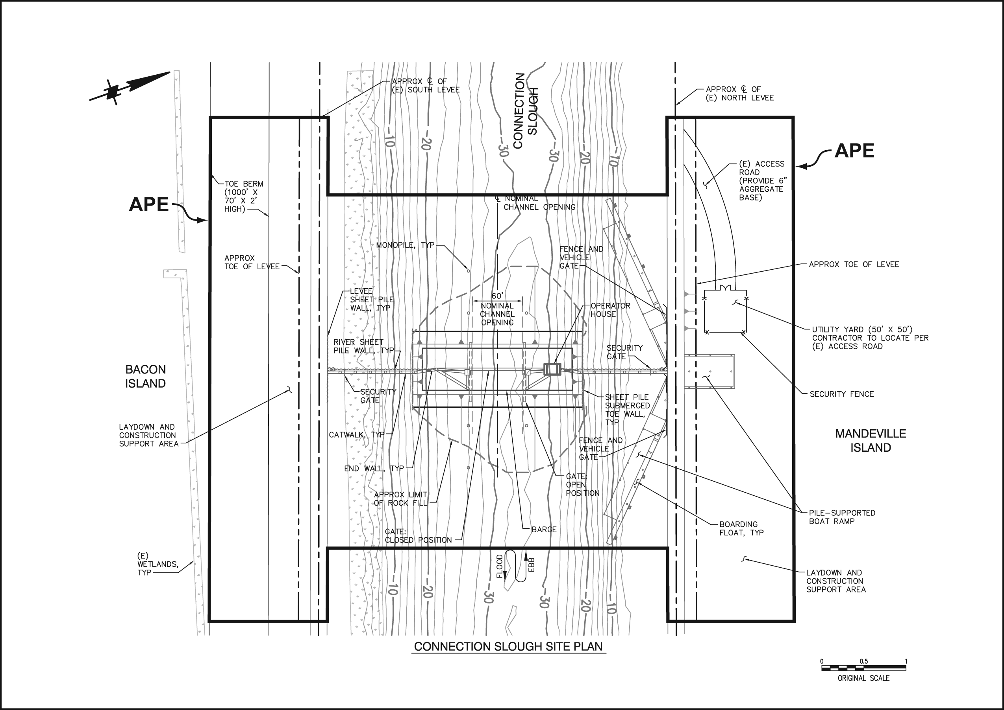
Figure 3.6-3 Connection Slough Site Plan View and APE

Native American Consultation
Applied Earthworks (Æ) contacted the Native American Heritage Commission (NAHC) to request a search of its sacred lands file for the area affected by the Proposed Action and the names and contact information of groups and/or individuals that could provide information relevant to this area. Æ contacted the groups and individuals identified by the NAHC by mail regarding the Proposed Action and solicited information regarding the proposed sites and surrounding area and the location of any sensitive Native American cultural resources within it. Æ also contacted all groups and individuals that were sent letters by telephone to confirm that the correspondence was received and to provide an opportunity for comment. The only comment from the Native American community regarding the Proposed Action was sent by the Ione Band of Miwok Indians, indicating that the Proposed Action is outside of their Ancestral Territory.
Reclamation as federal lead agency conducted Native American consultation to comply with their Section 106 responsibilities related to the Proposed Action. Reclamation contacted the Wilton Rancheria and the California Valley Miwok Tribe pursuant to 36 CFR Part 800.3(f)(2) and Part 800.4(a)(4) to inquire as to the potential presence of any sites of religious or cultural significance within the APE for the Proposed Action. Reclamation has not received any responses from the Tribes.

Survey
Æ archaeologist Randy Baloian performed a pedestrian surface survey of the Bacon Island portion of the Connection Slough APE and most of the Old River APE (Figure 3.6-1) on October 2, 2008. A small part of the APE was not surveyed because access has not been granted by the land owner. The survey consisted of systematic transects spaced at 15 to 20 meter intervals across the proposed sites. The following identifies the surface visibility, survey coverage, and survey results for each of the proposed areas.

Connection Slough Ape
Mandeville Island was not surveyed because access to the property has not granted by the land owner. The Bacon Island portion of the APE was surveyed. Surface visibility on Bacon Island was generally good (75 to 100 percent) along the levee road but decreased to 10 to 50 percent on the slope and level terrain below the crest of the levee. Survey coverage was confined to the areas immediately adjacent to the road by a corn field with dense vegetation that completely obscured ground visibility. No cultural resources were observed in the Bacon Island portion of the Connection Slough APE.

Old River Ape
Nearly the entire Old River APE was surveyed; however a small portion of it was not surveyed because access to the property has not been granted by the land owner. A large part of the Bacon Island portion of the Old River APE is recently graded, facilitating good to excellent surface visibility (90 to 100 percent). Survey coverage was limited to the areas immediately adjacent to the road by a dense corn field that completely obscured ground visibility. No cultural resources were observed in the Bacon Island portion of the Old River APE.
In the Holland Tract portion of the Old River APE, a short but dense blanket of grass covers the shoulders along the levee road. The vegetation becomes increasingly taller and thicker with greater distance from the road. Surface visibility ranged from 10 to 75 percent in this area. No cultural resources were observed in the Holland Tract portion of the Old River APE.

Roberts Island Disposal Site #1
The Roberts Island disposal site #1 APE was completely surveyed for use as a dredge materials disposal site as part of a Port of Stockton project at Rough and Ready Island (Port of Stockton 2003). Currently, the APE is graded, covered with dredged materials, and surrounded by a dirt berm.

Regulatory Setting

National Historic Preservation Act of 1966
The National Historic Preservation Act (NHPA) of 1966 established the federal historic preservation program and made it the policy of the federal government, in partnership with the states, local governments, Indian tribes, and private organizations and individuals, to preserve, protect, and manage cultural resources for “the inspiration and benefit of present and future generations” (16 U.S.C. 470-1, Section 2[3]).
Section 106 of the NHPA directs federal agencies to take into account the effects of their actions on historic properties and to afford the Advisory Council on Historic Preservation an opportunity to comment with respect to the effects of the undertaking. Implementing regulations for section 106 are found at 36 CFR 800, and establish the procedures federal agencies must follow when assessing the effects of a proposed action on historic properties. The term “historic properties” is defined at 36 CFR 800.16(l)(1) as “….any prehistoric or historic district, site, building, structure, or object included in, or eligible for inclusion in the [NRHP]…[and] includes properties of traditional religious importance to an Indian tribe or Native Hawaiian organization that meet the National Register criteria.”
To be eligible for listing on the NRHP, a cultural resource must be at least 50 years old (although there are exceptions) and must meet one or more of the eligibility criteria set forth at 36 CFR 60.4 which state:
The quality of significance in American history, architecture, archaeology, engineering and culture is present in districts, sites, buildings, structures, and objects that possess integrity of location, design, setting, materials, workmanship, feeling, and association and (a) that are associated with events that have made a significant contribution to the broad patterns of our history; or (b) that are associated with the lives of persons that are significant in our past; or (c) that embody the distinctive characteristics of a type, period, or method of construction, or that represent the work of a master, or that possess high artistic value, or that represent a significant and distinguishable entity whose components may lack individual distinction; or (d) that have yielded, or may likely yield, information important in prehistory or history.
Cultural resources are evaluated for potential listing on the NRHP with reference to an historic context and associated research questions, in consultation with the State Historic Preservation Officer and/or Tribal Historic Preservation Officer, tribes, and other interested organizations and individuals.

Executive Order 13007
Pursuant to Executive Order (EO) 13007 agencies must also consider the effects of their actions on the physical integrity of sacred sites, and access to and ceremonial use of such sites by Indian religious practitioners. EO 13007 defines a “sacred site” as:
…any specific, discrete, narrowly delineated location on Federal land that is identified by an Indian tribe, or Indian individual determined to be an appropriately authoritative representative of an Indian religion, as sacred by virtue of its established religious significance to, or ceremonial use by, an Indian religion; provided that the tribe or appropriately authoritative representative of an Indian religion has informed the agency of the existence of such a site.
EO 13007 directs federal agencies “…to the extent practicable, permitted by law, and not clearly inconsistent with essential agency functions,” to accommodate access to and use of such sites by Native American traditional religious practitioners, and to avoid affecting their physical integrity.

Resolution of Effects
Following 36 CFR 800.4, 800.5 and 800.6, Reclamation shall identify historic properties within the APE of an undertaking and apply the criteria of adverse effects to any historic properties within a project’s APE. If the results of the assessment of effects identify that a project would likely result in “No Adverse Effect,” Reclamation shall follow guidance at 36 CFR 800.5 (d) (1). If the results of the assessment of effects identify that a project would likely result in an “Adverse Effect” Reclamation shall follow guidance at 36 CFR 800.5 (d) (2) and continue to consult with the State Historic Preservation Officer, Native American groups, and other interested publics to resolve the adverse effect pursuant to 36 CFR 800.6.

Environmental Consequences
The impact analysis presented in this section addresses the regulatory requirements of NEPA and Section 106 of the NHPA.

No Action Alternative
No impacts to cultural resources would occur because the Proposed Action would not be implemented.

Proposed Action

Cultural Resources
There are no archaeological sites or historic buildings/structures within the boundaries of the Old River and Connection Slough APEs, but the APEs of the two project sites are within the Bacon Island Rural Historic District. The Bacon Island Rural Historic District appears to be eligible for inclusion in the NRHP. Regardless, implementation of the Proposed Action would not directly affect any historic sites within the district, nor would it affect the integrity or any other characteristics of the district that make it eligible for inclusion in the NRHP. The Proposed Action would not affect the Bacon Island Rural Historic District because it would primarily be constructed in waterways bordered by levees at the edges of the district and would not introduce any elements into the areas surrounding the levees that would compromise the setting, feeling, or association of the district. In addition, the Proposed Action is being constructed for demonstration purposes and would be deconstructed upon completion of data collection. There are no archaeological sites or historic buildings/structures within the boundaries of the Roberts Island #1 disposal site, and it has been previously used for the disposal of dredge materials; therefore, no impacts to cultural resources would result from its use.
The levees in the Old River and Connection Slough APEs are approximately 100 years old. These levees are not formally recorded, and their eligibility for inclusion in the NRHP has not been determined. For purposes of this analysis, however, they are conservatively assumed to be eligible. Implementation of the Proposed Action would require minor modifications to the levees that include the installation of sheet pile and boat ramps (Figure 2-9). These modifications would not alter the overall design or function of the levees. Therefore, the Proposed Action would have a minor impact on the levees under NEPA and a “No Adverse Effect” for purposes of Section 106.
A small portion of the Old River APE and the Mandeville Island portion of the Connection Slough APE were not surveyed because access to the property has not been granted by the land owners. Survey of the Old River APE did not identify any cultural resources and it is not anticipated that any cultural resources would be identified on the small part of the APE that is not surveyed. Observation of the Mandeville Island portion of the Connection Slough APE from the opposite bank on Bacon Island did not identify any cultural resources on Mandeville Island, and based on previous and current survey in the area it is not likely that pedestrian surface survey of the APE on Mandeville Island would identify any cultural resources. Regardless, there is a possibility that cultural resources are present within the Proposed Action APEs at the Old River site and on Mandeville Island that are not surveyed.
Environmental Commitment CR-1 addresses survey of the Old River APE and the Mandeville Island portion of the Connection Slough APE. Any areas within the APEs for these project sites not previously surveyed would be surveyed by a qualified archaeologist prior to implementation of the Proposed Action, and any cultural resources identified during survey would be recorded and considered pursuant to the Section 106 process detailed at 36 CFR Part 800. If any such resources are determined eligible for the NRHP, potential measures to resolve adverse effects may include avoidance, preservation in place, excavation, documentation, curation, data recovery, or other appropriate measures as determined through the Section 106 process. Subsequent to implementation of CR-1, any impacts to cultural resources in the Old River APE and the Mandeville Island portion of the Connection Slough APE that are not surveyed would be minor.

Unanticipated Discoveries of Cultural Resources
No archaeological sites or historic buildings/structures were identified within the Proposed Action APE. There is a possibility, however, of unanticipated and accidental archaeological discoveries during implementation of ground-disturbing activities associated with the Proposed Action. Ground disturbing project activity could have a substantial impact on inadvertently discovered cultural resources.
Environmental Commitment CR-2 addresses the unanticipated and accidental discovery of cultural resources during implementation of the Proposed Action. If any prehistoric or historic artifacts, or other indications of archaeological resources are discovered once project construction is underway, the discoveries shall be considered pursuant to the Section 106 process presented at 36 CFR 800 Part 13. Subsequent to implementation of CR-2, any impacts to inadvertently discovered cultural resources during implementation of the Proposed Action would be minor.

Unanticipated Discoveries of Human Remains
No human remains or evidence to suggest that human remains may be present were identified within the APE during cultural resources investigations for the Proposed Action. There is a possibility, however, of the unanticipated and accidental discovery of human remains during implementation of ground-disturbing activities.
Environmental Commitment CR-3 addresses the unanticipated and accidental discovery of human remains during implementation of the Proposed Action. If human remains are discovered once project construction is underway, all work would be halted immediately within 50 feet of the discovery and the discovery would be considered pursuant to Section 7050.5 of California’s Health and Safety Code and the Section 106 process presented at 36 CFR 800 Part 13. Subsequent to implementation of CR-3, any impacts to inadvertently discovered human remains during implementation of the Proposed Action would be minor.

