Hydrology and Water Quality

Affected Environment

Surface Water Hydrology
The San Joaquin River originates in the Sierra Nevada Mountains and flows west to the Central Valley. It meets the Sacramento River near the city of Antioch, and together they form the Sacramento-San Joaquin Delta, one of the largest estuaries in the United States. Two distributary rivers, the Old River and the Middle River, flow from the San Joaquin River before it joins the Sacramento River; both of these once were the main channels of the river. Because of the bend in the San Joaquin River channel at the head of the Old River, a substantial portion of the San Joaquin River flow continues down the Old River instead of heading northward along the mainstem of the San Joaquin. Flows along the Old River are eventually divided between the Old River, Middle River, and Grant Line Canal. In response to concerns about impacts to outmigrating salmon resulting from lower flows in these areas, DWR and DFG have, in the past, installed temporary rock barriers and have recently proposed other barrier technologies at the head of the Old River in order to keep fish in the main channel of the San Joaquin River in the spring.
Surface water in the Delta is dominated by tidal flows from San Francisco and Suisun bays and runoff from upstream in the Sacramento and San Joaquin River watersheds. Average daily inflow (and outflow) of water from tidal action is approximately 170,000 cfs. The average estimated freshwater outflow from the combined watershed is approximately 30,000 cfs (DWR 1993). Approximately 77 percent of the freshwater inflow is derived from the Sacramento River portion of the watershed. The mainstem and tributaries of the San Joaquin River contribute about 15 percent of the total freshwater inflow, and streams that flow directly into the Delta (e.g., the Mokelumne River) contribute the remainder of the freshwater.
Surface water flow in Old River and Connection Slough is dominated by natural tidal variations and is also affected by diversion pumping at the CVP and SWP export pumping facilities and other in-Delta exporters. The California Data Exchange Center (CDEC) installs, maintains, and operates an extensive hydrologic data collection network include a suite of hydrologic data collections stations in the Delta. The USGS also maintains a set of stream gages in the Delta. Table 3.9-1 displays the peak total flow at selected locations in the Delta for the months of January and February. This table includes both historic and simulated flows to account for the changes in operations for compliance with the recent CVP/SWP Operations BOs (USFWS 2008b, NMFS 2009a). Table 3.9-2 displays the peak total flow at selected locations in the Delta for the months of March and June. This table includes both historic and simulated flows to account for the changes in operations. These results were obtained through the use of the RMA-Delta Model (Appendix B).
Table 3.9-1 Simulated (2004) Peak Total Flow in January and February at Selected Sites in the Delta
 |  | Current Peak Total Flow (cfs) during January-February 2004
 |  | Ebb Tide |  | Flood Tide
 |  | January | February | January | February
Station Name | Code
Chipps Island |  | 442,671 | 456,090 | -386,759 | -369,202
False River | FAL | 56,240 | 54,715 | -60,552 | -62,003
Sacramento River @ Freeport | FPT | 61,877 | 75,071 | 17,507 | 15,921
Grant Line Canal | GLC | 6,361 | 6,213 | -5,345 | -5,012
Old River at Holland Cut | HOL | 29,612 | 29,112 | -31,728 | -33,618
Jersey Point | JPT | 159,472 | 157,996 | -161,246 | -157,081
Middle River S of Woodward Cut | MID | 6,741 | 7,051 | -9,438 | -9,353
Mokelumne River @ SJR | MOK | 21,488 | 22,563 | -13,091 | -12,799
Mossdale | RSAN087 | 2,929 | 4,455 | -148 | -101
Middle River @ Medford Island | MRC | 31,292 | 30,612 | -37,843 | -38,881
Old River @ Bacon Island | ROLD024 | 13,498 | 13,580 | -16,856 | -16,487
Old River W of Victoria Island | ROLD034 | 7,995 | 8,643 | -11,761 | -11,690
Old River @ San Joaquin River | OSJ | 11,390 | 10,662 | -13,509 | -15,867
Prisoners Point | PRI | 63,899 | 62,101 | -75,408 | -79,676
Rio Vista | RSAC101 | 143,270 | 197,193 | -102,473 | -100,547
Middle River @ Middle River | RMID015 | 12,485 | 12,816 | -16,977 | -16,989
Cache Slough @ Ryer Island | RYI | 97,616 | 140,896 | -96,081 | -91,321
San Andreas | SAN | 118,980 | 115,539 | -125,249 | -124,856
Threemile Slough | SLTRM004 | 27,568 | 27,220 | -36,818 | -40,107
Turner Cut | TRC | 2,256 | 2,227 | -3,319 | -3,189
Victoria Canal | VIC | 3,359 | 3,736 | -5,556 | -5,585

Table 3.9-2 Simulated (2004) Peak Total Flow in March and June at Selected Sites in the Delta
 |  | Peak Total Flow (cfs) for March and June 2004
 |  | Ebb Tide |  |  |  | Flood Tide
 |  | March |  | June |  | March |  | June
Station Name | Code | Lower Bound | Upper Bound | Lower Bound | Upper Bound | Lower Bound | Upper Bound | Lower Bound | Upper Bound
Chipps Island |  | 425,783 | 424,951 | 443,911 | 441,965 | -409,224 | -410,782 | -369,456 | -373,235
False River | FAL | 55,846 | 55,754 | 52,949 | 52,427 | -61,621 | -61,964 | -59,915 | -60,662
Sacramento River @ Freeport | FPT | 19,652 | 19,668 | 72,797 | 72,796 | 5,195 | 5,196 | 23,305 | 23,297
Grant Line Canal | GLC | 6,030 | 5,902 | 6,320 | 6,597 | -4,275 | -4,645 | -4,082 | -4,206
Old River at Holland Cut | HOL | 30,785 | 30,446 | 27,800 | 26,935 | -32,293 | -32,606 | -31,637 | -32,476
Jersey Point | JPT | 157,777 | 157,393 | 153,504 | 151,907 | -165,173 | -166,119 | -156,824 | -158,917
Middle River S of Woodward Cut | MID | 6,001 | 5,672 | 6,818 | 6,141 | -9,954 | -9,973 | -8,538 | -9,643
Mokelumne River @ SJR | MOK | 17,608 | 17,622 | 21,066 | 21,053 | -14,098 | -14,014 | -11,649 | -11,448
Mossdale | RSAN087 | 2,127 | 2,106 | 4,681 | 4,653 | -289 | -174 | 1,968 | 2,007
Middle River @ Medford Island | MRC | 31,681 | 31,471 | 29,865 | 29,056 | -38,649 | -39,149 | -37,556 | -38,578
Old River @ Bacon Island | ROLD024 | 13,616 | 13,428 | 13,254 | 12,541 | -17,172 | -17,628 | -15,759 | -16,740
Old River W of Victoria Island | ROLD034 | 6,981 | 6,384 | 8,342 | 7,331 | -12,730 | -13,294 | -10,496 | -13,150
Old River @ San Joaquin River | OSJ | 12,178 | 12,089 | 10,738 | 10,516 | -13,698 | -13,856 | -13,979 | -14,473
Prisoners Point | PRI | 63,752 | 63,508 | 60,957 | 59,954 | -75,810 | -76,659 | -78,691 | -80,261
Rio Vista | RSAC101 | 123,000 | 123,250 | 190,228 | 190,444 | -117,176 | -117,278 | -94,199 | -94,149
Middle River @ Middle River | RMID015 | 12,094 | 11,825 | 12,562 | 11,593 | -17,765 | -18,260 | -15,980 | -17,398
Cache Slough @ Ryer Island | RYI | 91,733 | 91,983 | 134,237 | 134,420 | -95,054 | -95,086 | -93,606 | -93,478
San Andreas | SAN | 118,136 | 117,805 | 115,083 | 113,631 | -127,245 | -128,071 | -124,296 | -126,708
Threemile Slough | SLTRM004 | 28,298 | 28,204 | 25,701 | 25,277 | -34,411 | -34,666 | -37,641 | -38,246
Turner Cut | TRC | 2,640 | 2,586 | 2,127 | 1,910 | -3,758 | -3,805 | -3,276 | -3,558
Victoria Canal | VIC | 2,908 | 2,616 | 3,620 | 3,133 | -6,172 | -6,815 | -5,036 | -6,908

Surface water flow near the Old River and Connection Slough sites also is dominated by natural tidal variations and diversion pumping at the various export pumping facilities. As a result of the channel size, configuration, and location of Connection Slough, flow rates at this site are substantially lower than at the Old River site. Figure 3.9-1 shows the peak water velocity on a flood tide in the Old River channel with current conditions. Peak flows rates of approximately 2 to 2.5 feet per second (ft/sec) occur near the downstream end of the in-channel island at its easterly turn for the oxbow north of Rock Slough Holland Cut and within the extension of the Holland Cut on the westerly side of the in-channel island. Similarly, Figure 3.9-2 shows the peak water velocity on an ebb tide in the Old River channel with current conditions. Peak flows at a rate of approximately 1.5 to 2 ft/sec occur in various sections of the channel.
Figures 3.9-3 through 3.9-10 display the range of simulated net flows for current operations at selected locations in the Delta. The month of January was selected a representative of winter conditions in the Delta. These figures include both the modeled flow under historic and simulated current operational flows based on a common hydrologic condition of tide and watershed inflow. Both conditions are provided to describe the hydrologic conditions that have been found in the Delta (historic) and those that would be expected under typical hydrologic conditions with current operations for compliance with the recent CVP/SWP Operations BOs (USFWS 2008b, NMFS 2009a). Likewise, Figures 3.9-11 through 3.9-18 display the range of modeled net flow from actual conditions and for current operations at selected locations in the Delta. The month of March was selected as representative of spring and early summer conditions in the Delta. These results were obtained through the use of the RMA-Delta Model (Appendix B).

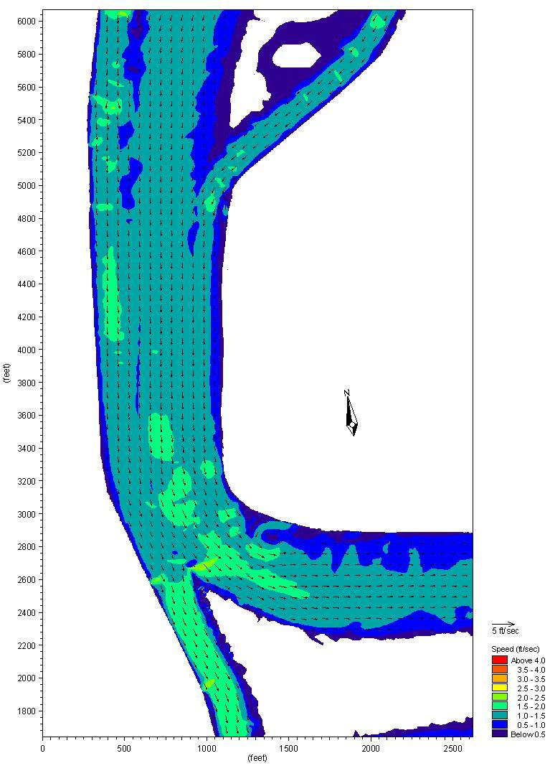

Figure 3.9-1 Peak Flood Tide Existing Velocity
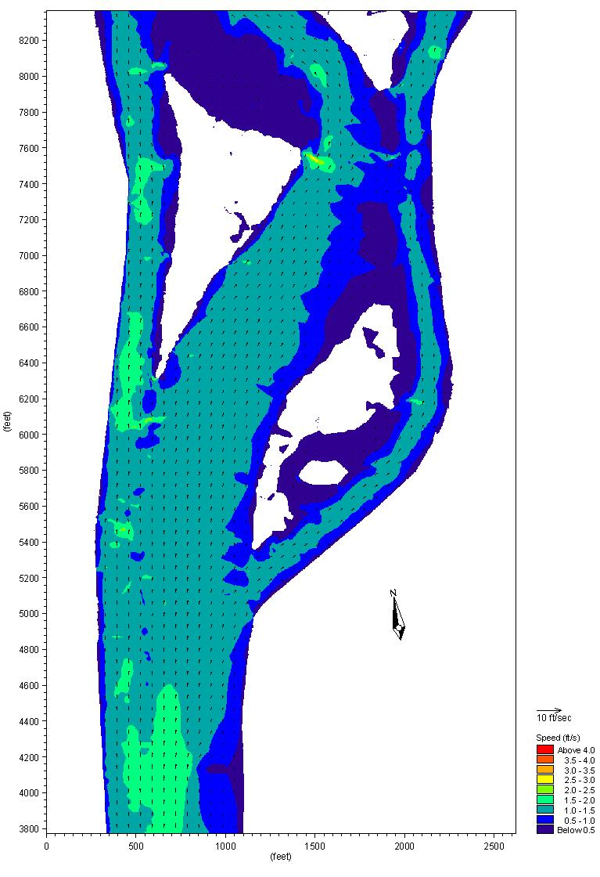

Figure 3.9-2 Peak Ebb Tide Existing Velocity
Delta waters and channels are also subject to large inflow from the Sacramento and San Joaquin River watershed. The Proposed Action would construct facilities in channels that convey a portion of the total runoff from the San Joaquin River watershed. Peak flood flows in early 1997 on the San Joaquin River in the south Delta (Vernalis) measured up to 75,000 cfs (USGS 2009). These peak flows are generally carried downstream in the mainstem of the San Joaquin River, but approximately one-third of the waters are carried in the Old and Middle River segments.
The lands surrounding the Old River and Connection Slough sites are within the 100-year floodplains (Contra Costa County 2005, San Joaquin County 1992). A system of levees protects the lands on the neighboring islands (Holland Tract, Bacon Island, and Mandeville Island), which are below sea level.

Surface Water Quality
The SWRCB has adopted water quality control plans and policies to protect water quality and contribute to the protection of beneficial uses in the Bay-Delta Estuary. The Water Quality Control Plan for the San Francisco Bay/Sacramento-San Joaquin Delta Estuary (Bay-Delta Plan) was adopted in 1995 and amended in 2006. Water quality and water rights for the Delta were established via D-1485 (1978) and D-1641 (2000). When combined, the Bay-Delta Plan and applicable Water Right Decisions establish water quality objectives that consider the need for the protection of beneficial uses, including agricultural, domestic, and industrial uses by humans and the needs of the ecosystem. These establish the water quality objectives and set the conditions for water management in the Delta.

Percent Exceedance
0
10
20
30
40
50
60
70
80
90
100
Net Flow (cfs)
0
10,000
20,000
30,000
40,000
50,000
60,000
70,000
80,000
Existing Conditions
(Jan 2004)
Current
Operations
Figure 3.9-3 Net Flow Exceedance for Historical (January 2004) and Simulated Current Operations at Chipps Island
Percent Exceedance
0
10
20
30
40
50
60
70
80
90
100
Net Flow (cfs)
-4,000
-3,500
-3,000
-2,500
-2,000
-1,500
-1,000
-500
0
Existing Conditions
(Jan 2004)
Current
Operations
Figure 3.9-4 Net Flow Exceedance for Historical (January 2004) and Simulated Current Operations at MID (Middle River South of Woodward Canal)
Percent Exceedance
0
10
20
30
40
50
60
70
80
90
100
Net Flow (cfs)
3,000
4,000
5,000
6,000
7,000
8,000
9,000
Existing Conditions
(Jan 2004)
Current
Operations
Figure 3.9-5 Net Flow Exceedance for Historical (January 2004) and Simulated Current Operations at Mokelumne River at San Joaquin River
Percent Exceedance
0
10
20
30
40
50
60
70
80
90
100
Net Flow (cfs)
1,400
1,500
1,600
1,700
1,800
1,900
2,000
2,100
2,200
2,300
Existing Conditions
(Jan 2004)
Current
Operations
Figure 3.9-6 Net Flow Exceedance for Historical and Simulated Current Operations (RSAN087), San Joaquin River at Mossdale for January 2004
Percent Exceedance
0
10
20
30
40
50
60
70
80
90
100
Net Flow (cfs)
-5,000
-4,000
-3,000
-2,000
-1,000
0
1,000
Existing Conditions
(Jan 2004)
Current
Operations
Figure 3.9-7 Net Flow Exceedance for Historical (January 2004) and Simulated Current Operations at MRC (Middle River at Medford Island)
Percent Exceedance
0
10
20
30
40
50
60
70
80
90
100
Net Flow (cfs)
-5,000
-4,000
-3,000
-2,000
-1,000
0
1,000
Existing Conditions
(Jan 2004)
Current
Operations
Figure 3.9-8 Net Flow Exceedance for Historical (January 2004) and Simulated Current Operations at OLD (ROLD024, Old River at Bacon Island)
Percent Exceedance
0
10
20
30
40
50
60
70
80
90
100
Net Flow (cfs)
-8,000
-7,000
-6,000
-5,000
-4,000
-3,000
-2,000
-1,000
0
Existing Conditions
(Jan 2004)
Current
Operations

Figure 3.9-9 Net Flow Exceedance for Historical (January 2004) and Simulated Current Operations at OLF (ROLD034, Old River near Byron)
Percent Exceedance
0
10
20
30
40
50
60
70
80
90
100
Net Flow (cfs)
-7,000
-6,000
-5,000
-4,000
-3,000
-2,000
-1,000
0
1,000
2,000
3,000
Existing Conditions
(Jan 2004)
Current
Operations

Figure 3.9-10 Net Flow Exceedance for Historical (January 2004) and Simulated Current Operations at PRI (Prisoner Point)
Existing Conditions (Mar 2004)
Current Operations
Lower Bound
Current Operations
Upper Bound
Percent Exceedance
0
10
20
30
40
50
60
70
80
90
100
Net Flow (cfs)
0
20,000
40,000
60,000
80,000
100,000
120,000
140,000
160,000
180,000
Figure 3.9-11 Net Flow Exceedance for Historical (March 2004) and Simulated Current Operations at Chipps Island
Percent Exceedance
0
10
20
30
40
50
60
70
80
90
100
Net Flow (cfs)
-4,000
-3,500
-3,000
-2,500
-2,000
-1,500
-1,000
-500
0
Existing Conditions (Mar 2004)
Current Operations-Lower Bound
Current Operations-Upper Bound
Figure 3.9-12 Net flow exceedance for Historical (March 2004) and Simulated Current Operations at MID (Middle River S of Woodward Canal

Percent Exceedance
0
10
20
30
40
50
60
70
80
90
100
Net Flow (cfs)
3,000
4,000
5,000
6,000
7,000
8,000
9,000
10,000
11,000
Existing Conditions (Mar 2004)
Current Operations-Lower Bound
Current Operations-Upper Bound
Figure 3.9-13 Net flow exceedance for Historical (March 2004) and Simulated Current Operations at MOK (Mokelumne River at San Joaquin River)
Existing Conditions (Mar 2004)
Current Operations-Lower Bound
Current Operations-Upper Bound
Figure 3.9-14 Net flow exceedance for Historical (March 2004) and Simulated Current Operations at MOS (RSAN087, San Joaquin River at Mossdale)
Existing Conditions (Mar 2004)
Current Operations-Lower Bound
Current Operations-Upper Bound
Figure 3.9-15 Net flow exceedance for Historical (March 2004) and Simulated Current Operations at MRC (Middle River at Medford Island)

Existing Conditions (Mar 2004)
Current Operations-Lower Bound
Current Operations-Upper Bound
Figure 3.9-16 Net flow exceedance for Historical (March 2004) and Simulated Current Operations at OLD (ROLD024, Old River at Bacon Island)
Existing Conditions (Mar 2004)
Current Operations-Lower Bound
Current Operations-Upper Bound
Figure 3.9-17 Net flow exceedance for Historical (March 2004) and Simulated Current Operations at OLF (ROLD034, Old River near Byron)
Existing Conditions (Mar 2004)
Current Operations-Lower Bound
Current Operations-Upper Bound
Percent Exceedance
0
10
20
30
40
50
60
70
80
90
100
Net Flow (cfs)
-10,000
-8,000
-6,000
-4,000
-2,000
-0
2,000
4,000
Figure 3.9-18 Net flow exceedance for Historical (March 2004) and Simulated Current Operations at PRI (Prisoners Point)
Figure 3.9-19 Monitored Salinity (μmho/cm) near the Proposed Action Locations
General water quality in the Delta has been the subject of much analysis debate with regard to its intended use. At some times and in some locations water quality in the Delta has been determined to be in violation of water quality objectives and impaired its beneficial uses. These violations have led to the development of Total Maximum Daily Load (TMDL) programs in an effort to control the input of these pollutants from their sources, including municipal, domestic, industrial, and agricultural wastewater and stormwater (Lee and Jones-Lee 2004). Delta waters have been impaired by many factors including:
- Bioaccumulation of organochlorine “legacy” pesticides and other toxic materials (dichlorodiphenyltrichloroethane [DDT], chlordane, dieldrin, polychlorinated biphenyls [PCBs], dioxins/furans, and heavy metals), organophosphorus-based pesticides, and pyrethroid-based pesticides that are a threat to the health of those who use some types of Delta fish as food.
- Elevated concentrations of total organic carbon and nutrients (principally nitrogen and phosphorus compounds), which stimulate algal and other plant growth and require additional treatment prior to the use as a domestic water supply source to control excessive trihalomethanes. The added nutrients also cause taste and odor issues in the water supply.
- Influent water, principally from the San Joaquin River, also carries salts and other dissolved solids that exceed water quality objectives and is an important issue for agriculture relying on Delta waters.
- Excessive algal and aquatic weed growth can contribute to a reduction in dissolved oxygen. This may result in the degradation of the rest of the aquatic ecosystem including fish kills.
- Invasive and non-native aquatic organisms have also resulted in the change in water quality and are suspected to be a major contributor to other ecosystem changes in the Delta.
- Population growth in the surrounding and adjacent watershed has increased point and non-point pollution, including the addition of ammonia and other common chemical compounds.

Groundwater
The Project sites are located in the Tracy Subbasin of the Great Valley Geomorphic Province (DWR 2006). The Tracy Subbasin is composed of four defined strata: the Tulare Formation, Older Alluvium, Flood Basin Deposits, and Younger Alluvium. The Flood Basin Deposits consist primarily of silts and clays between the Younger Alluvium and older and deeper sediments, and include occasional gravel interbeds in areas adjacent to existing waterways. Because of their fine-grained nature, the flood basin deposits have low permeability and correspondingly low yields to water wells. Occasional zones of fresh water are found in these basin deposits, but they generally contain poor quality groundwater. The Younger Alluvium aquifer unit includes sediments deposited in the channels of active streams as well as overbank deposits and terraces of those streams. This unit is locally highly permeable and is less than 100 feet thick.

Regulatory Setting

Federal

Clean Water Act
The EPA is the federal agency responsible for water quality management and administers the federal Water Pollution Control Act Amendments of 1972 and 1987, collectively known as the CWA. The CWA establishes the principal federal statutes for water quality protection. It was established with the intent “to restore and maintain the chemical, physical, and biological integrity of the nation’s water, to achieve a level of water quality which provides for recreation in and on the water, and for the propagation of fish and wildlife.” Several key sections of the CWA guide the regulation of water pollution in the United States:
- Section 208, Water Quality Control Plans. This section requires the preparation of local water quality control plans throughout the nation. Each water quality control plan covers a defined drainage area. The primary goal of each water quality control plan is to attain water quality standards established by the CWA and the state governments within the defined area of coverage. Minimum content requirements, preparation procedures, time constraints, and federal grant funding criteria pertaining to the water quality control plans are established in Section 208. Preparation of the water quality control plans has been delegated to the individual states by the EPA.
- Section 401, Water Quality Certifications. This section of CWA requires that, prior to the issuance of a federal license or permit for an activity or activities that may result in a discharge of pollutants into navigable waters (see Section 404 discussion, below), the permit applicant must first obtain a certification from the state in which the discharge would originate. A state certification indicates that the proposed activity or activities would not result in a violation of applicable water quality standards established by federal or state law, or that there are no water quality standards that apply to the proposed activity.
- Section 402, NPDES. The NPDES requires permits for pollution discharges into water bodies such that the permitted discharge does not cause a violation of federal and state water quality standards. NPDES permits define quantitative and/or qualitative pollution limitations for the permitted source, and control measures that must be implemented to achieve the pollution limitations. Pollution control measures are often referred to as BMPs.
- Section 404, Discharge of Dredge and Fill Material. Section 404 assigns the Corps with permitting authority for proposed discharges of dredged and fill material into waters of the U.S., defined as “…waters which are currently used, or were used in the past, or may be susceptible to use in interstate or foreign commerce, including all waters which are subject to the ebb and flow of the tide; territorial seas and tributaries to such waters.”
The Corps typically considers all natural drainages with defined beds and banks to be waters of the U.S. Section 404 establishes procedures by which the permitting agency is to review, condition, approve, and deny permit requests. Per the regulations, permitting agencies are responsible to conduct public noticing and provide the opportunity for public hearings during the review of each permit request. This includes informing USFWS and/or the NMFS of each permit request. Consultation with USFWS and/or NMFS is required for proposed discharges that could affect species protected by the federal ESA. Measures that are required by USFWS and/or NMFS to minimize impacts to federally protected species must be included as conditions of the permit.

Rivers and Harbors Act
The Rivers and Harbors Act (RHA) of 1899 prohibits the unauthorized alteration or obstruction of any navigable waters of the United States. As defined by the RHA, navigable waters include all waters that are:
- Historically, presently, or potentially used for interstate or foreign commerce and
- Subject to the ebb and flow of tides
Regulations implementing Section 10 of the RHA are coordinated with regulations implementing CWA Section 404. The RHA specifically regulates:
- Construction of structures in, under, or over navigable waters
- Deposition or excavation of material in navigable waters
- All work affecting the location, condition, course, or capacity of navigable waters
The RHA is administered by the Corps. If a proposed activity falls under the authority of RHA Section 10 and CWA Section 404, the Corps processes and issues a single permit. For activities regulated only under RHA Section 10, such as installation of a structure not requiring fill, permit conditions may be added to protect water quality during construction. The San Joaquin River is considered a navigable water between the mouth of the river and Sycamore Road (a point about 7 miles downstream of U.S. Highway 99 near Fresno).

National Flood Insurance Program
The Federal Emergency Management Agency (FEMA) administers the National Flood Insurance Program (NFIP). FEMA has completed Flood Insurance Rate Maps that identify Special Flood Hazard Areas in the Project area. To comply with the NFIP, communities must adopt a floodplain management ordinance addressing construction and habitation in flood zones. In California, DWR provides and encourages communities to adopt the California Model Floodplain Management Ordinance.

Executive Order 11988-Floodplain Management
EO 11988 requires federal agencies to recognize the values of floodplains and to consider the public benefits from restoring and preserving floodplains. Under this order the Corps is required to take action and provide leadership to:
- Avoid development in the base floodplain
- Reduce the risk and hazard associated with floods
- Minimize the impact of floods on human health, welfare, and safety and
- Restore and preserve the beneficial and natural values of the base floodplain.

State

Porter-Cologne Act
The Porter-Cologne Act (California Water Code Section 13000) is the principal law governing water quality regulation in California. It establishes a comprehensive program to protect water quality and the beneficial uses of water. The Porter-Cologne Act applies to surface waters, wetlands, and groundwater, and to both point and non-point sources of pollution. Pursuant to the Porter-Cologne Act, it is the policy of the State of California that:
- The quality of all the waters of the State shall be protected
- All activities and factors affecting the quality of water shall be regulated to attain the highest water quality within reason and
- The State must be prepared to exercise its full power and jurisdiction to protect the quality of water in the State from degradation
Pursuant to the Porter-Cologne Act, the responsibility for protection of water quality in California rests with the SWRCB. The SWRCB administers federal and state water quality regulations for California’s ocean waters and also oversees and funds the state’s nine RWQCBs. The RWQCBs prepare water quality control plans, establish water quality objectives, and carry out federal and state water quality regulations and permitting duties for inland water bodies, enclosed bays, and estuaries within their respective regions. The Porter-Cologne Act gives the SWRCB and RWQCBs broad powers to protect water quality by regulating waste discharge to water and land and by requiring clean up of hazardous wastes.

Section 401 Water Quality Certification
The CVRWQCB has jurisdiction over issues concerning CWA Section 401 Water Quality Certifications for the Project site.

Water Quality Control Plan for the San Francisco Bay/Sacramento-San Joaquin Estuary (Bay-Delta Plan)
The Water Quality Control Plans from all nine of the RWQCBs and the California Ocean Plan (prepared and implemented by the SWRCB) collectively constitute the State Water Quality Control Plan. However, the SWRCB (2006) prepared the Bay-Delta Plan to supplement the other water quality control plans adopted by the SWRCB and RWQCBs, and State policies for water quality control as they relate to the Bay-Delta Estuary watershed. The Bay-Delta Plan has been designed to support the intentions of the CWA and the Porter-Cologne Act by: (1) characterizing watersheds within the Delta; (2) identifying beneficial uses that exist or have the potential to exist in each water body; (3) establishing water quality objectives for each water body to protect beneficial uses or allow their restoration, and; (4) providing an implementation program that achieves water quality objectives. Implementation program measures include monitoring, permitting, and enforcement activities.

Storm Water Permit
Construction activities that involve 0.5 or more acres of land disturbance must comply with the General Permit for Discharges of Storm Water Associated with Construction Activity (Construction General Permit, 99-08-DWQ), which regulates stormwater originating from construction activities. Construction activity subject to this permit includes clearing, grading and disturbances to the ground such as stockpiling, or excavation, but does not include regular maintenance activities performed to restore the original line, grade, or capacity of the facility.
The Construction General Permit requires the development and implementation of a SWPPP. Section A of the Construction General Permit describes the elements that must be contained in a SWPPP. These elements include a site map(s) that shows the construction site perimeter, existing and proposed buildings, lots, roadways, storm water collection and discharge points, general topography both before and after construction, and drainage patterns across the project. The SWPPP must list the BMPs the discharger will use to protect storm water runoff and the placement of those BMPs. Additionally, the SWPPP must contain a visual monitoring program; a chemical monitoring program for “non-visible” pollutants to be implemented if there is a failure of BMPs; and a sediment monitoring plan if the site discharges directly to a water body listed on the 303(d) list for sediment.
The SWRCB is in the process of reissuing the Construction General Permit and released a preliminary draft of the new permit on March 2, 2007 (SWRCB 2007). A revision to the draft was released in March 2008. When adopted, this permit will replace the 1999 Construction General Permit and, as proposed, would require the permittee to implement additional minimum BMPs. The revised draft permit also requires specific analytical procedures to determine whether the BMPs are preventing further impairment due to sediment and preventing non-visible pollutants from violating water quality objectives. The new requirements would require monitoring (i.e., sampling and testing) of the quality of stormwater discharges at most sites. In addition, all sites would be required to meet new development and redevelopment performance standards to minimize or mitigate hydrologic impacts.

Fish and Game Code, Sections 1601 to 1603
Under Sections 1601 to 1603 of the Fish and Game Code, DFG must be notified prior to any project that would divert, obstruct, or change the natural flow, bed, channel, or bank of any river, stream, or lake. The term “stream” can include intermittent and ephemeral streams, rivers, creeks, dry washes, sloughs, blueline streams, and watercourses with subsurface flows. The Project Proponent will apply for a Streambed Alteration Agreement from DFG.

Environmental Consequences

No Action Alternative
The No Action alternative would not affect surface or groundwater hydrology or water quality because no gates or other facilities would be constructed across the Old River or Connection Slough channels or on adjacent lands. Hydrologic and water quality conditions would remain as they have in the past. The CVP and SWP would continue to operate, resulting in negative (upstream) net flow in certain channels in the Delta within existing regulatory restrictions.

Proposed Action

Construction
Construction would occur primarily within the Old River and Connection Slough channels and generally would not require grading or other topographic modifications. Channel bottom material would be dredged and disposed of on the northeast corner of Bacon Island; excess material would be disposed of on Roberts Island at an existing disposal site. On Bacon Island, the dredged material would be confined within a bermed area and would not result in erosion or siltation. Dredging for the foundation for the barge-mounted gates would result in a short-term increase in sediment load in a channel. This increase in turbidity would dissipate quickly as suspended particles settled to the bottom after dredging was complete. Moreover, as described in Section 2, turbidity and other water quality parameters would be monitored during in-water construction, and work would cease as needed to prevent exceedance of the standards approved by the regulatory agencies.
No storm water drainage systems are in place at the proposed sites; runoff enters the waterways. The only potential source of runoff water would be associated with dredged material disposal. The channel bottoms would be dredged with a clamshell, and the dredged material would be placed in a bermed disposal site on Bacon Island or Roberts Island. Material would be largely dewatered by the time it was placed in the storage areas, and the berms would confine any potential runoff. The dredged material is not expected to contain contaminants such as heavy metals because it is in a rural area, well-removed from industrial uses. The runoff from the dredge material disposal site would be controlled using standard BMPs for such sites.

Operations
Implementation of the Proposed Action would temporarily alter the flow path and velocity for tidal and watershed discharge flows through Old River and Connection Slough (and adjacent Delta channels) and thereby change one of the principal components of delta smelt habitat in the central and south Delta. These changes in peak flow would vary depending on the timing, amount and other characteristic (principally turbidity) of inflow from the Sacramento-San Joaquin Rivers watershed. Changes to the movement of water and the timing of water movements were evaluated using the RMA-Delta Model and the DSM2 computer model. The RMA-Delta Model (described in more detail in Appendix B) and DSM2 (Appendix A) calculate stages, flows, velocities; many water quality parameters, and the movement of individual particles. The RMA-Delta Model has been enhanced to simulate the upstream movement of delta smelt.

Hydrology
Flow Rates. When the gates were closed, the Proposed Action would alter the regional flow-path of water in some portions of the Delta region. These changes are shown in Table 3.9-3 for the period designed to protect adult delta smelt and Tables 3.9-4 and 3.9-5 for the juvenile delta smelt period. The greatest change to flow rates would be found in channels immediately adjacent to the Proposed Action facilities. On a more regional basis, water that would currently flow in the Old River or Connection Slough channels would be re-directed to other nearby north-south channels (e.g., Middle River). When the gates are open, the Proposed Action would have a negligible effect on Delta hydrology and water quality. Detailed results are available in Appendix B
Figures 3.9-20 through Figure 3.9-27 display the range of modeled net flow comparing current operations and the flow from the implementation of the Proposed Action at selected locations in the Delta. The month of January was selected as representative of conditions in the Delta when the Proposed Action would be operated for the protection of adult delta smelt. Likewise, Figures 3.9-28 through 3.9-35 display the range of simulated net flow comparing current operations and the flow from the implementation of the Proposed Action at selected locations in the Delta. The month of March was selected as representative of conditions in the Delta in the spring and early summer when the Proposed Action would be operated for the protection of juvenile and larval delta smelt. These results were obtained through the use of the RMA-Delta Model (Appendix B).
Table 3.9-3 Comparison of Peak Total (Ebb and Flood Tides) Flow: Simulated Operations with Operational Controls and Proposed Action
 |  | Peak Total Flow (cfs) for Simulated Operations and Proposed Action during January-February 2004
 |  | Ebb Tide |  |  |  |  |  | Flood Tide
 |  | January |  |  | February |  |  | January |  |  | February
Station Name | Code | Current Opera-tions | Proposed Action | % Change | Current Opera-tions | Proposed Action | % Change | Current Opera-tions | Proposed Action | % Change | Current Opera-tions | Proposed Action | % Change
Chipps Island |  | 442,671 | 440,997 | 0% | 456,090 | 454,538 | 0% | -386,759 | -386,185 | 0% | -369,202 | -368,106 | 0%
False River | FAL | 56,240 | 55,340 | -2% | 54,715 | 53,789 | -2% | -60,552 | -61,353 | -1% | -62,003 | -61,442 | 1%
Sacramento River @ Freeport | FPT | 61,877 | 61,874 | 0% | 75,071 | 75,071 | 0% | 17,507 | 17,500 | 0% | 15,921 | 15,927 | 0%
Grant Line Canal | GLC | 6,361 | 6,361 | 0% | 6,213 | 6,250 | 1% | -5,345 | -5,448 | -2% | -5,012 | -5,175 | -3%
Old River at Holland Cut | HOL | 29,612 | 16,976 | -43% | 29,112 | 16,768 | -42% | -31,728 | -21,177 | 33% | -33,618 | -22,018 | 35%
Jersey Point | JPT | 159,472 | 159,641 | 0% | 157,996 | 158,154 | 0% | -161,246 | -160,569 | 0% | -157,081 | -155,983 | 1%
Middle River S of Woodward Cut | MID | 6,741 | 6,638 | -2% | 7,051 | 6,984 | -1% | -9,438 | -9,587 | -2% | -9,353 | -9,533 | -2%
Mokelumne River @ SJR | MOK | 21,488 | 21,857 | 2% | 22,563 | 22,731 | 1% | -13,091 | -14,582 | -11% | -12,799 | -14,602 | -14%
Mossdale | RSAN087 | 2,929 | 2,917 | 0% | 4,455 | 4,454 | 0% | -148 | -149 | 0% | -101 | -117 | -16%
Middle River @ Medford Island | MRC | 31,292 | 37,012 | 18% | 30,612 | 35,617 | 16% | -37,843 | -47,566 | -26% | -38,881 | -50,264 | -29%
Old River @ Bacon Island | ROLD024 | 13,498 | 15,369 | 14% | 13,580 | 15,430 | 14% | -16,856 | -19,007 | -13% | -16,487 | -19,714 | -20%
Old River W of Victoria Island | ROLD034 | 7,995 | 8,042 | 1% | 8,643 | 8,686 | 1% | -11,761 | -12,146 | -3% | -11,690 | -11,956 | -2%
Old River @ San Joaquin River | OSJ | 11,390 | 18,582 | 63% | 10,662 | 18,814 | 76% | -13,509 | -19,256 | -43% | -15,867 | -21,982 | -39%
Prisoners Point | PRI | 63,899 | 73,984 | 16% | 62,101 | 71,384 | 15% | -75,408 | -90,169 | -20% | -79,676 | -94,854 | -19%
Rio Vista | RSAC101 | 143,270 | 143,481 | 0% | 197,193 | 197,180 | 0% | -102,473 | -102,722 | 0% | -100,547 | -101,149 | -1%
Middle River @ Middle River | RMID015 | 12,485 | 10,495 | -16% | 12,816 | 10,929 | -15% | -16,977 | -15,843 | 7% | -16,989 | -15,772 | 7%
Cache Slough @ Ryer Island | RYI | 97,616 | 97,904 | 0% | 140,896 | 140,890 | 0% | -96,081 | -96,156 | 0% | -91,321 | -91,427 | 0%
San Andreas | SAN | 118,980 | 119,100 | 0% | 115,539 | 115,756 | 0% | -125,249 | -126,456 | -1% | -124,856 | -125,747 | -1%
Threemile Slough | SLTRM004 | 27,568 | 27,528 | 0% | 27,220 | 27,203 | 0% | -36,818 | -37,023 | -1% | -40,107 | -39,715 | 1%
Turner Cut | TRC | 2,256 | 2,908 | 29% | 2,227 | 2,948 | 32% | -3,319 | -4,460 | -34% | -3,189 | -4,240 | -33%
Victoria Canal | VIC | 3,359 | 3,293 | -2% | 3,736 | 3,644 | -2% | -5,556 | -5,671 | -2% | -5,585 | -5,620 | -1%

Table 3.9-4 Comparison of Peak Total (Ebb and Flood Tides) Flow: Simulated Operations with Operational Controls and Proposed Action using hydrologic conditions found in March 2004
 |  | Juvenile Period - March 2004
 |  | Ebb Tide |  |  |  |  |  | Flood Tide
 |  | Lower Bound |  | Upper Bound |  |  |  |  | Lower Bound |  | Upper Bound
Station Name | Code | Current Operations | Proposed Action | Current Operations | Proposed Action | % change Lower Bound | % change Lower Bound |  | Current Opera-tions | Proposed Action | Current Opera-tions | Proposed Action | % change Lower Bound | % change Lower Bound
Chipps Island |  | 443,911 | 440,718 | 441,965 | 439,116 | -1% | -1% |  | -369,456 | -372,369 | -373,235 | -376,864 | -1% | -1%
False River | FAL | 52,949 | 50,900 | 52,427 | 49,772 | -4% | -5% |  | -59,915 | -57,195 | -60,662 | -57,551 | 5% | 5%
Sacramento River @ Freeport | FPT | 72,797 | 72,795 | 72,796 | 72,793 | 0% | 0% |  | 23,305 | 23,269 | 23,297 | 23,270 | 0% | 0%
Grant Line Canal | GLC | 6,320 | 5,975 | 6,597 | 6,147 | -5% | -7% |  | -4,082 | -2,073 | -4,206 | -2,133 | 49% | 49%
Old River at Holland Cut | HOL | 27,800 | 15,672 | 26,935 | 21,667 | -44% | -20% |  | -31,637 | -10,111 | -32,476 | -16,367 | 68% | 50%
Jersey Point | JPT | 153,504 | 150,217 | 151,907 | 147,850 | -2% | -3% |  | -156,824 | -152,306 | -158,917 | -154,319 | 3% | 3%
Middle River S of Woodward Cut | MID | 6,818 | 6,369 | 6,141 | 5,674 | -7% | -8% |  | -8,538 | -9,359 | -9,643 | -10,148 | -10% | -5%
Mokelumne River @ SJR | MOK | 21,066 | 21,887 | 21,053 | 22,101 | 4% | 5% |  | -11,649 | -13,473 | -11,448 | -13,440 | -16% | -17%
Mossdale | RSAN087 | 4,681 | 4,639 | 4,653 | 4,609 | -1% | -1% |  | 1,968 | 1,989 | 2,007 | 2,010 | 1% | 0%
Middle River @ Medford Island | MRC | 29,865 | 34,319 | 29,056 | 32,925 | 15% | 13% |  | -37,556 | -51,245 | -38,578 | -52,555 | -36% | -36%
Old River @ Bacon Island | ROLD024 | 13,254 | 14,511 | 12,541 | 13,706 | 9% | 9% |  | -15,759 | -3,901 | -16,740 | -1,671 | 75% | 90%
Old River W of Victoria Island | ROLD034 | 8,342 | 7,966 | 7,331 | 6,951 | -5% | -5% |  | -10,496 | -6,566 | -13,150 | -8,272 | 37% | 37%
Old River @ San Joaquin River | OSJ | 10,738 | 18,858 | 10,516 | 18,756 | 76% | 78% |  | -13,979 | -22,503 | -14,473 | -22,206 | -61% | -53%
Prisoner Point | PRI | 60,957 | 71,704 | 59,954 | 70,598 | 18% | 18% |  | -78,691 | -96,856 | -80,261 | -98,755 | -23% | -23%
Rio Vista | RSAC101 | 190,228 | 190,906 | 190,444 | 191,299 | 0% | 0% |  | -94,199 | -94,387 | -94,149 | -94,357 | 0% | 0%
Middle River @ Middle River | RMID015 | 12,562 | 10,145 | 11,593 | 9,220 | -19% | -20% |  | -15,980 | -26,438 | -17,398 | -28,004 | -65% | -61%
Cache Slough @ Ryer Island | RYI | 134,237 | 134,724 | 134,420 | 135,043 | 0% | 0% |  | -93,606 | -93,625 | -93,478 | -93,493 | 0% | 0%
San Andreas | SAN | 115,083 | 112,353 | 113,631 | 110,120 | -2% | -3% |  | -124,296 | -122,271 | -126,708 | -124,409 | 2% | 2%
Threemile Slough | SLTRM004 | 25,701 | 24,660 | 25,277 | 23,996 | -4% | -5% |  | -37,641 | -36,237 | -38,246 | -36,766 | 4% | 4%
Turner Cut | TRC | 2,127 | 3,038 | 1,910 | 2,722 | 43% | 43% |  | -3,276 | -6,041 | -3,558 | -6,219 | -84% | -75%
Victoria Canal | VIC | 3,620 | 3,344 | 3,133 | 2,664 | -8% | -15% |  | -5,036 | -6,590 | -6,908 | -8,176 | -31% | -18%

Table 3.9-5 Comparison of Peak Total (Ebb and Flood Tides) Flow: Simulated Operations with Operational Controls and Proposed Action using hydrologic conditions found in June 2004
 |  | Peak Total Flow (cfs) for Simulated Operations and Proposed Action during June 2004
 |  | Ebb Tide |  |  |  |  |  | Flood Tide
 |  | Lower Bound |  | Upper Bound |  |  |  | Lower Bound |  | Upper Bound
Station Name | Code | Current Operations | Proposed Action | Current Operations | Proposed Action | % change Lower Bound | % change Lower Bound | Current Operations | Proposed Action | Current Operations | Proposed Action | % change Lower Bound | % change Lower Bound
Chipps Island |  | 425,783 | 421,024 | 424,951 | 420,002 | -1% | -1% | -409,224 | -412,285 | -410,782 | -414,874 | -1% | -1%
False River | FAL | 55,846 | 54,039 | 55,754 | 54,054 | -3% | -3% | -61,621 | -59,544 | -61,964 | -59,575 | 3% | 4%
Sacramento River @ Freeport | FPT | 19,652 | 19,652 | 19,668 | 19,668 | 0% | 0% | 5,195 | 4,676 | 5,196 | 4,668 | -10% | -10%
Grant Line Canal | GLC | 6,030 | 5,865 | 5,902 | 5,724 | -3% | -3% | -4,275 | -4,275 | -4,645 | -4,298 | 0% | 7%
Old River at Holland Cut | HOL | 30,785 | 19,486 | 30,446 | 28,537 | -37% | -6% | -32,293 | -21,351 | -32,606 | -32,287 | 34% | 1%
Jersey Point | JPT | 157,777 | 153,314 | 157,393 | 152,782 | -3% | -3% | -165,173 | -160,164 | -166,119 | -161,240 | 3% | 3%
Middle River S of Woodward Cut | MID | 6,001 | 5,766 | 5,672 | 5,378 | -4% | -5% | -9,954 | -10,013 | -9,973 | -10,451 | -1% | -5%
Mokelumne River @ SJR | MOK | 17,608 | 18,913 | 17,622 | 18,958 | 7% | 8% | -14,098 | -16,158 | -14,014 | -16,205 | -15% | -16%
Mossdale | RSAN087 | 2,127 | 2,070 | 2,106 | 2,176 | -3% | 3% | -289 | -21 | -174 | 83 | 93% | 148%
Middle River @ Medford Island | MRC | 31,681 | 36,768 | 31,471 | 36,486 | 16% | 16% | -38,649 | -51,345 | -39,149 | -51,987 | -33% | -33%
Old River @ Bacon Island | ROLD024 | 13,616 | 14,874 | 13,428 | 14,656 | 9% | 9% | -17,172 | -17,158 | -17,628 | -17,155 | 0% | 3%
Old River W of Victoria Island | ROLD034 | 6,981 | 7,009 | 6,384 | 6,447 | 0% | 1% | -12,730 | -12,730 | -13,294 | -12,755 | 0% | 4%
Old River @ San Joaquin River | OSJ | 12,178 | 19,792 | 12,089 | 19,919 | 63% | 65% | -13,698 | -23,900 | -13,856 | -23,572 | -74% | -70%
Prisoners Point | PRI | 63,752 | 76,161 | 63,508 | 76,023 | 19% | 20% | -75,810 | -93,745 | -76,659 | -94,445 | -24% | -23%
Rio Vista | RSAC101 | 123,000 | 124,759 | 123,250 | 124,850 | 1% | 1% | -117,176 | -118,385 | -117,278 | -118,495 | -1% | -1%
Middle River @ Middle River | RMID015 | 12,094 | 10,096 | 11,825 | 9,905 | -17% | -16% | -17,765 | -28,909 | -18,260 | -30,332 | -63% | -66%
Cache Slough @ Ryer Island | RYI | 91,733 | 92,335 | 91,983 | 92,434 | 1% | 0% | -95,054 | -95,768 | -95,086 | -95,780 | -1% | -1%
San Andreas | SAN | 118,136 | 115,591 | 117,805 | 115,133 | -2% | -2% | -127,245 | -124,669 | -128,071 | -125,525 | 2% | 2%
Threemile Slough | SLTRM004 | 28,298 | 27,172 | 28,204 | 27,041 | -4% | -4% | -34,411 | -32,817 | -34,666 | -32,905 | 5% | 5%
Turner Cut | TRC | 2,640 | 3,400 | 2,586 | 3,318 | 29% | 28% | -3,758 | -6,276 | -3,805 | -6,454 | -67% | -70%
Victoria Canal | VIC | 2,908 | 2,626 | 2,616 | 2,332 | -10% | -11% | -6,172 | -6,715 | -6,815 | -8,119 | -9% | -19%

Percent Exceedance
0
10
20
30
40
50
60
70
80
90
100
Net Flow (cfs)
0
10,000
20,000
30,000
40,000
50,000
60,000
70,000
80,000
Current
Operations
Proposed Action
Figure 2.9-20 Net Flow Exceedance for Current Operations and Proposed Action at Chipps Island for January 2004
Percent Exceedance
0
10
20
30
40
50
60
70
80
90
100
Net Flow (cfs)
0
10,000
20,000
30,000
40,000
50,000
60,000
70,000
80,000
Current
Operations
Proposed Action
Figure 3.9-21 Net Flow Exceedance for Current Operations and Proposed Action at MID (Middle River South of Woodward Canal) for January 2004 (Adult Period)
Percent Exceedance
0
10
20
30
40
50
60
70
80
90
100
Net Flow (cfs)
3,000
4,000
5,000
6,000
7,000
8,000
9,000
Current
Operations
Proposed Action
Figure 3.9-22 Net Flow Exceedance for Current Operations and Proposed Action at MOK (Mokelumne River at San Joaquin River) for January 2004
Percent Exceedance
0
10
20
30
40
50
60
70
80
90
100
Net Flow (cfs)
1,400
1,500
1,600
1,700
1,800
1,900
2,000
2,100
2,200
2,300
Current
Operations
Proposed Action
Figure 3.9-23 Net Flow Exceedance for Current Operations and Proposed Action at MOS (RSAN087, San Joaquin River at Mossdale) for January 2004
Percent Exceedance
0
10
20
30
40
50
60
70
80
90
100
Net Flow (cfs)
-5,000
-4,000
-3,000
-2,000
-1,000
0
1,000
Current
Operations
Proposed Action
Figure 3.9-24 Net Flow Exceedance for Current Operations and Proposed Action at MRC (Middle River at Medford Island) for January 2004
Percent Exceedance
0
10
20
30
40
50
60
70
80
90
100
Net Flow (cfs)
-5,000
-4,000
-3,000
-2,000
-1,000
0
1,000
Current
Operations
Proposed Action
Figure 3.9-25 Net Flow Exceedance for Current Operations and Proposed Action at OLD (ROLD024, Old River at Bacon Island) for January 2004
Percent Exceedance
0
10
20
30
40
50
60
70
80
90
100
Net Flow (cfs)
-8,000
-7,000
-6,000
-5,000
-4,000
-3,000
-2,000
-1,000
0
Current
Operations
Proposed Action
Figure 3.9-26 Net Flow Exceedance for Current Operations and Proposed Action at OLF (ROLD034, Old River near Byron) for January 2004
Percent Exceedance
0
10
20
30
40
50
60
70
80
90
100
Net Flow (cfs)
-7,000
-6,000
-5,000
-4,000
-3,000
-2,000
-1,000
0
1,000
2,000
3,000
Current
Operations
Proposed Action
Figure 3.9-27 Net Flow Exceedance for Current Operations and Proposed Action at PRI (Prisoners Point) for January 2004
Current Operations
Lower Bound
Proposed Action
Lower Bound
Current Operations
Upper Bound
Proposed Action
Upper Bound
Percent Exceedance
0
10
20
30
40
50
60
70
80
90
100
Net Flow (cfs)
0
20,000
40,000
60,000
80,000
100,000
120,000
140,000
160,000
180,000
Figure 3.9-28 Net Flow Exceedance for Current Operations and Proposed Action at Chipps Island for March 2004
Percent Exceedance
0
10
20
30
40
50
60
70
80
90
100
Net Flow (cfs)
-4,000
-3,500
-3,000
-2,500
-2,000
-1,500
-1,000
-500
0
Current Operations-Lower Bound
Proposed Action-Lower Bound
Current Operations-Upper Bound
Proposed Action-Upper Bound
Figure 3.9-29 Net Flow Exceedance for Current Operations and Proposed Action at MID (Middle River South of Woodward Canal) for March 2004
Figure 3.9-30 Net Flow Exceedance for Current Operations and Proposed Action at MOK (Mokelumne River at San Joaquin River) for March 2004
Figure 3.9-31 Net Flow Exceedance for Current Operations and Proposed Action at MOS (RSAN087, San Joaquin River at Mossdale) for March 2004
Percent Exceedance
0
10
20
30
40
50
60
70
80
90
100
Net Flow (cfs)
-7,000
-6,000
-5,000
-4,000
-3,000
-2,000
-1,000
0
Current Operations-Lower Bound
Proposed Action-Lower Bound
Current Operations-Upper Bound
Proposed Action-Upper Bound
Figure 3.9-32 Net Flow Exceedance for Current Operations and Proposed Action at MRC (Middle River at Medford Island) for March 2004
Percent Exceedance
0
10
20
30
40
50
60
70
80
90
100
Net Flow (cfs)
-6,000
-4,000
-2,000
0
2,000
4,000
6,000
Current Operations-Lower Bound
Proposed Action-Lower Bound
Current Operations-Upper Bound
Proposed Action-Upper Bound
Figure 3.9-33 Net Flow Exceedance for Current Operations and Proposed Action at OLD (ROLD024, Old River at Bacon Island) for March 2004

Figure 3.9-34 Net Flow Exceedance for Current Operations and Proposed Action at OLF (ROLD034, Old River near Byron) for March 2004
Percent Exceedance
0
10
20
30
40
50
60
70
80
90
100
Net Flow (cfs)
-10,000
-8,000
-6,000
-4,000
-2,000
-0
2,000
4,000
Current Operations-Lower Bound
Proposed Action-Lower Bound
Current Operations-Upper Bound
Proposed Action-Upper Bound
Figure 3.9-35 Net Flow Exceedance for Current Operations and Proposed Action at PRI (Prisoners Point) for March 2004
Erosion and Sedimentation. Surface water flow rates near the Old River and Connection Slough sites would be modified by the installation of the sheet piles and gates. Detailed analyses of near-field hydrodynamic effects with gates in their open position were performed by Moffatt & Nichol using the MIKE 11 and 21 hydrodynamic models (details are included in Appendix L, Near-Field Hydrodynamic Analyses). These analyses also included modeled effects in a larger area, including areas surrounding the channel islands in Old River. The simulations provide data for surface water conditions on the ebb and flood tides during peak flows. The model results indicate that effects of the Proposed Action would not exceed erosion and deposition thresholds established for the Delta by DWR. In two major flood events (January 1993 and January-February 1997), the results show concentrated flows greater than 4 ft/sec near gates in center of the channel, but channel-averaged velocities less than 3 ft/sec at these same locations. These conditions showed concentrated flows near channel banks of the study area of 0.5 - 1.5 ft/sec; and concentrated flows of 0.5 - 2.0 ft/sec at the nearby channel islands of the study area. Existing flow velocities in these regions are generally less than 2 ft/sec. It is important to note that the January 1993 and January-February 1997 events were large magnitude events, and that normal large ebb tides would produce velocities less than those described above.

Figure 3.9-36 shows the peak water velocity on flood tides and high watershed runoff conditions in the Old River channel with the gates open. This specific condition would be expected to occur approximately 2 hours per year. Peak flow rates through the constricted opening would be approximately 5 feet/second. This flow rate would decrease to approximately that of the existing conditions before reaching the in-channel island and eastern trending oxbow north of Rock Slough. Calm areas would be present immediately upstream and downstream of the facilities near the shore. Low velocity downstream flows would occur upstream of the project facilities.
Figure 3.9-37 shows the peak water velocity on ebb tides in the Old River channel with the gates open but other project facilities installed. Peak flow rates through the constricted opening would not exceed 4 ft/sec. This flow rate would decrease to approximately 2.0 to 2.5 ft/sec approximately 1,000 feet downstream of the gates, before reaching the in-channel island north of the project facilities and Holland Cut. Calm areas would be present immediately upstream and downstream of the facilities near the shore. Low velocity upstream flows would occur upstream of the project facilities.
Figure 3.9-36 Peak Wat er Velocity for Flood Tides with the Proposed Action at Old River (January 13, 1993)
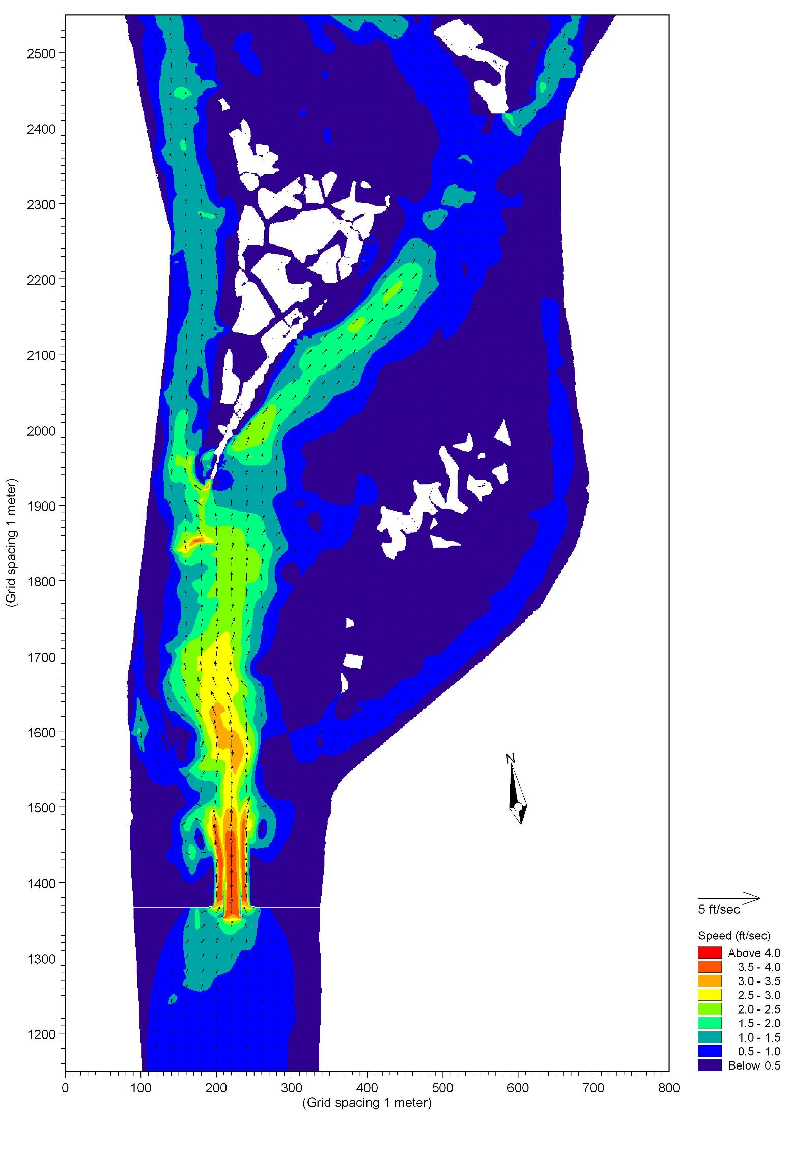

Figure 3.9-37 Peak Water Velocity for Ebb Tides with the Proposed Action at Old River (January 6, 1997)
Flooding. Although the 2-Gates facilities would occasionally alter the existing hydrology of two specific stream channels in the Delta, the facilities have been designed to avoid the substantial modification of hydrology under high flow (flood) conditions from the Sacramento and San Joaquin River watersheds. As a fundamental operational criterion, the gates would be kept open during the high-flow conditions to permit the passage of the flood flows. This would restore much of the pre-Project channel capacity of the Old River and Connection Slough.
DSM2 was used to model the peak flood event from February 1997 event, which was roughly a 100-year event. The stage hydrographs of the existing and “gates open” conditions for this flood event at the proposed barrier on Old River are compared in Figure 3.9-39. As the figure illustrates, the barrier would not increase the flood stage profile at the peak stages immediately upstream or downstream of the barrier.
The stage hydrographs of the existing and gates open conditions for the February 1998 flood event at gage location ROLD014 downstream of the barrier are compared in Figure 3.9-31. The stage hydrographs of the existing and gates open conditions for the February 1998 flood event at gage location ROLD024 upstream of the barrier are compared in Figure 3.9-41. Figures 3.9-40 and 3.9-39 confirm that the barrier would not increase the flood stage profile at the peak stages within a mile upstream or downstream of the barrier.
The exceedance probability expressed as a percent for river stage at the sites immediately upstream and downstream of the barrier is presented in Figure 3.9-40 for the Old River barrier. Lines are shown for the baseline condition, as well as gates open on the upstream side of the structure and gates open on the downstream side of the structure. The exceedance probability plots support the finding of no impact on flood stage greater than 8.4 feet North American Vertical Datum of 1988 (NAVD88) due to the Project barrier. These results include an inherent conservatism in the analysis due to lack of overtopping of the barrier that would normally occur for flood stages greater than 6.6 feet NAVD88. The 100-year flood stage within Old River is 9.71 feet NAVD88.
Figure 3.9-38 Change in Low and High Tide Water Surface Elevation near 2-Gates Facilities
Figure 3.9-39 Stage Profiles for February 1997 Flood Event at Old River—2-Gates Barrier
Figure 3.9-40 Stage Profiles for February 1998 Flood Event at Old River Gage Station ROLD014
Figure 3.9-41 Stage Profiles for February 1998 Flood Event at Old River Gage Station ROLD024

Figure 3.9-42 Exceedance Probabilities for High Stages at Old River—2-Gates Barrier
Additionally, Proposed Action facilities, especially the sheet pile materials connecting the barriers to the existing levee system, are designed to preclude adversely affecting the existing levee system. This design consideration further minimizes the potential to adversely affect off-site flooding. Refer to Appendices L and M for additional detail regarding flooding.

Water Quality
Depending upon the duration of the gates closure, weather, and initial water quality conditions, the proposed operations could result in changes in water quality similar to those found in other dead-end sloughs of the Delta. When the gates were closed, small portions of channels adjacent to the Old River and Connection Slough barriers would likely receive reduced mixing, which may result in slightly degraded water quality including slightly reduced oxygen, minor changes in salinity, and may have a tendency to allow for the development of patches of aquatic plants and temporarily trap floating debris. This effect would be temporary and would not be as pronounced as conditions in permanent dead-end sloughs because operations of the Proposed Action are anticipated to include a relatively short closure periods (up to approximately two hours per day), the gates would not be completely sealed, and some small flow volumes would move past the gates. These conditions would dissipate soon after the gates were opened. These changes would be most pronounced when ambient air temperature is high, winds speeds are low, and tidal action is small. Therefore, changes to water quality from gate closures would be small.
When the gates were open and extreme tidal actions occurred, increased water velocities near the gates could result in localized sediment mobilization and the potential for channel bottom erosion. As described in Environmental Commitment HYDRO-1 (Section 2), this effect would be monitored, and remedial actions would be implemented should observable sediment transport be detected; thus, operations would result in minimal effects on channel sediments.
Due to its proximity to the Proposed Action facilities, changes in salinity could occur at the compliance location at Rock Slough specified under D-1641. Simulations of the Proposed Action operations conducted using DSM2 indicate that operation of the Proposed Action would not to lead to violations of the Rock Slough standard, although there were instances (winter) when salinity was increased by a small amount compared to existing conditions at Rock Slough (Figure 3.9-43). Installation of barriers and closure of the gates would generally improve water quality at Rock Slough by reducing salinity intrusion. During the periods of operation, gate closure would slightly reduce local flushing, which could lead to a slight degradation of water quality at Rock Slough. This would only be a significant concern if Contra Costa Water District (CCWD) operations required significant flow from Rock Slough.
No other water quality impacts have been identified. However, the Proposed Action would include local and regional water quality monitoring to support all testing and adaptive management of the facilities. Water quality monitoring would be conducted at a series of compliance points and at municipal and agricultural water diversion intakes to identify if changes in water quality occur that are associated with Project operations. If these data identify water quality effects associated with the Proposed Action, adjustments to operation criteria would be implemented to minimize salinity or other water quality effects at sensitive locations. Operational adjustments would primarily involve changes to timing and duration of gate opening.
Figure 3.9-43 Projected Salinity near the CCWD Rock Slough Water Diversion Location

Groundwater
The Proposed Action would only contact the uppermost portion of groundwater-bearing formations as a result of dredging to approximately 35 feet below sea level and would have no effect on local or regional groundwater hydrology or groundwater water quality. The Proposed Action would not increase the use of groundwater, nor would it interfere with natural groundwater recharge because no impermeable surfaces would be created on land.

DWR 2009b: http://www.water.ca.gov/news/newsreleases/2009/051309bubblecurtain.doc
Detailed descriptions of DSM2 are available at http://baydeltaoffice.water.ca.gov/modeling/deltamodeling/models/dsm2/dsm2.cfm.

