CALFED Science Program Brown Bag Series Presents:

An Evaluation of Four Sacramento-San Joaquin River Delta

Juvenile Salmon Survival Studies

Ken Newman, USFWS

Tuesday August 11, 2009, 12 noon – 1:30 p.m.

Delta Room, 5th Floor

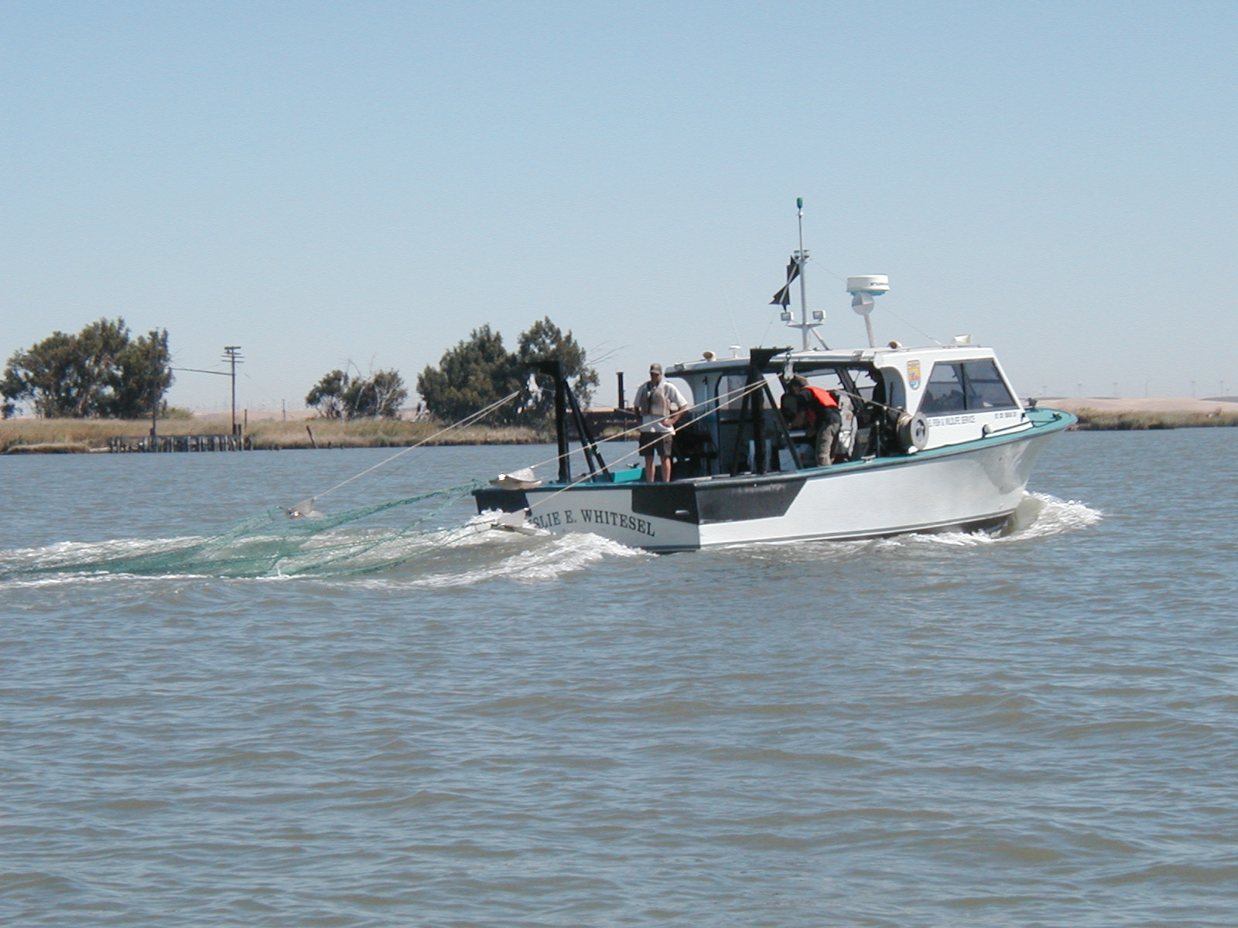
650 Capitol Mall, Sacramento
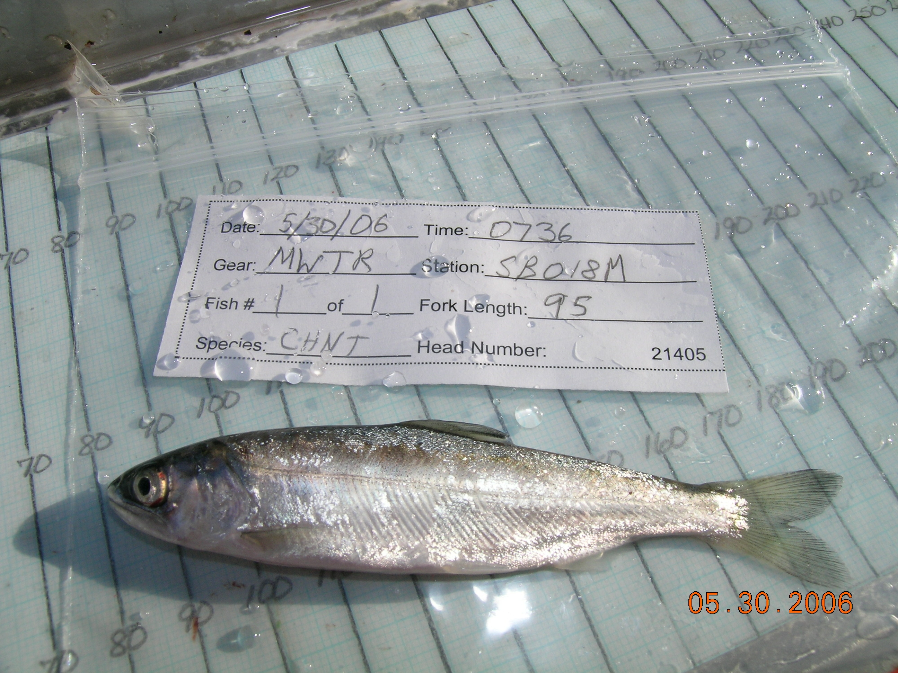
The U.S. Fish and Wildlife Service (USFWS) has completed its evaluation of four juvenile salmon mark and recapture studies conducted in the Sacramento-San Joaquin Delta. The objectives of the studies were to estimate juvenile salmon survival and to identify factors influencing their survival in the Delta. The results of these studies have been the basis for various management actions for the protection of the Delta’s juvenile salmon. The evaluation was conducted to determine if previous conclusions were sound by taking a more robust approach to analyzing the data. The data from these four studies were reanalyzed using Bayesian hierarchical models. The Bayesian model framework was able to simultaneously account for different sources of variation, such as between year variation in capture and survival probabilities. Ken Newman, a mathematical statistician with USFWS, will be sharing the results of the CALFED Science Program funded evaluation of these four studies.

Please allow extra time for parking and security procedures at 650 Capitol Mall. Current photo identification is required. Cameras and cell phones with camera capability are prohibited without prior written review and approval from CBDA, Federal Protective Service and GSA Property Management for the 650 Capitol Mall building. Please contact Caprice Shular at the California Bay-Delta Program at (916) 445-5387 or cshular@calwater.ca.gov for building access information.

