YBUS Status Update
3/8/2016

J.R. Burau

Current Status

Weather and River Forecasts

Another storm is due in Thurs (top panel in figure 1) which is forecast to raise stages at the Fremont Weir to ~33’ on Sun. with an unknown peak occurring sometime later in the weekend. Based on this latest forecast, it looks like the Fremont Weir will overtop Sunday Mar 13. Peak flows in the Yolo Bypass at I5 (CDEC station CCY) are forecast to be 4k+ cfs late Friday night. Another storm is now forecast in the Mar 14-16 (figure 3), with precip mostly as snow in the Sierras. The 14 day forecast average precip (figure 3) is showing a weakening probability of another large storm set, so the 3/14/16 storm could be our last shot.

Equipment
All of the gear associated with this study has been deployed and the real time flow and telemetry gear is fully operational.

Recommendations

I recommend we release at I5 (predicted peak of ~4k+ cfs) on Friday evening, then consider conducting a Phase 2 release on Sunday/Monday depending on how much water we expect to go into the Yolo Bypass and when. If this is even physically possible for Marty’s team.

Figures

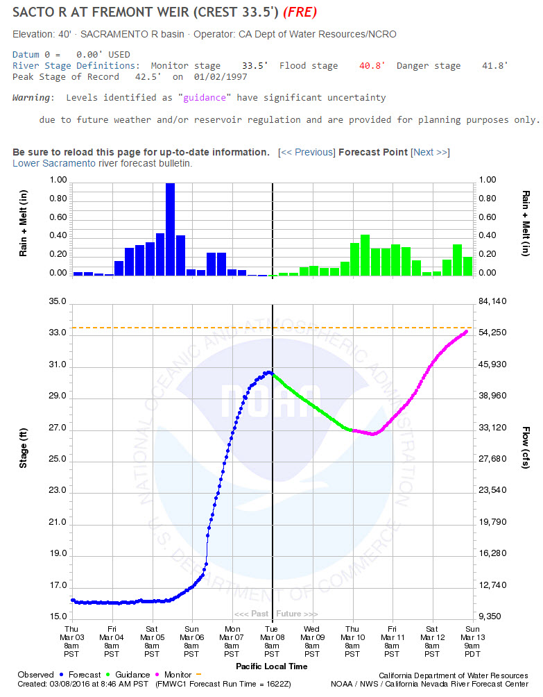
Figure 1 – Stage forecast at the Fremont Weir (Mar 8 8:46am PST forecast).
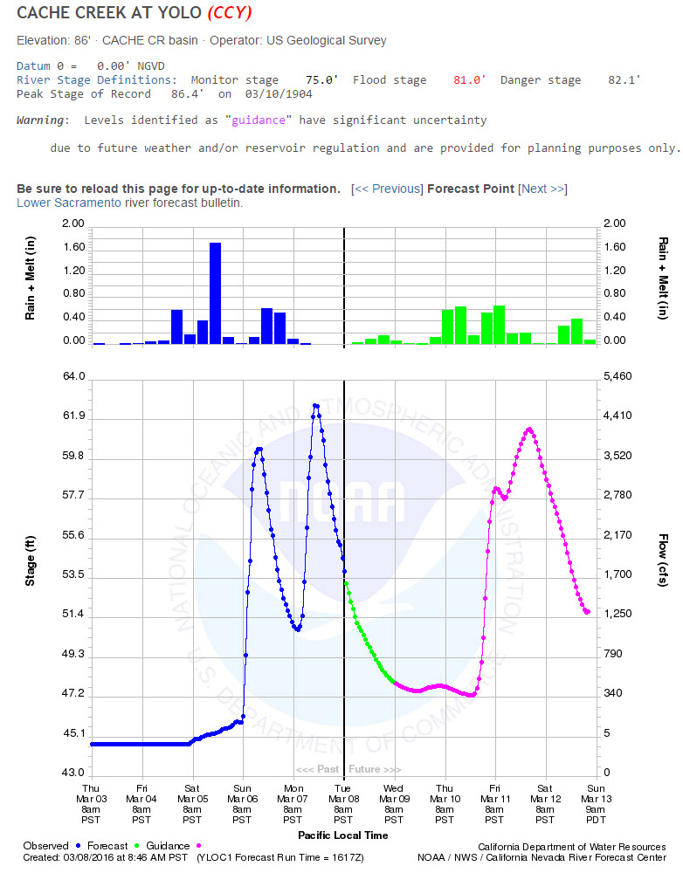
Figure 2 - Stage forecast at the Cache Creek at Yolo (Mar 5 8:46am PST forecast).

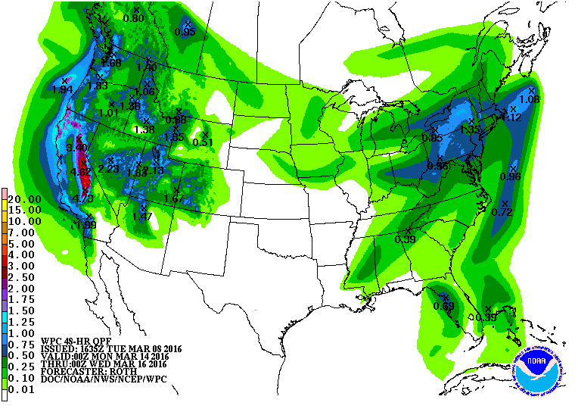
Figure 3 – 5-7 day forecast cumulative precipitation Mar. 14-16, 2016.

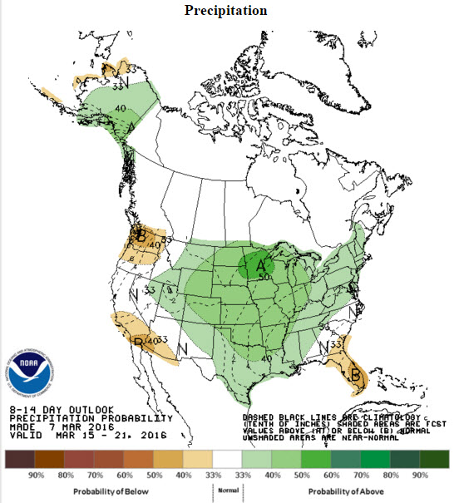
Figure 4 – 14 Day precipitation forecast – Mar 15-21, 2016.

