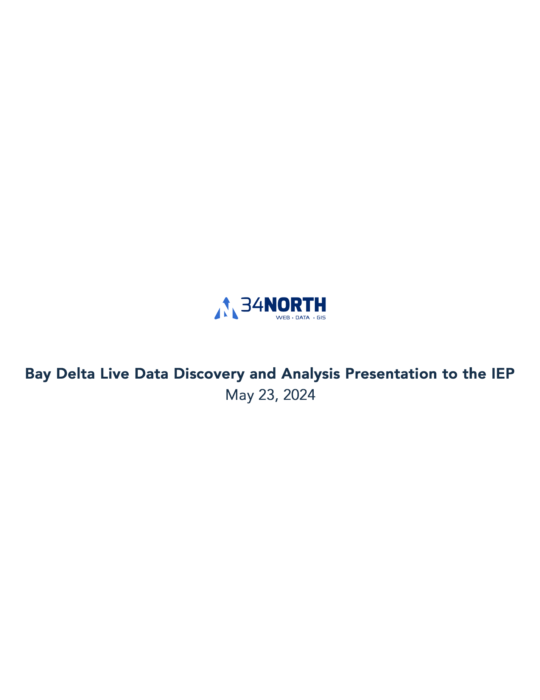

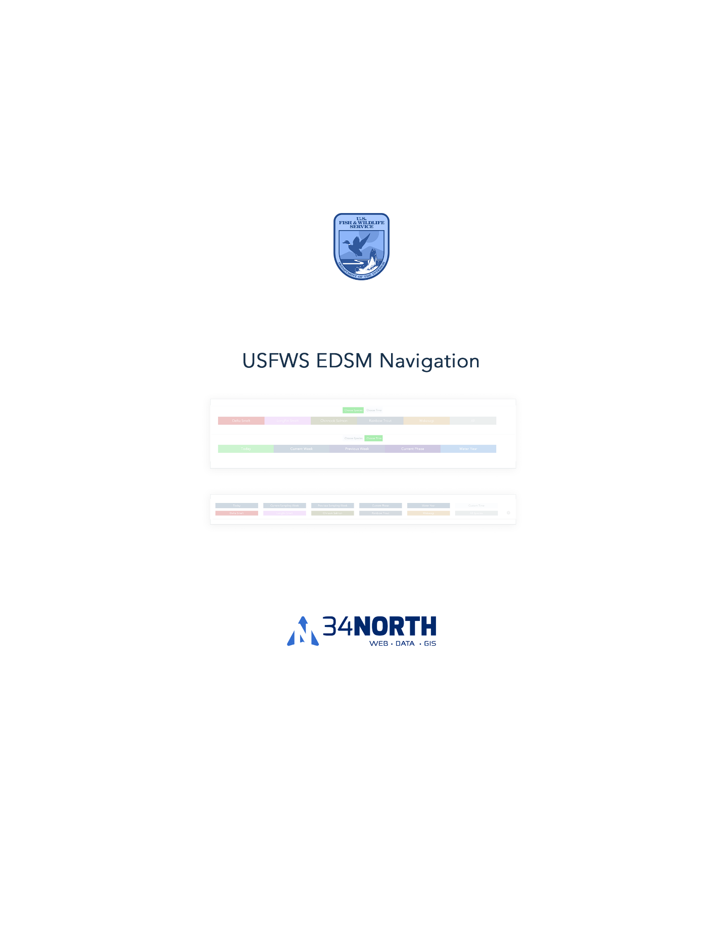

Species and Time Buttons contained in tabs: <https://baydeltalive.com/edsm/delta-smelt-wt-2>





Species contained within a drop-down: <https://baydeltalive.com/edsm/edsm-extended-view-(species-as-selector)>



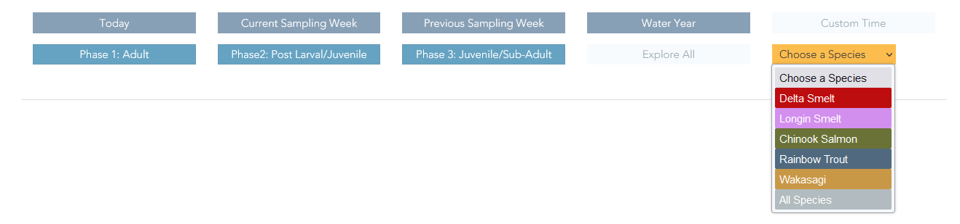

Species and Time buttons are visible all at once with out tabs: <https://baydeltalive.com/edsm/delta-smelt-wt-7>



Buttons initial colors are the same but changes colors for Species buttons and adds pressed button style for the Time buttons: <https://baydeltalive.com/edsm/side-by-side-same-color-buttons>



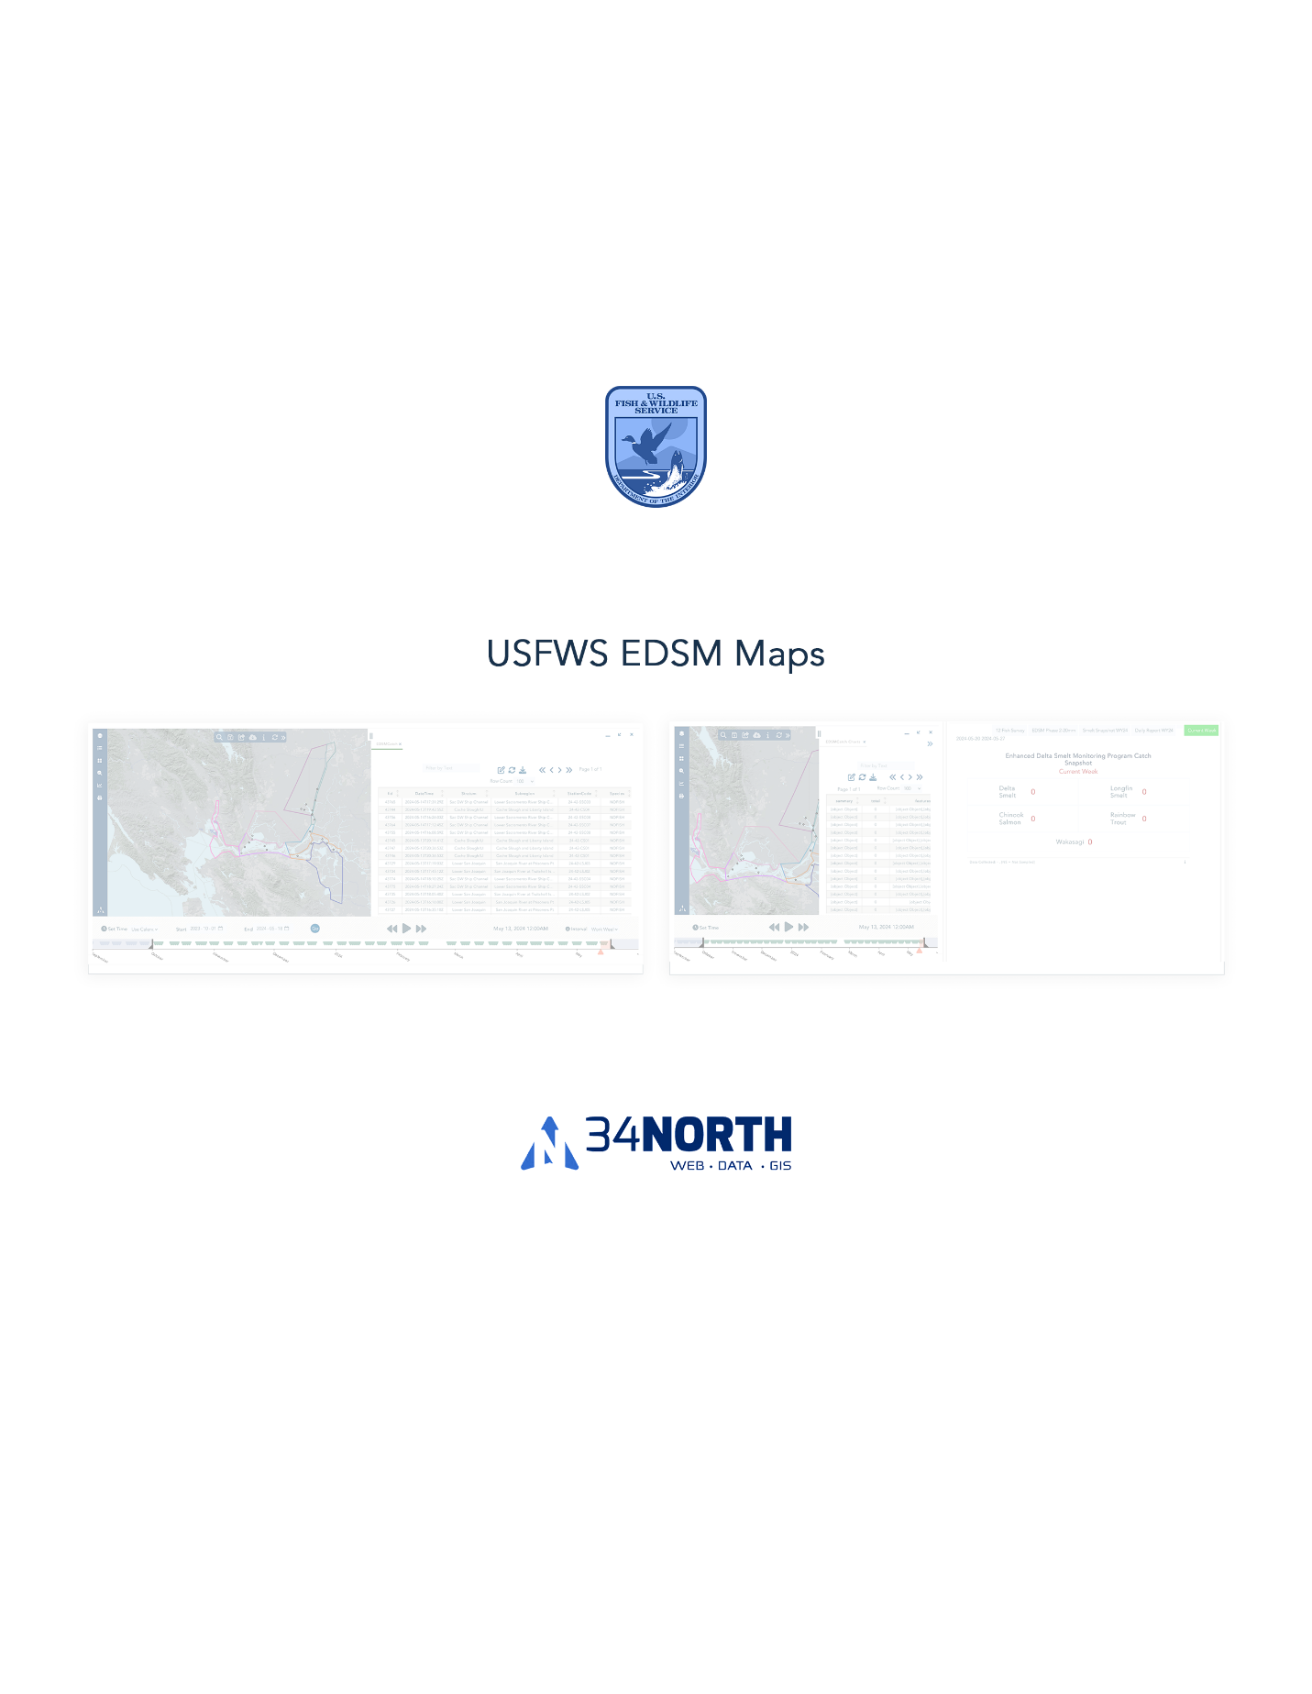

Full Map View: <https://baydeltalive.com/edsm/delta-smelt-wt-2>

Full Map with Attribute Table Map Cover View: <https://baydeltalive.com/edsm/delta-smelt-wt-1>

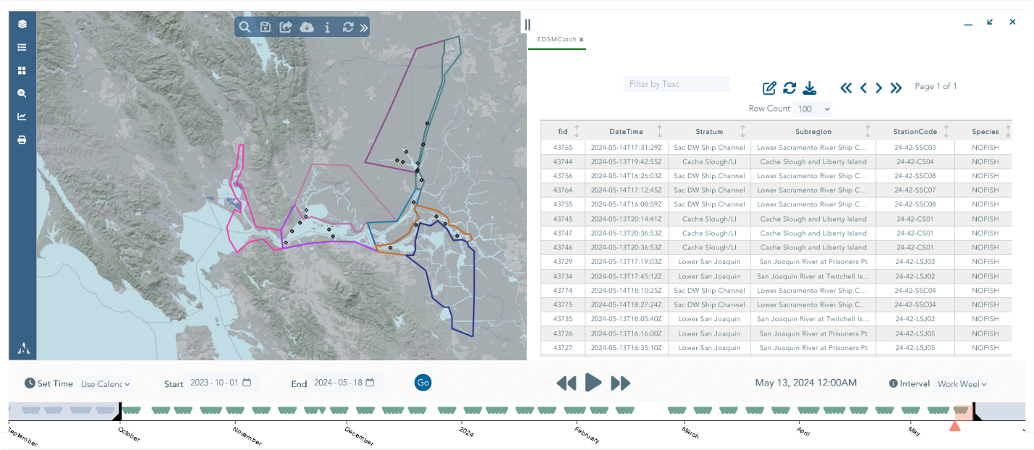

Side By Side Map Cover View: <https://baydeltalive.com/edsm/delta-smelt-wt-3>

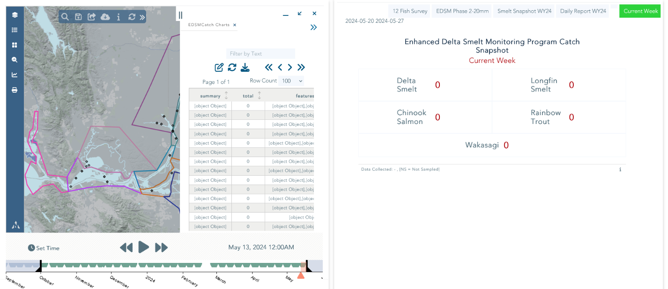

Condensed Map Cover View: <https://baydeltalive.com/edsm/condensed-map-cover-view>

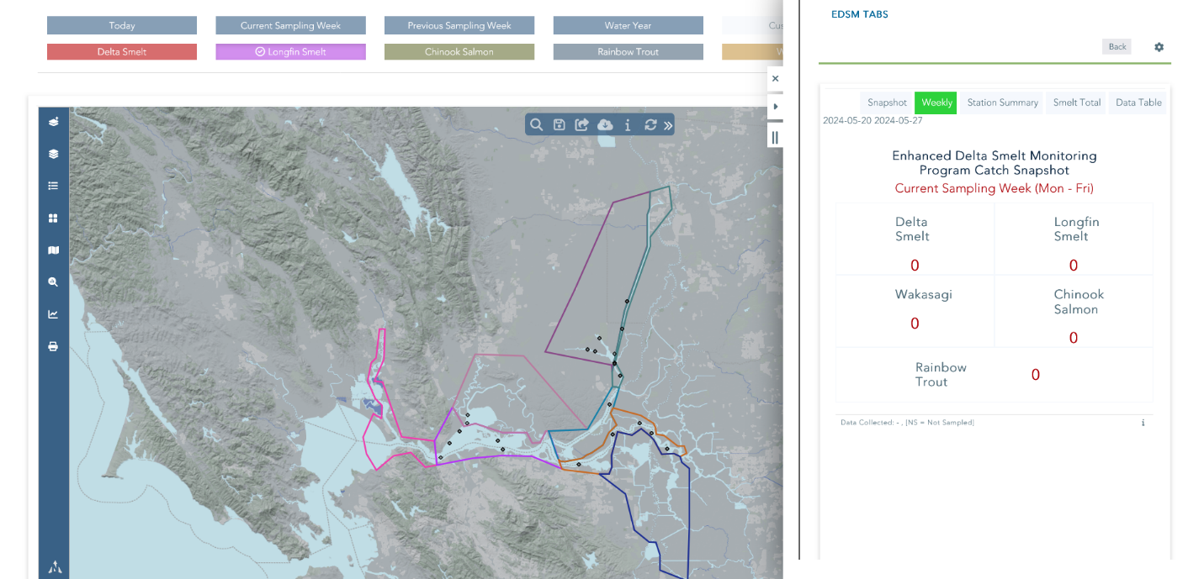

Side By Side (Without Map Cover) View: <https://baydeltalive.com/edsm/delta-smelt-wt-4>

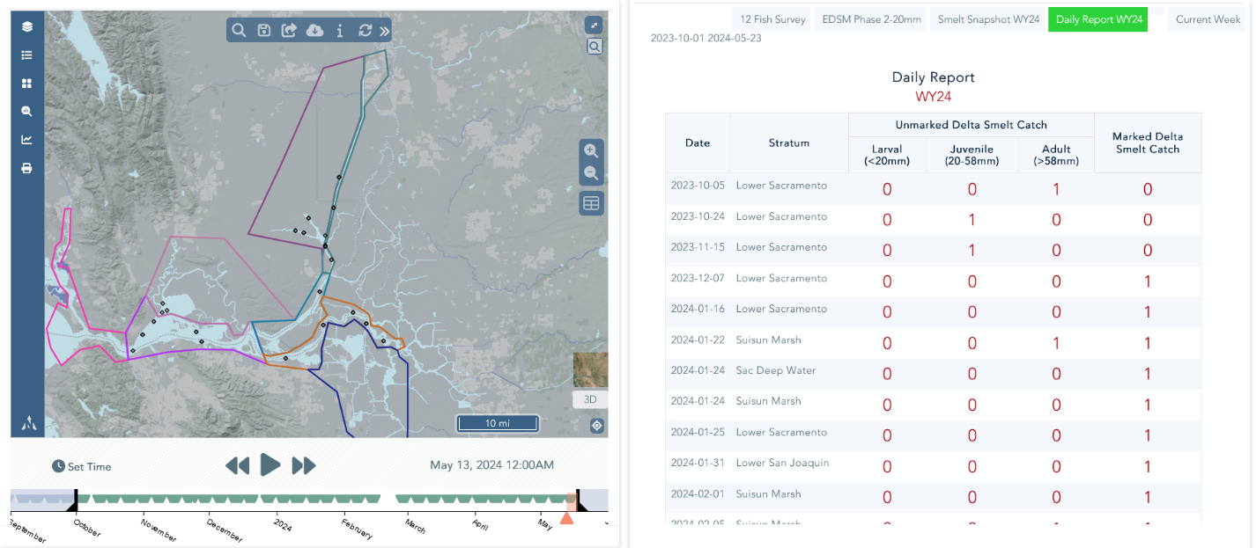

Daily Report (Water Year 2024) Table: <https://baydeltalive.com/edsm/delta-smelt-wt-6>

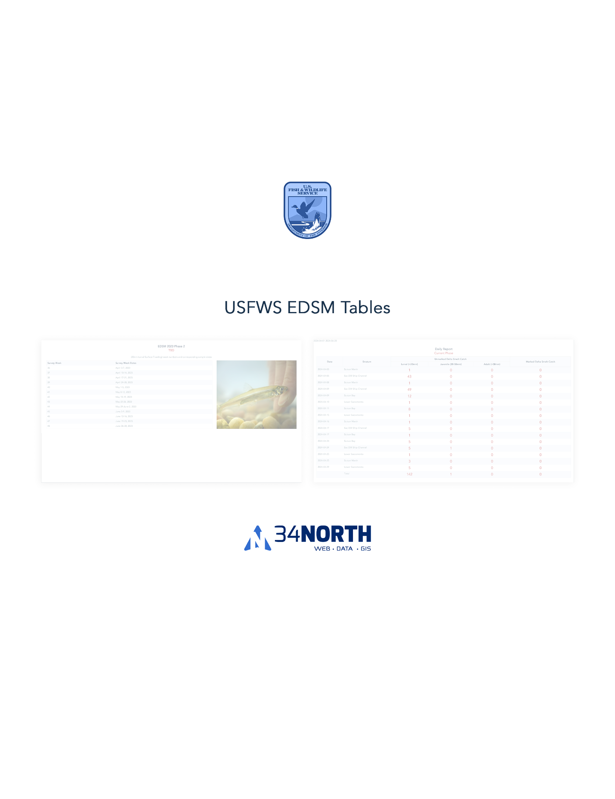

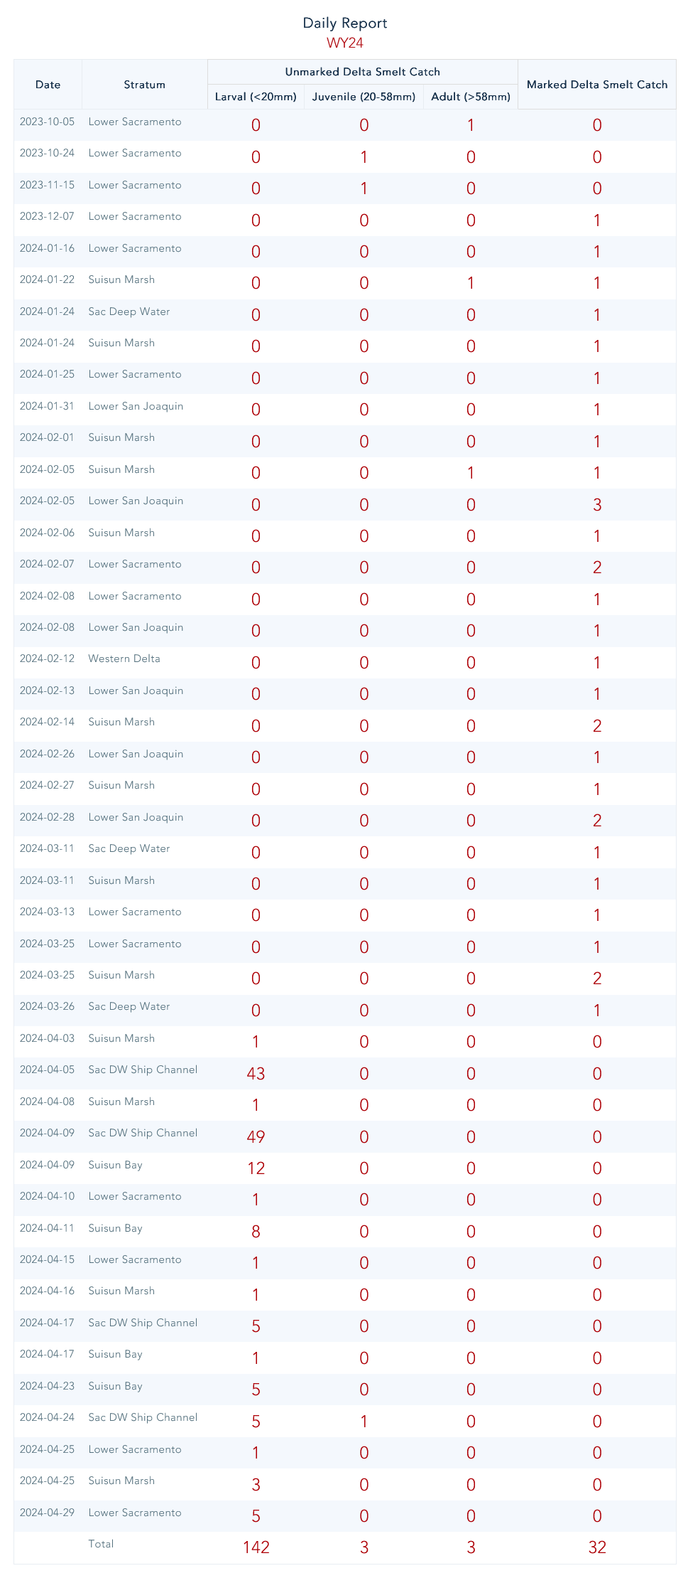

Daily Report (Current Phase) Table: <https://baydeltalive.com/edsm/edsm-extended-view-(species-as-selector)>

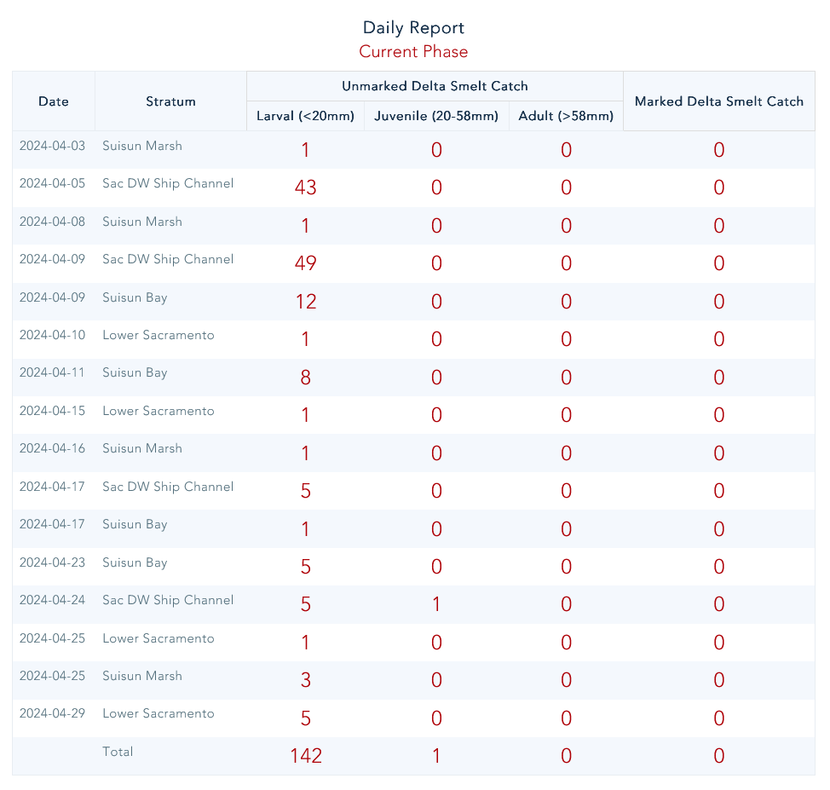

Daily Report (Current Week) Table: <https://baydeltalive.com/edsm/edsm-extended-view-(species-as-selector)>

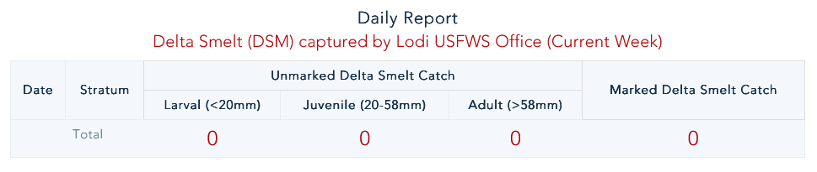

Daily Report (Smelt Snapshot Water Year 2024) Table: <https://baydeltalive.com/edsm/delta-smelt-wt-7>

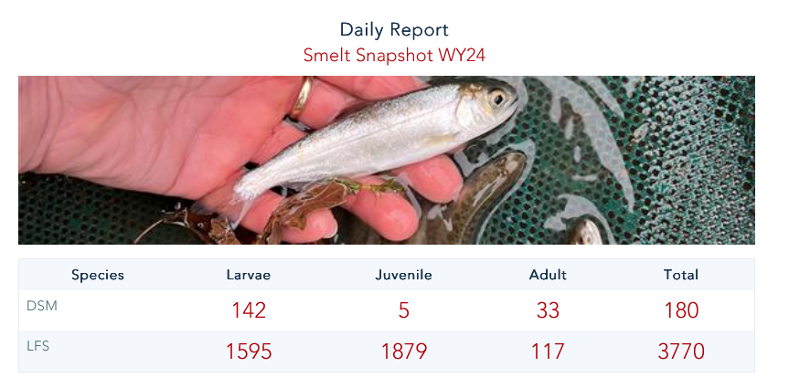

Report (20mm Summary By Phase) Table: <https://baydeltalive.com/edsm/smelt-monitoring-team-edsm-chipps-weekly-catch-report>

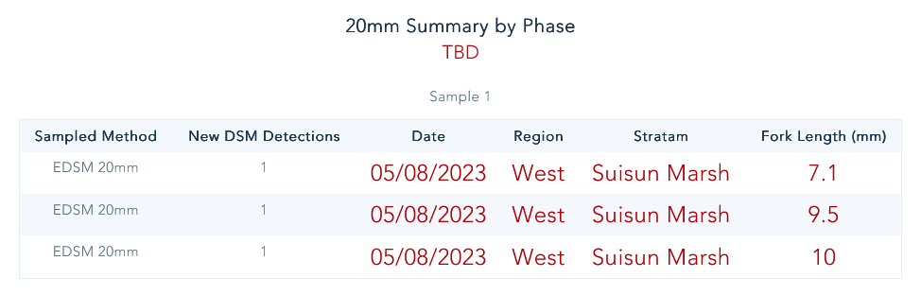

Report (Edsm 2023 Phase 2) Table: <https://baydeltalive.com/edsm/smelt-monitoring-team-edsm-chipps-weekly-catch-report>

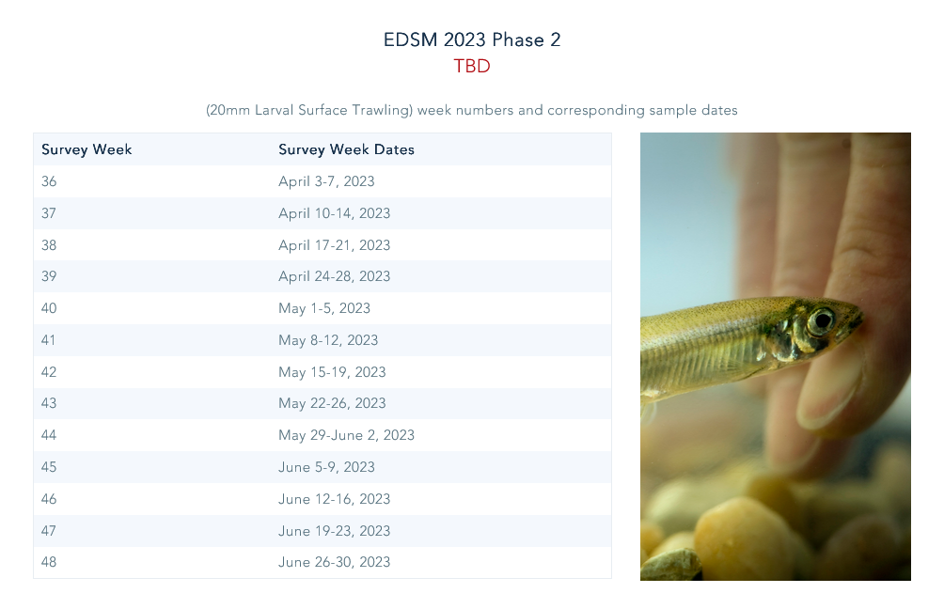

TBD: <https://baydeltalive.com/edsm/smelt-monitoring-team-edsm-chipps-weekly-catch-report>

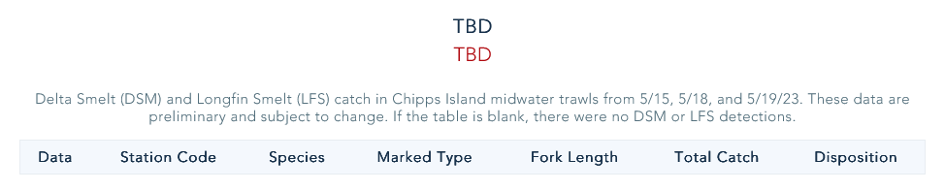

Report (Interagency Ecological Program) Table: <https://baydeltalive.com/edsm/smelt-monitoring-team-edsm-chipps-weekly-catch-report>

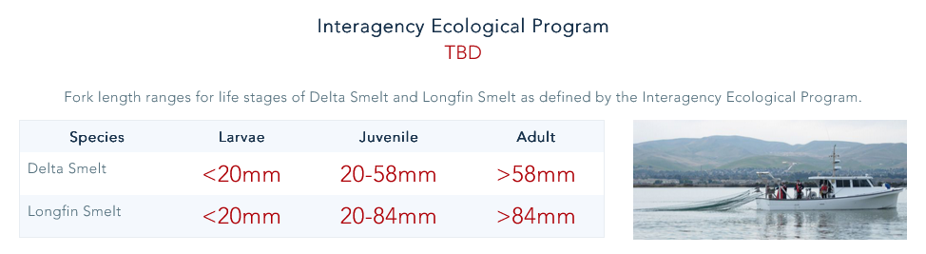

Report (20mm Survey) Table: <https://baydeltalive.com/edsm/smelt-monitoring-team-edsm-chipps-weekly-catch-report>

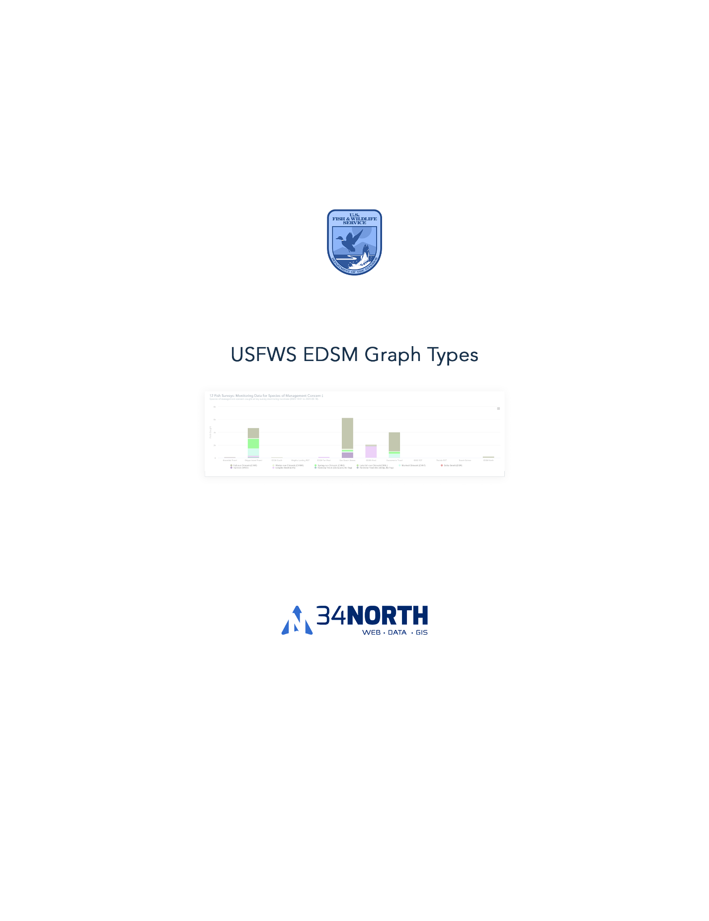

12 Fish Survey Graph <https://baydeltalive.com/edsm/delta-smelt-wt-3>

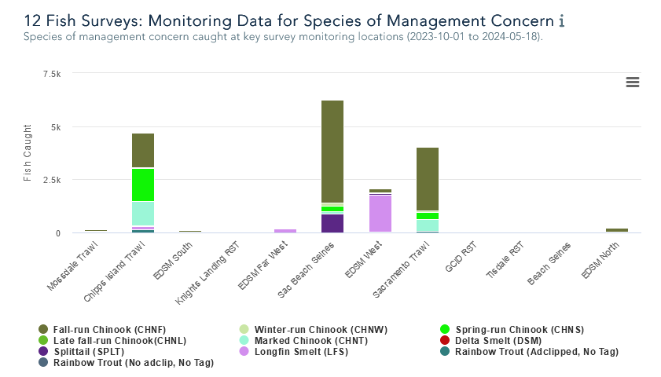

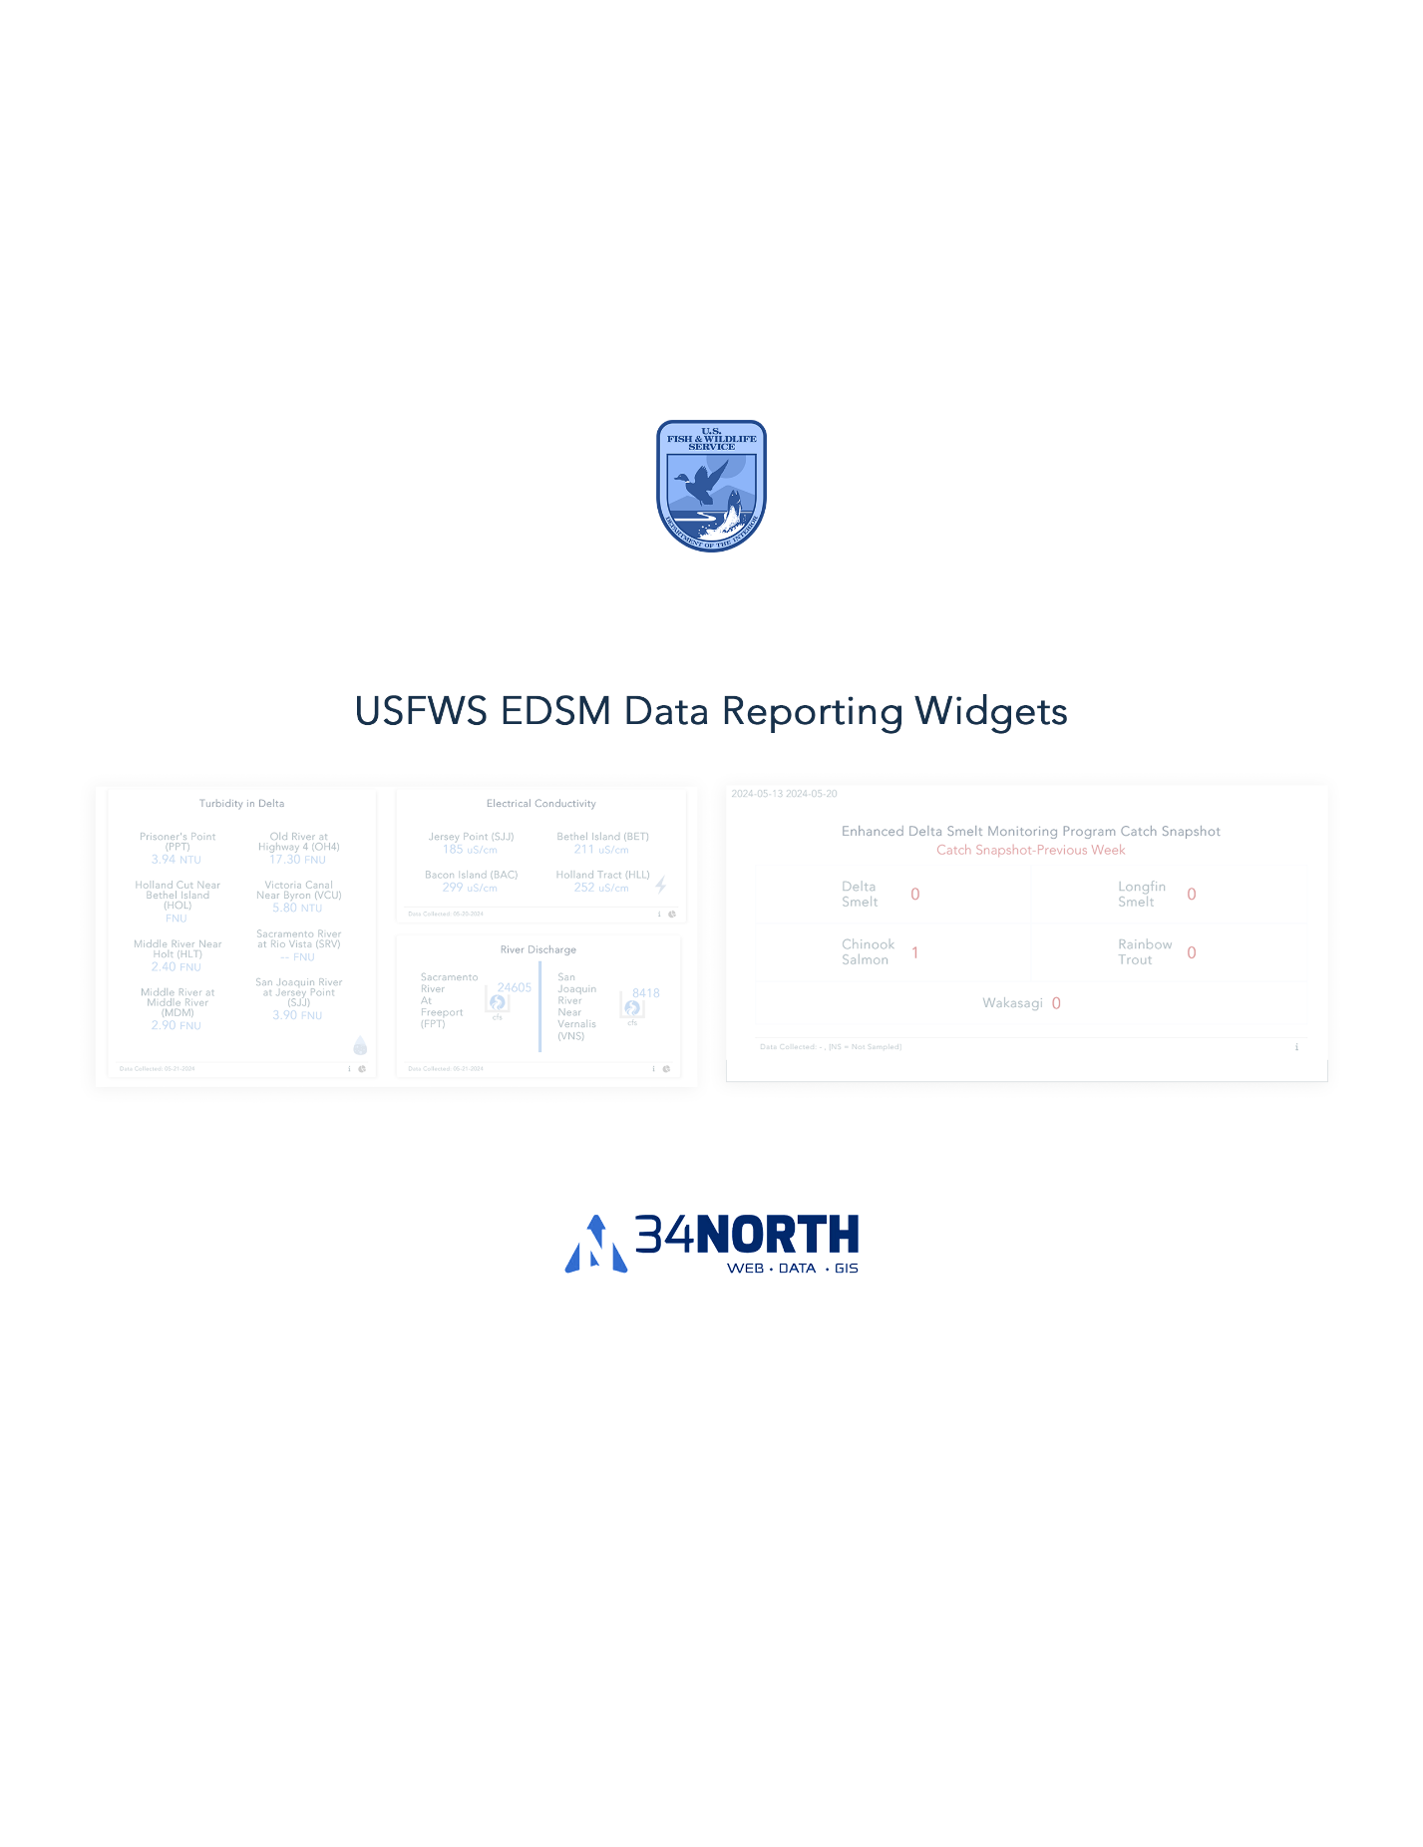

EDSM Catch Snapshot (Preview Week): <https://baydeltalive.com/edsm/delta-smelt-wt-6>

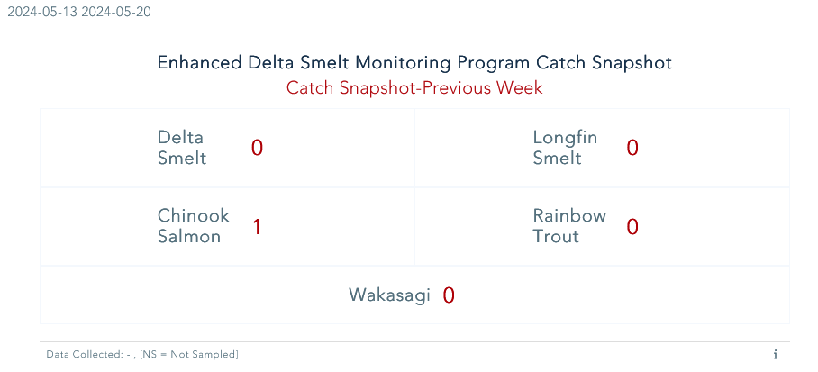

EDSM Catch Snapshot (Current Week): <https://baydeltalive.com/edsm/delta-smelt-wt-6>

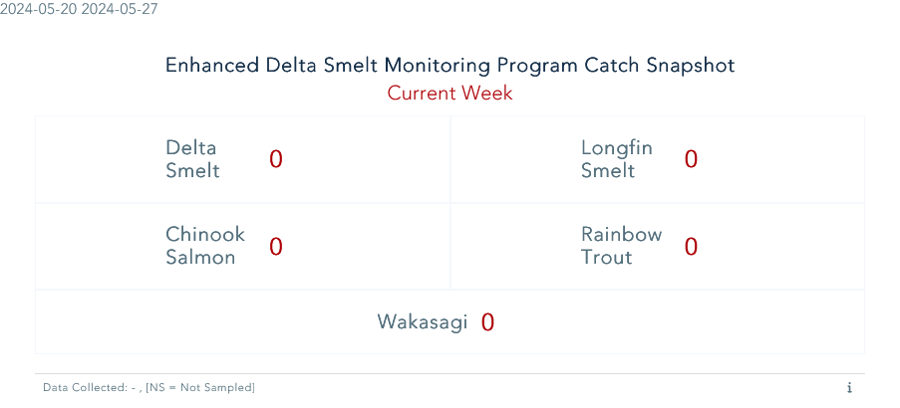

EDSM Catch Snapshot (Phase 2-20mm): <https://baydeltalive.com/edsm/delta-smelt-wt-6>

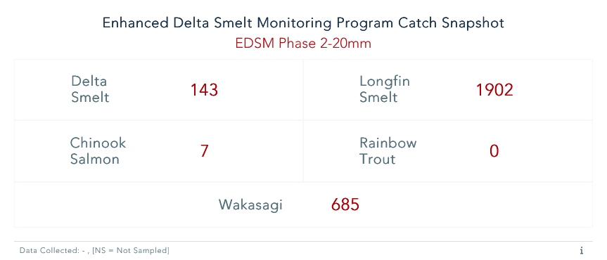

EDSM One Species: <https://baydeltalive.com/edsm/smelt-monitoring-team-edsm-chipps-weekly-catch-report>

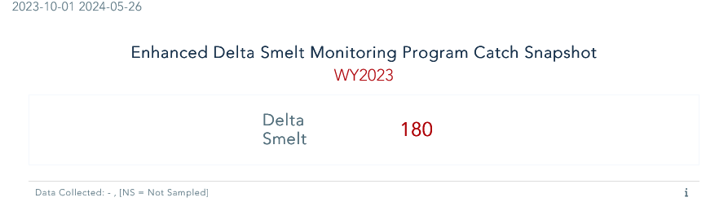EDSM One Species: <https://baydeltalive.com/edsm/smelt-monitoring-team-edsm-chipps-weekly-catch-report>

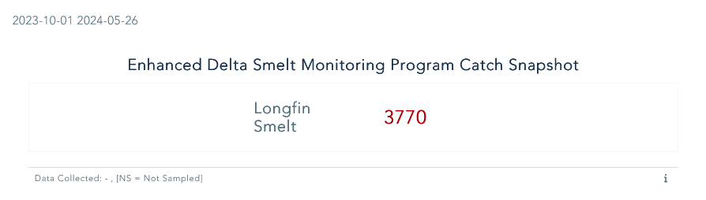

Chipps Island One Species: <https://baydeltalive.com/edsm/smelt-monitoring-team-edsm-chipps-weekly-catch-report>

Total Number of EDSM 20mm Site Sampled: <https://baydeltalive.com/edsm/smelt-monitoring-team-edsm-chipps-weekly-catch-report>

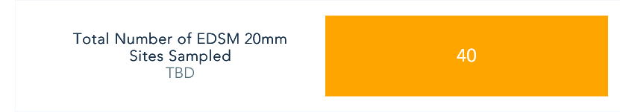

Week 41 20mm DSM Abundance Estimate: <https://baydeltalive.com/edsm/smelt-monitoring-team-edsm-chipps-weekly-catch-report>

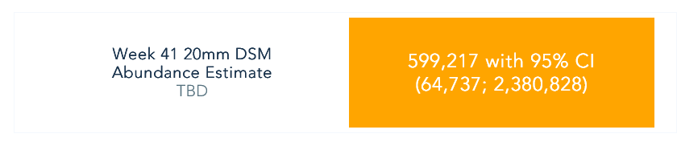

Total Numbers of Tows Sampled: <https://baydeltalive.com/edsm/smelt-monitoring-team-edsm-chipps-weekly-catch-report>

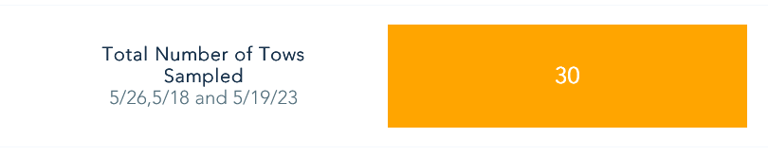

QWEST: <https://baydeltalive.com/edsm/delta-smelt-work-team-data-dashboard>

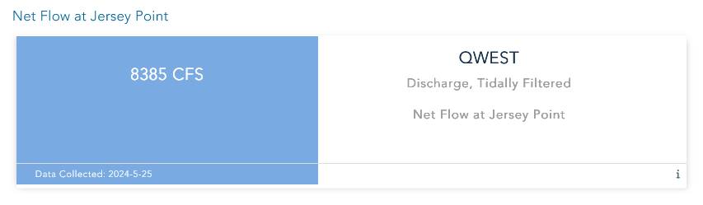

Water Operations Summary: <https://baydeltalive.com/edsm/delta-smelt-work-team-data-dashboard>

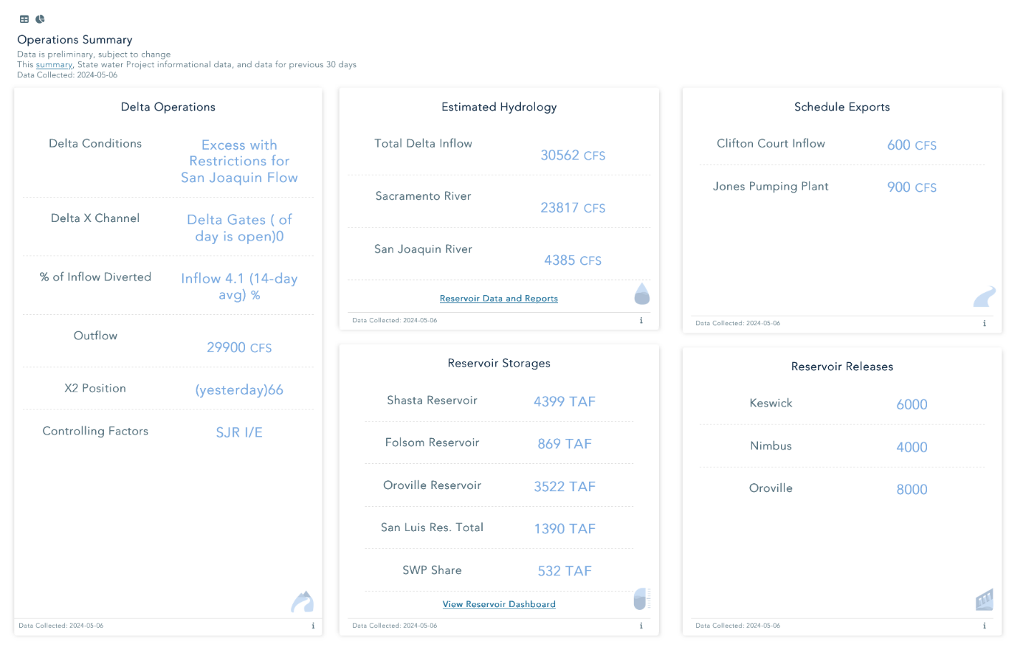

Water Quality Conditions: <https://baydeltalive.com/edsm/delta-smelt-work-team-data-dashboard>

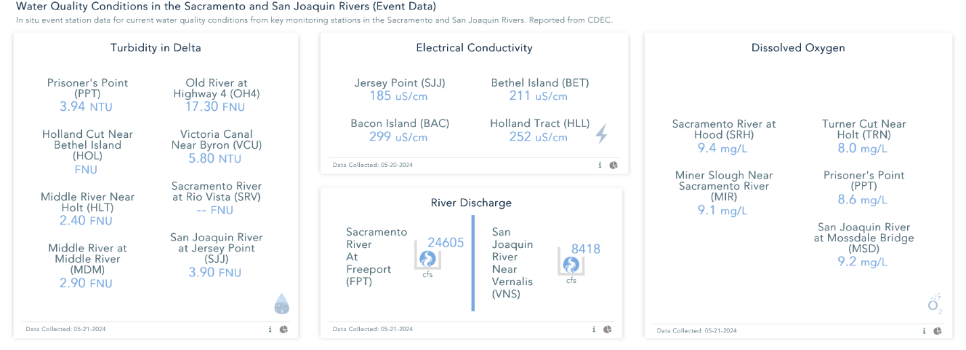

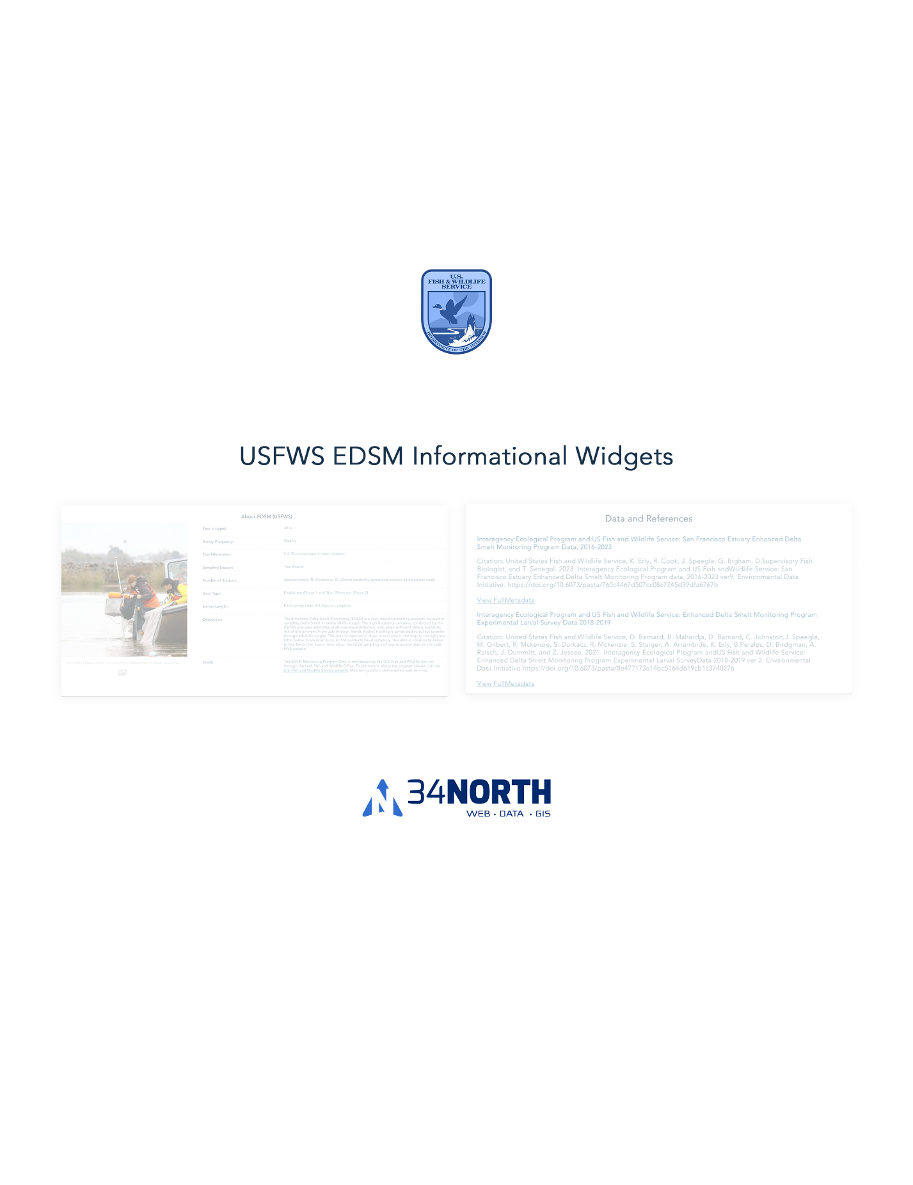

Data and References: <https://baydeltalive.com/edsm/delta-smelt-wt-1>

About Widget: <https://baydeltalive.com/edsm/delta-smelt-wt-1>

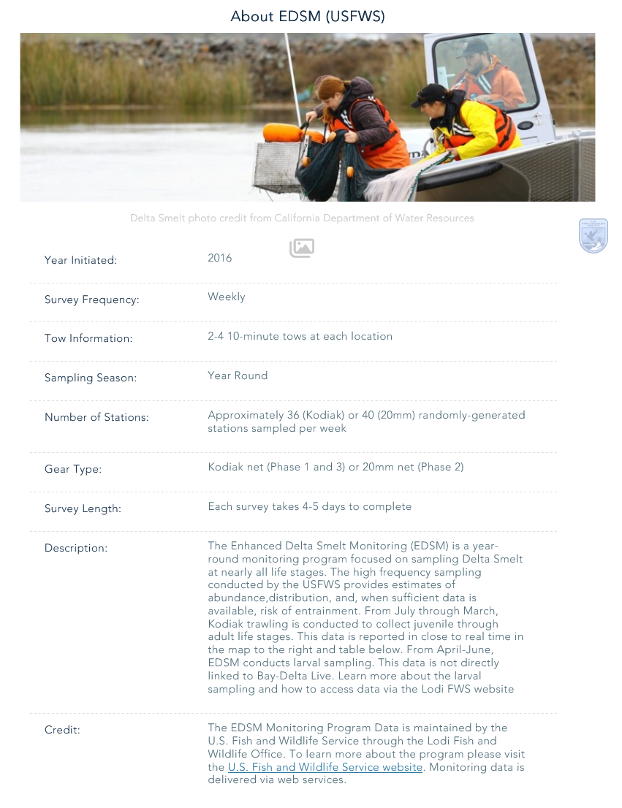

Data Downloads: <https://baydeltalive.com/edsm/delta-smelt-wt-1>

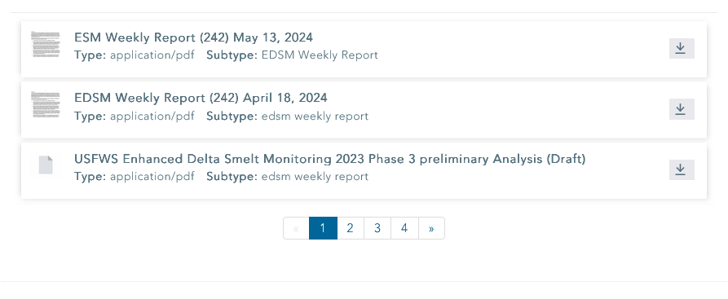

20mm CSV Uploads: <https://baydeltalive.com/edsm/20mm-csv>

