**2019 EMP Discrete Water Quality Summary Report**

**Introduction:**

Water year 2019 was classified as Above Average in the Sacramento Valley and San Joaquin Valley, unlike the previous year, which was classified as Below Average. More information about water year types can be found on the hydrology page.To analyze discrete water quality trends from 2019, the EMP stations were grouped into six regions of the San Francisco Bay-Delta estuary: San Pablo Bay, Suisun and Grizzly Bay, Confluence, Central Delta, Southern Interior Delta, and Northern Interior Delta (Table 1). The 2018-2019 data from all stations within the same region were plotted on one graph and then combined with the graphs from other regions to make a facet graph for each parameter. The minimum and maximum values in 2019 were determined for each field parameter or laboratory analyte to show the range within a single year. The instances when a result fell below the reporting limit were excluded from these minimum and maximum calculations. When this occurred, a vertical dashed line capped at the reporting limit was added to the graph to represent the presence of a non-detect.

**Specific Conductance (Figure 1):**

Specific conductance varied greatly in 2019 across the sampling regions with the highest levels occurring in the western regions (San Pablo Bay, Suisun Bay and Grizzly Bay and Confluence) where water from the Pacific Ocean has the strongest influence. Specific conductance ranged from 77.8 µS/cm (C10A in Southern Interior Delta, June) to 41,956 µS/cm (D41 in San Pablo Bay, November) during 2019. Lower specific conductance values were seen in 2019 than compared to 2018, which was likely due to increased precipitation and runoff during a wet year, keeping the San Francisco Estuary fresher throughout the year.

**Turbidity (Figure 2):**

Turbidity values ranged from 0.3 NTU (MD10A in Southern Interior Delta, April) to 142.3 NTU (NZ325 in San Pablo Bay, February) during 2019. The year 2019 had much higher levels of turbidity than in 2018, especially during the winter months in the northern and western regions when rain and snowpack runoff occurred more frequently and to a much larger degree in the watershed. All six regions experienced a spike in turbidity in February 2019 when the first set of big storms hit, causing higher flows throughout the estuary and therefore a higher likelihood of increased sediment disturbance.

**Dissolved Ammonia (Figure 3):**

Dissolved ammonia levels in 2019 ranged from ≤ 0.05 mg/L (which is the reporting limit) to 0.75 mg/L (C3A in Northern Interior Delta, November). Dissolved ammonia levels are typically higher at C3A in the Northern Interior Delta due to its location downstream of the effluent discharge from Sacramento Regional Sanitation District. Ammonia levels are typically lower throughout the Delta and Bays, likely due to dilution and nitrification. More non-detects were seen in 2019 compared to 2018, but this was in fact due to the reporting limit increasing from 0.01 mg/L to 0.05 mg/L and was not necessarily a product of lower concentrations.

**Chlorophyll *a* (Figure 4):**

Chlorophyll *a* values in 2019 ranged from ≤ 0.5 µg/L (which is the reporting limit) to 38.1 µg/L (C10A in Southern Interior Delta, July). The highest levels of chlorophyll *a* were seen in the Southern Interior Delta region during the summer months in 2019. This was mostly due to elevated levels at station C10A, which is known for being shallow during dry periods of the year (as low as 3.5 feet in 2019), with increased temperatures and lower flows allowing for increased phytoplankton production. These elevated chlorophyll *a* levels in the summer at C10A also align with the continuous fluorescence data collected at this station. More information about the phytoplankton genera is described in the phytoplankton section. Chlorophyll levels were consistently lower in 2019 than 2018 for all regions, as most regions saw a spike in chlorophyll in Spring 2018 that did not occur in 2019.

**Dissolved Nitrate+Nitrite (Figure 5):**

Dissolved nitrate + nitrite values ranged from ≤ 0.05 mg/L (which is the lowest reporting limit) to 3.6 mg/L (P8 in Southern Interior Delta, January) in 2019. The Southern Interior Delta region had the highest fluctuation of dissolved nitrate + nitrite concentrations and had the highest levels compared to the rest of the estuary, likely due to influence from nearby agricultural land use and wastewater treatment effluent. Most regions saw a spike in dissolved nitrate + nitrite in late 2018 to early 2019, but all regions saw less variability in 2019 compared to 2018. Reporting limits for dissolved nitrate + nitrate were as high as 7.5 and 15 mg/L for western regions in late 2019 due to chloride influence on the analytical method. These reporting limits were cropped out of graphs for scale. The dissolved nitrate + nitrite values for D4 in January and D10 in November were removed from the graphs because they were outliers.

**Total phosphorus (Figure 6):**

In 2019, total phosphorous levels ranged from 0.04 mg/L (C3A in Northern Interior Delta-June, NZ068 in Northern Interior Delta-May, and D19 in Central Delta-May, D22 in Confluence-July) to 0.37 mg/L (P8 in Southern Interior Delta, January). Total phosphorus concentrations were similar in 2019 compared to 2018 in most regions except for the Southern Interior Delta, which experienced lower levels in 2019. This was likely due to increased precipitation and more water moving through the system causing dilution. The total phosphorus value for NZ002 in April was removed from the graph because it was an outlier.

**Tables and Figures:**

**Table 1: Station grouping of the six regions.**

|  |  |
| --- | --- |
| **REGION NAME** | **EMP DISCRETE WATER QUALITY STATION** |
| **Northern Interior Delta** | C3A |
| NZ068 |
| **Southern Interior Delta** | P8 |
| MD10A |
| C10A |
| C9 |
| **Central Delta** | D28A |
| D19 |
| D16 |
| D26 |
| **Confluence** | D10 |
| D4 |
| D12 |
| D22 |
| **Suisun & Grizzly Bay** | D7 |
| NZ032 |
| NZS42 |
| D8 |
| **San Pablo Bay** | D41 |
| D41A |
| D6 |
| NZ002 |
| NZ004 |
| NZ325 |

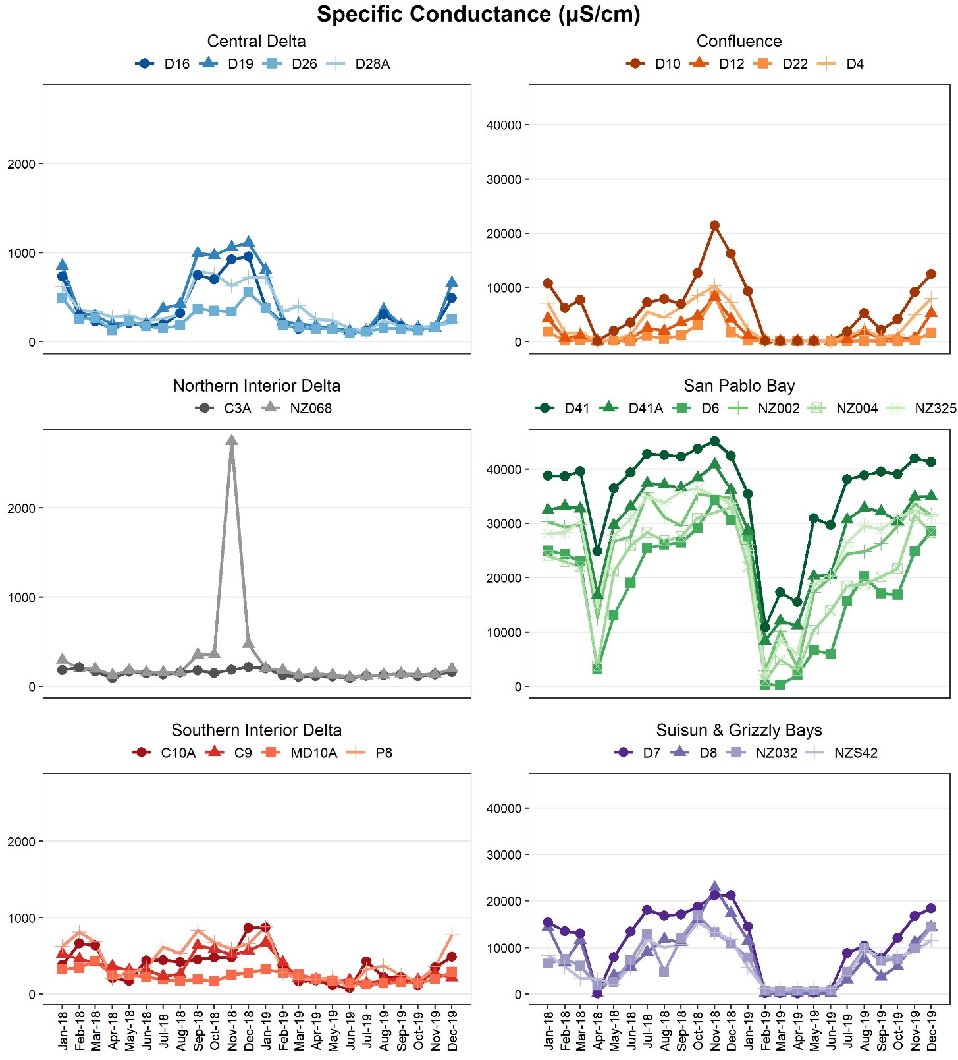

**Figure 1: Surface specific conductance in µS/cm at six regions in the San Francisco Bay-Delta estuary during 2018-2019.**

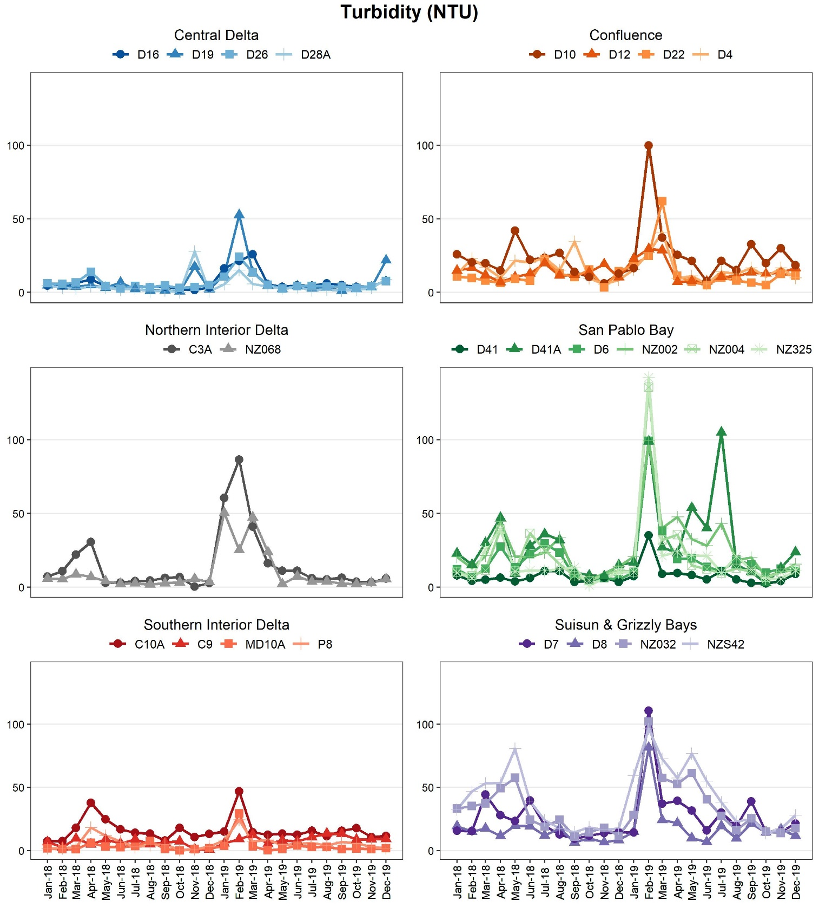

**Figure 2: Surface turbidity in NTU at six regions in the San Francisco Bay-Delta estuary during 2018-2019.**

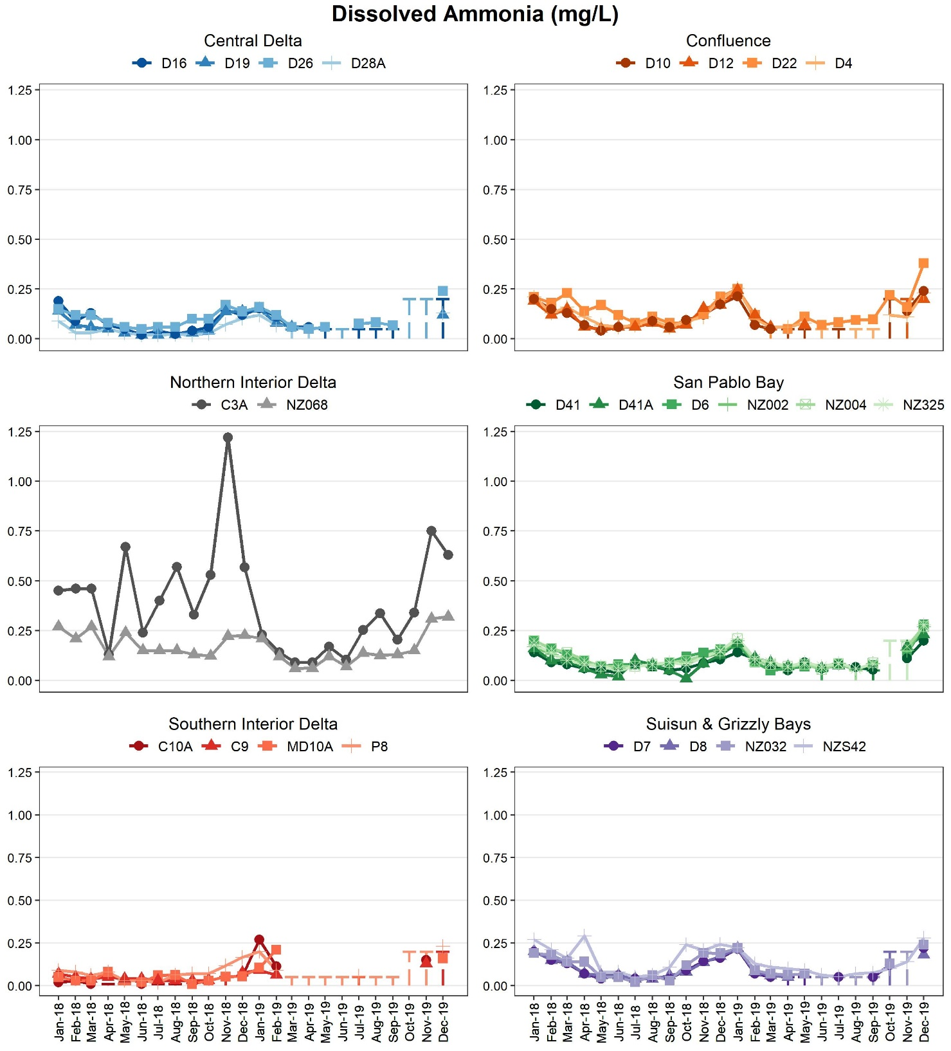

**Figure 3: Dissolved ammonia concentrations in mg/L at six regions in the San Francisco Bay-Delta estuary during 2018-2019. Dashed lines represent the range of possible values for months where the raw value was a non-detect.**

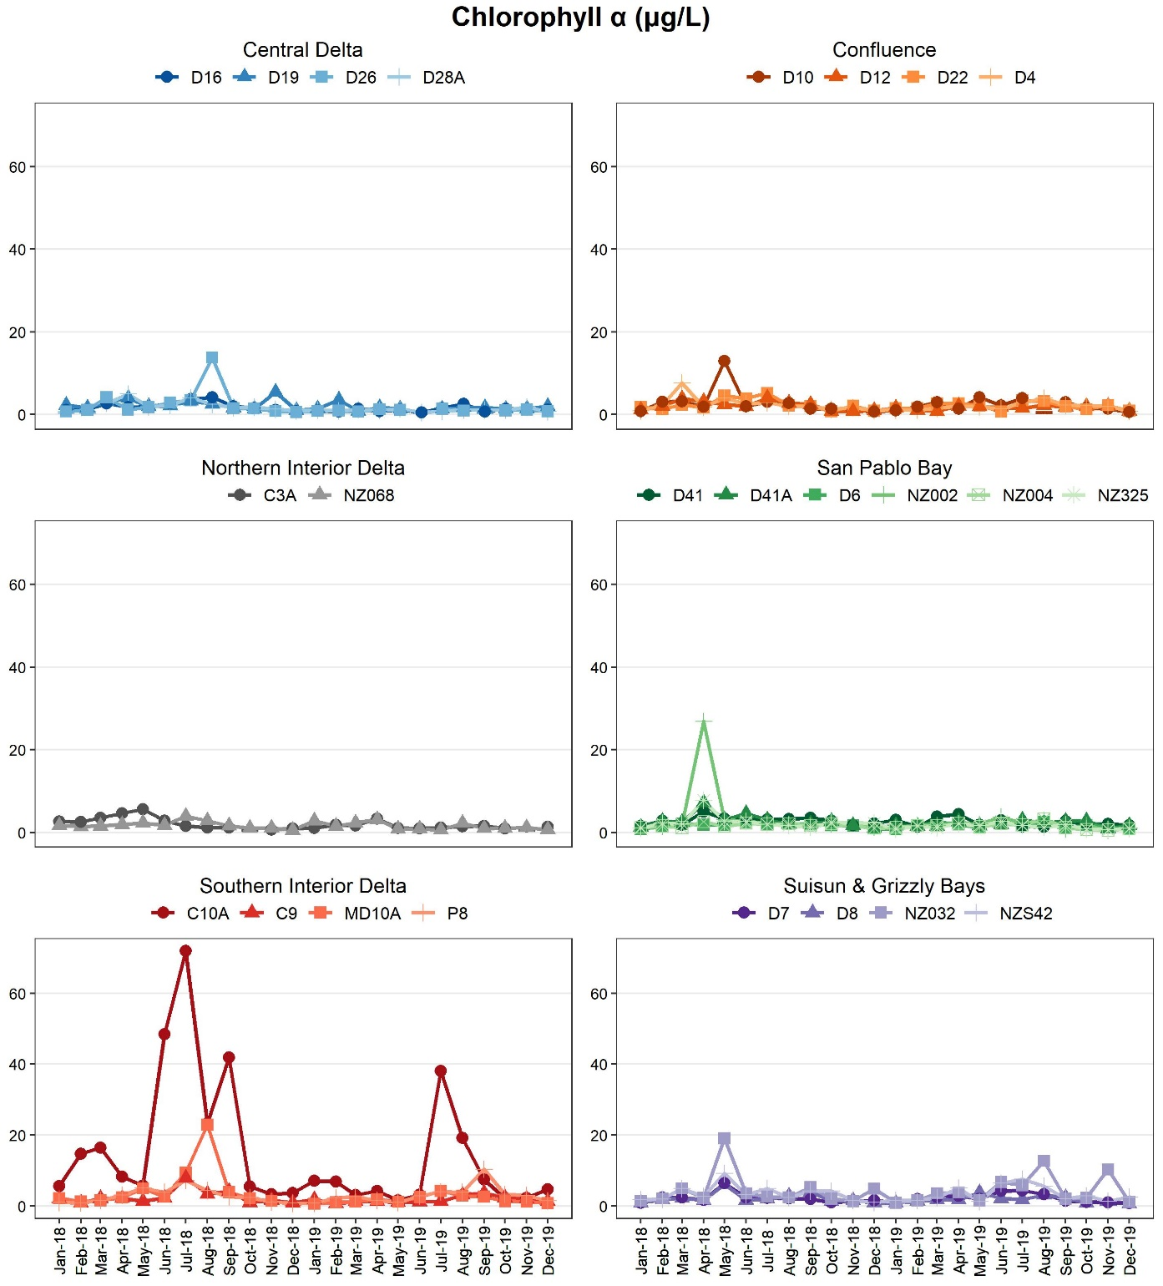

**Figure 4: Chlorophyll a concentrations in µg/L at six regions in the San Francisco Bay-Delta estuary during 2018-2019. Dashed lines represent the range of possible values for months where the raw value was a non-detect.**

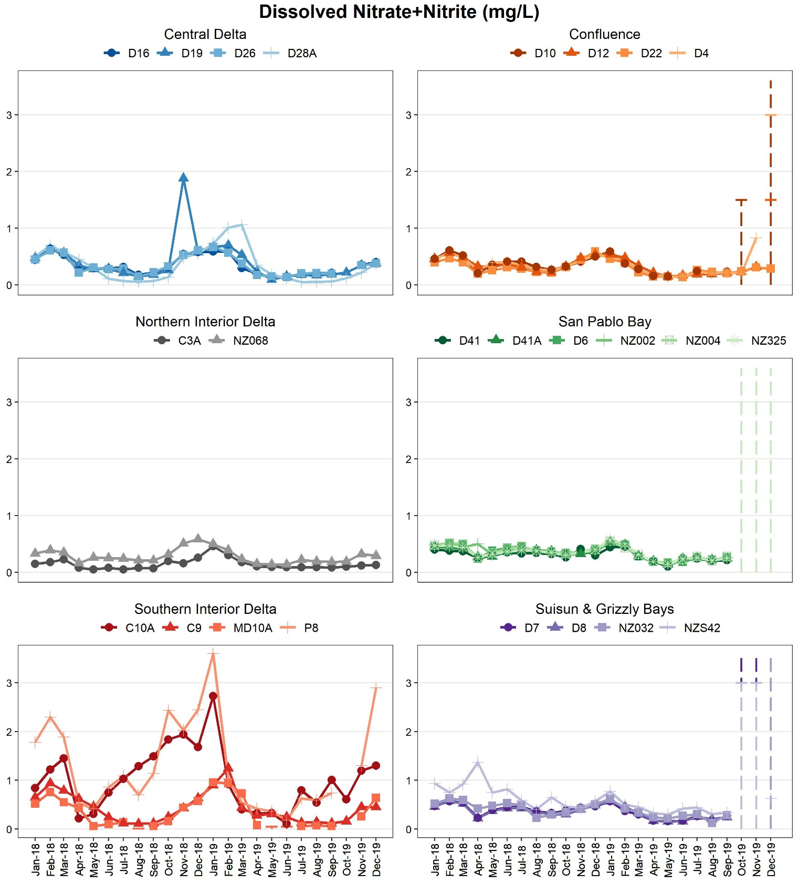

**Figure 5: Dissolved nitrate and nitrite concentrations in mg/L at six regions in the San Francisco Bay-Delta estuary during 2018-2019. Dashed lines represent the range of possible values for months where the raw value was a non-detect.**

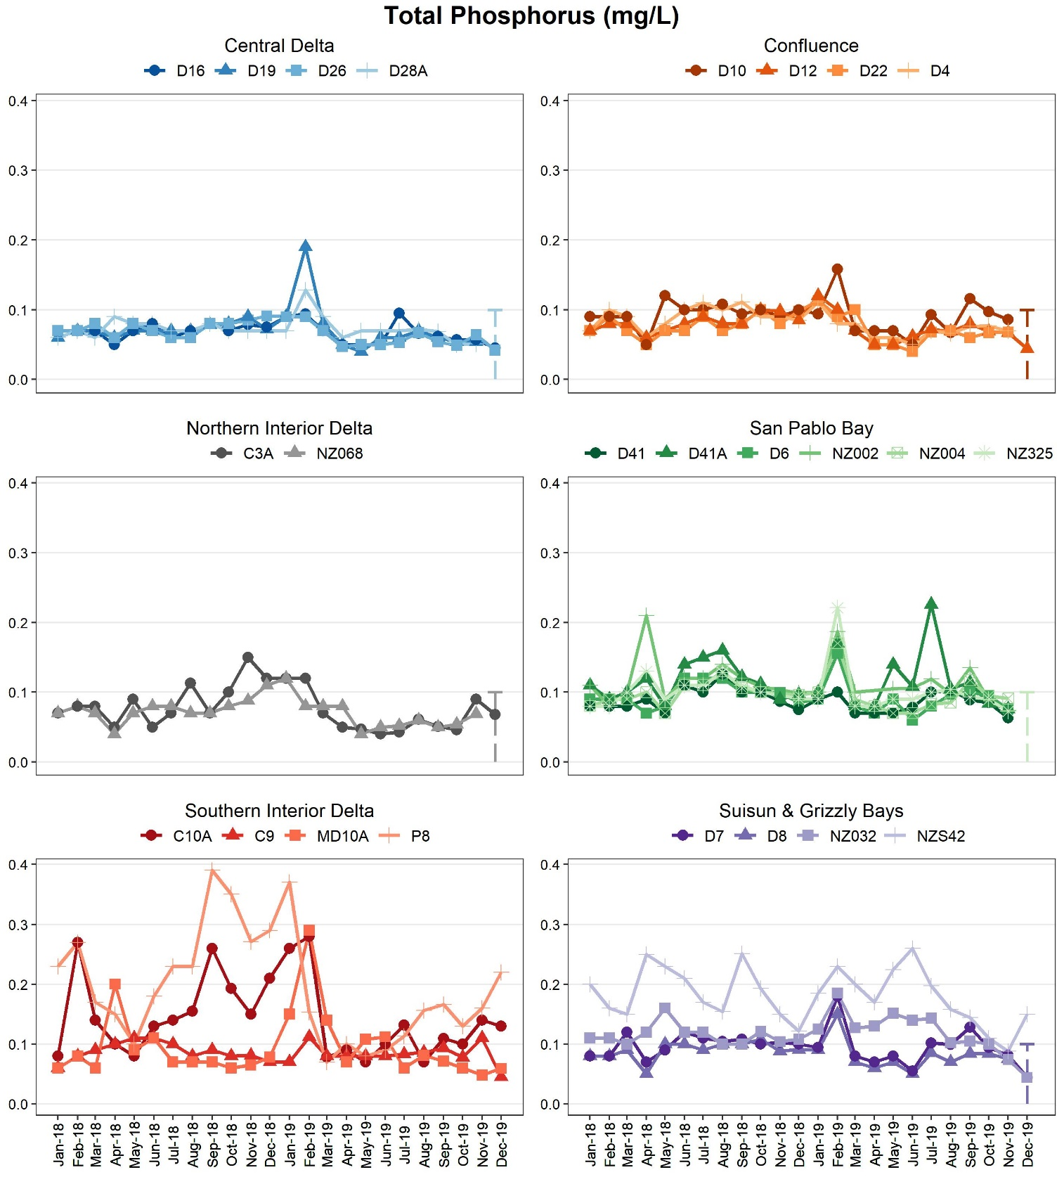

**Figure 6: Total phosphorous concentrations in mg/L at six regions in the San Francisco Bay-Delta estuary during 2018-2019. Dashed lines represent the range of possible values for months where the raw value was a non-detect.**