Ecosystem Restoration: Fall-Run Chinook Salmon on the Tuolumne River

What is This Indicator, and Why Is It Important?
This indicator reports the escapement (the number of adult salmon escaping mortality and successfully returning each year to spawn) of adult fall-run Chinook salmon, a candidate species for listing under the Endangered Species Act, on the Tuolumne River. The Tuolumne River population is one of the few remaining self-sustaining populations of fall-run Chinook salmon in the Central Valley. Because of concerns about its status, it was targeted for restoration efforts, with the same doubling targets as applied to other runs (see Technical Note and System-Wide Salmon indicator). As with other runs, this indicator focuses specifically on the instream conditions that are the locus of restoration efforts and that strongly influence the success of four key phases of the species’ survival and reproduction in the Tuolumne River (see conceptual model in Figure 1). This information must then be evaluated in the context of changes in ocean conditions and climate conditions (i.e., periods of wet and dry years) that also have significant effects on salmon production and abundance.

What Has Happened To Affect the Indicator?
The Tuolumne fall run has been affected by a combination of factors, including degraded habitat for both adult and juvenile salmon, water shortages due to drought and water diversions, high temperatures due to low water levels, and excessive predation. The La Grange Dam, one of the oldest dams in California, greatly restricted flows needed for both upstream adult and downstream juvenile migrations, and prevented the movement through the system of the larger sediment necessary for riffle formation (i.e., spawning gravels). The construction of the New Don Pedro Dam (upstream of the La Grange Dam) in the late 1960s for hydroelectric production, irrigation storage, and flood control was associated with a FERC Settlement Agreement that defined minimum flows below both dams to protect salmon habitat. However, there are times when rapid changes in flow volumes, or conflicting demands for water during dry years, cause stranding or the dewatering of side pools, as well as occasional temperature increases that are hazardous to salmon. Finally, past gravel and gold mining left a legacy of large pits that have altered the river’s morphology and flow and that harbor increased populations of large predators that may impact juvenile populations during their spring emigration.

Restoration actions in the Tuolumne River (Figure 2) have therefore focused on managing flows to keep temperatures below lethal maximums during critical periods, the addition of spawning gravels at several locations, maintaining the levees that isolate the large mining pits from the river, filling in pits, and restoring a more natural morphology to the river, particularly in terms of functional floodplains. However, restoration actions have not been able to address the shift in peak spring flows needed for juvenile emigration from the historical period of June / July to the current April / May. This has resulted in earlier spawning periods and most probably genetic changes to the stock. In addition to these factors that operate within Tuolumne River, the run may have been affected by mortality associated with the operation of water export pumps in the Delta. Finally, the use of dormant spray pesticides on orchards in the river’s watershed in January and February may result in pulses of toxicity during the period when fry are most abundant.

What Do the Data Show?
The data show (Figure 2) that adult fall-run Chinook escapement has fluctuated widely, alternating between periods with high escapement and periods with low escapement. Overall, however, there has been a decline between 1940 and later periods in the numbers of fish in both the high and low portions of the cycles. In the years since significant restoration actions began in the early 1990s, escapement numbers have increased steadily. These actions succeeded in maintaining adequate flows and temperatures in most years during critical migration periods, providing additional floodplain habitat for juveniles, and in reducing predation on juveniles during the spring emigration of juveniles. Temperature stresses increased in 2001, due primarily to a drop in flows to levels more characteristic of the early 1990s.

Despite these recent trends, however, as the Discussion and the Technical Note make clear, it will take between 10 and 25 years, including dry periods with low flow, to reliably assess the longer-term success of restoration efforts. The current escapement levels do not yet meet the AFRP’s population doubling targets for the Tuolumne River.

Discussion
The reduction of spawning habitat in the system and the interruption of required migration flows (due to the construction of the La Grange dam) reduced the long-term sustainability of the population by decreasing the overall reproductive potential of the system. Similarly, the large mining pits, and the increased predator populations they harbor, may have reduced sustainability by increasing the mortality rate of the juveniles that were produced in the remaining spawning habitat. The amount of floodplain habitat also affects juvenile growth and survival. Floodplains provide refuges from predators and flow, as well as increased food sources and habitat diversity.

Returns of adult fall-run Chinook salmon are influenced by factors within the Tuolumne River watershed, in the San Joaquin River and the Delta/estuary, and in the Pacific Ocean (see Figure 1). During the adult upstream migration, in the spawning areas, and during the juvenile emigration phase, temperature, which is influenced by water releases from the New Don Pedro and La Grange Dams, is a key factor that can affect reproduction and survival. In the larger San Joaquin River / Bay-Delta system, the timing and extent of high temperatures, the availability of food (in the river), the presence of sufficient transport flows, predation, and entrainment by export pumps all combine to affect the success of outmigration. In the Pacific Ocean, conditions related to both shorter-term events (such as El Niños) and longer-term shifts in ocean climate (such as the Pacific Decadal Oscillation) also affect overall patterns of salmon abundance. These factors can interact in complex ways and the degree to which they become limiting, either individually or in combination, depends on their relative severity and on the state of the population at any given time.

This wide range of influences contributes to year-to-year variability in escapement, as well as to longer-term fluctuations in population levels. Because of these sources of variability, it will take some time to determine whether the increase in escapement in the 1990s is part of a long-term increasing trend or merely the upward-trending portion of another cycle of abundance such as those that have occurred since the 1950s.
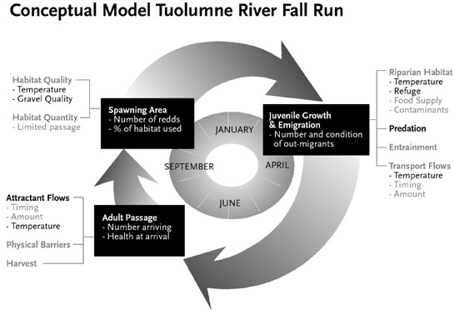

Figure 1. Conceptual model of the Tuolumne River fall run, emphasizing factors and processes that operate within the Tuolumne River itself. The ocean life history phase is not included, and processes in the Delta are subsumed under juvenile growth and emigration.

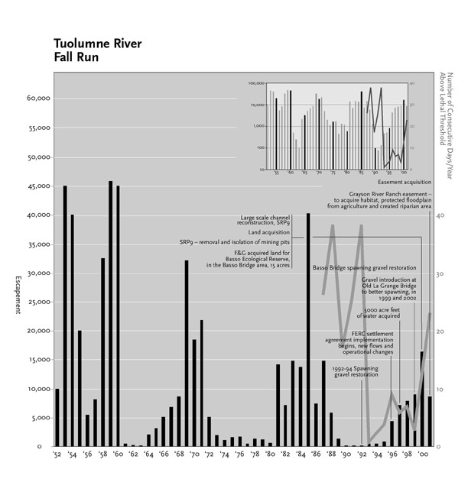

Figure 2. Long-term trend in escapement. Key restoration actions and the number of consecutive days in each year’s migration periods that temperatures were above lethal thresholds are superimposed on the escapement trend. Inset shows the log of escapement values.

Technical Note: Fall-Run Chinook Salmon on the Tuolumne River

The Indicator
Goal: See Technical Note for the System-Wide Salmon indicator.

Response Time: See Technical Note for the System-Wide Salmon indicator.

The Data
Data Collection: Escapement data on the Tuolumne River extend back to 1940. Data represent a combination of visual counts at the Modesto Dam fish ladder, visual counts of spawning salmon and carcasses, and, beginning in 1973, mark-recapture sampling on carcasses. The Turlock Irrigation District gathers temperature data at several points along the river.

See Technical Note for the System-Wide Salmon indicator for further discussion of methods of estimating escapement and gathering flow and temperature data.

In general, elevated temperatures are considered to be lethal if they persist for three consecutive days or more. Thus, the temperature metric shows the number of periods during which temperatures remained above the lethal thresholds for three days or longer.

Data Quality / Limitations: See Technical Note for the System-Wide Salmon indicator for further discussion of data quality issues related to escapement estimates.

There are no reliable estimates of juvenile production or of juvenile survival. These are important data gaps in the understanding of the system.

With regard to estimates of predation on juvenile salmon, while the mining pits are thought to harbor increased populations of predators that prey on juvenile salmon, the data on this issue are not yet definitive. Electroshock surveys have documented the presence of populations of large mouth black bass in the mining pits, but the limitations of this technique reduce its effectiveness for more mobile predators such as striped bass and squawfish. As a result, data on the population sizes of predators in the Tuolumne is incomplete and uncertain. In addition, the large mouth black bass that are resident in the large mining pits are predominantly warmer water fish. The relatively low temperatures in the Tuolumne during the spring juvenile emigration period may therefore lower their digestion and feeding rates and reduce their impact on Chinook juveniles. The lack of reliable population estimates for potentially significant predators, combined with the absence of rigorous feeding studies, means that suppositions about predator impact and about the effect of the removal of mining pits are only partially substantiated (see Longer-Term Science Needs, below).

Longer-Term Science Needs
See Technical Note for the System-Wide Salmon indicator for a discussion of science needs related to improving estimates of escapement and juvenile production, and to developing improved, quantitative recovery goals.

Improved population estimates of predatory fish species, along with studies of their feeding habits and feeding rates, would help estimate the impact of these populations on the spring juvenile emigration in the Tuolumne River. A key question is whether mortality rates due to predation are in excess of what would normally be expected in a healthy salmon stream. This information is needed to more accurately estimate the effects of mining pits on juvenile salmon mortality and to better predict and measure the effectiveness of restoration actions targeted at the mining pits.

