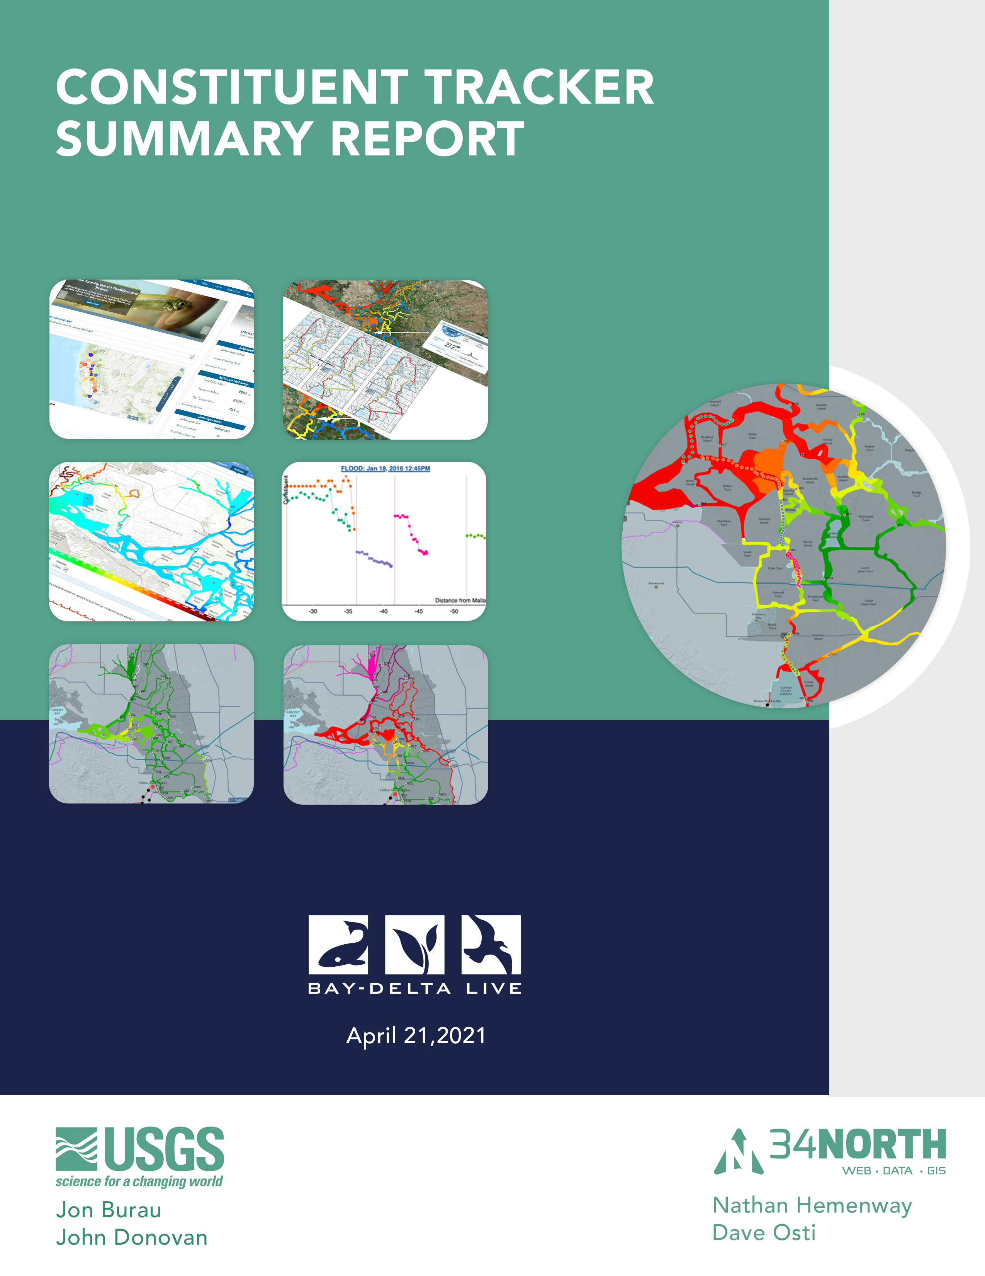

Contents

Constituent Tracker Overview
Version and Access 3
What is the Constituent Tracker: An Overview? 3
Area of Interest 4

Modeling of Expected Constituent Concentration Field 5
The Problem of Tidal Aliasing 6
Project Relevance and Benefits 3
Our Approach

Application Development
Tidal Excursion
Tideline
Dynamic Weights
Velocity Hub

Algorithm Documentation

Appendix A– Eulerian Tidal Excursion Estimate
Appendix B: References and Guiding Documents

Constituent Tracker Overview

Version and Access

The Constituent Tracker version 1.0.0 is currently available to a specified user group on www.baydeltalive.com. General stakeholder use will be available in Fall of 2021. The tool is currently implemented for modeling turbidity and electrical conductivity. Additional constituents will be available in future versions.

Turbidity Model:
https://www.baydeltalive.com/current_conditions/constituent-tracker-turbidity
Electrical Conductivity Model:
https://www.baydeltalive.com/current_conditions/constituent-tracker-electrical-conductivity

For access to latest version of model and help guide, email support@opennrm.org.

What is the Constituent Tracker- Overview?

In collaboration with USGS (concept and algorithm development) and DWR (transect data), the development of this project aims to advance the Bay-Delta Live (BDL) data management platform and leverage the Delta’s sensor network and to provide data and decision support tools for viewing and analyzing continuous water quality conditions at finer spatial scales. This data assimilation application may be incorporated into existing monitoring programs to evaluate current conditions, assess turbidity, salinity and nutrient conditions, supplement or replace DWR early warning turbidity transect operations, as well as help to evaluate changes due to wetland restoration, flow alteration, gate installations and other management actions.

The Constituent Tracker (CT) combines measured observations of water quality constituents and measured velocities to produce graphical products based on the tidal excursions of these constituents from their slack-water distributions (viewing data at a constant point in tide). This work was performed to assess the feasibility of using this approach as a replacement time series graphs, high speed boat mapping and data used at a constant point in time.

Area of Interest

The Sacramento-San Joaquin Bay Delta is an inland river delta and estuary in California. The total area of the Delta, including both land and water, is about 1,100 square miles and is the hub of California’s water supply, supplying fresh water to two-thirds of the state’s population and millions of acres of farmland. Saltwater from the San Francisco Bay mixes with fresh water from the Sacramento, San Joaquin, and other rivers to create the largest estuary on the West Coast. This estuary provides habitat critical to the survival of many fish and wildlife species. It is also a rich agricultural area, a recreational wonderland, and a complex ecosystem that is home to a variety of wildlife.
The conveyance of water from north to south relies on the movement of that water through the Delta and its maze of levees and islands and maintaining the right balance of saltwater and fresh water. Careful operations of the State Water Project (SWP) and federal Central Valley Project (CVP) are critical to keeping the balance, especially in the face of new and ongoing water management challenges.

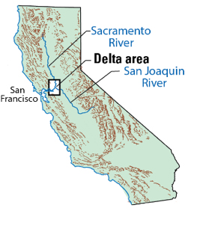

Modeling of Expected Constituent Concentration Field

The ability to quantitatively understand constituent dynamics in the Delta is hindered by the ability to accurately calculate and visualize data from the existing flow measurement network (USGS and DWR collect flow (stage, velocity, discharge)) (Figure. 1).

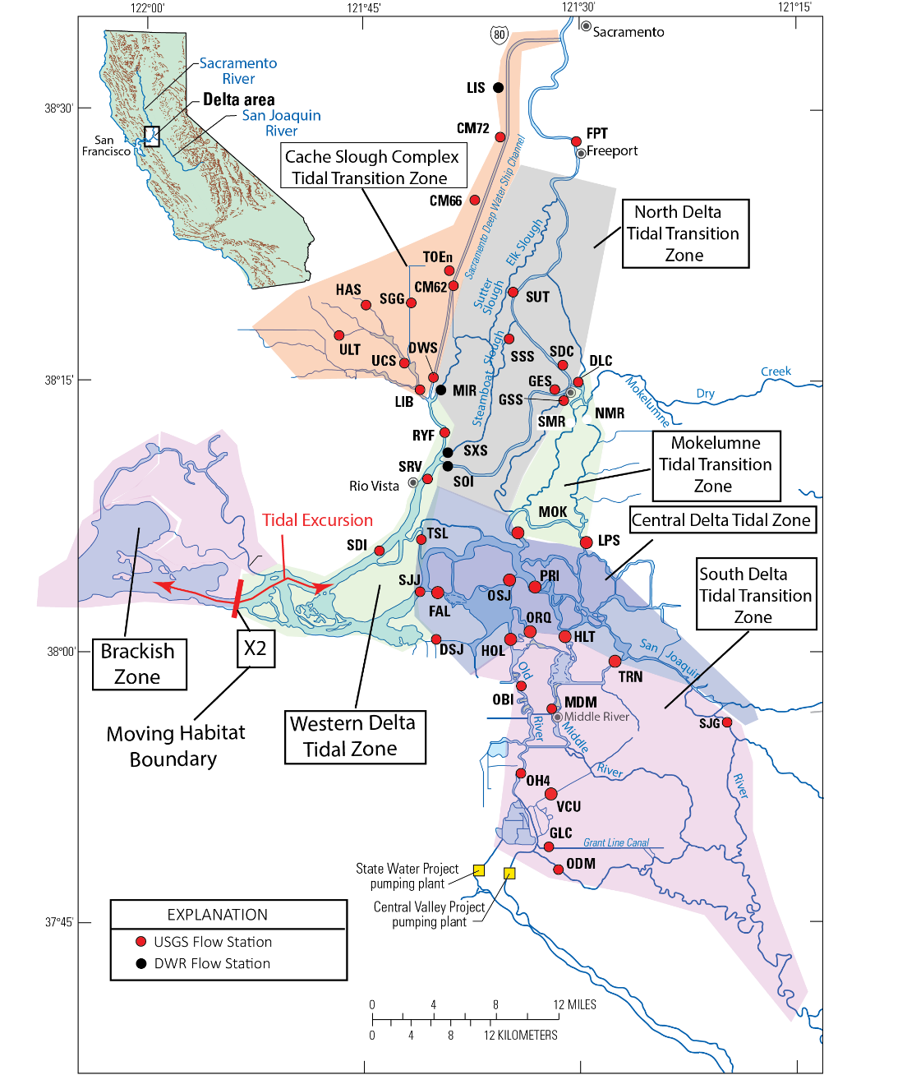

Figure 1: Delta Regions (zones) and Fixed Monitoring Station flow and water quality network. X2 is a moving boundary that moves daily with the tides (~8 miles a day twice a day) and at longer timescales with changes in Delta Outflow.
Current spatial distribution plots (www.baydeltalive.com/turbidity) show that constituent distributions in the Delta appear to be well-behaved fields when in fact the spatial constituent gradients vary significantly over the tidal excursion. These current methods of interpolation yield the approximate spatial distribution of constituents, but for management action and water operations, the true details of the gradients in the constituent fields are needed. To accomplish this goal, USGS developed a 1D transport equation and data assimilation method (funded by DWR and DSP) to fill in the details of the spatial structure in the constituent fields between sampling stations in the North Delta using a conservative tracer.

Building on the USGS transport equations and techniques, 34 North applied these techniques to develop a web-based real time tool to visualize the detailed constituent field throughout the Delta. While the algorithms will be most accurate in the North Delta, stakeholders can explore spatial maps and near real time visualizations throughout the watershed where continuous monitoring is present.

The Problem of Tidal Aliasing

The spatial distribution of water quality constituents over the transect shown figure 2 can move up to about ~4.5 miles, a distance known as the tidal excursion. The tidal excursion is the distance a parcel of water travels with the tidal currents in ½ tidal cycle. An Eulerian estimate of the tidal excursion is, (see Appendix B for origin of this relationship). To estimate the tidal excursion in Old River we note the peak flood currents at station HOL (a WQ sensor on Old River immediately south of Franks Tract (see figure 2) are roughly 43 cm/s (1.75 ft/s), which gives an Eulerian tidal excursion estimate of 7.5 km (4.7 mi) based on eq. A.5. The length of Old River between Franks Tract and Clifton Court Forebay (CCFB) is 25 km (16mi), so the tidal excursion, and by extension the location of the turbidity field, can move by as much as 1/3 the length of Old River between Franks Tract and CCFB, respectively. To get a sense of the scale of the movements of water quality constituents within Old River, consider that if the high turbidity region near station HOL were mapped at the end of ebb, it would move to the position shown on figure X (January 11), the distance shown by the red line placed west of Old River.

The problem is the tides quickly move the water quality constituent spatial structure during any monitoring or data collection effort which distorts the measured spatial structure. For example, if a field sampling effort starts at the end of ebb, monitoring is occurring when turbidity is as far out of the South Delta as it is going to be for that day. If the field study lasts 6 hours, or a complete ebb tide, the program will be sampling turbidity when it is as far as into the South Delta as it will be for that day. The tidal currents are literally moving the turbidity field during sampling. The transect shown, figure 2, is an example of this phenomena. It begins at the end of ebb and finishes at the end of flood (e.g. roughly 6 hours). The turbidity measurements during the early part of the transect will more closely represent the position of the turbidity field as far north as it will be for a given tidal day, while the portion of the transect taken near the end of flood will more closely represent of the position of the turbidity field when it is as far south as it will be during the tidal day – as much as ~4.5 miles closer, during spring tides.

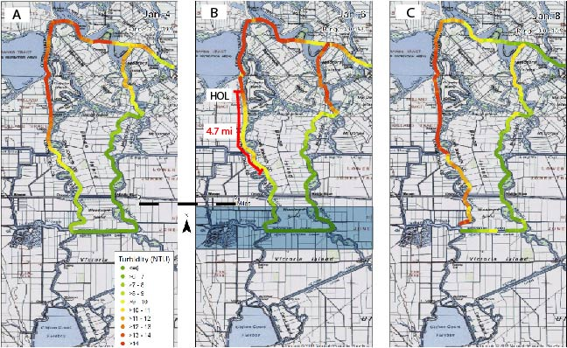

Figure 2. DWR biweekly spatial mapping of the turbidity distribution in the loop from Old River to Woodward Canal to Middle River, to the San Joaquin to Old River is used by the Delta Smelt Working Group - a multi-agency regulatory entity that provides guidance to the water project operators on compliance with State and Federal Delta Smelt biological opinions. To obtain the example “heat” maps shown in figure 2, DWR drags a water quality Sonde behind a boat while collecting GPS position data.

This well-known phenomenon is known as tidal aliasing: which is the collection of spurious data when the sampling time is a significant fraction of the fundamental period of the phenomena being measured – in our case the M2 partial tide, which has a period of 12.42 hours. Basically, the boat-measured spatial distribution is highly aliased (distorted) because the turbidity field moves a significant distance with the tidal currents during the period the boat is collecting data.

Project Relevance and Benefits

The Constituent Tracker (CT) combines measured observations of water quality constituents and measured velocities to produce graphical products based on the tidal excursions of these constituents from their slack-water distributions (viewing data at a constant point in tide). This project is aimed at using an advection-based model to make near real time estimations of the position of a constituent to better inform water operations their regulatory impacts. For example, there are a number of different regulatory triggers aimed at protecting delta smelt that can impact water operations. The main triggers being salvage at the pumps and elevated turbidities in the central and south Delta. For example, reductions in pumping are required when the 14-day average turbidity exceeds 12 NTU at stations PRI, HOL, and VCU (Figure 1). These decisions and triggers along with other regulatory actions are evaluated over a period of days. By improving data collection techniques and tools for near real time analysis this project will:

- Help support decision making to manage water projects at a finer scale.
- Obviate the need for on-the-water boat transects.
- Provide non-aliased estimates of the location of the turbidity field at slack water after the max flood and ebb each day, stringing together images of the turbidity field at slack after max flood (Figure X).
- Improve project operational response to water quality variability.
- Improve understanding of how constituent fields move at variable timescales.
- Demonstrate that water quality conditions are influenced by twice daily rapid and powerful tidal cycles (affecting up to 8 miles of water quality conditions in the western Delta).
- Support decision making for the Delta Smelt Working Group rand reduce reliance on DWR turbidity transect data and maps.

Using this tool within existing regulatory frameworks, a better understanding of constituent fields in the central and south Delta by will have the collateral benefit of increasing water supply reliability south of the Delta and potentially exports of water to regions south of the Delta.

Project Approach

Our overall approach in the development of the Constituent Tracker is to make the best use of a detailed knowledge of transport processes and of all of the data collected in the Delta (time series collected within channels and near junctions, drifter data, etc.) in order to provide the most realistic near real-time maps of water quality constituent spatial distributions.

Using linear interpolation on a grid via the Laplace equation (hereafter referred to as grid interpolation) we can provide reasonable Delta-scale estimates of constituent distributions at either a constant point in time or constant point in tide. Constituent concentration spatial gradients can be more accurately estimated within either a maximum flood or ebb tidal excursion of the data collection location using the assumption of pure advection.

The Constituent Tracker grid coverage extents from the Sacramento River where it meets the Deep Water Ship Channel in the north down to the Chipps Island in the West to the San Joaquin River at Mossdale Bridge in the south. In order to map the station particles using the advection algorithm, the project divided the rivers into 13 reaches, grouping appropriate stations within each reach. Both the EC and Turbidity maps pair over 40 stations with velocity and the water quality constituent.
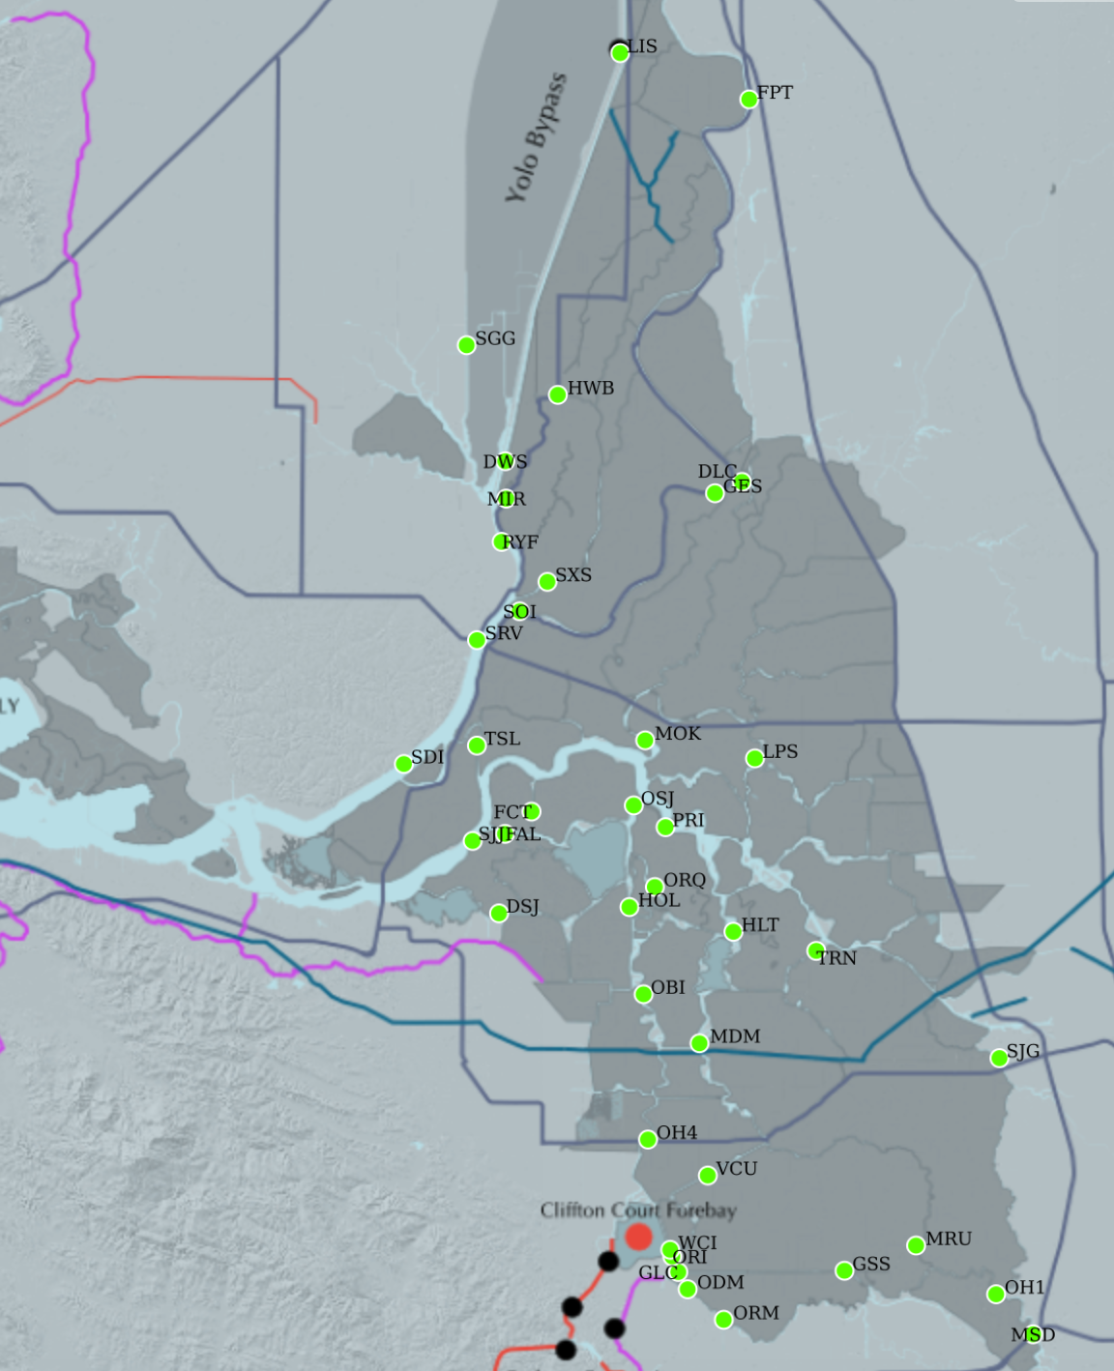
Figure 3. – Grid coverage and the location of USGS fixed site flow and water quality sampling locations. The constituent tracker would also utilize DWR-run flow and water quality gages in the Delta to increase the precision of the spatial maps produced using this approach.

Turbidity Reaches and CDEC Stations:
Sacramento River (SAC): SDI, SRV, SOI, GES, FPT
Steamboat Slough (STM): SRV, SXS, FPT
Sutter Slough (SUT): RYF, MIR, HWB, FPT
Cache Slough (CSC): SDI, SRV, RYF, DWS, LIS
North Mokelumne (NMK): MOK, DLC
South Mokelumne (SMK): LPS, DLC
Old River (OLD): SJJ, FAL, HOL, OBI, OH4, WCI
Middle River (MID): MOK, OSJ, ORQ, HLT, MDM, VCU, WCI
San Joaquin River (SJ): SJJ, OSJ, PRI, TRN, SJG, MSD
San Joaquin West (SJW): ORI, GLC, ODM, ORM, MRU, OH1
Dutch Slough (DUT): SJJ, DSJ
Fisherman’s Cut (FIS): SJJ, FAL, FCT
Threemile Slough (THR): SDI, TSL
Georgiana’s Slough (GEO): MOK, GSS, GES
Liberty Island (LIB): RYF, SGG

Application Development

Phase 1: This application linearly interpolates the spatial distributions to a common point in tide (not time) where the common points in tide (phase) are at slack after max flood and at slack after max ebb. Spatial maps that are linearly interpolated to a common point in tide give us a Delta scale estimate of the extreme positions of the constituent fields that occur within a tidal day: either fully into the Delta (slack after max flood) or out of the Delta (slack after max ebb).

Identifying the peak ebb/flood set in a given tidal day is non-trivial because the peak currents during flood and ebb tides can be similar, if not identical (Figure X) during the spring/neap cycle. The period of similar peak currents occurs during periods when the diurnal inequality is minimal, which typically occurs during the transition between spring and neap tides, or on places/times when river flows create uni-directional flows. Thus, picking out the maximum flood ebb/sets can be challenging.

Given this ambiguity, this application uses the maximum tidal excursion associated with each tide instead of the max current speed to pick the max ebb/flood set. The tidal excursion - the time integral of velocity from slack to slack (Equation A.1) – doesn’t rely solely on the current extremes but includes the duration of a given tide in the calculation which gives us better discrimination between tide cycles. Because this project is focused on comparing the extreme positions of constituent fields over a tidal cycle, the tidal excursion is a calculated quantity needed for phase 2. Because the tidal excursion uses the integral of the velocity over the tide cycle, changes in the spring/neap cycle are much more apparent in the tidal excursion (Figure X). In the example shown in Figure X, and generally in the Delta, the tidal excursions during spring tides are roughly 40% longer than during neaps, and, importantly for this project, differences in the tidal excursion between tides are greater.
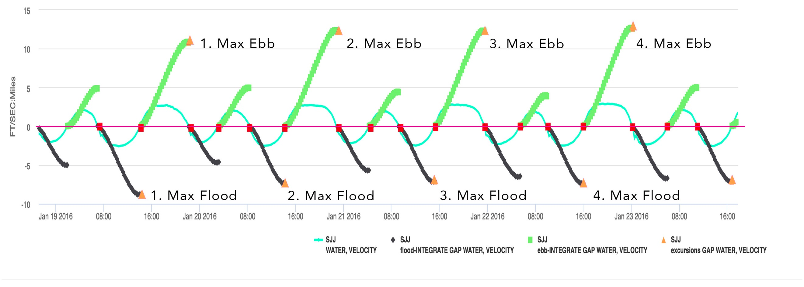

Figure 6 – Time series plot of velocity (blue-green line, scale not shown) and the tidal excursion: green = ebb & black = flood, time integral of velocity from slack to slack, maximum excursion (orange triangles) and slack water periods (red squares on the red zero line) at Jersey Point.

The maximum salinity intrusion into the Delta that occurs within a tidal day occurs at slack after flood tide Figure X. Whereas, the lowest EC’s are associated with slack after ebb tides, the extreme positions of the salinity field over a tidal day, which are the most important positions of the salt field to water project and fisheries resource managers and are much more accurate measures of the spatial structure of constituents than taking transects using a boat, as described above. The fact that EC and the tidal currents are in quadrature (e.g. 90 degrees out of phase) is a strong indication that transport of EC at this station is advection dominated, as it is throughout the Delta, consistent with the principal assumption on which this project is based.

Finally, figure X shows how EC varies over the spring/neap cycle, where the maximum salinity intrusion on each day declines as the daily maximum flood tide declines in the transition between spring to neap tides.

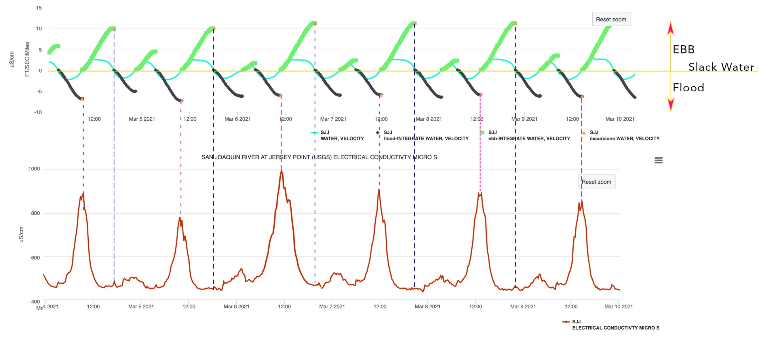

Figure 7. Time series of electrical conductivity (bottom panel) and tidal excursion (green line; ebb, black line; flood, top panel) and water velocity (blueline, top panel) collected at the San Joaquin River at Jersey Point (March 4-5, 2021). Vertical dashed blue line indicates slack after max ebb and the vertical dashed purple line represents slack after flood tide.

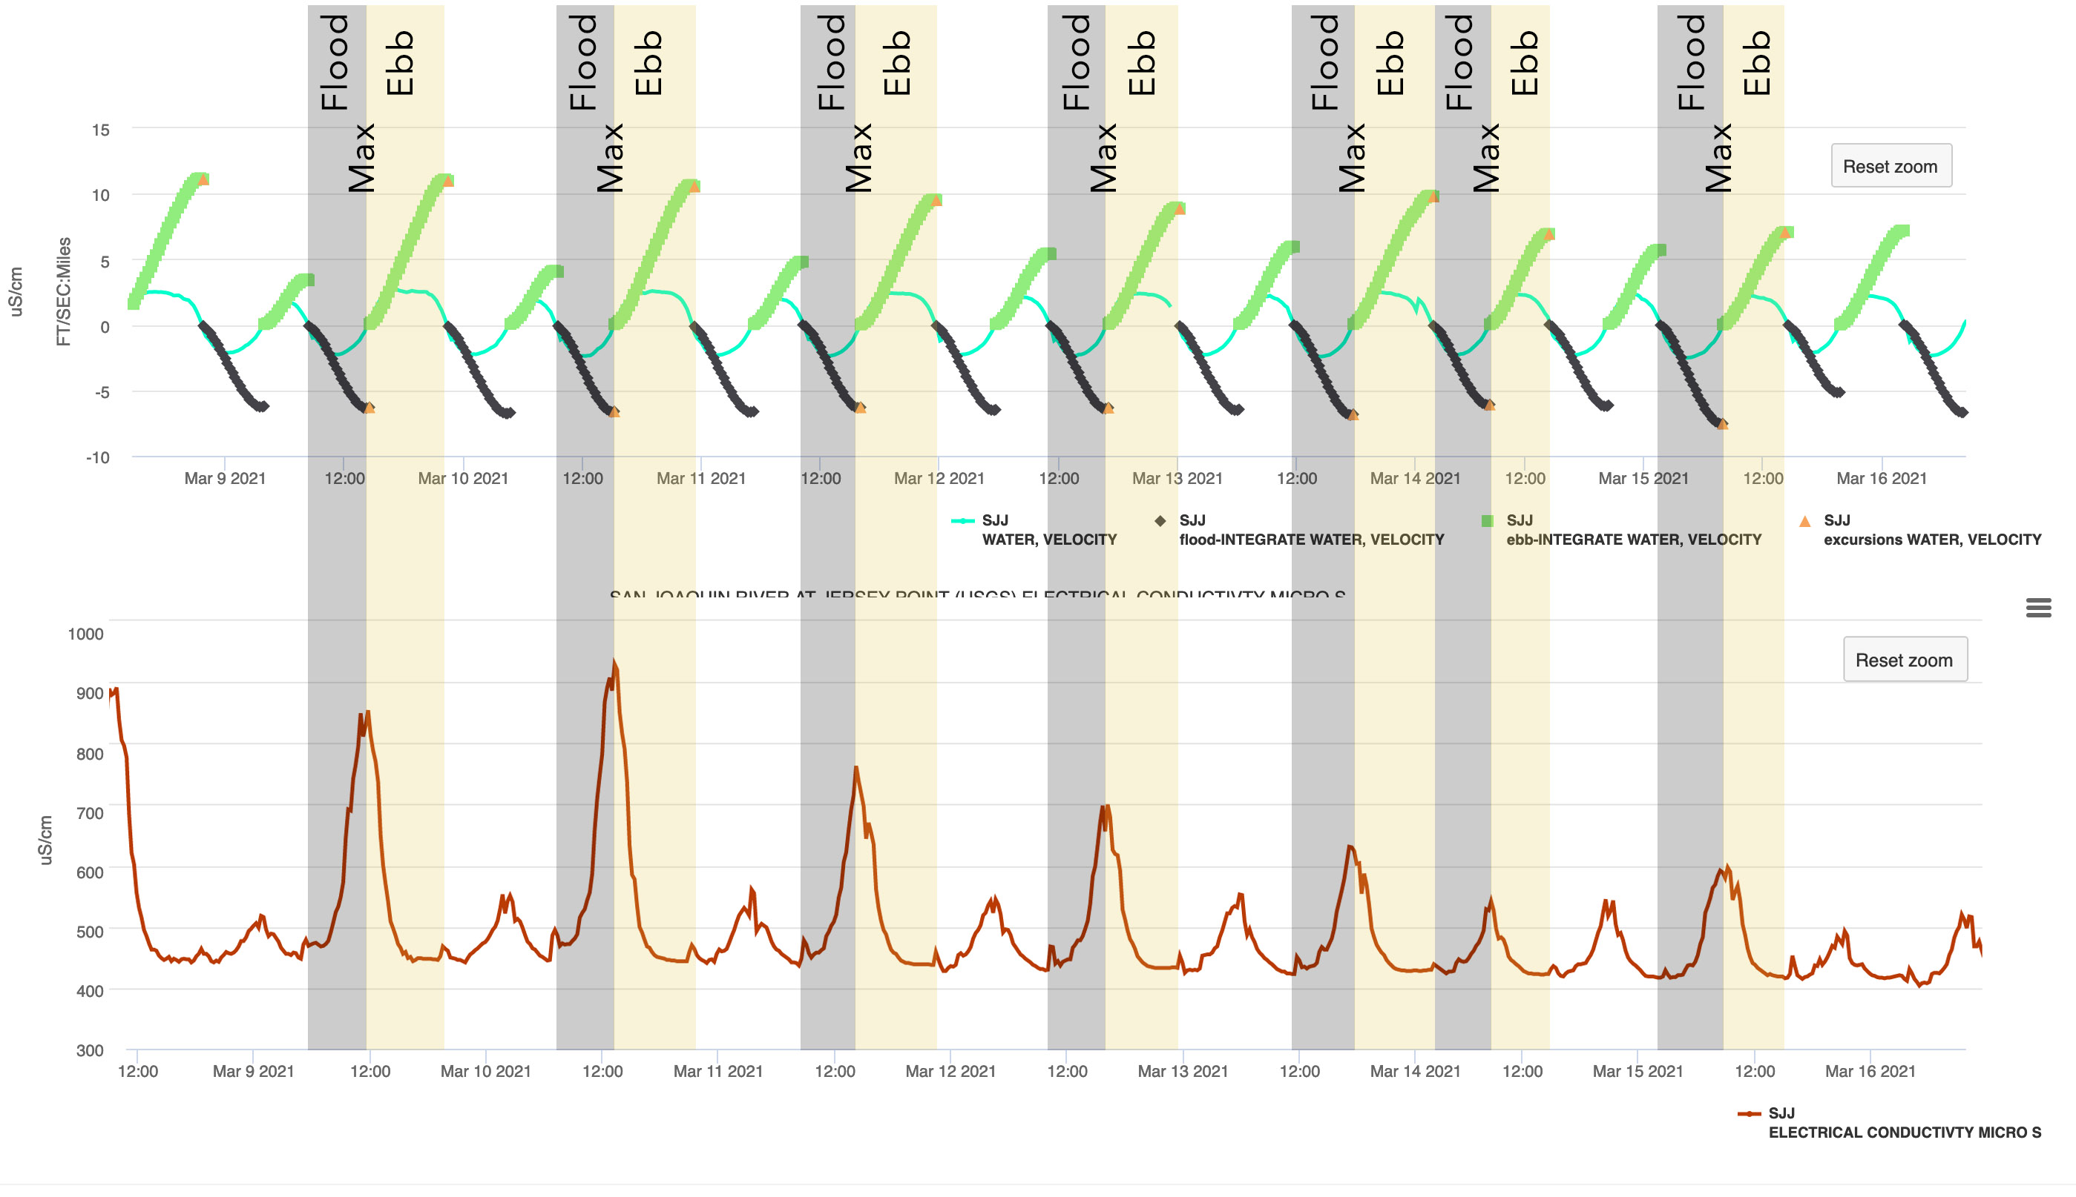
Figure 8. Time series of electrical conductivity (top panel) and tidal excursion (cyan line, bottom panel) and water velocity (green line, bottom panel) collected at the San Joaquin River at Jersey Point (November 23 – December 3, 2015.

Tideline

The creation of a “Tideline” was developed to visually aggregate slack water for the max flood and ebb for each station during the tidal cycle. The user interface displays a constant point in tide (Figure 9).

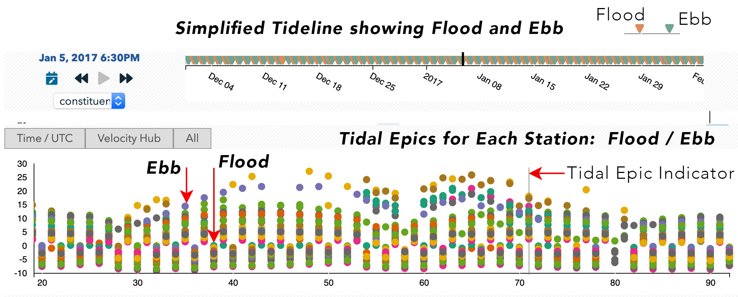
Figure 9. Tideline Graphical Interface. Each dot represents the tidal excursion estimate at slack water from a real time station for each max flood and max ebb tide.

Dynamic Weights

The results of these data assimilation processes are displayed using a custom GIS grid. Constituent values for each polygon are generated using a weighted algorithm provided by RMA based on solving the Laplace equation which effectively linearly interpolate across each polygon in the grid.

Previous versions of the CT used a fixed station list, which was problematic given there can be occasional gaps in the data either because the station actually goes down or the realtime data feed breaks, causing the interpolation within the reach that includes the data gap to fail.
Using a Dynamic Weighting Algorithm, where stations with a data gap are dropped from the interpolation algorithm, we can compensate for missing data in the visualizations using the data that is available. The Dynamic Weighting Algorithm has been fully tested for Turbidity and Electrical Conductivity back to 2010. Data is provided by the California Data Exchange Center (CDEC). CDEC is the data service of choice because it is the only source that aggregates the data from USGS, DWR, USBR and other organization sources.

While the constant point in tide approach provides real-time estimates of tidally averaged constituent fields, they are based on linear interpolation (e.g. phase 1) which cannot predict the spatial constituent gradients between stations. Which leads us to phase 2, where we use velocity, that is also collected at all of the water quality stations, and the assumption of pure advection to improve the estimates of the spatial structure between stations.

Phase 2. Particle Tracking: The CT implemented an algorithm to estimate the spatial variability in constituents between stations. Fortunately, the work identifying the max ebb/flood set in phase 1 can be used to simply affiliate the incremental distance water has traveled from each station for each time a water quality and velocity measurement is recorded (Figure 7).

The Constituent Tracker has geo-referenced each water quality station on a grid. By doing so, the CT can then plot the location and distance of the excursion points across this grid. The particles contain copious amounts metadata including the stations’ constituent value. At the mapping of these excursions (e.g. at every particle location, or dot on the map in Figure 8), the particles’ value is transferred to the underlying grid cell.

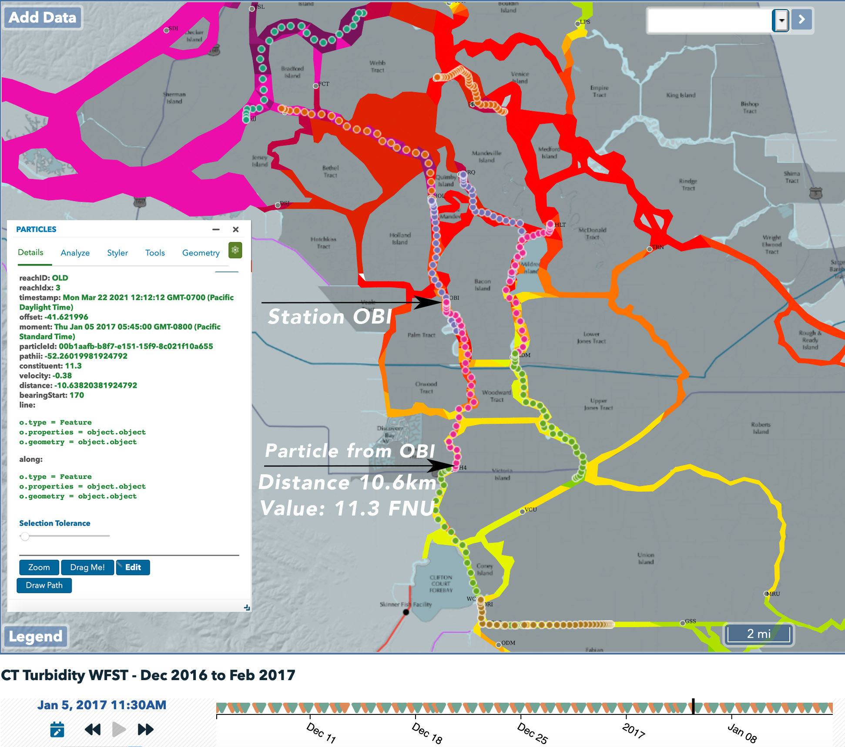
Figure 10. Particle Tracking from Station OBI on Max Flood. Distance traveled = 10km (6.59 mi)

Velocity Hub

The Velocity Hub (vHub) (Figure 9) is the graphical user interface developed to visualize particle tracking from each stations. Clicking on the vHub button on the Tideline opens up the interface. Clicking on a station will draw the excursions on the map for each slack water selected on the tideline. The user can advance the tides using the forward and back buttons on the player controls and can select the Flood/Ebb/All toggle button to advance the data per tidal epic.

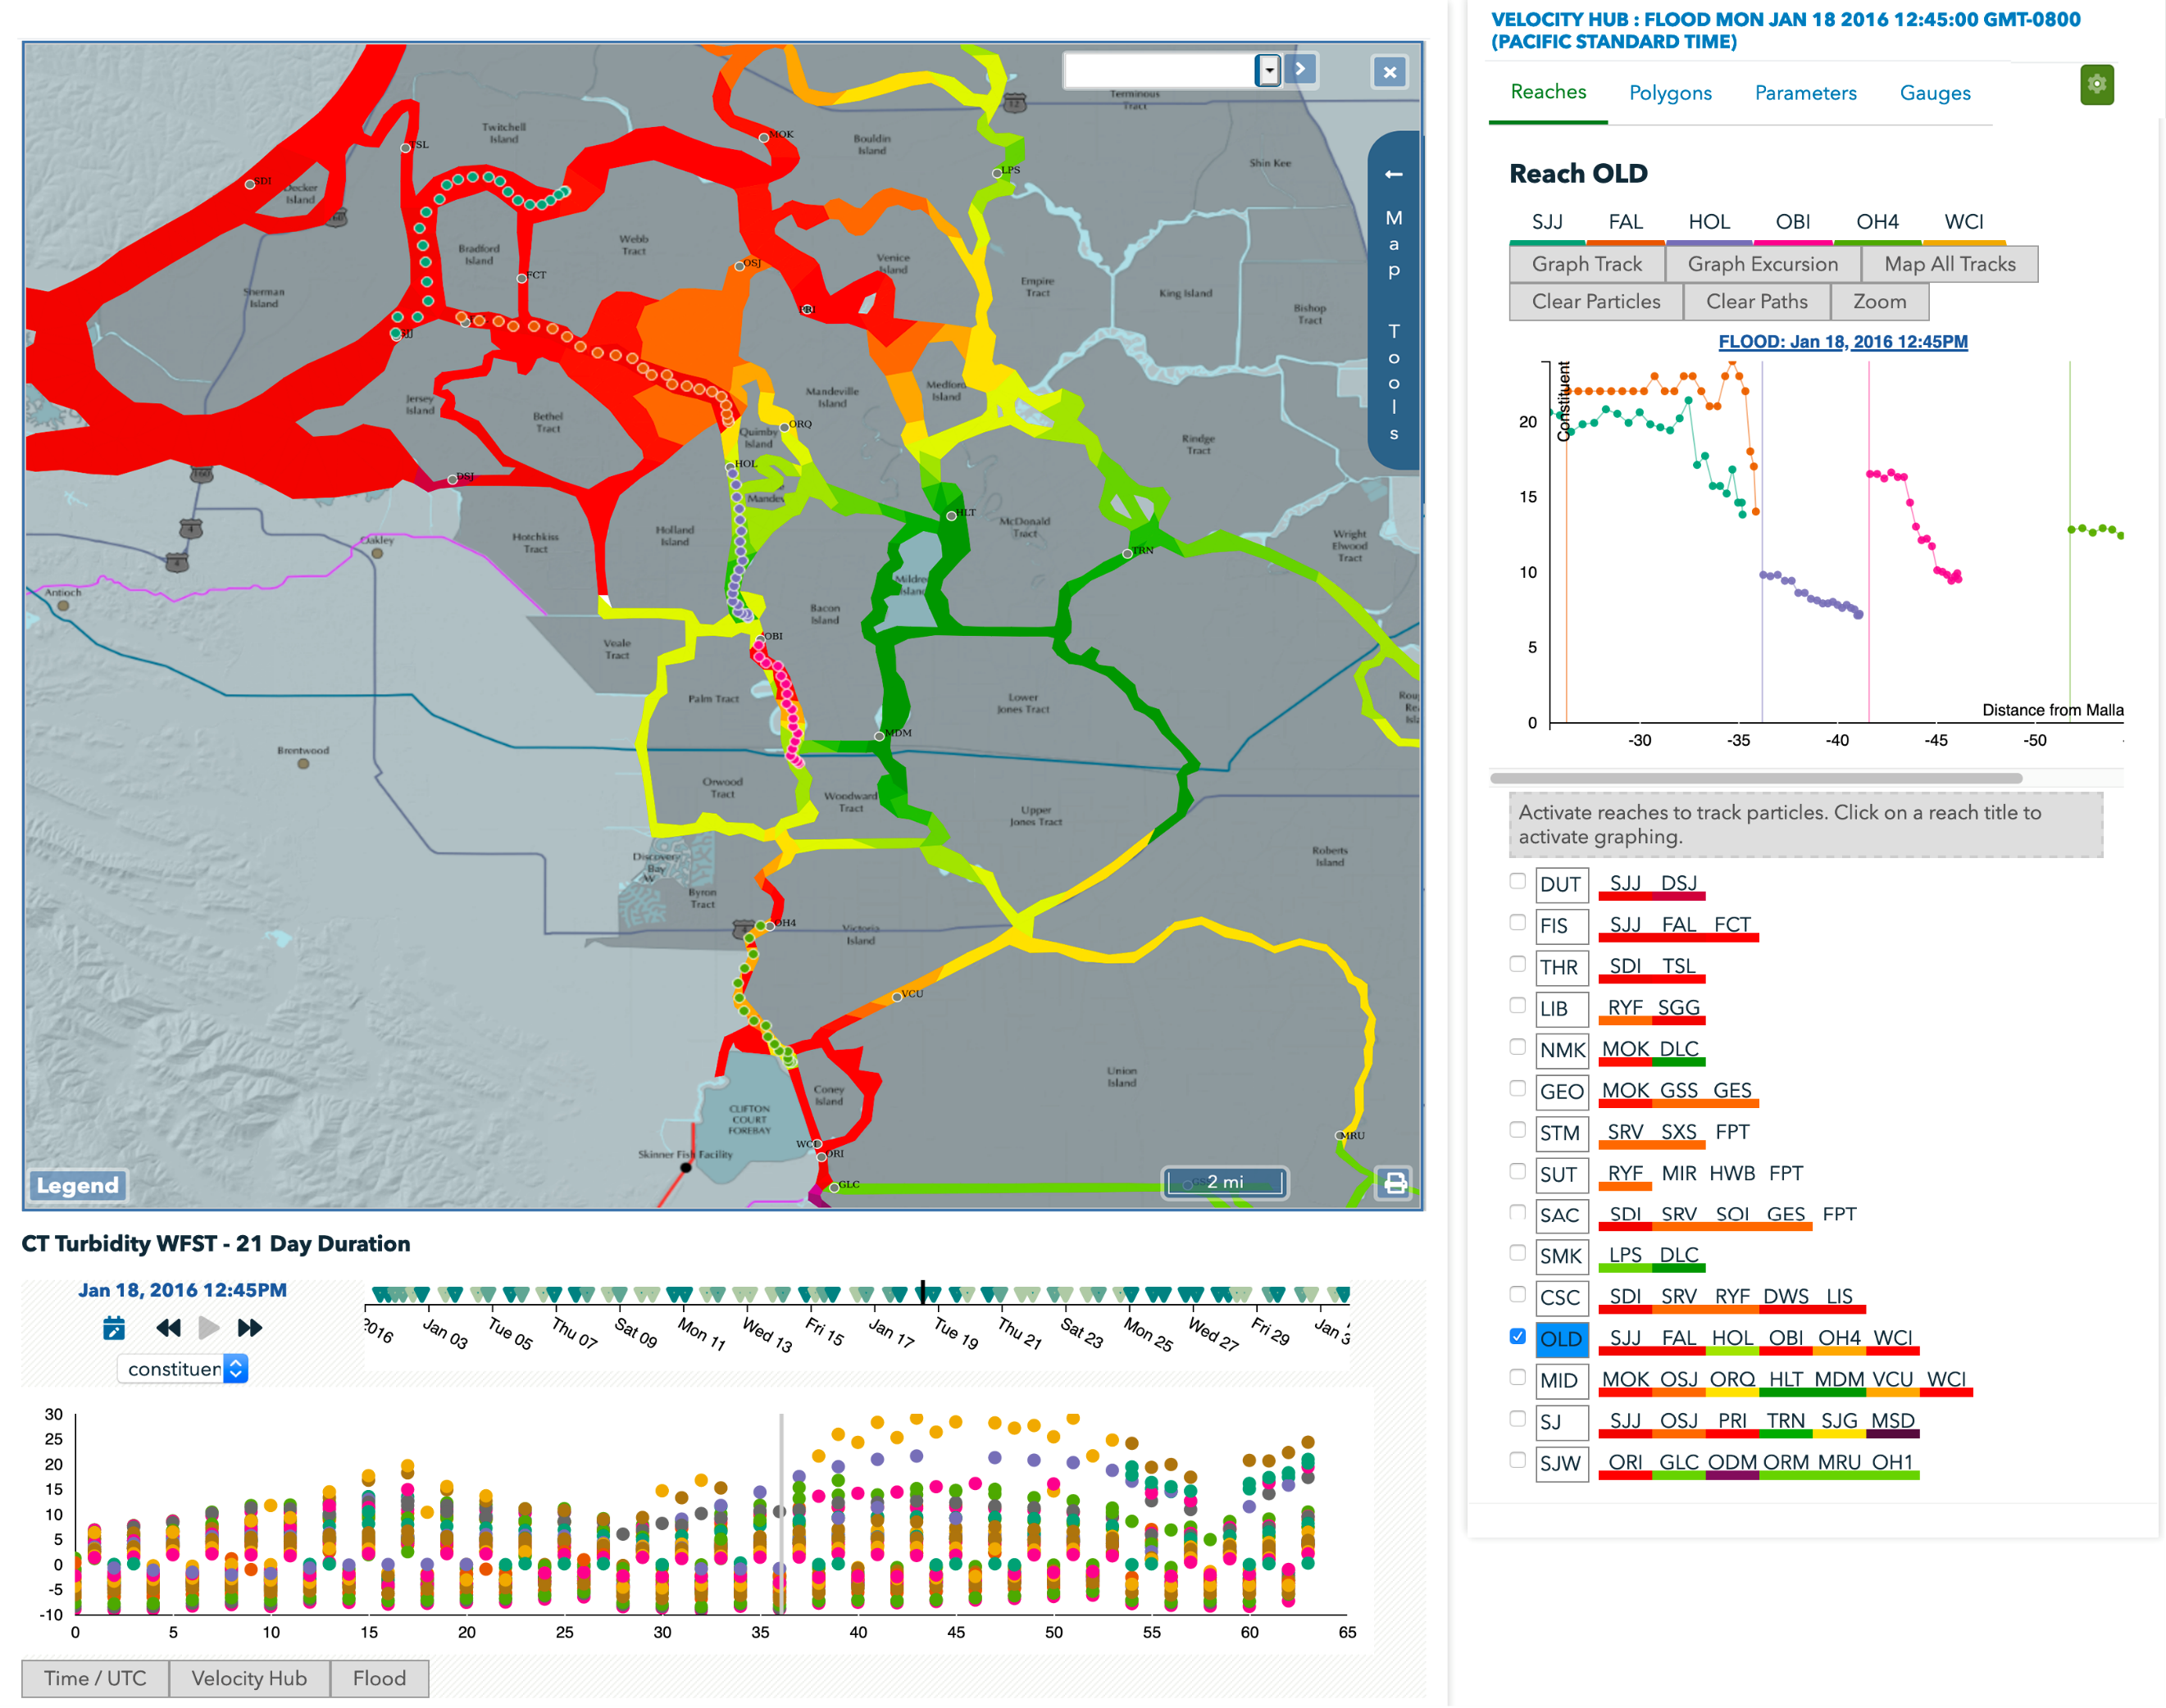
Figure 9. Image of the map, velocity hub and the tideline. The upper right graph displays the excursion data and distances from Mallard for the selected Old River Reach. The particles are displayed on the maps.

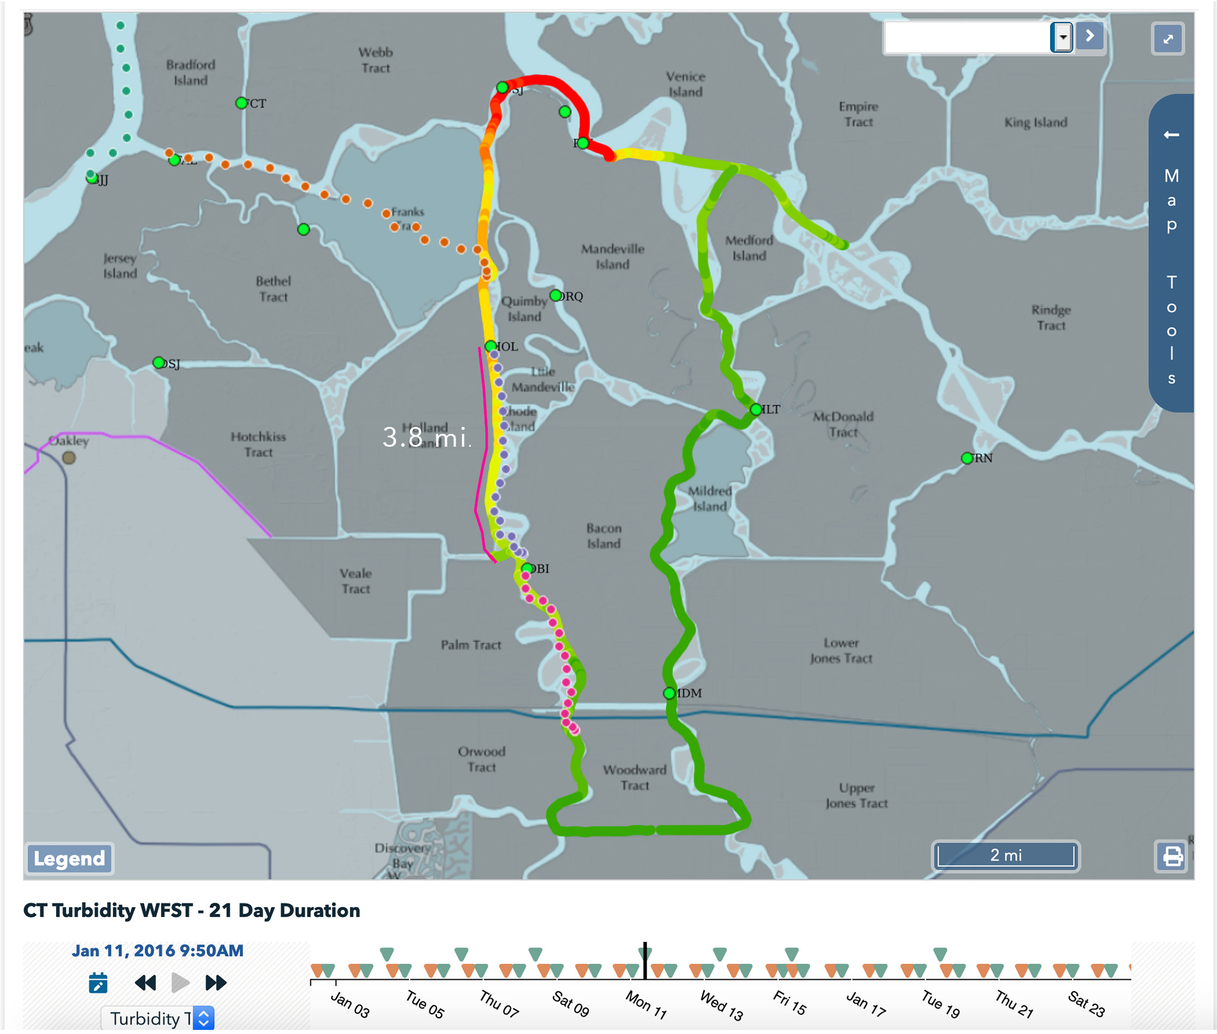
Figure 4 – Turbidity transects collected by DWR by dragging a YSI sonde by boat (Courtesy of the 1/11/16 Delta Smelt Working Group notes). These transect take approximately 6 hours to complete depending on the tidal currents and weather (which is often inclement), roughly ½ of the principal tidal period of 12.42 hours (M2 partial tide).

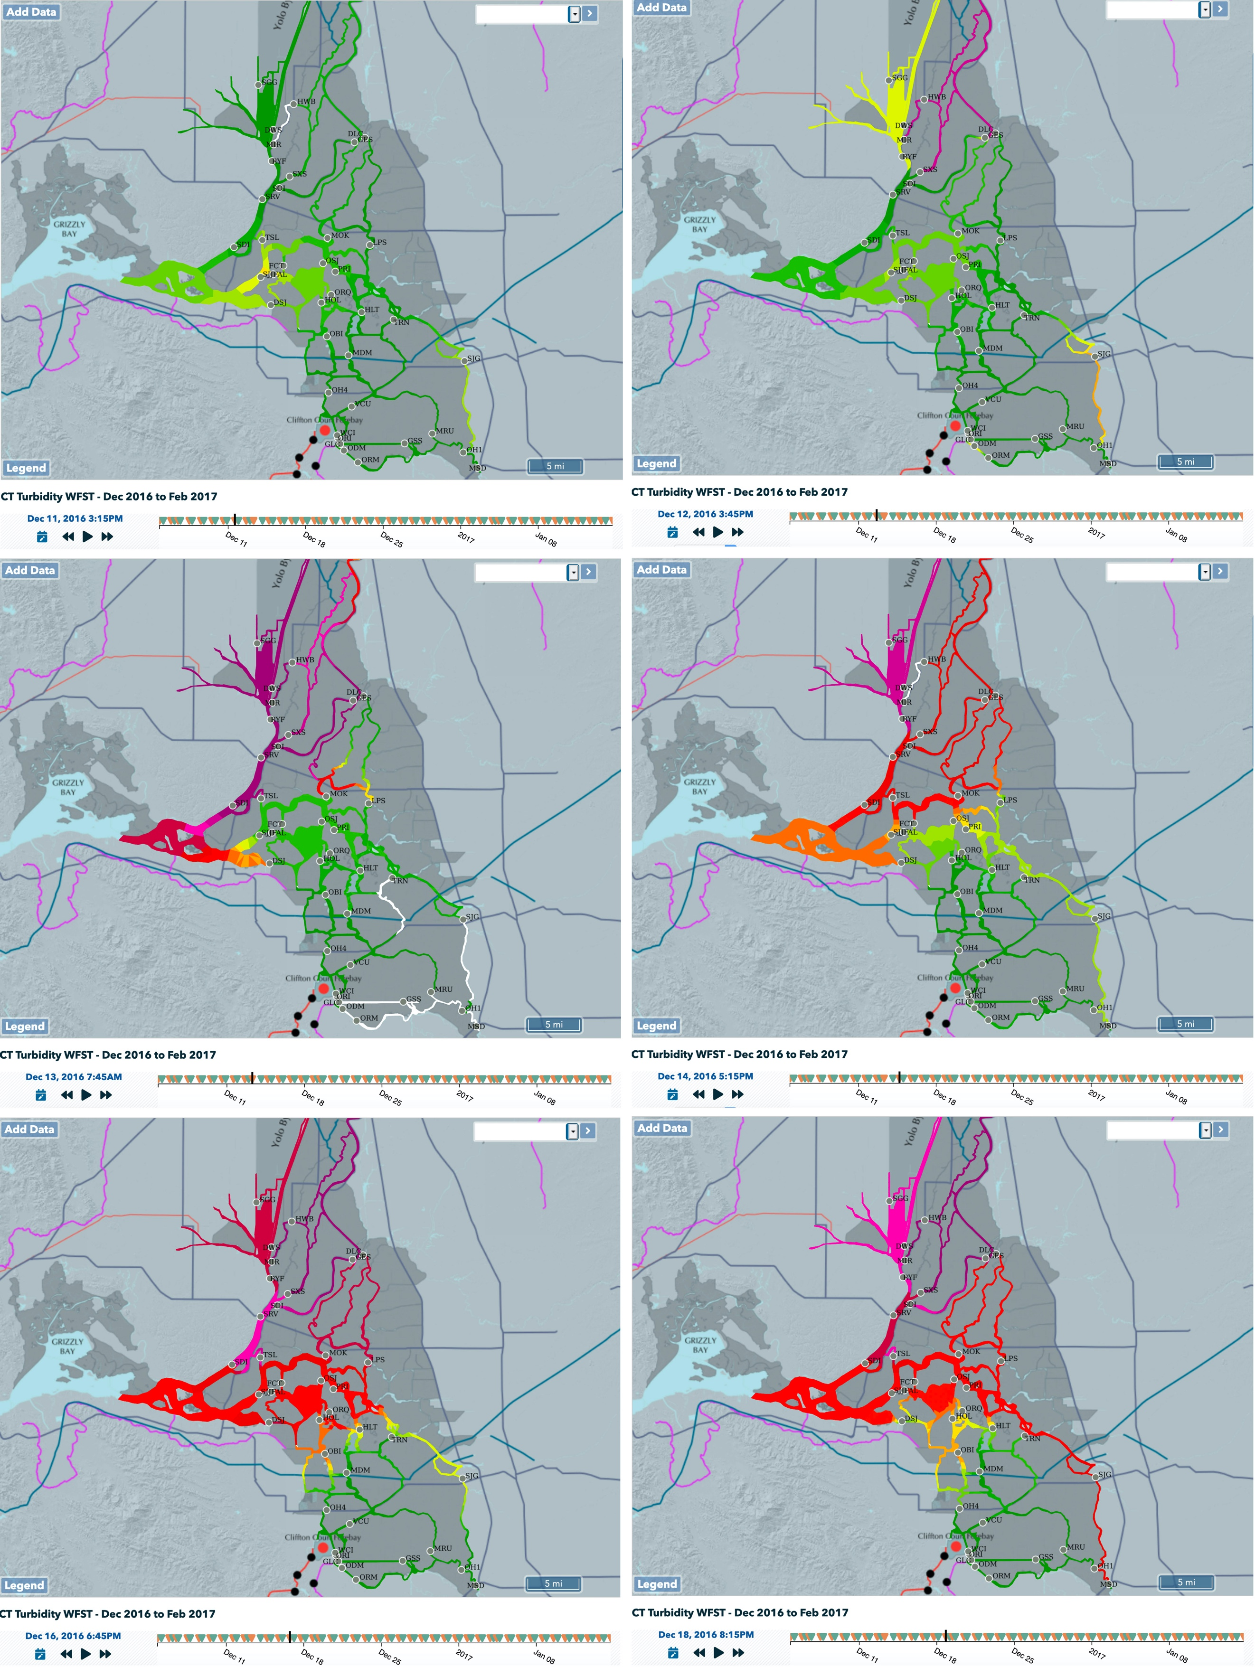

Figure 5: First Flush December 2016: CT – Turbidity at slack after Max Flood

Algorithms

The CT tackles the reality of real time data by first running a series of signal processing algorithms to prepare the data. The procedure is as follows:
- Analyzing the Data:
  - Fill data gaps (4 hours maximum fill)
  - Smooth and Normalized Velocity data
  - Identifying slack water from velocity:
    - Zero Crossing
    - Peaks and Valleys
    - High to High (Hi2Hi)
    - Low to Low (Lo2Lo)
- Heuristic Algorithms: Making Decisions with the Data:
  - Signal to Noise Algorithm to identify a good signal: Yes or No.
    - If yes – Identify the start and end of tidal epic using Velocity:
      - Zero Crossing
      - Hi2Hi
      - Lo2Lo
    - If no – the application moves down stream along a predefined river reach to the next station and runs the same data check.
  - Run the Flood and Ebb Integrates
  - Find & record the excursion times and distances

Appendix A– Eulerian Tidal Excursion Estimate
The tidal excursion, the maximum distance traveled by a parcel of water on a single tide, can be estimated based on a local Eulerian velocity measurements,, simply as:

(A.1)

where is the time of slack water and is the next slack water.
If we let and , and the tidal currents can be reasonably approximated by a single partial tide, , then equation 1 becomes

(A.2)

(A.3)

L_{ex}= U*P/pi (A.4)

Now, if we assume the tidal currents in the Delta are well represented by the M2 tide, P=12.42 hrs, 6.21 hrs, or ,, and the peak currents are in cm/s, the tidal excursion is

(A.5)

L_{ex}(mi) = 2.6969*U(ft/s) (A.6)

A

Appendix B: References and Guiding Documents

DeGeorge, John; Andrews, Steve. 2011. User Information for 34 North Polygon Weighting Program. Resource Management Associates. https://www.baydeltalive.com/docs/24407

The Delta. California Department of Water Resources. https://water.ca.gov/Water-Basics/The-Delta

Thompson, Matthew P; Scott, Joe H.; Helmbrechet, Don; Calkin, David E. 2012. Integrated Wildfire Risk Assessment: Framework Development and Application on the Lewis and Clark National Forest in Montana, USA. Integrated Environmental Assessment and Management. Volume 9, Number 2. pp. 329-342.

Guiding Documents (not exhaustive list)

Additionally, the Delta is large (1,100 sq. miles) and is a complex web of channels that involves a significant number of junctions. Even though there are over 40 flow and water quality stations in the Delta (Figure 1) the data collection station density is insufficient to provide complete coverage of all of the channels using the advection algorithm (there will be gaps) and the stations necessary to completely cover all of the junctions. The number of stations necessary for complete coverage is cost prohibitive for the additional level of coverage needed and, besides, this level of granularity is not generally needed for scientific nor management purposes.

