**A Delta Multi-Parameter Water Operations Model:** Slack Water Model for Salt and Sediment Transport in the Sacramento-San Joaquin River Delta

Endangered species protections for Delta smelt, a functionally extinct endemic-to-the-Sacramento/San Joaquin Delta fish, can significantly constrain water supplies south of the Delta in the winter, when, tragically, there is the greatest amount of water available for export.

There are a number of different regulatory triggers aimed at protecting delta smelt that can curtail pumping: the main triggers being salvage at the pumps and elevated turbidities in the central and south Delta. For example, reductions in pumping are required when the 14-day average turbidity exceeds 12 NTU at stations PRI, HOL, and VIC.

Within existing regulatory frameworks, a better understanding of the turbidity field in the central and south Delta will have the collateral benefit of increasing water supply reliability south of the Delta. Exports of water to regions south of the Delta. The Delta plays a critical role in California’s economy, the largest state economy in US (~20% of US GDP) and the 6th largest economy in the world.

Field measurements of salt and sediment concentrations (or turbidity) made from boats (e.g. along-channel transects) often involve campaigns that are long in duration compared to a tidal cycle. As a result, they can provide a spurious picture of the spatial distribution of concentrations and how they vary over time. This project makes use of existing concentration and flow data collected at fixed stations to provide maps of the spatial patterns in the concentration data.

**Water Project Operation Issues**

1. Water projects are managed by large scale processes.
2. Water project operational response to water quality variability is slow (days to weeks).
3. Water quality conditions are governed by constituent fields that move at variable timescales.
4. Water quality conditions are influenced by twice daily rapid and powerful tidal cycles (affecting up to 8 miles of water quality conditions in the western Delta).
5. Other factors impacting the constituent field and further complicate issues are river flows, spring/neap (14-day) cycle and pumping.
6. Delta Smelt Working Group reliance on DWR turbidity transect data and maps are misleading (tidal currents can move the turbidity field back and forth in these channels on the order of 5 miles twice a day, every day).

**Delta Multi-Parameter Model Objective**

1. Develop a predictive tool using measured observations of water quality constituents or proxies (specific conductivity and turbidity) and measured velocities to demonstrate the constituent field at a constant point in *tide.* The point in the tide most interesting to management agencies for protecting fisheries is slack water. Specifically, after the largest flood tide of the day because this tidal phase corresponds to the condition where the turbidity field is at its farthest incursion into south Delta on any given day.

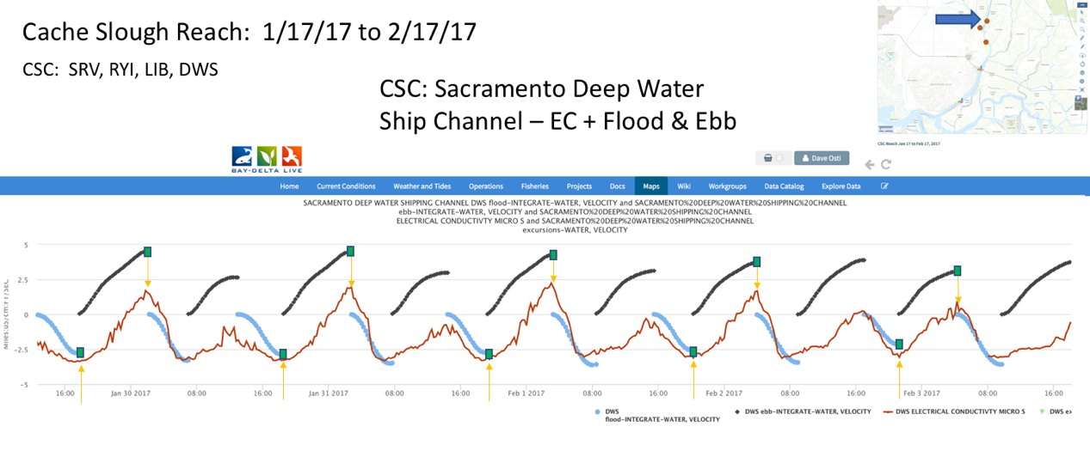

Figure 1: Delta Multi-Parameter Model Algorithm that collects a constituent value at slack water. Example Station – Sacramento Deep Water Ship Channel.

1. Develop and prepare daily graphical products showing excursion of these constituents from their slack-water distributions. This work will be performed in order to reduce the need for in situ measurements of turbidity.
2. Develop heat maps and animations (3-week duration) of the constituent field interpolated at slack water to show the tidally-averaged movement of the maximum incursion of turbidity into the South Delta. These animations will not only show where the maximum turbidity is on any given day but would show whether turbidity is moving towards or away from the pumps and the extent to which changes in pumping alter these movements.

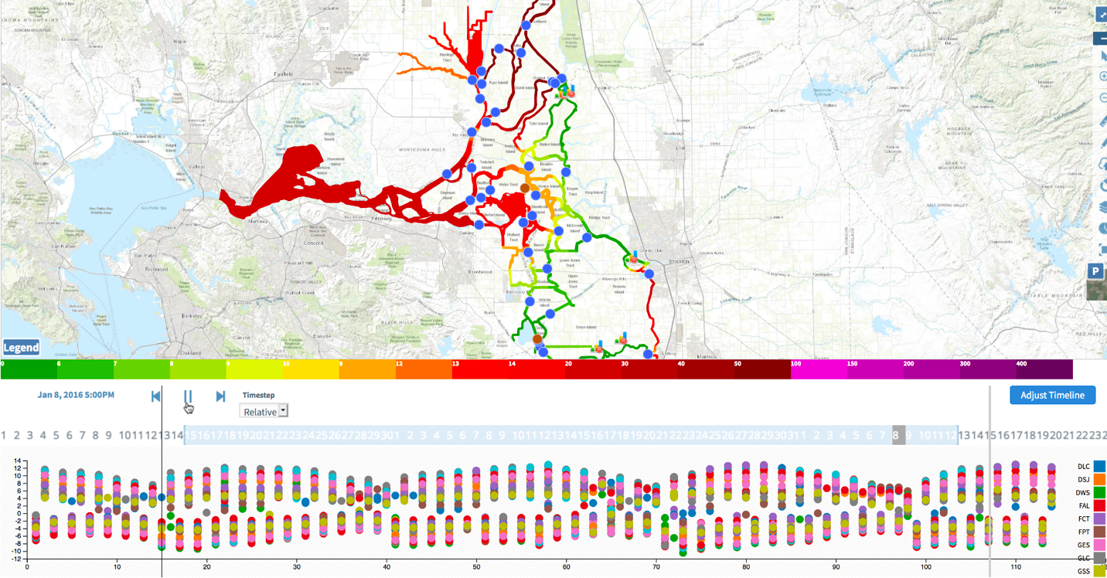

Figure 2: DMP Model Algorithm production of heat maps to display turbidity field across a constant point in tide. Developed “Tideline” to indicate relative time for slack water across the Delta. Jan 8, 2016 First Flush.

1. Apply model infrastructure to evaluate additional constituents including temperature, chlorophyll and food web transport.

**Relevance and Benefits**

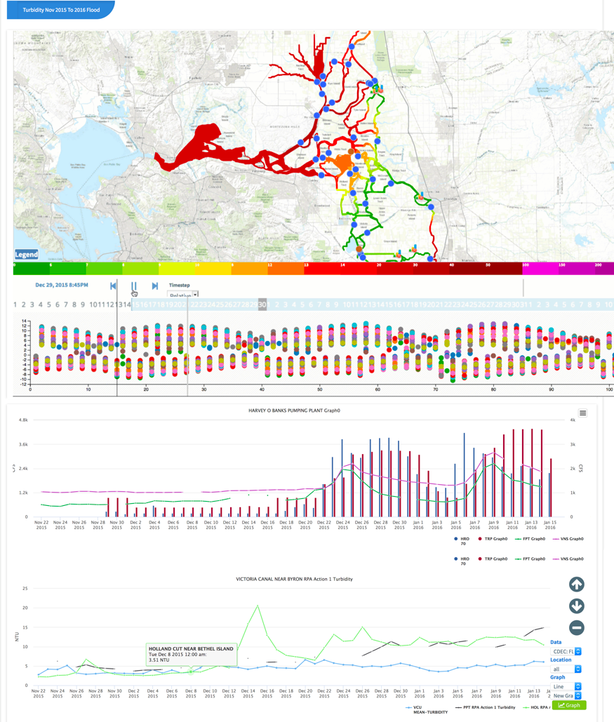**Operational Response to Water Quality:** Improve data and information provided to managers to reduce operational response to near real time.

Figure 3: Delta Water Operations Data Dashboard: Graph 1: Pumping at Banks and Tracy + Flow at Freeport and Vernalis. Graph 2: Three Day Turbidity Average at Prisoners Point, Holland and Victoria Cut.

**Fisheries:** Endangered species protections can significantly constrain water supplies south of the Delta in the winter when there is greatest amount of water available for export. Ex: Regulatory Triggers: 14-Day average turbidity exceeds 12 ntu at PRI, HOL, VIC. Model can provide Delta-scale context for the distribution and evolution of constituent fields (turbidity) within Old and Middle River corridor, transport between Georgiana Slough through Franks Tract into South Delta etc.

**Bi-Weekly Spatial Mapping:** Obviate the need for on-the-water boat transects. Model will more closely represent turbidity field in the south Delta by as much as 4.5 miles closer, during spring tides.

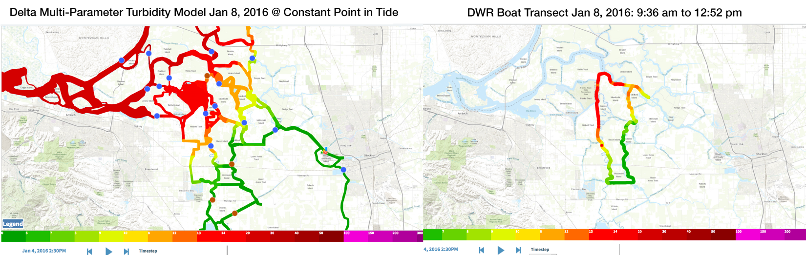

Figure 4: Delta Water Operations Turbidity Data Comparison to DWR Boat Transect. Jan 8, 2016.

**Model Scale:** Will provide managers with a broader/process-based understanding of the sources of the tidally-averaged turbidity distributions and their trajectories.

**Leveraging BDL**

**BDL Data Network:** BDL data network and infrastructure includes automated access to CDEC, NWIS, water operations data, fish salvage, USFWS and CDFW fish surveys, DWR transect data.

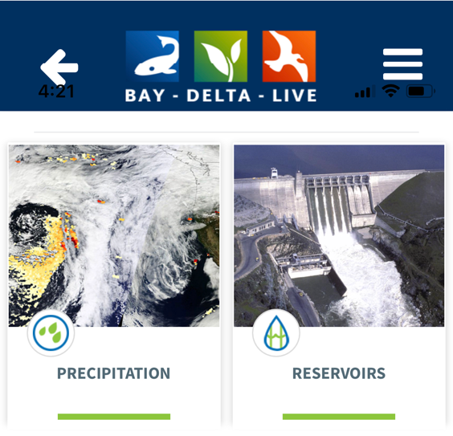**BDL Website and Mobile Applications:** Established platform for presentation and communication of model results. Combined with key real time operations data.

Figure 5: BayDeltaLive Mobile Smart Phone APP

**BDL Community Partnerships:** BDL current investment and participation come from all major agencies: DWR, USGS, USFWS, NMFS.

**Model Progress and Status**

1. Custom aggregate velocity and constituent at each station downstream/upstream.
2. Generate a time series of normalized velocity values for each station where each semidiurnal low and high are 0 and 1, respectively.
3. Generate a time series of Signal To Noise Ratio (SNR) for each station.
4. Generate a time series of the lowest SNR for each tidal cycle (snrLo).
5. Define an object LoToLoCycle that stores the start and end of each tidal cycle.
6. Implemented excursion algorithm: loop through data, find tidal cycle low at most downstream and upstream station, review SnrLo, loop. throughLotoLoCycle list at each station, identify ebbs, calculate and store excursion.
7. Link each ebb to the prev/next ebb and flood.
8. Calculate the combined total excursion for each pairing of flood and following ebb (prevPairSum).
9. Train, validate and visualize.

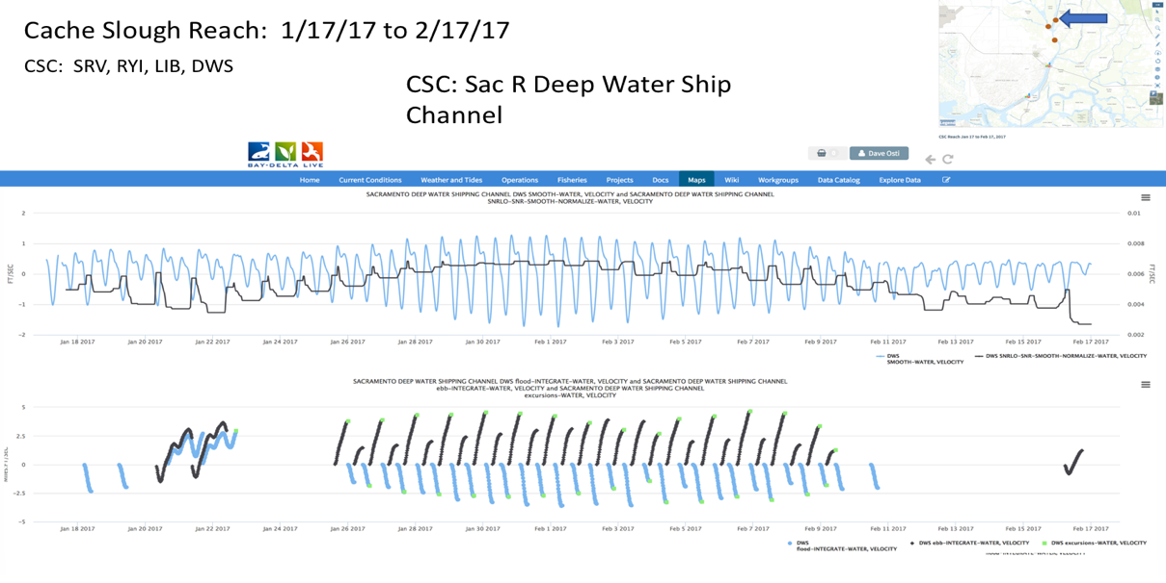

Figure 6: Signal to Noise Ratio and Excursions data generated from the Multi-Parameter Water Ops Model

**Next Phases**

1. In partnership with DWR and USGS, proceed with model training and validation with retrospective data. Daily monitoring.
2. Continued model training and for extreme conditions/edge cases (high flow, spring/neap tides, station failure). Develop tools to automate validation procedures.
3. Implementation of advection, signal to noise algorithms and plots for constituent excursion tracking points.
4. Model automation.
5. User Interface and User Experience: Tideline, model result interaction and reporting, visualization.
6. Adapt model to additional constituents.
7. Integrate additional operations data: fish trawls, operations, GIS.
8. Conditions prediction methods and research.
9. Reporting dashboards, syndication.
10. Review and feedback for further development by IEP.
11. Research paper.