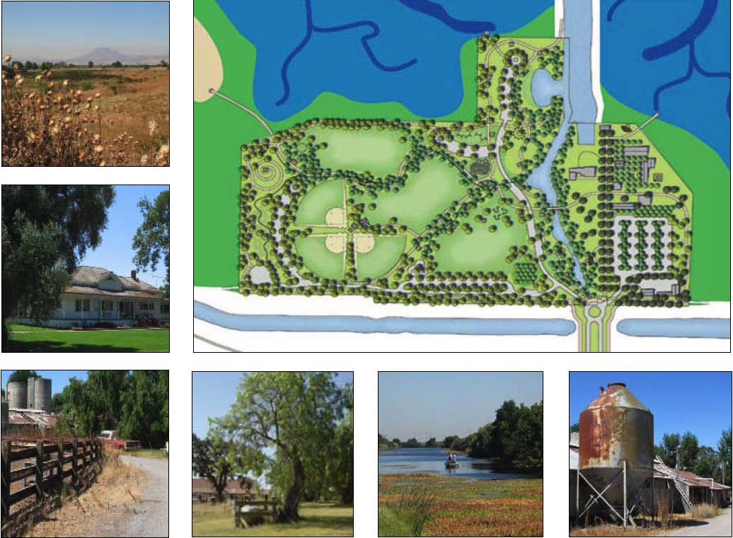

Submitted to
February 2006
City of Oakley


in association with
EndresWare
Harrison Associates
San Francisco Estuary Institute
Sycamore Associates
 |  | Submitted to
 | City of Oakley |  | February 2006

TABLE OF CONTENTS
1. SUMMARY...................................................................................................................
List of Figures
- 1. Context
2a. Dutch Slough Community Park Conceptual Master Plan
2b. Dutch Slough Community Park Conceptual Master Plan Key
2c. Dutch Slough Community Park Conceptual Master Plan Use Zones
- 3. Historic Zone
- 4. Sellers Avenue Entrance Plan
- 5. Sellers Avenue Entrance – Sections A and B
- 6. Sellers Avenue Entrance – Section C
- 7. Utilities
- 8. Grading Zones
- 9. Tidal March Buffer Area
- 10. Architectural Identity - Vista Pavilion Schematic
- 11. Architectural Identity - Vista Pavilion
- 12. Architectural Identity - Offices, Event Kitchen and Restrooms
- 13. Architectural Identity - Museum Education Center
- 14. Architectural Identity - Wildlife Observation Blinds
- 15. Architectural Identity - Outdoor Restrooms
- 16. Architectural Identity - Concession Stand

i DRAFT – FEBRUARY 2006
CITY OF OAKLEY DUTCH SLOUGH COMMUNITY PARK AND PUBLIC ACCESS
CONCEPTUAL MASTER PLAN SUMMARY
- 17. Tidal Marsh Restoration Area Public Access Features
- 18. Shared-use Trail: Community Park - Section
- 19. Shared-use Trail: Tidal Marsh Restoration Area - Section
- 20. Shared-use Trail: Jersey Island Road - Section
- 21. Dutch Slough Access Park Concept
- 22. Dutch Slough Access Park – Section A

DRAFT – FEBRUARY 2006
CITY OF OAKLEY DUTCH SLOUGH COMMUNITY PARK AND PUBLIC ACCESS
I. CONCEPTUALMASTERPLANSUMMARY
This Summary was prepared for review by the Oakley City Council and Planning Commission. It presents an overview of the major components to be contained in the Dutch Slough Community Park and Public Access Conceptual Master Plan. Information contained within this Summary is subject to change based on the comments and direction provided by the Oakley City Council.
Dutch Slough Community Park, located on the northeastern edge of the City of Oakley, will be the main access point to the City’s greatest open space amenity, the Sacramento-San Joaquin River Delta (figure 1). The Conceptual Master Plan provides for that access via three components. These are:
♦ Dutch Slough Community Park, a 55-acre site that will be the City’s largest park and the gateway to the Dutch Slough Tidal Marsh Restoration Project lands. ♦ Dutch Slough Tidal Marsh Restoration Project, where trail-related recreation and interpretive opportunities will be provided within limited portions of the 1,166 acres of restored wetlands. ♦ Jersey Island Road/Dutch Slough Access Park, an 8-acre site east of Jersey Island Road at Dutch Slough that will provide public access to the Delta.
DRAFT – FEBRUARY 2006
CITY OF OAKLEY DUTCH SLOUGH COMMUNITY PARK AND PUBLIC ACCESS
A. Dutch Slough Community Park
Dutch Slough Community Park will be the City of Oakley’s largest park as well as the main access point to the Dutch Slough Tidal Marsh Restoration Project (figures 2a and 2b). The park, located on a former dairy farm and adjacent to Dutch Slough Marsh, affords many opportunities to celebrate the cultural and ecological history of the site. Existing buildings, including a former one-room schoolhouse, will be reused for park functions, while remnants and materials from the remaining outbuildings will be incorporated into the design. The park will balance active uses, including ball fields, picnic areas, restroom buildings and playgrounds, with more passive recreation and interpretive trails along the slough. Sustainable design principles will be incorporated throughout, creating a community destination that educates and inspires the public and is compatible with the adjacent sensitive habitat.
1. Community Park Vision
The Dutch Slough Community Park (the Community Park) will be many things to many people. At its core, the vision embodied in the Dutch Slough Community Park Conceptual Master Plan will marry seemingly disparate outdoor recreation and educational experiences in one setting.
Dutch Slough Community Park is to be a place:
♦ That celebrates the natural resources of the Sacramento-San Joaquin River Delta, Dutch Slough, its floodplain and margins, gleaming wetlands and open waters, patterns of sun and shadow cast from riparian trees, the scent of willows wafting through the air, and tactile qualities of wind. It is a place to respectfully hear and watch wildlife forage, dabble, duck, burrow, hide, and proliferate and to watch native plants grow and blossom.
DRAFT – FEBRUARY 2006
CITY OF OAKLEY DUTCH SLOUGH COMMUNITY PARK AND PUBLIC ACCESS
♦ To enjoy with friends and family engaging in outdoor fun and games, to gain cultural enrichment, to hold events, and to add to the quality of life for all Oakley residents. Because of these qualities it is also a place to exercise and recreate the mind and body.
♦ That reminds the visitor of the natural and cultural history of the Delta, of how native Americans used the marsh and dune environments of the historic landscape (that will now be recreated), of how the Dutch Slough’s waters and peat soils were manipulated and managed to provide lands for raising crops, dairy and cattle ranching, a place to live, and now a Community Park. Because of these qualities it is also a place to learn about history and science from the environment and the artifacts left behind from past uses.
2. Park Organization, Use Areas and Facilities
The Community Park will be organized into a series of active and passive use areas, including a riparian play zone, a historic zone, and a maintenance area (figure 2c). Active recreation areas are all located on the western side of Emerson Slough. To recognize the habitat values associated with the tidal marsh restoration area, Community Park use areas are arranged in a fashion that creates a transition between active uses near the southern portion of the site and a vegetated buffer and passive uses around the outer edges of the Park that border the restoration area. With the exception of ball fields, the Community Park will be for day use only. Use areas and facilities include:
♦ Large Open Field Areas: a series of three open meadow areas, at approximately three acres each in size, located in the western portion of the Community Park, that could be used for any number of individual or group functions and sports/festival events. For example, these areas are all sized to accommodate formal soccer play and other field sports. An Amphitheater and nearby Concession Stand would support the central field as the focal place for events of up to 3,000 to 5,000 people at one time. It should be noted that while field areas and other places within the
DRAFT – FEBRUARY 2006
CITY OF OAKLEY DUTCH SLOUGH COMMUNITY PARK AND PUBLIC ACCESS
Community Park could be used for overflow parking, it is likely that additional parking for such events may be required off-site.
♦ Small Open Areas: A variety of smaller-sized open areas are located around the Community Park trail system and within the historic zone. They could be used for picnicking, informal play, passive relaxation, and when combined with supporting picnic shelters, small group uses.
♦ Family and Small Group Picnic Areas: Numerous family and small group picnic shelters (25 to 50 people) are located around the western portion of the Community Park trail system.
♦ Riparian Corridor Themed Play Areas: Constructed drainage channels will be created as creeks (see infrastructure below) are fed in the summer months by water pumped from on-site windmills. While planting along the creeks will enhance the riparian habitat character of the Park, these corridors will also be a connector spine for a series of seven children’s play areas. These play areas include: y Orchard Play Area y Sand Dune Play Area y Meadows Play Area y Little Slough Play Area y Willow Tunnel Play Area y Delta Islands Grass Maze Play Area y Wind Play Area
♦ Softball Fields: Three adult softball fields around a central complex with restrooms, supporting storage facilities, and the Concession Stand will be developed. The ballfields will be fully fenced and lighted for nighttime use.
DRAFT – FEBRUARY 2006
CITY OF OAKLEY DUTCH SLOUGH COMMUNITY PARK AND PUBLIC ACCESS
♦ Emerson Slough Water Access: A graded sandy area for sunning and informal water access will be developed just off of the Emerson Slough.
♦ Skating Area: A 5,000-square-foot skate area will be included in the active recreation zone.
♦ Amphitheater: Located at the southwest corner of the central field area, this multi-use area will accommodate larger events such as the Almond Festival, organized recreational activities and more passive use when not programmed.
♦ Concession Stand: The concession stand is centrally sited to specifically service both the ball fields and amphitheater area, but also is centrally located to most park use.
♦ Vista Pavilion: A facility just east of the Gilbert House and sited to be used in conjunction with the Gilbert House grounds at the base of Emerson Slough, this multiple-use facility would accommodate weddings/large group uses of up to 300 people indoors at one time (see 6. Park Design Character and Architectural Identity).
♦ Windswept Ranch Historic Area/Museum Center: Eight existing and new buildings will make up the museum complex. The Gilbert House, Caretaker’s Cottage, and one barn structure will be retained. The Ironhouse School will be relocated to a site of an existing building just east of the Gilbert House. The footprint of other existing buildings will be repeated with new structures that will reflect the scale and synergy of the existing ranch complex. New structures will include: y Education Center and Museum – at the entrance to the historic zone near the parking area y Administration Building – will include offices and meeting space for docents, a commercial kitchen to support
events at the Vista Pavilion, and storage areas.
y The Vista Pavilion (see above)
y Canoe/kayak storage building (see 3. Access)
DRAFT – FEBRUARY 2006
CITY OF OAKLEY DUTCH SLOUGH COMMUNITY PARK AND PUBLIC ACCESS
The lawns around the historic area will include individual picnic tables and areas for passive use. A community garden, that could initially be used as a nursery for park re-vegetation programs, will be sited at the eastern side of the historic zone adjacent to the Administration Building (figure 3).
♦ Interpretive Facilities: In addition to the Windswept Ranch Historic Area/Museum Center buildings and themed play areas, the following interpretive features will be provided within the Community Park: y Point-access Boardwalks and overlooks: two boardwalks with overlook facilities extending into the tidal marsh
restoration project. y Outdoor classrooms: two areas located within the historic zone, one back-dropped by the Emerson Slough ripar
ian landscape and the other by the tidal marshes of the Gilbert property. y Interpretive signs: located along the perimeter trail of the Park. y Windmills: windmills will be used as both an identify feature for the Community Park and to assist in providing
water within the Park’s constructed streams and other water features. A “headwater windmill” will identify the southern arm of the internal creek system
Interpretive themes are included in the description for the Tidal Marsh Restoration Project area below.
♦ Restrooms: Public restrooms will be located throughout the Park. These include individual restroom structures as well as facilities associated with the Concession Stand, Education Center, Vista Pavilion, and Maintenance/Shop building.
♦ Fencing: Perimeter fencing of the park, Emerson Slough, historic zone, and maintenance area will be developed as needed for security or for habitat protection purposes.
DRAFT – FEBRUARY 2006
CITY OF OAKLEY DUTCH SLOUGH COMMUNITY PARK AND PUBLIC ACCESS
♦ Maintenance: An approximately 1-acre area at the southeast corner of the Park will be used for maintenance and park storage needs. It will include an operations building, maintenance shop, and storage building.
♦ Dogs: Dogs on leash would be permitted within the Park at all times. Early morning hours will be scheduled for off-lease dog use west of the Emerson Slough.
3. Access
Access to and throughout Dutch Slough Community Park will accommodate a wide variety of transportation modes including autos, buses, bicycles, pedestrians, and small boats, such as canoes and kayaks. The primary access to the Park will be from Sellars Avenue and will serve as the Gateway to the Dutch Slough Restoration Area.
♦ Sellers Avenue Entry Gateway (figures 4 through 6): Access to the Community Park will be via Sellers Avenue. The character of the street landscape will change as it approaches the Community Park. The transition will include a road that, if necessary, could be used for two lanes of traffic. However, at most times, the vehicular traffic will be limited to one lane with an expanded bicycle lane to both calm traffic and to encourage non-vehicular use of the Park. It will culminate in a round-about with a central water feature.
♦ Parking: A total of 432 parking spaces will be provided within the Park. There will be an equestrian staging area located at the southwest corner of the Park adjacent to the Emerson Slough Trail. Bicycle parking will be provided at all parking and use areas.
♦ Bus Loading Area: A bus loading area is located near the pedestrian entrance to the historic zone.
DRAFT – FEBRUARY 2006
CITY OF OAKLEY DUTCH SLOUGH COMMUNITY PARK AND PUBLIC ACCESS
♦ Interior Park Trails: Approximately 2.5 miles of shared-use trails will provide pedestrian and bicycle access throughout the Park. These trails will connect to trails along Sellers Avenue, the City and local community trail network, the Wetland Restoration Project trails, and the Marsh Creek Trail, a component of the regional trail system.
♦ Canoe/Kayak Access: Two canoe/kayak access points to Emerson Slough will be provided. A general-use access point is located on the west side of the Slough near two parking areas. The other is located within the historic zone and will be for group use. Associated with that access point will be a small canoe/kayak storage building for use by local school groups and organizations.
♦ Americans with Disabilities Act (ADA): All facilities within the Community Park will be ADA-compliant.
4. Infrastructure
Development of the community park will require a network of utilities to service the various structures, buildings and uses. Sustainable approaches to bringing power to the site will be incorporated, where possible, including wind and solar. In addition, stormwater management onsite will need to address flooding and protecting water quality of the slough.
♦ Utilities (figure 7): All utilities service lines will be underground within the Community Park. Water, sewer, electrical, and communication services will be extended from Sellers Avenue into the Park. Wells will be developed and well water for irrigation use where possible.
♦ Windmills: A series of functioning windmills will be used to pump groundwater to support the internal creek channels and Park Gateway feature.
♦ Solar: To the extent practical, all new buildings outside of the historic area complex will incorporate solar energy systems into their design.
DRAFT – FEBRUARY 2006
CITY OF OAKLEY DUTCH SLOUGH COMMUNITY PARK AND PUBLIC ACCESS
♦ Grading and Drainage (figure 8): The majority of the Community Park is subject to flooding. All new buildings and the relocated Ironhouse School will be sited and designed such that their finished floor elevations will be above the 100-year flood level. Water quality swales will be installed at all major parking areas. Drainage from the western portions of the Community Park will be directed to constructed creek channels designed to also serve as water quality features.
5. Park Landscape
The landscape of the Community Park will reflect the natural and historic setting, as well as respond to the local climatic conditions. This approach will not only reinforce the unique character of the site, but also result in reduced maintenance and water needs.
♦ Plants: With the exception of turf areas, existing ornamental trees around the Gilbert House of historic value, community gardens, and two contained orchard theme planting areas, native plants will be used exclusively throughout the Park.
♦ Riparian Enhancement: Emerson Slough will be expanded to the west and enhanced with native riparian plants. In addition, constructed creek drainages will be designed to extend the riparian zone throughout the western portions of the Community Park.
♦ Perimeter Buffer and Wind Protection (figure 9): A vegetated zone will extend around the entire perimeter of the Park. This will serve to buffer both adjacent wildlife habitat areas within the marsh restoration project area as well as residences to the south from park activities. The perimeter plantings, along with the creek riparian zones and other tree plantings, will provide wind protection for most use areas.
DRAFT – FEBRUARY 2006
CITY OF OAKLEY DUTCH SLOUGH COMMUNITY PARK AND PUBLIC ACCESS
6. Park Design Character and Architectural Identity
Given the site’s agricultural history and natural features, and taking into account the proposed park program, the Community Park’s design character intends to harmonize the confluence of the urban and rural context (figures 10 through 16).
Several buildings will be contained in the Community Park. They include:
Historic Structures y Gilbert House (existing) y Ironhouse School (relocated and reconstructed) y Barn (reconstructed for use as the Windswept Ranch Museum Storage) y Caretaker’s Cottage (existing)
New Structures y Windswept Ranch Offices, Event Kitchen, and Restrooms y Outdoor Classrooms y Concession Stand y Outdoor Restrooms y Learning Stations y Learning Platforms y Individual (2 tables) and Group Picnic Shelters (10 to 20 tables) y Amphitheater y Vista Pavilion Group Event Picnic Shelter (max. 299 people) y Canoe/Kayak Storage Building
DRAFT – FEBRUARY 2006
CITY OF OAKLEY DUTCH SLOUGH COMMUNITY PARK AND PUBLIC ACCESS
y Dutch Slough Community Park Maintenance and Equipment Storage Yard
-Operations Building
- Maintenance Shop Building
- Equipment Storage
y Point Access Boardwalks
y Wildlife Overlooks/Decks/Observation Blinds with Railings
y Trail Bridges
y Windmills
The architectural designs will maintain the farm-like character of the site while energizing it with contemporary details. Building forms will use the basic geometry of vernacular agricultural structures and will be divided into parts such as breezeways, arcades, porches, overhangs or other articulations that complement a sense of human scale. Transparency and layering of materials will be used to create filtered light effects within structures similar to the existing barn structures.
Building materials will be as environmentally sustainable as practical. Characteristics will include:
y Wood siding - natural or painted to complement natural wood.
y Metal siding - galvanized, zinc or coated with galvalume/zincalume factory finish coatings.
y Roofing - corrugated, standing seam or flat panel standing seam with light valued non-reflective colors.
y Colors - that reflect natural colorings intrinsic to the actual material being used and blending with natural land
scape surroundings. Accent colors will be used in small areas only.
DRAFT – FEBRUARY 2006
CITY OF OAKLEY DUTCH SLOUGH COMMUNITY PARK AND PUBLIC ACCESS
y Finishes - selected for long-term durability and ease of maintenance given the local climatic factors, especially the impact of summer sun and the effects of salt air and strong winds from the bay. y Recessed windows - with awnings and shaded areas of glass to reduce solar heat gain and glare.
B. Tidal Marsh Restoration Area
The Dutch Slough Tidal Marsh Restoration Project is being planned by the California Department of Water Resources (DWR), the State Coastal Conservancy (SCC), the City of Oakley, and the California Bay-Delta Authority (CBDA). DWR is the landowner, having purchased the site in 2003 with funds from the SCC and CBDA (figure 17).
The three goals of the tidal marsh restoration are to: ♦ Provide shoreline access, educational and recreational opportunities. ♦ Benefit native species by re-establishing natural ecological processes and habitats. ♦ Contribute to scientific understanding of ecological restoration by implementing the project under an adaptive man
agement framework.
1. Access
The Community Park will be the primary starting point for the public’s experience of the restored wetlands. Public access trails (figures 18 through 20) that link the Community Park to the tidal marsh restoration area are:
♦ Emerson Loop Trail: an approximately 2.9-mile-long trail loop leading west from the Community Park parallel to the Contra Costa Canal, then north along the existing Marsh Creek Trail, extending to the east along Dutch Slough, and back to the Community Park along Emerson Slough.
DRAFT – FEBRUARY 2006
CITY OF OAKLEY DUTCH SLOUGH COMMUNITY PARK AND PUBLIC ACCESS
♦ Gilbert – Burroughs Trail: an approximately 3-mile-long trail leading east from the Community Park parallel to the Contra Costa Canal then following the Jersey Island Road levee to the Dutch Slough Access Park. A point access spur trail will travel west along the Dutch Slough levee.
2. Facilities
A series of interpretive points, observation blinds, and fishing access platforms will be located along the trail system. A tightly-spaced series of education stations are to be located along Emerson Slough to facilitate school use emanating from the Community Park.
3. Interpretive Themes
Both the Community Park and restored tidal marshes are an interpretive stage about local history, environmental change, and landscape patterns/processes of the Delta. Themes that will guide interpretive programs include:
♦ Climate - Sitting in the ‘rain shadow’ of Mount Diablo and experiencing slightly less rain than outlying areas.
♦ Topography - A unique set of eolian soils including the Oakley Series; outcasts of the San Joaquin and other Sierran Rivers “drifted landward by winds."
♦ Tides - Early explorers spending a good deal of time struggling over a “River or Sea” debate, and measuring of the tides. Tidal influence and sea level rise as primary scientific tools in marsh restoration.
♦ Dutch Slough - A tidal marsh slough which wound its way closest to the Southwestern upland edge of the vast delta offering an important river access way. Indigenous people paddled the meanders of the slough in vessels crafted from its tule edge. Later, people carved cuts to the slough to make way for larger ships bearing the wheat of the land. More recently, thruways were carved to make celery islands.
DRAFT – FEBRUARY 2006
CITY OF OAKLEY DUTCH SLOUGH COMMUNITY PARK AND PUBLIC ACCESS
♦ Tidal Marsh - The uniqueness of a marsh so influenced by massive riparian input and tidal pulse debated in early land grants of the area as to its channel/pond network and its melding with the plains.
♦ Marsh Creek - Down the North-Northeastern flank of “Bolbones peak” or Mt. Diablo, the creek and its tributaries often bifurcated into multiple channels and finally dissipated into Oakley sands. Here the creek built out its fan pushing up against the marsh edge and Dutch Slough, until settlers required their lands to be well drained for crop production.
♦ The Oak Grove/Chamisal - Remnant Oaks of an ancient Oakley grove that early explorers passed by on expedition to the “Tulares”.
♦ Levees - The story of early diking from 1852 to the new super dikes built today to protect development.
♦ Irrigation - Farmers moving from wheat to fruit demanded water and thus developed wells and windmills, followed by waterways and massive troughs across the land such as the Contra Costa Canal.
♦ Beasts - The early explorers noted ‘buros’, the great elk that migrated across the plains and delta. The Spanish and early settlers grazed their cattle on the marsh, particularly in the summer when the cattle needed access to water. Weary horses came by boat to “Brentwood Sanitarium” (now the Community Park) to heal their cobblestoned feet. Dairy Cows and later “Stockers” (calves fattening for market) occupied the site.
♦ “Sandlappers” - The name of ridicule given to early settlers who dared to occupy these sandlands which were once harvests of acorns, tule, and fish, and transformed them to wheat, hay, vineyards, fruits (esp. almonds, and mulberry silk farms) to gardens and to restoration sites and parklands.
♦ Schools - They learned from the land and their ancestors' intimacy with it. Settlers built school houses which served small towns and became private residences when schools had to serve larger populations.
DRAFT – FEBRUARY 2006
CITY OF OAKLEY DUTCH SLOUGH COMMUNITY PARK AND PUBLIC ACCESS
4. Boating
Traditionally, motorized boating that has occurred along the existing sloughs will be permitted. However, tidal marsh restoration area sloughs and open water areas will be managed for non-powered boating access only, except for emergency access and project monitoring under the adaptive management program. Canoe/kayak access points are provided from within the Community Park.
5. Dogs
Dogs on leash will be permitted on all trails. Pooper-scooper stations will be located at all trail entrances from within the Community Park.
C. Jersey Island Road / Dutch Slough Access Park
This triangular parcel will be developed as a day-use area and boat launching site (figures 21 and 22). This will involve expanding the existing significant backfilling of the current levee to create a useable space that is accessible for both boat launching and ADA purposes. Facilities within the Access Park will include:
♦ Entry gate and kiosk
♦ Parking (automobile and auto/trailer)
♦ Boat Launch (three to four lanes)
♦ Family picnic areas with shade structures atop the expanded levee
♦ Fishing access from the picnic area
♦ Restrooms
DRAFT – FEBRUARY 2006
CITY OF OAKLEY DUTCH SLOUGH COMMUNITY PARK AND PUBLIC ACCESS
♦ Bait shop (concessionaire)
♦ Trail connections to Tidal Marsh Restoration Project and Community Park and other levees
Approximately 3.1 acres of the existing site are comprised of jurisdictional wetland habitats that will likely be filled or significantly altered to develop the Access Park. This alteration will require Federal and State permitting and mitigation of impacted habitat resources prior to development of the Access Park. In addition, a variety of permit conditions from RD 799 will be required for reconstruction of the Dutch Slough levee.
D. Maintenance and Operations
The Community Park, Access Park, and Tidal Marsh Restoration Area will have a number of general maintenance zones each requiring a different level of landscape and building maintenance service. These zones are:
♦ Community Park: Historic Zone (approximately 9 acres) that will include the historic buildings, landscaping, gardens, outdoor classrooms, group event picnic shelter, and parking.
♦ Community Park: Recreation Areas (approximately 35 acres) that will include the gateway, active athletic fields, group and family picnic areas, children’s play areas, water access area, picnic areas, parking, and maintenance area.
♦ Community Park: Emerson Slough (approximately 2.5 acres) consisting of open, tidal waters.
♦ Community Park: Native Riparian Landscape Buffers (approximately 8.5 acres) that will include trails, trees, boardwalks, view areas.
DRAFT – FEBRUARY 2006
CITY OF OAKLEY DUTCH SLOUGH COMMUNITY PARK AND PUBLIC ACCESS
♦ Dutch Slough Access Park (approximately 8 acres) that will include parking, a fishing pier, boat launch facilities and trail connections.
♦ Tidal Marsh Restoration Trails (approximately 8.5 miles) that will include trails and interpretive facilities.
In addition to maintenance services, each of these areas will require operational support for safety and patrol, programming, and facility use and reservations.
Currently the City of Oakley does not have any adopted maintenance policies and standards. All park maintenance in Oakley is now funded through a Street Lighting and Landscape Assessment District. This assessment is sufficient for normal neighborhood parks. However, the Community Park, Access Park, and Tidal Marsh Restoration Area trail system, because of the unique nature of the facilities, will likely require supplemental funding sources.
E. Phasing
Full development of the Community Park is likely to take 10 to 15 years. Initial phases of work will include: ♦ Demolition of existing structures (except for historic structures to be retained) and site preparation of the entire
property to render it safe for public access
♦ Development of the Community Park water, sewer, and electric service lines
♦ Major site grading
♦ Re-vegetation
♦ Limited parking and related public amenities
DRAFT – FEBRUARY 2006
CITY OF OAKLEY DUTCH SLOUGH COMMUNITY PARK AND PUBLIC ACCESS
Extending public access along Marsh Creek from the existing trail to Dutch Slough is a priority. Other trails and interpretive features will be constructed in association with the Dutch Slough Tidal Marsh Restoration project.
DRAFT – FEBRUARY 2006
FIGURE 1
DRAFT- FEBRUARY 2006 CONTEXT
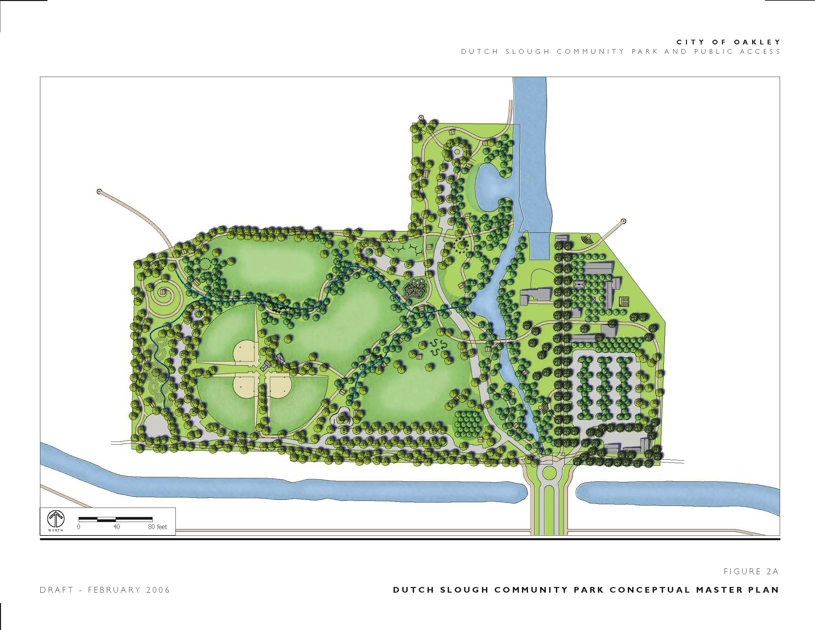
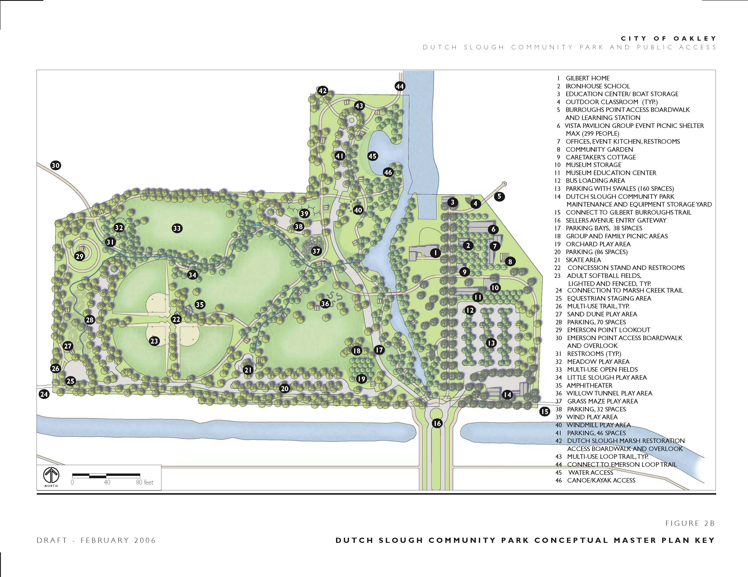
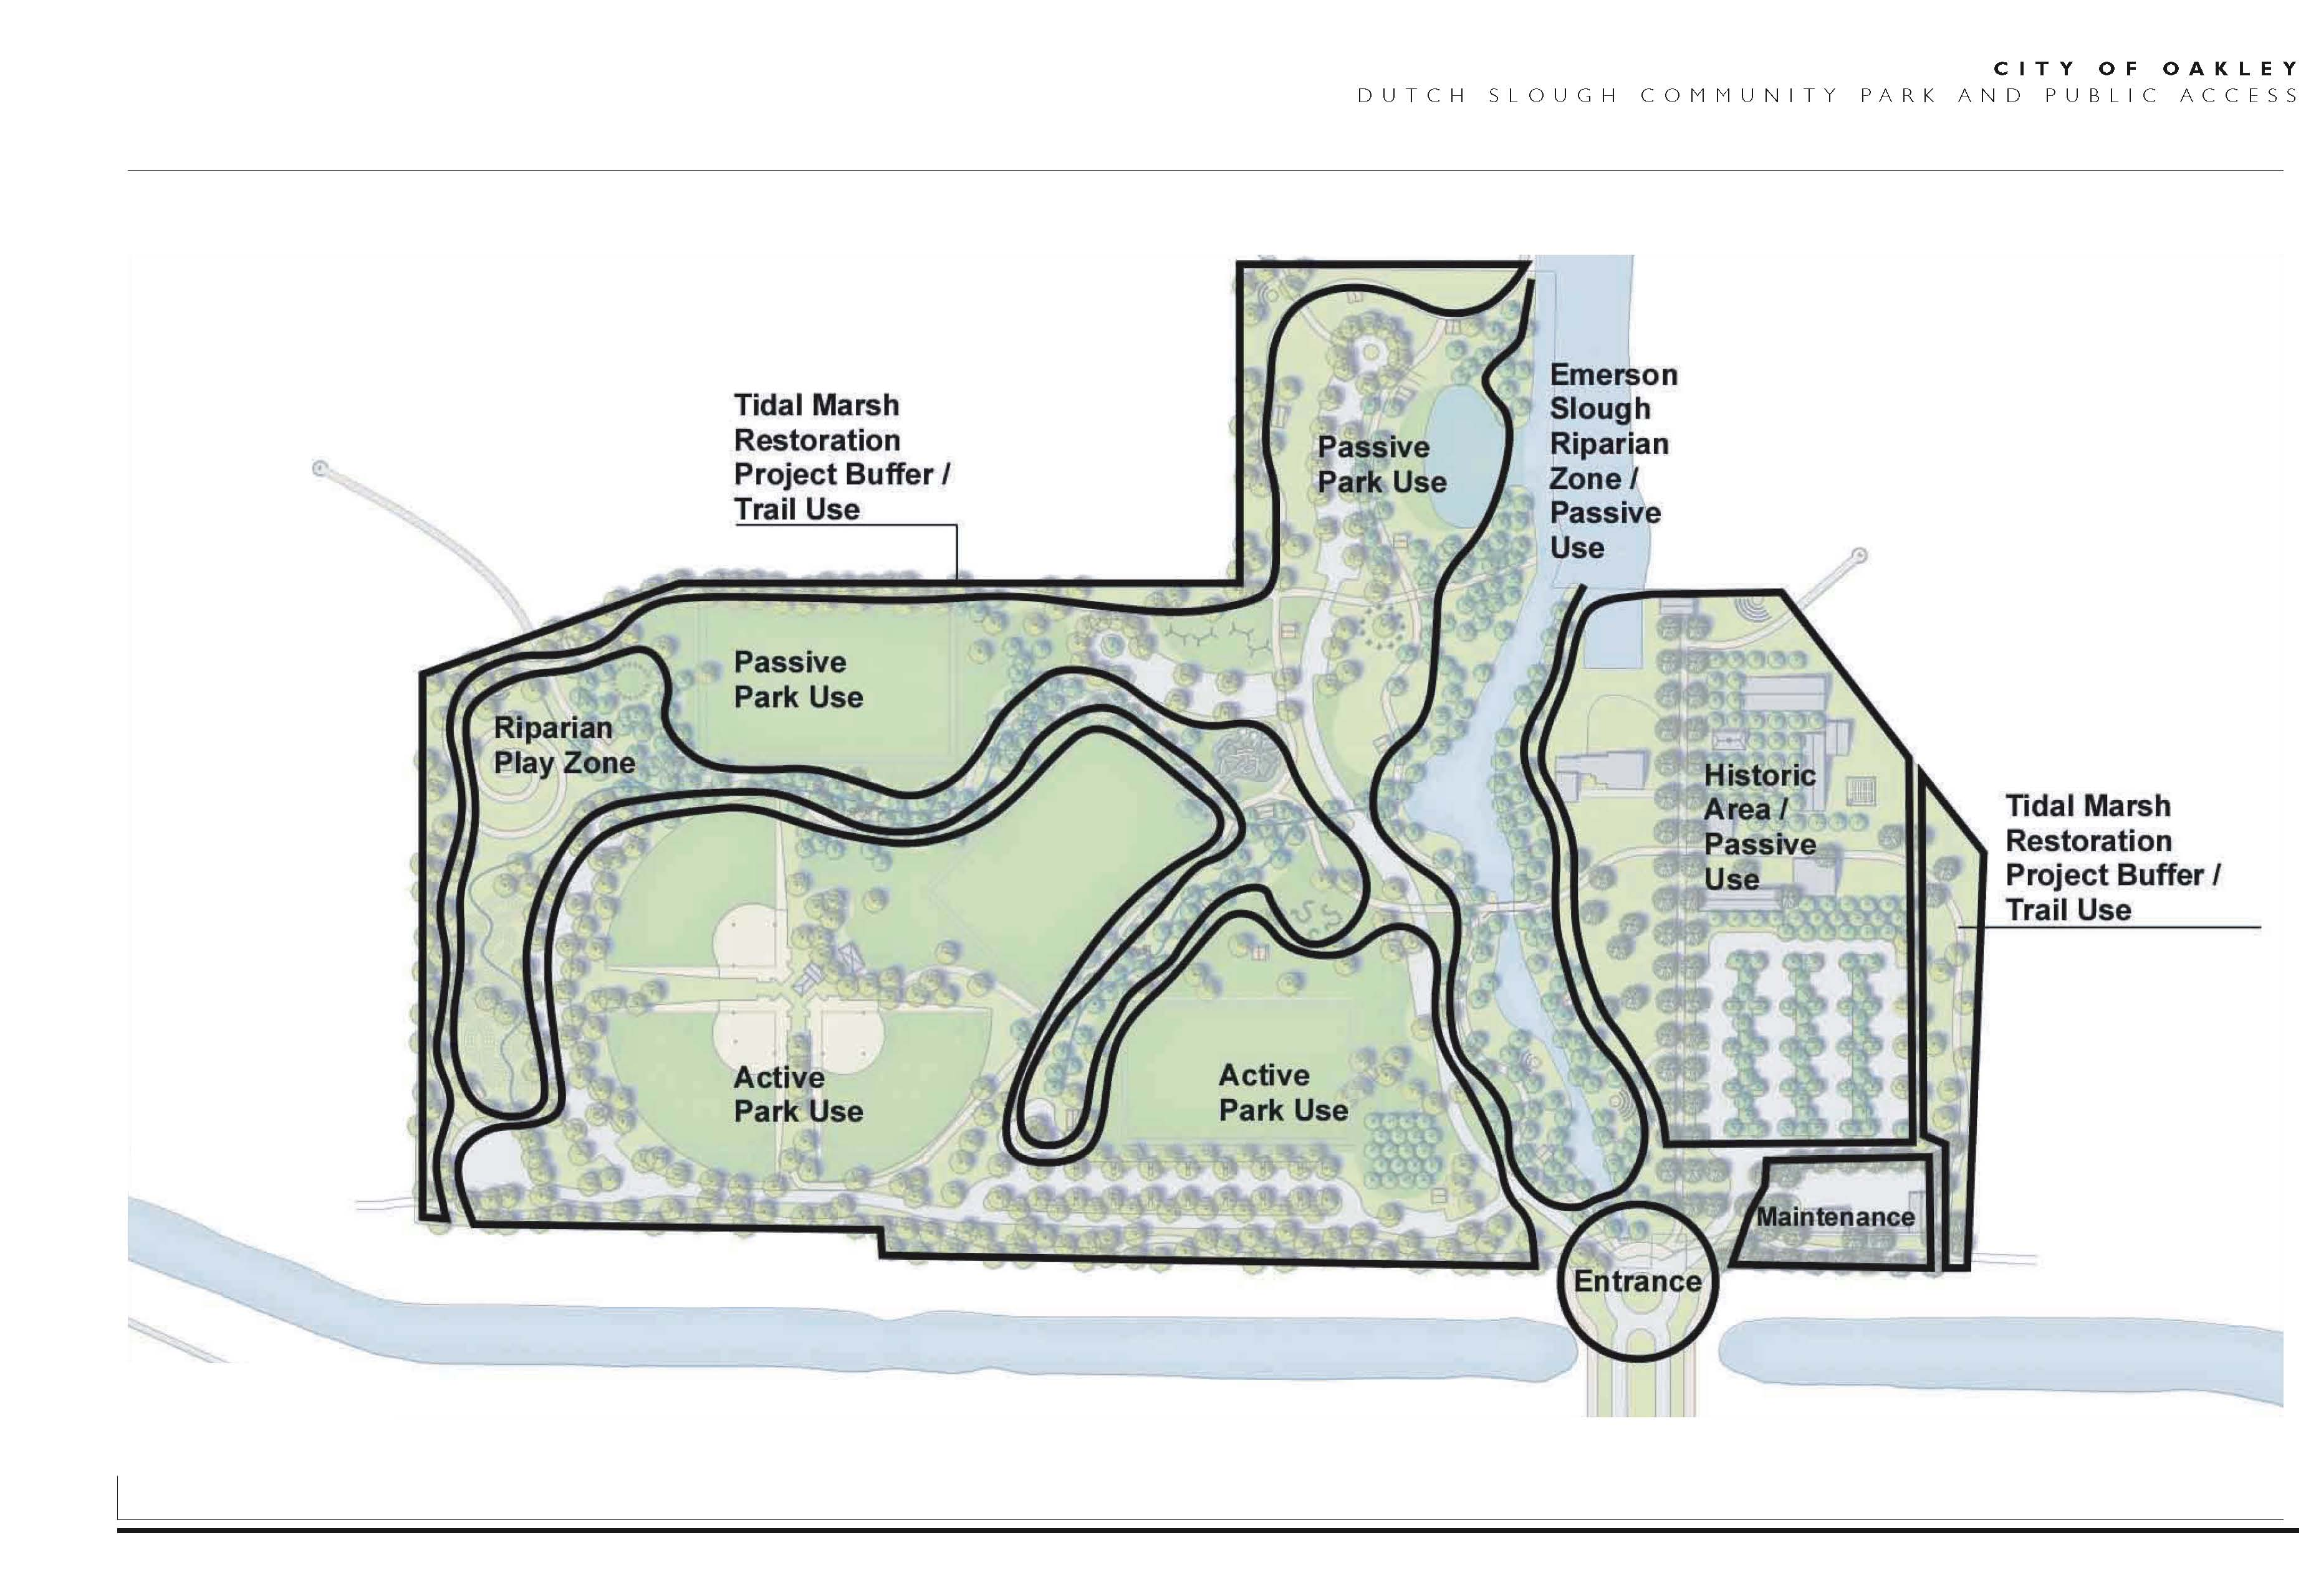
FIGURE 2C DRAFT- FEBRUARY 2006 DUTCH SLOUGH COMMUNITY PARK CONCEPTUAL MASTER PLAN USE ZONES
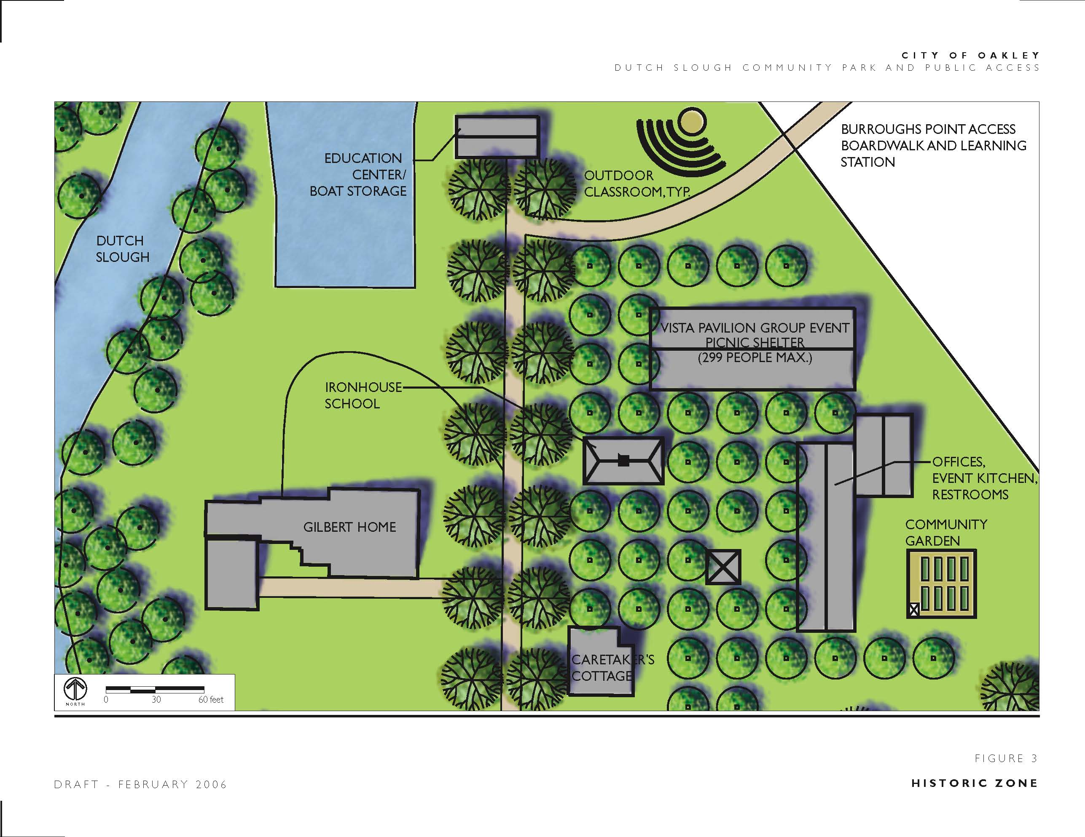
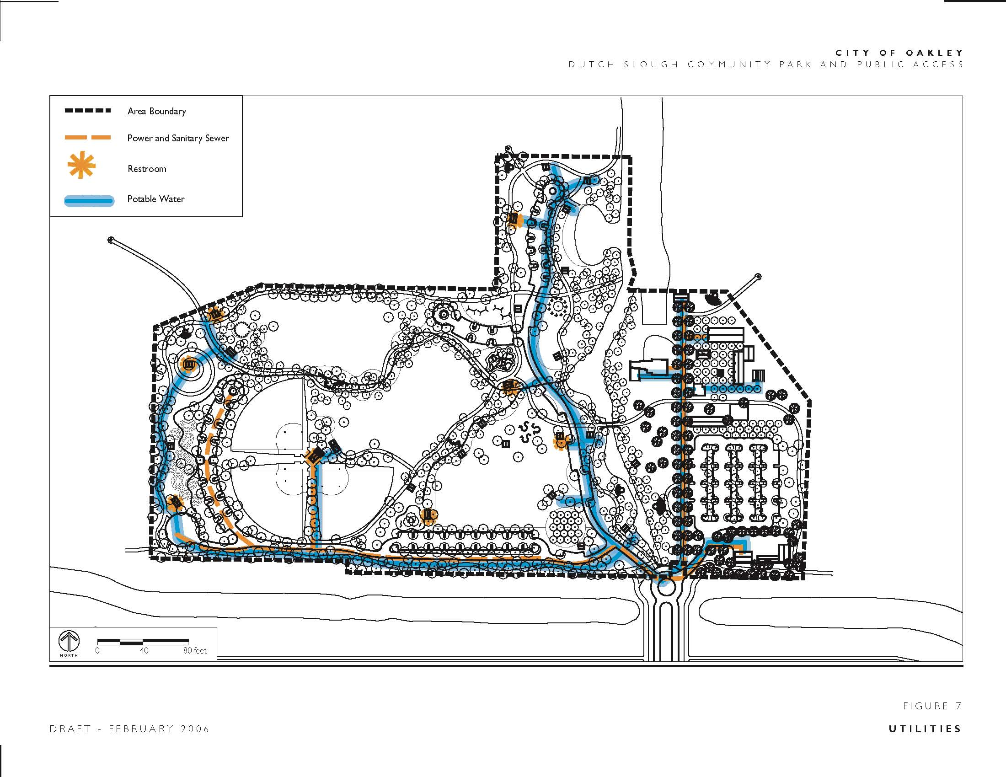
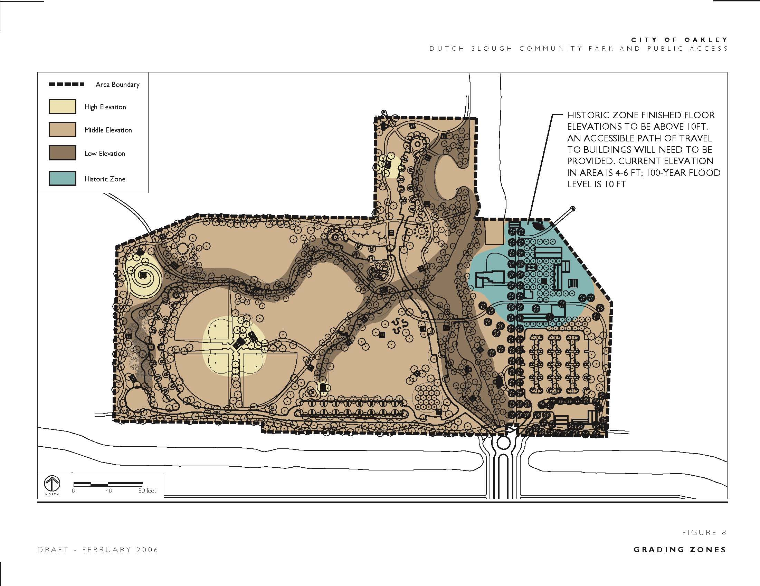
FIGURE 10
DRAFT - FEBRUARY 2006 ARCHITECTURAL IDENTITY- VISTA PAVILION SCHEMATIC
FIGURE 11
DRAFT - FEBRUARY 2006 ARCHITECTURAL IDENTITY- VISTA PAVILION
FIGURE 12
DRAFT - FEBRUARY 2006 ARCHITECTURAL IDENTITY- OFFICES, EVENT KITCHEN AND RESTROOMS
FIGURE 13
DRAFT - FEBRUARY 2006 ARCHITECTURAL IDENTITY- MUSEUM EDUCATION CENTER
FIGURE 14
DRAFT - FEBRUARY 2006 ARCHITECTURAL IDENTITY- WILDLIFE OBSERVATION BLINDS
FIGURE 15
DRAFT - FEBRUARY 2006 ARCHITECTURAL IDENTITY- OUTDOOR RESTROOM
FIGURE 16
DRAFT - FEBRUARY 2006 ARCHITECTURAL IDENTITY - CONCESSION STAND

