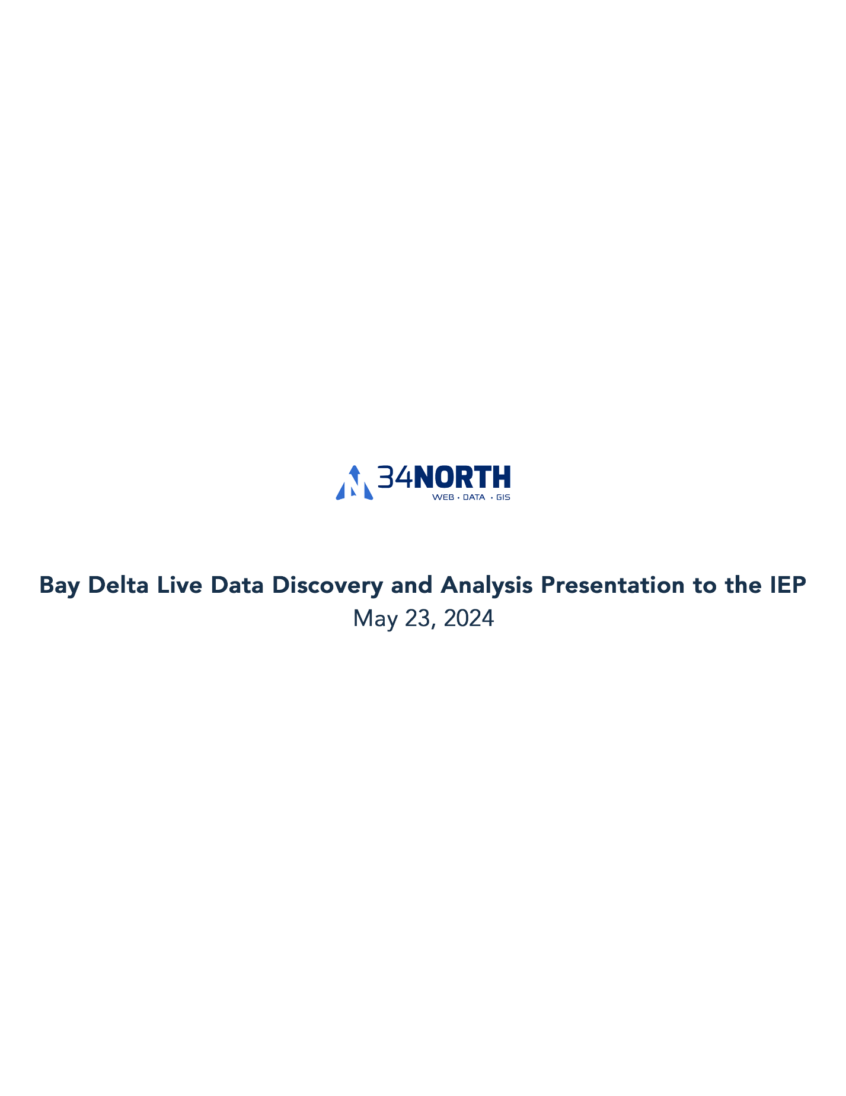

**Change this title to = EDSM Design and Component Review**

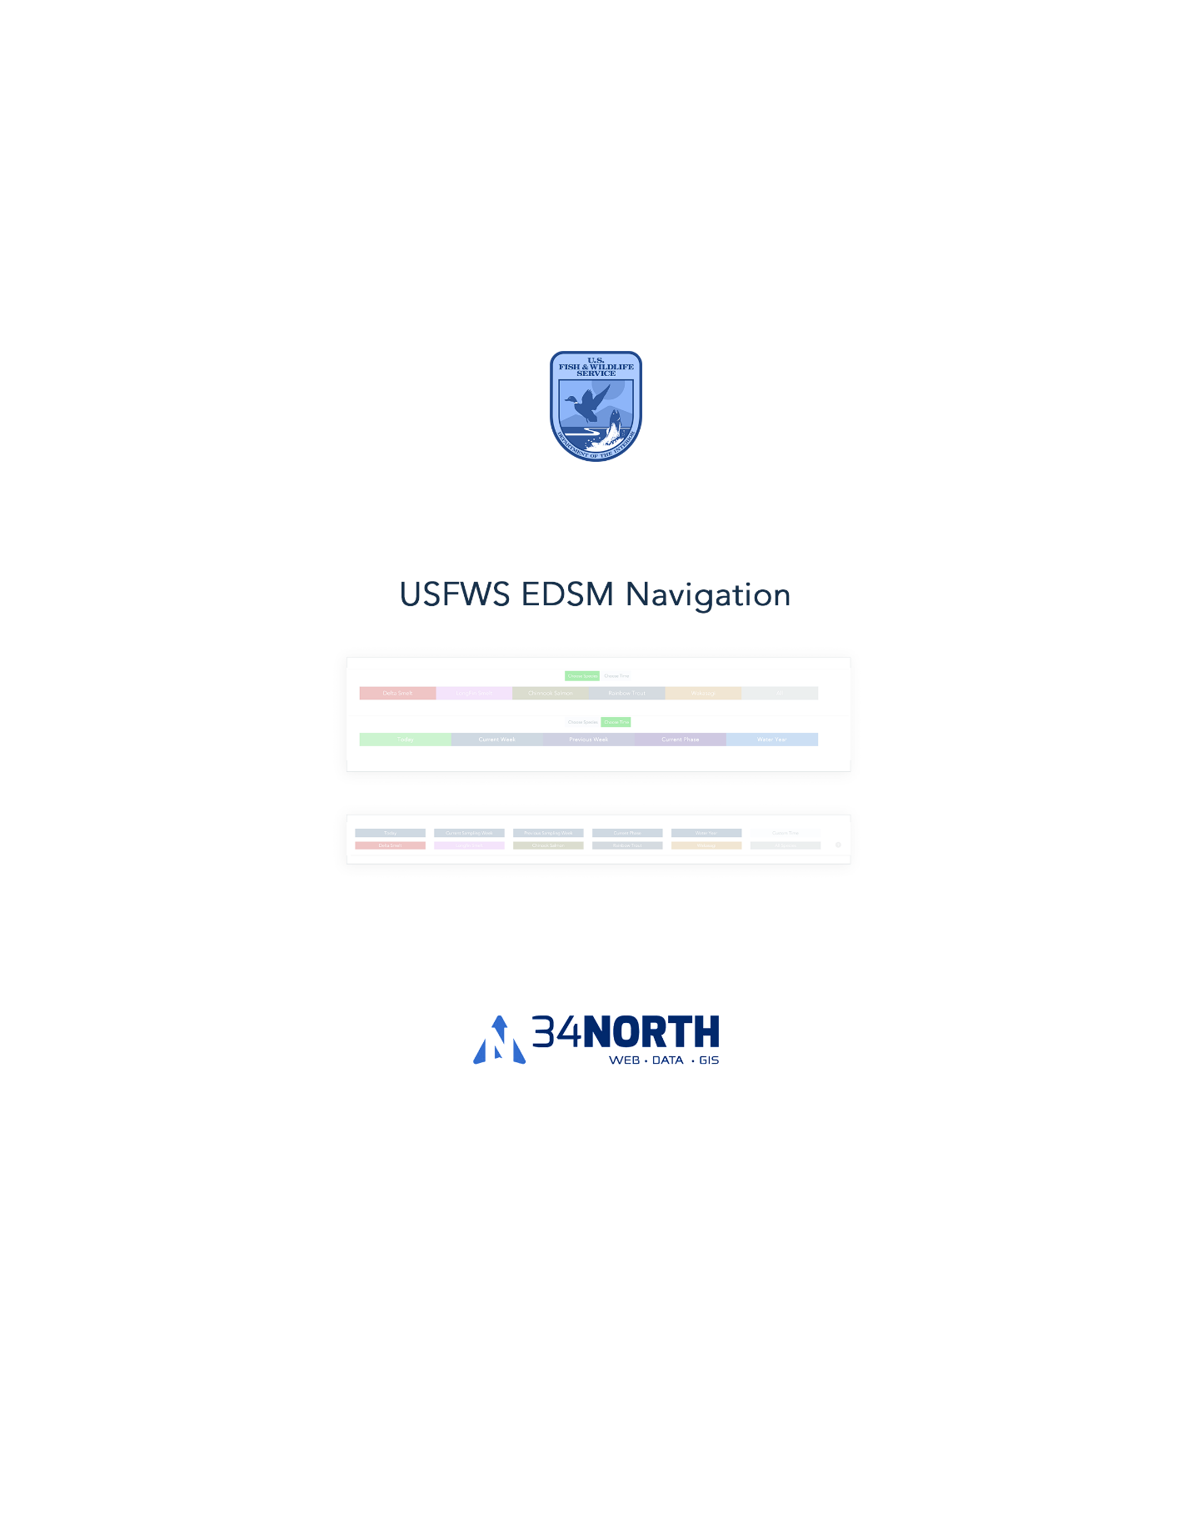

Title= Option 1 Colorful Buttons Tabbed Option

Description: Species and Time Buttons contained in tabs: <https://baydeltalive.com/edsm/delta-smelt-wt-2>





Title= Option 2 Colors Grey/Blue Defaulted On and Time Buttons Visible

Species contained within a drop-down: <https://baydeltalive.com/edsm/edsm-extended-view-(species-as-selector)>



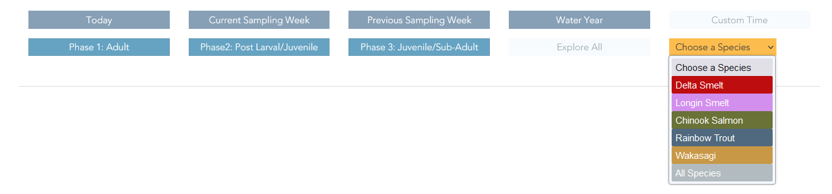

Title= Option 3 Color Defaulted On and All Buttons Visible

Species and Time buttons are visible all at once with out tabs: <https://baydeltalive.com/edsm/delta-smelt-wt-7>



Title = Option 4 Color on Click and All Buttons Visible

Buttons initial colors are the same but changes colors for Species buttons and adds pressed button style for the Time buttons: <https://baydeltalive.com/edsm/side-by-side-same-color-buttons>



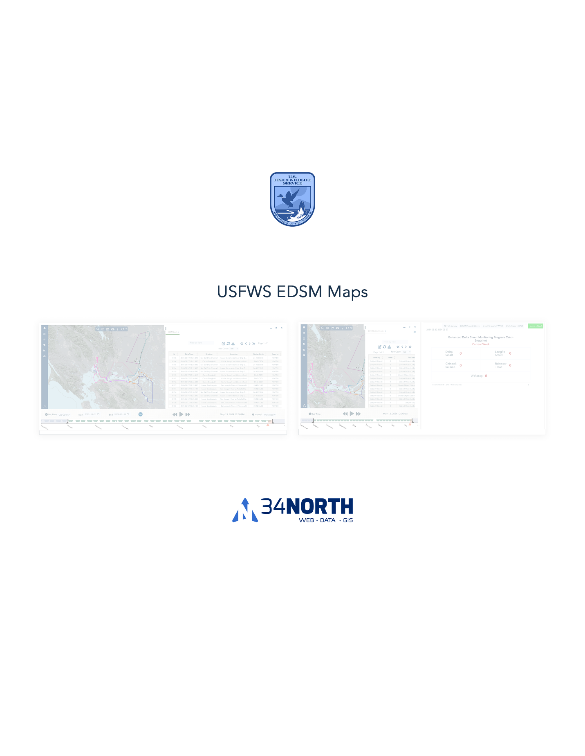

Title - **USFWS EDSM Map Layout Options**

Map view **Full Screen Width**. Reporting widgets and content will live below the map. Example: <https://baydeltalive.com/edsm/delta-smelt-wt-2>

Map view **Full Screen Width** with Reporting Content in **Map Cover**. This example shows Attribute Table in **Map Cover** View. Reporting widgets can live in this map cover. Example <https://baydeltalive.com/edsm/delta-smelt-wt-1>

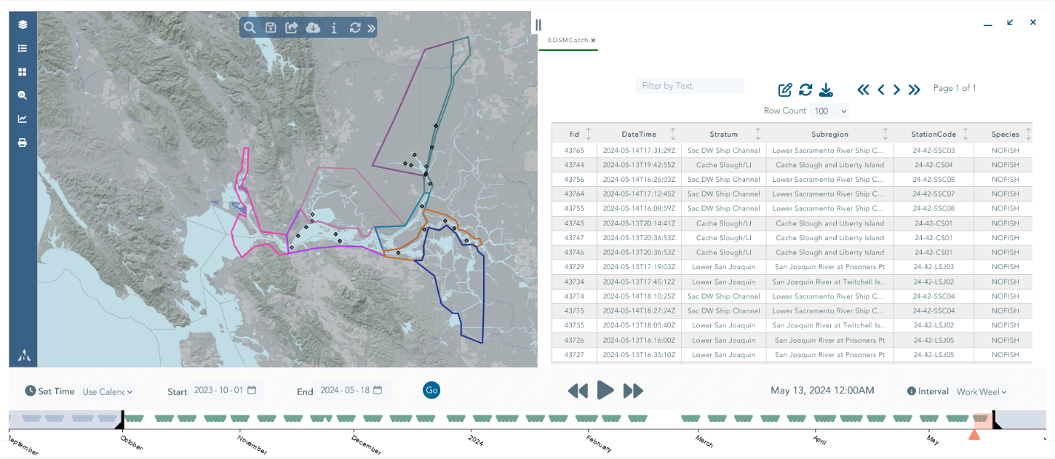

**Side By Side Map Cover View**

<https://baydeltalive.com/edsm/delta-smelt-wt-3>

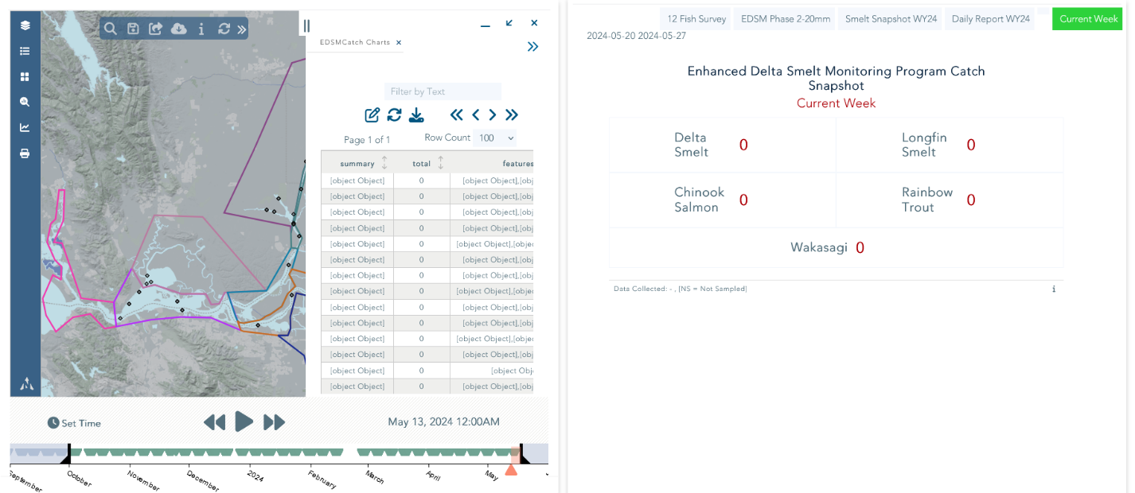

**Side By Side (Without Map Cover) View**

<https://baydeltalive.com/edsm/delta-smelt-wt-4>

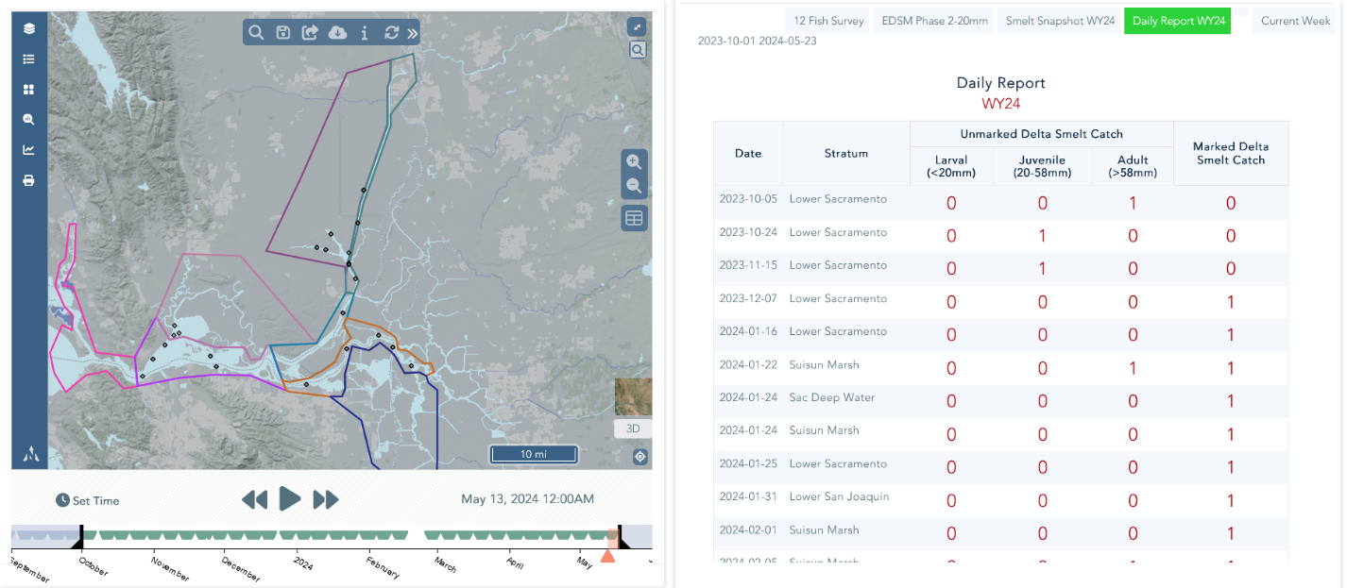

**Map Full Screen Map Nav**

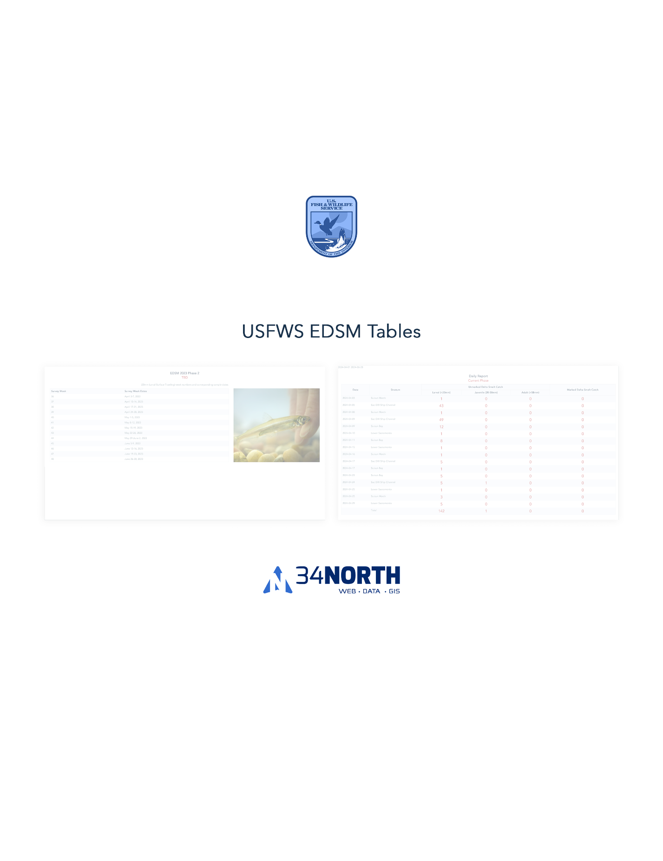

New Title= Table Options for Data Presentation

**Title= Report and General Data Table**

(Any data can be presented in this table)

Note: Alhussein, I croped this table to 16 rows so it is easy to read

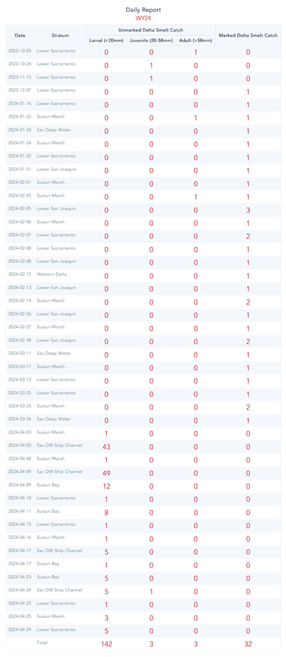

**Daily Report (Current Phase) Table**

<https://baydeltalive.com/edsm/edsm-extended-view-(species-as-selector)>

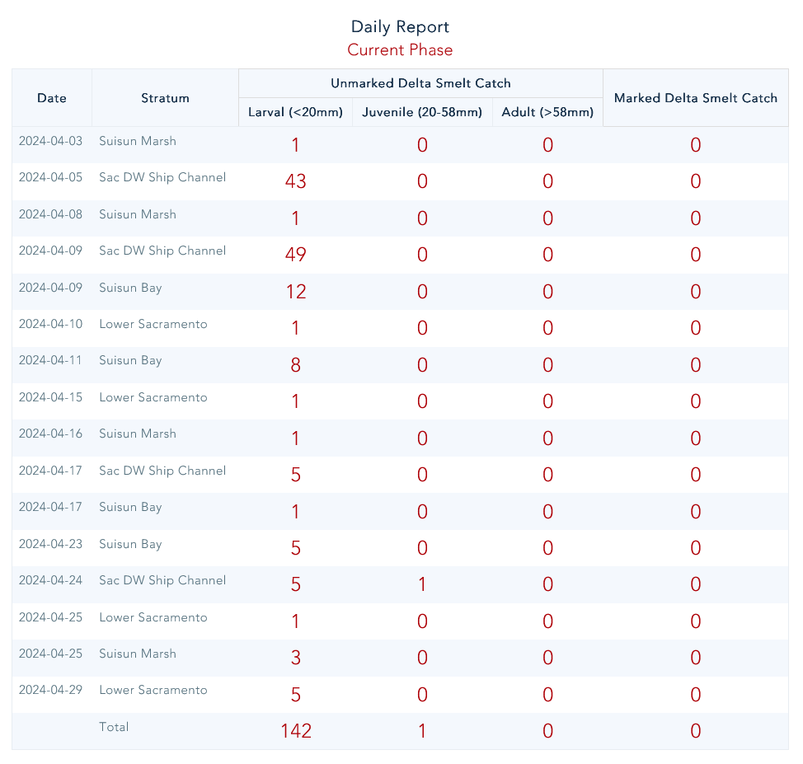

**Daily Report (Smelt) Small Table**

<https://baydeltalive.com/edsm/edsm-extended-view-(species-as-selector)>

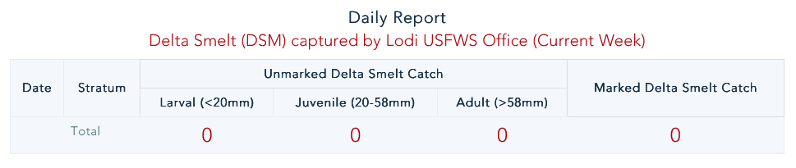

**Daily Report Snapshot Table**

<https://baydeltalive.com/edsm/delta-smelt-wt-7>

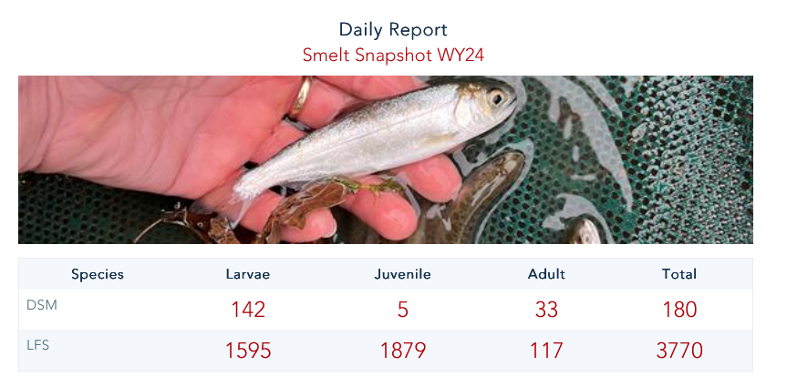

**Report (20mm Summary by Phase) Table**

<https://baydeltalive.com/edsm/smelt-monitoring-team-edsm-chipps-weekly-catch-report>

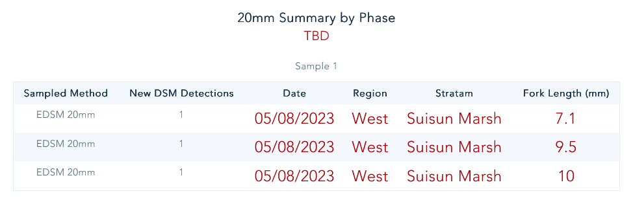

**Report (20mm Survey) Table**

<https://baydeltalive.com/edsm/smelt-monitoring-team-edsm-chipps-weekly-catch-report>

**Report (EDSM Survey Dates) Informational Table** <https://baydeltalive.com/edsm/smelt-monitoring-team-edsm-chipps-weekly-catch-report>

**Report (Interagency Ecological Program) Informational Table:** <https://baydeltalive.com/edsm/smelt-monitoring-team-edsm-chipps-weekly-catch-report>

**TBD Informational Table**

<https://baydeltalive.com/edsm/smelt-monitoring-team-edsm-chipps-weekly-catch-report>

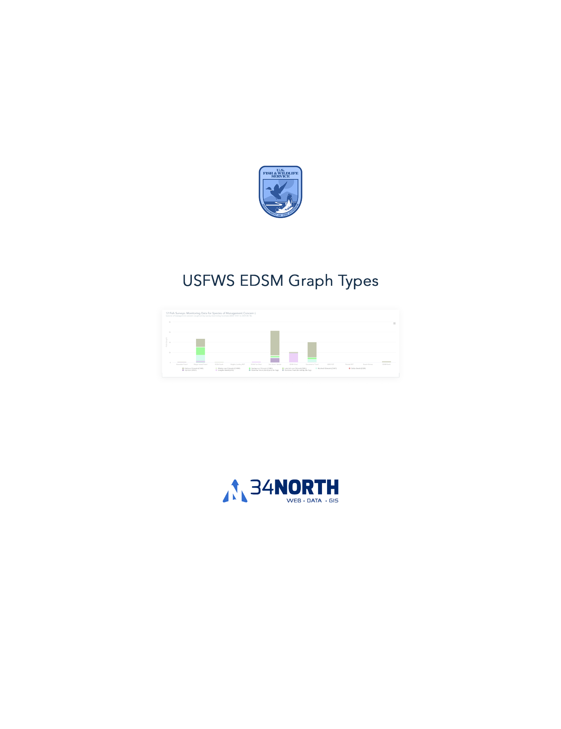

**12 Fish Survey Graph by Stratum**

<https://baydeltalive.com/edsm/delta-smelt-wt-3>

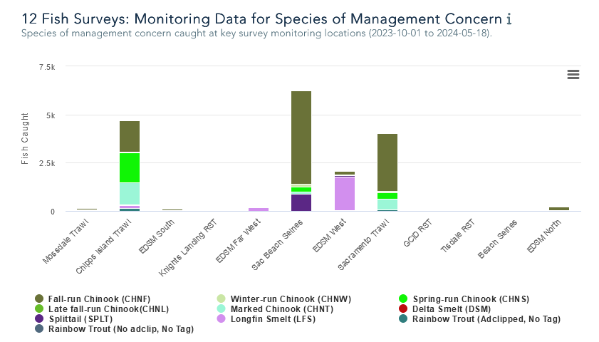

** Add 12- Survey Location Bar chart

*** Add WQ Charts Here

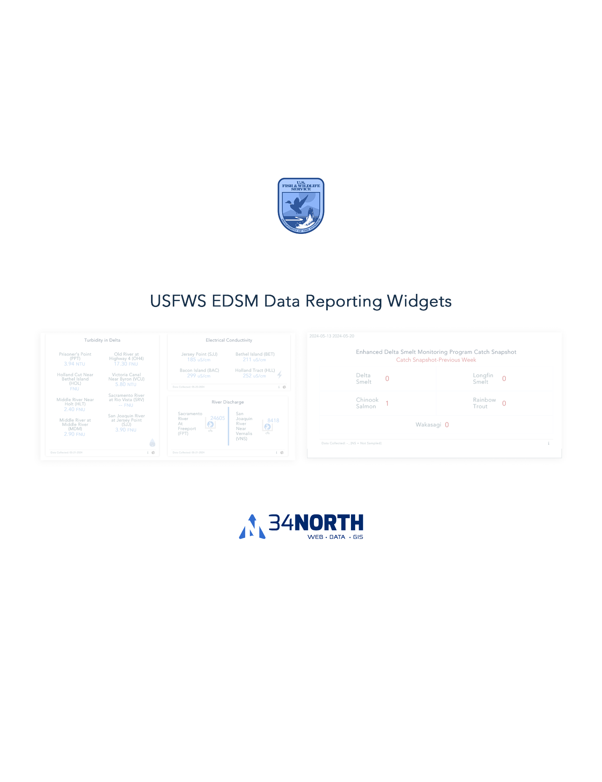

**EDSM Catch Snapshot Widgets**

(Time Period Predefined and time stamped in lower left corner)

<https://baydeltalive.com/edsm/delta-smelt-wt-6>

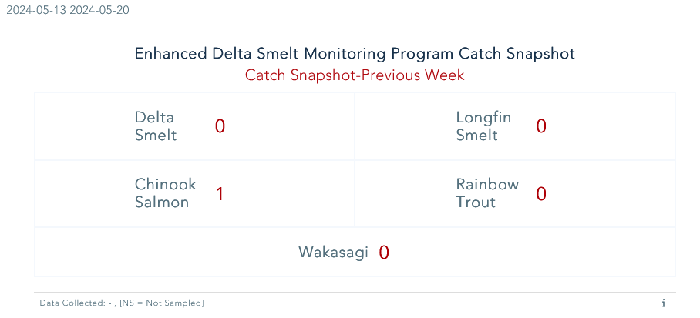

(Current Week)

<https://baydeltalive.com/edsm/delta-smelt-wt-6>

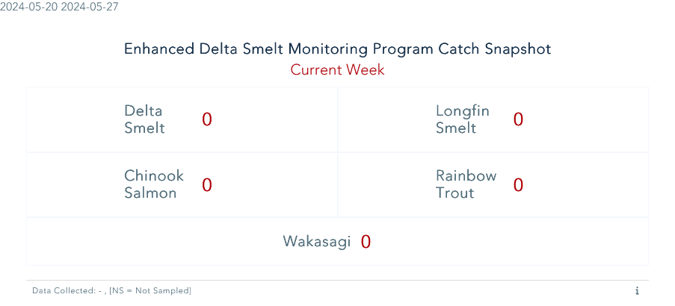

**EDSM Catch Snapshot**

(Multiple Species and Time)

<https://baydeltalive.com/edsm/delta-smelt-wt-6>

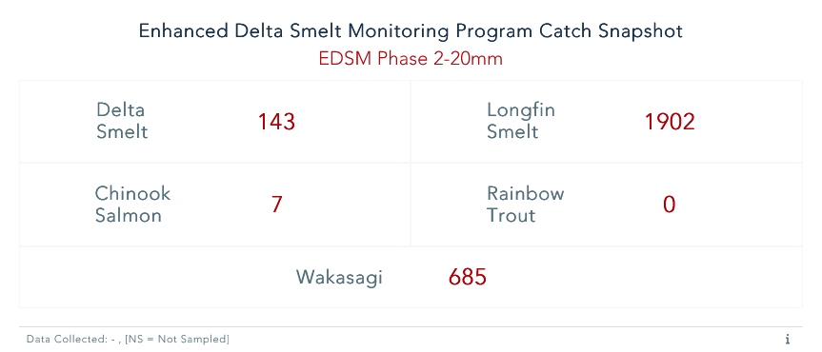

**EDSM Single Species and Time Option**

<https://baydeltalive.com/edsm/smelt-monitoring-team-edsm-chipps-weekly-catch-report>

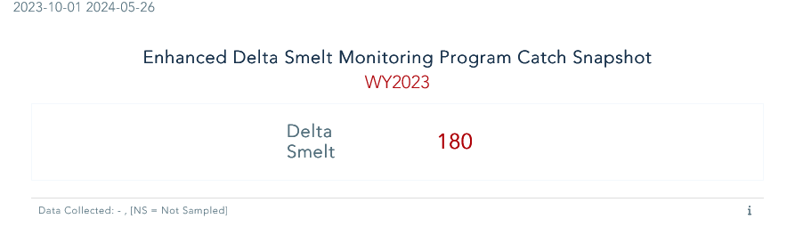

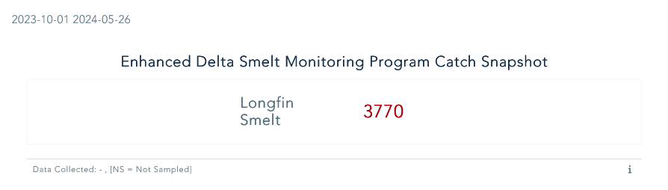

<https://baydeltalive.com/edsm/smelt-monitoring-team-edsm-chipps-weekly-catch-report>

**Total Number of EDSM 20mm Site Sampled- Informational Widgets**

<https://baydeltalive.com/edsm/smelt-monitoring-team-edsm-chipps-weekly-catch-report>

**Alhussein , These should all be a separate colors so you know they are not the same thing. I can’t read the white text in color background

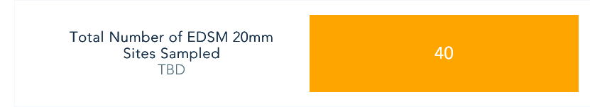

**Week 41 20mm DSM Abundance Estimate**

<https://baydeltalive.com/edsm/smelt-monitoring-team-edsm-chipps-weekly-catch-report>

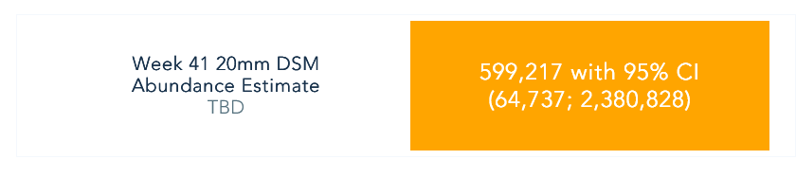

**Total Numbers of Tows Sampled**

<https://baydeltalive.com/edsm/smelt-monitoring-team-edsm-chipps-weekly-catch-report>

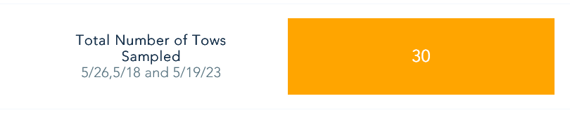

**Flows and QWEST or Any Water Quality Reporting Widget**

<https://baydeltalive.com/edsm/delta-smelt-work-team-data-dashboard>

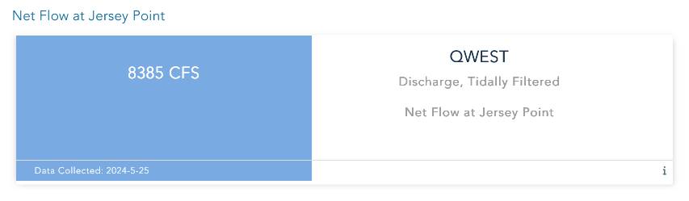

**Water Operations Summary**

<https://baydeltalive.com/edsm/delta-smelt-work-team-data-dashboard>

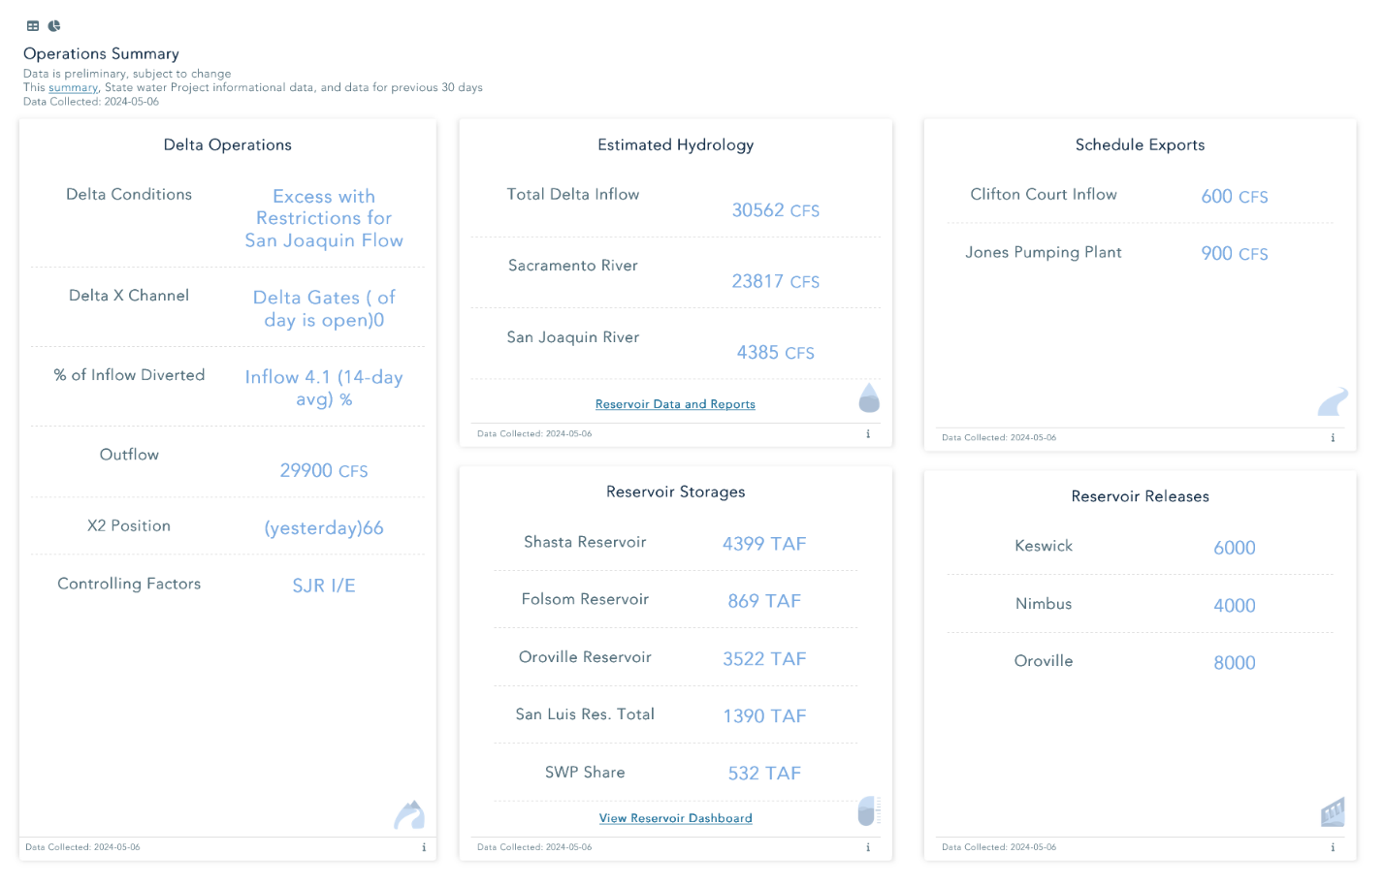

**Water Quality Conditions**

<https://baydeltalive.com/edsm/delta-smelt-work-team-data-dashboard>

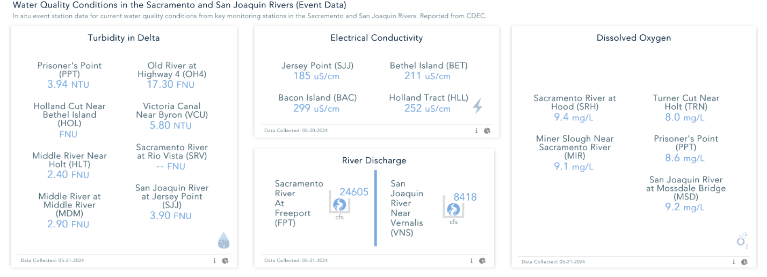

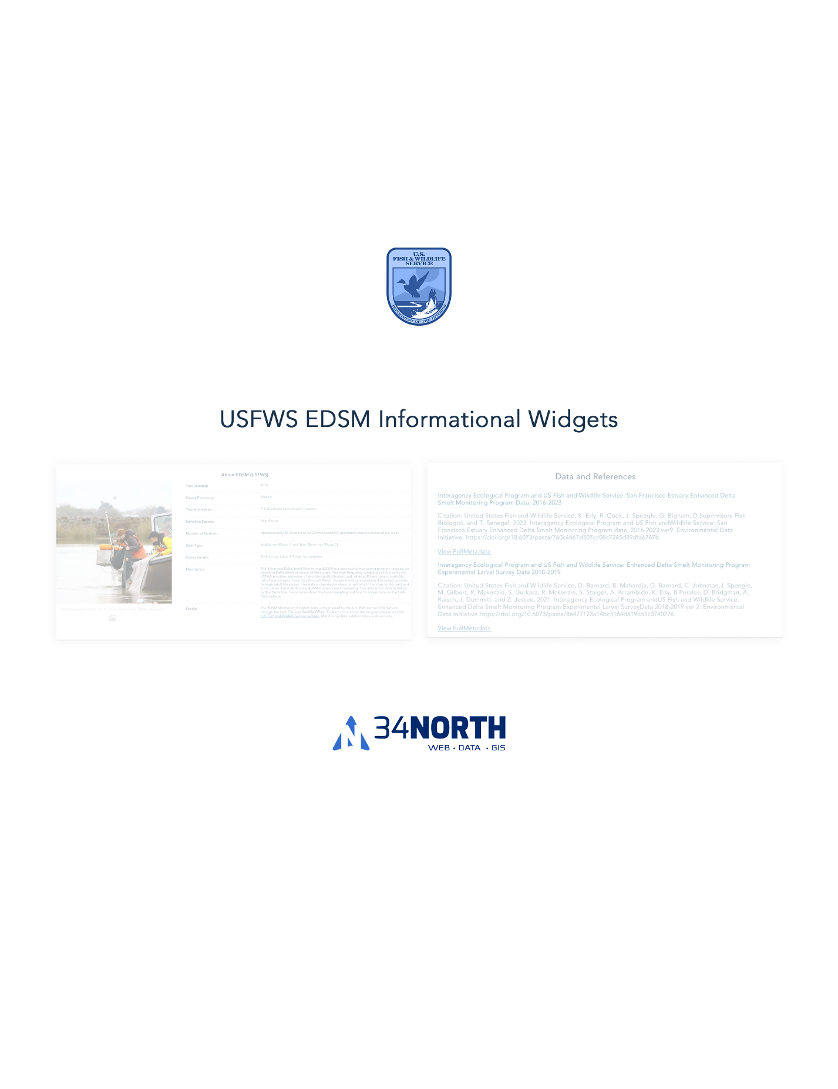

Change title to: USFWS EDSM Informational Lists and Text Widgets

**Data and References**

<https://baydeltalive.com/edsm/delta-smelt-wt-1>

About Widget: <https://baydeltalive.com/edsm/delta-smelt-wt-1>

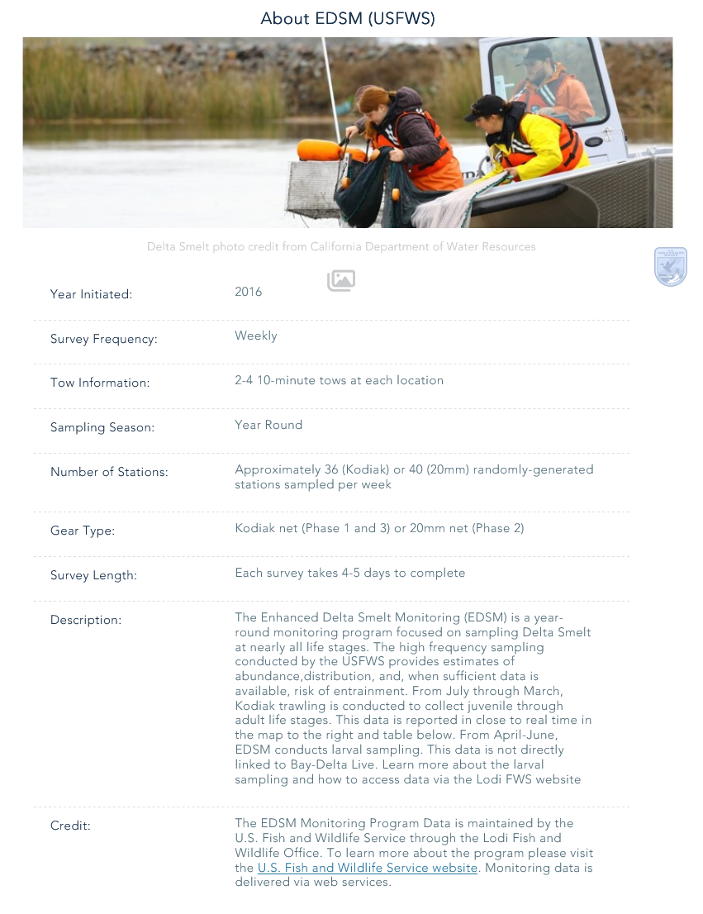

**Data Download List**

*Can you add the title we plan to add

<https://baydeltalive.com/edsm/delta-smelt-wt-1>

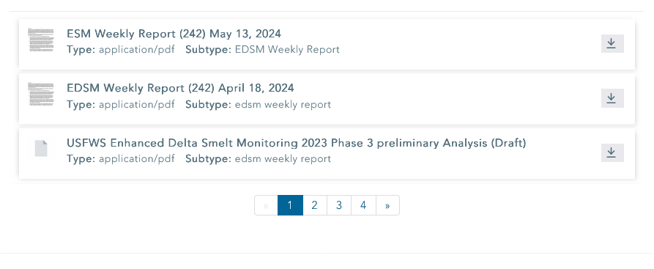

**20mm CSV Uploader**

<https://baydeltalive.com/edsm/20mm-csv>

