**Environmental Monitoring Program Site Development Report**

Data

* All Environmental Monitoring Program related data was updated through the most recent data (as is posted online).
* Benthic data was converted from a table of catch values to a matrix table format. The benthic data was sent to 34 North in year blocks and needed to be merged, adding 0’s where necessary to complete the matrix and have one file for the period of record.
* Link genus and species columns in the data for Zooplankton, Phytoplankton, and Benthic organisms. This linkage allows the user to view data as “genus species” .
* Taxonomic structure, extensive work developing query techniques for exploring hierarchical data.

Data Filters

* Develop unique filters for each set of biological data.
  + Zooplankton filter by Phylum, Family and Genus Species. In addition, Zooplankton data is also filtered by gear type (CB Net, Pump and Mysid Net)
  + Phytoplankton filter by Class, Taxon, and Common Name (Phyto Group)
  + Benthic filter by Phylum, Order, and Genus Species

Explore Data

* Develop use cases and limits on exploring the environmental data sets (for example limit number of species to be graphed on one graph)
* Custom color assignment for most common species and parameters. Colors were assigned from a list of top species.

Site Content

* Upload the text for the Who, What, and Reporting tabs. Text needed to be converted and styled for Web View.
* Images
  + Upload images with detailed metadata to the Portal. Images and metadata were provided by the EMP staff. In some instances, additional metadata (taxonomic hierarchy) was needed for the species viewer
  + Create and design a new image viewer to be able to view images and metadata simultaneously.
* Custom Help Pages, develop pages to help general users navigate the site. Also, develop pages to direct the data managers to edit and update content.
* The contextual information for the Who, What and Reporting tabs of each data type has been made into an individual wiki to allow for ease of access for editing and updating information.

|  |  |
| --- | --- |
| **Tab Name** | **Wiki URL** |
| What is Hydrology? | http://emp.baydeltalive.com/wiki/11392 |
| How is Hydrology Monitored? | http://emp.baydeltalive.com/wiki/11393 |
| Reporting of Hydrologic Conditions in the San Francisco Estuary | http://emp.baydeltalive.com/wiki/11760 |
| What is Water Quality? | http://emp.baydeltalive.com/wiki/11390 |
| How is Water Quality Monitored? | http://emp.baydeltalive.com/wiki/11391 |
| Environmental Monitoring Program Reporting Requirements for Discrete Water Quality Monitoring | http://emp.baydeltalive.com/wiki/11998 |
| What are Zooplankton? | http://emp.baydeltalive.com/wiki/11365 |
| How are Zooplankton Monitored? | http://emp.baydeltalive.com/wiki/11366 |
| Environmental Monitoring Program Reporting Requirements for Zooplankton | http://emp.baydeltalive.com/wiki/11367 |
| What are Benthic Organisms? | http://emp.baydeltalive.com/wiki/11368 |
| How are Benthic Organisms Monitored? | http://emp.baydeltalive.com/wiki/11369 |
| Environmental Monitoring Program Reporting Requirements for Benthic Organisms | http://emp.baydeltalive.com/wiki/11370 |
| What are Phytoplankton? | http://emp.baydeltalive.com/wiki/11371 |
| How is Phytoplankton Monitored? | http://emp.baydeltalive.com/wiki/11372 |
| Environmental Monitoring Program Reporting requirements for Phytoplankton | http://emp.baydeltalive.com/wiki/11386 |
| What are Estuary Fish and Why are they Important? | http://emp.baydeltalive.com/wiki/11551 |
| How are Fish Monitored? | http://emp.baydeltalive.com/wiki/11558 |
| Reporting of Fish Status and Trends in the San Francisco Estuary | http://emp.baydeltalive.com/wiki/11564 |

Reporting Tab Custom Graphs

* Custom filters for building the reporting tab graphs (i.e. Grouping all samples <5% of total as Other for Phytoplankton Reporting Graphs)
* Custom Captions for Reporting Tab Graphs
* Build custom graphs for each program based on samples provided by EMP
  + Benthic: 10 graphs
  + Zooplankton: 4 graphs, 1 table
  + Phytoplankton: 13 graphs
  + Water Quality: 18 graphs

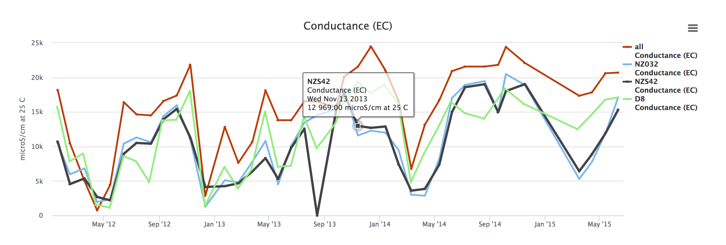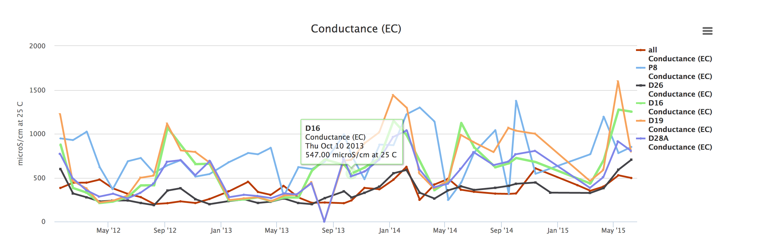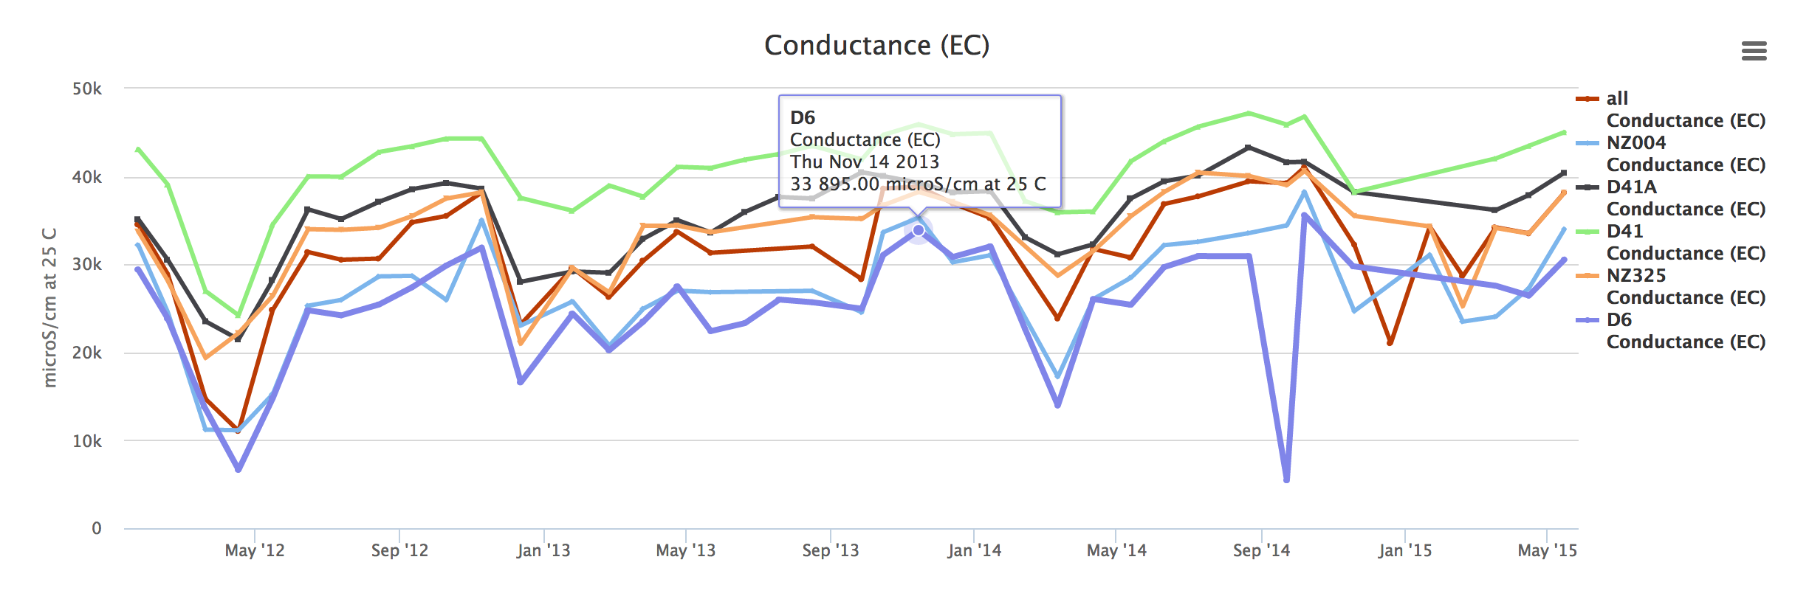

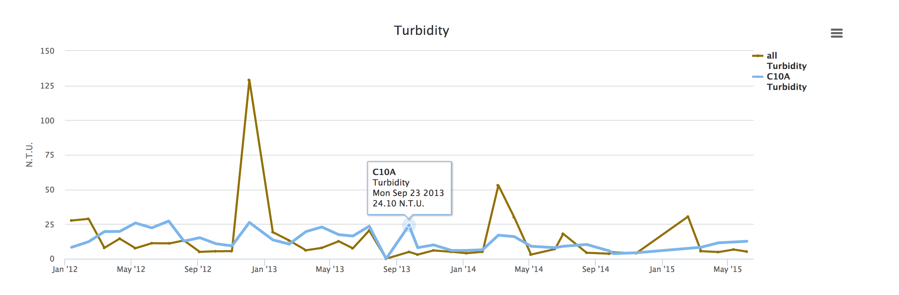

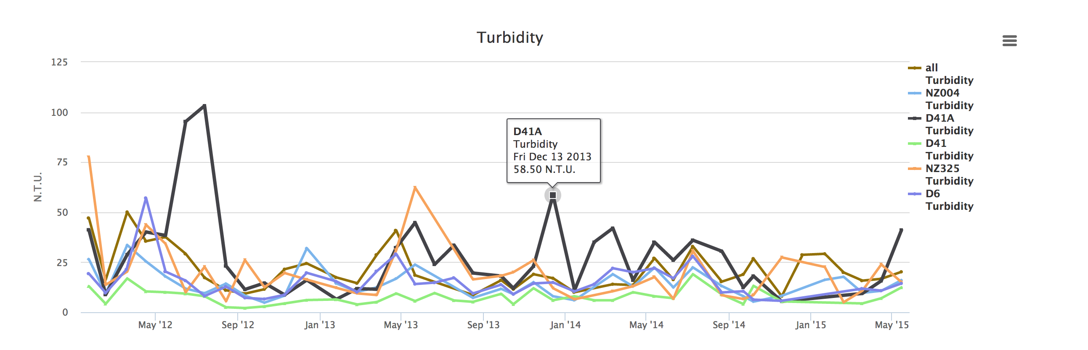

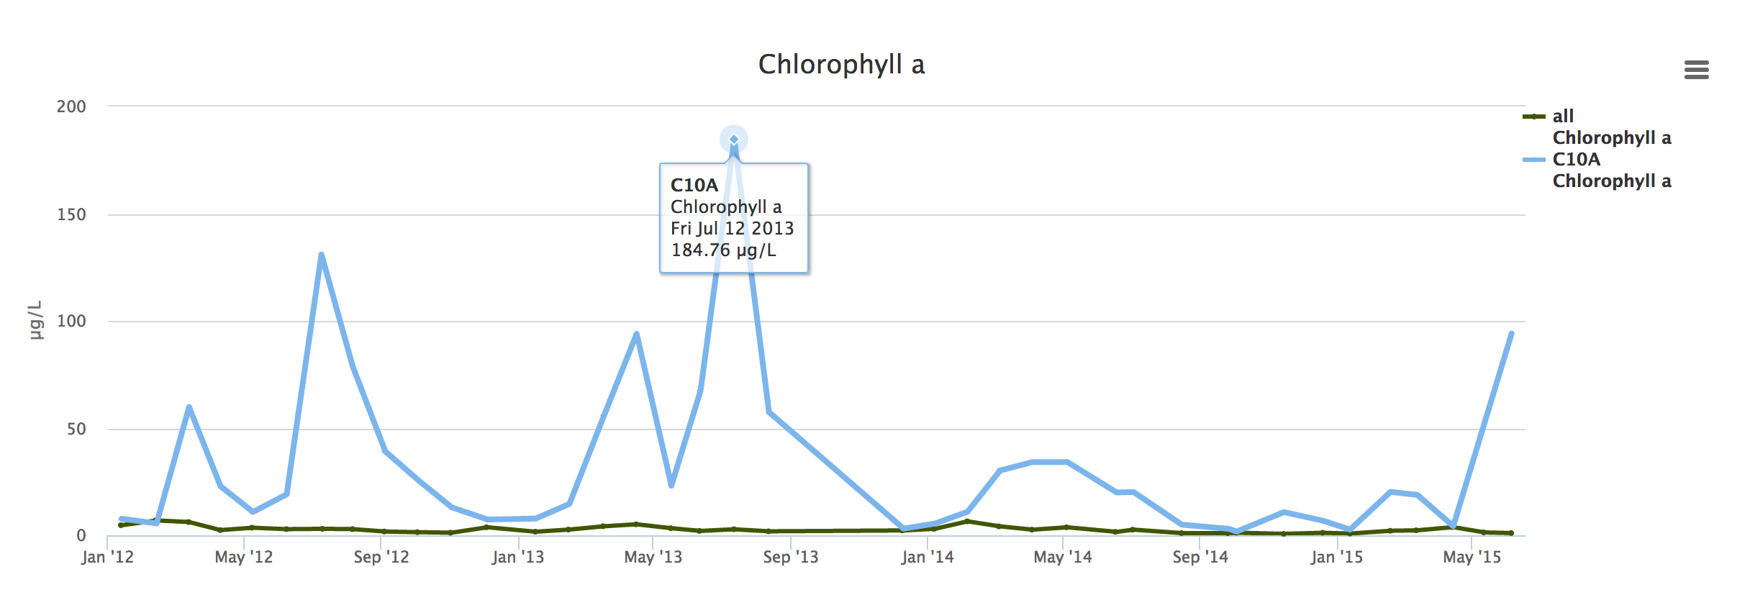

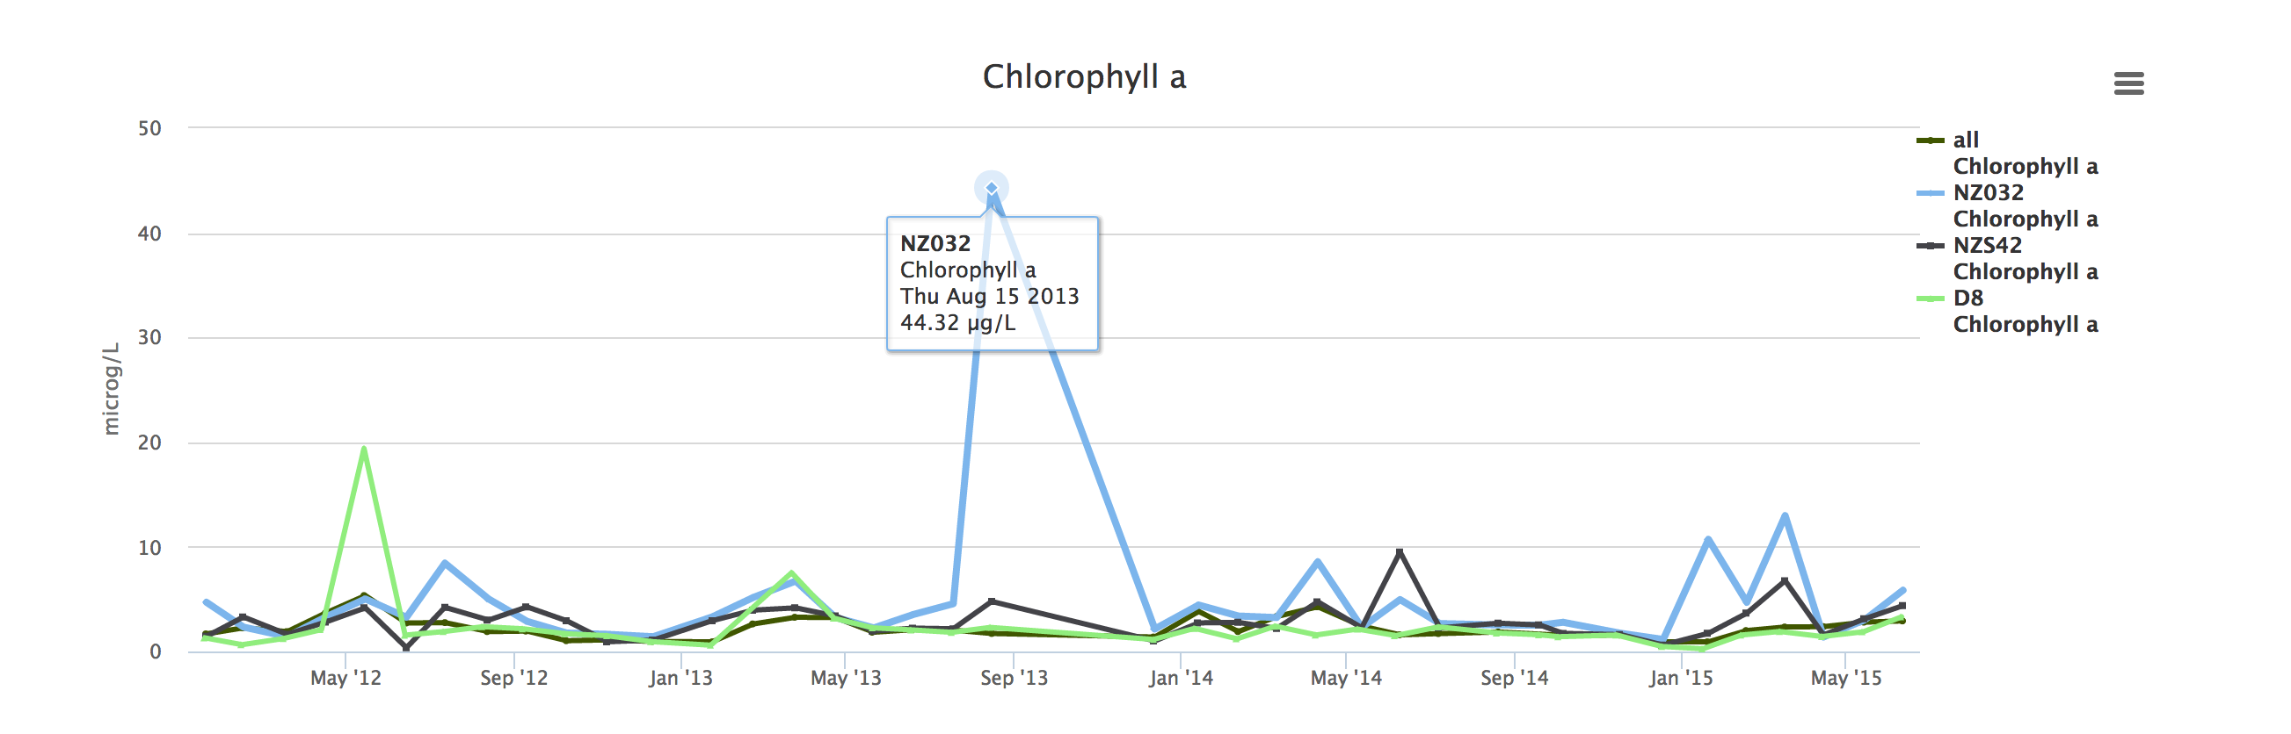

* + Hydrology: 4 graphs

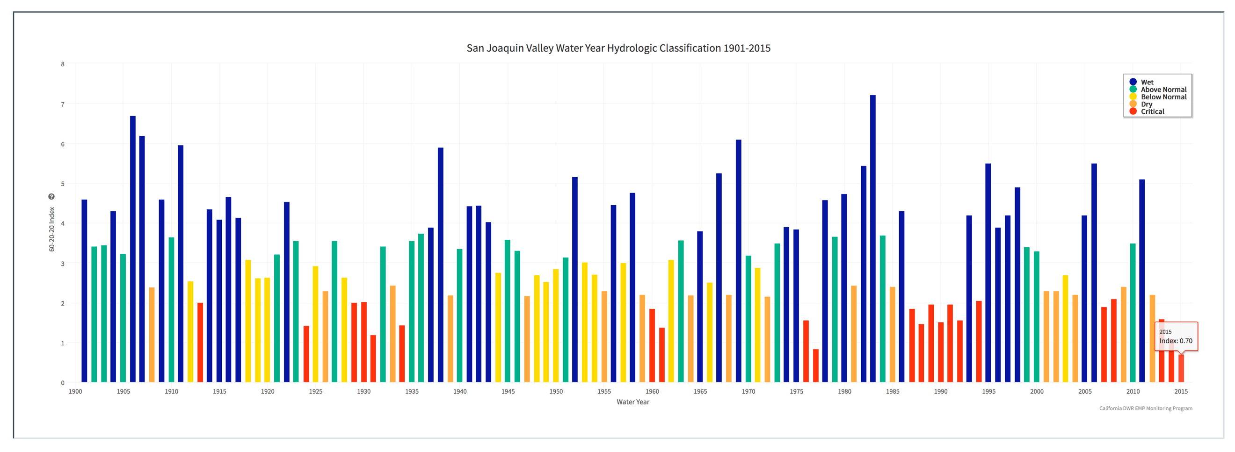

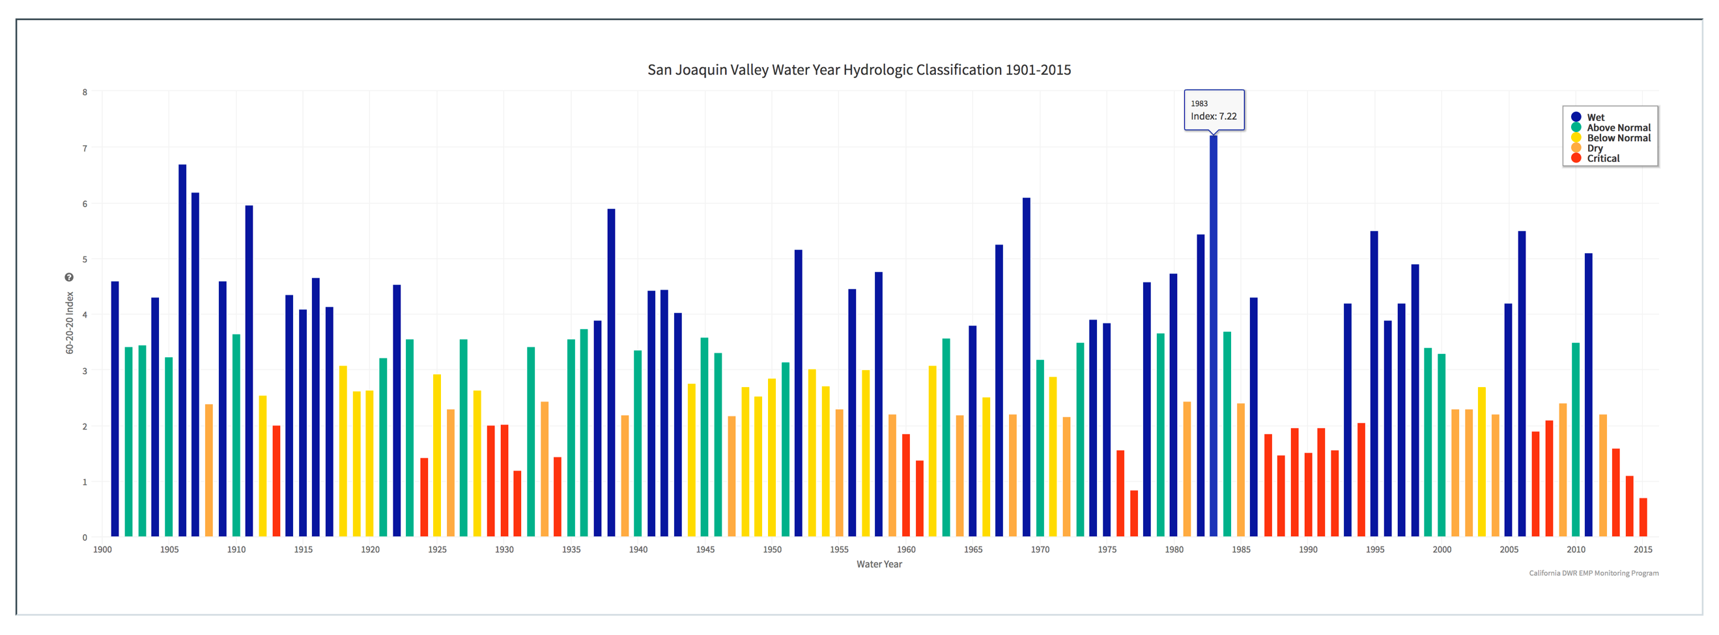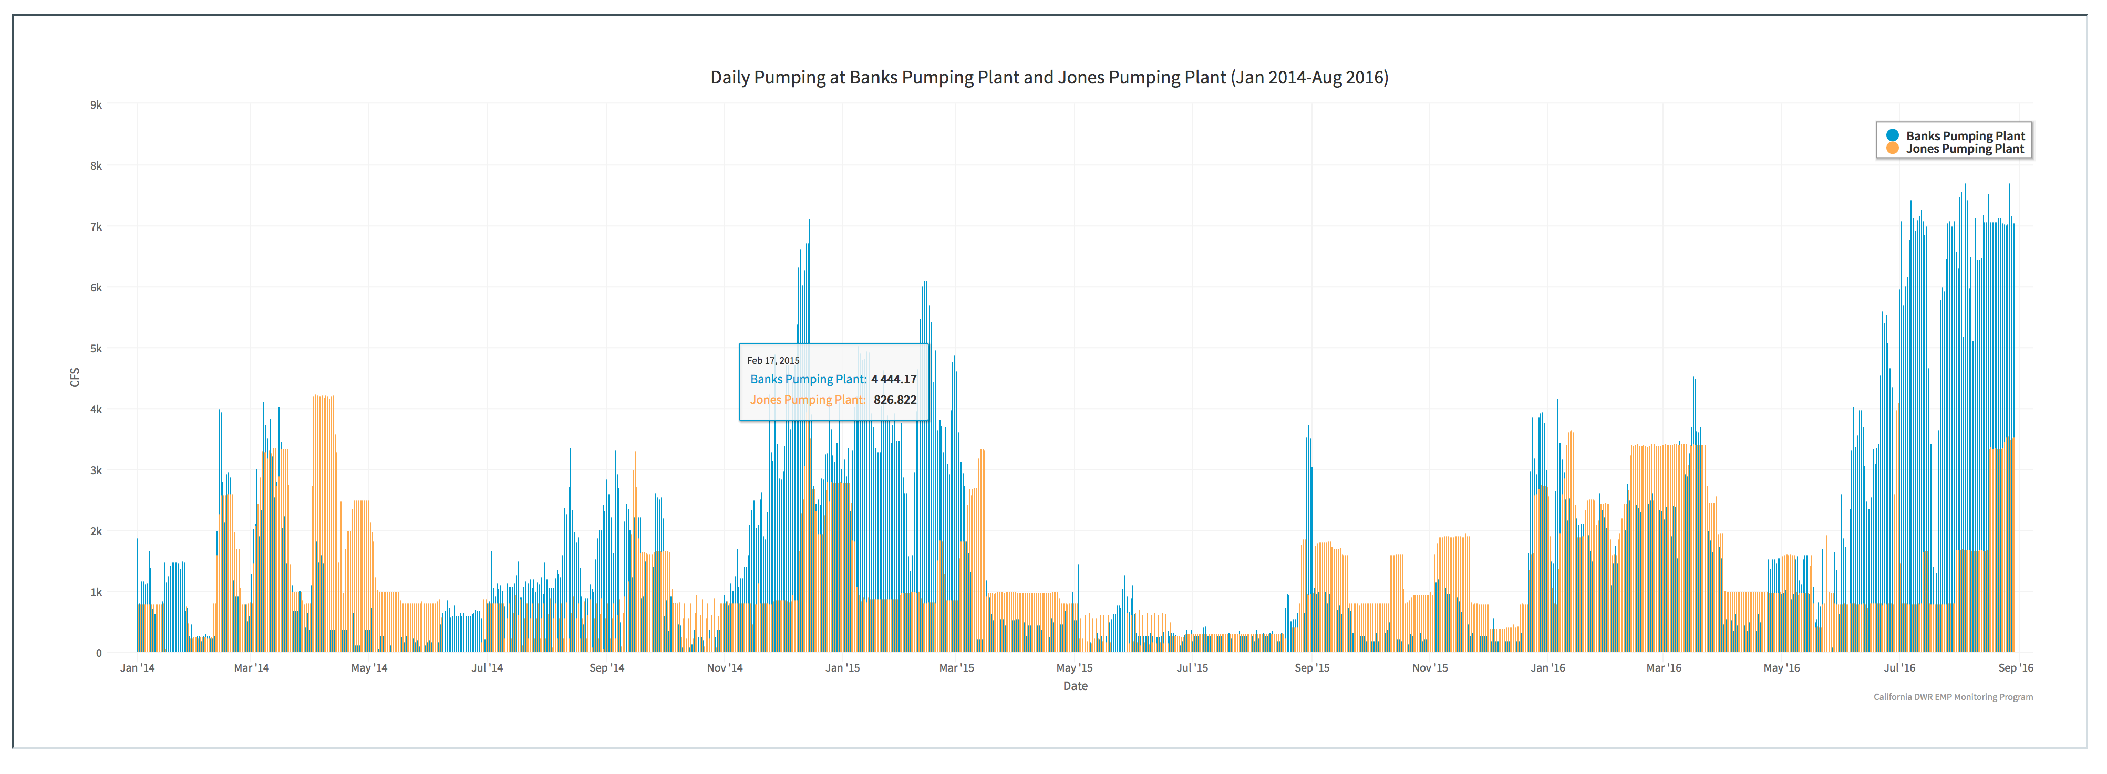

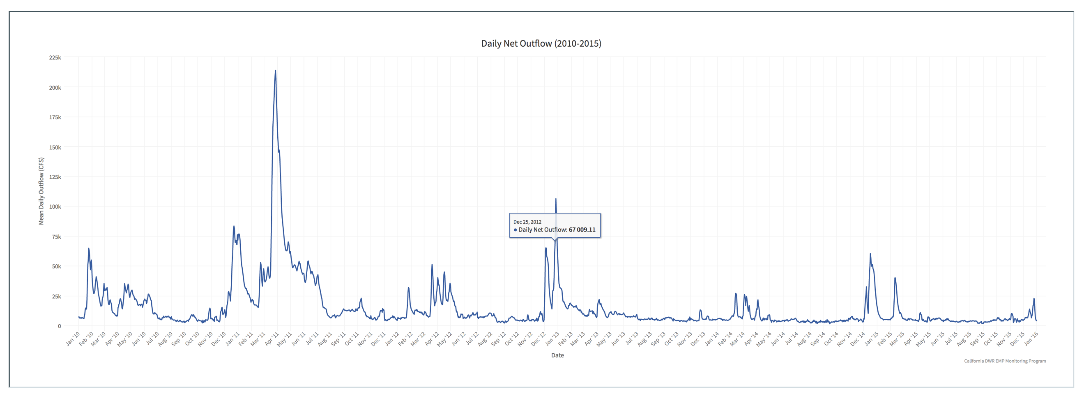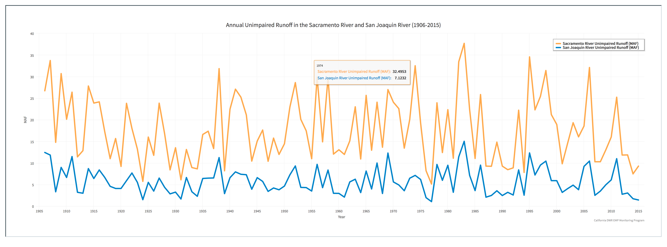

Period of Record

* Set up visualization for all water quality parameters.

Explore Data

* Organized all data to be searchable based on data type.

Custom GIS

* All layers created for the EMP exist in 2 forms (Web Feature Service, WFS, and Web Mapping Service, WMS)
* The Unique station identifier has been included in the GIS as well as metadata (other samples collected at that location, start and end date of data collection, station name, station ID, and station latitude and longitude)

**GIS Layers**

|  |  |
| --- | --- |
| **Layer Name** | **Description** |
| EMP Benthic Monitoring Stations | This layer represents the locations of historic and active Benthic monitoring stations of the Environmental Monitoring Program. The Department of Water Resources’ Benthic Organism Study measures the composition (what kinds?), abundance (how many?), diversity (how many kinds?), and distribution (where are they?) of benthic organisms as part of the IEP’s Environmental Monitoring Program (EMP). Changes in their composition, abundance, diversity, and distribution are documented within the SF Estuary, from San Pablo Bay east through the upper Estuary to the mouths of the Sacramento, Mokelumne, and San Joaquin Rivers. These sites represent a wide variety of habitats that vary in size and physical make-up as well as water quality and sediment composition. The aquatic habitats sampled range from narrow, freshwater channels in the Delta to broad, estuarine bays. |
| EMP Stations by Data Type | This layer represents the locations of all monitoring stations for all programs that are a part of the Environmental Monitoring Program. The Environmental Monitoring Program (EMP) is cooperatively carried out by the California Department of Water Resources ([DWR](http://www.water.ca.gov/ewqes/)), and the United States Bureau of Reclamation ([USBR](http://www.usbr.gov/mp/cvo/)), with assistance from the California Department of Fish and Wildlife ([CDFW](http://www.dfg.ca.gov/delta/data/)), the United States Geological Survey ([USGS](http://sfbay.wr.usgs.gov/sediment/cont_monitoring/index.html)), and the United States Fish and Wildlife Service ([USFWS](http://www.fws.gov/stockton/)). The DWR [Environmental Water Quality and Estuarine Studies Branch](http://www.water.ca.gov/ewqes/) (EWQES) is responsible for the EMP’s water quality, phytoplankton, and benthos monitoring elements and the DFG Bay-Delta region is responsible for [zooplankton](http://www.water.ca.gov/bdma/meta/zooplankton.cfm) monitoring. |
| EMP Stations by Historic vs Active | This layer represents the locations of all monitoring stations for all programs that are a part of the Environmental Monitoring Program. The Environmental Monitoring Program (EMP) is cooperatively carried out by the California Department of Water Resources ([DWR](http://www.water.ca.gov/ewqes/)), and the United States Bureau of Reclamation ([USBR](http://www.usbr.gov/mp/cvo/)), with assistance from the California Department of Fish and Wildlife ([CDFW](http://www.dfg.ca.gov/delta/data/)), the United States Geological Survey ([USGS](http://sfbay.wr.usgs.gov/sediment/cont_monitoring/index.html)), and the United States Fish and Wildlife Service ([USFWS](http://www.fws.gov/stockton/)). The DWR [Environmental Water Quality and Estuarine Studies Branch](http://www.water.ca.gov/ewqes/) (EWQES) is responsible for the EMP’s water quality, phytoplankton, and benthos monitoring elements and the DFG Bay-Delta region is responsible for [zooplankton](http://www.water.ca.gov/bdma/meta/zooplankton.cfm) monitoring. |
| EMP Stations by Data Type and Historic vs Active | This layer represents the locations of all monitoring stations for all programs that are a part of the Environmental Monitoring Program. The Environmental Monitoring Program (EMP) is cooperatively carried out by the California Department of Water Resources ([DWR](http://www.water.ca.gov/ewqes/)), and the United States Bureau of Reclamation ([USBR](http://www.usbr.gov/mp/cvo/)), with assistance from the California Department of Fish and Wildlife ([CDFW](http://www.dfg.ca.gov/delta/data/)), the United States Geological Survey ([USGS](http://sfbay.wr.usgs.gov/sediment/cont_monitoring/index.html)), and the United States Fish and Wildlife Service ([USFWS](http://www.fws.gov/stockton/)). The DWR [Environmental Water Quality and Estuarine Studies Branch](http://www.water.ca.gov/ewqes/) (EWQES) is responsible for the EMP’s water quality, phytoplankton, and benthos monitoring elements and the DFG Bay-Delta region is responsible for [zooplankton](http://www.water.ca.gov/bdma/meta/zooplankton.cfm) monitoring. |
| EMP Phytoplankton Monitoring Stations | This layer represents the locations of historic and active Phytoplankton monitoring stations of the Environmental Monitoring Program. The California DWR Phytoplankton and Chlorophyll-a monitoring measures the composition (what kinds?), abundance (how many?), diversity (how many kinds?), and distribution (where are they?) of phytoplankton. It also measures phytoplankton biomass as chlorophyll-a; both types of monitoring are performed as part of the IEP’s Environmental Monitoring Program (EMP). Thirteen fixed sites are currently sampled for both phytoplankton and chlorophyll-a (Figure 1), with two additional sites sampled at variable locations based on bottom specific conductance of 2,000 and 6,000 micro-Siemens, respectively. Historically, samples were collected once or twice monthly at up to 33 sites. Phytoplankton and chlorophyll-a samples are collected monthly alongside the **water quality** and **zooplankton** sampling. |
| EMP Discrete Water Quality Monitoring Stations | This layer represents the locations of historic and active discrete water quality monitoring stations of the Environmental Monitoring Program. The Department of Water Resources (DWR) Division of Environmental Services’ (DES) water quality monitoring programs follow specific protocols that document long term water quality trends in the Sacramento-San Joaquin Delta. There are two monitoring programs in DES that measure water quality at different time scales. Discrete water quality monitoring involves collecting a large water sample on a monthly basis to be analyzed for numerous water quality tests. Real-time water quality monitoring measures fewer water quality parameters, but on a more frequent interval, like every 15 minutes. These two programs are mandated by the Water [Right Decision 1641](http://www.waterboards.ca.gov/waterrights/board_decisions/adopted_orders/decisions/d1600_d1649/wrd1641_1999dec29.pdf#_blank) and provide information for water resource managers. |
| EMP Active Discrete Water Quality Monitoring Stations | This layer represents the locations of currently active discrete water quality monitoring stations of the Environmental Monitoring Program. The Department of Water Resources (DWR) Division of Environmental Services’ (DES) water quality monitoring programs follow specific protocols that document long term water quality trends in the Sacramento-San Joaquin Delta. There are two monitoring programs in DES that measure water quality at different time scales. Discrete water quality monitoring involves collecting a large water sample on a monthly basis to be analyzed for numerous water quality tests. Real-time water quality monitoring measures fewer water quality parameters, but on a more frequent interval, like every 15 minutes. These two programs are mandated by the Water [Right Decision 1641](http://www.waterboards.ca.gov/waterrights/board_decisions/adopted_orders/decisions/d1600_d1649/wrd1641_1999dec29.pdf#_blank) and provide information for water resource managers. |
| EMP Zooplankton Monitoring Stations | This layer represents the locations of historic and active Zooplankton monitoring stations of the Environmental Monitoring Program. The California Department of Fish and Wildlife’s Zooplankton Study determines the composition (what kinds?), abundance (how many?), and distribution (where are they?) of zooplankton in the upper SFE as part of the Interagency Ecological Program’s Environmental Monitoring Program (EMP). The Zooplankton Study monitors zooplankton in the upper SFE from San Pablo Bay east through the Delta. |
| EMP Active Zooplankton Monitoring Stations | This layer represents the locations currently active Zooplankton monitoring stations of the Environmental Monitoring Program. The California Department of Fish and Wildlife’s Zooplankton Study determines the composition (what kinds?), abundance (how many?), and distribution (where are they?) of zooplankton in the upper SFE as part of the Interagency Ecological Program’s Environmental Monitoring Program (EMP). The Zooplankton Study monitors zooplankton in the upper SFE from San Pablo Bay east through the Delta. |
| EMP Active Benthic Monitoring Stations | This layer represents the locations of currently active Benthic monitoring stations of the Environmental Monitoring Program. The Department of Water Resources’ Benthic Organism Study measures the composition (what kinds?), abundance (how many?), diversity (how many kinds?), and distribution (where are they?) of benthic organisms as part of the IEP’s Environmental Monitoring Program (EMP). Changes in their composition, abundance, diversity, and distribution are documented within the SF Estuary, from San Pablo Bay east through the upper Estuary to the mouths of the Sacramento, Mokelumne, and San Joaquin Rivers. These sites represent a wide variety of habitats that vary in size and physical make-up as well as water quality and sediment composition. The aquatic habitats sampled range from narrow, freshwater channels in the Delta to broad, estuarine bays. |
| EMP Active Phytoplankton Monitoring Stations | This layer represents the locations of currently active Zooplankton monitoring stations of the Environmental Monitoring Program. The California DWR Phytoplankton and Chlorophyll-a monitoring measures the composition (what kinds?), abundance (how many?), diversity (how many kinds?), and distribution (where are they?) of phytoplankton. It also measures phytoplankton biomass as chlorophyll-a; both types of monitoring are performed as part of the IEP’s Environmental Monitoring Program (EMP). Thirteen fixed sites are currently sampled for both phytoplankton and chlorophyll-a (Figure 1), with two additional sites sampled at variable locations based on bottom specific conductance of 2,000 and 6,000 micro-Siemens, respectively. Historically, samples were collected once or twice monthly at up to 33 sites. Phytoplankton and chlorophyll-a samples are collected monthly alongside the **water quality** and **zooplankton** sampling. |
| EMP Real Time Water Quality Monitoring Stations | This layer represents the real time water quality monitoring stations that are part of the EMP program. Hydrologic data are collected in the field, and the data are synthesized into information about real-time hydrologic conditions, which is used to make more informed water management decisions. These data are collected using a variety of climatic and hydrologic instruments at gaging stations and other sites throughout California. Monthly discrete hydrologic data are collected at some of these sites, while real-time data are increasingly collected at fixed gaging stations. The California Department of Water Resources (DWR) and many other local, state, and federal agencies collect and monitor hydrologic data throughout California. |
| CDEC Stations in the Delta | This layer represents a collection of CDEC monitoring stations in and around the Delta. The California Data Exchange Center (CDEC) provides a centralized database to store, process, and exchange real-time hydrologic information gathered by various cooperators throughout the State. CDEC then disseminates this information to the cooperators, public and private agencies, news media, and the general public. The data collected by CDEC enable forecasters to prepare flood forecasts and water supply forecasts; reservoir and hydroelectric operators to schedule reservoir releases; and water suppliers to anticipate water availability. |
| X2 Locations | This layer represents the key X2 positions in the Delta for salinity control operations. In 1995, the State Water Resources Control Board adopted X2 as a water quality standard to help restore the relationship between springtime precipitation and the geographic location and extent of estuarine habitat. The regulatory requirements for this springtime (February through June) standards are indexed to monthly flows into reservoirs on the eight largest rivers draining into the Bay Delta. This requires water managers to position X2 further downstream in wet months than in dry months either by increasing reservoir releases or, more commonly, decreasing exports from the Delta. Compliance is achieved by positioning X2 downstream of one of three locations: Roe Island (65km), Chipps Island (74 km), or the confluence of the Sacramento and San Joaquin rivers (81km). The State Boards did not set standards for managing the location of X2 during other times of the year. |
| Suisun Marsh Salinity Control Gates | The Suisun Marsh Salinity Control Gates (SMSCG) were completed and began operating in 1988. The facility consists of a boat lock, a series of three radial gates, and flashboards. The SMSCG control salinity by restricting the flow of higher salinity water from Grizzly Bay into Montezuma Slough during incoming tides and retaining lower salinity Sacramento River water from the previous ebb tide. Operation of the SMSCG in this fashion lowers salinity in Suisun Marsh channels and results in a net movement of water from east to west. When Delta outflow is low to moderate and the SMSCG are not operating, net movement of water is from west to east, resulting in higher salinity water in Montezuma Slough. The SMSCG usually begin operating in early October and, depending on salinity conditions, may continue operating through the end of the control season in May. When the channel water salinity decreases sufficiently below the salinity standards, or at the end of the control season, the flashboards are removed and the SMSCG raised to allow unrestricted movement through Montezuma Slough. |
| Delta Cross Channel | The Delta Cross Channel was constructed in 1953 to deliver low-salinity water from the Sacramento River in Northern California to the South Delta where it is pumped to the San Francisco Bay Area and other parts of the State for public consumption and to the San Joaquin Valley for agriculture use. The Delta Cross Channel is critical for controlling ocean salinity as part of the Central Valley Project, Delta Division. The Delta Cross Channel was built to augment the flow of Sacramento River water through the Delta from the Sacramento’s main channel to the CVP export pumps. Constructed near Walnut Grove in 1951, the channel facilitates the transfer of water from the Sacramento River across the Bay Delta to the Central Valley Project export pumps located near Tracy. Water is diverted from the river through a short excavated channel near Walnut Grove into the slough. |
| State Water Project Canals | This layer represents the locations of canals that are part of the State Water Project. The California State Water Project is a water storage and delivery system of reservoirs, aqueducts, powerplants and pumping plants. Its main purpose is to store water and distribute it to 29 urban and agricultural water suppliers in Northern California, the San Francisco Bay Area, the San Joaquin Valley, the Central Coast, and Southern California. Of the contracted water supply, 70 percent goes to urban users and 30 percent goes to agricultural users. The Project makes deliveries to two-thirds of California's population. It is maintained and operated by the California Department of Water Resources. The Project is also operated to improve water quality in the Delta, control Feather River flood waters, provide recreation, and enhance fish and wildlife. |
| State Water Project Reservoirs | This layer represents the locations of reservoirs that are part of the State Water Project and the reservoir points are sized relative to their storage capacity. The California State Water Project is a water storage and delivery system of reservoirs, aqueducts, powerplants and pumping plants. Its main purpose is to store water and distribute it to 29 urban and agricultural water suppliers in Northern California, the San Francisco Bay Area, the San Joaquin Valley, the Central Coast, and Southern California. Of the contracted water supply, 70 percent goes to urban users and 30 percent goes to agricultural users. The Project makes deliveries to two-thirds of California's population. It is maintained and operated by the California Department of Water Resources. The Project is also operated to improve water quality in the Delta, control Feather River flood waters, provide recreation, and enhance fish and wildlife. |
| Central Valley Project Canals | This layer represents the locations of canals that are part of the Central Valley Project. The Central Valley Project, one of the Nation`s major water conservation developments, extends from the Cascade Range in the north to the semi-arid but fertile plains along the Kern River in the south. Initial features of the project were built primarily to protect the Central Valley from crippling water shortages and menacing floods, but the CVP also improves Sacramento River navigation, supplies domestic and industrial water, generates electric power, conserves fish and wildlife, creates opportunities for recreation, and enhances water quality. The CVP serves farms, homes, and industry in California`s Central Valley as well as major urban centers in the San Francisco Bay Area; it is also the primary source of water for much of California`s wetlands. In addition to delivering water for farms, homes, factories, and the environment, the CVP produces electric power and provides flood protection, navigation, recreation, and water quality benefits. This multiple-purpose project plays a key role in California`s powerful economy, providing water for 6 of the top 10 agricultural counties in the nation`s leading farm state. It has been estimated that the value of crops and related service industries has returned 100 times Congress`s $3 billion investment in the CVP. |
| Central Valley Project Reservoirs | This layer represents the locations of reservoirs that are part of the State Water Project and the reservoir points are sized relative to their storage capacity. The Central Valley Project, one of the Nation`s major water conservation developments, extends from the Cascade Range in the north to the semi-arid but fertile plains along the Kern River in the south. Initial features of the project were built primarily to protect the Central Valley from crippling water shortages and menacing floods, but the CVP also improves Sacramento River navigation, supplies domestic and industrial water, generates electric power, conserves fish and wildlife, creates opportunities for recreation, and enhances water quality. The CVP serves farms, homes, and industry in California`s Central Valley as well as major urban centers in the San Francisco Bay Area; it is also the primary source of water for much of California`s wetlands. In addition to delivering water for farms, homes, factories, and the environment, the CVP produces electric power and provides flood protection, navigation, recreation, and water quality benefits. This multiple-purpose project plays a key role in California`s powerful economy, providing water for 6 of the top 10 agricultural counties in the nation`s leading farm state. It has been estimated that the value of crops and related service industries has returned 100 times Congress`s $3 billion investment in the CVP. |

Saved Maps

|  |  |  |
| --- | --- | --- |
| Layer Name | Layer URL | Thumbnail |
| EMP Stations by Data Type (Active) | http://emp.baydeltalive.com/layers/12025 |  |
| EMP Stations by Data Type and Historic vs. Active | http://emp.baydeltalive.com/maps/10994 |  |
| EMP Stations by Historic vs Active | http://emp.baydeltalive.com/layers/11975 |  |
| EMP Active Zooplankton Monitoring Stations | http://emp.baydeltalive.com/maps/11778 |  |
| EMP Active Discrete Water Quality Monitoring Stations | http://emp.baydeltalive.com/maps/11776 |  |
| EMP Active Phytoplankton Monitoring Stations | http://emp.baydeltalive.com/maps/11772 |  |
| EMP Active Benthic Monitoring Stations | http://emp.baydeltalive.com/maps/11774 |  |
| EMP Zooplankton Monitoring Locations (Active and Historic) | http://emp.baydeltalive.com/maps/11640 |  |
| EMP Discrete Water Quality Monitoring Locations (Active and Historic) | http://emp.baydeltalive.com/maps/11756 |  |
| EMP Phytoplankton Monitoring Locations (Active and Historic) | http://emp.baydeltalive.com/maps/11636 |  |
| EMP Benthic Monitoring Locations (Active and Historic) | http://emp.baydeltalive.com/maps/11639 |  |
| EMP Discrete Water Quality Stations | http://emp.baydeltalive.com/maps/11776 |  |
| EMP Real Time Water Quality Monitoring Locations | http://emp.baydeltalive.com/layers/12051 |  |
| X2 Key Locations | http://emp.baydeltalive.com/layers/11526 |  |
| CDEC Stations Delta Area | http://emp.baydeltalive.com/maps/12032 |  |

Maps

* Create saved maps of monitoring (current and historic) locations for the Environmental Monitoring Program.

|  |  |
| --- | --- |
| Saved Map Name | Map URL |
| Delta Region California Data Exchange Center Monitoring Locations | http://emp.baydeltalive.com/maps/12032 |
| Environmental Monitoring Program Current Benthic Monitoring locations | http://emp.baydeltalive.com/maps/11774 |
| Environmental Monitoring Program Current Zooplankton Monitoring Locations | http://emp.baydeltalive.com/maps/11778 |
| Environmental Monitoring Program Current Phytoplankton Monitoring Locations | http://emp.baydeltalive.com/maps/11772 |
| Environmental Monitoring Program Current Discrete Water Quality Monitoring Locations | http://emp.baydeltalive.com/maps/11776 |
| Environmental Monitoring Program Discrete Water Quality Monitoring Current and Historic Monitoring Locations | http://emp.baydeltalive.com/maps/11756 |
| Environmental Monitoring Program Zooplankton Current and Historic Monitoring Locations | http://emp.baydeltalive.com/maps/11640 |
| Environmental Monitoring Program Phytoplankton Current and Historic Monitoring Locations | http://emp.baydeltalive.com/maps/11636 |
| Environmental Monitoring Program Benthic Monitoring Stations Current and Historic | http://emp.baydeltalive.com/maps/11639 |

To Do:

1. Connect species table.
2. Connect color table to new site.
3. Review all data visualization with QA/QC data sheets from monitoring teams. 34 North to review first.
4. Review data point presentation. Decimal, comma placement etc.
5. Finalize any additional content.
6. Discrete data calculations.
7. Data packaging on reporting tabs.