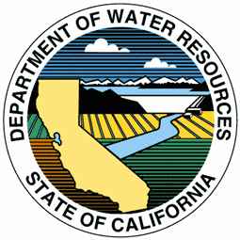

Final Report: Integration of the Water Data Library (WDL) into BayDeltaLive.com
Spatial Data Discovery, Synthesis, and Decision Support Tools

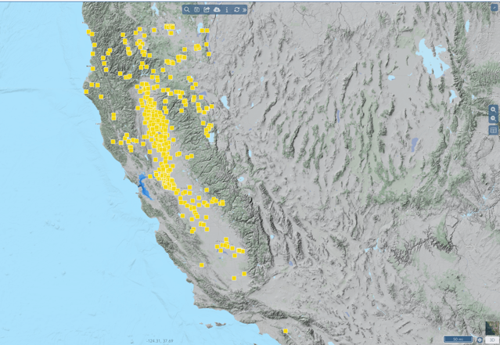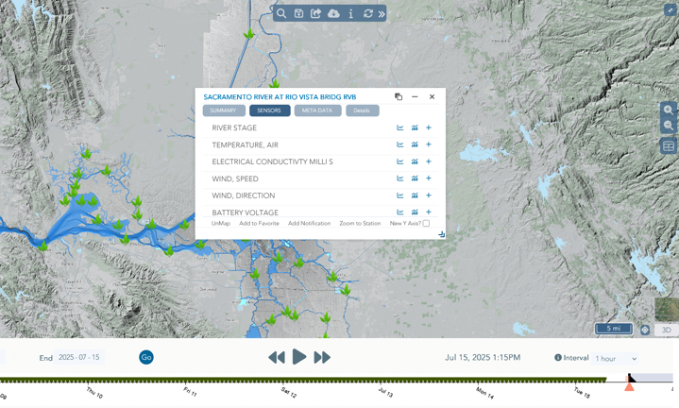

Prepared for: The State Water Contractors, Darcy Austin
By:
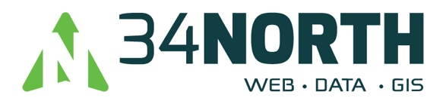

*Deliverable 1: Efficient Retrieval and Visualization of QA/QC Time Series Data
We enabled seamless spatial visualization and retrieval of QA/QC-processed WDL time series data. These data can substitute CDEC records where station overlap occurs.
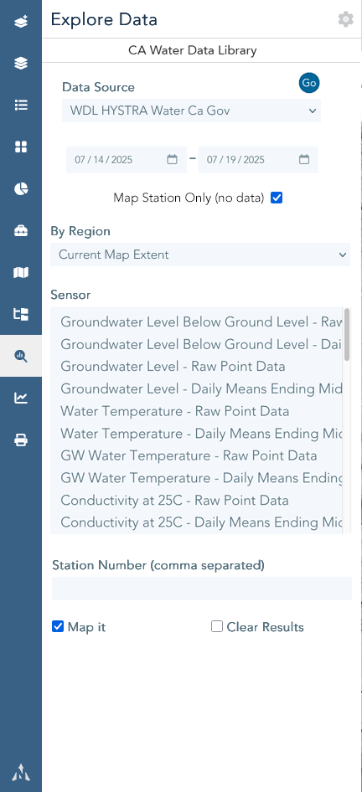
Interactive Search Interface: Users can search by custom date ranges, regional extent, or specific station IDs.
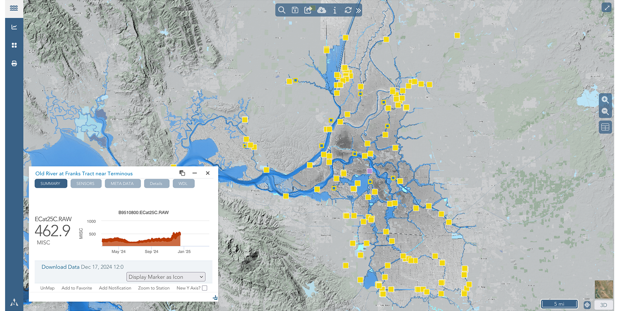
Mapped Sensor Stations: All WDL stations are viewable via the BayDeltaLive interface, filterable across California. The icons change from yellow to yellow with blue center if data is available for both CDEC and WDL.

Deliverable 2: Multi-Scale Temporal Data Discovery
Implemented advanced calendar controls, custom intervals, and spatial timelines for efficient temporal navigation.

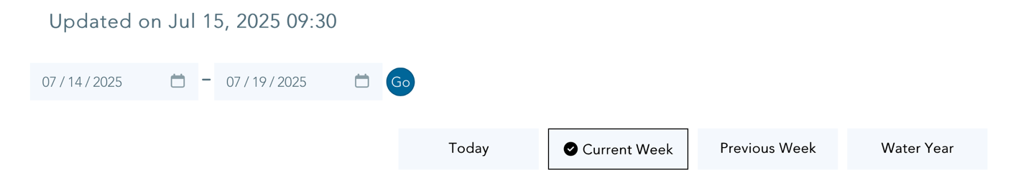
Custom Time Controls: Daily, Weekly, Water Year, and user-defined intervals.
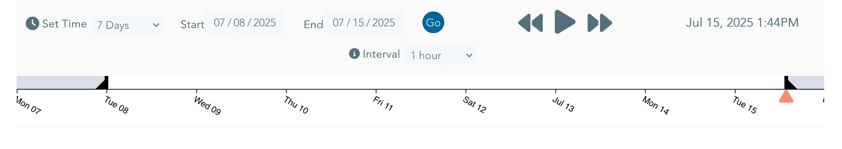
Timeline Map Integration: Allows temporal filtering directly from map views.

*Deliverable 3: Centralized Data Management Structure and PostgreSQL Index Optimization
Streamlined data access by centralizing the data architecture, minimizing time and effort needed for locating, cleaning, and formatting datasets.
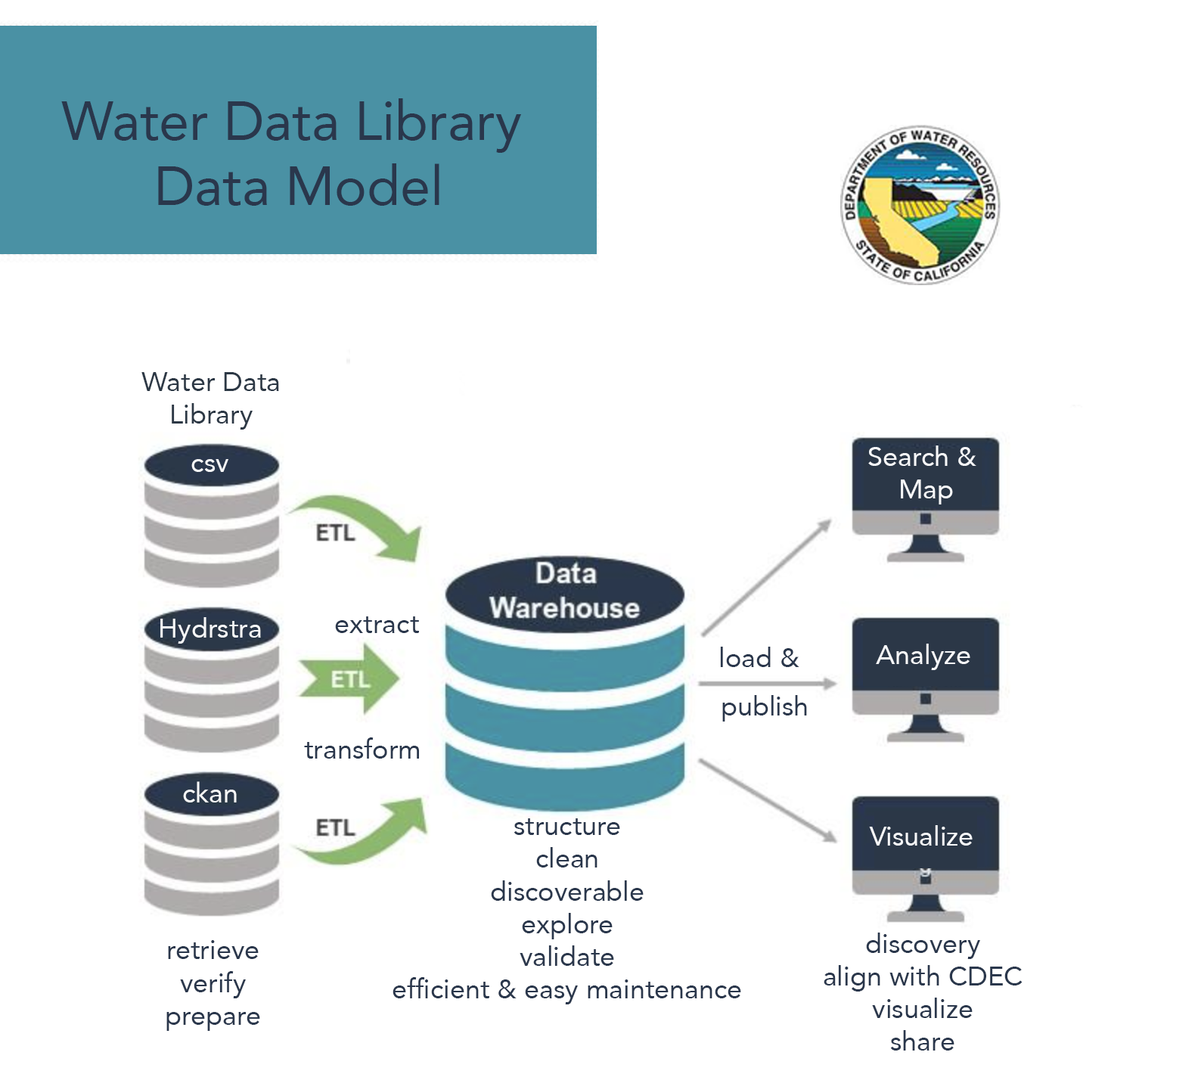

PostgreSQL Index Optimization
As part of our ongoing performance enhancement strategy, we completed a targeted index audit and optimization across key PostgreSQL tables. This process involved analyzing execution plans to identify costly queries and designing a strategy that included composite and partial indexing. We prioritized indexing on time-series sensor data and spatial reference tables, using PostgreSQL’s advanced capabilities like GIN, BRIN, and conditional indexes. Our approach was tailored to specific workloads, with a focus on reducing latency for dashboard queries and improving backend efficiency.

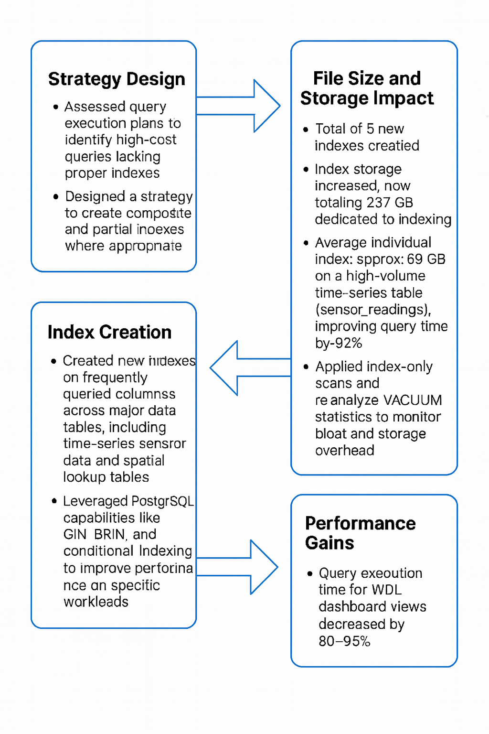
In total, five new indexes were implemented, resulting in a cumulative index file size of 237 GB. The largest index—approximately 59 GB—was applied to a high-volume sensor readings table and delivered a 92% improvement in query execution time. Overall, dashboard query performance improved by 80–95%, with faster load times and more responsive visualizations. All indexes were documented in our internal schema catalog, and regular monitoring is planned to assess index growth, storage impact, and the potential need for reindexing or partitioning in the future.

*Deliverable 4: Integrated Multi-Source Data Synthesis
Enabled synthesis of WDL data with BDL-accessible datasets such as CDEC, NWIS, EMP, CEDEN, NOAA, and spatial GIS layers.
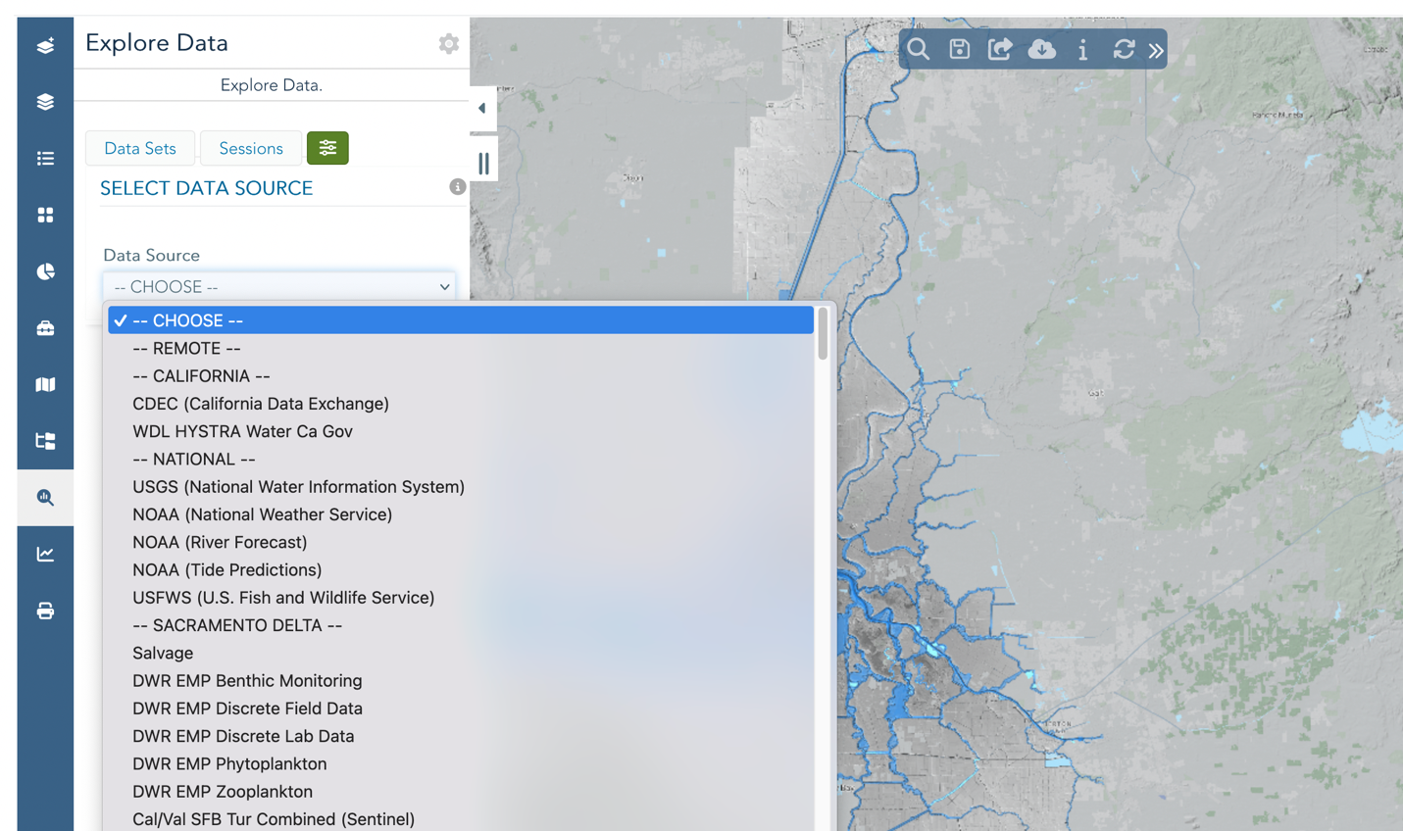Data catalog access for NWIS, CDEC, NOAA, USFWS EDSM, DWR EMP etc
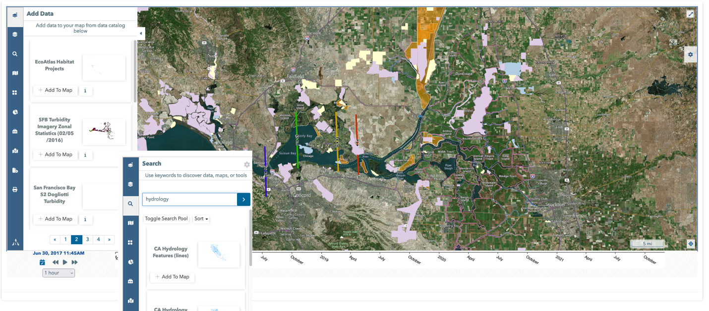
Rich Geospatial Layers for enhanced storytelling and spatial analysis
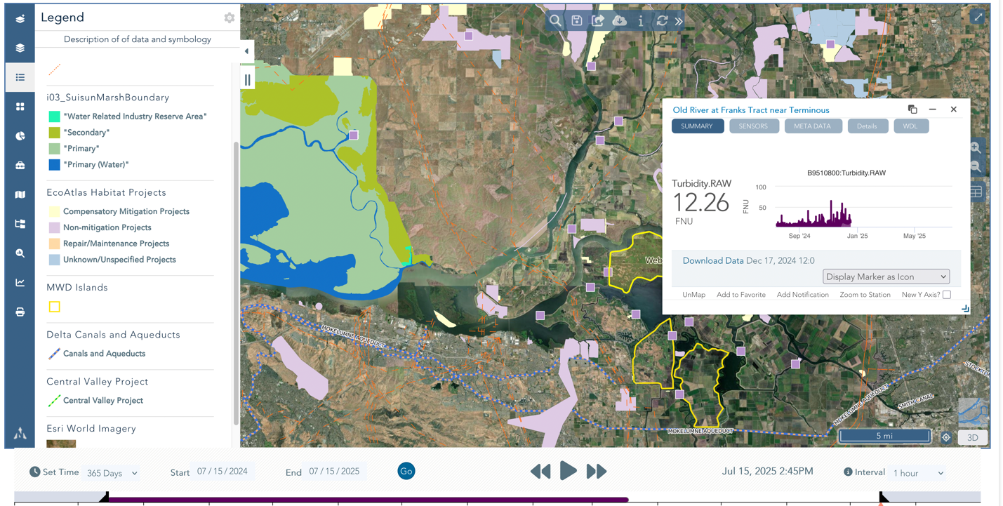
WDL sensors alongside current habitat projects, key infrastructure, and islands of interest.

*Deliverable 5: Data Filters, Custom Algorithms and Formula Integration
To support more insightful analysis of environmental sensor data, we implemented a set of time-based filters within the WDL Explore Data Dashboard. These include daily minimum, maximum, and average values, as well as rolling 3-day and 7-day daily averages. We also added a 3-day excursion sum to help identify periods where values exceed or fall below defined thresholds, and a “0 average” filter that excludes zero values—useful for handling sensor downtime or seasonal gaps. These tools allow users to detect trends, smooth variability, and flag critical events more easily.
These filters improve the clarity and usability of high-frequency time-series data, helping users generate meaningful summaries without external data processing. Performance has been optimized through efficient SQL and caching strategies, and users can toggle filters directly in the interface. This implementation lays the groundwork for further enhancements, including user-defined windows and filter-aware data exports.

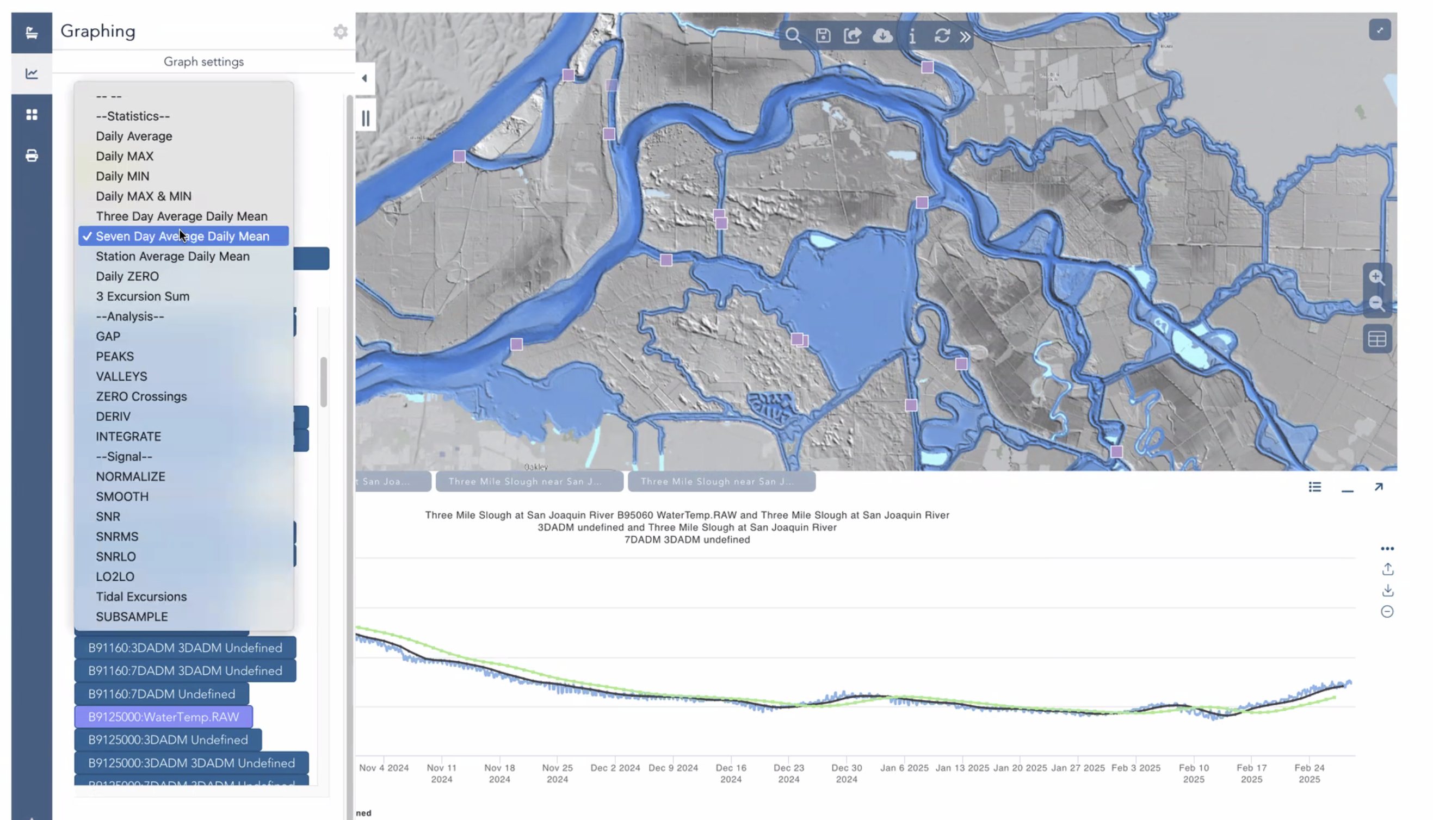
Example of applied time-series filters in the WDL Explore Data Dashboard. Shown are daily averages, 3-day and 7-day rolling means, and excursion sums, which help smooth data, highlight trends, and identify threshold exceedances across environmental sensor readings
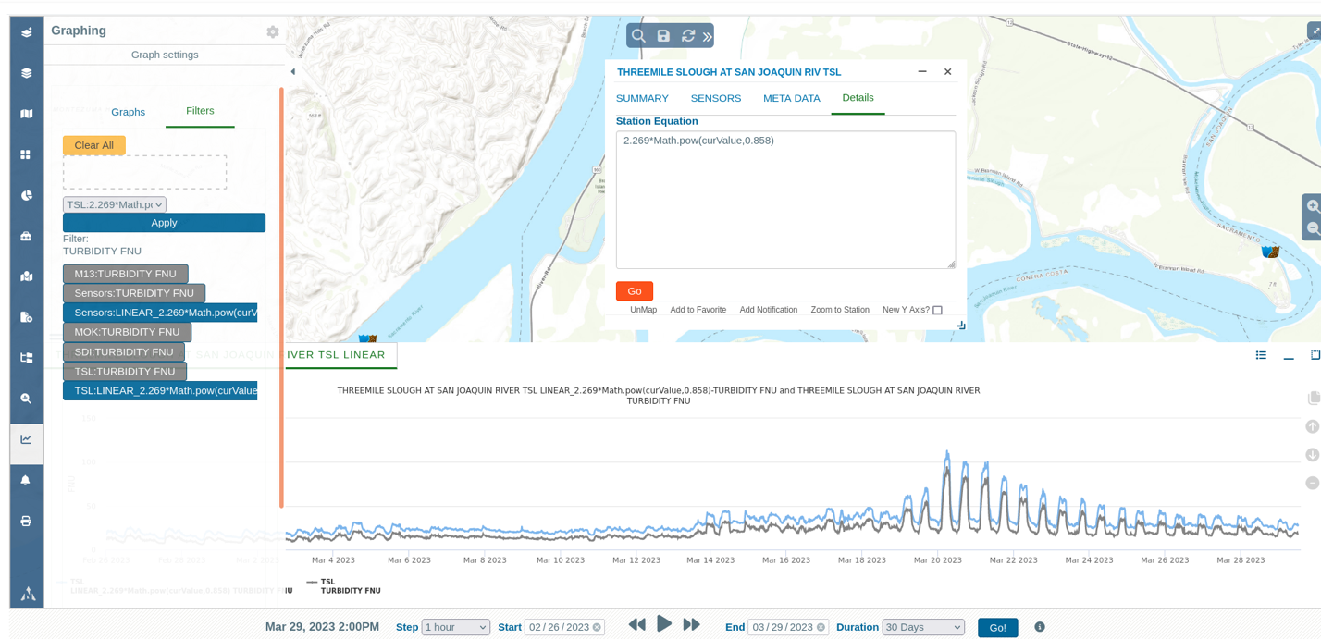
Users can now apply custom formulas to WDL data. For example, Suspended Sediment Concentration (SSC) formulas derived from turbidity can be configured and applied per station. SSC = 2.268 × Turbidity^0.858

*Deliverable 6: Time Series Visualization Tools
Developed new interactive time series tools for generating and saving visual comparisons. Charts support multi-year comparisons and user-driven overlays.

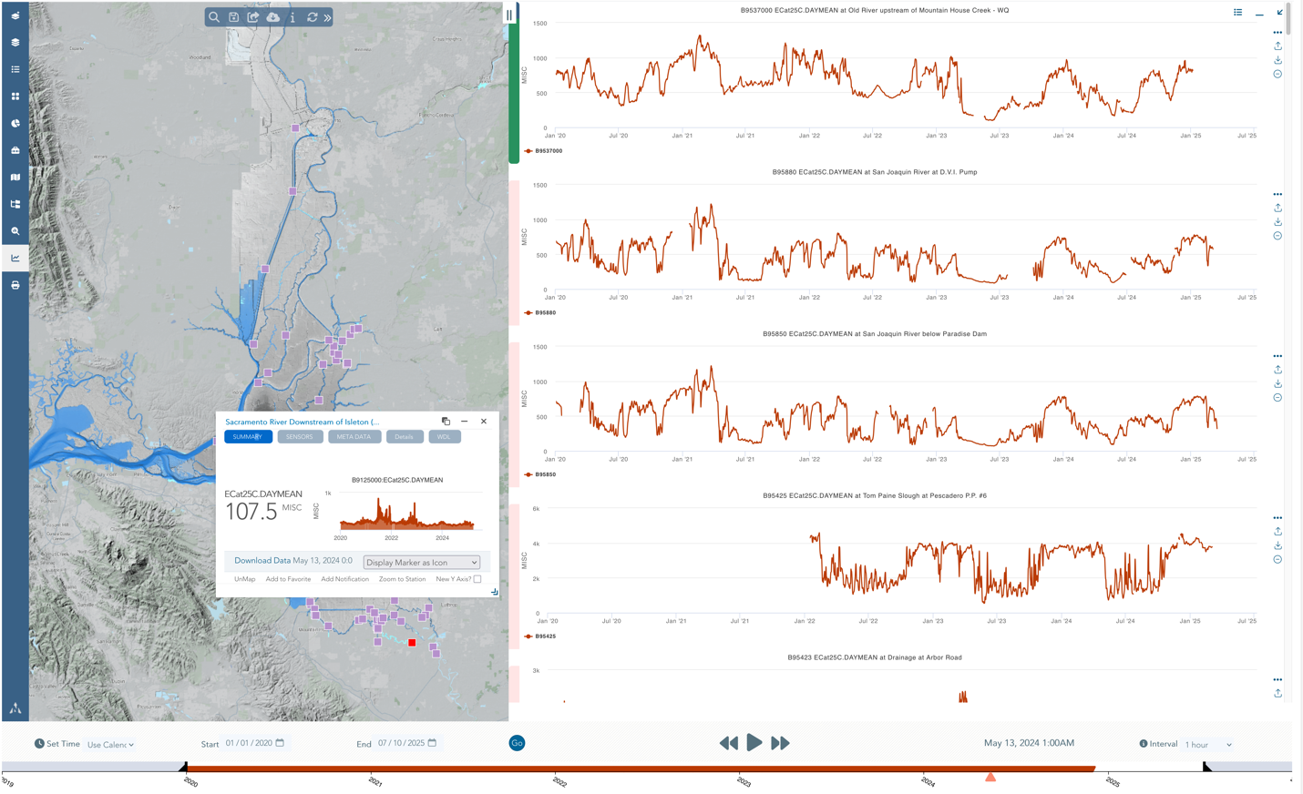
Data Dashboard: 5-year Electrical Conductivity Daily Mean at all WDL stations
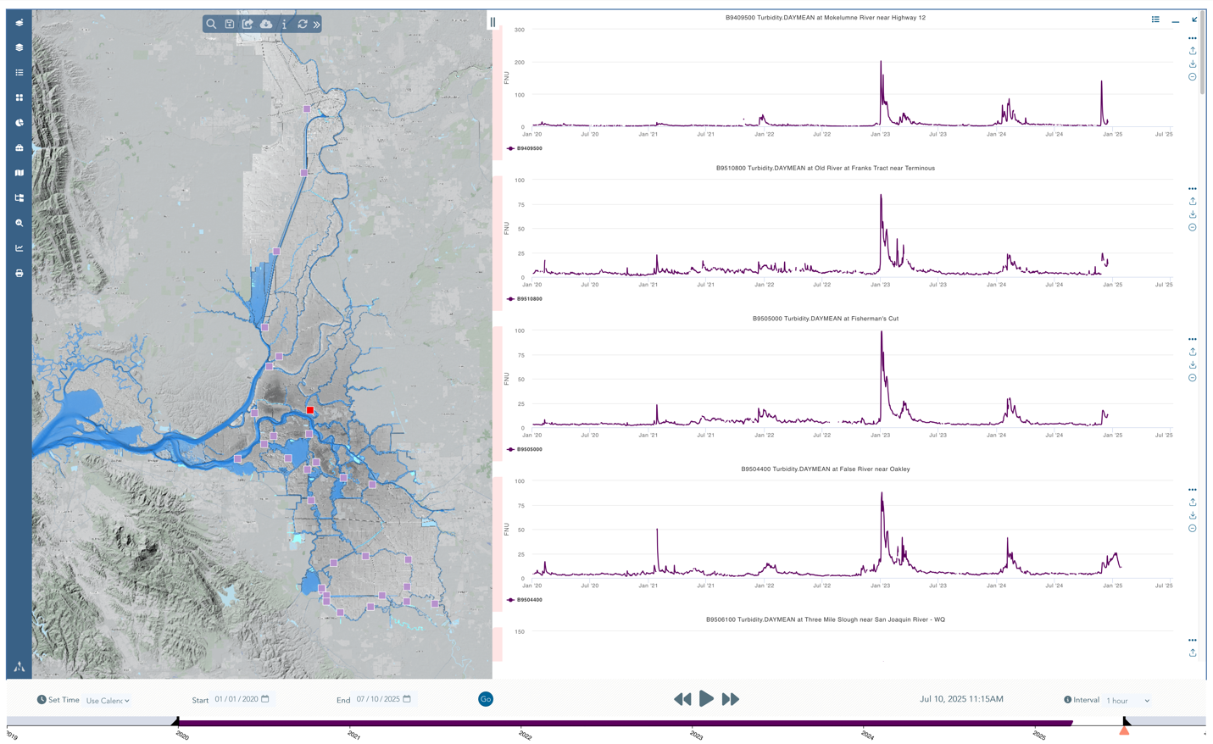Turbidity Dashboard: Image displays 5 years turbidity data at all WDL locations.

Deliverable 7: Downloadable Data Packages and Analysis Tools
Introduced powerful tools for extracting data to Save & Share customized maps, Bulk download sensor data by station and type and Export charts as images or CSV files for reporting and modeling.

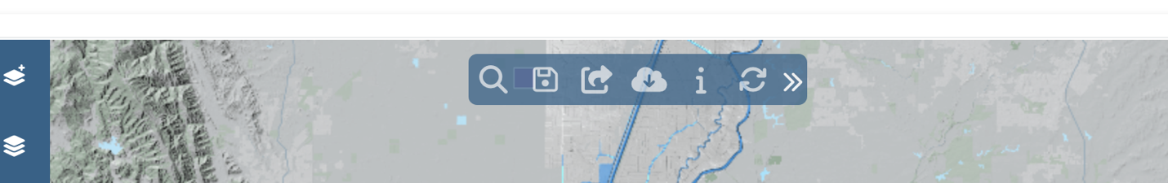
Map Tools: SAVE maps with your custom configuration of sensors, timeframe and charts. SHARE saved map with colleagues. DOWNLOAD all sensor data on the map in ONE ZIP FILE, by station and sensor.

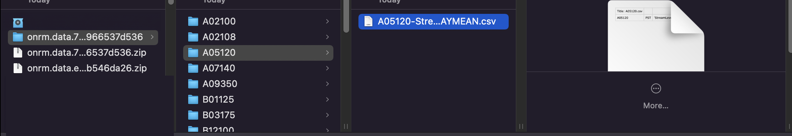
Bulk Download from Map: Image shows unzipped file view of a bull download. All stations csv for use in desktop analysis software and scripting.

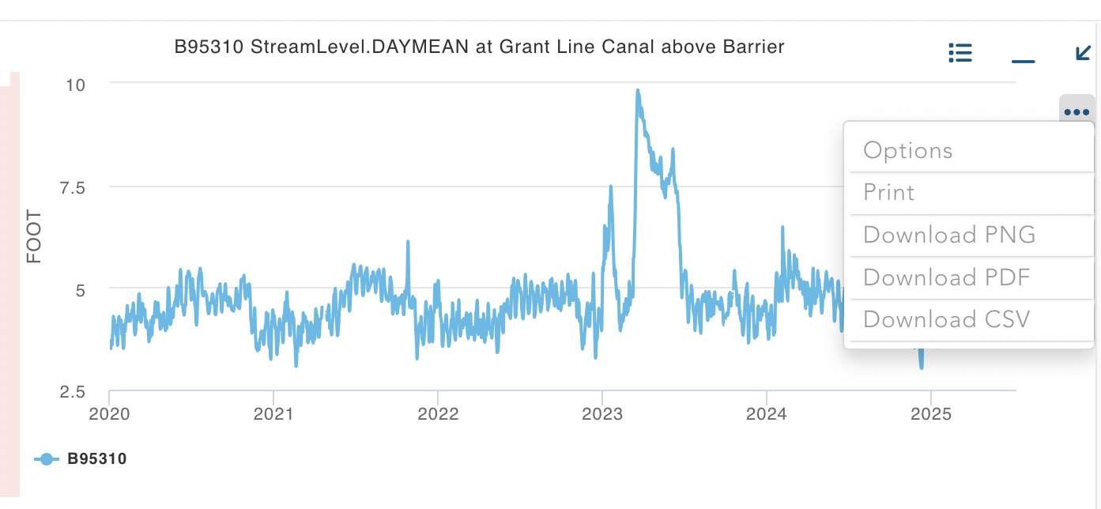
Chart Tools: Download, print, capture image of data using chart tools.

*Deliverable 8: Enhanced Stakeholder Access and Dashboards
Created dashboards with sensor-specific presets for quick access. Users can toggle timeframes and generate comparative charts without requiring prior technical experience.
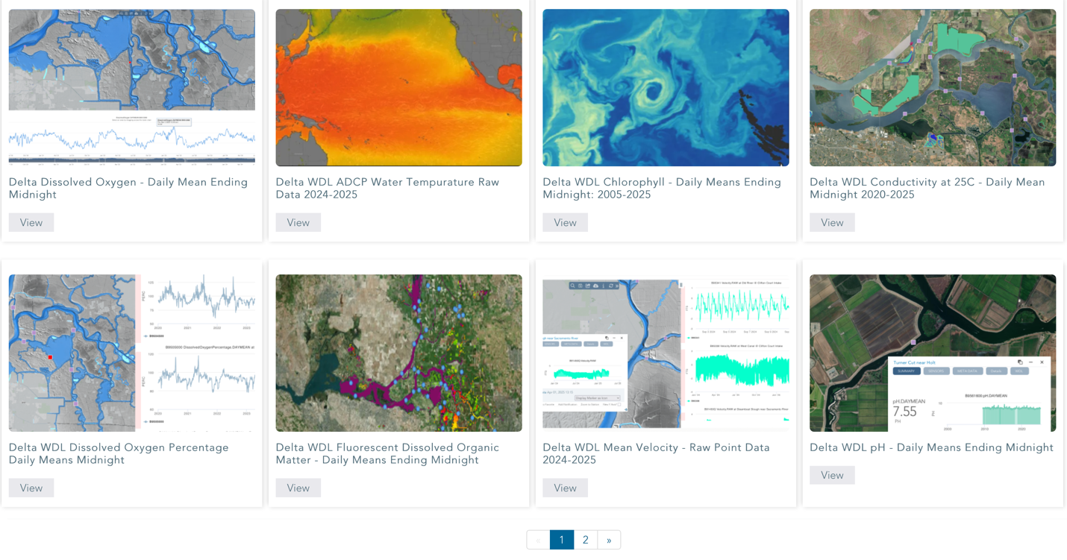WDL Data Presets: Dashboard presets developed for Turbidity, Conductivity, and
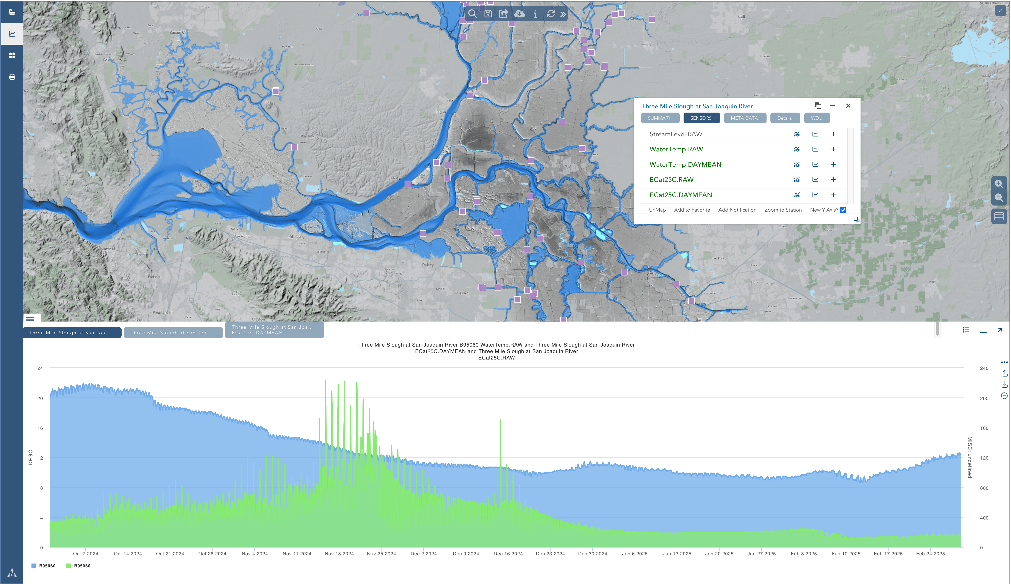
Water Quality Monitoring: Water Data Library water temperature and electrical conductivity from October 2024-February 2025

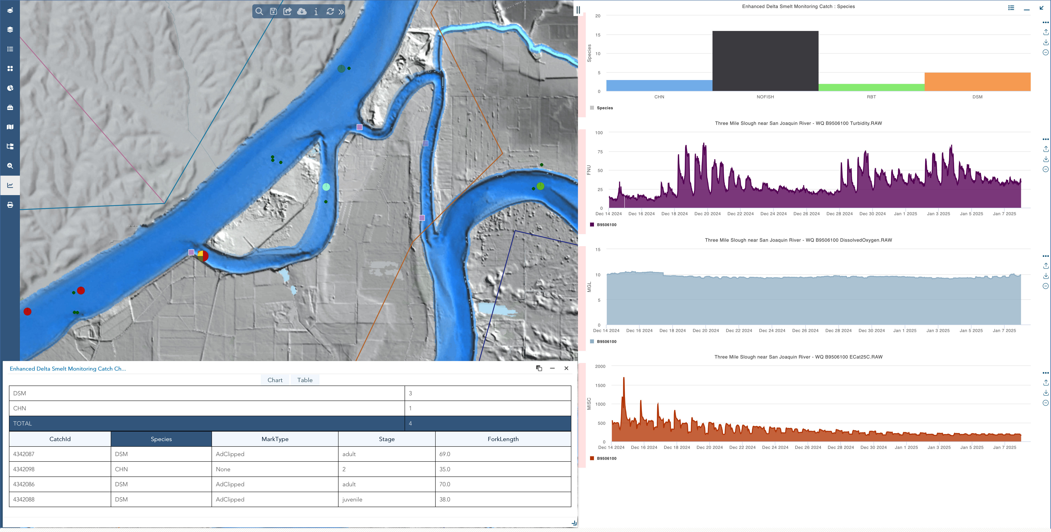
Water Quality and Fisheries Monitoring: Water Data Library water temperature and turbidity at 3-mile slough mapped with USFWS Enhanced Delta Smelt Monitoring Program monitoring results at the nearby location.

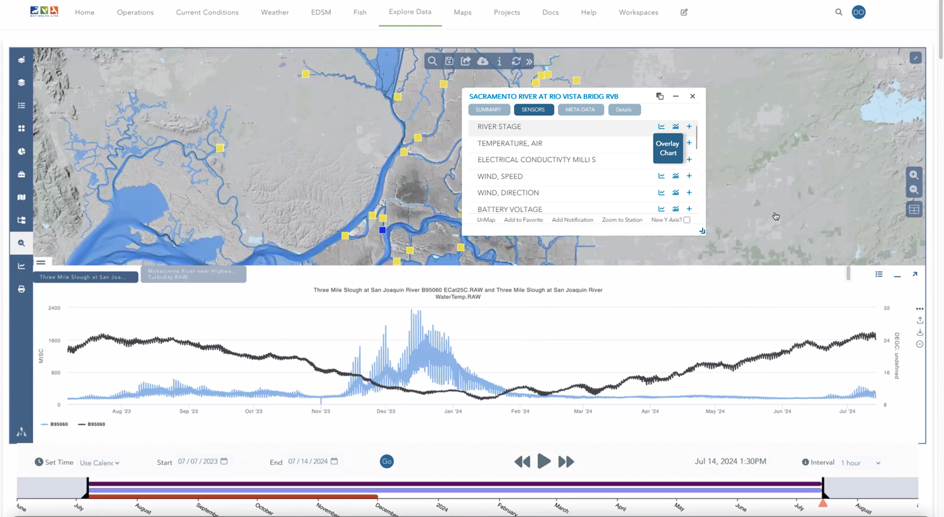
Data Comparison Tools: Overlay and compare any sensor.
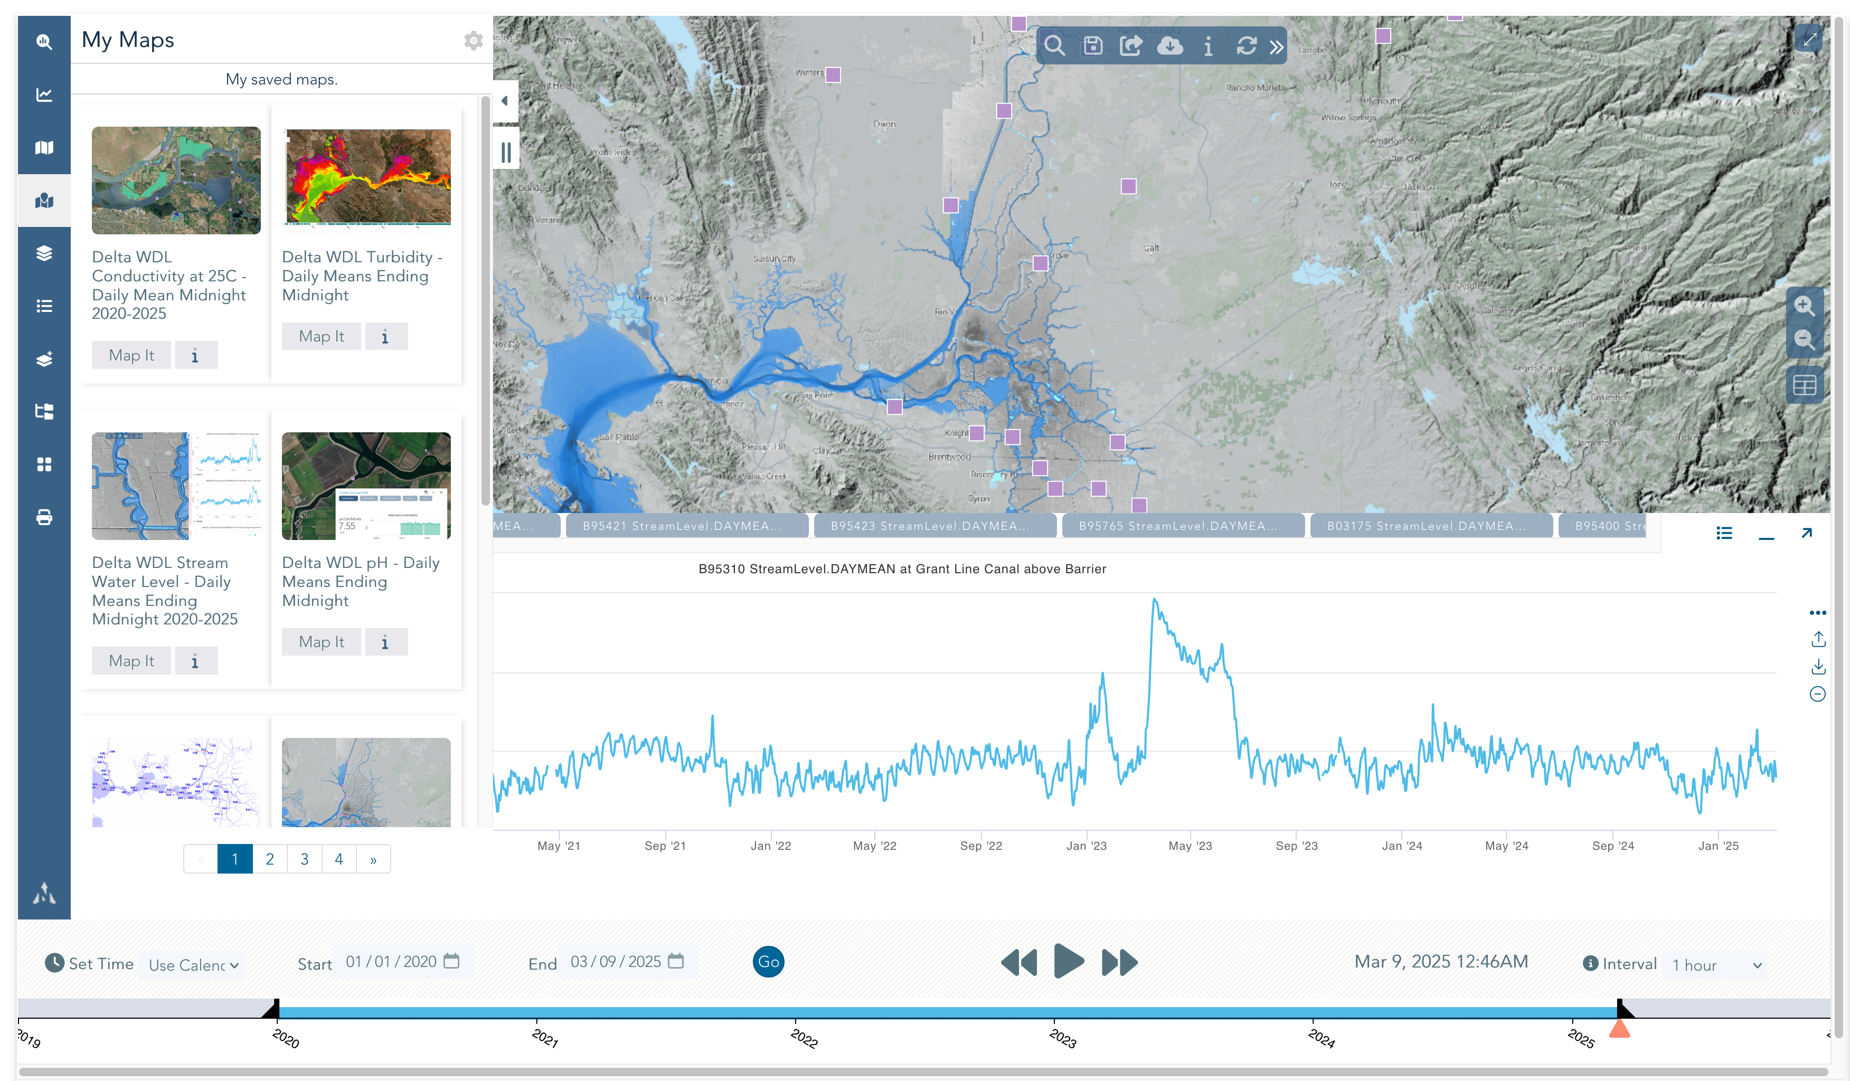User Dashboards: Quick access to your saved data and maps.

