**Turbidity Transects 2016-2017**



Project Description:

* The 2016-2017 Turbidity Transects will obtain a finer resolution of turbidity concentration in the South Delta. As turbidity is a key environmental trigger in the USFWS and NMFS Biological Opinions for anadromous fish and Delta Smelt, this mid-channel turbidity monitoring will be an important supplement to the existing continuous water quality station network in the Central and South Delta. Following each transect, results will be distributed within 24-hours as a GIS map (shown below) and utilized to inform real-time drought operations for the State Water Project (SWP) and Interagency Ecological Program (IEP) stakeholder project teams.



Project Need:

* As listed in the NMFS Salmon and the USFWS Delta Smelt Biological Opinions, turbidity is utilized as an indicator of fish movement. Daily turbidity transects will create a necessary ‘early warning’ system for improved efficiency between State Water Project operations and Delta Smelt and salmonid trawl efforts. From December 1, 2016, through June 30, 2017, regular transects will track the changing turbidity conditions and provide operational flexibility for flow management. Supplemental monitoring will be conducted in other regions and outside the project timeline, as deemed necessary.
* Requested by the Real Time Drought Operations Team (RTDOT) to meet USFWS 2008 RPA 1 & RPA 2 components.



Project Objectives:

* To reduce ‘take’ of endangered species at the SWP during drought conditions anticipated in WY 2017
* 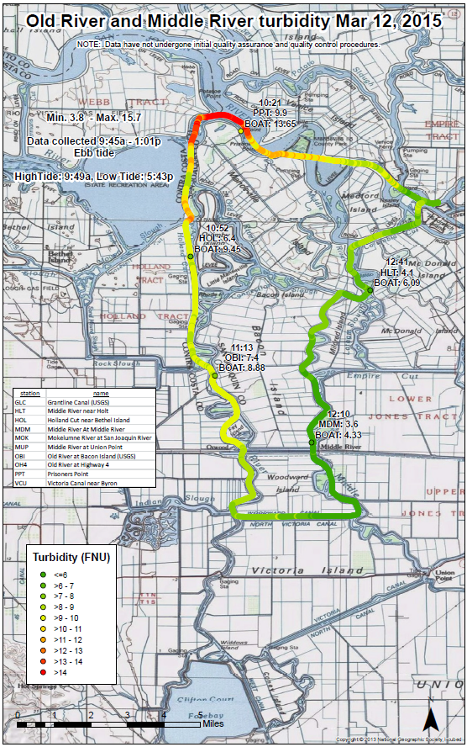To examine the effects of transient hydrodynamics of turbidity and/or weather conditions on the movement of Delta Smelt and Salmon in the Delta
* To provide an “early warning” to real-time drought operations on turbidity spikes
* To supplement the existing continuous water quality station network in the Central and South Delta



Schedule of Milestones:

* November - December 2016: Testing and training
* December 2016 – May 2017: Field sampling
* August 2017: IEP Newsletter article

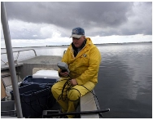Project Cost:

**$92,812 - $143,416**

Sponsored by: Russ Stein/Derrick Adachi

Project Manager:

Karen Gehrts, DWR

916-376-9694

Principle Investigators:

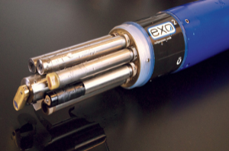Mike Dempsey, DWR

Emma Siegfried, DWR

Collaborators:

Russ Stein, DWR

Harry Spanglet, DWR